**Kubernetes**

**main.tf**

terraform {

required_version = ">= 1.5.0"

required_providers {

aws = {

source = "hashicorp/aws"

version = "~> 5.0"

}

}

}

provider "aws" {

region = var.region

}

# EKS cluster with one managed node group (2 nodes)

module "eks" {

source = "terraform-aws-modules/eks/aws"

version = "~> 20.0"

cluster_name = var.cluster_name

cluster_version = "1.29"

vpc_id = var.vpc_id

subnet_ids = var.private_subnet_ids

enable_irsa = true

eks_managed_node_groups = {

default2 = {

min_size = 2

max_size = 3

desired_size = 2

instance_types = ["t3.medium"]

capacity_type = "ON_DEMAND"

}

}

}

# To let kubectl know where the cluster is

data "aws_eks_cluster" "this" {

name = module.eks.cluster_name

depends_on = [module.eks]

}

data "aws_eks_cluster_auth" "this" {

name = module.eks.cluster_name

}

output "cluster_name" { value = module.eks.cluster_name }

output "cluster_endpoint" { value = data.aws_eks_cluster.this.endpoint }

output "cluster_certificate" { value = data.aws_eks_cluster.this.certificate_authority[0].data }

output "nodegroup_role_arn" { value = module.eks.eks_managed_node_groups["default2"].iam_role_arn }

# Access entry for clahaan-user6

resource "aws_eks_access_entry" "clahaan_user5" {

cluster_name = module.eks.cluster_name # directly put your cluster name

principal_arn = "arn:aws:iam::909688465000:user/clahaan-user5"

type = "STANDARD"

}

# Attach Cluster Admin policy

resource "aws_eks_access_policy_association" "clahaan_user5_cluster_admin" {

cluster_name = module.eks.cluster_name # directly put your cluster name

policy_arn = "arn:aws:eks::aws:cluster-access-policy/AmazonEKSClusterAdminPolicy"

principal_arn = aws_eks_access_entry.clahaan_user5.principal_arn

access_scope {

type = "cluster"

}

}

**terraform.tfvars**

region = "ap-south-1"

cluster_name = "Pra-eks-node"

vpc_id = "vpc-07ea395ad99b60b99"

private_subnet_ids = ["subnet-053773abd414e0b3a", "subnet-06c6453d2125124b4"]

public_subnet_ids = ["subnet-0963bfb6f84925488", "subnet-09eeb3e63141439cf"]

**variable.tf**

variable "region" {

type = string

default = "ap-south-1"

}

variable "cluster_name" {

type = string

default = "Pra-eks-node"

}

variable "vpc_id" { type = string }

variable "private_subnet_ids" { type = list(string) }

variable "public_subnet_ids" { type = list(string) }

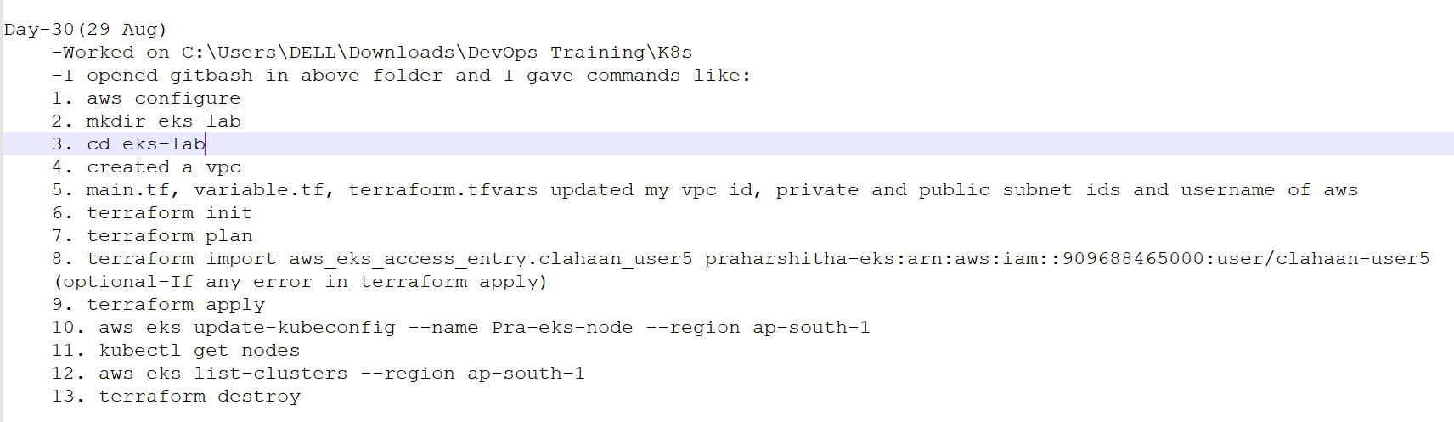

1. aws configure

2. mkdir eks-lab

3. cd eks-lab

4. created a vpc

5. main.tf, variable.tf, terraform.tfvars updated my vpc id, private and public subnet ids and username of aws

6. terraform init

7. terraform plan

8. terraform import aws_eks_access_entry.clahaan_user5 praharshitha-eks:arn:aws:iam::909688465000:user/clahaan-user5

(optional-If any error in terraform apply)

9. terraform apply

10. aws eks update-kubeconfig --name Pra-eks-node --region ap-south-1

11. kubectl get nodes

12. aws eks list-clusters --region ap-south-1

13. terraform destroy

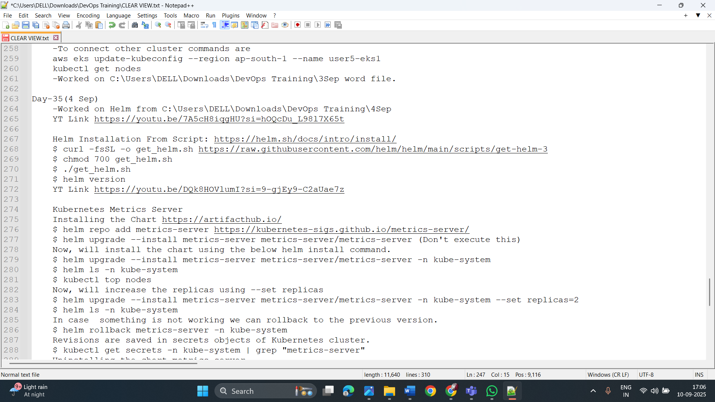

Day-34 (3 Sep)

-To connect other cluster commands are

aws eks update-kubeconfig --region ap-south-1 --name user5-eks1

kubectl get nodes

-Worked on C:\Users\DELL\Downloads\DevOps Training\3Sep word file.

Day-35(4 Sep)

-Worked on Helm from C:\Users\DELL\Downloads\DevOps Training\4Sep

YT Link https://youtu.be/7A5cH8iqgHU?si=hOQcDu_L98l7X65t

Helm Installation From Script: https://helm.sh/docs/intro/install/

$ curl -fsSL -o get_helm.sh https://raw.githubusercontent.com/helm/helm/main/scripts/get-helm-3

$ chmod 700 get_helm.sh

$ ./get_helm.sh

$ helm version

YT Link https://youtu.be/DQk8HOVlumI?si=9-gjEy9-C2aUae7z

Kubernetes Metrics Server

Installing the Chart https://artifacthub.io/

$ helm repo add metrics-server https://kubernetes-sigs.github.io/metrics-server/

$ helm upgrade --install metrics-server metrics-server/metrics-server (Don't execute this)

Now, will install the chart using the below helm install command.

$ helm upgrade --install metrics-server metrics-server/metrics-server -n kube-system

$ helm ls -n kube-system

$ kubectl top nodes

Now, will increase the replicas using --set replicas

$ helm upgrade --install metrics-server metrics-server/metrics-server -n kube-system --set replicas=2

$ helm ls -n kube-system

In case something is not working we can rollback to the previous version.

$ helm rollback metrics-server -n kube-system

Revisions are saved in secrets objects of Kubernetes cluster.

$ kubectl get secrets -n kube-system | grep "metrics-server"

Uninstalling the chart metrics-server.

$ helm uninstall metrics-server -n kube-system

-Then creating chart C:\Users\DELL\Downloads\DevOps Training\4Sep from Helm-for-Freshers-Step-by-Step-Guide PDF file.