Table of Contents
Job Portal Website Project Documentation 1
1. Requirement Analysis 1
1.2 Functional Requirements 1
1.3 Technical Requirements 2
2. Diagrams 2
3. Demonstration Plan 5
4. Testing Plan 6
5. Future Enhancements 6

Table of Figures
Figure 1 ER Diagram 3
Figure 2 Use Case Diagram 4
Figure 3 Wireframe 5
Figure 4 Gantt Chart 6

Job Portal Website Project Documentation

1. Requirement Analysis

1.1 Project Overview
The Job Portal is a web-based platform designed to connect job seekers with employers. It allows employers to post job vacancies, while job seekers can search, apply, and manage their job applications. The platform offers user-friendly dashboards for both job seekers and employers, with additional administrative functionalities for site managers.

1.1.1 Objective
- Develop a web application for job seekers to search and apply for job openings.
- Enable employers to post job listings and manage applications.
- Provide site admins with the tools to manage users, job postings, and monitor site activity.

1.1.2 Core Features
- User Authentication: Secure login and registration for job seekers, employers, and admins.
- Job Listings: Categorized job posts with filters for easy navigation.
- Application Management: Allow job seekers to apply and track applications, while employers can review and manage incoming applications.
- User Dashboards: Separate dashboards for job seekers, employers, and admins.
- Search Functionality: Advanced job search with keyword filters.
- Email Notifications: Alerts for job applications, status updates, and approvals.

1.2 Functional Requirements

1.2.1 User Roles
- Admin
  - Manage all users (job seekers, employers).
  - Approve or reject job postings.
  - Monitor site activities and generate reports.
- Employer
  - Register/Login.
  - Post, update, and delete job listings.
  - View applications for their posted jobs.
  - Contact applicants via the platform.
- Job Seeker
  - Register/Login.
  - Create and manage their profiles (upload resumes, add skills).
  - Search for jobs and apply.
  - Track application status (Applied, Reviewed, Rejected).

1.2.2 Feature Breakdown
- Authentication: Separate registration forms for job seekers and employers.
- Job Listings: Include categories, tags, and filters (location, salary range, job type).
- Search Functionality: Keyword-based job search with additional filters.
- User Dashboards: Employer and job seeker dashboards for managing applications and profiles.
- Notifications: Email alerts for job applications, approvals, etc.
- Resume Upload: Accept PDF/Word formats.

1.3 Technical Requirements
- Frontend: Django templates, responsive design using Bootstrap
- Backend: Django framework with Django REST Framework (if needed).
- Database: MySQL for storing user, job, and application data.
- Admin Interface: Customizable with Django Jazzmin for enhanced functionality.

2. Diagrams
Here are some key diagrams representing the system structure:

2.1 Entity-Relationship Diagram (ERD)

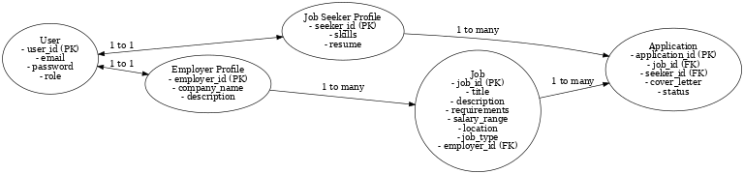
Figure 1 ER Diagram
Displays relationships between key entities such as users, jobs, and applications.

2.2 Use Case Diagram

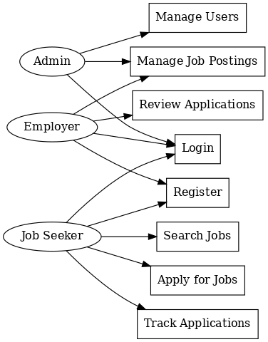
Figure 2 Use Case Diagram
Visualizes the interactions between users (job seekers, employers, and admins) and the system.

2.3 Frontend Wireframes

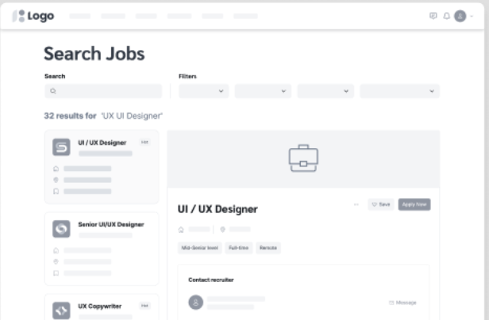
Figure 3 Wireframe
Basic layout showcasing the design of key pages for job seekers and employers.

2.4 Gantt Chart

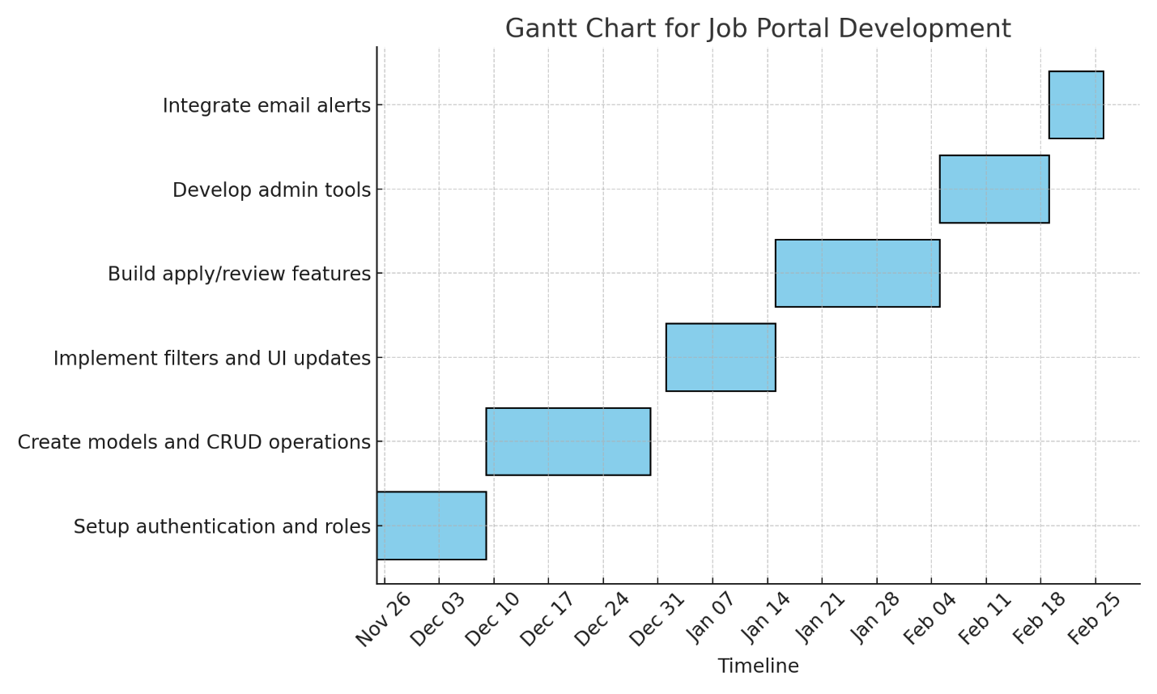
Figure 4 Gantt Chart
The Gantt Chart outlines the timeline and development phases of the project.

3. Demonstration Plan

Phase-wise Development & Demonstration
- Phase 1: User Management
  - Goal: Implement authentication and role-based access control.
  - Demonstrate:
    - Registration and login for job seekers and employers.
    - Admin access to manage user roles.
  - Expected Outcome:
    - Users can register and log in based on their roles (job seeker/employer).
- Phase 2: Job Management
  - Goal: Develop models for jobs and applications.
  - Demonstrate:
    - Employers can post, update, and delete job listings.
    - Job seekers can view job listings with details.
  - Expected Outcome:
    - Employers can manage their job posts; job seekers can browse available jobs.
- Phase 3: Search and Filter
  - Goal: Implement job search functionality.
  - Demonstrate:
    - Keyword-based job search with filters (location, job type, salary).
  - Expected Outcome:
    - Job seekers can find jobs based on specific criteria.
- Phase 4: Application Workflow
  - Goal: Develop application submission and management.
  - Demonstrate:
    - Job seekers can apply for jobs with resumes.
    - Employers can review and update application status.
  - Expected Outcome:
    - Smooth workflow for job applications and employer feedback.
- Phase 5: Admin Dashboard
  - Goal: Build the admin dashboard for managing users and jobs.
  - Demonstrate:
    - Admin can monitor job postings and user activities.
    - Admin can generate reports on site metrics.
  - Expected Outcome:
    - Admins have full control over platform management.
- Phase 6: Notifications
  - Goal: Integrate email notifications.
  - Demonstrate:
    - Email alerts for job application submissions and status updates.
  - Expected Outcome:
    - Users receive relevant notifications for key actions.

4. Testing Plan
- Unit Testing: Test individual components like models, views, and forms.
- Integration Testing: Validate interactions between different modules.
- User Acceptance Testing (UAT): Gather feedback to improve functionality.

5. Future Enhancements
- Mobile App Development: Extend platform functionality to mobile.
- Machine Learning: Add smart job recommendations.
- Payment Gateway: Enable premium employer services.

