**RV UNIVERSITY**

# School of Computer Science and Engineering Bengaluru – 560059



**Linux Administration**

**Course Code: CS1106**

**II Semester SoCSE**

# Laboratory Record

**Name Prahlad Bhat**

**USN 1RUA24BCA0066**

**Academic Year 2024 - 2025**

# RV UNIVERSITY

**School of Computer Science and Engineering**

## Bengaluru – 560 059



# LABORATORY CERTIFICATE

This is to certify that **Mr./Ms.** **PRAHLAD BHAT**

has satisfactorily completed the course of activities in **Linux Administration (CS)** prescribed by the **School of Computer Science and Engineering** during the year **2024-25.**

|  |  |
| --- | --- |
| **Name of the Candidate:** | **PRAHLAD BHAT** |
| **USN: 1RUA24BCA0066** | **Semester: II** |

|  |  |  |
| --- | --- | --- |
|  | **Ma** | **rks** |
| **Maximum** |  | **Obtained** |
| **5** |  |  |

**Signature of Faculty in-charge Program Director**

**Date:**

## Vision and Mission of the School of Computer Science and Engineering Vision

To be a pioneering school of Computer Science and Engineering committed to fostering liberal education and empowering the next generation of technologists to make a positive global socio-economic impact.

## Mission

* To be a pioneer in computer science education and benchmark ourselves with the world's top computer science and engineering institutions.

* To provide state-of-the-art facilities that enable exemplary pedagogy, advanced research, innovation and entrepreneurship in emerging technologies of computer science.

* To promote a culture of cooperation and inclusiveness among students and faculty from diverse communities enabling them to take part in interdisciplinary and multidisciplinary research, contributing to institution-building.

* To foster excellence through national and international academic, industry collaborations, bringing in diverse perspectives to drive innovation.

* To nurture a talented pool of ethical, self-driven and empathetic problem solvers to achieve sustainable development goals.

## INDEX

|  |  |  |  |
| --- | --- | --- | --- |
| **Sl.**  **No** | **Program Name.** | **Date** | **Page No.** |
| 1 | Basic Linux Navigation |  |  |
| 2 | Using the vi/vim editor |  |  |
| 3 | Exploring the Directory Structure and File Types |  |  |
| 4 | Creating and Managing User Accounts |  |  |
| 5 | Writing Basic Shell Scripts |  |  |
| 6 | Mounting and Formatting USB Drives |  |  |
| 7 | Backing Up and Compressing Files |  |  |
| 8 | Managing User and Group Permissions and Communication Utilities |  |  |
| 9 | Process Management |  |  |
| 10 | Disk Space Management |  |  |

**Lab 1: Basic Linux Navigation**

**Aim: Learn to use the command line programs to navigate and manage a linux system**

**Commands used:**

* ls
* cd
* pwd
* touch
* mkdir
* rmdir
* rm
* mv
* cp

**Usage:**

1. ls – list directory contents

Syntax: ls [options] [directory]

<Insert screenshot(s) here of ls, ls –a, ls –la, etc>

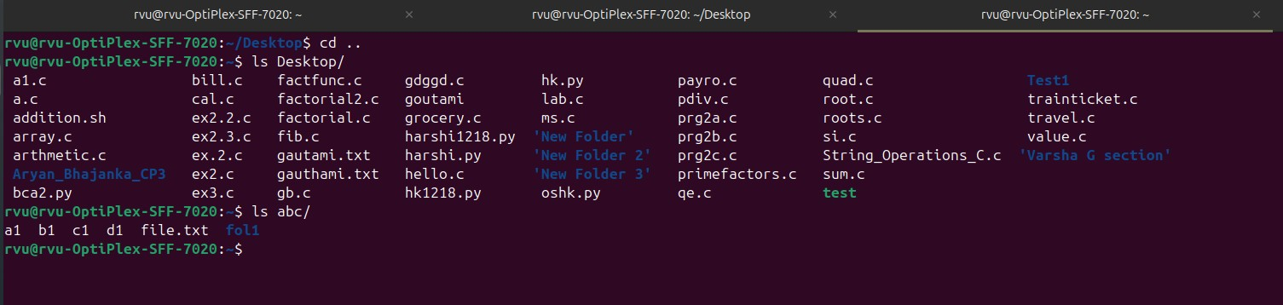

1. cd-change directory

Syntax: cd [directory]

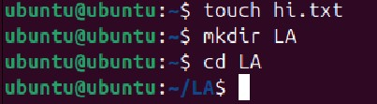

1. pwd-display current directory

Syntax: pwd

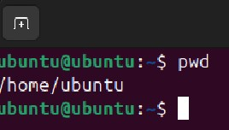

1. touch-create empty file

Syntax: touch [filename]



1. mkdir- make directory

Syntax: mkdir [options] [directory_name]



1. rmdir-remove directory

Syntax: rmdir [options] [directory_name]

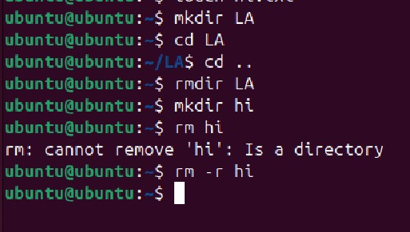

1. Rm-remove files and directories

Syntax: rm [options] [file/directory]



1. mv-move or rename files

Syntax: [options] [source] [destination]

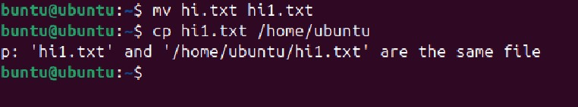

1. cp- copy files/ directories

Syntax: [options] [soruce] [destination]



**Lab 2: Using the vim/vim editor**

**Learn to use the text-based editor vim.**

**used:**

* + vimtutor
  + vim

**Usage:**

* 1. vimtutor – learn how to use the vim editor

<Insert screenshot(s) here of vimtutor>

* 1. vim

<Insert screenshot(s) here of you using of vim >

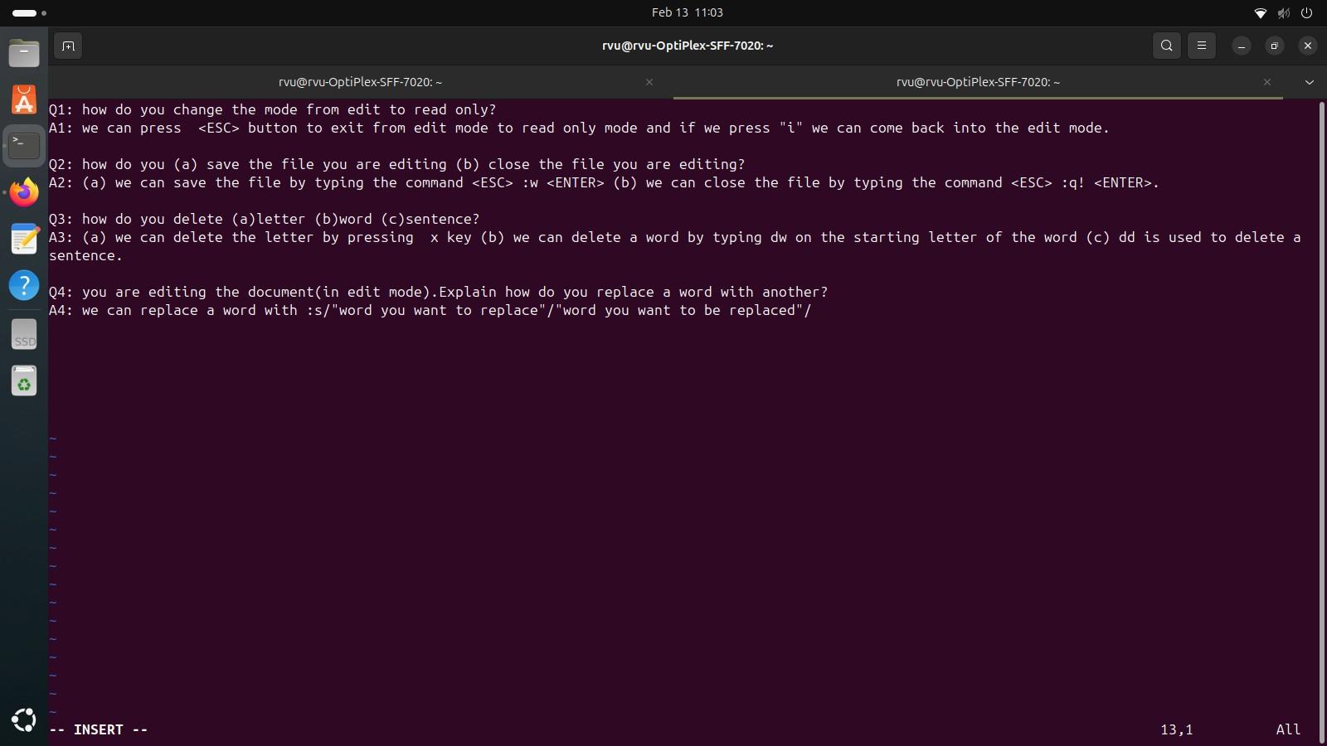

**Exploring directory structures and file types.**

**used:**

* + cd /etc :Configuration files (system-wide settings)
  + cd /sbin :System binaries (for administration, e.g., reboot, fdisk).

**Usage:**

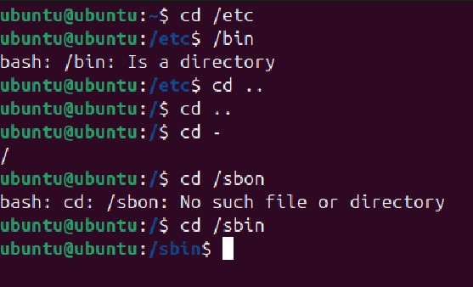

**Lab 4:**

**Creating and Managing User Accounts**

**used:**

* + Sudo adduser username :adds user
  + sudo passwd username

**Usage:**

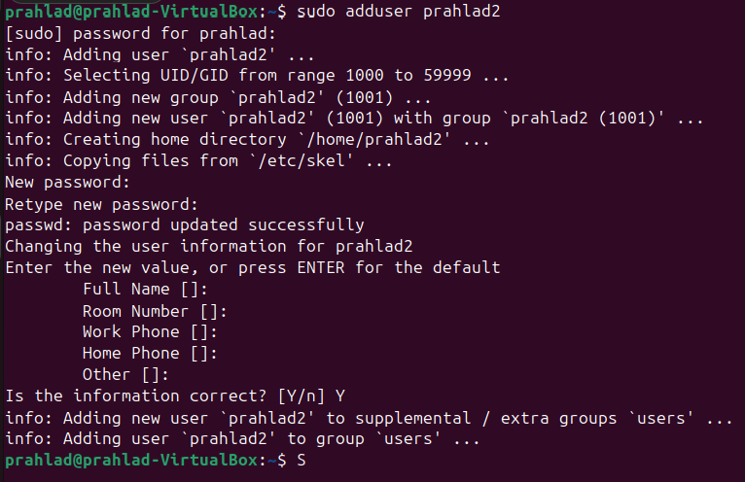

**Writing Basic Shell Scripts**

**used:**

* + echo :prints the message
  + Read :takes the input of the user
  + Chmod :changes the permissions of a file

**Usage:**

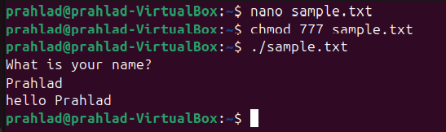

**Lab 6:**

**Aim:Mounting and Formatting USB Drives**

**Commands used:**

* + Lsblk :identifies the usb device
  + Sudo mkfs.vfat :formats the pendrive
  + Sudo mount :mounts the pendrive
  + Sudo umount :unmounts the pendrive

**Usage:**

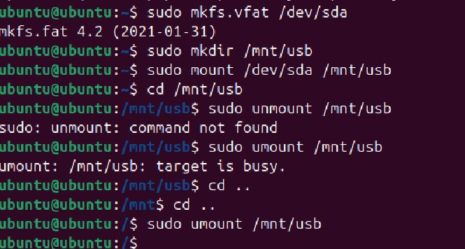

**Aim:Backing Up and Compressing Files**

**Commands used:**

* + Touch :creates an empty file
  + Cp :copies the file to the given destination
  + Tar -czvf :compresses the file
  + Gzip :compresses a single file

**Usage:**

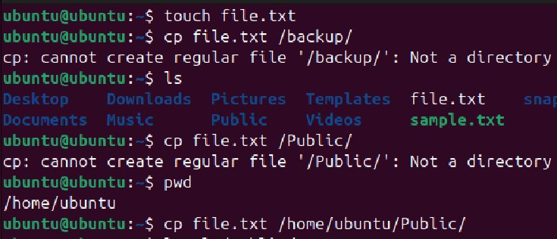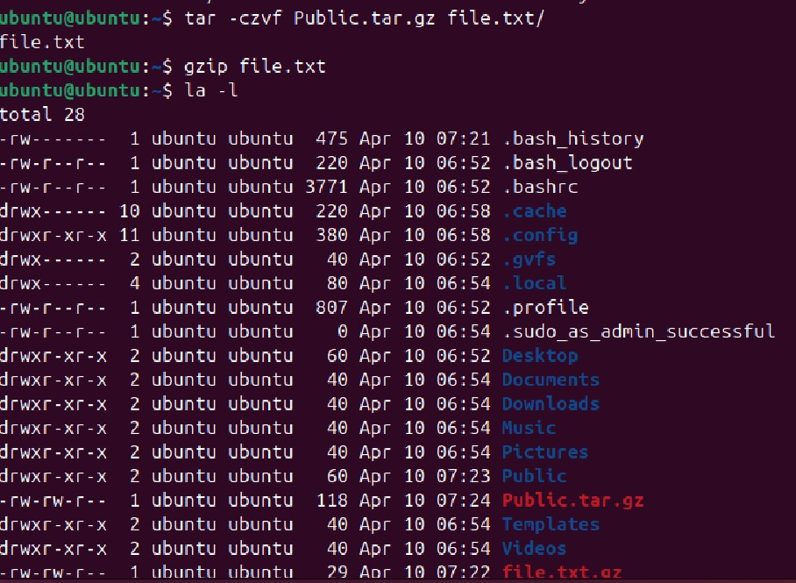

**Aim:Managing User and Group Permissions and Communication Utilities**

**Commands used:**

* + Ls -l :list all the files
  + Chmod 755 :changing the permissions
  + Who :to see whos logged in

**Usage:**

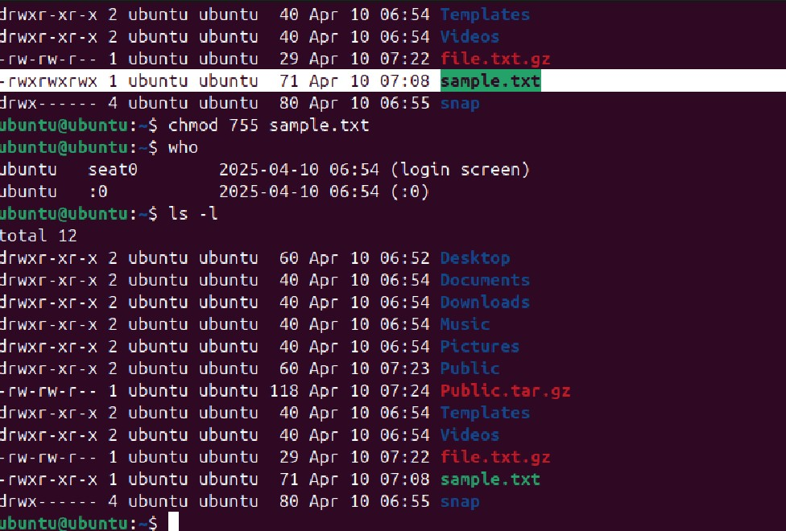

**Aim:Managing User and Group Permissions and Communication Utilities**

**Commands used:**

* + Ps :list running process
  + Ps aux :shows all process
  + Top :live view of system process
  + Pgrep :get pid by name
  + Pidof :pid of specific program
  + Kill 4279 :kill the process using pid
  + Pkill :kill the process using a process name

**Usage:**

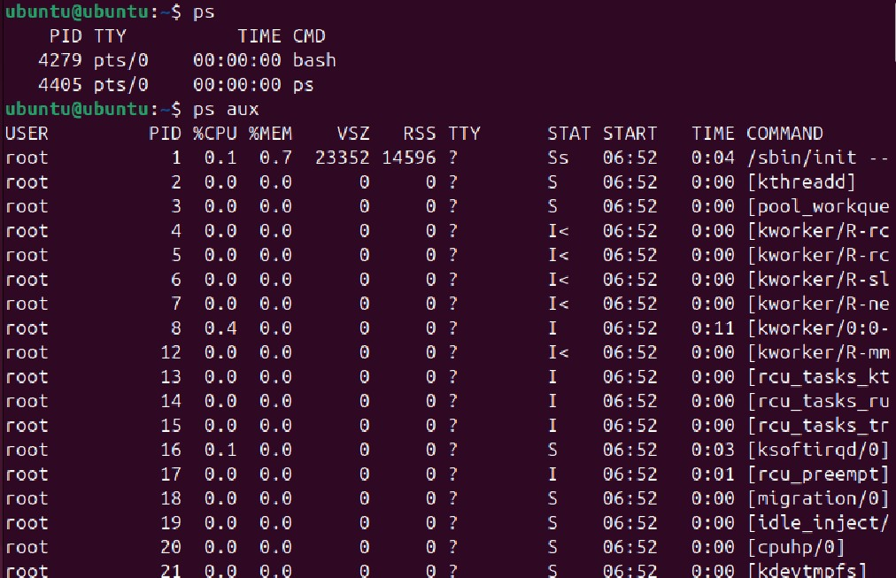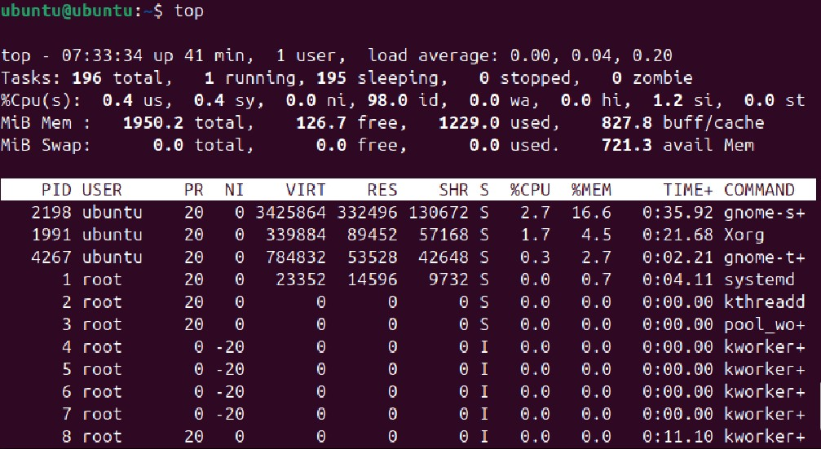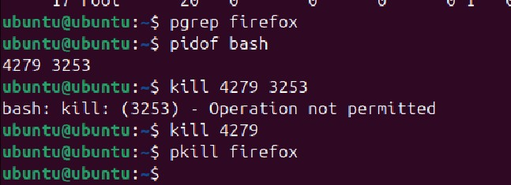

**Aim:Disk Space Management**

**Commands used:**

* + Df :disk filesystem usage
  + -h :human readable format
  + Du :disk usage of files/folders
  + -s :summarize
  + -h :human readable format

**Usage:**

