**Criterion B: Design**

**ENTITY RELATIONSHIP DIAGRAM**

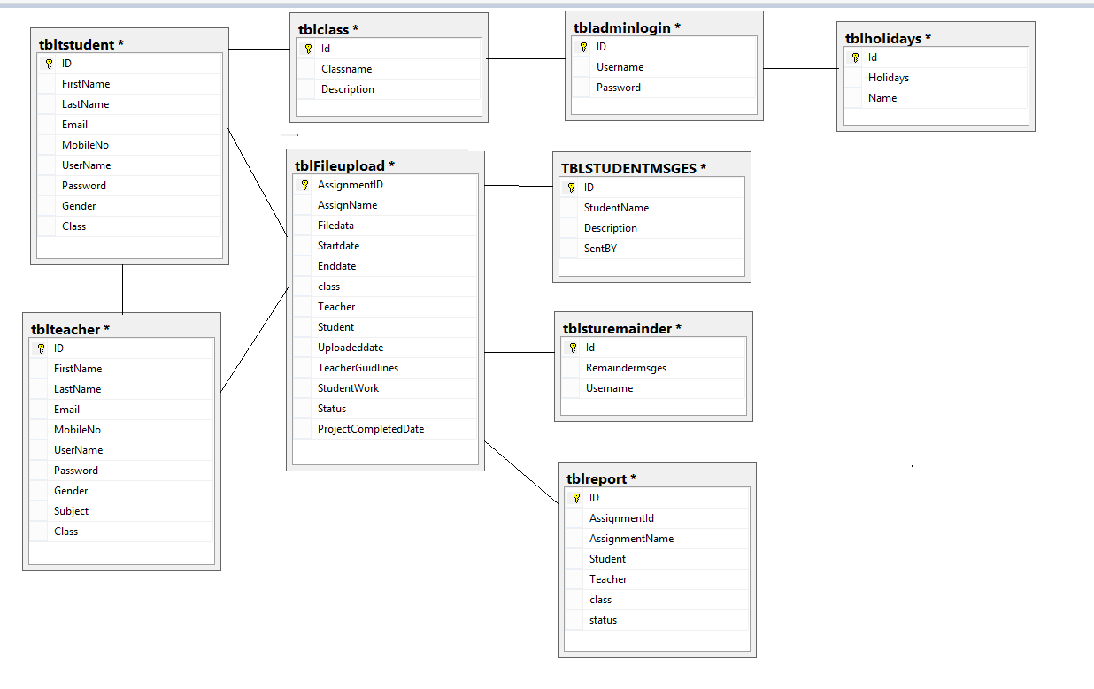

ERD provides clear information about the structure of the database.

**TABLES SHOWING FIELDS & DATA TYPES**

**Table: tbladminlogin**

|  |  |  |  |
| --- | --- | --- | --- |
| Field name | Data type | Description | Other information |
| ID | int | Uniquely identifies | Primarykey |
| Username | varchar(50) | Loginname |  |
| Password | varchar(50) | Password |  |

**Table: tblclass**

|  |  |  |  |
| --- | --- | --- | --- |
| Field name | Data type | Description | Other information |
| Id | int | Uniquely identifies | Primarykey |
| Classname | varchar(50) | Classname |  |
| Description | varchar(50) | Description of class |  |

**Table: tblFileupload**

|  |  |  |  |
| --- | --- | --- | --- |
| Field name | Data type | Description | Other information |
| AssignmentID | Int | Uniquely identifies | Primarykey |
| AssignName | varchar(50) | Assignmentname |  |
| Filedata | nvarchar(50) | Documents |  |
| Startdate | varchar(50) | Project start date |  |
| Enddate | varchar(50) | Project end date |  |
| class | varchar(50) | Class of teacher belongs |  |
| Teacher | varchar(50) | Name of Teacher |  |
| Student | varchar(50) | Name of student |  |
| Uploadeddate | varchar(50) | Project Uploaded date |  |
| TeacherGuidlines | nvarchar(500) | Guidelines of the project |  |
| StudentWork | nvarchar(500) | Student Documents |  |
| Status | varchar(50) | Status of current project |  |
| ProjectCompletedDate | varchar(50) | Complete date of project |  |

**Table:** **tblholidays**

|  |  |  |  |
| --- | --- | --- | --- |
| Field name | Data type | Description | Other information |
| Id | int | Uniquely identifies | Primarykey |
| Holidays | nvarchar(500) | Document File |  |
| Name | varchar(50) | Holidays Name |  |

**Table: tblreport**

|  |  |  |  |
| --- | --- | --- | --- |
| Field name | Data type | Description | Other information |
| ID | Int | Uniquely identifies | Primarykey |
| AssignmentId | Int | Assignment ID |  |
| AssignmentName | varchar(50) | Assignment Name |  |
| Student | varchar(50) | Student Name |  |
| Teacher | varchar(50) | Teacher name |  |
| class | varchar(50) | Class name |  |
| status | varchar(50) | Status of assignment |  |

**Table: tblsturemainder**

|  |  |  |  |
| --- | --- | --- | --- |
| Field name | Data type | Description | Other information |
| Id | Int | Uniquely identifies | Primarykey |
| Remaindermsges | varchar(50) | Remainder msg for student |  |
| Username | varchar(50) | Student Name |  |

**Table: tblteacher**

|  |  |  |  |
| --- | --- | --- | --- |
| Field name | Data type | Description | Other information |
| ID | int | Uniquely identifies | Primarykey |
| FirstName | varchar(50) | First name of teacher |  |
| LastName | varchar(50) | Lastname of teacher |  |
| Email | varchar(50) | Email of teacher |  |
| MobileNo | varchar(50) | Mobileno of teacher |  |
| UserName | varchar(50) | Username to login |  |
| Password | varchar(50) | Password to login |  |
| Gender | varchar(50) | Gender of teacher |  |
| Subject | varchar(50) | Subject they teach |  |
| Class | varchar(50) | Class they teach |  |

**Table: tblstudent**

|  |  |  |  |
| --- | --- | --- | --- |
| Field name | Data type | Description | Other information |
| ID | int | Uniquely identifies | Primarykey |
| FirstName | varchar(50) | First name of Student |  |
| LastName | varchar(50) | Lastname of Student |  |
| Email | varchar(50) | Email of Student |  |
| MobileNo | varchar(50) | Mobileno of Student |  |
| UserName | varchar(50) | Username to login |  |
| Password | varchar(50) | Password to login |  |
| Gender | varchar(50) | Gender of Student |  |
| Class | varchar(50) | Class they were studying |  |

**PROPOSED FORMS**

|  |  |
| --- | --- |
| **Form name** | **Outline** |
| frmMainpages | To provide a user-friendly interface to access all forms and reports |
| frmAdminlogin | Admin login form |
| frmclass | To add the class/Upload the holiday details |
| frmstudent | To make registration for the student |
| frmteacher | To make registration for the teacher |
| frmassignment | To add Assignments details/Add remainder |
| frmstudentupload | To view student uploaded works |
| frmReport | View completed projects and to make a report |
| frmviewreports | View completed reports |
| frmteacherlogin | Teacher login form |
| frmviewprofile | To view their own profile(teacher) |
| frmviewdocuments | To view their student assignment/add Guidelines |
| frmchats | To update deadlines of the assignment |
| frmstudentuploaded | To view student completed work. |
| frmtimetable | To view time table of class |
| frmstudentlogin | Student login from |
| Frmviewprofile | To view their own profile(Student) |
| Frmviewassignments | To view assignment to complete |
| Frmdefault | Remainder form |

**Test plan**

|  |  |  |
| --- | --- | --- |
| **Action to be Tested** | **Test Method** | **Examples** |
| Unique no. is being added to each new added Teacher and student. | Unique no. is allocated to new Teacher and Student | All the fields in the form will be mandatory( First name Last name, Username , Password, Gender, Class ,Subject) |
| Program is able to read and edit values in the database | Check the ‘all’ registration details in the table for both student and teacher table. If any update is made it should be updating check. | The data be edited after inserting into the database if the details updated ( Class, Assignment details, Registration details) |
| Uploading of documents (like table, deadlines, list of holidays)were being stored in database. | Check all the information all the data was properly inserting or not | The uploading of files is stored in the database ,and each field should be inserted ,if not validation rises. |
| Proper validation for all forms | Required field validator is present so every important data should be properly added. | The uploading of files is stored in the database ,and each field should be inserted(assignment, start date and end date) |
| Relationships created correctly | Data is added to one table that cascades into another | Relationship is maintained for the tables like (Class to assignment, Class to teacher and the student) |
| Forms work as expected | Data is added and changed using the forms. All buttons are tested | While running the project the all commands were performing, they are able to function well. |
| Downloading of  documents (Teachers and Students) | Every user is accepting the correct document are checked through the database | While the user like (Student and Teacher )clicked on button and the file be downloaded. |
| Uploading of their data ( guidelines and assignment work) | Checks all the information of their uploading of data and storing is properly has being be done or not | The teacher will be adding Sthe guidelines about the project and student will upload the completed work should be added mandatory |

**Class Diagram**

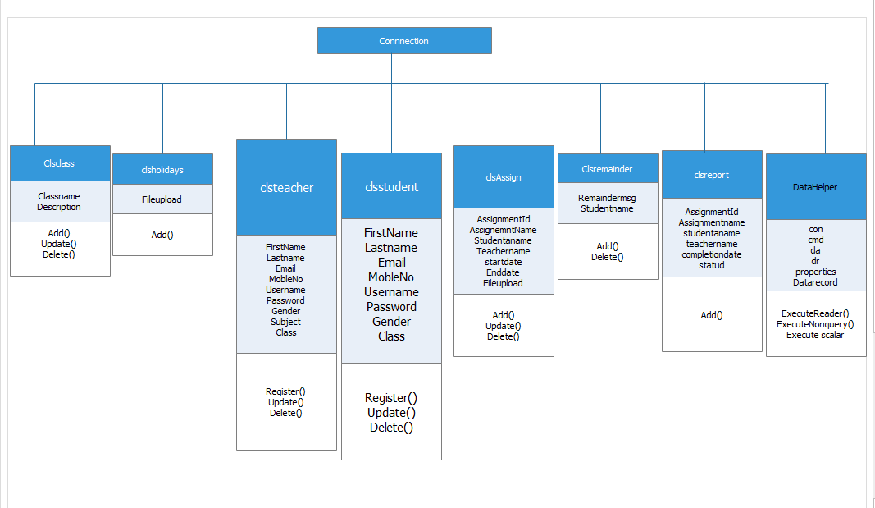

**FlowChart**

**Admin**

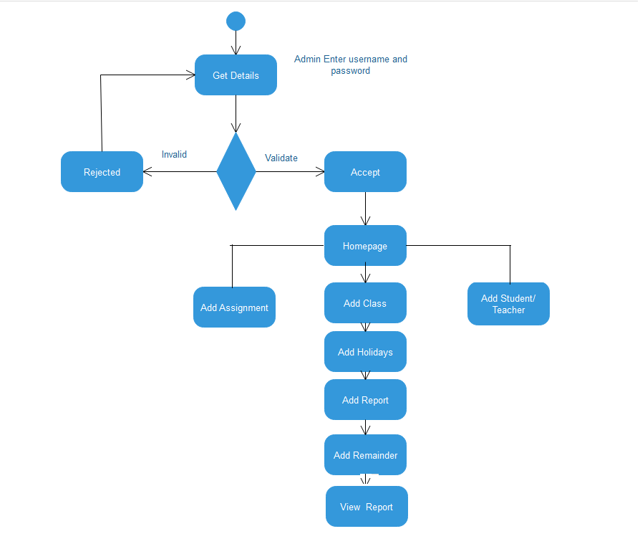

**Teacher Flow chart**

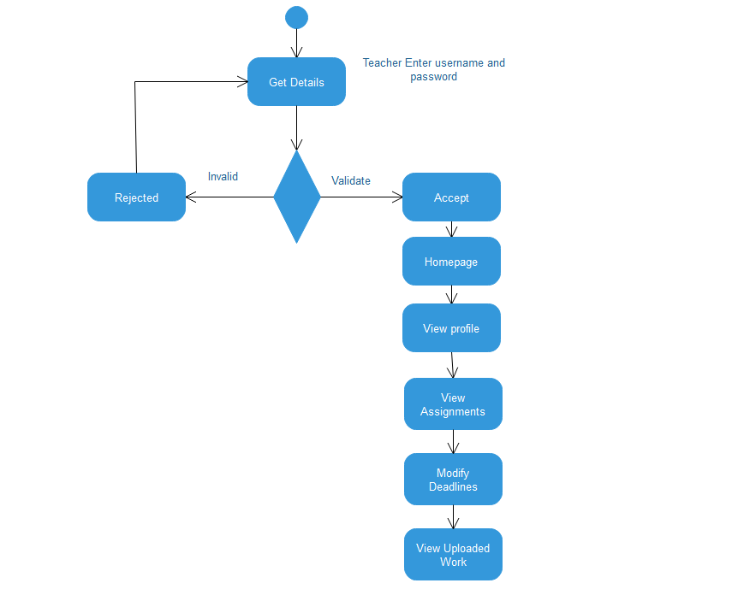

**Student Flow Chart**

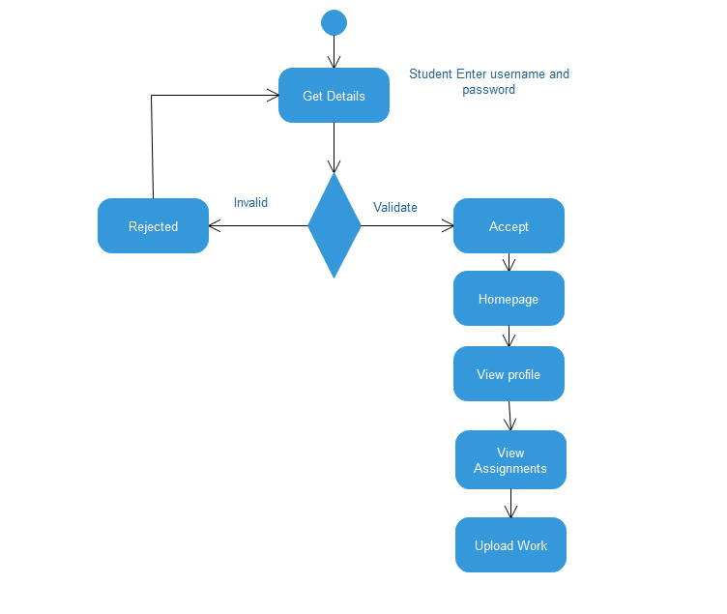

**Screens**

**Admin**

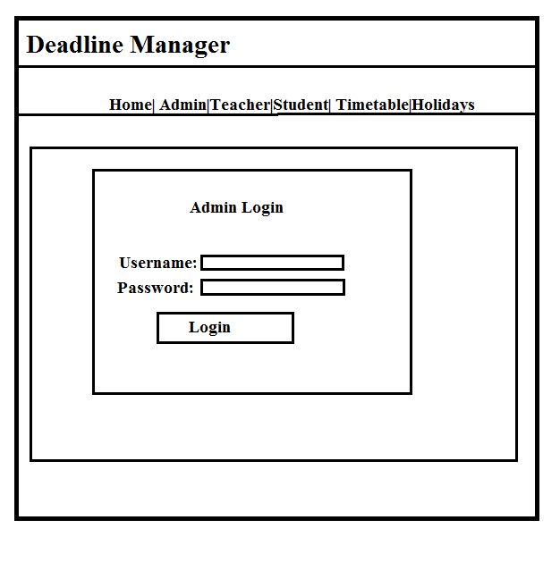

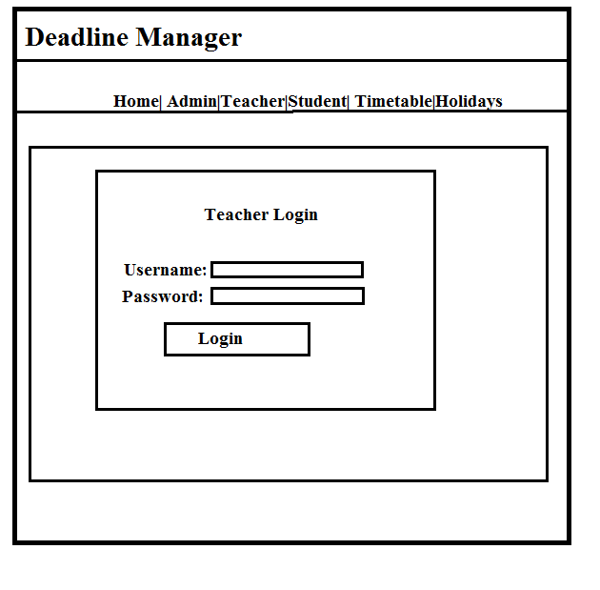

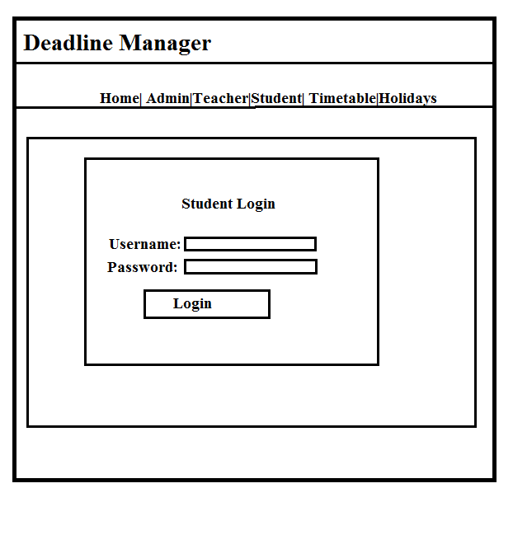

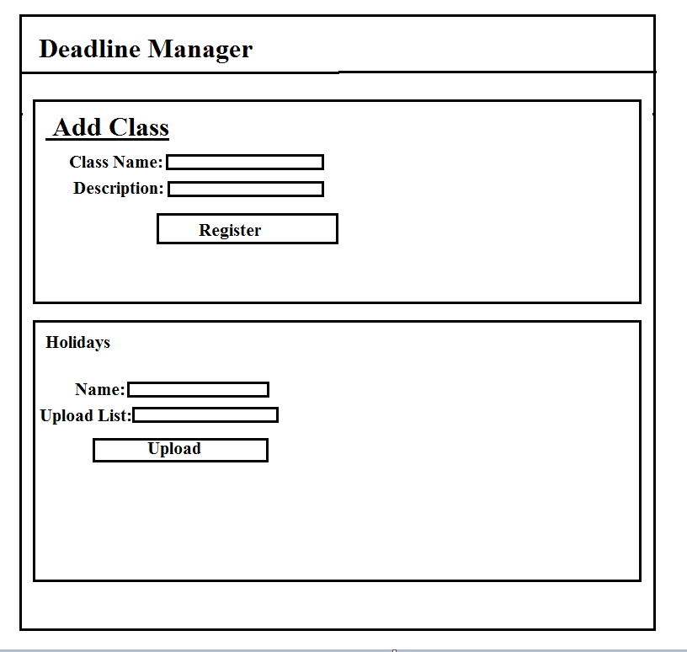

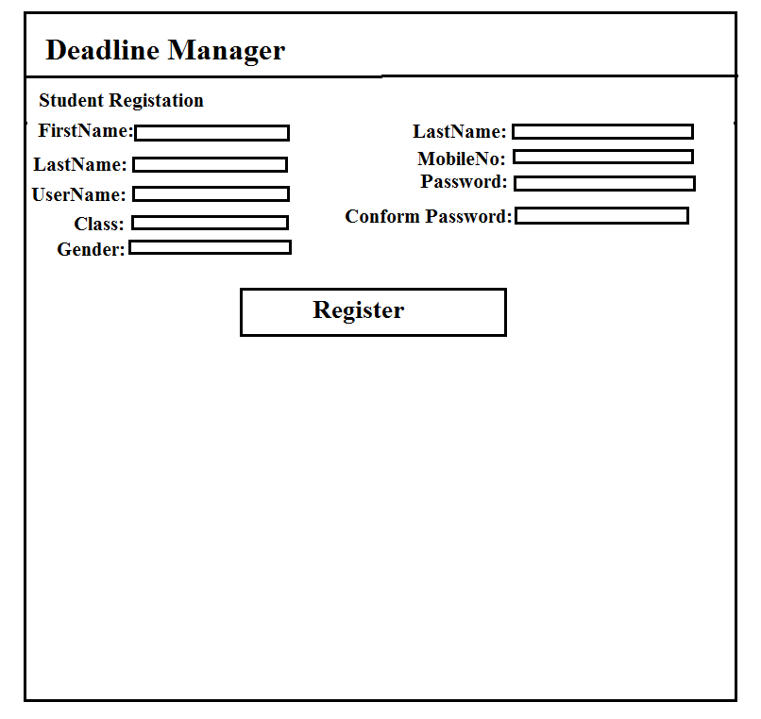

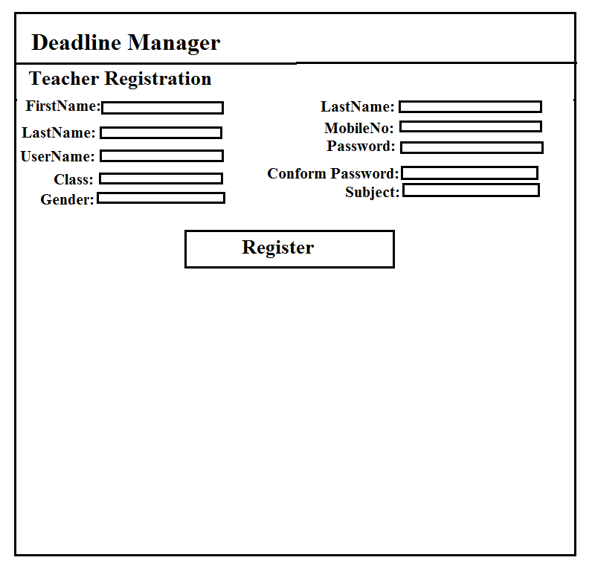

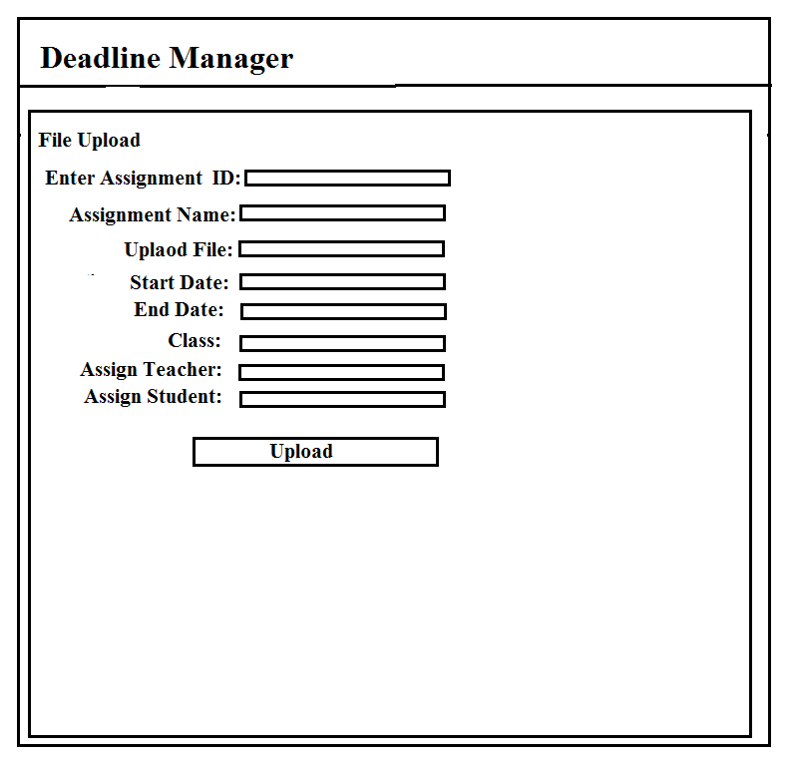

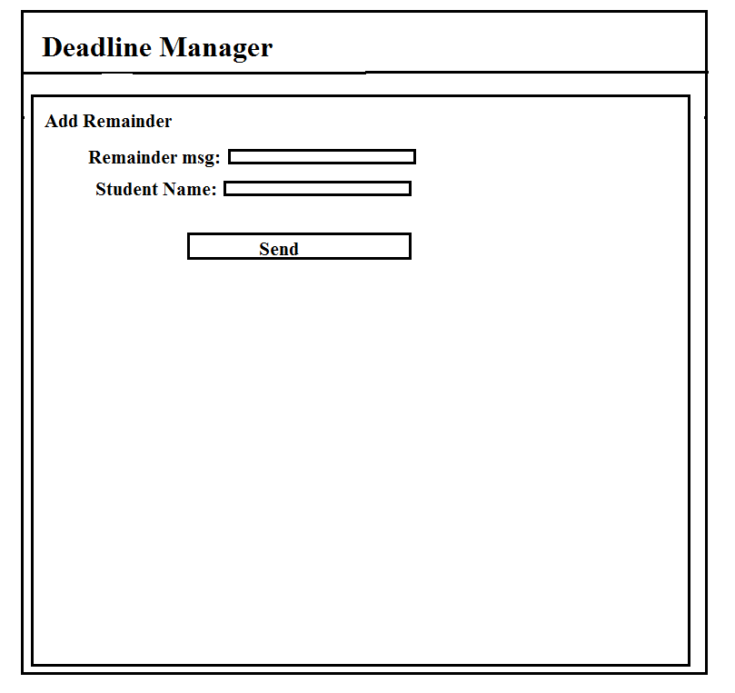

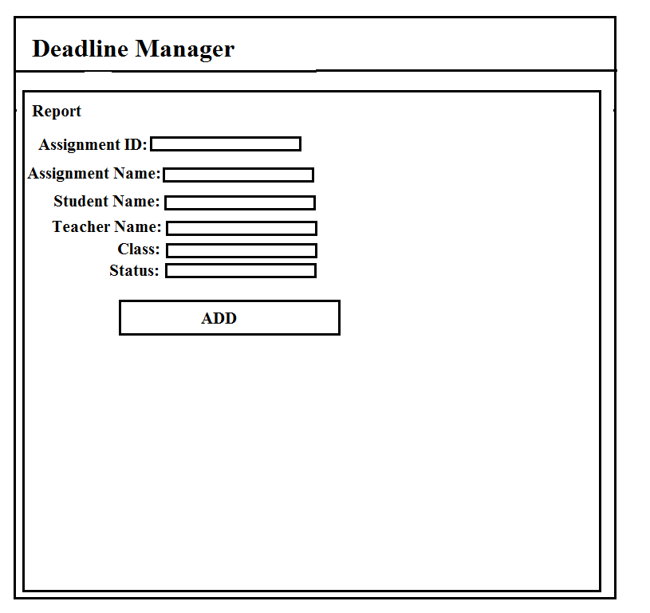

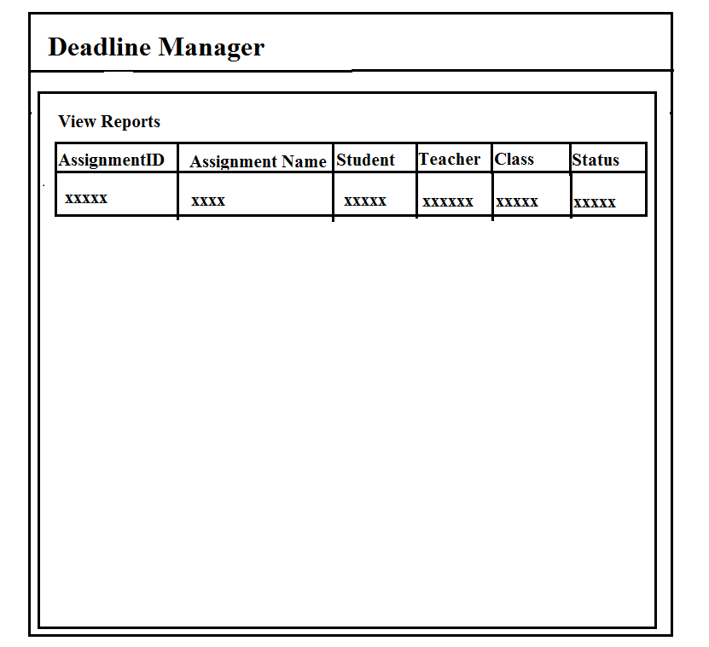

**Teacher**



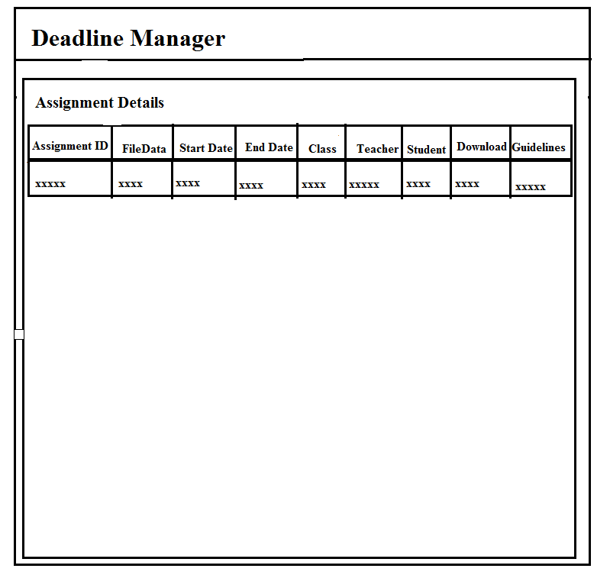

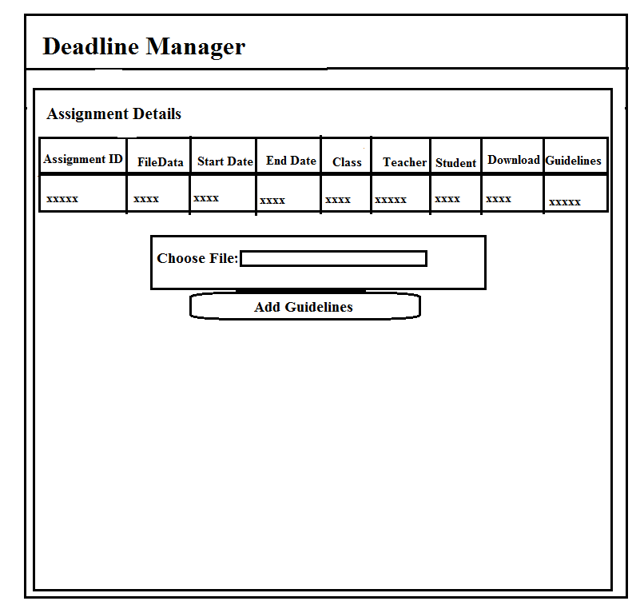

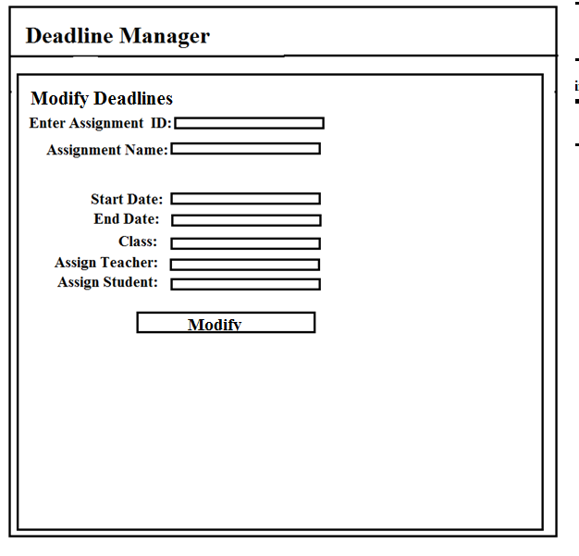

**Student**



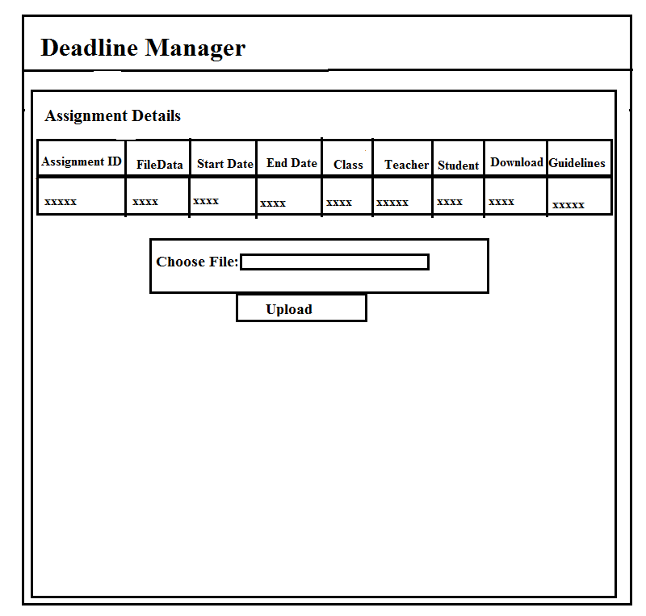

**UML Diagrams**

**Admin Use case Diagram**

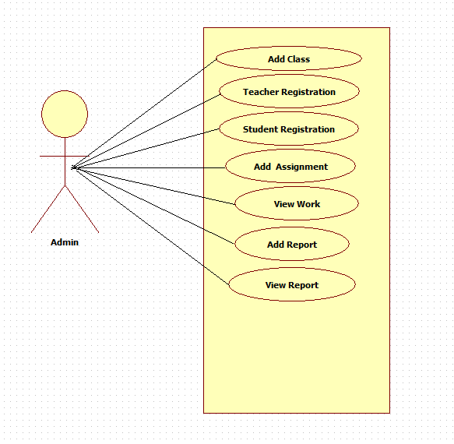

**\**

**Teacher Use case**

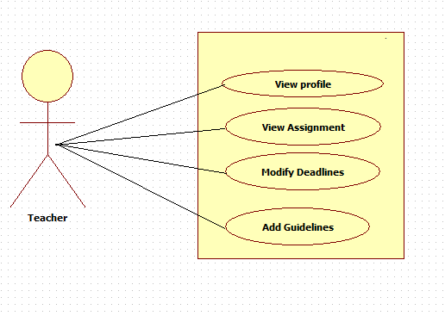

**Student Use case**

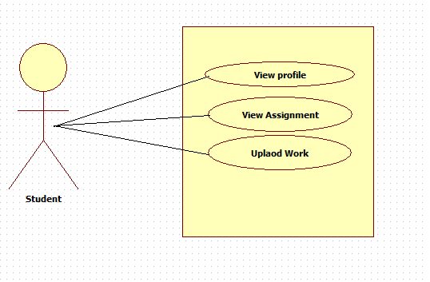

**Admin Sequence Diagram**

**Add Class**

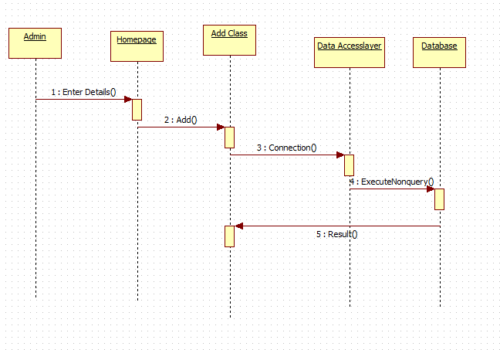

**Teacher Registration**

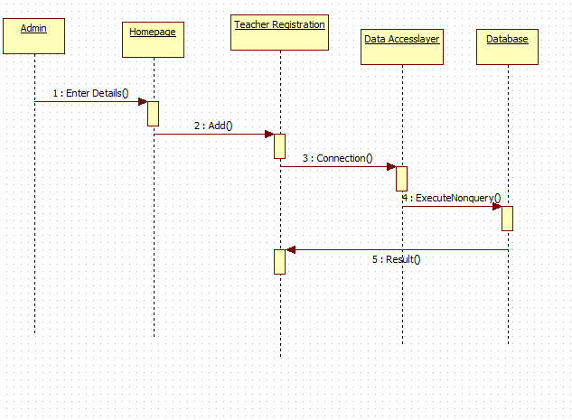

**Student Registration**

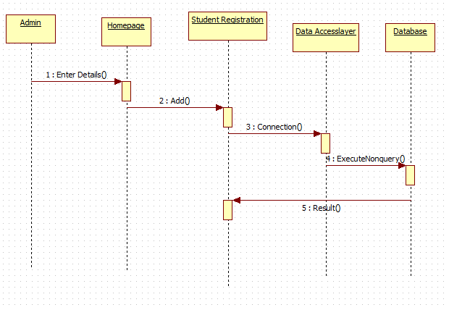

**Add Assignment**

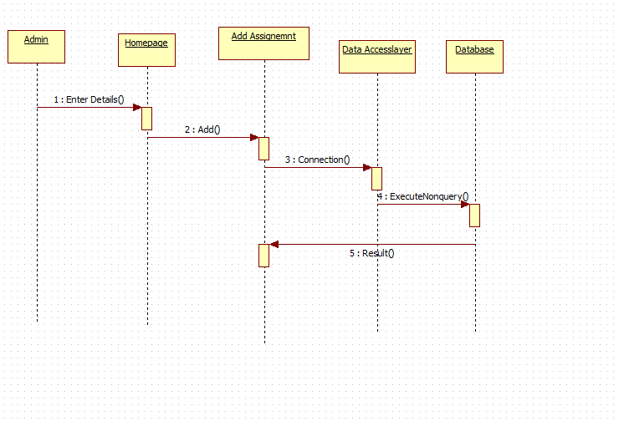

**View Work**

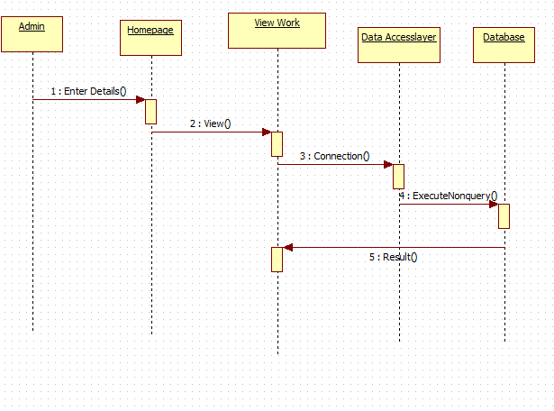

**Add Report**

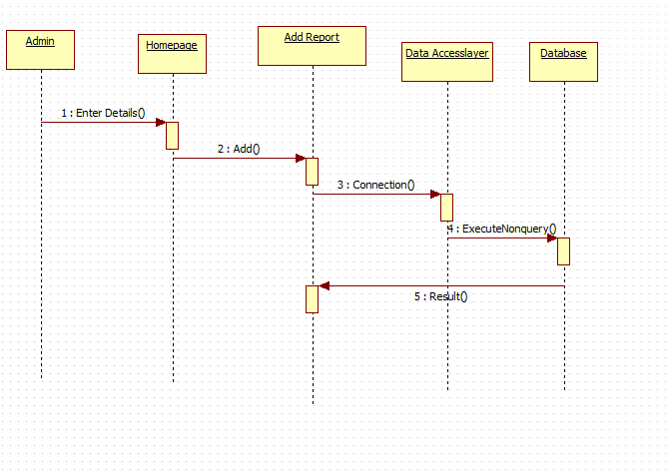

**View Report**

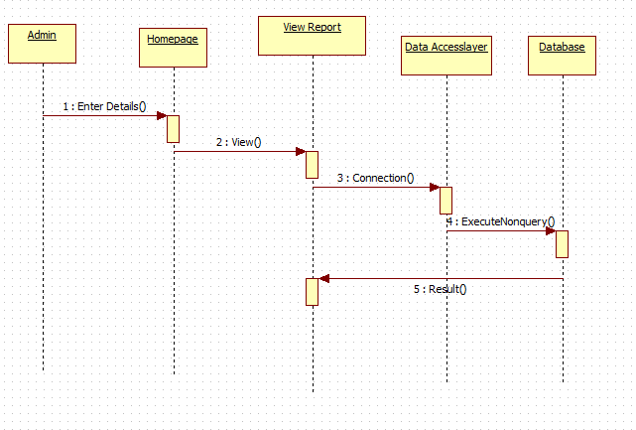

**Teacher Sequence Diagram**

**View Profile**

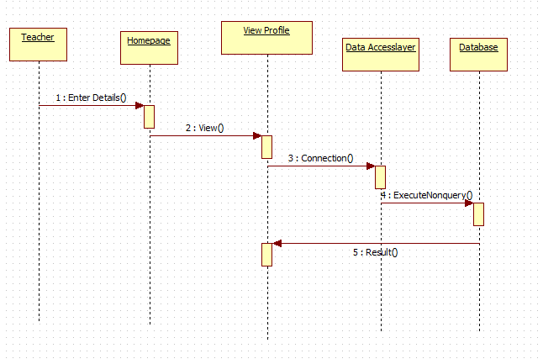

**View Assignment**

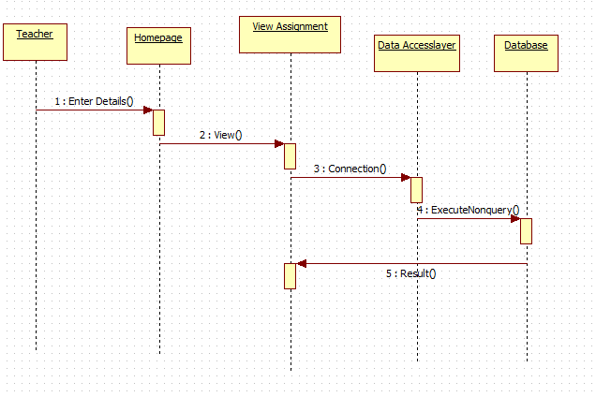

**Add Guidelines**

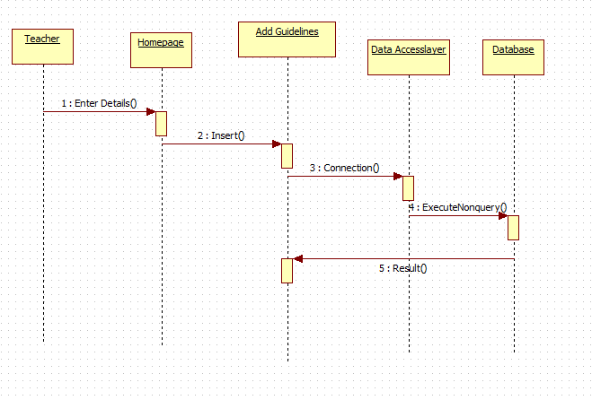

**Update Deadlines**

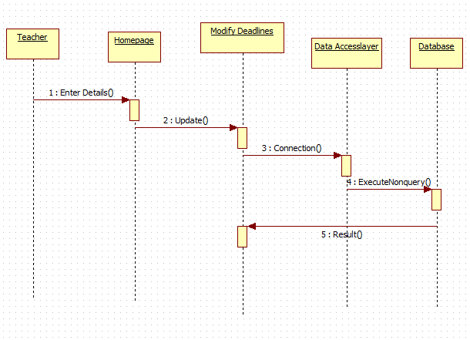

**Student Sequence**

**View profile**

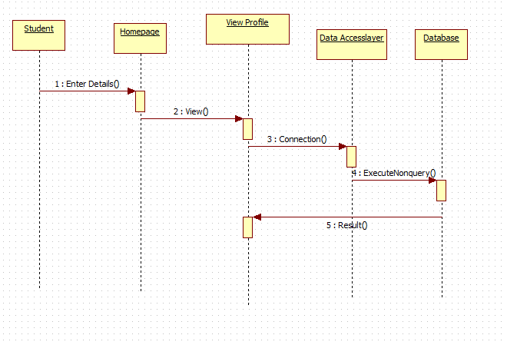

**View Assignment**

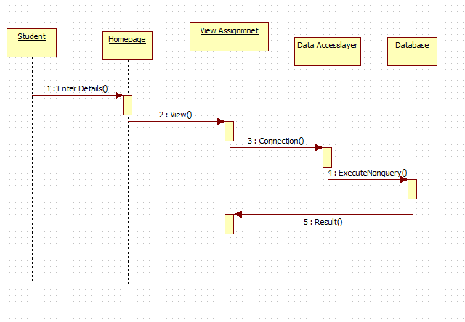

**Student Upload work**

