Name: Chimaraoke Praise Chukwuemeka.

Course: Web Technology.

Course code: CSC 105.

Date: 12th of October, 2023.

**ASSIGNMENT.**

**QUESTION** **1**:

Research on HTTP and HTTPS , stating what each status code represents and when we can possibly have each.

**Answer:**

**What Is HTTP?**

Hypertext Transfer Protocol (HTTP) transfers data from a web server to your browser so that it can access and load websites.

You’ve likely already seen it in your browser’s address bar (e.g. [http://www.semrush.c](https://www.semrush.com/)om).

It is an application-level protocol for distributed, collaborative, hypermedia information systems.

This is the foundation for data communication for the World Wide Web(i.e. the Internet) since 1990.

Basically, HTTP is a TCP/IP based communication protocol, that is used to deliver data (HTML files, image files, query results, etc.) on the World Wide Web. The default port is TCP 80, but other ports can be used as well. It provides a standardized way for computers to communicate with each other. HTTP specification specifies how clients' request data will be constructed and sent to thefree server, and how the servers respond to these requests.

At a fundamental level, when you visit a website, your browser makes an HTTP request to a server. Then that server responds with a resource (an image, video, or the HTML of a web page) - which your browser then displays for you.

This is HTTP's message-based model. Every HTTP interaction includes a request and a response.

By its nature, HTTP is stateless.

**Stateless** means that all requests are separate from each other. So each request from your browser must contain enough information on its own for the server to fulfill the request. That also means that each transaction of the message based model of HTTP is processed separately from the others.

## **What Is HTTPS?**

HTTPS is the acronym for Hypertext Transfer Protocol Secure. Like HTTP, its main purpose is to transfer data from a server to your browser, so you can load websites.

However, HTTPS uses an encrypted connection to communicate between the server and the browser. A SSL (secure sockets layer) certificate protects the transferred data from being stolen as it’s exchanged.

HTTPS was created in 1994 but wasn’t widely used as the standard until 2019. Its popularity is mostly due to Google [recommending that sites switch to HTTPS](https://searchengineland.com/google-starts-giving-ranking-boost-secure-httpsssl-sites-199446) in 2014.

You can also spot HTTPS in your browser’s address bar (e.g. [https://www.semrush.com](https://www.semrush.com/))

Thanks to its encrypted connection, HTTPS is more secure than HTTP.

Site security is important even if you don’t have an ecommerce site or a website that handles sensitive data. A secure site protects your customers from getting their data stolen and protects your website from security breaches that cost time and money to fix.

# **HTTP Status Codes**

### What are HTTP status codes?

An HTTP status code is a server response to a browser’s request. When you visit a website, your browser sends a request to the site’s server, and the server then responds to the browser’s request with a three-digit code: the HTTP status code.

### **1: 1xx Status Codes: Informational**

The 1xx-level HTTP status codes tell users that the request that they have made has been received but is still processing. The 1xx status codes do not necessarily mean there is an issue, it is just there to let you something is still in the process of completing.

### **2: 2xx Status Code: Success**

The 2xx-level HTTP status codes indicate that the client’s request from the server was successfully received and processed. Unlike 4xx status codes, 2xx status codes are what you want to get.

### **3: 3xx: Redirection**

The 3xx status codes are used in cases of URL redirection. Websites are always changing and evolving, so there may be times where marketers need to direct users to an updated, or different page. Redirects help alleviate users from having to search for what they are looking for and maintain your ranking in search engines. The redirect actions may be carried out by the browser automatically or may require additional interaction from users. The 3xx HTTP status codes are vital for SEO (Search Engine Optimization) and user experience, as well as tell search engines what content you want them to crawl and index. If not properly implemented, users may be directed to an unintended location, which could result in a 4xx status code and could affect SEO quality scores.

### **4: 4xx: Client Error**

The classification with the most HTTP status codes, 4xx HTTP status codes are not what you want your users to see. Any status code that begins with a 4 means there is an issue with the client. 4xx status codes are usually generated if a page has been deleted and not redirected, or something incorrectly entered within a URL or link. If users get a dreaded 4xx status code, that means there is a problem with the client/browser receiving information from the server. These are errors that users will see pop up on their screen and create a negative user experience, leading to a bit of frustration and them looking somewhere else.

### **5: 5xx: Server Error**

Like the 4xx status codes, the 5xx status codes indicate there is an error, however the error in question is not likely due to a bad connection or the browser itself. 5xx status codes indicate there is an issue at the server level and cannot process the request from the client. Along with the error, the server should respond with an explanation of the error, whether it is a temporary or permanent condition, and how it may be remedied.

**QUESTION 2**

Differentiate after well explanation on response and request.

**Answer:**

### The Request/Response Procedure

At its most basic level, the request/response process consists of a web browser asking the web server to send it a web page and the server sending back the page. The browser then takes care of displaying the page

### The Request/Response Procedure

At its most basic level, the request/response process consists of a web browser asking the web server to send it a web page and the server sending back the page. The browser then takes care of displaying the page (see [Figur](https://www.oreilly.com/library/view/learning-php-mysql/9781449337452/ch01s01.html#the_basic_client_solidus_server_request)e 1.0)

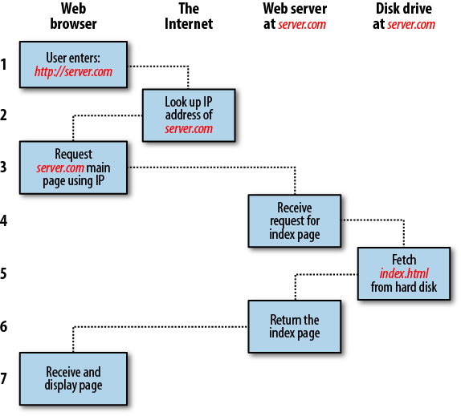

Figure 1.0 The basic client/server request/response sequence

These are the steps in the request and response sequence:

1. You enter [http://server.com](http://server.com/) into your browserâs address bar.
2. Your browser looks up the IP address for *server.com*.
3. Your browser issues a request for the home page at *server.com*.
4. The request crosses the Internet and arrives at the *server.com* web server.
5. The web server, having received the request, looks for the web page on its hard disk.
6. The server retrieves the web page and returns it to the browser.
7. Your browser displays the web page.

**DIFFERENCE BETWEEN RESPONSE AND REQUEST.**

**The main difference between a response and a request is the direction in which they are sent. A request is sent from client(browser) to server while response is sent from the server to client(browser).**

**The second difference is purpose that is behind each message. A request used to request information from the server while response is used to provide information back to the client.**

**QUESTION 3**

Write a short note on HTML and Tags.

**Answer:**

The **HyperText Markup Language** or **HTML** is the standard [markup language](https://en.m.wikipedia.org/wiki/Markup_language) for documents designed to be displayed in a [web browser](https://en.m.wikipedia.org/wiki/Web_browser). It defines the meaning and structure of [web content](https://en.m.wikipedia.org/wiki/Web_content)

**HTML TAGS:** HTML tags are the hidden *keywords* within a web page that define how your web browser must format and display the content.

Most tags must have two parts, an opening and a closing part. For example, <html> is the opening tag and </html> is the closing tag. Note that the closing tag has the same text as the opening tag, but has an additional forward-slash ( / ) character. I tend to interperet this as the "end" or "close" character.

### **Example:**

Below is a basic html document:

<html>

<head>

<title>My name is Praise</title>

</head>

<body>

This is all about me!

</body>

</html>

**QUESTION 4**

Write a short note in client and server and types of server

**Answer:**

In computer science, the terms “client” and “server” refer to two separate but related concepts. A client is a program that makes requests to a server. A server is a program that fulfills those requests.

For example, when you type www.google.com into your web browser, your browser is acting as a client. It makes a request to Google’s servers for the website you’ve requested. Google’s servers then fulfill that request by sending back the HTML code for the Google home page. Your browser then renders that HTML code into the familiar page of text, images, and links we all know so well.

**TYPES OF SERVERS.**

## **DNS Server**

A DNS server’s primary function is converting domain names to their matching IP addresses. It also ensures that users don’t have to remember IP addresses and that businesses get relevant brand name.

## **Web Proxy Server**

There are different protocols that a web proxy server can operate on, though they serve the same purpose. Their job is to accept customer requests, sort them, and take action on their behalf.

## **Email Servers**

A mail server processes and distributes email messages through a network. It’s a service that accepts messages sent by email clients and forwards them to another server.

## **File Servers**

File servers are more sophisticated and can map networked files onto drives. It enables a person to explore folders using their PC’s file browser. The main benefit of having a server is that it allows users to submit and download shared files.

## **Print Server**

A print server establishes a remote connection with nearby computers through which multiple users can print. They allow companies to distribute one printer among numerous workgroups.

## **Proxy Server**

The server relays customer requests for resources to servers that host such resources.

## **Application Server**

Application servers bridge the gap between database servers and the end user. They permit clients to get apps without downloading them on their devices.