CASE STUDY
Aerodynamic Characterisation of a NACA 6412
F1 Front Wing Section: 2D Foil Analysis and 3D Ground Effect Study

Omgbrumaye Praise
Aerospace Engineering, Lagos State University (LASU)
July 2026

Tools: XFLR5 v6.62 (XFoil + VLM2) | Python 3.13 (NumPy, Matplotlib)
Repository: github.com/Praise1417/naca6412-f1-frontwing-study
Part 2 of a 6-month Aerospace Portfolio Series (Part 1: nosecone-cfd)

Summary
This study characterises the NACA 6412 aerofoil section as a candidate F1 front wing profile through two complementary aerodynamic analyses performed in XFLR5 v6.62. The first is a 2D direct foil (XFoil) analysis at Re = 1,000,000, sweeping angle of attack from −5° to 18° to establish baseline lift, drag, and pitching moment behaviour. The second is a 3D vortex-lattice (VLM2) study of a wing built from the same section, run at a fixed angle of attack of 5° across five ground clearance ratios (h/c = 1.0, 0.5, 0.3, 0.2, 0.1) to isolate the ground effect phenomenon central to front wing aerodynamics.
The 2D study found a maximum lift coefficient of 1.698 at 15.5°, a minimum drag coefficient of 0.00724 at 2.5°, and peak aerodynamic efficiency (Cl/Cd = 147.2) at 6°. The 3D ground effect sweep found lift coefficient rising from 0.941 at h/c = 1.0 to 1.735 at h/c = 0.1 — an 84% increase — while drag coefficient fell from 0.0247 to 0.0180 over the same range, a trend consistent with the physical mechanism exploited by real F1 front wings operated at very low ride heights.
Note on scope
This is a low-order aerodynamic study using panel/vortex methods (XFoil and VLM2), not a full viscous 3D CFD analysis. Its purpose is to establish baseline section performance and isolate the inviscid ground-effect mechanism efficiently, ahead of a planned higher-fidelity CFD validation in a future project.

Table of Contents
1. Introduction
1.1 Motivation
1.2 Objectives
2. Methodology — Module 1: 2D Direct Foil Analysis
2.1 Aerofoil Geometry
2.2 Solver Configuration
3. Methodology — Module 2: 3D Ground Effect Study
3.1 Wing Geometry
3.2 Ground Effect Modelling Approach
3.3 Solver Configuration
4. Results — Module 1: 2D Foil Characterisation
4.1 Lift and Drag Behaviour
4.2 Drag Polar and Efficiency
4.3 Pitching Moment
5. Results — Module 2: Ground Effect Sweep
5.1 Lift and Drag vs Ground Clearance
5.2 Aerodynamic Efficiency
5.3 Sensitivity Analysis
6. Discussion
6.1 Physical Mechanisms
6.2 Design Implications for F1 Front Wings
6.3 Limitations
7. Conclusions
8. References

1. Introduction

1.1 Motivation
Front wing aerodynamics is one of the most heavily developed areas of Formula 1 vehicle design, governing not only front-axle downforce but also the airflow quality delivered to the floor, sidepods, and rear of the car. A defining characteristic of front wing performance is ground effect: because the wing operates only millimetres above the track surface, its aerodynamic behaviour departs substantially from that of a wing in free air. Understanding this departure — both the underlying physical mechanism and its practical magnitude — is essential to interpreting why front wings are designed and set up the way they are.
This study uses the NACA 6412 section, a moderately cambered aerofoil, as a representative candidate profile to investigate this behaviour using accessible panel and vortex-lattice methods in XFLR5, as a precursor to higher-fidelity CFD work planned later in this portfolio series.

1.2 Objectives
- Characterise the 2D aerodynamic performance of the NACA 6412 section across a wide angle of attack range at a representative Reynolds number.
- Quantify how lift and drag coefficients change as a 3D wing built from this section approaches a ground plane, across a range of ground clearance ratios (h/c).
- Identify and explain the physical mechanisms responsible for the observed trends.
- Establish a clean, reproducible, and honestly-scoped baseline dataset for future higher-fidelity validation.

2. Methodology — Module 1: 2D Direct Foil Analysis

2.1 Aerofoil Geometry
The NACA 6412 is a 4-digit series aerofoil with 6% maximum camber located at 40% chord, and 12% maximum thickness. The “6412” naming directly encodes this geometry, following the standard NACA 4-digit parametrisation:
y_c = (m/p²)(2px − x²) for x ≤ p | y_c = (m/(1−p)²)(1 − 2p + 2px − x²) for x > p
where m = 0.06 (maximum camber), p = 0.4 (location of maximum camber), and thickness distribution follows the standard NACA thickness formula at 12% maximum thickness. The section geometry was generated within XFLR5's built-in NACA foil generator.
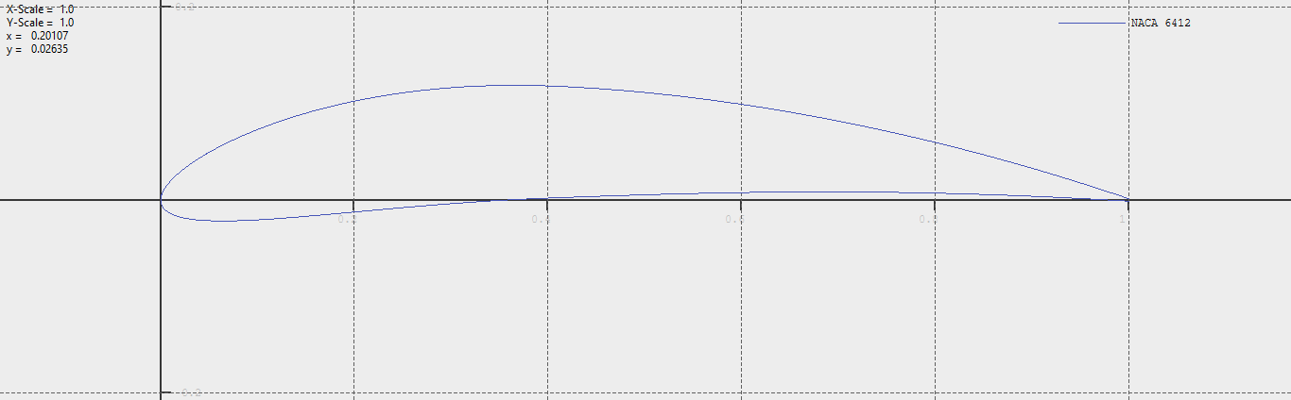

NACA 6412 aerofoil profile — 6% maximum camber at 40% chord, 12% maximum thickness.

2.2 Solver Configuration
Parameter | Value
Solver | XFoil (Direct Foil Design/Analysis module)
Analysis type | Type 1 — Fixed Reynolds number polar
Reynolds number | 1,000,000
Mach number | 0.000 (incompressible)
Transition criterion (Ncrit) | 9.0 (standard free-stream turbulence assumption)
Transition points (xtrf) | 1.000 top, 1.000 bottom (free transition)
Angle of attack range | −5.0° to 18.0°
Polar identifier | T1_Re1.000_M0.00_N9.0

3. Methodology — Module 2: 3D Ground Effect Study

3.1 Wing Geometry
A single-element wing, named naca6412_frontwing within XFLR5, was constructed using the NACA 6412 section as its constant spanwise profile. The wing was analysed at a fixed geometric angle of attack of 5° for all ground clearance cases, isolating ground clearance as the sole independent variable.
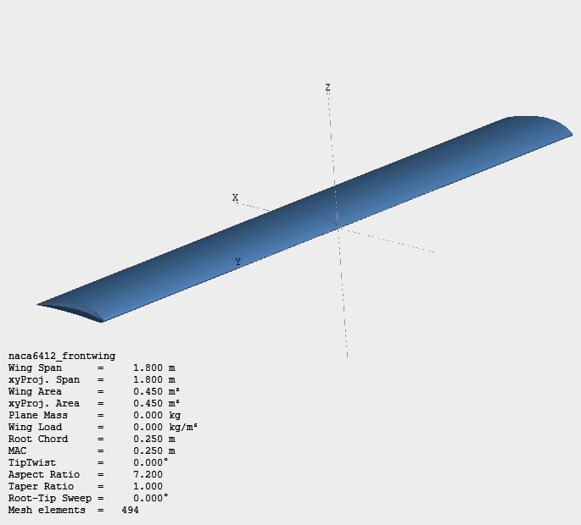

3D render of naca6412_frontwing in XFLR5, showing the wing panel geometry.

3.2 Ground Effect Modelling Approach
XFLR5 models ground effect via an image-plane method within its 3D panel solver: the ground is represented as a mirror plane, and an image wing is placed symmetrically below it, with the two wings' mutually induced velocities capturing the aerodynamic interaction of the real wing with the ground.
Modelling decision — viscous vs inviscid
The ground effect sweep was run using the inviscid VLM2 solver rather than the viscous-coupled VLM2 option. This was a deliberate choice: ground effect is fundamentally a circulation/pressure phenomenon rather than a viscous one, and viscous section behaviour was already independently characterised in Module 1. Additionally, the viscous coupling in XFLR5 requires a bracketing range of stored 2D polars at neighbouring Reynolds numbers to interpolate correctly; only a single polar at exactly Re = 1,000,000 was available, which the solver could not use for interpolation. Running inviscid VLM2 avoided this limitation while remaining physically appropriate for the phenomenon under study.

3.3 Solver Configuration
Parameter | Value
Solver | VLM2 (Vortex Lattice Method, ring vortices)
Boundary condition | Neumann (wing surface)
Viscous coupling | Off (inviscid)
Freestream velocity | 60.0 m/s
Reynolds number | 1,000,000
Angle of attack | 5.0° (fixed)
Ground clearance ratios tested (h/c) | 1.0, 0.5, 0.3, 0.2, 0.1
Air density | 1.225 kg/m³
Air viscosity | 1.5 × 10⁻⁵ m²/s

4. Results — Module 1: 2D Foil Characterisation

4.1 Lift and Drag Behaviour
The lift curve for the NACA 6412 section (Figure 1) shows the expected behaviour of a cambered aerofoil: a positive lift coefficient at zero angle of attack (Cl = 0.699 at α = 0°), reflecting the section's inherent camber generating lift even at zero geometric incidence. The curve is linear through the mid-range, with lift increasing at approximately 0.108 per degree between α = −2° and α = 5°, consistent with thin aerofoil theory's prediction near 2π per radian for attached flow. Beyond approximately α = 9°, the curve flattens as the boundary layer thickens and separates progressively from the trailing edge forward, reaching Cl,max = 1.698 at α = 15.5° before a gentle post-stall decline — a well-behaved trailing-edge stall rather than an abrupt separation.
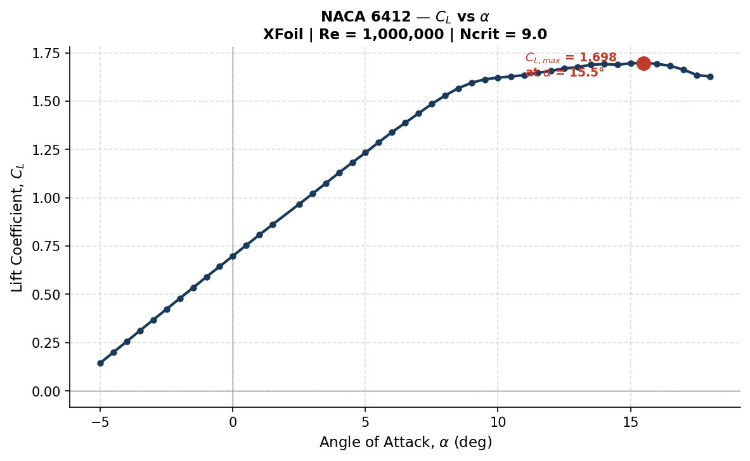
Figure 1 : Lift coefficient vs angle of attack. Linear region followed by gradual stall onset near α = 17°.
Drag remains low and nearly flat across the linear lift region (Figure 2), reaching a minimum of Cd = 0.00724 at α = 2.5° — the section's “drag bucket,” where the boundary layer remains substantially laminar before transitioning. Beyond α ≈ 9°, drag rises sharply and non-linearly as the growing separated region consumes momentum, mirroring the flattening of the lift curve over the same range.
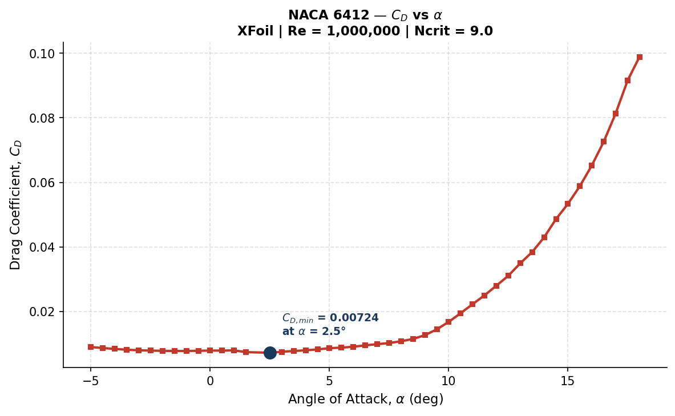
Figure 2 : Drag coefficient vs angle of attack, showing the low-drag bucket and post-stall drag rise.

4.2 Drag Polar and Efficiency
The drag polar (Figure 3) presents the full Cl–Cd performance envelope in one view. The curve bows sharply left (low drag) through moderate lift before bending right past Cl ≈ 1.4, visually marking the exit from the drag bucket into separated flow. Maximum aerodynamic efficiency, Cl/Cd = 147.2, occurs at α = 6° (Figure 4) — the practical sweet spot for efficient operation, though a front wing pursuing maximum downforce would typically be run well past this point, deliberately trading efficiency for greater absolute lift.
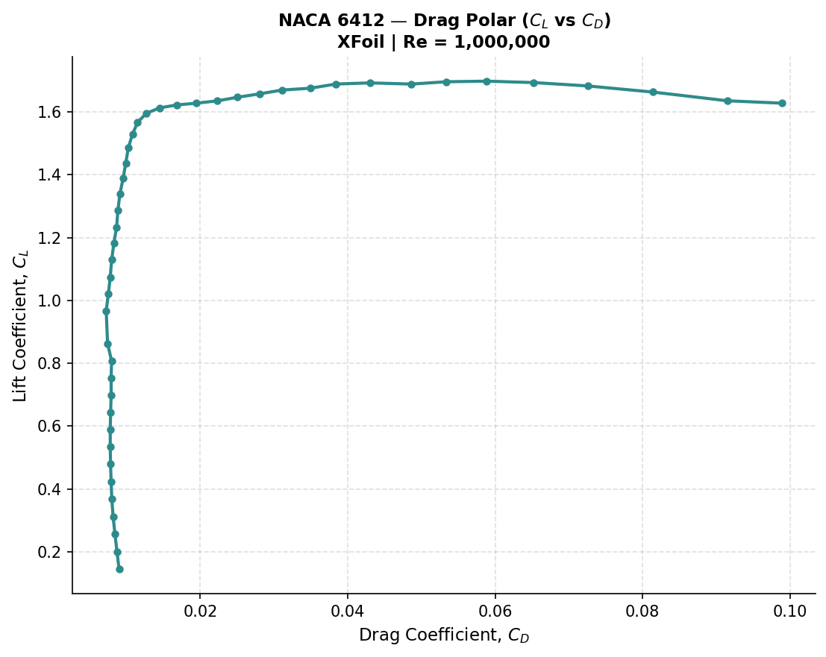
Figure 3 : Drag polar (Cl vs Cd), showing the drag bucket and the transition into separated flow.
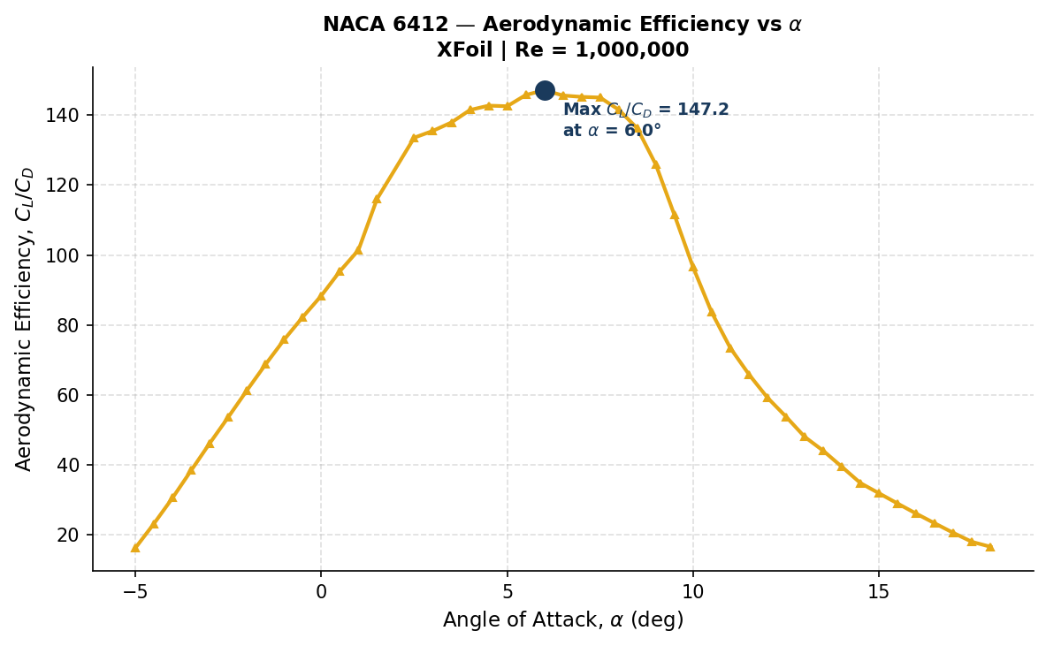
Figure 4 : Aerodynamic efficiency (Cl/Cd) vs angle of attack, peaking at α = 6°.

4.3 Pitching Moment
The pitching moment coefficient (Figure 5) remains negative and relatively stable near −0.15 through the linear lift range, becoming less negative as stall approaches — typical of a cambered section whose aerodynamic centre sits aft of the leading edge, producing a nose-down moment. For a wing-mounted application, this moment is reacted structurally at the mounting points; its relative stability across the operating range means structural loading characteristics do not change dramatically until stall is approached.
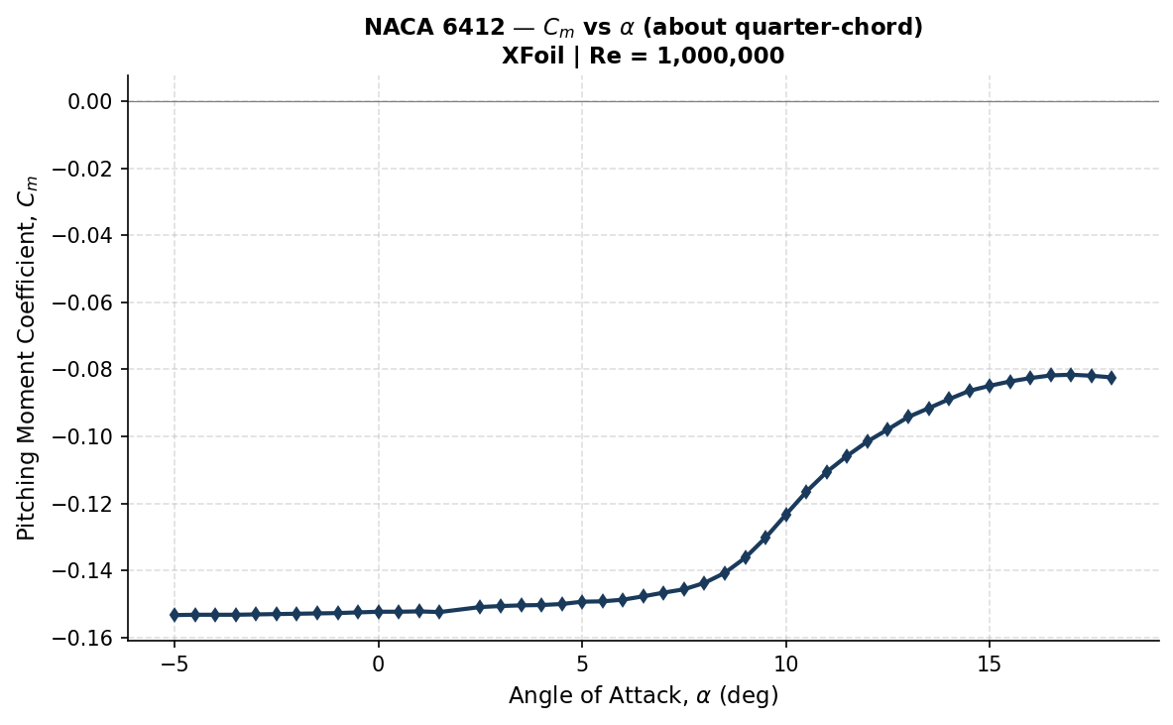
Figure 5 : Pitching moment coefficient vs angle of attack.

5. Results — Module 2: Ground Effect Sweep

5.1 Lift and Drag vs Ground Clearance
h/c | Cl | Cd | Cl/Cd
1.0 | 0.9409 | 0.0247 | 38.1
0.5 | 1.0374 | 0.0210 | 49.3
0.3 | 1.1713 | 0.0194 | 60.3
0.2 | 1.3316 | 0.0188 | 70.9
0.1 | 1.7349 | 0.0180 | 96.4
At h/c = 1.0 — effectively out of ground effect for this geometry — the wing produces Cl = 0.941 at α = 5°. As the wing is brought closer to the ground, lift rises steadily to 1.037 at h/c = 0.5, 1.171 at h/c = 0.3, 1.332 at h/c = 0.2, and finally 1.735 at h/c = 0.1: an 84% increase across the sweep at fixed angle of attack (Figure 6). This is the direct consequence of the ground plane restricting flow beneath the wing — as the gap narrows, air passing underneath accelerates and local static pressure drops relative to the upper surface, and this larger pressure differential is registered directly as increased lift. Critically, the rate of increase is non-linear: the Cl gain between h/c = 0.2 and h/c = 0.1 (+0.403) is more than ten times the gain between h/c = 1.0 and h/c = 0.5 (+0.037), confirming that ground effect strengthens sharply as clearance approaches zero — precisely why real F1 front wings are run only millimetres from the road surface.
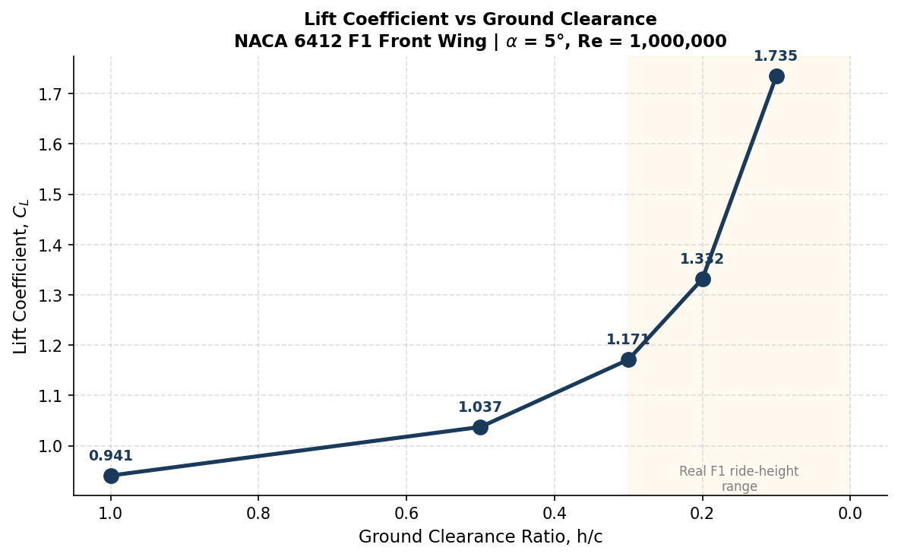
Figure 6 : Lift coefficient vs ground clearance ratio (h/c), with the real F1 ride-height range shaded.
Drag decreases consistently as h/c decreases (Figure 7), from Cd = 0.0247 at h/c = 1.0 to Cd = 0.0180 at h/c = 0.1, a 27% reduction. This is explained by the inviscid nature of the VLM2 solver: with no viscous drag modelled, computed drag here is entirely induced drag, a function of spanwise lift distribution and effective aspect ratio. The ground plane behaves similarly to an image-effect wing extension, increasing effective aspect ratio and reducing wingtip vortex strength, which lowers induced drag even as lift rises. In real, viscous flow this trend would be partially offset by increased skin friction and pressure drag from the accelerated flow beneath the wing — which is why Module 1's viscous section data is presented separately rather than combined into this result.
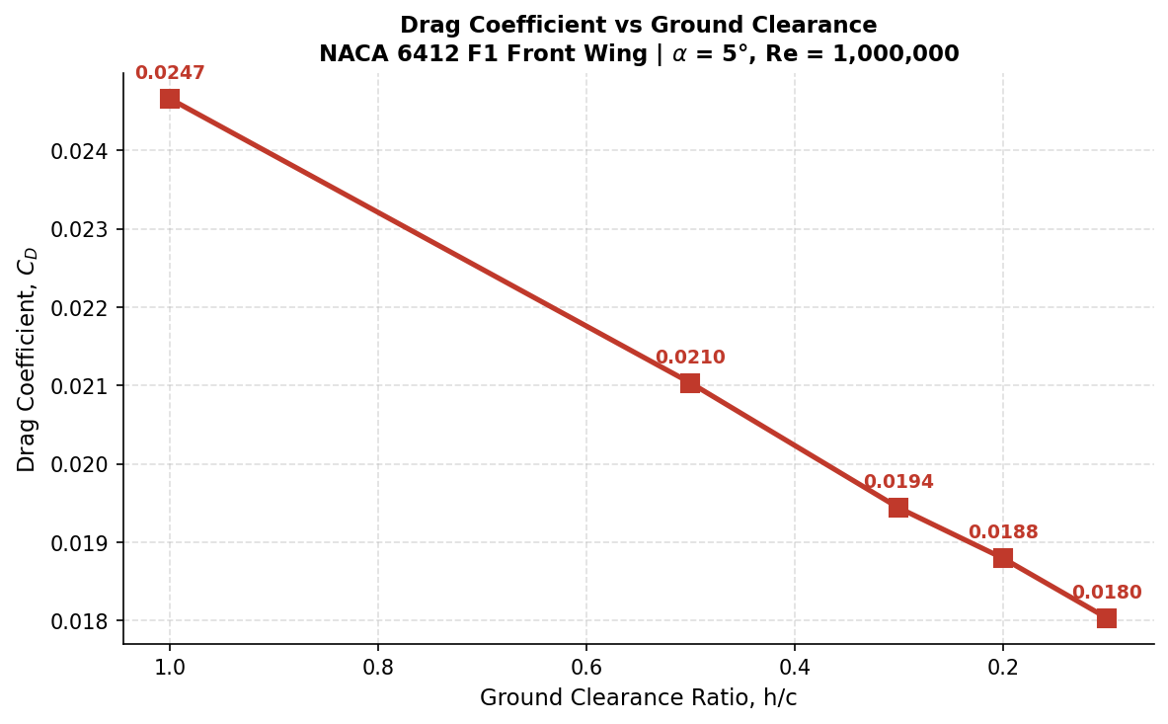
Figure 7 : Drag coefficient vs ground clearance ratio (h/c).
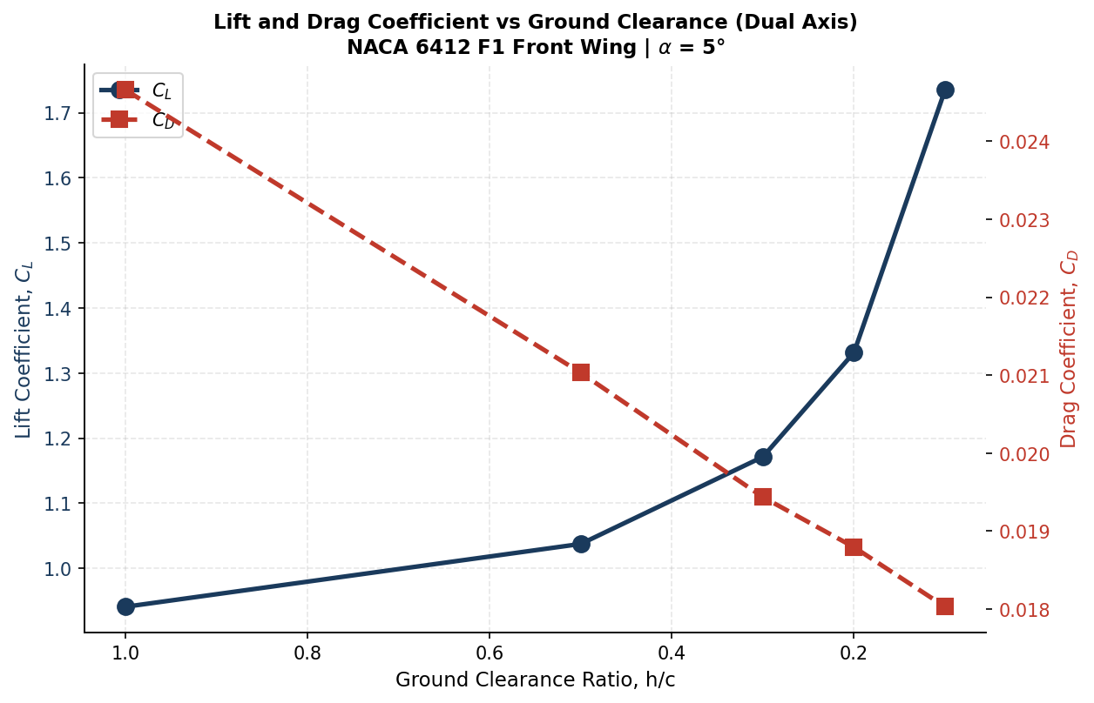
Figure 8 : Combined lift and drag trends vs ground clearance ratio (dual axis).

5.2 Aerodynamic Efficiency
Aerodynamic efficiency rises dramatically through the sweep, from Cl/Cd = 38.1 at h/c = 1.0 to Cl/Cd = 96.4 at h/c = 0.1 — a 2.5x improvement (Figure 9). Because the lift gain and drag reduction trends compound in the same direction as h/c decreases, this efficiency curve rises faster than either individual trend, underscoring why ground effect is aerodynamically prized rather than merely tolerated: it is one of the few regimes in which a vehicle can simultaneously gain performance and reduce drag penalty through geometry alone.
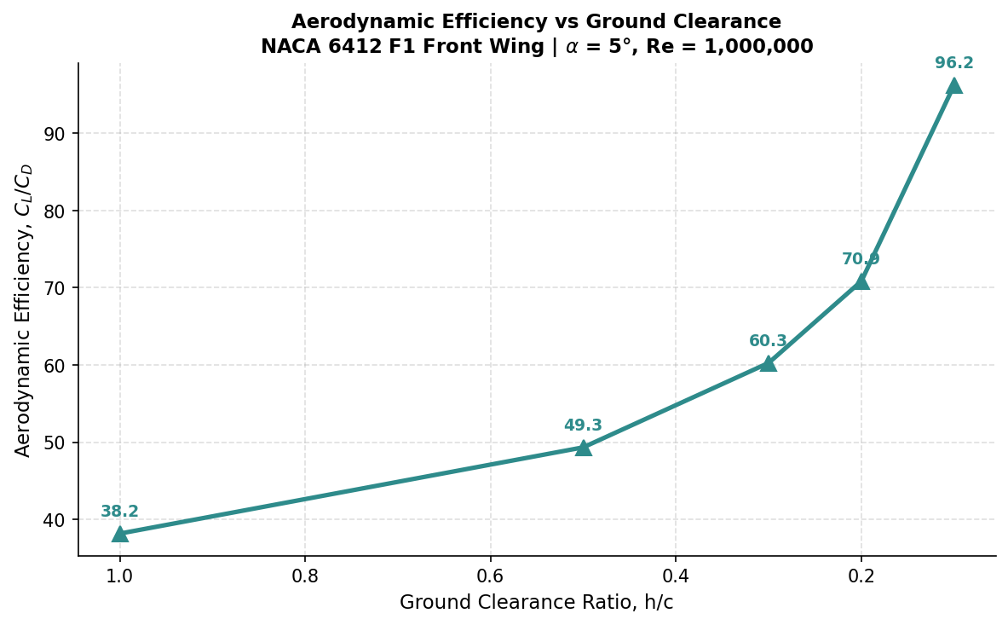
Figure 9 : Aerodynamic efficiency (Cl/Cd) vs ground clearance ratio.
Plotting Cd against Cl with each point coloured by its h/c value (Figure 10) traces the aerodynamic path the wing follows as it approaches the ground — an h/c-parametrised polar rather than a conventional alpha-parametrised one. The near-monotonic path moving consistently up and to the left (increasing Cl, decreasing Cd) confirms there is no adverse trade-off anywhere in the tested h/c range within the limits of the inviscid model.
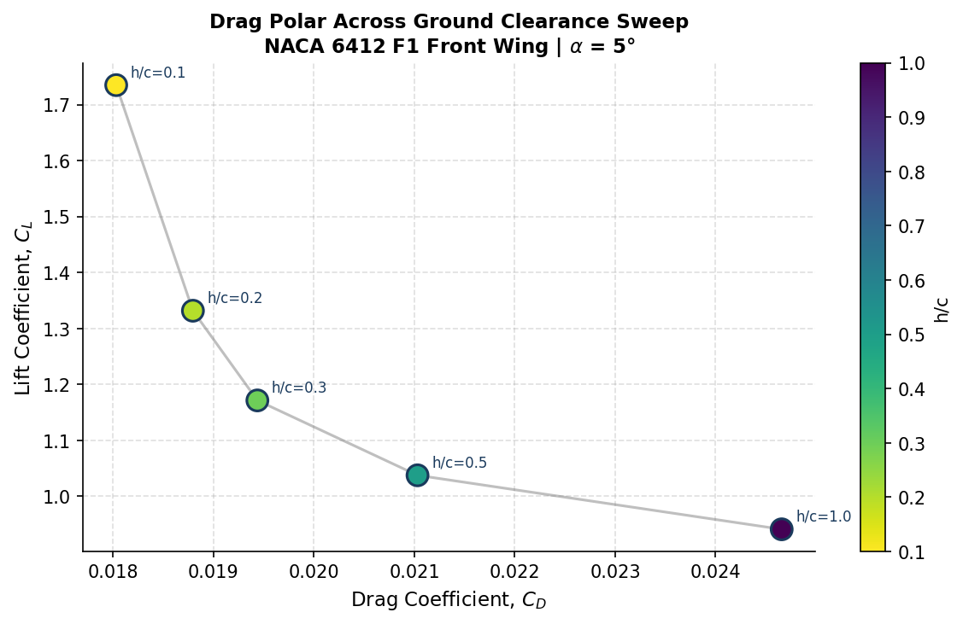
Figure 10 : Drag polar parametrised by ground clearance ratio (h/c) rather than angle of attack.

5.3 Sensitivity Analysis
The sensitivity of Cl to h/c reduction increases by roughly an order of magnitude across the tested range, rising from approximately 0.07 (h/c 1.0→0.5) to 4.0 (h/c 0.2→0.1) per unit reduction in h/c. This has a direct design implication: at large ride heights, small manufacturing or setup variations in wing height have negligible aerodynamic consequence, but at the very low ride heights used in real F1 operation, millimetre-scale changes in ground clearance produce disproportionately large changes in downforce — which is exactly why ride-height control and floor/wing stiffness are such tightly engineered aspects of a real F1 car's aerodynamic platform.
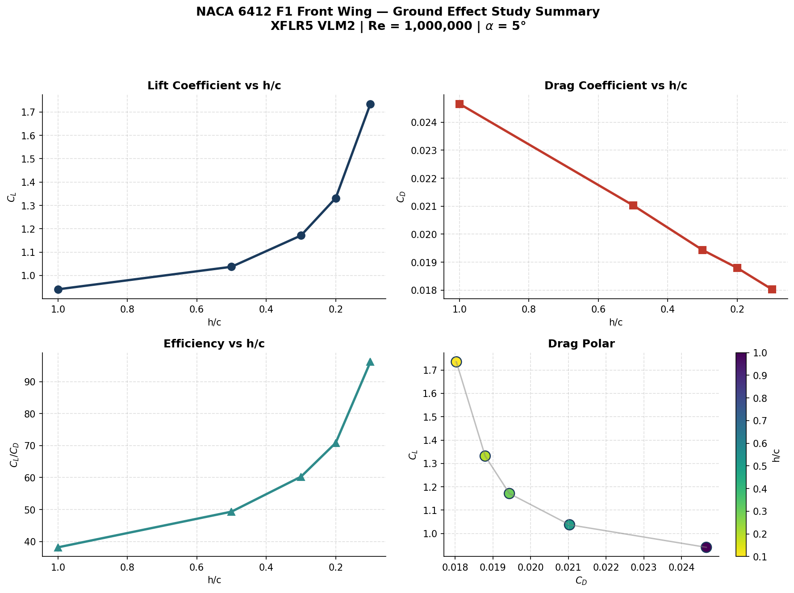
Figure 11 : Combined summary dashboard — Cl, Cd, efficiency, and drag polar across the full h/c sweep.

6. Discussion

6.1 Physical Mechanisms
Two distinct physical regimes are captured across the two modules. Module 1 isolates the section's fundamental viscous performance — boundary layer development, transition, and separation — independent of any 3D or proximity effects, governing the lift curve slope, drag bucket, and stall characteristics observed. Module 2 isolates a largely geometric, inviscid phenomenon: the constraint of the flow field by a nearby ground plane, captured through an image-plane vortex method. These mechanisms are complementary rather than competing — in a physical wing, both operate simultaneously, with total performance reflecting some combination of the viscous section behaviour established in Module 1 and the inviscid proximity augmentation established in Module 2.

6.2 Design Implications for F1 Front Wings
The accelerating, non-linear lift gain observed as h/c decreases below approximately 0.3 explains why front wings are deliberately operated at very low ride heights despite the mechanical and regulatory complexity this introduces. It also explains why ride-height sensitivity is such a critical setup and structural design parameter: a car whose front wing height varies under load (through suspension compression, aerodynamic loading, or track undulation) will see disproportionately large swings in downforce precisely in the regime where the wing normally operates — motivating the very stiff, tightly controlled front-wing and floor assemblies seen on real F1 cars.

6.3 Limitations
- VLM2 is an inviscid panel method; it does not model flow separation, viscous wake effects, or boundary-layer interaction with the physical ground surface, all of which are present in reality.
- The steep Cl rise at h/c = 0.1 is qualitatively consistent with real ground effect but should be treated as indicative rather than a precise quantitative prediction, given the limitations of potential-flow theory at very small clearances.
- The 2D and 3D studies were not run as a single coupled viscous-in-ground-effect analysis; their results characterise each phenomenon in isolation rather than in combination.
- Only a single angle of attack (5°) was tested in the ground effect sweep; wing behaviour at other angles of attack in ground effect was not investigated in this study.
- No 3D wingtip, endplate, or multi-element interaction effects were modelled — the wing is treated as a simplified single-element planform.

7. Conclusions
- The NACA 6412 section exhibits well-behaved 2D aerodynamic performance at Re = 1,000,000, with Cl,max = 1.698 at α = 15.5°, Cd,min = 0.00724 at α = 2.5°, and peak efficiency Cl/Cd = 147.2 at α = 6°, with a gentle, well-behaved stall characteristic suitable for a front wing application.
- Ground effect produces a substantial, non-linear increase in lift coefficient as ground clearance decreases, rising 84% from h/c = 1.0 to h/c = 0.1 at a fixed 5° angle of attack, with the largest gains concentrated in the h/c < 0.3 range closest to real F1 ride heights.
- In the inviscid VLM2 model, drag coefficient falls simultaneously with the lift rise, an effect attributed to the ground plane's image-effect increase in effective aspect ratio and consequent reduction in induced drag.
- Aerodynamic efficiency (Cl/Cd) more than doubles across the tested range, from 38.1 to 96.4, reinforcing why ground effect is deliberately exploited rather than incidentally tolerated in race car aerodynamic design.
- This study establishes a clean, reproducible, and honestly-scoped low-order aerodynamic baseline, intended as groundwork for a future higher-fidelity 3D viscous CFD validation of the same geometry.

8. References
[1] Deperrois, A. — XFLR5 v6.62: Analysis of Foils and Wings Operating at Low Reynolds Numbers.
[2] Drela, M. — XFOIL: An Analysis and Design System for Low Reynolds Number Airfoils, MIT.
[3] Katz, J. & Plotkin, A. — Low-Speed Aerodynamics, 2nd Edition (Vortex Lattice Method theory), Cambridge University Press.
[4] Zhang, X., Toet, W., Zerihan, J. — Ground Effect Aerodynamics of Race Cars, Applied Mechanics Reviews, 2006.
[5] Abbott, I. H. & Von Doenhoff, A. E. — Theory of Wing Sections, Dover Publications.
[6] Anderson, J. D. — Fundamentals of Aerodynamics, McGraw-Hill.

