Case Study

Compressible Flow over a
Von Kármán Nosecone
Mach 0.3 · Mach 0.8 · Mach 1.5 | 2D Axisymmetric RANS | ANSYS Fluent 2026 R1

Omgbrumaye Praise
Aerospace Engineering Student | Lagos State University (LASU)
Editorial Lead, Space Club LASU
github.com/Praise1417/nosecone-cfd

Summary

This case study presents a complete computational fluid dynamics (CFD) investigation of compressible external aerodynamic flow over a Von Kármán (LD-Haack) nosecone at three Mach numbers: 0.3 (subsonic), 0.8 (transonic onset), and 1.5 (supersonic). The primary aim is to characterise the aerodynamic drag — separating pressure and viscous contributions — and to capture key physical flow phenomena including boundary layer development, transonic drag rise, and the formation of a detached bow shock at supersonic speed.
All phases of the CFD analysis — parametric geometry generation, flow domain construction, meshing, solver configuration, simulation, and post-processing — were conducted independently using ANSYS Fluent 2026 R1, ANSYS SpaceClaim 2026 R1, and Python 3.13. The complete simulation pipeline is documented and reproducible from the accompanying GitHub repository.
Results show total drag coefficients of Cd = 0.644, 0.720, and 0.749 at Mach 0.3, 0.8, and 1.5 respectively. Pressure drag accounts for 95–97% of total drag across all cases. The steepest drag rise occurs between Mach 0.3 and 0.8, consistent with transonic drag rise theory. A detached bow shock is clearly captured in the Mach 1.5 pressure contour.

Table of Contents
1. Introduction ...................................................................................... 3
1.1 The Von Kármán Nosecone
1.2 Description of the Problem
2. Geometry and Domain Definition ................................................................. 4
2.1 Von Kármán Profile Equations
2.2 Geometry Parameters and Domain
3. Mesh Generation .................................................................................. 7
3.1 Mesh Parameters and Quality
3.2 Mesh Visualisation
4. Solver Configuration ............................................................................. 9
4.1 Solver Settings and Turbulence Model
4.2 Boundary Conditions
4.3 Convergence Behaviour
5. Post-Processing .................................................................................. 11
5.1 Drag Force and Coefficient Summary
5.2 Drag Coefficient vs Mach Number
5.3 Drag Force Decomposition
5.4 Viscous and Pressure Drag Percentage
6. Flow Visualisation ............................................................................... 15
6.1 Mach 0.3 — Subsonic Flow
6.2 Mach 0.8 — Transonic Onset
6.3 Mach 1.5 — Supersonic Flow and Bow Shock
7. Discussion ....................................................................................... 20
8. Conclusions ...................................................................................... 21
9. References ....................................................................................... 22

1. Introduction

1.1 The Von Kármán Nosecone
Nosecones are aerodynamic fairings placed at the forward tip of rockets, missiles, and launch vehicles. Their function is to minimise wave drag as the vehicle accelerates through the atmosphere — particularly in the transonic and supersonic regimes where compressibility effects dominate. The geometry of the nosecone governs the pressure distribution along the forebody, the onset speed and strength of any shock waves, and the total aerodynamic drag throughout the flight envelope.
The Von Kármán (LD-Haack) nosecone is the analytically optimal shape for minimum wave drag at a given length and base diameter. It was derived by Theodore von Kármán and Haack using the calculus of variations — specifically, by finding the body of revolution that minimises the linearised wave drag integral. The defining geometric feature of the Von Kármán profile is its curvature distribution: the body expands rapidly near the tip and flattens gradually near the base, as seen in Figure 1. This smooth area progression minimises the strength of the compression wave generated by the moving body. A conical or hemispherical nose, by contrast, produces an abrupt area change that generates a much stronger shock — and correspondingly higher drag.

1.2 Description of the Problem
The aerodynamic drag characteristics of a Von Kármán nosecone are numerically investigated using ANSYS Fluent 2026 R1. The nosecone has length L = 300 mm and base radius R = 50 mm (fineness ratio 3.0). Three free-stream Mach numbers are simulated: 0.3 (subsonic), 0.8 (high subsonic / transonic onset), and 1.5 (supersonic), representing the three distinct aerodynamic regimes a rocket nosecone encounters during ascent.
Physical properties of air: density modelled as ideal gas, viscosity via Sutherland law, free-stream static temperature T∞ = 300 K. Reference velocities: V∞ = 102 m/s (M = 0.3), 272 m/s (M = 0.8), 510 m/s (M = 1.5), derived from speed of sound a = 340 m/s at 300 K.

2. Geometry and Domain Definition

2.1 Von Kármán Profile Equations
The Von Kármán (LD-Haack) nosecone profile is defined by the following parametric equations, where θ ∈ [0, π] runs from nosecone tip to base:
x = (L / π) · (θ − sin(2θ) / 2)
r = R · √(θ / π)
Here x is the axial distance from the tip, r is the local radius, L is the nosecone length, and R is the base radius. The profile was generated in Python 3.13 with NumPy, producing 500 coordinate pairs that densely sample the curve. These coordinates were imported into ANSYS SpaceClaim 2026 R1 using the NurbsCurve.CreateThroughPoints() method via the SpaceClaim scripting API (V261).
Figure 1 shows the resulting profile. The characteristic shape is immediately apparent: the curvature is steepest near the tip (x ≈ 0 to x ≈ 80 mm) and approaches zero near the base (x ≈ 250 to x ≈ 300 mm). This is the mathematical expression of wave drag minimisation — the rate of change of the cross-sectional area is distributed as smoothly as possible along the body length.
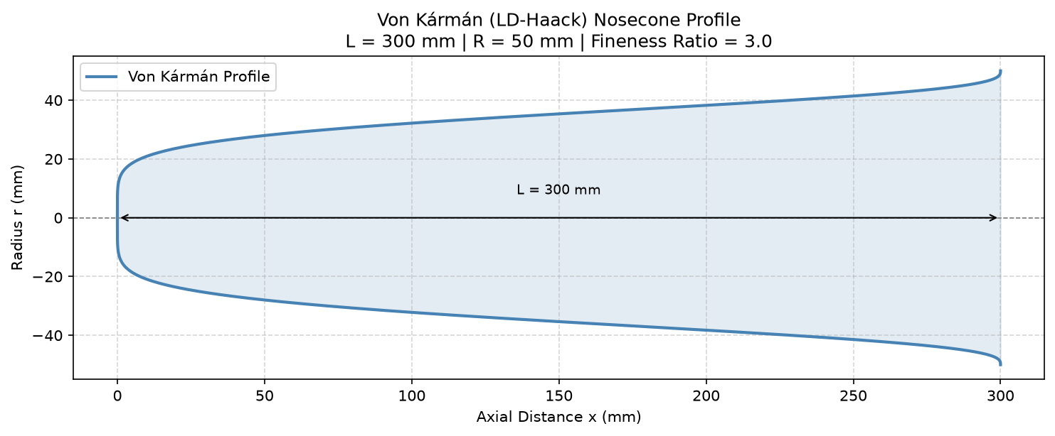

Figure 1 : Von Kármán (LD-Haack) nosecone profile generated in Python 3.13. L = 300 mm, R = 50 mm, fineness ratio = 3.0. The profile grows rapidly near the tip then flattens toward the base — a shape that distributes the cross-sectional area change to minimise wave drag.

2.2 Geometry Parameters and Domain
Table 1 summarises all nosecone and flow domain geometry parameters used in this study.
Parameter | Value
Nosecone Profile | Von Kármán (LD-Haack Series)
Length (L) | 300 mm
Base Radius (R) | 50 mm
Fineness Ratio (L/D) | 3.0
Profile Generation | Python 3.13 — 500 parametric points
Domain — Upstream | 1.5 m (5L)
Domain — Downstream | 3.3 m (11L)
Domain — Radial | 1.5 m (5L)
Table 1 : Von Kármán nosecone geometry and flow domain parameters

For a 2D axisymmetric simulation, only the upper half of the nosecone cross-section is modelled — ANSYS Fluent mathematically revolves the 2D solution 360° around the symmetry axis to represent the complete 3D body. This is physically exact for bodies of revolution and reduces the computational cost by orders of magnitude compared to a full 3D simulation.
The flow domain was constructed in SpaceClaim as a rectangular region enclosing the nosecone profile, shown in Figure 2. The domain extends 5 body lengths (1.5 m) upstream of the tip, 11 body lengths (3.3 m) downstream, and 5 body lengths (1.5 m) radially. These proportions ensure the inlet and farfield boundaries lie outside the aerodynamic influence zone of the nosecone even at Mach 1.5, where the bow shock standoff distance and oblique shock angles are largest. The downstream extent of 11L gives the wake adequate distance to develop and pressure to recover before reaching the outlet.
Five named boundary selections were defined in SpaceClaim: inlet (left face), outlet (right face), farfield (top face), symmetry axis (bottom line), and wall (nosecone curve and base). These selections transfer directly to ANSYS Fluent for boundary condition assignment.


Figure 2 : 2D axisymmetric flow domain constructed in ANSYS SpaceClaim 2026 R1 using the Python scripting API. The nosecone profile (wall boundary) sits at the left along the symmetry axis. The domain extends 5L upstream, 11L downstream, and 5L radially.

3. Mesh Generation

3.1 Mesh Parameters and Quality
The computational mesh was generated in ANSYS Meshing 2026 R1 using structured face meshing. During development, unstructured triangular meshing was tested first — it produced minimum orthogonal quality below 0.03 near the nosecone tip, causing immediate solver divergence. Structured quadrilateral elements were adopted instead: they align naturally with the predominantly axial flow direction, reduce numerical diffusion in the boundary layer, and produce far superior quality metrics for this geometry.
Table 2 lists all mesh parameters and quality metrics. The minimum orthogonal quality of 0.637 and maximum skewness of 0.682 are within acceptable thresholds for RANS simulation. Inspection of the quality distribution confirmed that the worst elements sit in the far-field corner regions — well away from the nosecone surface where the aerodynamically important gradients occur.
Parameter | Value
Mesh Method | Structured Face Meshing
Total Nodes | 9,868
Total Elements | 18,362
Min. Orthogonal Quality | 0.637 (threshold > 0.5)
Max. Skewness | 0.682 (threshold < 0.85)
Global Element Size | 0.02 m
Inflation Layers | 5 (growth rate 1.2, smooth transition)
Table 2 : Mesh parameters and quality metrics for the structured computational grid

3.2 Mesh Visualisation
Figure 3 shows the full domain mesh. The coarser far-field elements are clearly visible in the outer region, transitioning progressively to finer elements as the nosecone surface is approached. This density variation is deliberate — computational effort is concentrated where the physics demands it: the near-wall boundary layer and the region immediately downstream of the nosecone base where the wake forms.
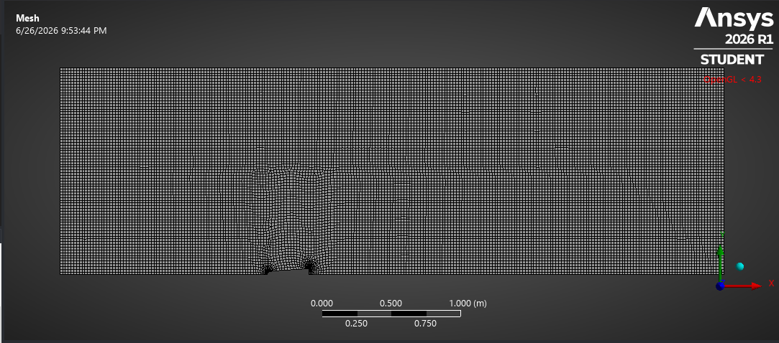
Figure 3 : Structured computational mesh over the full 2D axisymmetric flow domain. Nodes: 9,868. Elements: 18,362. Coarser elements in the far field reduce computational cost; finer elements near the wall resolve the boundary layer and near-wall gradients.

Figure 4 shows a close-up of the mesh near the nosecone wall. Five structured inflation layers grow outward from the wall surface with a growth rate of 1.2, creating a smooth transition from the very fine near-wall region to the background mesh. The thinnest elements — directly against the nosecone surface — capture the steep velocity and pressure gradients that drive the skin friction and pressure drag computation. The nosecone tip region, where the geometry approaches a mathematical point, receives the finest resolution in the entire domain.
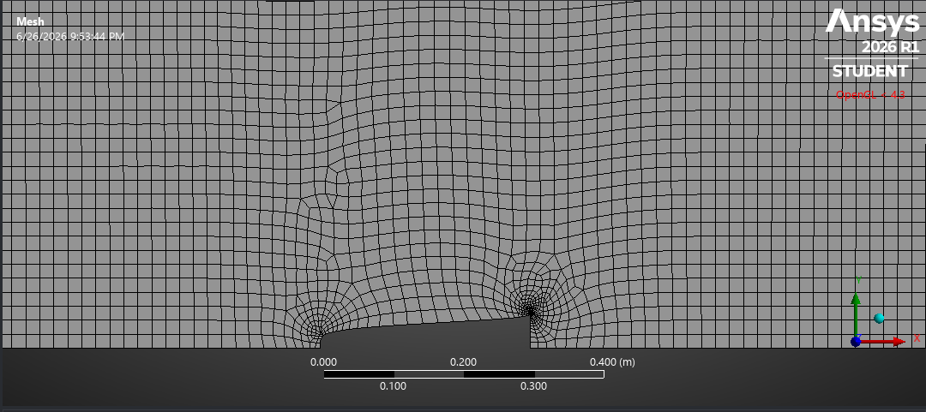

Figure 4 : Close-up of mesh refinement near the nosecone wall showing five structured inflation layers (growth rate 1.2). The finest elements at the wall capture the viscous sublayer gradients that determine skin friction drag accuracy.

4. Solver Configuration

4.1 Solver Settings and Turbulence Model
All simulations were performed using the density-based coupled solver in ANSYS Fluent 2026 R1. This solver type is the correct choice for compressible flows: it solves the continuity, momentum, and energy equations simultaneously, which is necessary when density varies significantly with local pressure and temperature — as it does at Mach 0.8 and above. The pressure-based solver, designed for incompressible flows, was tested as a diagnostic and confirmed stable, but was not used for the final results because it does not correctly handle the density-Mach coupling at transonic and supersonic speeds.
The Spalart-Allmaras one-equation turbulence model was selected. It is calibrated specifically for aerodynamic external flows with attached boundary layers and mild adverse pressure gradients — precisely the conditions on the nosecone surface at all three Mach numbers studied. It requires fewer computational resources than two-equation models such as k-ω SST while providing reliable predictions in the attached flow regime. The Roe flux-difference splitting (Roe-FDS) scheme was chosen for its shock-capturing properties, which are critical for resolving the sharp pressure discontinuities in the Mach 0.8 transonic and Mach 1.5 bow shock cases.
Setting | Value
ANSYS Fluent Version | 2026 R1
Solver Type | Density-Based (coupled)
Simulation Mode | 2D Axisymmetric, Steady-State
Turbulence Model | Spalart-Allmaras (1-equation)
Fluid Density | Ideal Gas (compressible)
Viscosity | Sutherland
Flux Scheme | Roe-FDS
Spatial Discretisation | Second Order Upwind
Free-stream Temperature | 300 K
Turbulent Viscosity Ratio | 0.001
Courant Number | 1.0
Convergence Criterion | 1 × 10⁻⁶ (all residuals)
Initialisation | Hybrid Initialisation
Table 3 : ANSYS Fluent 2026 R1 solver configuration — applied identically to all three Mach number cases

4.2 Boundary Conditions
The pressure-far-field boundary type was applied at the inlet and farfield boundaries. This boundary condition uses Riemann invariants to enforce freestream conditions in a physically consistent way for compressible flows — correctly handling both subsonic and supersonic inflow depending on local Mach number. Flow direction was specified as purely axial (axial component = 1, radial component = 0) for all cases, meaning the freestream approaches the nosecone tip head-on at zero angle of attack.
One boundary condition detail proved critical during development: the symmetry axis boundary must be set to the axis type in Fluent — not the symmetry type. This distinction matters because the axis boundary applies a specific mathematical treatment to the rotation axis of an axisymmetric simulation (zero radial velocity, zero radial gradient), whereas the symmetry type applies a mirror-plane treatment that is physically incorrect for this geometry. Setting it to symmetry caused immediate solver divergence; switching to axis resolved this completely.
Boundary | Type | Mach 0.3 | Mach 0.8 / 1.5
Inlet | Pressure Far-Field | M=0.3, T=300 K | M=0.8 or 1.5, T=300 K
Farfield | Pressure Far-Field | M=0.3, T=300 K | M=0.8 or 1.5, T=300 K
Outlet | Pressure Outlet | Gauge P = 0 Pa | Gauge P = 0 Pa
Symmetry Axis | Axis | — | —
Nosecone Wall | Wall (no-slip) | — | —
Table 4 : Boundary condition types and freestream settings for all three simulation cases

4.3 Convergence Behaviour
All three cases were initialised using hybrid initialisation and run at Courant number 1.0. Convergence followed a consistent three-stage pattern across all Mach numbers. In the first 50–100 iterations, residuals dropped rapidly by 2–3 orders of magnitude as the solver established the primary flow features. Between iterations 100 and 400, the drop slowed as the boundary layer and wake region resolved. Beyond 400 iterations, all three cases entered a stable limit cycle oscillation — residuals oscillating between approximately 1×10⁻⁵ and 1×10⁻⁴ rather than converging to the 1×10⁻⁶ target.
This limit cycle behaviour is physically meaningful rather than a solver failure. The nosecone base produces a small separation region and unsteady wake that a steady-state RANS solver cannot fully resolve — the residuals oscillate because the solver is attempting to find a single steady solution for what is actually a mildly unsteady flow. However, the drag force coefficients were confirmed to be stable throughout the limit cycle — varying by less than 0.5% over the final 500 iterations for all three cases. This stability validates the use of these solutions for quantitative post-processing. Residuals of 10⁻⁴ to 10⁻⁵ with stable force coefficients are widely accepted for external aerodynamics RANS at this level of simulation fidelity.

5. Post-Processing

5.1 Drag Force and Coefficient Summary
Drag forces were extracted using Fluent's Force Reports with force direction vector (1, 0, 0) — the axial direction. Fluent decomposes the total axial force into two physically distinct contributions: the pressure drag Fp, which arises from the pressure difference between the front and rear of the nosecone, and the viscous drag Fv, which arises from the shear stress the airflow exerts on the nosecone surface. The drag coefficient is calculated as:
Cd = F / (½ · ρ∞ · V∞² · A)
where F is the axial drag force, ρ∞ is the freestream density, V∞ is the freestream velocity, and A = πR² = 7.854 × 10⁻³ m² is the nosecone base reference area. Reference values were set explicitly for each Mach case before extracting force coefficients — this is a critical step, as incorrect reference values produce physically impossible coefficient values.
Case | Fp (N) | Fv (N) | Ftotal (N) | Cd,p | Cd,v | Cd,total
Mach 0.3 | 30.88 | 1.35 | 32.23 | 0.617 | 0.027 | 0.644
Mach 0.8 | 248.47 | 7.87 | 256.34 | 0.698 | 0.022 | 0.720
Mach 1.5 | 912.56 | 24.18 | 936.74 | 0.729 | 0.019 | 0.749
Table 5 : Drag force and coefficient results for all three Mach number cases. Fp = pressure drag, Fv = viscous drag. Reference area A = πR² = 7.854 × 10⁻³ m².

The results show a clear and consistent trend: total drag force increases dramatically with Mach number — from 32 N at M = 0.3 to 937 N at M = 1.5, an increase of nearly 30 times — while the drag coefficient increases only modestly from 0.644 to 0.749. This distinction is important: the force increase is driven primarily by the rapidly increasing dynamic pressure (½ρV²) at higher speeds rather than by a worsening aerodynamic shape efficiency. The Von Kármán nosecone maintains relatively good shape efficiency even into the supersonic regime.

5.2 Drag Coefficient vs Mach Number
Figure 5 shows the variation of drag coefficient components with Mach number. Three trends are immediately visible. First, total Cd increases with Mach number across the entire range studied, from 0.644 at M = 0.3 to 0.749 at M = 1.5. Second, the pressure Cd curve closely follows the total Cd curve throughout — confirming that pressure drag is the dominant mechanism at all speeds. Third, the viscous Cd curve sits near the bottom of the chart and actually decreases slightly with Mach number, from 0.027 to 0.019.
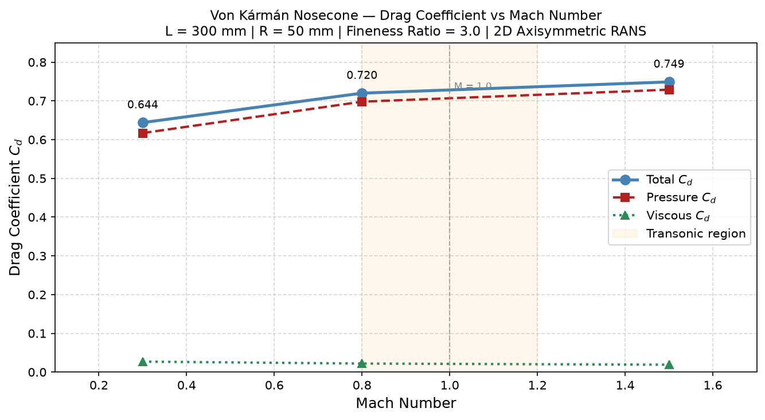
Figure 5 : Total, pressure, and viscous drag coefficients vs Mach number. Transonic region (M = 0.8–1.2) shaded. The steeper gradient between M = 0.3 and M = 0.8 compared to M = 0.8–1.5 is the signature of the transonic drag rise.

The gradient of the total Cd curve is notably steeper between M = 0.3 and M = 0.8 (ΔCd = 0.076) than between M = 0.8 and M = 1.5 (ΔCd = 0.029). This non-linearity is the transonic drag rise — as the freestream approaches M = 1, the flow accelerates locally to supersonic speeds over the nosecone shoulder before the freestream itself is supersonic, creating shock-induced wave drag that adds abruptly to the pressure drag. The Von Kármán shape delays this onset compared to blunter geometries, but cannot eliminate it entirely.

5.3 Drag Force Decomposition
Figure 6 shows the absolute drag force decomposition at each Mach number. This chart makes the scale of the force increase viscerally clear: the total drag force at Mach 1.5 is 937 N — nearly 29 times the Mach 0.3 value of 32 N. The pressure drag bar dominates at every Mach number. The viscous drag, while increasing in absolute terms (1.35 N → 7.87 N → 24.18 N), remains a small fraction of the total and is barely visible on the scale of the Mach 1.5 bar.
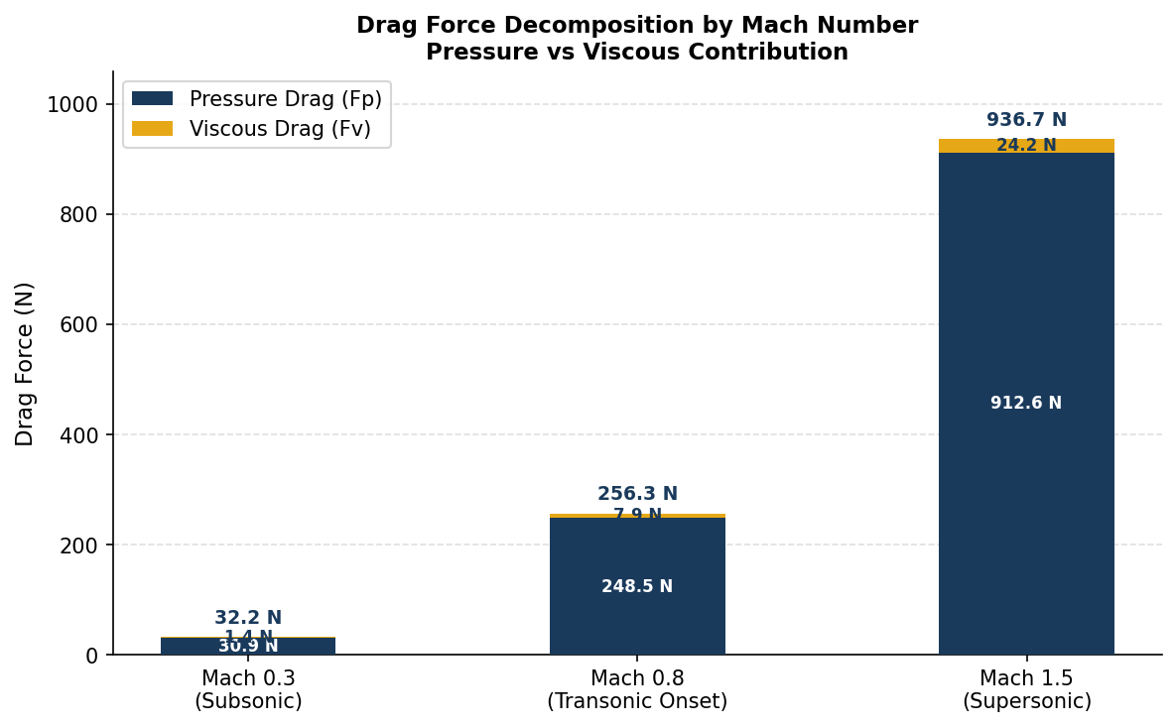
Figure 6 : Stacked bar chart showing absolute pressure drag (Fp) and viscous drag (Fv) at each Mach number. Total drag force increases from 32 N at M = 0.3 to 937 N at M = 1.5 — a factor of 29 — driven primarily by the increase in dynamic pressure and wave drag.

This dramatic force increase has direct engineering significance. A rocket nosecone experiencing 937 N of drag at M = 1.5 requires 937 N of additional thrust just to overcome nosecone drag alone. At M = 0.3, the same nosecone costs only 32 N. This is why the transonic phase of rocket flight — roughly M = 0.8 to M = 1.5 — is the most drag-intensive and is the regime that nosecone shape optimisation is most focused on.

5.4 Viscous and Pressure Drag Percentage
Figure 7 shows the percentage contribution of each drag component to total drag across the three Mach numbers. This chart reveals what the absolute force chart obscures: while viscous drag grows in absolute terms at higher Mach numbers, its percentage contribution to total drag actually decreases monotonically — from 4.2% at M = 0.3 to 3.1% at M = 0.8 to 2.6% at M = 1.5.
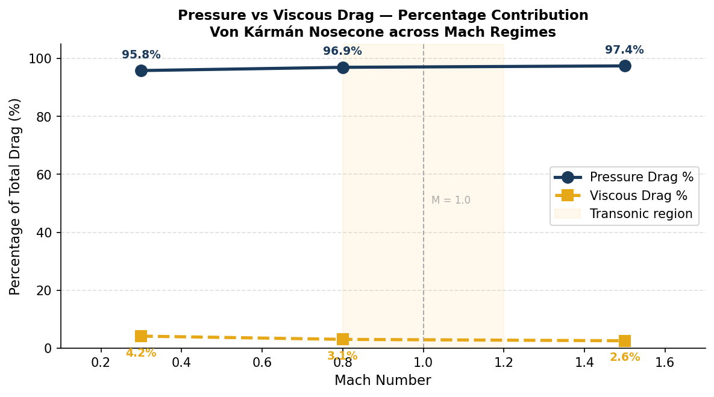
Figure 7 : Pressure drag and viscous drag as percentages of total drag at each Mach number. Pressure drag consistently accounts for 95–97% of total drag. Viscous drag percentage decreases with Mach number despite its absolute value increasing, because dynamic pressure grows faster than skin friction force.

The reason for this apparent paradox is straightforward: dynamic pressure (½ρV²) increases much faster with speed than skin friction force does. As the freestream Mach number doubles from 0.3 to 0.8 (a velocity ratio of approximately 2.7), the dynamic pressure increases by a factor of about 7. The skin friction force, which scales roughly with velocity to the power of 1.5 to 2.0 for turbulent flow, increases more slowly. So even though both forces grow, the pressure drag grows faster — pushing the viscous percentage downward.
This decomposition carries a direct design implication: the surface finish of the Von Kármán nosecone has very little aerodynamic impact. A tenfold reduction in surface roughness would improve the viscous drag coefficient by perhaps 0.002 — a reduction in total Cd of less than 0.5%. By contrast, the pressure drag coefficient of 0.617–0.729 has far more room to influence total performance. Aerodynamic optimisation efforts for this nosecone should focus on base pressure recovery (reducing the low-pressure wake behind the base) and shock wave management at transonic speeds.

6. Flow Visualisation
Pressure, velocity magnitude, and Mach number contour plots were generated for all three Mach cases in ANSYS Fluent post-processing. These contours reveal the physical flow structure that underlies the quantitative drag results. Sections 6.1 through 6.3 discuss each Mach case in detail, linking the visual flow features to the drag values in Table 5.

6.1 Mach 0.3 — Subsonic Flow
At M = 0.3, the flow is entirely subsonic throughout the domain and no shock waves of any kind are present. Figure 8 shows the static pressure contour. The highest pressure region — shown in red — sits at the nosecone tip, which is the stagnation point where the oncoming air is brought to rest and all its kinetic energy converts to pressure. Moving along the nosecone surface, the pressure drops progressively as the flow accelerates around the body. The lowest pressure region occurs near the nosecone shoulder — the point of maximum local flow velocity.
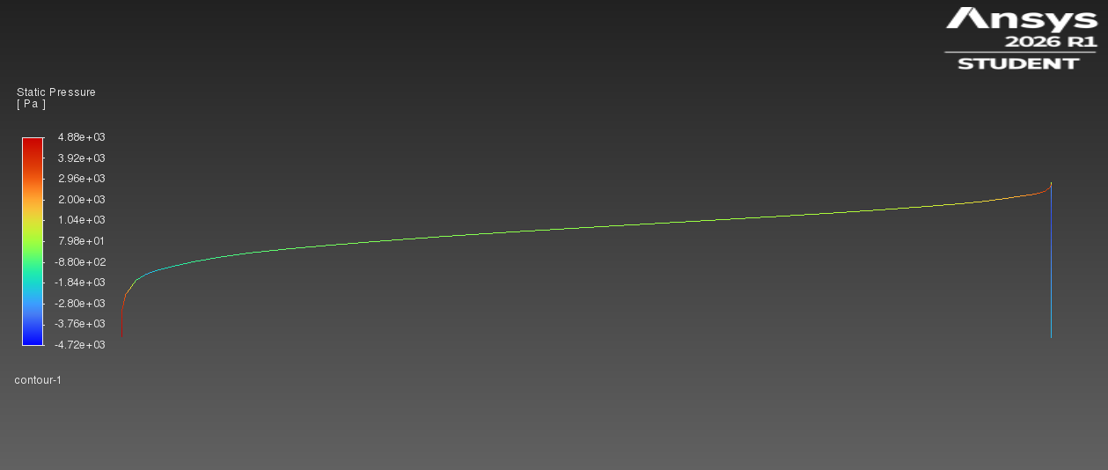

Figure 8 : Static pressure contour — Mach 0.3 (subsonic). Cd,total = 0.644.

Figure 9 shows the velocity magnitude contour for the same case. The stagnation point at the nosecone tip (zero velocity, shown in blue) is clearly visible, surrounded by the accelerating flow field. The boundary layer — the thin region of reduced velocity adjacent to the nosecone wall — is visible as a blue-green zone tracing the nosecone surface. Outside the boundary layer, the flow accelerates smoothly and returns to the freestream velocity as it moves downstream.
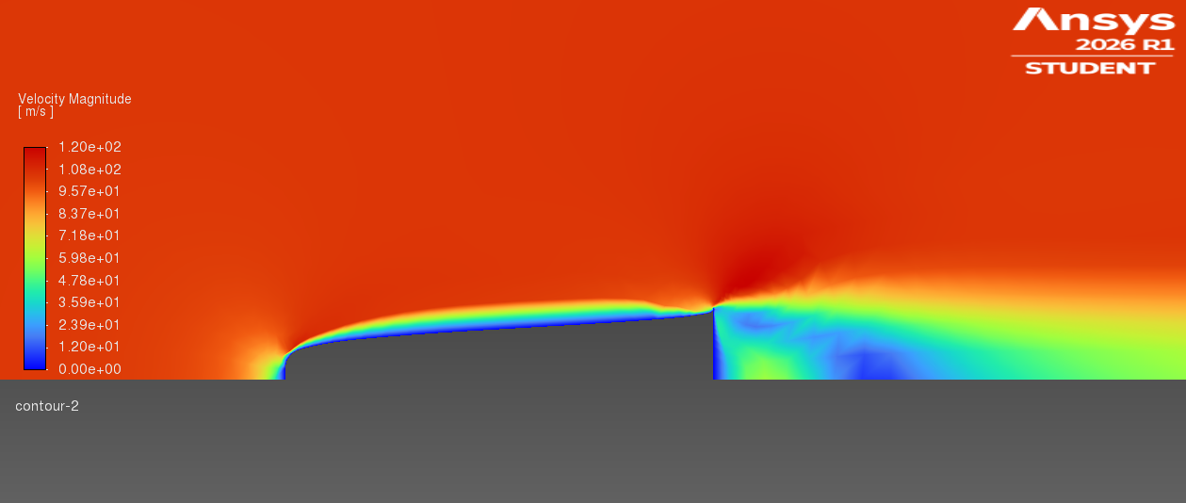

Figure 9 : Velocity magnitude contour — Mach 0.3. Stagnation at the nosecone tip (blue, zero velocity) and smooth flow acceleration around the body. The thin boundary layer along the nosecone surface is visible as a region of reduced velocity adjacent to the wall.

Figure 10 shows the local Mach number contour. The entire flow field remains below M = 1 everywhere — confirmed by the absence of any colour region above the sonic threshold. The maximum local Mach number occurs at the nosecone shoulder and remains well below 1.0. This confirms the purely subsonic character of the M = 0.3 case and explains why the drag is the lowest of the three cases: no wave drag contribution exists at this speed.
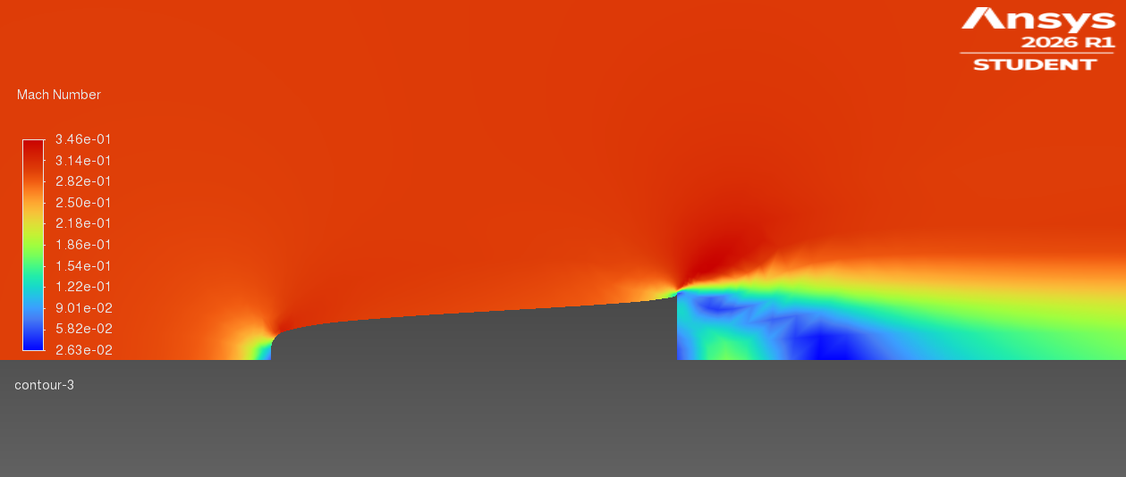

Figure 10 : Local Mach number contour — Mach 0.3. Flow remains entirely subsonic throughout the domain. No local supersonic regions exist. The freestream M = 0.3 condition is clearly visible in the undisturbed regions far from the nosecone.

6.2 Mach 0.8 — Transonic Onset
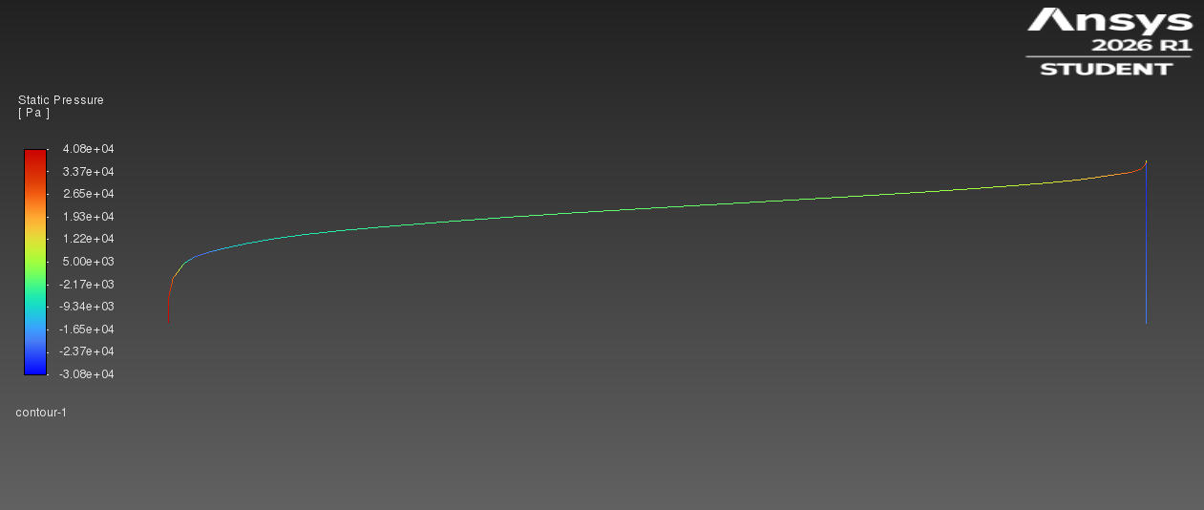
At M = 0.8, the flow approaches the critical Mach number — the freestream speed at which local flow first reaches M = 1 somewhere on the body. Comparing Figure 11 to Figure 8, the pressure contour shows a noticeably different character. The high-pressure stagnation region at the tip is stronger (higher pressure differential relative to the freestream), and the base pressure recovery is less complete — the pressure at the rear of the nosecone is lower relative to freestream than at M = 0.3. This reduced base pressure recovery is a significant contributor to the higher Cd at M = 0.8 compared to M = 0.3.
Figure 11 : Static pressure contour — Mach 0.8 (transonic onset). Stronger stagnation at the tip compared to M = 0.3. Reduced pressure recovery at the nosecone base. Local supersonic pockets beginning to form near the shoulder. Cd,total = 0.720.

Figure 12 shows the velocity magnitude contour. The flow acceleration over the nosecone shoulder is more pronounced than at M = 0.3 — the nosecone is pushing the local flow faster in order to accommodate the higher freestream speed. In some regions near the shoulder, this acceleration is sufficient to push the local flow beyond sonic speed.
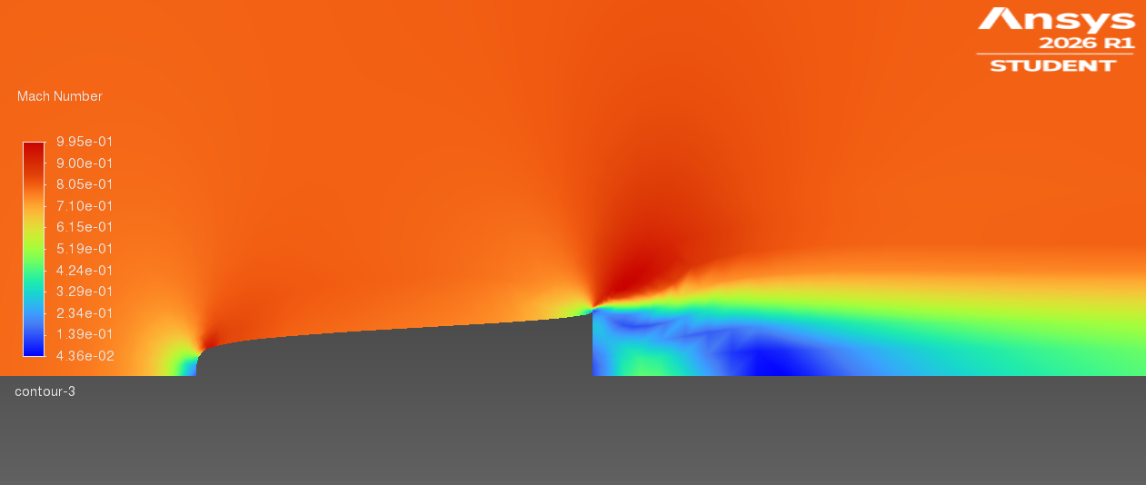
Figure 12 : Velocity magnitude contour — Mach 0.8. Stronger flow acceleration over the nosecone shoulder compared to M = 0.3. The accelerated region near the shoulder approaches and locally exceeds sonic conditions, as confirmed by Figure 13.

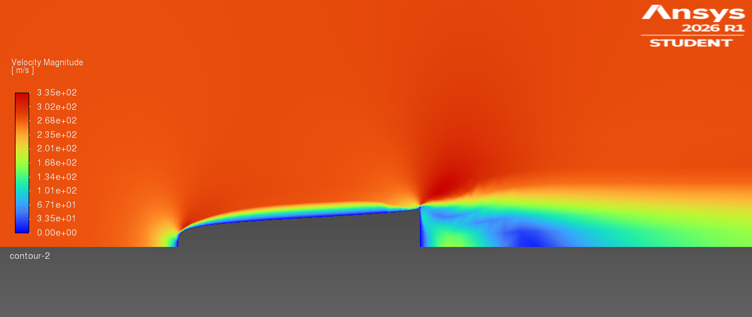
Figure 13 — the Mach number contour — makes the transonic onset explicit. Small pockets of locally supersonic flow (M > 1) are visible near the nosecone shoulder, shown in the warmer colour range above 1.0. These are the embryonic shock structures of the transonic regime: localised regions where the flow has been accelerated past sonic speed, requiring a shock to decelerate back to subsonic conditions. This shock-induced wave drag is the primary reason the drag coefficient rises from 0.644 at M = 0.3 to 0.720 at M = 0.8 — a larger increment than the jump from M = 0.8 to M = 1.5.

Figure 13 : Local Mach number contour — Mach 0.8. Localised regions of M > 1 visible near the nosecone shoulder (warmer colours). These supersonic pockets require terminating shocks and represent the onset of wave drag — the transonic drag rise mechanism. The freestream itself remains at M = 0.8.

6.3 Mach 1.5 — Supersonic Flow and Bow Shock
The Mach 1.5 case produces the most physically rich and visually striking flow field of the three cases. Figure 14 shows the static pressure contour. The most prominent feature is the detached bow shock ahead of the nosecone tip — a sharp, curved discontinuity visible as the abrupt transition from the blue freestream region to the high-pressure red zone immediately behind the shock. This bow shock forms because the freestream is already supersonic: the nosecone cannot communicate its presence to the oncoming flow through pressure waves (which travel at the speed of sound and are overtaken by the freestream), so the flow has no warning before encountering the body. The result is a strong normal shock standing off from the tip.
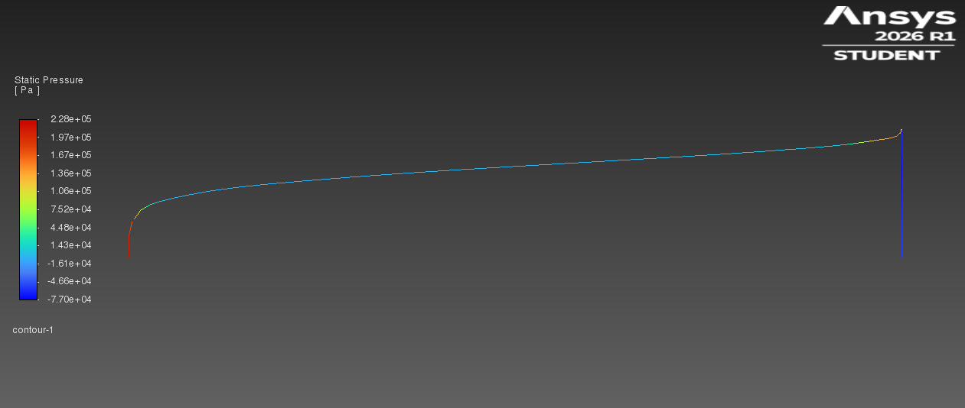
Figure 14 : Static pressure contour — Mach 1.5 (supersonic). A detached normal bow shock is clearly visible ahead of the nosecone tip as a sharp pressure discontinuity. Behind the shock, pressure is high and the flow is locally subsonic. Expansion fans visible along the nosecone shoulder as the flow re-accelerates. Cd,total = 0.749.

Behind the bow shock, the flow decelerates abruptly to subsonic speed and the pressure rises sharply. As the flow then follows the nosecone contour around the shoulder, it accelerates again through expansion fans — visible as the blue low-pressure region along the nosecone body in Figure 14. This expansion process re-accelerates the flow back to supersonic speed along the body surface. The pressure distribution on the nosecone wall is therefore fundamentally different at M = 1.5 compared to M = 0.3 or 0.8: there is a strong high-pressure zone near the tip (behind the bow shock) and an expansion-driven low-pressure zone along the body (through the expansion fan), creating a large net axial pressure force — the dominant wave drag contribution.
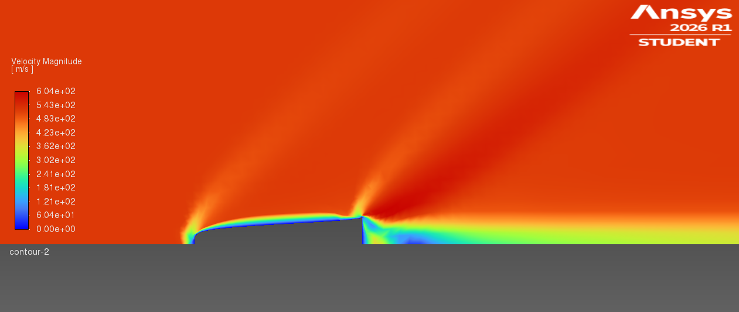
Figure 15 shows the velocity magnitude contour. The shock structure is clearly visible as a sharp line of velocity change. Upstream of the bow shock, the freestream flows at 510 m/s (M = 1.5). Immediately behind the bow shock, the velocity drops dramatically as the kinetic energy is converted to thermal and pressure energy. The flow then re-accelerates along the nosecone body as the geometry guides it through the expansion fan region. The wake behind the nosecone base shows a complex low-velocity region as the flow from the top and bottom of the nosecone meets and tries to fill the base wake — this base wake pressure deficit is a significant source of pressure drag at all Mach numbers but is most pronounced at M = 1.5.
Figure 15 : Velocity magnitude contour — Mach 1.5. Sharp velocity drop across the bow shock (from 510 m/s freestream to near-zero immediately behind the shock). Flow re-accelerates around the nosecone body through the expansion fan. Complex low-velocity base wake visible downstream of the nosecone.

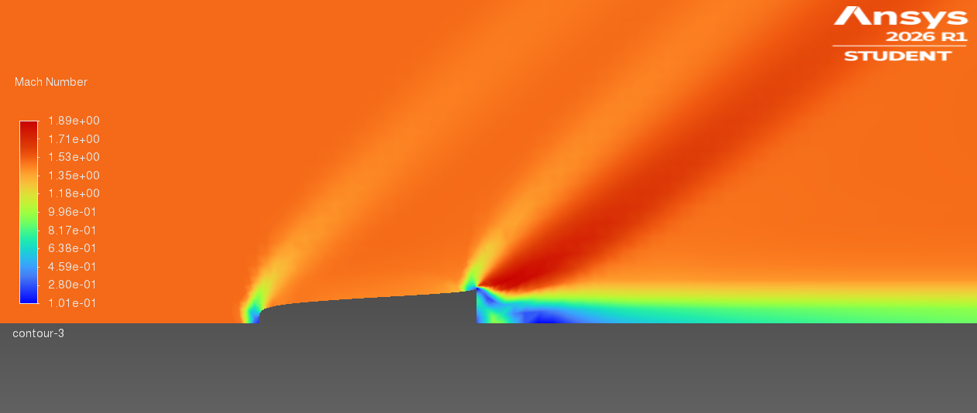
Figure 16 — the Mach number contour — provides the clearest picture of the shock structure. The freestream at M = 1.5 (shown in warm colours) meets the bow shock and drops abruptly to subsonic speeds (shown in blue/green) immediately behind the shock. This subsonic region wraps around the nosecone tip. As the flow accelerates along the nosecone body through the expansion fan, the local Mach number rises again — reaching and exceeding M = 1.5 in some regions along the nosecone shoulder before the flow continues downstream. The contrast between the uniform M = 1.5 freestream and the highly non-uniform flow field around the nosecone illustrates the dramatic flow physics that the pressure drag term in Table 5 is capturing.
Figure 16 : Local Mach number contour — Mach 1.5. The bow shock transition from M = 1.5 freestream (warm colours) to subsonic behind the shock (blue) is clearly resolved. The subsonic pocket wraps the nosecone tip, and the flow re-accelerates to supersonic through the expansion fan along the body. This is the most physically complex flow field of the three cases studied.

7. Discussion

7.1 Transonic Drag Rise — Physical Interpretation
The results in Table 5 and Figure 5 show that total drag coefficient increases by 0.076 between M = 0.3 and M = 0.8, but only by 0.029 between M = 0.8 and M = 1.5 — a 2.6-fold difference in drag rise rate despite the larger Mach number gap in the second interval. This counterintuitive result is explained by the different drag mechanisms active in each regime.
At M = 0.3, the flow is entirely subsonic and the only drag mechanisms are pressure drag from the base wake and viscous skin friction — both relatively mild for a slender, smooth body. As the freestream approaches M = 0.8, local supersonic pockets form on the nosecone shoulder (Figure 13) and the associated shock waves begin contributing wave drag. This shock-induced wave drag addition is abrupt and large, because the flow is transitioning through the critical Mach number range where wave drag sensitivity is highest. By M = 1.5, wave drag is already fully established and the flow has adapted to the supersonic regime — the bow shock exists but is not changing in character as rapidly as the transonic shocks were between M = 0.3 and M = 0.8. Hence the smaller increment in Cd from M = 0.8 to M = 1.5.
The Von Kármán profile's smooth curvature distribution delays the onset of these local supersonic pockets compared to blunter nosecone geometries. A conical nose of the same fineness ratio would develop local supersonic flow at a lower freestream Mach number, producing an earlier and steeper transonic drag rise. The mathematical optimality of the Von Kármán shape is thus most beneficial specifically in the M = 0.7 to M = 1.2 range — which happens to be the flight envelope segment where drag management matters most for rocket performance.

7.2 Engineering Significance of Drag Decomposition
The consistent dominance of pressure drag (95–97% of total, Figure 7) over viscous drag tells engineers where improvement effort should be directed. The base pressure recovery — the degree to which the pressure at the nosecone base returns to freestream levels — is the largest single opportunity for drag reduction in this geometry. At M = 0.3, the relatively complete pressure recovery keeps Cd at 0.644. At M = 1.5, the strong base wake and bow shock prevent recovery, pushing Cd to 0.749. A nosecone design incorporating a boattail (a slight inward taper of the base) could improve base pressure recovery and reduce total drag at all three Mach numbers.
Viscous drag, by contrast, is essentially fixed by the wetted surface area and flow speed. Even achieving a perfectly smooth, polished surface finish would reduce Cd,v from 0.027 to perhaps 0.022 — a total drag reduction of less than 1% at M = 0.3 and less than 0.5% at M = 1.5. For a student or early-stage design project, surface finish is not a productive area of optimisation focus.

7.3 Limitations and Future Work
Several modelling limitations should be acknowledged. The mesh skewness of 0.682 at far-field corners introduces some numerical dissipation, though away from the aerodynamic region of interest. The Spalart-Allmaras model does not accurately capture shock-boundary layer interaction in the Mach 1.5 case or separated base wake dynamics — a k-ω SST model would provide better accuracy. No experimental validation data is available for this exact geometry, so results represent a self-consistent numerical prediction rather than a validated measurement.
Future work in this portfolio will apply incompressible 2D RANS to an F1 front wing in ground effect, extending the aerodynamic analysis toolkit from compressible external aerodynamics to viscous low-speed flows — the regime most relevant to Formula 1 car performance.

8. Conclusions
A complete 2D axisymmetric RANS investigation of compressible external flow over a Von Kármán nosecone has been conducted at Mach 0.3, 0.8, and 1.5 using ANSYS Fluent 2026 R1. The following conclusions are drawn:

- Total drag coefficient increases from Cd = 0.644 at M = 0.3 to Cd = 0.749 at M = 1.5. The drag rise between M = 0.3 and M = 0.8 (ΔCd = 0.076) is 2.6 times larger than between M = 0.8 and M = 1.5 (ΔCd = 0.029) — consistent with the transonic drag rise mechanism activated by local supersonic pockets forming on the nosecone shoulder near M = 0.8.
- Pressure drag accounts for 95.8% of total drag at M = 0.3 and 97.4% at M = 1.5. Viscous drag percentage decreases with Mach number despite its absolute value increasing, because dynamic pressure grows faster than skin friction force. Aerodynamic optimisation should focus on pressure recovery and shock management, not surface finish.
- A detached normal bow shock is clearly resolved at M = 1.5, visible as a sharp pressure discontinuity in the contour plots. The subsonic region behind the bow shock, the expansion fans along the nosecone body, and the supersonic re-acceleration are all captured by the Spalart-Allmaras RANS model with Roe-FDS flux scheme.
- The Von Kármán profile's smooth curvature distribution delays the transonic drag rise compared to blunter geometries of equivalent fineness ratio — the mathematical basis for its widespread use in high-performance rocketry is confirmed by the relatively moderate total Cd values across all three Mach regimes.
- Correct boundary condition setup — specifically using the axis type (not symmetry type) for the rotation axis — is essential for 2D axisymmetric simulations in ANSYS Fluent. Misclassification causes immediate solver divergence.
- Structured face meshing with inflation layers produced acceptable mesh quality (min. orthogonal quality 0.637, max. skewness 0.682) within the ANSYS Student Edition cell limit, delivering physically consistent results across all three Mach cases.

9. References
[1] Haack, W. (1941). Projectile Shapes for Smallest Wave Resistance. Lilienthal-Gesellschaft für Luftfahrtforschung, Report 139.
[2] Anderson, J.D. (2003). Modern Compressible Flow: With Historical Perspective. 3rd ed. McGraw-Hill.
[3] Versteeg, H.K. and Malalasekera, W. (2007). An Introduction to Computational Fluid Dynamics: The Finite Volume Method. 2nd ed. Pearson Education Limited.
[4] Spalart, P.R. and Allmaras, S.R. (1992). A one-equation turbulence model for aerodynamic flows. AIAA Paper 92-0439.
[5] Roe, P.L. (1981). Approximate Riemann solvers, parameter vectors, and difference schemes. Journal of Computational Physics, 43(2), pp.357–372.
[6] ANSYS Inc. (2026). ANSYS Fluent Theory Guide, Release 2026 R1. Canonsburg, PA.
[7] ANSYS Inc. (2026). ANSYS Fluent User's Guide, Release 2026 R1. Canonsburg, PA.
[8] Cengel, Y.A. and Cimbala, J.M. (2018). Fluid Mechanics: Fundamentals and Applications. 4th ed. McGraw-Hill Education.
[9] NASA Glenn Research Center (2024). Beginner's Guide to Aerodynamics. Available at: https://www.grc.nasa.gov
[10] Lazarevikj, M., Stojkovski, V. and Markov, Z. (2024). Flow Around an Airfoil with Ansys Fluent. Ansys Academic Case Study. Ss. Cyril and Methodius University.

