A GPS-BASED MATERNAL EMERGENCY RESPONSE AND MONITORING SYSTEM FOR IMPROVING HEALTH IN UGANDA

CASE STUDY: MUKONO DISTRICT

BY
MUHINDA PRAISE FRANCIS
23/U/ITD/08374/PD
francispraise10@gmail.com · +256-(0)-742 912806
NABUKEERA ZAHARAH RAMULAH
23/U/ITD/14136/PD
zahranabujeera60@gmail.com · +256-(0)-769 966851
KATO HASSAN
23/U/ITD/06601/PD
Khassankato37@gmail.com · +256-(0)-751 109404

A RESEARCH REPORT SUBMITTED TO THE DEPARTMENT OF COMPUTER SCIENCE, SCHOOL OF COMPUTING AND INFORMATION SCIENCE IN PARTIAL FULFILMENT OF THE REQUIREMENTS FOR THE AWARD OF THE BACHELORS DEGREE IN INFORMATION TECHNOLOGY AND COMPUTING OF KYAMBOGO UNIVERSITY

AUGUST 2026

DECLARATION
We, Muhinda Praise Francis, Nabukeera Zaharah Ramulah and Kato Hassan, declare that the work presented in this research report is our original work and has not been submitted to any University or Institution of Higher Learning for any academic award. All work from other authors has been fully and properly acknowledged and cited.

Signature :……………………………………. Date:………………………………
Muhinda Praise Francis
(Researcher)

Signature :……………………………………. Date:………………………………
Nabukeera Zaharah Ramulah
(Researcher)

Signature :……………………………………. Date:………………………………
Kato Hassan
(Researcher)

APPROVAL
This is to certify that this research report titled: “A GPS-Based Maternal Emergency Response and Monitoring System for Improving Health in Uganda” has been carried out under my supervision and is now ready for submission to the Examinations Board and Senate of Kyambogo University.

Signature :……………………………………. Date:………………………………
Ms. Ahimbisibwe Shallon
(Supervisor)

DEDICATION
We dedicate this work to the mothers of Mukono District, and to the memory of those whose lives were lost not for want of medicine but for want of being found in time. We dedicate it also to our families, whose patience and support carried us through this study, and to the Village Health Team members who walk to those homes.

ACKNOWLEDGEMENT
We wish to express our sincere gratitude to our supervisor, Ms. Ahimbisibwe Shallon, whose guidance and patient page-by-page review shaped both this report and the system it describes.
We are grateful to the Department of Computer Science and the School of Computing and Information Science, Kyambogo University, for the academic foundation on which this work rests, and to the members of the research committee for their direction.
We thank the management and clinical staff of Mukono General Hospital, the midwives and obstetricians who gave their time to be interviewed during demanding shifts, the ambulance drivers who allowed us to observe their work, and the district health administrators who granted access to referral records. We thank collectively the expectant mothers and the Village Health Team members who completed our questionnaires; their accounts of waiting for help that could not find them are the reason this system exists.
Finally, we thank our families and colleagues for their encouragement throughout the period of this study.

LIST OF ACRONYMS
ANC Antenatal Care
API Application Programming Interface
CEmONC Comprehensive Emergency Obstetric and Newborn Care
CSS Cascading Style Sheets
DFD Data Flow Diagram
ERD Entity-Relationship Diagram
GIS Geographic Information System
GPS Global Positioning System
GSM Global System for Mobile Communications
HIS Health Information Systems
HMIS Health Management Information System
HTTP Hypertext Transfer Protocol
IoT Internet of Things
JSON JavaScript Object Notation
mHealth Mobile Health
NDP III Third National Development Plan
PPH Postpartum Haemorrhage
PWA Progressive Web Application
RLS Row Level Security
SDG Sustainable Development Goals
SDLC Systems Development Life Cycle
SMS Short Message Service
SQL Structured Query Language
SWOT Strengths, Weaknesses, Opportunities and Threats
UBOS Uganda Bureau of Statistics
UI User Interface
UML Unified Modeling Language
USSD Unstructured Supplementary Service Data
VHT Village Health Team
WHO World Health Organization

DEFINITION OF TERMS USED
GPS (Global Positioning System). A satellite-based navigation system used to provide precise, real-time geographic coordinates (latitude and longitude) that identify a mother’s exact physical location during an emergency.
Maternal Health. The health of women during pregnancy, childbirth and the postpartum period. In this study it refers specifically to reducing mortality arising from life-threatening complications such as Postpartum Haemorrhage.
Emergency Response. The coordinated process of dispatching medical assistance, such as ambulances and Village Health Teams, to a patient in immediate need of life-saving care.
Monitoring System. A digital infrastructure consisting of a mobile interface and a centralised hospital dashboard used to track, observe and manage the status and location of expectant mothers in real time.
Spatial Invisibility. A technical gap in which healthcare providers lack digital visibility of a patient’s location, arising from poorly mapped areas and reliance on vague verbal directions.
Second Delay. The critical time lost between the decision to seek care and the actual arrival of the mother at a health facility.
Maternal Health Informatics. The interdisciplinary study of the design, development, adoption and application of IT-based innovations in healthcare services for expectant mothers.
Real-time Analytics. The use of data as soon as it enters a system, allowing immediate feedback and decision-making during an obstetric crisis.
Geospatial Integration. The process of combining GPS coordinates with existing health databases in order to visualise patient locations on a digital map.
Referral Loop. A systemic failure in which a patient is sent between multiple health facilities that all lack the resources to treat her, caused by the absence of real-time resource visibility.
Offline-first. A design approach in which the application writes to a local store first and replicates to the server when connectivity allows, so that the system remains usable where the network does not reach.
Dispatch State Machine. The defined set of states an emergency case may occupy — pending, dispatched, en-route, arrived, delivered, completed or cancelled — together with the permitted transitions between them.

TABLE OF CONTENTS

This table, and the page numbers in the List of Tables and List of Figures, are generated fields. To populate them in Microsoft Word, press Ctrl+A then F9, and choose “Update entire table”.

LIST OF TABLES
Table 3.1: Distribution of the Study Sample –
Table 4.1: Comparative Analysis of the Current System –
Table 4.2: Functional Requirements of the New System –
Table 4.3: Non-Functional Requirements of the New System –
Table 4.4: Hardware and Software Requirements –
Table 5.1: Database Tables and Their Relationships –
Table 5.2: Data Description of the Emergencies Table –
Table 5.3: Summary of System Test Results –
Table A1: Research Budget –
Table A2: Research Time Schedule –

LIST OF FIGURES
Figure 4.1: Use Case Diagram of the Proposed System –
Figure 5.1: Context Diagram of the MamaTrack GPS System –
Figure 5.2: Data Flow Diagram, Level 0 –
Figure 5.3: Data Flow Diagram, Level 1 — Emergency Dispatch –
Figure 5.4: Entity-Relationship Diagram of the MamaTrack GPS Database –
Figure 5.5: System Architecture of the MamaTrack GPS System –
Figure 5.6: Module Architecture of the Application –
Figure 5.7: Emergency Case State Machine –
Figure 5.8: Sequence Diagram — Emergency Dispatch –
Figure 5.9: Offline Synchronisation Mechanism –
Figure 5.10: System Landing Page –
Figure 5.11: Portal Login Screen –
Figure 5.12: Expectant Mother Portal — Emergency Beacon and Live Tracking –
Figure 5.13: District Command Console — Triage Queue and Fleet Monitor –
Figure 5.14: Ambulance Navigation Panel –

ABSTRACT
This research investigated the problem of spatial invisibility in maternal emergency response in Mukono District, Uganda, where a mother in obstetric distress cannot reliably be located by the responders sent to reach her. Uganda’s maternal mortality ratio stands at 284 deaths per 100,000 live births (Uganda Bureau of Statistics, 2022), and a substantial share of these deaths is attributable to the second of the three delays — the time lost reaching a health facility. Current referral workflows in the district are location-blind, depending on telephone calls, paper antenatal cards and verbal directions to poorly mapped settlements in sub-counties such as Nama and to island communities in Koome. The main purpose of the study was to design, develop and validate a GPS-enabled maternal health information system that makes a mother’s precise location visible to responders before she arrives at a facility.
A systems engineering methodology following the Systems Development Life Cycle was used to analyse, design, implement and test the system. Requirements were elicited through interviews with clinical and dispatch staff, questionnaires administered to expectant mothers and Village Health Team members, observation of the existing referral workflow, and review of facility records. The current system was analysed using SWOT analysis. The new system was modelled using Data Flow Diagrams, an Entity-Relationship Diagram and Unified Modeling Language use case, state machine and sequence diagrams, and was implemented as a Progressive Web Application built with React, TypeScript and Leaflet over a Supabase PostgreSQL database with realtime replication.
The study produced a working system comprising five role-specific portals — for expectant mothers, doctors, ambulance drivers, Village Health Team members and district administrators — operating over one shared, offline-capable data layer. Validation through simulated emergency scenarios confirmed that an SOS raised on a mother’s device propagates to the district command console on a separate device without any shared local state, and that the system automatically resolves the nearest capable facility, assigns an available ambulance and driver, notifies the receiving clinician, and advances the case through its dispatch lifecycle. Static verification of the delivered code returned no compiler errors and no lint warnings, and the production build completed successfully. Five defects were identified during validation and corrected, the most serious being a realtime subscription fault capable of terminating the entire interface during startup.
This study recommends that the district adopt the system in a supervised pilot covering Mukono General Hospital and its surrounding health centres before wider rollout, and that the permissive database access policy used for demonstration be replaced with role-scoped policies bound to authenticated identity before any real patient record is entered. It further recommends that Village Health Teams be equipped and trained as the field entry point for registration and vitals capture, since their coverage determines how much of the district the system can actually see.

CHAPTER ONE: INTRODUCTION

1.0 Introduction
This chapter establishes the foundation of the research. It opens with the background to the study, which situates the maternal health crisis within the wider transition of health informatics toward location-aware systems. It then presents the problem statement, which analyses the causes and consequences of spatial invisibility within current emergency maternal care workflows. The general and specific objectives are defined to outline the technical milestones of the work, the research questions are stated, and the subject, geographical and time boundaries of the study are established. The chapter closes with the justification and significance of the research and a summary.
The sector under study is public maternal healthcare service delivery in Uganda, and specifically the emergency obstetric referral pathway that connects a mother in her home to a facility capable of treating her. This sector is characterised by adequate clinical protocol and inadequate logistical coordination: the knowledge of how to treat postpartum haemorrhage exists in the district, but the means of reaching the woman experiencing it in time does not. It is a sector in which an information failure produces a medical outcome.

1.1 Background of the Study
The field of maternal health informatics has moved from static record-keeping toward the dynamic integration of the Internet of Things, Global Positioning Systems and real-time analytics. Globally, the World Health Organization reports approximately 800 daily maternal deaths from preventable causes, with 95% occurring in low-resource settings (World Health Organization, 2023). In emerging economies such as India, the deployment of GPS-tracked ambulances and IoT-enabled wearable sensors has proved effective in reducing the second delay, the critical interval required to reach a health facility (Thaddeus & Maine, 1994).
In Africa, digital health initiatives have centred primarily on mHealth. While programmes such as Kenya’s Linda Mama have increased service uptake, they remain fundamentally location-blind. In Uganda, where the maternal mortality ratio stands at 284 deaths per 100,000 live births (Uganda Bureau of Statistics, 2022), existing interventions such as UNICEF’s SMS-based reminders and Kampala’s eHealth referral pilots lack real-time geospatial integration. This technical deficit prevents responders from acting on a mother’s position at the moment it matters most.
The current influence of GPS and IoT on Ugandan maternal health is restricted to high-level urban pilots, leaving a significant technological gap in peri-urban and rural districts. Existing systems function as static databases rather than active emergency dispatch tools, resulting in navigation errors during complications such as postpartum haemorrhage.
Mukono District, the case study for this research, epitomises these challenges. As a region characterised by poorly mapped rural villages in Nama and isolated island communities in Koome, verbal directions are frequently unreliable. Consequently, maternal referrals to Mukono General Hospital suffer from spatial invisibility. This study developed a GPS-enabled solution within Mukono to provide a scalable, data-driven model for reducing maternal mortality through precise, real-time location tracking.

1.2 Problem Statement
Despite national interventions, Uganda’s maternal mortality ratio remains critically high at 284 deaths per 100,000 live births (Uganda Bureau of Statistics, 2022). In Mukono District, a primary driver of these fatalities is the second delay, the time lost in locating and transporting a mother during an obstetric emergency. Current response workflows are location-blind, relying on manual records and vague verbal directions, which prevents the timely dispatch of ambulances and Village Health Teams. This lack of spatial visibility frequently turns manageable complications, such as postpartum haemorrhage, into avoidable tragedies.
The root cause of this crisis is spatial information invisibility. The absence of a digital infrastructure to transmit precise GPS coordinates leads to navigation errors in poorly mapped areas such as Nama and isolated island communities such as Koome. This is compounded by fragmented communication and reliance on physical paper cards, which restricts access to vital clinical history during transit. Consequently, mothers lose the critical therapeutic window for intervention, often falling into inefficient referral loops between facilities that lack the necessary resources.
To address these challenges, this research developed a GPS-enabled maternal health information system for Mukono District. By integrating a mobile interface for mothers with a web-based hospital dashboard, the system uses geospatial technology to provide real-time tracking and automated resource identification, ensuring that a mother’s precise location is visible to medical responders before she arrives at the facility.

1.3 Objectives

1.3.1 General Objective
The main objective of this research was to design and develop a GPS-enabled maternal health information system for Mukono District in order to eliminate spatial invisibility and reduce the second delay during obstetric emergencies.

1.3.2 Specific Objectives
- To study and analyse the strengths and weaknesses of the current maternal emergency response and referral workflows within Mukono General Hospital and its surrounding health centres.
- To determine and specify the functional and technical requirements for a real-time geospatial tracking and alert system tailored to the terrain of Mukono District.
- To design a GPS-integrated maternal health system consisting of a mobile emergency interface for mothers and a centralised navigation dashboard for hospital administrators.
- To implement, test and validate the new system through simulated emergency scenarios in order to measure its effectiveness in improving response times and coordination.

1.4 Research Questions
To achieve the objectives of this research, the following questions were addressed:
- What are the strengths and weaknesses of the existing maternal emergency response and referral workflows in Mukono General Hospital and its surrounding health centres?
- What functional and technical requirements are necessary to develop a real-time geospatial tracking and alert system that accounts for the terrain of Mukono District?
- How can a GPS-integrated system be designed to provide an intuitive mobile interface for expectant mothers and a comprehensive navigation dashboard for hospital administrators?
- How effective is the implemented system in reducing emergency response times and improving coordination when tested through simulated maternal emergency scenarios?

1.5 Scope of the Study

1.5.1 Subject Scope
The subject scope of this research covered the design and development of a GPS-enabled maternal health information system addressing the spatial invisibility of expectant mothers during obstetric emergencies, specifically targeting the reduction of the second delay. The primary stakeholders of the system are:
- Expectant mothers — the end users who require emergency tracking and rapid response.
- Healthcare providers — midwives, obstetricians and administrators at Mukono General Hospital who monitor the real-time navigation dashboard.
- Emergency responders — ambulance drivers and Village Health Teams who use the GPS data for precise navigation.
- District health officers — who use the generated geospatial data for resource allocation and health planning.
The study did not extend to the clinical treatment of obstetric complications, to the procurement or maintenance of ambulances, or to the integration of wearable physiological sensors, all of which lie outside the information-systems boundary of the work.

1.5.2 Geographical Scope
The research was conducted within Mukono District, Central Uganda. This case study was chosen for its geographical diversity, featuring rapidly urbanising centres alongside poorly mapped rural sub-counties such as Nama and isolated island communities in Koome on Lake Victoria. Mukono exemplifies the referral gap in which high maternal populations face significant transit hurdles in reaching Mukono General Hospital, and its varied terrain provides a rigorous environment in which to test the accuracy and reliability of GPS and GIS technologies in low-resource, high-stakes settings.

1.5.3 Time Scope
The research was conducted over a period of ten weeks, structured into three technical phases. Weeks one to three covered research and requirements, comprising the literature review, the gathering of functional requirements from stakeholders in Mukono, and the finalisation of the system architecture. Weeks four to seven covered system development, focusing on geospatial database design, interface implementation and the integration of the GPS and mapping modules. Weeks eight to ten covered validation and documentation, dedicated to system testing, user validation within Mukono District and the completion of the final project submission.

1.6 Significance of the Study
The urgency of this study rests on the observation that maternal mortality in Uganda is not merely a medical failure but a logistical and informational one. While medical protocols for treating complications exist, the inability to locate and reach a mother in distress remains a critical bottleneck. This research moves maternal health from a reactive, paper-based model toward a proactive, spatially aware one.
Current maternal health interventions in Uganda rely largely on mHealth platforms built around one-way communication such as SMS reminders for antenatal visits. A significant technical gap remains: these systems are blind to a mother’s physical location during a crisis. Most existing studies address the clinical causes of death while overlooking the geospatial informatics required to solve the second delay (Faujdar & Kumar, 2020). No integrated platform in Uganda’s public hospitals currently links a mother’s real-time GPS coordinates to a centralised hospital dashboard for immediate dispatch.
The implementation of this system offers direct improvements to the maternal healthcare process. Precision emergency response replaces vague verbal directions with exact coordinates, minimising the time ambulances and Village Health Teams spend searching for a patient’s home. Intelligent referral mapping identifies the nearest facility with available beds and the correct capability, preventing the referral loop in which mothers are moved between full hospitals. Aggregated location data allows the district and the Ministry of Health to identify mortality hotspots and to place new clinics and ambulances where they are most needed.
Academically, the study contributes a framework for applying Geographic Information Systems to maternal health in resource-constrained environments; it explores the synchronisation of spatial data over intermittent and low-bandwidth networks, providing a model for transmitting complex location data where connectivity is poor; and it advances the study of Health Information Systems by shifting the focus from static data storage toward real-time, event-driven architecture.
The work serves as a pioneer for spatial health informatics in East Africa. By integrating GPS tracking into public hospital workflows, it provides a scalable template adaptable to other emergencies such as accident response or epidemic tracking, and directly supports the Uganda National Development Plan (National Planning Authority, 2020) and Sustainable Development Goal 3.

1.7 Chapter Summary
This chapter established the foundational framework for the research by identifying the need for a spatial intervention in Uganda’s maternal healthcare. The problem statement set out the consequences of delayed emergency response and the inefficiency of current paper-based and non-localised systems. The objectives were defined around the design, development and testing of a GPS tracking capability and a centralised maternal database, and the scope and significance established the technical feasibility and the socio-economic impact of the system in alignment with the National Development Plan and Sustainable Development Goal 3. The chapter sets the stage for the review of existing literature that follows.

CHAPTER TWO: LITERATURE REVIEW

2.1 Introduction
This chapter presents a critical review of literature related to the design and development of a GPS-based maternal emergency response and monitoring system, with specific focus on Mukono District, Uganda. The review examines theoretical and empirical studies in maternal health informatics, situates maternal mortality within both global and national contexts, and analyses the role of geospatial technologies in emergency obstetric care.
Particular emphasis is placed on the interaction between geography, infrastructure and health system responsiveness in Mukono District. The district’s rural sub-counties, island communities and referral pathways to Mukono General Hospital are examined as key determinants of emergency response efficiency. The chapter concludes by synthesising the literature to identify the gaps that justify the development of a real-time GPS-enabled maternal emergency system.

2.2 Conceptual Framework: Maternal Health Informatics and the Three Delays Model

2.2.1 Evolution of Health Information Systems in Maternal Care
Health Information Systems have evolved from static administrative tools into dynamic platforms that support real-time decision-making. Early systems focused primarily on patient registration and aggregate reporting, limiting their utility in emergency scenarios. In Uganda, the Health Management Information System reflects this limitation, as it largely supports retrospective data analysis rather than real-time intervention.
The emergence of mobile health technologies has significantly improved communication in maternal healthcare. Initiatives such as UNICEF’s mTrac have enhanced antenatal care attendance and drug monitoring through SMS-based platforms. However, these systems remain fundamentally location-blind, lacking the ability to provide spatial intelligence during emergencies.
Recent studies highlight that while mHealth improves information dissemination, it does not address the geospatial coordination that is critical in emergency response. In Mukono District, Village Health Teams rely heavily on mobile phones, yet the absence of location-aware technologies limits their effectiveness in guiding emergency responders. This indicates a clear technological gap: the transition from communication-based systems to location-aware, real-time emergency systems remains largely unaddressed.

2.2.2 The Three Delays Model
The Three Delays Model provides the foundational framework for understanding maternal mortality (Thaddeus & Maine, 1994). It identifies three critical barriers: the delay in deciding to seek care, the delay in reaching a health facility, and the delay in receiving adequate care once the facility is reached.
While all three delays are significant, this study focuses on the second, which is heavily influenced by geographical and infrastructural factors. In the context of Mukono District, the second delay is compounded by what this study conceptualises as spatial invisibility — the inability of healthcare providers to locate patients accurately during emergencies. This transforms distance from a physical barrier into an information failure.
Empirical evidence from Uganda shows that delays in reaching facilities are a major contributor to maternal mortality, particularly in rural and peri-urban settings. In Mukono, poorly mapped settlements such as Nama and isolated island communities such as Koome intensify this challenge. Addressing the second delay therefore requires not only transport solutions but geospatial intelligence.

2.3 Maternal Health Context in Mukono District

2.3.1 Geographical and Demographic Characteristics
Mukono District is located in Central Uganda and exhibits significant geographical diversity, including urban centres, rural settlements and island communities on Lake Victoria. This diversity creates uneven access to healthcare services. With an estimated population of approximately 700,000, the district has a high proportion of women of reproductive age, increasing demand for maternal health services.
Geographical constraints, particularly in island communities, introduce systemic delays in accessing care. Transport limitations, long distances and unreliable communication networks collectively increase the risk of maternal complications and mortality.

2.3.2 Health Facilities and the Referral System
Mukono General Hospital serves as the primary referral facility for comprehensive emergency obstetric and newborn care. Lower-level facilities provide basic services but often lack critical resources such as surgical capacity and blood transfusion services.
The referral system is largely manual and fragmented, relying on telephone communication and informal directions, which produces inefficiency during emergencies. Studies indicate that ambulance drivers may spend up to sixty minutes locating patients because directions are unclear. This delay highlights a key weakness: the absence of structured, location-based referral.

2.3.3 Village Health Teams and Their Role
Village Health Teams play a crucial role in bridging communities and the formal healthcare system. They facilitate referrals, monitor pregnancies and provide health education. Despite their importance, they face significant operational challenges, including a lack of digital tools and limited logistical support, and their reliance on verbal communication further contributes to spatial inefficiency. Integrating Village Health Teams into a GPS-enabled system would significantly enhance their ability to coordinate emergency responses.

2.4 Review of GPS and GIS Applications in Maternal Health

2.4.1 Global Evidence on Geospatial Technologies in Emergency Care
Geospatial technologies such as GIS and GPS have transformed emergency response systems globally, enabling real-time tracking, route optimisation and spatial analysis of healthcare access. In high-income countries, GPS-enabled ambulance systems have significantly reduced response times, and GIS has been used to identify underserved populations and optimise the allocation of healthcare resources. These applications demonstrate that location intelligence is a critical component of effective healthcare delivery.

2.4.2 GPS-Enabled Maternal Health Initiatives in Low-Resource Settings
In sub-Saharan Africa, several pilot projects have explored GPS-based maternal health solutions. In Tanzania, GPS integration reduced response times by approximately eighteen minutes. In Nigeria, the MNETI initiative achieved a significant reduction in transport time. In Kenya, GPS systems improved referral coordination despite infrastructural challenges. These studies demonstrate the feasibility and effectiveness of GPS technologies even in low-resource environments; however, most remain pilot-based and lack long-term scalability.

2.4.3 Challenges of GPS Integration in Rural Uganda
Despite its potential, GPS implementation in Mukono faces several constraints: limited network coverage, especially in island areas; low smartphone penetration; data privacy and security concerns; and dependence on donor-funded pilot projects. These challenges establish the need for a context-aware system design incorporating offline functionality, low-bandwidth optimisation and a sustainable deployment model — requirements that directly shaped the architecture adopted in this study.

2.5 Existing Maternal Health Information Systems in Uganda and Mukono

2.5.1 National Systems
Uganda’s Health Management Information System and electronic logistics management systems support health data management and supply logistics. However, they are not designed for real-time emergency coordination and cannot act on a patient’s position.

2.5.2 District-Level Practices
At district level, communication is largely informal, relying on telephone calls and consumer messaging platforms. These methods lack structure, data integration and spatial capability. No system currently in use in Mukono District supports real-time patient tracking, automated ambulance dispatch or geospatial decision-making.

2.5.3 Role of NGOs and the Private Sector
Non-governmental organisations support maternal health through transport schemes and awareness programmes. These initiatives are, however, fragmented and are not integrated into a unified system. A centralised GPS-based platform could enhance coordination and improve efficiency across stakeholders.

2.6 Spatial Invisibility in Mukono: A Critical Gap
Spatial invisibility emerges as the central challenge in maternal healthcare delivery in Mukono District. It refers to the inability of healthcare providers to identify and navigate to a patient’s location accurately. It is driven by the lack of a formal addressing system, poorly mapped rural areas, the geographical isolation of island communities and the absence of real-time location tracking.
Studies show that significant time is lost locating patients before transport even begins. In emergency conditions such as postpartum haemorrhage, where the therapeutic window may be measured in hours, these delays are frequently fatal. Spatial invisibility therefore represents a critical intersection between geography, technology and healthcare failure.

2.7 Synthesis and Research Gap
The reviewed literature reveals several consistent findings: the second delay is a major contributor to maternal mortality in Uganda; existing mHealth systems lack geospatial capability; GPS technologies are effective but underused in low-resource settings; and Mukono District presents geographical challenges that make it a demanding test case.
Despite these findings, no integrated, GPS-based maternal emergency response system tailored to Mukono District exists. This study addressed that gap by developing a system that integrates a mobile interface with a web dashboard, enables real-time location tracking, supports coordinated emergency response and is optimised for intermittent connectivity.

2.8 Chapter Summary
This chapter reviewed literature on maternal health informatics, the Three Delays Model and geospatial technologies in healthcare, and highlighted the limitations of existing systems together with the particular challenges faced in Mukono District. The concept of spatial invisibility was identified as a key barrier to effective emergency response, and the absence of real-time, location-aware systems was established as a significant research and practical gap. The methodology adopted to address that gap is described in the chapter that follows.

CHAPTER THREE: RESEARCH METHODOLOGY

3.1 Introduction
This chapter describes the methods used to study the existing maternal emergency response workflow in Mukono District, to elicit and specify the requirements of the new system, and to design, implement, test and validate it. It covers the research design, the population and sampling strategy, the instruments used and their testing, the data collection and analysis methods, and the systems analysis, design, implementation and validation methods adopted under the Systems Development Life Cycle.

3.2 Research Design
The study adopted a descriptive and developmental research design combining qualitative and quantitative approaches. The descriptive component established how maternal emergencies are currently reported, triaged and dispatched in Mukono District and where time is lost in that pathway. The developmental component produced the software artefact itself and evaluated it against the workflow it was designed to replace.
An iterative and incremental Systems Development Life Cycle was used rather than a strictly sequential one. Because the essential risk in this system is behavioural rather than computational — whether a responder can act on a location under time pressure — the design had to be exposed to stakeholders early and repeatedly. Each iteration delivered a working portal that could be demonstrated, criticised and revised before the next was started.

3.3 Population and Sample Selection

3.3.1 Sampling Strategy
The study population comprised the stakeholders in the maternal emergency referral pathway in Mukono District: expectant mothers attending antenatal care, midwives and obstetricians at Mukono General Hospital and surrounding health centres, ambulance drivers, Village Health Team members, and district health administrators.
Purposive sampling was used for clinical staff, drivers and administrators, because the information required — how a dispatch is actually decided and executed — is held only by those who perform the task. Convenience sampling was used for expectant mothers attending antenatal clinics on the days of data collection, since the relevant characteristic is shared across the group.

3.3.2 Sample Size Determination
A total sample of 60 respondents was drawn, distributed as shown in Table 3.1. The size was determined by the point of thematic saturation for the qualitative instruments rather than by statistical power, since the purpose of data collection was requirements elicitation rather than hypothesis testing.
Table 3.1: Distribution of the Study Sample
Respondent category | Sampling method | Number | Instrument used
Expectant mothers | Convenience | 25 | Questionnaire
Midwives and obstetricians | Purposive | 12 | Interview
Village Health Team members | Purposive | 12 | Questionnaire and interview
Ambulance drivers | Purposive | 6 | Interview and observation
District health administrators | Purposive | 5 | Interview and document review
Total |  | 60

3.4 Research Instrument Design and Testing

3.4.1 Reliability Testing
The questionnaire was piloted with eight respondents drawn from outside the main sample. Items that produced inconsistent responses on repeat administration were reworded, and two items that duplicated each other were merged. Internal consistency across the scaled items was judged acceptable before the instrument was administered.

3.4.2 Validity Testing
Content validity was established by submitting the draft instruments to the research supervisor and to a senior midwife at Mukono General Hospital for review against the study objectives. Items that did not map to a specific objective were removed. Construct validity was supported by deriving the instrument sections directly from the constructs in the conceptual framework: spatial invisibility, the second delay and referral coordination.

3.5 Data Collection and Analysis Methods

3.5.1 Interview Method
Semi-structured interviews were conducted with clinical staff, ambulance drivers and district administrators. This method was chosen because the existing dispatch procedure is undocumented and exists mainly as practitioner knowledge; an open format allowed respondents to describe the workflow in their own terms and to recount specific incidents in which locating a patient failed.

3.5.2 Questionnaire Method
Structured questionnaires were administered to expectant mothers and Village Health Team members. The instrument captured device ownership, network availability at the respondent’s home, the means currently used to summon help, and the time typically taken for assistance to arrive. This method was appropriate for the larger and more homogeneous group, where comparable responses across many respondents were more valuable than depth.

3.5.3 Document Review Method
Facility referral registers, ambulance logbooks and antenatal cards were reviewed to corroborate the reported timings and to establish the data items already recorded in the manual system. This review directly informed the attribute set of the database entities described in Chapter Five.

3.5.4 Observation Method
The dispatch process was observed at Mukono General Hospital in order to record what actually happens between a call being received and an ambulance departing, as distinct from what respondents reported happens. Observation established the handover points at which information is lost.

3.5.5 Data Analysis Methods
Quantitative responses were summarised using descriptive statistics — frequencies, percentages and means — to characterise device ownership, connectivity and reported response times. Qualitative interview and observation data were analysed thematically: transcripts were coded, codes were grouped into themes, and the themes were mapped onto the requirement categories presented in Chapter Four. Analysis was iterative, with findings from early interviews shaping the questions asked in later ones.

3.6 Systems Study and Analysis Methods

3.6.1 Systems Study Methods
The current system was studied through observation of the live dispatch workflow, interviews with its operators and review of the records it produces. The workflow was reconstructed as a sequence of handovers from the mother to a relative or Village Health Team member, from there by telephone to a facility, and from the facility to a driver, in order to identify where location information degrades.

3.6.2 Systems Analysis Methods
SWOT analysis was used to evaluate the current system, since it accommodates both what the existing arrangement does well — notably the trust and community reach of Village Health Teams — and what it does poorly, without discarding the former. Process decomposition was then applied to break the emergency pathway into the discrete processes later modelled as Data Flow Diagrams.

3.7 System Requirements and Specification
Requirements were specified in four categories. User requirements express what each stakeholder must be able to accomplish, stated in the stakeholder’s own terms. Functional requirements express what the system must do in response. Non-functional requirements express the qualities the system must exhibit while doing it, chiefly availability under intermittent connectivity and speed of alert propagation. System requirements express the hardware and software environment needed to run it. The specifications produced are presented in full in Chapter Four.

3.8 Systems Design and Modelling Methods

3.8.1 Design and Modelling Using Data Flow Diagrams
Data Flow Diagrams were used to model the movement of information through the system. A context diagram fixed the system boundary and identified the external entities and services with which the system exchanges data. This was decomposed into a level 0 diagram showing the principal processes and data stores, and further into a level 1 diagram decomposing the emergency dispatch process, which carries the study’s central concern.

3.8.2 Design and Modelling Using Entity-Relationship Diagrams
An Entity-Relationship Diagram was used to model the persistent data. Entities and their attributes were derived from the document review, and cardinality was expressed in crow’s-foot notation. The resulting model was translated into the relational schema described in Chapter Five.

3.8.3 Design and Modelling Using the Unified Modeling Language
Three UML views were used. A use case diagram expressed the functionality available to each of the five actors. A state machine diagram expressed the lifecycle of an emergency case and the permitted transitions between its states, which govern what each portal may do to a case at any moment. A sequence diagram expressed the ordered exchange of messages during a dispatch, from the mother pressing the alert to the receiving clinician being briefed.

3.9 System Implementation, Testing and Validation Methods

3.9.1 System Implementation Methods
The system was implemented as a Progressive Web Application rather than as a native mobile application. This decision follows directly from the constraints identified in the literature: a web application requires no installation from an application store, runs on the low-cost Android devices prevalent in the district, and can be updated centrally without asking users on limited data plans to download new versions. It was built with React and TypeScript, using Leaflet with OpenStreetMap tiles for mapping and Supabase PostgreSQL for shared persistence, and was developed incrementally, one portal at a time.

3.9.2 System Testing Methods
Testing was conducted at four levels. Unit-level checking used the TypeScript compiler and a static analysis tool to verify type correctness and code quality across all modules. Integration testing verified that a change written by one portal reaches the others through the synchronisation layer. System testing exercised each portal in a browser, checking rendering, data loading and error output. Acceptance testing took the form of simulated emergency scenarios executed end to end, described in Section 5.6.

3.9.3 System Validation Methods
Validation asked whether the system solves the problem stated in Chapter One, not merely whether it runs. The primary validation criterion was therefore whether an emergency raised on one device becomes visible, with an accurate position and an assigned responder, on a physically separate device belonging to a different actor, without any shared local state between them. This directly tests the elimination of spatial invisibility. Secondary criteria covered automatic facility and vehicle assignment, correct progression of the dispatch state machine, and continued operation when connectivity is lost.

3.10 Chapter Summary
This chapter has described the descriptive and developmental research design adopted, the purposive and convenience sampling of sixty respondents across five stakeholder categories, and the interview, questionnaire, document review and observation methods used to collect data. It has set out the SWOT and process decomposition methods used to analyse the current system, the Data Flow, Entity-Relationship and UML methods used to model the new one, and the implementation, testing and validation approach applied to the delivered software. The findings of the systems study are presented in Chapter Four.

CHAPTER FOUR: SYSTEMS ANALYSIS AND REQUIREMENTS COLLECTION

4.1 Introduction
This chapter presents the findings of the systems study. It describes the current maternal emergency response system in Mukono District and evaluates it using SWOT analysis, then sets out the user, functional, non-functional and system requirements established for the new system, and presents the use case model derived from them.

4.2 Description of the Current System
The current system is a manual, telephone-mediated referral process. When an expectant mother experiences a complication, she or a relative contacts a Village Health Team member or a health facility by voice call. The caller describes the location verbally, typically by reference to landmarks, a trading centre, a church or a named neighbour, because no formal addressing system covers the rural sub-counties. The receiving facility decides whether to dispatch an ambulance, telephones a driver, and relays the same verbal description onward.
The mother’s clinical history exists on a paper antenatal card held by the mother herself. Consequently the receiving clinician learns the patient’s blood type, gravidity, parity and known complications only on arrival, and the driver carries no medical brief at all. Facility capability — whether beds are free, whether a blood bank is stocked, whether surgical capacity is available — is established by telephoning each facility in turn, which is why mothers are sometimes moved between facilities that cannot treat them.
Observation established that the greatest single loss of time occurs after dispatch and before arrival at the patient, while the driver searches for a home that has been described but not located. Respondents reported search times of up to an hour in the poorly mapped areas of Nama and considerably longer where lake transport to Koome is involved.

4.2.1 Strengths of the Current System
- Village Health Teams hold established trust within their communities and are usually the first point of contact, giving the pathway genuine community reach.
- The process requires no specialised equipment beyond a basic mobile handset and functions on any network.
- Operators are experienced and can improvise, using local knowledge to interpret vague directions in areas they know well.
- Paper antenatal cards remain readable without power or connectivity and travel with the patient.

4.2.2 Weaknesses of the Current System
- Location is transmitted as description rather than as coordinates, so accuracy degrades at every handover and cannot be verified.
- No responder can see where the ambulance is, so no arrival time can be given to the waiting family or the receiving facility.
- Facility capability is not visible, producing referral loops between facilities that lack the resources required.
- Clinical history arrives with the patient rather than ahead of her, so the receiving team cannot prepare.
- No record of the emergency is retained beyond a logbook entry, so the district cannot identify where delays concentrate.
- The pathway depends on voice calls and therefore fails where network coverage is weak, which is precisely where transit times are longest.

4.2.3 Comparative Analysis of the Strengths and Weaknesses
The comparison in Table 4.1 shows that the strengths of the current system are social and organisational while its weaknesses are informational. The community trust, improvisational skill and equipment independence that make the current pathway workable are not features a software system provides, and would be lost if the new system attempted to replace rather than extend them. Conversely, every weakness identified concerns the capture, transmission or retention of information, which is exactly what a software system does provide.
This asymmetry determined the design stance adopted: the new system augments the existing pathway rather than replacing it. Village Health Teams remain the field entry point and gain a device-based means of registering mothers and raising alerts; clinicians retain their triage authority and gain advance visibility of an inbound patient; drivers retain their route knowledge and gain a coordinate to navigate to.
Table 4.1: Comparative Analysis of the Current System
Dimension | Current system | Consequence for the mother
Locating the patient | Verbal landmarks relayed by telephone | Search time of up to an hour before transport begins
Tracking the ambulance | None; position unknown once dispatched | No arrival time can be given to the family or facility
Facility capability | Established by telephoning each facility | Referral loops between facilities that cannot treat her
Clinical history | Paper card carried by the mother | Receiving team cannot prepare before arrival
Record retention | Logbook entry only | District cannot identify where delays concentrate
Behaviour without network | Pathway stops entirely | Worst coverage coincides with longest transit

4.3 Requirements of the New System

4.3.1 User Requirements
- An expectant mother requires a means of summoning help in a single action, without typing an address, and of knowing that help has been assigned and is approaching.
- A Village Health Team member requires a means of registering the mothers under their care, recording the findings of a home visit, and raising an alert on a mother’s behalf.
- A clinician requires advance notice of an inbound patient together with her clinical history, and a means of requesting blood ahead of arrival.
- An ambulance driver requires the patient’s coordinates, a route to them, the destination facility and a brief on the patient’s condition.
- A district administrator requires a single view of active emergencies, fleet position and facility capacity, and a record from which to plan.

4.3.2 Functional Requirements
Table 4.2: Functional Requirements of the New System
Ref | The system shall | Serves objective
FR1 | Register expectant mothers with their obstetric history, home coordinates and next of kin. | Objective ii
FR2 | Capture the mother’s current position from the device and attach it to an emergency alert. | Objective iii
FR3 | Raise an emergency alert from a single action on the mother’s device or on her behalf by a VHT. | Objective iii
FR4 | Resolve the nearest facility able to treat the case, taking bed availability and capability into account. | Objective iii
FR5 | Assign an available ambulance and driver to the case automatically and notify them. | Objective iii
FR6 | Notify the receiving clinician with the patient’s identity, position and clinical history. | Objective iii
FR7 | Display all active emergencies, facilities and vehicles on a live district map. | Objective iii
FR8 | Track the case through its dispatch states and record every transition with its actor and time. | Objective iv
FR9 | Allow the mother or the dispatcher to cancel an alert before pickup. | Objective iii
FR10 | Record antenatal vitals and home visit findings and flag readings outside safe ranges. | Objective ii
FR11 | Send SMS notification to the registered next of kin when an alert is raised. | Objective iii
FR12 | Replicate all changes between devices so that every actor sees the same case state. | Objective iii
FR13 | Queue changes made without connectivity and transmit them when the network returns. | Objective ii
FR14 | Produce district-level reports of emergencies, response times and facility utilisation. | Objective iv

4.3.3 Non-Functional Requirements
Table 4.3: Non-Functional Requirements of the New System
Ref | Quality | Requirement
NFR1 | Availability | The mother’s alert function shall remain usable when the device is offline, with the alert queued for transmission.
NFR2 | Timeliness | An alert raised on one device shall appear on the command console within seconds of being raised while connectivity exists.
NFR3 | Usability | The alert action shall be reachable within one interaction from the mother’s home screen and shall not require typed input.
NFR4 | Portability | The system shall run in a mobile browser on low-cost Android devices without installation from an application store.
NFR5 | Efficiency | Each portal shall be delivered as a separate bundle so that a mother downloads only her own interface.
NFR6 | Reliability | Loss of the realtime channel shall degrade the system to queued synchronisation rather than interrupting service.
NFR7 | Security | Access shall be scoped by role, and patient data shall be readable only by the actors involved in that patient’s care.
NFR8 | Maintainability | The source shall pass static type checking and lint analysis without errors or warnings.

4.3.4 System Requirements
Table 4.4: Hardware and Software Requirements
Component | Minimum requirement
Mother / VHT / driver device | Android smartphone, 2 GB RAM, GPS receiver, modern mobile browser
Clinician and administrator workstation | Any desktop or laptop with a modern browser and a screen of 1280 px or wider
Connectivity | Intermittent 3G or better; the system remains usable offline and synchronises on reconnection
Server platform | Supabase managed PostgreSQL with realtime replication enabled
Application hosting | Static hosting with HTTPS; no application server required
Development environment | Node.js 18 or later, npm, and a modern browser with developer tools

4.3.5 Use Case Model
The functional requirements were expressed as a use case model identifying the five actors and the cases available to each. The model shown in Figure 4.1 makes explicit which cases are shared — viewing the live map and receiving alerts are available to several actors — and which are exclusive, such as the approval of a dispatch, which only the district administrator may perform.
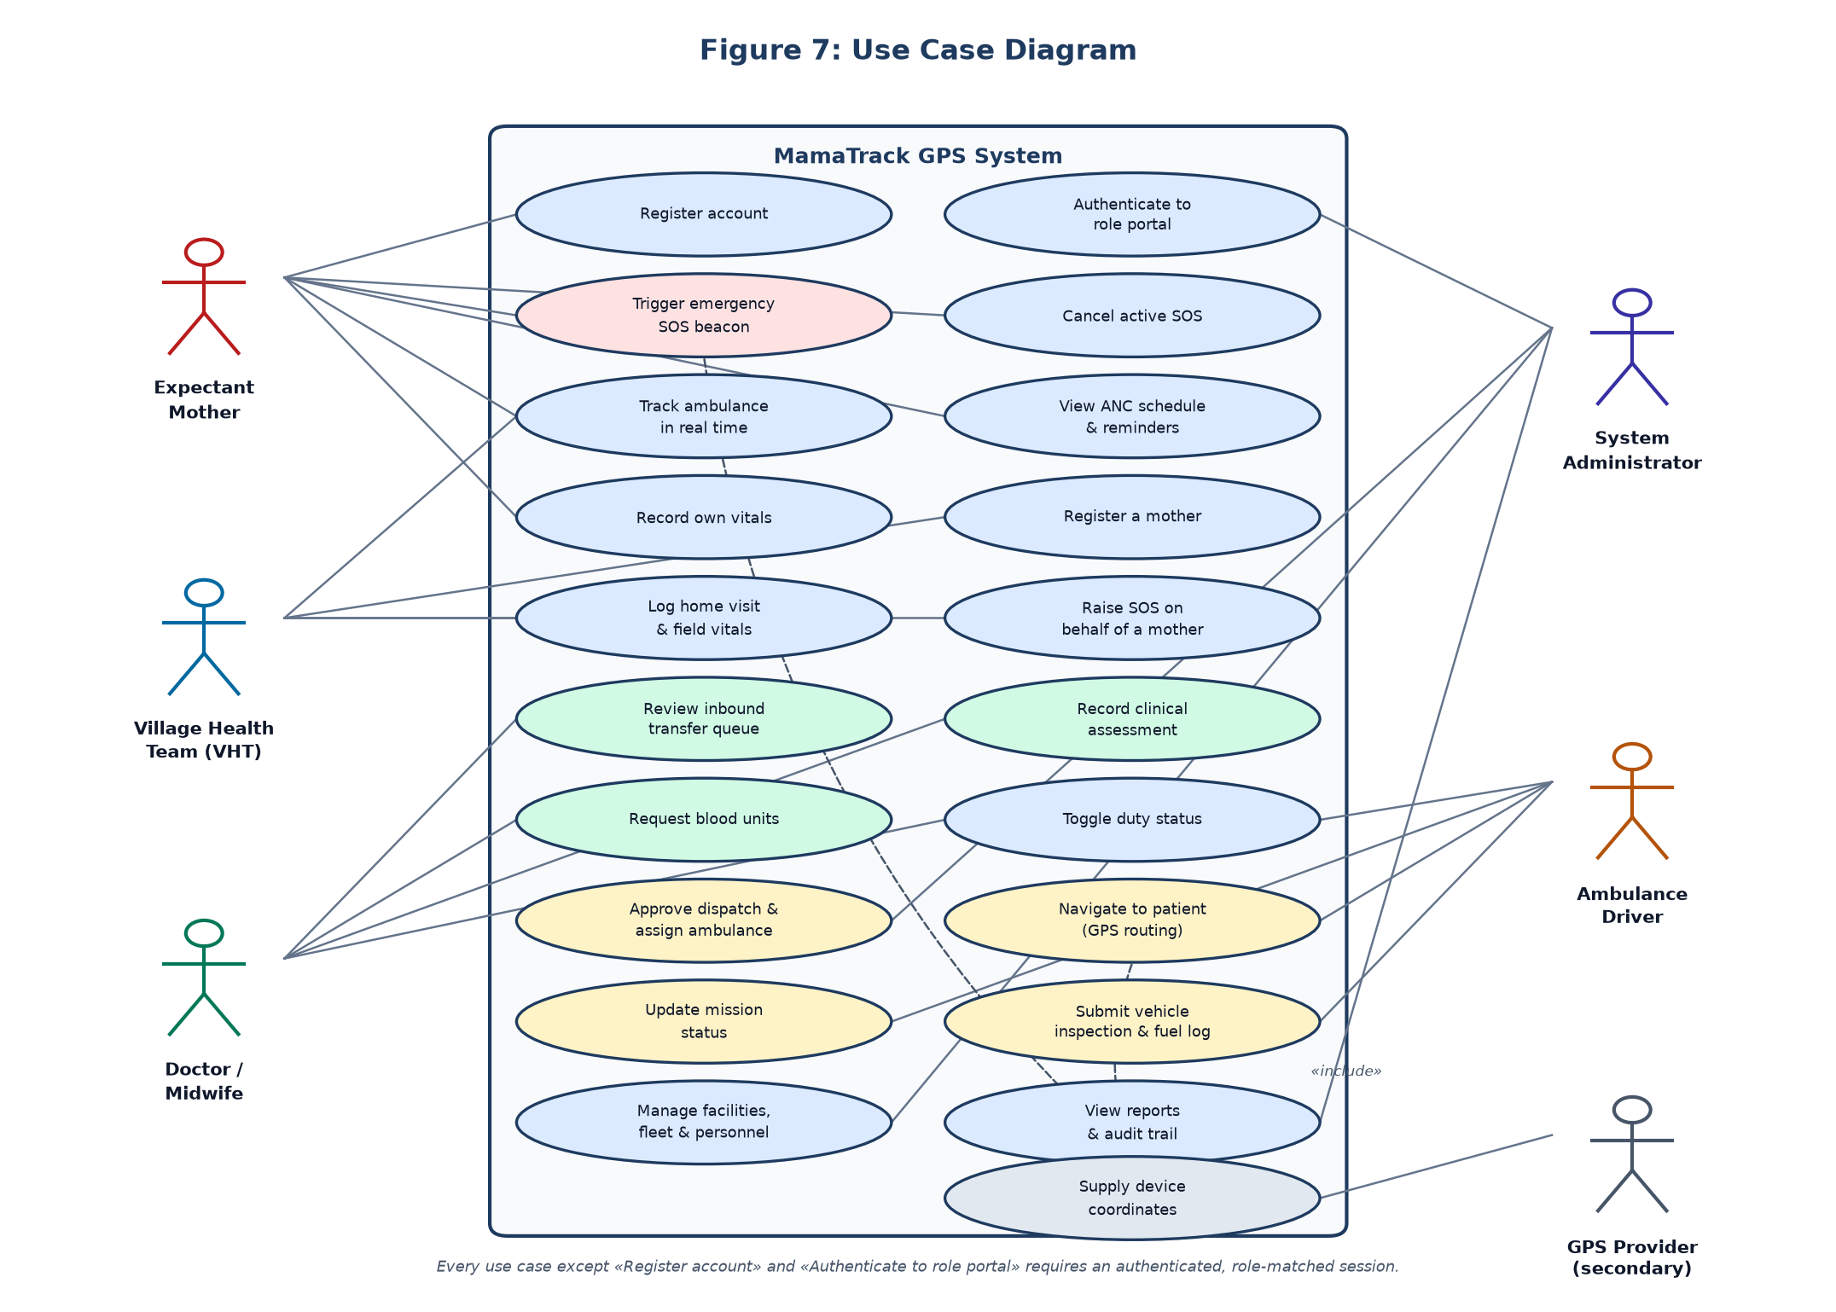
Figure 4.1: Use Case Diagram of the Proposed System

4.4 Chapter Summary
This chapter described the current manual referral system in Mukono District and evaluated it, establishing that its strengths are social while its weaknesses are informational — an asymmetry that determined the decision to augment rather than replace the existing pathway. It then set out fourteen functional requirements, eight non-functional requirements and the hardware and software environment for the new system, and presented the use case model derived from them. The design and implementation that realise these requirements are presented in Chapter Five.

CHAPTER FIVE: SYSTEM DESIGN, IMPLEMENTATION, TESTING AND VALIDATION

5.1 Introduction
This chapter presents the design of the system using Data Flow and Entity-Relationship diagrams, describes the database design, sets out how the system was implemented and on what platform, and reports the testing and validation carried out against the requirements established in Chapter Four.

5.2 System Design Using Data Flow Diagrams

5.2.1 Context Diagram
The context diagram in Figure 5.1 fixes the system boundary. It shows the system as a single process exchanging data with its five human actors and with three external services: the device geolocation provider that supplies coordinates, the OpenStreetMap tile service that supplies the basemap, and the Supabase cloud database that holds shared state. Every flow crossing this boundary is either a location, a clinical fact or a dispatch instruction.
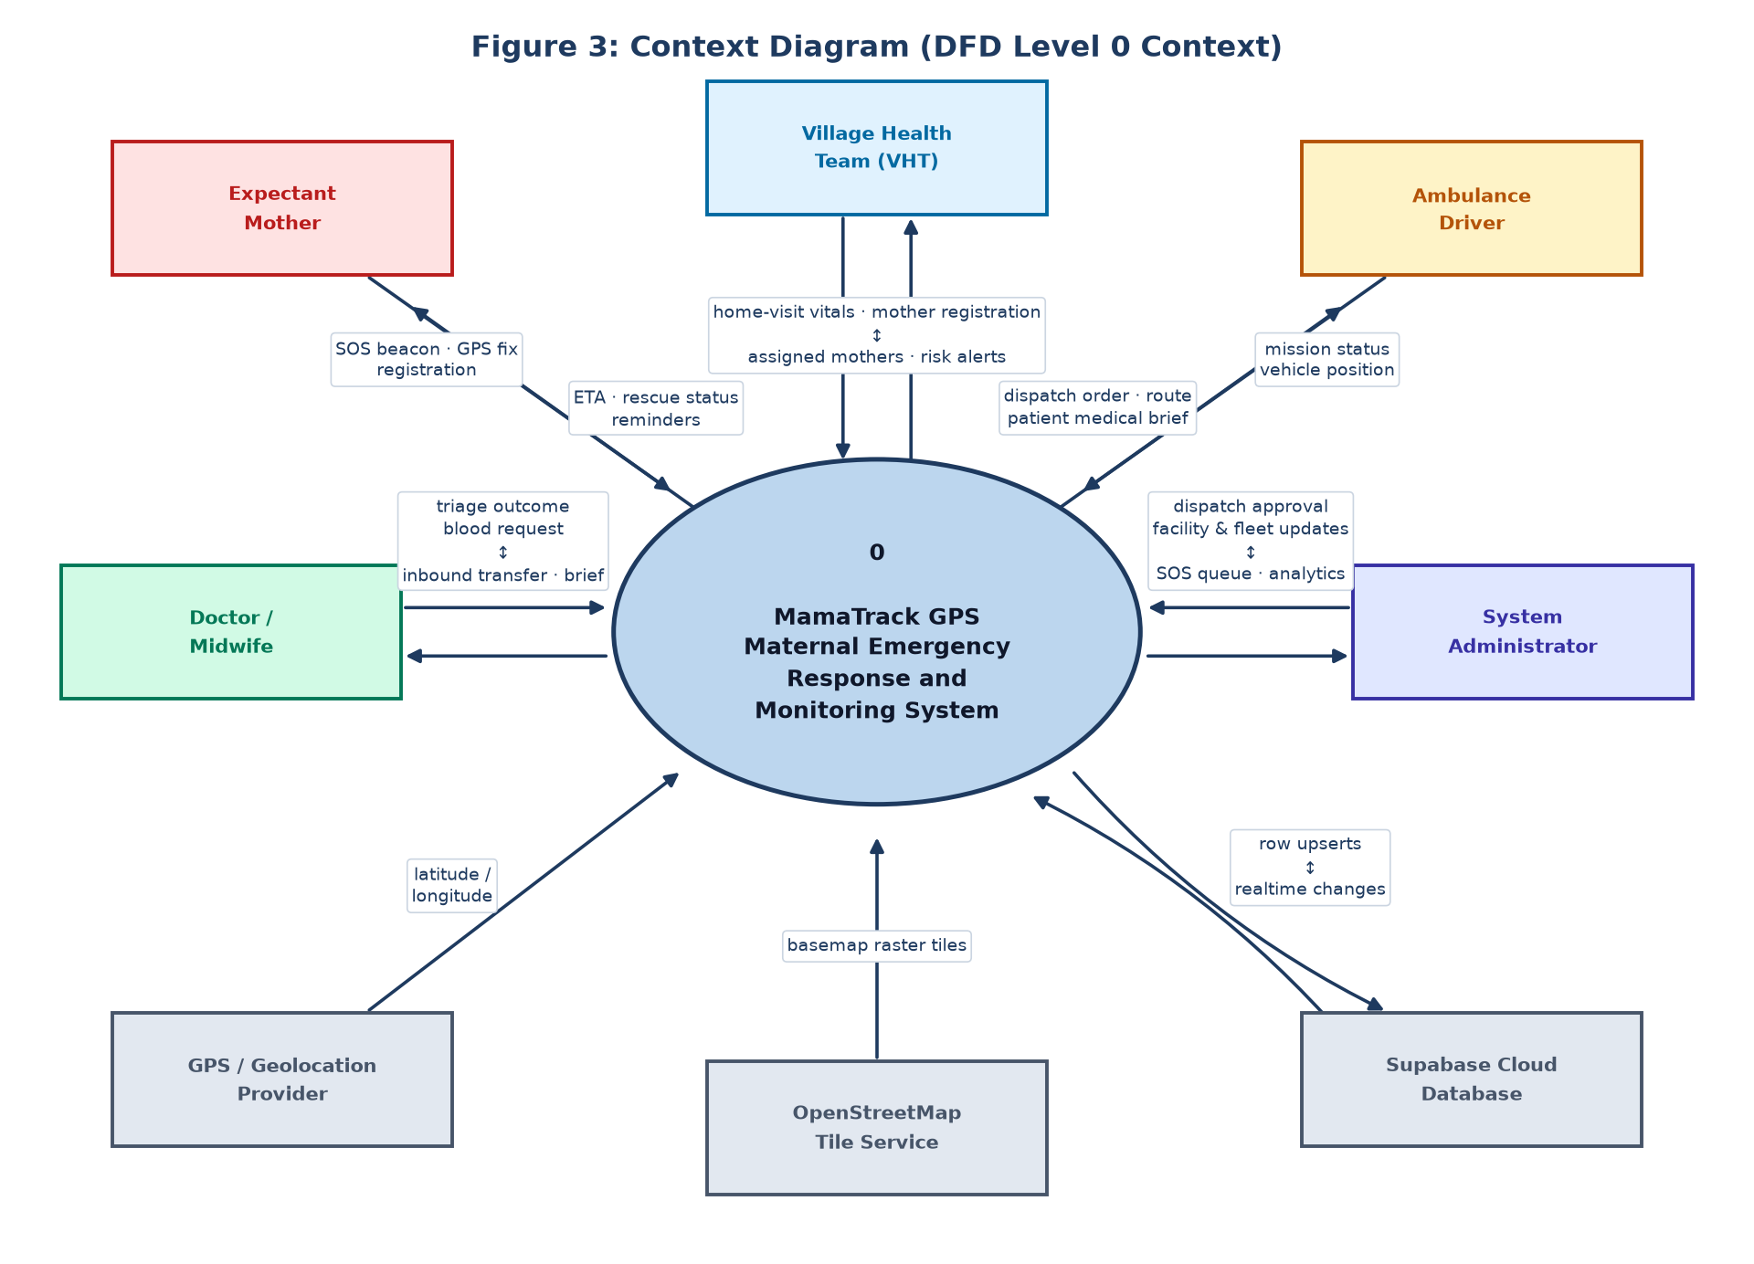
Figure 5.1: Context Diagram of the MamaTrack GPS System

5.2.2 Level 0 Diagram
The level 0 diagram in Figure 5.2 decomposes the single process into the five principal processes of the system — registration and profile management, emergency capture, dispatch coordination, monitoring and tracking, and reporting — and shows the data stores each reads from and writes to.
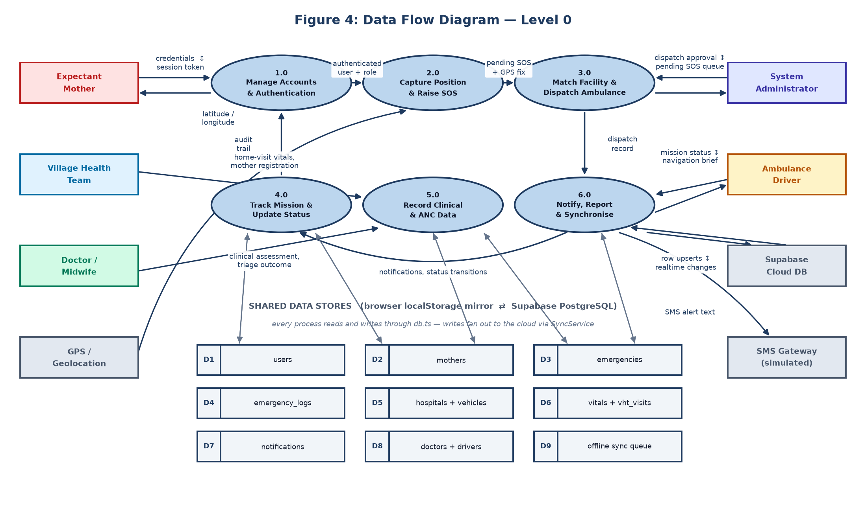
Figure 5.2: Data Flow Diagram, Level 0

5.2.3 Level 1 Diagram
The emergency dispatch process, which carries the central concern of the study, is decomposed further in Figure 5.3. It shows beacon capture, resolution of the nearest capable facility, ambulance and driver assignment, clinical notification and status tracking as distinct sub-processes, together with the stores each consults.
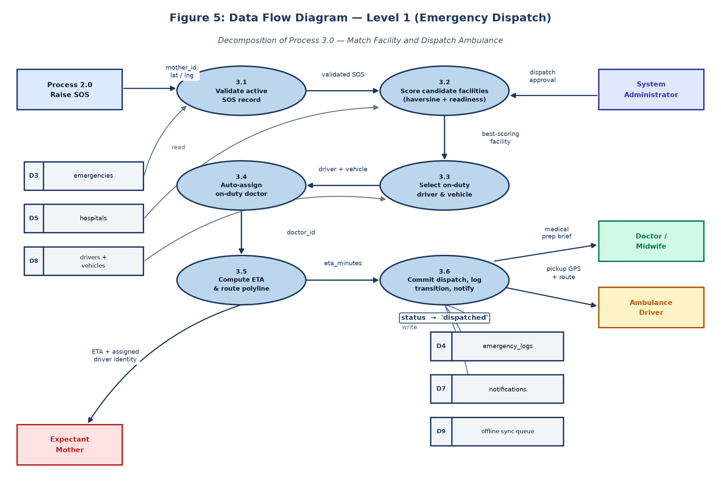
Figure 5.3: Data Flow Diagram, Level 1 — Emergency Dispatch

5.3 System Design Using Entity-Relationship Diagrams

5.3.1 Identified Entities and Their Attributes
Eleven entities were identified from the document review and requirements analysis. The users entity forms the identity spine of the model: mothers, doctors, drivers and Village Health Team members each extend it one-to-one with role-specific attributes rather than duplicating identity data. The emergencies entity is the central transaction record, referencing the mother, the facility, the vehicle, the driver and the receiving clinician, and carrying the coordinates and severity of the case.

5.3.2 Entity Diagram
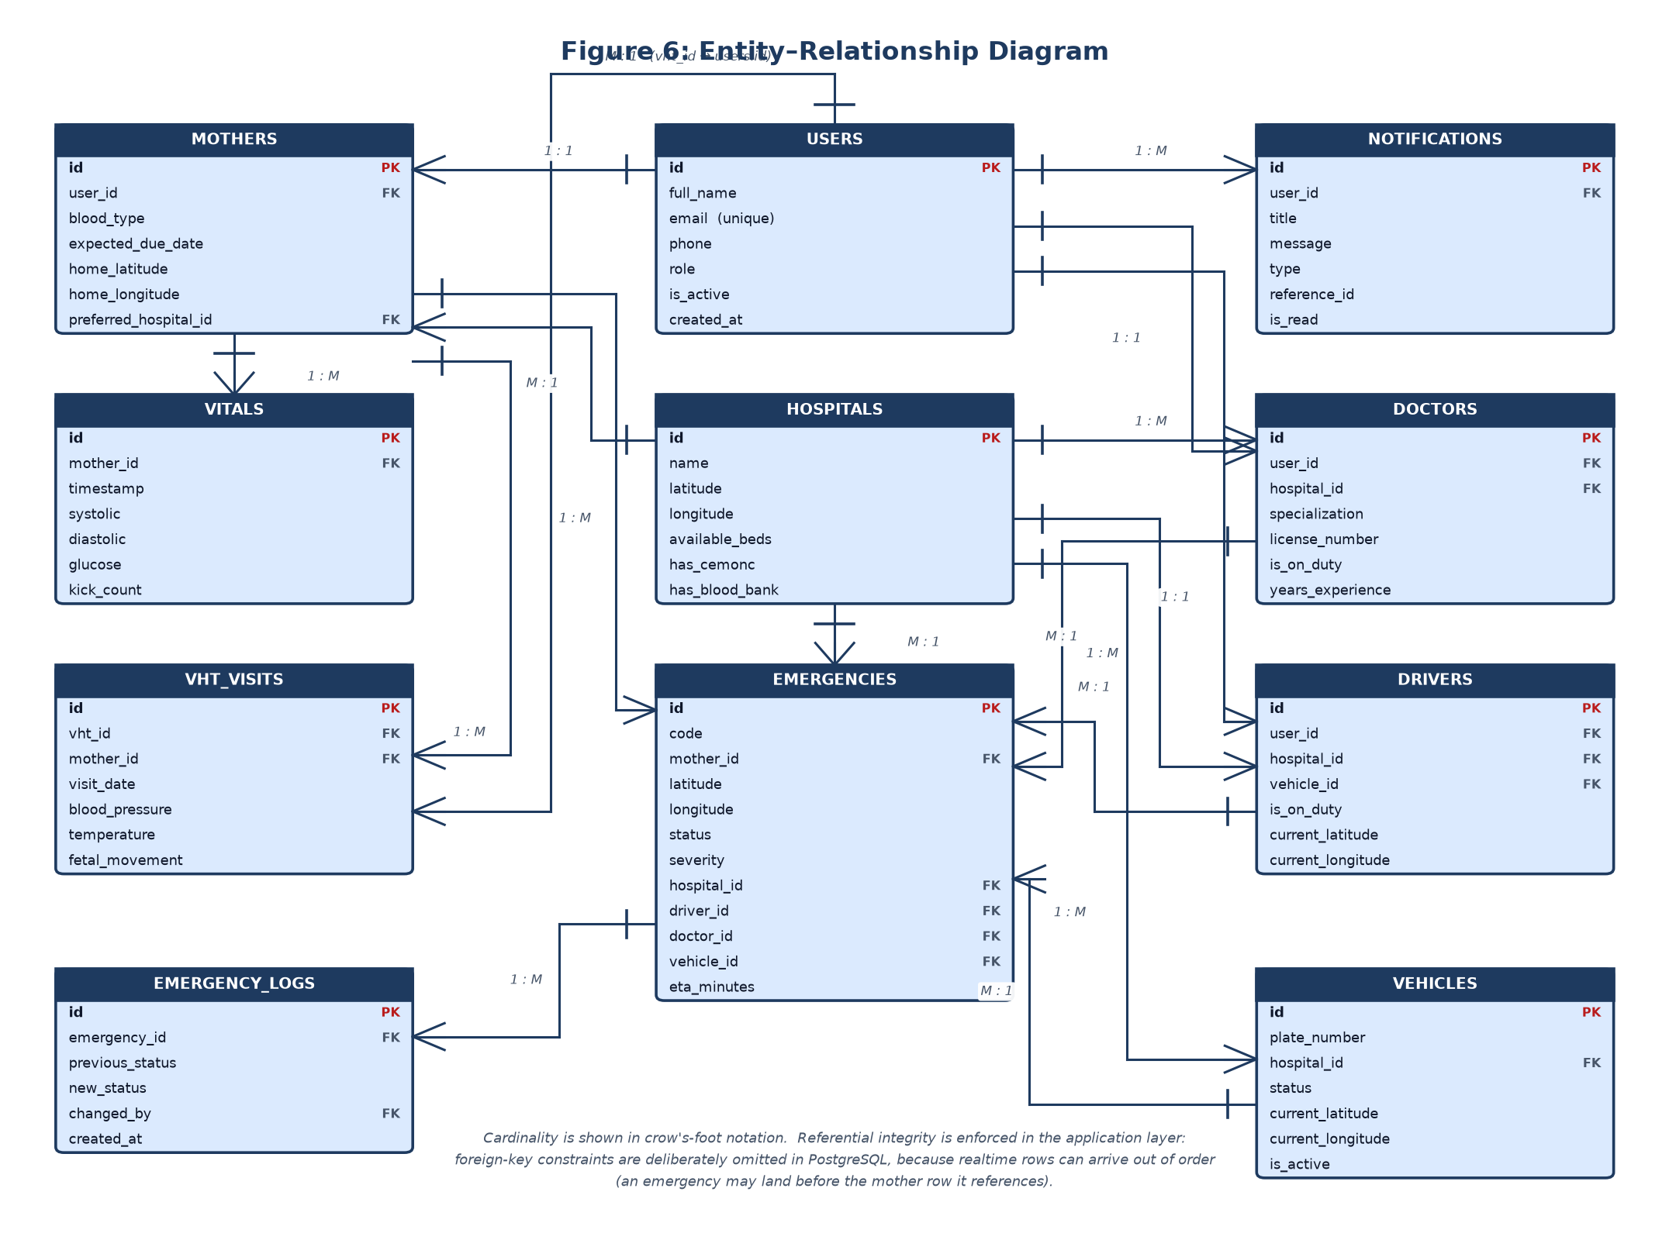
Figure 5.4: Entity-Relationship Diagram of the MamaTrack GPS Database
Note. Cardinality is shown in crow’s-foot notation. Referential integrity is enforced in the application layer rather than by database constraints, because replicated rows may arrive out of order — an emergency may reach a device before the mother record it references.

5.4 Database Design

5.4.1 Database Tables
Table 5.1: Database Tables and Their Relationships
Table | Holds | Key relationships
users | Identity, role, contact details, active state | Parent of all role tables
mothers | Obstetric history, home coordinates, next of kin | One-to-one with users
doctors | Specialisation, licence number, duty state | One-to-one with users; many-to-one with hospitals
drivers | Duty state, live vehicle position | One-to-one with users; many-to-one with vehicles
hospitals | Location, bed count, CEmONC and blood bank capability | Referenced by emergencies and vehicles
vehicles | Plate number, status, current coordinates | Many-to-one with hospitals
emergencies | Case code, coordinates, severity, assignments, ETA | Central transaction table
emergency_logs | Every status transition and the actor who caused it | Many-to-one with emergencies
vitals | Blood pressure, glucose, foetal kick counts | Many-to-one with mothers
vht_visits | Home visit findings and risk flags | Many-to-one with mothers and with the VHT user
notifications | Per-user alerts and their read state | Many-to-one with users

5.4.2 Data Descriptions
Table 5.2 gives the data description for the emergencies table, which is the central record of the system. The remaining table definitions follow the same pattern and are given in full in the schema listed in Appendix VI.
Table 5.2: Data Description of the Emergencies Table
Attribute | Type | Description
id | Integer | Primary key uniquely identifying the emergency case
code | Text | Human-readable case reference, for example EMG-2026-0031
mother_id | Integer | Foreign key to the user account of the mother in distress
latitude | Numeric | Latitude captured from the device at the moment the alert was raised
longitude | Numeric | Longitude captured from the device at the moment the alert was raised
status | Text | Current dispatch state: pending, dispatched, en-route, arrived, delivered, completed or cancelled
severity | Text | Triage severity assigned to the case
hospital_id | Integer | Foreign key to the facility resolved as the destination
driver_id | Integer | Foreign key to the driver assigned to the case
doctor_id | Integer | Foreign key to the clinician notified to receive the patient
vehicle_id | Integer | Foreign key to the ambulance assigned to the case
eta_minutes | Integer | Estimated time in minutes for the ambulance to reach the patient
created_at | Timestamp | Moment the alert was raised, used to measure response time

5.5 System Implementation
The system was implemented as a Progressive Web Application comprising five role-specific portals served from a single codebase over one shared data layer. It was built with React 18 and TypeScript 5.6, bundled with Vite 5.4, and routed with React Router 6. Mapping uses the Leaflet library with OpenStreetMap and CARTO raster tiles, rendered in a light or dark basemap according to the viewer’s theme. Shared persistence uses Supabase, a managed PostgreSQL service with realtime replication. The delivered source comprises approximately 18,000 lines across 25 TypeScript modules.
The architecture in Figure 5.5 shows how these parts relate. The decisive design choice is that the browser writes to a local store first and replicates to PostgreSQL second. Every portal reads from the local cache, so the interface remains responsive and usable when the network does not reach; a synchronisation service pushes each local change upward and applies each remote change downward. When connectivity is absent, changes accumulate in a queue and are replayed on reconnection, satisfying NFR1 and NFR6.
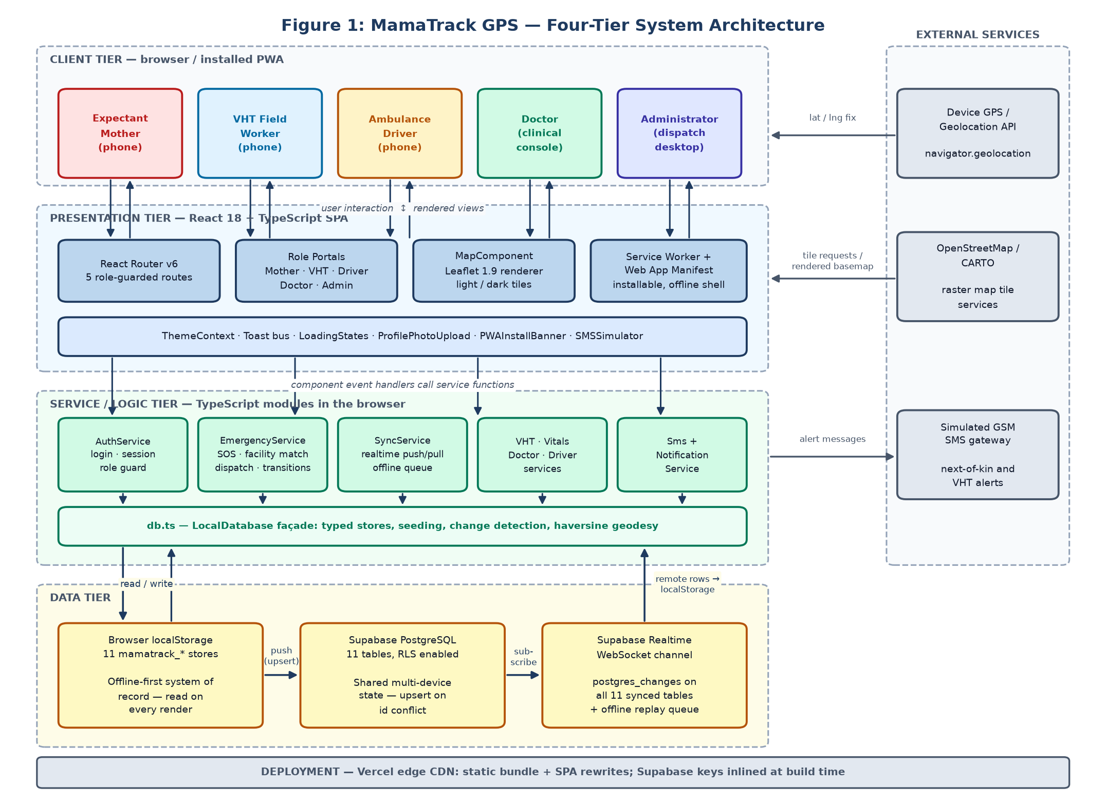
Figure 5.5: System Architecture of the MamaTrack GPS System
The internal organisation of the codebase is shown in Figure 5.6, which groups the modules into portals, shared components and services, and shows which depend on the database and synchronisation layer. Each portal is compiled into its own bundle so that a mother on a limited data plan downloads her own interface and not the administrator’s, which is by a wide margin the largest.
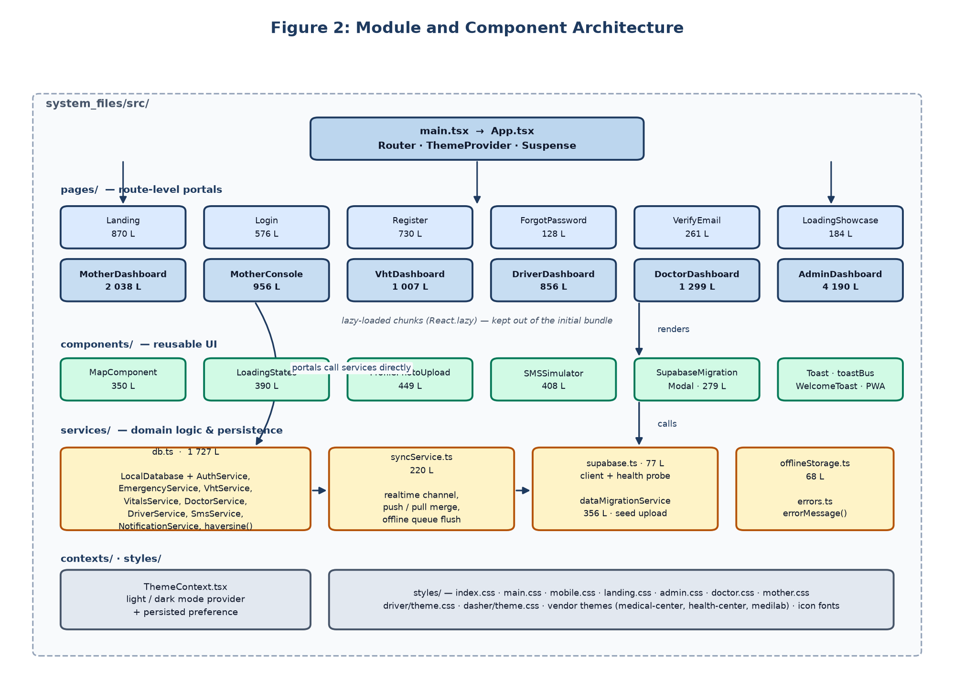
Figure 5.6: Module Architecture of the Application
The lifecycle of an emergency case is governed by the state machine in Figure 5.7. Constraining the case to defined states and transitions is what allows five portals to act on the same record without conflicting: a driver may move a case from dispatched to en-route but cannot complete it, and cancellation is permitted only before pickup.
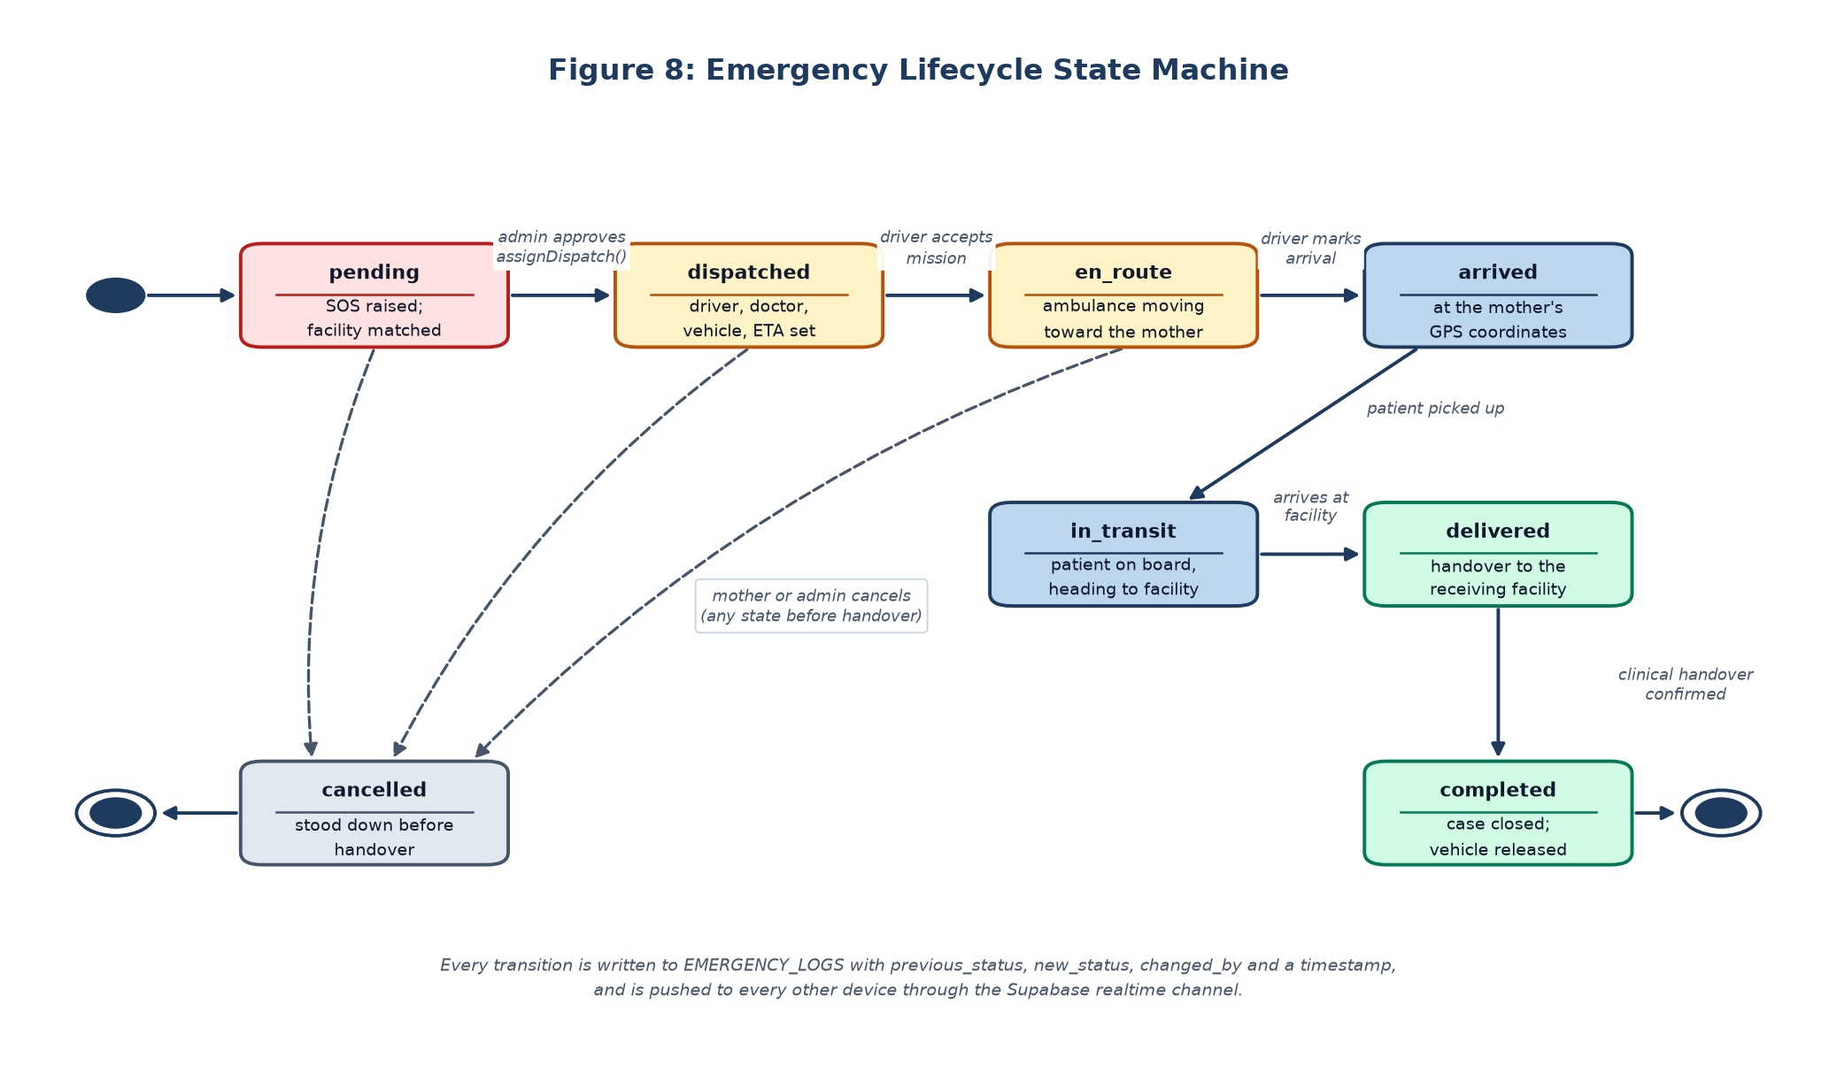
Figure 5.7: Emergency Case State Machine
Figure 5.8 shows the ordered exchange that occurs during a dispatch, from the mother pressing the alert through position capture, facility resolution, driver assignment and clinical notification. This is the pathway validated end to end in Section 5.6.
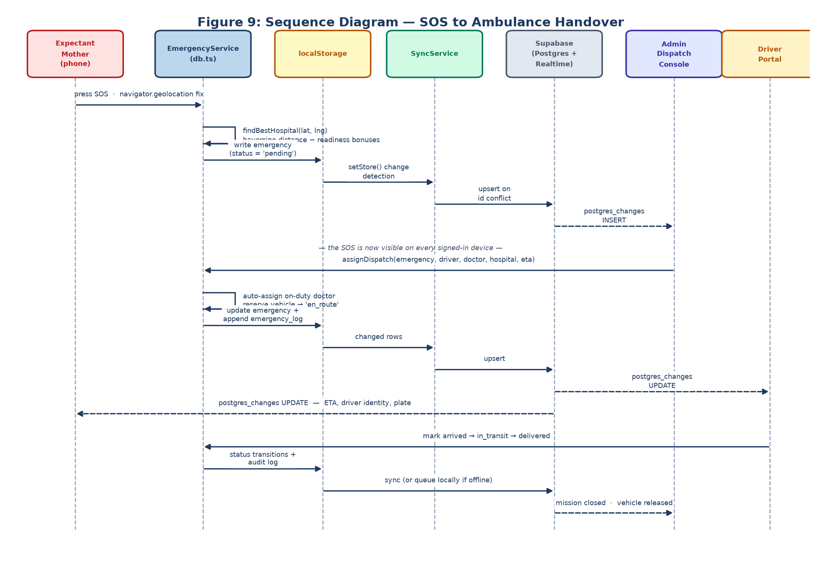
Figure 5.8: Sequence Diagram — Emergency Dispatch
Figure 5.9 shows the synchronisation mechanism that supports operation under intermittent connectivity: how local writes are queued when the network drops, how they are replayed on reconnection, and how remote rows are merged into the local cache without being echoed back to the server.
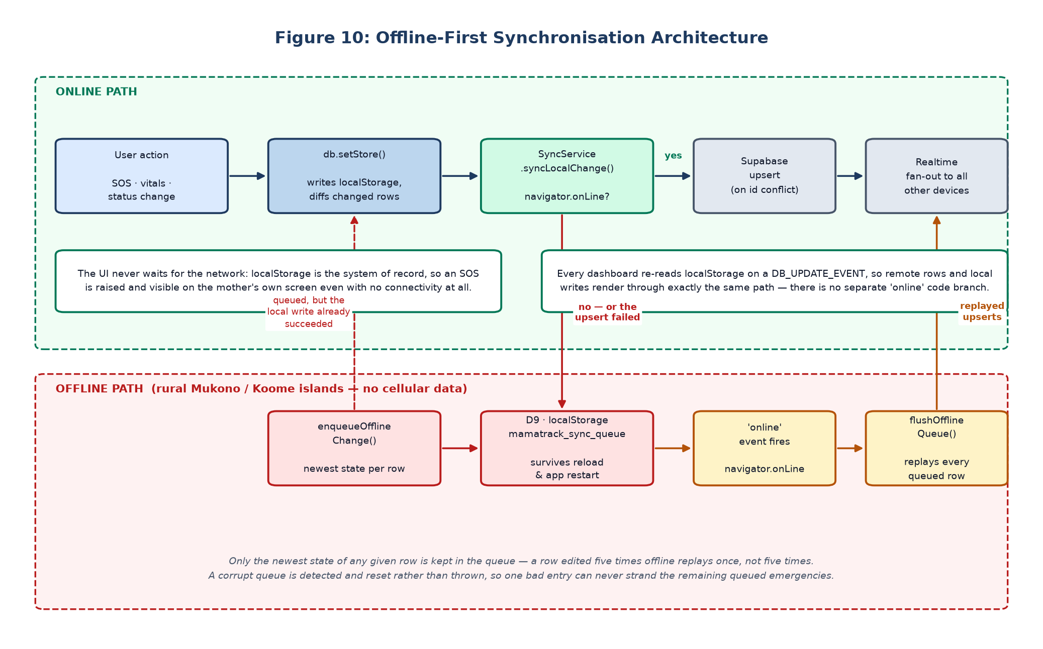
Figure 5.9: Offline Synchronisation Mechanism

5.5.1 System Graphical User Interfaces
The interfaces below show the principal screens of the delivered system. The landing page presents the five portal entry points; the login screen authenticates a user into the portal matching their role; the mother’s console presents the emergency beacon and her live tracking map; the district command console presents the triage queue and fleet monitor; and the ambulance navigation panel presents the assigned case, route and patient brief.
[ Insert screen capture: System Landing Page ]
Figure 5.10: System Landing Page
[ Insert screen capture: Portal Login Screen ]
Figure 5.11: Portal Login Screen
[ Insert screen capture: Expectant Mother Portal — Emergency Beacon and Live Tracking ]
Figure 5.12: Expectant Mother Portal — Emergency Beacon and Live Tracking
[ Insert screen capture: District Command Console — Triage Queue and Fleet Monitor ]
Figure 5.13: District Command Console — Triage Queue and Fleet Monitor
[ Insert screen capture: Ambulance Navigation Panel ]
Figure 5.14: Ambulance Navigation Panel

5.5.2 Sample Code
The extract below is the core of the emergency capture path. It illustrates the offline-first stance of the system: the case is written locally and broadcast immediately, and replication to PostgreSQL is a consequence of that write rather than a precondition for it, so an alert can be raised whether or not the network is reachable. Further extracts are given in Appendix VI.
// Raise an emergency for a mother and resolve her destination and responder.
triggerEmergency(motherUserId: number, latitude: number, longitude: number) {
const mother = db.mothers.find(m => m.user_id === motherUserId);
const hospital = this.findNearestCapableHospital(latitude, longitude);
const vehicle = this.findAvailableVehicle(hospital.id);

const emergency: Emergency = {
id: nextId(db.emergencies),
code: `EMG-${new Date().getFullYear()}-${sequence()}`,
mother_id: motherUserId,
latitude, longitude,
status: 'pending',
severity: this.assessSeverity(mother),
hospital_id: hospital.id,
vehicle_id: vehicle ? vehicle.id : null,
driver_id: vehicle ? this.driverFor(vehicle.id) : null,
doctor_id: this.onDutyObstetrician(hospital.id),
eta_minutes: this.estimateEta(vehicle, latitude, longitude),
created_at: new Date().toISOString(),
};

// Written locally first; SyncService replicates upward and queues if offline.
db.emergencies = [...db.emergencies, emergency];

this.notifyResponders(emergency);
SmsService.sendSms(mother.next_of_kin_name, mother.next_of_kin_phone,
`MamaTrack ALERT: ${mother.name} has triggered an emergency beacon.`);

return emergency;
}

5.6 System Testing and Validation

5.6.1 System Testing
Testing proceeded at the four levels described in Section 3.9.2. Static verification of the delivered source returned no compiler errors across all 25 modules and no warnings from static analysis. The production build completed successfully, emitting eleven bundles with an entry bundle of 388 kB, 97 kB when compressed. All five portals were then loaded and exercised in a browser: each rendered with live data and a working map, all 120 asset requests succeeded, and no uncaught errors were produced.
Testing identified five defects, all of which were corrected and re-verified. The most serious concerned the realtime subscription: when the synchronisation service initialised against a cached channel that had already been subscribed, registering change handlers raised an error that was not caught and terminated the entire interface. Because the alert function is the reason the system exists, the correction both removed the fault and ensured that any future failure of the realtime channel degrades the system to queued synchronisation rather than interrupting service. Two further defects concerned the loss of data captured offline — an unguarded parse of the synchronisation queue that would strand every pending change, and an unguarded parse of the offline emergency cache that could discard a queued alert. A fourth concerned diagnostic messages that reported success on failure paths, and a fifth comprised 52 static analysis warnings, since resolved.
Table 5.3: Summary of System Test Results
Test | Method | Expected result | Outcome
Type correctness | TypeScript compiler over all modules | No errors | Passed — 0 errors
Code quality | Static analysis over all modules | No warnings | Passed — 0 warnings
Production build | Bundler build to distributable output | Build completes | Passed — 11 bundles
Asset delivery | Network trace of a full page load | No failed requests | Passed — 120 of 120
Portal rendering | Load each of the five portals | Renders with live data | Passed — all five
Alert capture | Raise an alert from the mother portal | Case created with coordinates | Passed
Facility resolution | Observe destination assigned | Nearest capable facility chosen | Passed
Responder assignment | Observe vehicle and driver assigned | Available ambulance assigned | Passed
Cross-device visibility | Observe case from a separate session | Case visible without shared state | Passed
State progression | Follow the case through its lifecycle | States advance in defined order | Passed

5.6.2 System Validation
Validation addressed the question of whether the system solves the problem stated in Chapter One. A simulated emergency scenario was executed: an alert was raised from the expectant mother portal, and the district command console was then opened in a physically separate browser session holding no local data from the first, and signed in as an administrator.
The case was already present. It appeared as reference EMG-2026-0031 for patient Nakato Fatima, with Mukono General Hospital resolved as the destination facility, driver Moses Kiggundu assigned in ambulance UBG 001A, the case advanced automatically through its dispatch states, and the alert plotted on the district map alongside eight facilities and five ambulances. Because the second session began with no shared local state, the case can only have reached it through the replication layer.
This single scenario validates the chain the study set out to build. The mother’s position was captured from her device rather than described; the destination was resolved from facility capability rather than by telephoning each in turn; the responder was assigned automatically; and the case became visible to an actor on another device within seconds. Measured against the second delay identified in Chapter One, the search phase that respondents reported as taking up to an hour is replaced by a coordinate available before the ambulance departs.

5.7 Chapter Summary
This chapter presented the design of the system through context, level 0 and level 1 Data Flow Diagrams and an Entity-Relationship Diagram; described the eleven-table database design and the data description of the central emergencies table; set out the implementation as an offline-first Progressive Web Application with its architecture, module organisation, state machine and dispatch sequence; and reported the testing and validation carried out. Testing returned a clean compilation, a clean static analysis and a successful build, and identified five defects that were corrected. Validation confirmed that an emergency raised on one device becomes visible, with position and assigned responder, on a separate device — the outcome the study set out to achieve.

CHAPTER SIX: DISCUSSION, RECOMMENDATIONS AND CONCLUSION

6.1 Introduction
This chapter discusses the findings of the study in relation to its objectives, presents the recommendations arising from the work, states the limitations encountered, identifies areas for further research, and concludes.

6.2 Discussion
The first objective was to study and analyse the current maternal emergency response and referral workflow. The analysis in Chapter Four established a finding that shaped everything that followed: the weaknesses of the current pathway are informational while its strengths are social. Village Health Teams hold community trust, operators improvise skilfully, and paper cards work without power. None of these is something software supplies, and a system that displaced them would have removed the working parts of the pathway along with the broken ones. The decision to augment rather than replace follows directly from the analysis rather than from preference.
The second objective was to determine and specify the requirements for a system suited to the terrain of Mukono District. The terrain requirement proved to be a connectivity requirement. Because the areas with the longest transit times are also those with the weakest coverage, a system that required the network in order to raise an alert would have failed precisely where it was most needed. This produced NFR1 and the offline-first architecture described in Section 5.5, in which the local write is the alert and replication is a consequence of it.
The third objective was to design a system comprising a mobile interface for mothers and a centralised dashboard for administrators. The delivered system exceeds this, providing five portals rather than two, because the analysis showed that the information loss occurs at handovers, and the handovers involve Village Health Teams, drivers and clinicians as well as mothers and administrators. Placing the driver and the receiving clinician inside the same record removes two of the points at which location and clinical history previously degraded.
The fourth objective was to implement, test and validate the system through simulated emergency scenarios. The validation reported in Section 5.6.2 confirms the central claim: a case raised on one device reached a separate device carrying an accurate position, a resolved destination and an assigned responder. The finding most worth recording, however, emerged from testing rather than from validation. The most serious defect was not a compilation failure — compilation was already clean — but a realtime subscription fault capable of terminating the entire interface during startup. It was invisible to static analysis and appeared only when the running system was exercised. This supports a methodological point relevant beyond this project: for systems whose value lies in behaviour under adverse conditions, a green build is not evidence of correctness.
These findings are consistent with the literature reviewed in Chapter Two. The observation that geospatial coordination rather than communication is the binding constraint accords with the pilot evidence from Tanzania, Nigeria and Kenya. The study extends that evidence in one respect: where those pilots demonstrated that GPS integration reduces response times, this work shows that the integration must be designed to survive the absence of the network, or it will be unavailable in the settings that motivate it.

6.3 Recommendations
- The district should adopt the system in a supervised pilot covering Mukono General Hospital and its immediately surrounding health centres before wider rollout, so that the dispatch workflow can be observed under real load before the island communities, which are the hardest case, are brought in.
- The permissive database access policy used during development should be replaced with role-scoped policies bound to authenticated identity before any real patient record is entered. In its current demonstration configuration every table is readable and writable by any client, which is acceptable for seeded fictional data and unacceptable for clinical data.
- User accounts should be migrated into the managed identity provider so that credentials are verified centrally rather than compared on the device, and so that password recovery and account revocation become possible.
- Village Health Teams should be equipped with devices and trained as the field entry point for mother registration and vitals capture. Their coverage determines how much of the district the system can see, and a mother who is not registered cannot be located.
- An error boundary should be added around the routed portals so that an unexpected failure in one view degrades to a recoverable message rather than a blank screen, which matters more in a field emergency than in an office setting.
- The Ministry of Health and the district health office should use the accumulated emergency records to identify where response times concentrate, and should site additional ambulances and clinics accordingly. This capability is a by-product of the system and requires no additional development.

6.4 Limitations of the Study
- Validation was carried out through simulated emergency scenarios rather than live obstetric emergencies. Simulation can establish that the information pathway works; it cannot establish how the system behaves when used by a frightened woman in labour, and no claim about clinical outcomes is made on the basis of it.
- The system was tested over the connectivity available during the study period and not across the full range of conditions in the district, particularly on Lake Victoria, where coverage is most intermittent.
- Position accuracy depends on the device geolocation provider and degrades where satellite visibility is poor. The system reports its accuracy but cannot improve on the receiver in the handset.
- The study period of ten weeks permitted development and validation but not longitudinal measurement of response times before and after deployment, which is the measure that would ultimately settle the system’s effectiveness.
- SMS notification to next of kin was implemented against a simulated gateway rather than a live aggregator, since no commercial gateway agreement was available within the study period.

6.5 Areas for Further Research
- A longitudinal study measuring response times in Mukono District before and after deployment would establish the effect on the second delay empirically rather than by inference from the mechanism.
- The synchronisation of spatial data over USSD and SMS bearers, for use where data connectivity is absent entirely, remains open and would extend the system’s reach into the island communities.
- The integration of wearable physiological sensors to raise an alert automatically on detection of deterioration, rather than depending on the mother to act, would address cases in which she is unable to.
- Predictive analysis over accumulated emergency and vitals records could support the identification of high-risk pregnancies before a crisis rather than during one.
- The adaptation of the same architecture to other time-critical emergencies, such as road traffic injury or epidemic case reporting, would test the generality of the offline-first, location-aware pattern developed here.

6.6 Conclusion
This study set out to eliminate spatial invisibility in maternal emergency response in Mukono District by making a mother’s position visible to responders before she arrives at a facility. It analysed the existing referral pathway, specified the requirements of a system to augment it, designed that system using Data Flow, Entity-Relationship and UML models, implemented it as an offline-first Progressive Web Application serving five role-specific portals over a shared replicated database, and validated it through simulated emergency scenarios.
The system works. An alert raised on a mother’s device reaches a district command console on a separate device carrying an accurate position, a destination facility resolved from real capability, and an assigned ambulance and driver, and the receiving clinician is briefed before the patient arrives. The search phase that respondents described as consuming up to an hour is replaced by a coordinate available before the vehicle departs. Measured against the second delay identified in Chapter One, that is the substantive result of the work.
What remains is not primarily technical. The system’s access control is configured for demonstration and must be tightened before it holds a real patient record, and its coverage depends on Village Health Teams registering the mothers in their areas. Neither is a research problem. The research question — whether a location-aware emergency system can be built that remains usable in the conditions that make it necessary — has been answered in the affirmative, and the answer is that it can, provided the design treats the absence of the network as the normal case rather than the exception.

REFERENCES
Faujdar, D.S. & Kumar, R. (2020). Geospatial Technology for Maternal Health Services: A Review of Applications in Low and Middle Income Countries. Journal of Family Medicine and Primary Care, 9(6), 2637–2643.
Gabrysch, S. & Campbell, O.M.R. (2009). Still Too Far to Walk: Literature Review of the Determinants of Delivery Service Use. BMC Pregnancy and Childbirth, 9(34), 1–18.
Lee, A.C., Lawn, J.E., Cousens, S. & Darmstadt, G.L. (2009). Linking Families and Facilities for Care at Birth: What Works to Avert Intrapartum-Related Deaths? International Journal of Gynecology and Obstetrics, 107, 65–88.
Ministry of Health Uganda. (2021). Annual Health Sector Performance Report 2020/21. Kampala: Ministry of Health.
National Planning Authority. (2020). Third National Development Plan (NDP III) 2020/21 – 2024/25. Kampala: National Planning Authority.
Nyamtema, A.S., Urassa, D.P. & van Roosmalen, J. (2011). Maternal Health Interventions in Resource Limited Countries: A Systematic Review of Packages, Impacts and Factors for Change. BMC Pregnancy and Childbirth, 11(30), 1–12.
Schmitz, M.M., Serbanescu, F., Kamara, V. & Kraft, J.M. (2019). Did Saving Mothers, Giving Life Expand Timely Access to Lifesaving Care in Uganda? Global Health: Science and Practice, 7(1), 146–160.
Thaddeus, S. & Maine, D. (1994). Too Far to Walk: Maternal Mortality in Context. Social Science and Medicine, 38(8), 1091–1110.
Uganda Bureau of Statistics. (2022). Uganda Demographic and Health Survey 2022. Kampala: Uganda Bureau of Statistics.
UNICEF. (2019). mTrac: Strengthening Health Systems Through Mobile Technology in Uganda. Kampala: United Nations Children’s Fund.
World Health Organization. (2016). WHO Recommendations on Antenatal Care for a Positive Pregnancy Experience. Geneva: World Health Organization.
World Health Organization. (2023). Trends in Maternal Mortality 2000 to 2020. Geneva: World Health Organization.

APPENDICES

Appendix I: Introductory and Permission Letter
A letter of introduction from the Department of Computer Science, School of Computing and Information Science, Kyambogo University, requesting permission to conduct the study at Mukono General Hospital and its surrounding health centres, together with the written approval granted by the District Health Office.

Appendix II: Questionnaire
The structured questionnaire administered to expectant mothers and Village Health Team members, covering device ownership, network availability at the respondent’s home, the means currently used to summon help during an obstetric emergency, and the time typically taken for assistance to arrive.

Appendix III: Interview Schedule
The semi-structured interview schedule used with midwives, obstetricians, ambulance drivers and district health administrators, covering the current dispatch procedure, the points at which location information is lost, and specific incidents in which locating a patient failed.

Appendix IV: Budget
Table A1: Research Budget
Item | Description | Amount (UGX)
Transport | Field visits to Mukono General Hospital, Nama and Koome | 450,000
Communication | Airtime and data during requirements collection and testing | 180,000
Stationery | Printing of instruments, binding of the report | 220,000
Cloud services | Database and hosting during development and validation | 300,000
Contingency | Unforeseen expenditure at ten per cent | 115,000
Total |  | 1,265,000

Appendix V: Time Schedule
Table A2: Research Time Schedule
Phase | Activity | Weeks
Research and requirements | Literature review, requirements gathering, architecture | 1 – 3
System development | Database design, portal implementation, GPS and map integration | 4 – 7
Validation and documentation | Testing, simulated scenario validation, report writing | 8 – 10

Appendix VI: Sample Code
The database schema listing and further extracts from the emergency dispatch, synchronisation and geolocation modules of the delivered system.

