Ocean University of China

Final Project Report for Human Computer Interaction

Group Number：01

Student ID and Name：

Tyrone Zeka BK2018024

Praise Mlambo BK2018024

Instructor: Xie Cui

Date of Submission: mm / DD / 2021

# Requirement Analysis

**System Requirements**

This system runs on web browsers and have been tested on Microsoft Edge , Opera and Chrome. The also needs to be an internet connection for some of the files that happen to be online. Adding on to that there must be a local server running to serve the files so as to enable the system to run properly.

**Task Abstraction**

**Who will be interested in using the visualization?**

The people who will be most interested in this visualization are as follows:

~ Travellers - (people who take trips regularly to different parts of the world)

~ Government officials (people who are in charge of the administration in particular regions)

~ Business people (individuals with investments in different parts of the world)

~ Covid researchers (intellectuals conducting studies on Covid)

**What potential domain tasks could be interesting for different user types?**

**Travellers - Main task**

They want to know when it is safe to travel.

**sub -tasks:**

~ they look for places with less number of cases as they are more likely to have less travel restrictions (locating outliers)

~ they also look for places higher recovery numbers for the reason mentioned above (by comparing trends)

**Government - Main task**

They want to see the change in covid cases in their country compared with other country.

**sub - tasks:**

~ they want to see the daily changes in the cases to see what kind of measures to implement (discover distribution).

~ they want to see rate of recovery to test measure effectiveness of different countries (by analyzing the data).

**Business people - Main Task**

To avoid making investments in high risk countries.

**Sub - tasks**

~ they search the data for places with less numbmer of cases (locating outliers).

~ they also look for places higher recovery numbers (by comparing trends).

# Project Introduction

**Project Goals**

In this project we aimed to represent the covid 19 information in a estatically pleasing way that can convey the information well for the users to be able to understand the current situation in different regions and as such help them make their descisions much more effectively.

**System Architecture**

This system was primarily built on d3js and html. In terms of styling we used css for the styles for make the display more ordely and easier to understand.

We built the system with the intention that I be used as a web application on the browser.

**Datasets used:**

<https://coronavirus-tracker-api.herokuapp.com/all>

https://www.kaggle.com/imdevskp/corona-virus-report

**Data abstraction**

Data type - Table

Number of fields/ attributes- 10

Number of items - 187 items

~**Analyze each field**

**Country**

~ attribute type => Categorical

~ cardinality/range => unique (187 values)

**Confirmed**

~ attribute type => Quantitative

~ cardinality/range => min() & max()

**Deaths**

~ attribute type => Quantitative

~ cardinality/range => min() & max()

**Recovered**

~ attribute type => Quantitative

~ cardinality/range => min() & max()

**New cases**

~ attribute type => Quantitative

~ cardinality/range => min() & max()

**New deaths**

~ attribute type => Quantitative

~ cardinality/range => min() & max()

**New recovery**

~ attribute type => Quantitative

~ cardinality/range => min() & max()

**Death per 100 cases**

~ attribute type => Quantitative

~ cardinality/range => 0 - 100

**Recovery per 100 cases**

~ attribute type => Quantitative

~ cardinality/range => 0 - 100

**WHO region**

~ attribute type => categorical

~ cardinality/range => unique (6 unique values)

# Instruction on how to use the system

1. How to use the Covid-19 World Map (Cases):

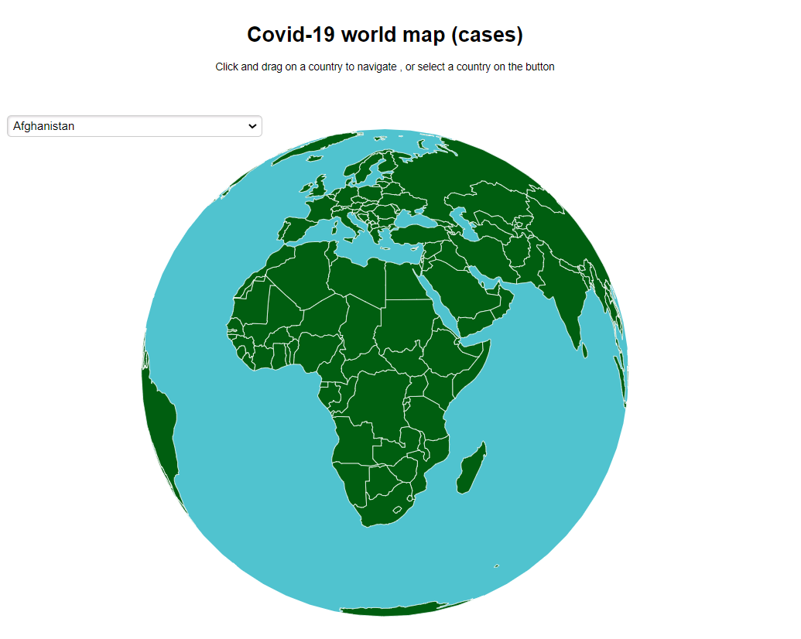

~To use this part, its quite intuitive

~There is a drop down menu to choose which country you’d like to view. Click the country name and the map will rotate to your currently selected country, Hover the mouse over the country to view the country’s details.

~A user can also click and hold down the mouse on any of the green parts (countries) and they can rotate the entire map to choose which country/region they want to view. When they find it, they can again just hover over it and the respective details about that region will be displayed on a Toolbox that’ll appear.

1. How to use the radial bar plot:

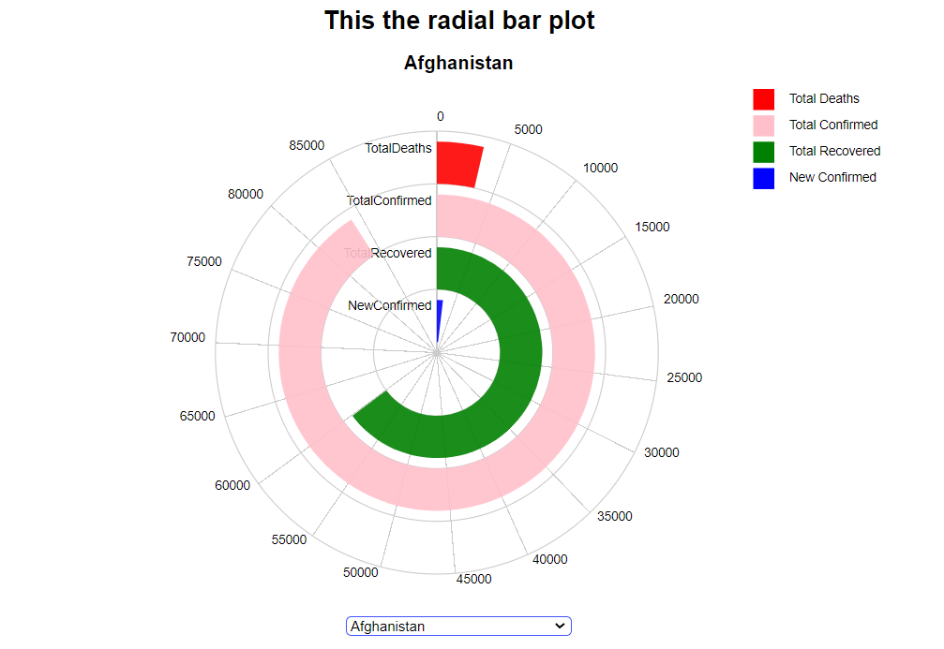

~For the radial bar plot , the different bars in the plot stand for different types of data. Each is differentiated by the differences in color:

-RED = The number of total deaths in selected country.

-PINK = The number of the total confirmed cases in selected country.

-GREEN = The number of the total recoveries in selected country.

-BLUE = Newly confirmed cases in selected country.

~To choose a country to display information about, the user just needs select the country name from the drop down menu available below the graph.

~Choosing another country is also similar this way, the graph will update itself and show the new information for the newly selected country.

1. How to use the circular bar plot:

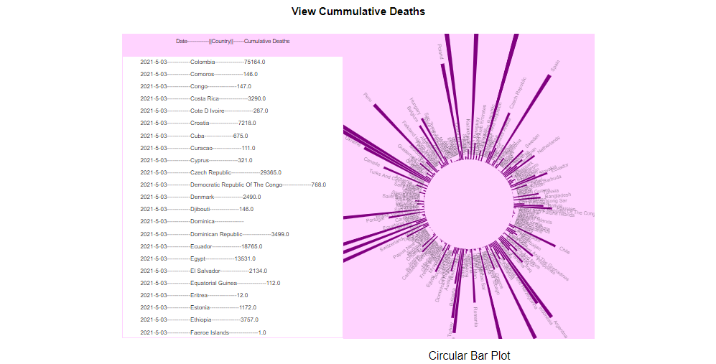

~The circular shows the cumulative deaths for different countries as the date changes.

~This graph changes on its own when the page first loads it is initialized and it starts changing.

~We can use it to see some random trends or patterns in the cumulative deaths.

~When a user hovers over the list of dates, country and cumulative deaths, the list stops moving and the user can look / read the data on the list in detail if they wanted to.

# System Introduction

~The system consists of one interface screen where the users can get all the information they need. The system has three graphs, A map that shows all the covid-19 cases, a radial bar plot that shows data about total deaths, total confirmed cases, recovered and confirmed cases for each country, and also a circular bar plot.

~The system is interactive as well, on the map, a user can rotate the map to choose any country they want by pressing down the mouse on the map and moving the mouse, this will rotate the map. The users also have the option of manually choosing the country on a drop down menu just at the top left corner of the map.

In the radial barplot the users also have the option to choose any country they want on the drop down menu on the bottom of the graph. This provides for the interactivity of the graph.

On the circular barplot graph the scrolling list that shows the cumulative deaths in countries on particular dates can stop scrolling when user hovers mouse over it so that they can see/focus on the details on it more clearer.

~The datasets used were very large, so we had to find ways to scale down the datasets while retaining the information so that the visualizations would be crisp and effective without lag or anything.

# Analysis Target

**Task 1:** How many cases are currently active in a particular country.

In order to have an informative platform and tackle all our objectives, we decided to make a dashboard with all the graphs on the same page to attract all the attention of the user and at the same time we didn’t want to make the screen too crowded for the reader. The dashboard consists of 3 unique graphs .ie. A world map, a radial bar plot and a circular bar plot. Navigation between the three graphs is pretty easy as they are on the same page. To use the map, you can choose to hover on a particular country you want details for and a tool-tip will pop up with the current number of confirmed cases.

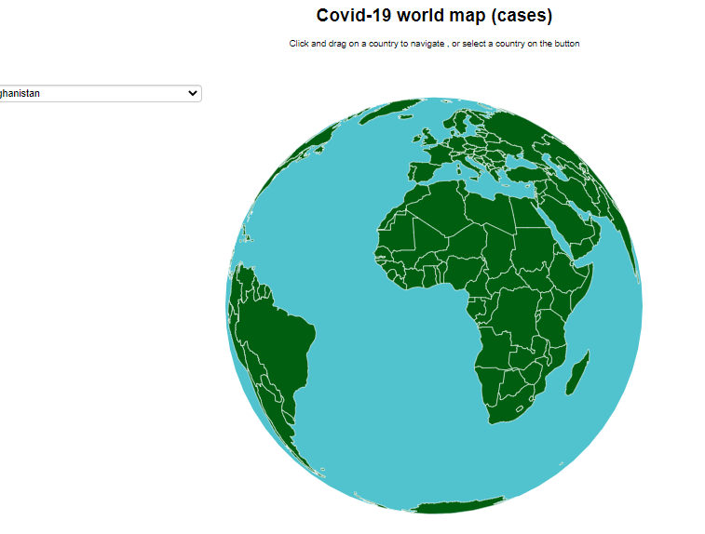

**Task 2**: Show the statistics of each country

Next to the map is the radial map that shows all the relevant details as to our system requirements that is total deaths, total confirmed cases, total recovered and new confirmed cases.

The last graph is a Circular Bar Plot which shows the cumulative deaths for each country as the virus progressed. This graph gets the data from an api and it updates automatically and it will just be rotating showing all the data of the countries.

Most of these graphs were developed in a modular way where each student had to make a function or module for his graph and then we combined them into the final project and made the platform. We also used Bootstrap for the development for the front-end.

# Task division

Methembe Tshuma - Radial bar plot , video recording

Praise Mlambo - Circular bar plot , experiment report

Tyrone Zeka - World map ,readme files and css

# References

* Our data is from heroku app api : <https://coronavirus-tracker-api.herokuapp.com/>
* A D3.js Bar Chart race of covid-19 cases by Felipe Rego: <https://feliperego.github.io/blog/2020/08/21/Bar-Chart-Race-D3js-COVID19-Global-Cases>
* Covid-19 world-wide totals per million population- d3js maps by Mikael Koutero: <https://bl.ocks.org/eetuko/4535086c3fabe76a173b432c44b254c6>
* An interactive visualization of the exponential spread of Covid-19 from 91-DIVOC: [https://91-divoc.com/pages/covid-visualization/](https:/91-divoc.com/pages/covid-visualization/)
* Covid-19 Dashboard by the center for systems and Engineering at John Hopkins University: <https://coronavirus.jhu.edu/map.html>

# Summary

1. **Describe how your project went from the initial proposal, to the intermediate progress, to the final work**.

We started off by doing a survey and gave out some questionnaires to ask if the project was worth doing and it seemed like it had people hyped about it.

In our first proposal we had to focus on the requirements of our project.We described the overview and scenarios and tasks.Furthermore we had to do the description of data.In addition we had to describe the visualization and the initial sketch.

We then went on to choose the data for the project and initial we had chosen a dataset from Kaggle but we latter realized it was not the best dataset for our problem solution hence we changed to an API.

After that we then made sure that every one of the group members was developing. We would meet on Saturdays and discuss on the development of the project and bring about more ideas and critics on the progress

1. **What has changed in your visualization goals or tasks?**

Most of our initial goal did not change compared with the final project. What we see to have changed mostly is that we had to add a unique circular bar plot as initially we wanted to use a line graph.

Furthermore , we initially planned that we were going to have the other view of a calender but right now we have decided not to do it for we realize that the views that we have are enough and suitable for all our tasks.

1. **What has changed in your technical objectives?**

We first considered using pandas for data processing but we realized that its usability was not that good as such that it was time consuming.So we decided to use excel instead of pandas. Also instead of using only HTML and CSS for the front-end, we decided to use Bootstrap and Materialize CSS.

1. **As far as D3's available technologies are concerned, have your initial proposals been realized? Your original proposal**

We believe our full proposal has not been successfully realized but we were very close.

1. **Is there anything you want to achieve, but you don't know how to do it in the end? If so, what kind of solution did you adopt, or did you give up the original idea?**

We wanted to design a multiple line graph but we realized it had some complex designs with the interactivity. So as an ultimate result we had to drop the idea of the line graph altogether.

(**6) If you were to redevelop a visual analysis project (or any other interactive visualization) from scratch, what would you do differently?**

Firstly we would find and process the data in advance so that we don’t end up being delayed by the unavailability of data.Now that we have learned and gained more knowledge regarding d3 then if we are to do a new project even if it’s different from the current one we would improve on time such that we will finish it in half the time we spent for this current one.

**(7) The course learning of personal perception or experience, especially feedback to improve the quality of teaching some specific constructive opinions.**

I believe there could be a better way of teaching D3.js the library itself as most of the theory parts of the class were well covered in class but the programming parts were not well covered as most of the things we just had to search on Google and Stackoverflow.