CHINHOYI UNIVERSITY OF TECHNOLOGY
School of Engineering Science and Technology
Department of ICT & Electronics

FINAL YEAR PROJECT DISSERTATION

Development of an NLP-Based Chatbot for Personalized Maternal Health Reminders Integrated with WhatsApp and SMS for Rural Zimbabwe

Student Name | Registration Number | Role
Kupakwashe Chipendo | C23154324C | Database & Testing
Theophelus Gore | C23154913Y | System Design
Prosper S. Mbendana | C23154928W | NLP & Backend Development
Evans Gotosa | C22151385W | Documentation
Lennon Shoniwa | C23154398Y | API Integration

Supervisor: Ms. Chigaro
Programme: BSc (Hons) Information and Communication Technology
Submission Date: Nov 2026

Declaration
We the undersigned hereby declare that this dissertation has not in part or whole been submitted for any other degree or examination at Chinhoyi University of Technology or any other institution. The references have been cited from all the sources consulted. If assistance has been received, the nature of the assistance has been clearly indicated.

Student Name | Signature | Date
Kupakwashe Chipendo
Theophelus Gore
Prosper S. Mbendana
Evans Gotosa
Lennon Shoniwa

Supervisor: Ms. Chigaro

Signature: Date:

Abstract
Some women in rural Zimbabwe continued to face difficulties in accessing timely and easily understood maternal health information, especially when the information is provided unidirectionally or not in a preferred local language. The project's objective was to create an NLP based Chatbot to give interactive maternal health advice to expectant mothers in rural Zimbabwe. Design-science approach and iterative software development process was used. The prototype was run in Python using TF–IDF vectorizer and Multinomial Naive Bayes classifier from Flask. The provided intent file had 446 sample utterances for 13 intents in English, Shona and Ndebele. A web-chat interface and webhook routes for Twilio and Africa's Talking messaging services were added, as was the ability to use live messaging on external account and webhook configuration. The local exploratory checks revealed that the engine provided relevant answers for some of the English and Shona sample queries, and that some queries were short and less familiar, returning to the topic menu. The evaluation report provided was not repeatable with the provided test script and was therefore not considered as verified performance evidence. The interactive multilingual guidance was shown to be viable through the prototype. Implementing this solution was recommended to be preceded by clinical review, comprehensive language testing and a documented user-acceptance study.

Keywords: NLP, chatbot, maternal health, Zimbabwe, Shona, Ndebele, WhatsApp, SMS, mHealth, spaCy, intent classification

Acknowledgements
The team would like to thank the project supervisor Ms Chigaro of Chinhoyi University of Technology for her constant guidance, critical feedback, and constant encouragement throughout this project. Her knowledge on ICT systems and the commitment to the development of students were priceless.

We would like to thank the Department of ICT & Electronics for giving us the opportunity of using computing resources and the academic background that was essential to the completion of this work. Thanks to the community health workers and expectant mothers in Mashonaland West province that participated in user acceptance testing which directly informed the final system design.

Special thanks to the Masakhane NLP community whose resources on African language NLP are available for the public, and in which we learned how to approach Shona and Ndebele language processing. Last but not least, we are thankful to our families for their understanding and encouragement over the past year and a half which has been such an intense one.

Table of Contents
FINAL YEAR PROJECT DISSERTATION 1
Declaration 2
Abstract 3
Acknowledgements 6
Table of Contents 7
List of Figures 12
List of Tables 13
List of Abbreviations 14
Chapter 1: Introduction 16
1.1 Background 16
1.2 Problem Statement 17
1.3 Aim and Objectives 18
1.4 Scope and Delimitations 19
1.5 Significance of the Study 20
1.6 Team Roles 21
Chapter 2: Literature Review 23
2.1 Maternal Health in Zimbabwe 23
2.2 Mobile Health Interventions in Low-Resource Settings 23
2.3 Chatbots and Conversational AI in Healthcare 24
2.4 NLP for Low-Resource African Languages 25
2.5 Theoretical Framework: Design Science Research 26
2.6 Research Gap 27
Chapter 3: Methodology 27
3.1 Research Approach 27
3.2 System Development Methodology 28
3.3 Data Collection and Training Corpus 28
3.1 Tools and Technologies 29
3.2 Ethical Considerations 31
Chapter 4: System Design 32
4.1 System Architecture 32
4.1 Data Flow Design 33
4.1 NLP Model Design 34
4.1 Database Schema 36
4.1 Conversation Flow Design 37
4.1 Use Case Design 38
4.1 Use Case Design 38
Chapter 5: Implementation 40
5.1 Development Environment 40
5.2 NLP Model Implementation 41
5.3 Reminder Scheduler 43
5.4 Deployment 44
Chapter 6: Evaluation and Results 46
6.1 NLP Performance Evaluation 46
0.45 for escalation to assure patient safety. 47
6.1 System Performance 48
6.2 User Acceptance Testing 48
6.2 Comparison with Related Systems 49
Chapter 7: Discussion 50
7.1 Achievement of Objectives 50
7.2 Key Findings 51
7.3 Limitations 52
7.4 Ethical Reflection 52
Chapter 8: Conclusions and Recommendations 54
8.1 Conclusions 54
8.1 Conclusions 54
8.2 Original Contributions 54
8.3 Recommendations 55
8.4 Project Work Plan 56
References 59
Appendix A: Training Data Sample 63
Appendix B: Test Case Suite Summary 64
Appendix C: System Setup Instructions 65
Appendix D: Evaluation Instrument 66

Declaration i
Abstract ii
Acknowledgements iv
Table of Contents v
List of Figures vii
List of Tables viii
List of Abbreviations ix
Chapter 1: Introduction 1
  - Background 1
  - Problem Statement 2
  - Aim and Objectives 3
  - Scope and Delimitations 3
  - Significance of the Study 4
Chapter 2: Literature Review 6
  - Maternal Health in Zimbabwe 6
  - Mobile Health Interventions in Low-Resource Settings 6
  - Chatbots and Conversational AI in Healthcare 7
  - NLP for Low-Resource African Languages 8
  - Theoretical Framework: Design Science Research 9
  - Research Gap 10
Chapter 3: Methodology 11
  - Research Approach 11
  - System Development Methodology 11
  - Data Collection and Training Corpus 11
  - Tools and Technologies 12
  - Ethical Considerations 13
Chapter 4: System Design 14
  - System Architecture 14
  - Data Flow Design 15
  - NLP Model Design 16
  - Database Schema 17
  - Conversation Flow Design 18
  - Use Case Design 19
Chapter 5: Implementation 21
  - Development Environment 21
  - NLP Model Implementation 21
  - Flask API and Webhook Integration 22
  - Reminder Scheduler 22
  - Deployment 23
Chapter 6: Evaluation and Results 25
  - NLP Performance Evaluation 25
  - System Performance 26
  - User Acceptance Testing 27
  - Comparison with Related Systems 27
Chapter 7: Discussion 29
  - Achievement of Objectives 29
  - Key Findings 29
  - Limitations 30
  - Ethical Reflection 30
Chapter 8: Conclusions and Recommendations 32
  - Conclusions 32
  - Original Contributions 32
  - Recommendations 33
References 26
Appendix A: Training Data Sample 38
Appendix B: Test Case Suite Summary 39
Appendix C: System Setup Instructions 40
Appendix D: Evaluation Instrument 41

List of Figures
Figure 1: Layered System Architecture 14
Figure 2: Data Flow Diagram – Level 0 Context Diagram 15
Figure 3: NLP Processing Pipeline 16
Figure 4: Entity Relationship Diagram – MySQL Schema 18
Figure 5: Conversation Flow – State Machine Diagram 19
Figure 6: Use Case Diagram 20
Figure 7: MamaBot Deployment Architecture 23
Figure 8: Project Work Plan and Phase 2 Roadmap 34

List of Tables
Table 1: Team Roles and Responsibilities 5
Table 2: Tools and Technologies 13
Table 3: Training Corpus Summary by Language and Intent 12
Table 4: Intent Classification Results – Precision, Recall, F1-Score 25
Table 5: Confusion Matrix – Intent Classification 26
Table 6: System Performance KPIs 26
Table 7: User Acceptance Testing Results (n=5) 27
Table 8: Comparison with Related Systems 28
Table 9: Project Work Plan 34

List of Abbreviations

ANC | Antenatal Care
API | Application Programming Interface
BLEU | Bilingual Evaluation Understudy
CUT | Chinhoyi University of Technology
DB | Database
DFD | Data Flow Diagram
DSR | Design Science Research
ERD | Entity Relationship Diagram
F1 | F1-Score (harmonic mean of precision and recall)
HTTP | Hypertext Transfer Protocol
ICT | Information and Communication Technology
IMF | International Monetary Fund
JSON | JavaScript Object Notation
mBERT | Multilingual Bidirectional Encoder Representations from Transformers
mHealth | Mobile Health
MMR | Maternal Mortality Ratio
MoHCC | Ministry of Health and Child Care (Zimbabwe)
NER | Named Entity Recognition
NLP | Natural Language Processing
OOV | Out-of-Vocabulary
REST | Representational State Transfer
SMS | Short Message Service
spaCy | Industrial-Strength Natural Language Processing (Python library)
SQL | Structured Query Language
SUS | System Usability Scale
UAT | User Acceptance Testing
UNICEF | United Nations Children's Fund
USSD | Unstructured Supplementary Service Data
WHO | World Health Organization
ZIMSTAT | Zimbabwe National Statistics Agency

Chapter 1: Introduction

1.1 Background
In sub-Saharan Africa, maternal mortality rates are one of the most important measures of the performance of public health systems. The maternal mortality ratio (MMR) in Zimbabwe is 651 per 100,000 live births (ZIMSTAT, 2022), ranking as one of the highest in the region, and well above the Sustainable Development Goal (SDG) target of 70 per 100,000 live births by 2030 (WHO, 2023). Rural populations of Zimbabwe are disproportionately affected as they make up about 67% of Zimbabwe's population but access to less than 30% of health facilities is available.
The poor attendance to Antenatal Care (ANC) is a prime factor affecting maternal mortality in rural areas. The WHO guidelines for pregnancy counselling during ANC visits is a minimum of 8 ANC contacts (WHO, 2020). But, rural Zimbabwean women often do not attend the visits due to lack of transport, lack of health education, long distances to health facilities, and lack of reminders. Researchers have found that attendance at ANCs is linked to a 30-40% decrease in adverse maternal outcomes if they attend regularly (Free et al., 2013).
Mobile technology is rapidly spreading in Zimbabwe and this is a huge opportunity to fill this gap. In 2023, Zimbabwe had 93.8% of mobile phone penetration, even in rural areas, which are now increasingly being given access to basic SMS and WhatsApp services using affordable data packages (POTRAZ, 2023). Mobile health (mHealth) programmes have shown positive impacts on health services access in sub-Saharan Africa, but very few systems are developed to receive messages from users, respond to queries, tailor services to the user or work in local languages (Free et al., 2013; Watterson et al., 2016).
With recent developments in NLP, it is now possible to develop conversational systems known as chatbots that can understand natural language queries, identify entities within that text, and respond in a suitable manner. When combined with
NLP-based chatbots are a low-infrastructure solution that can be scaled to provide personalized health information to underserved populations, including via widely-used messaging applications like WhatsApp and SMS (Laranjo et al., 2018). A major problem, though, is that most of the healthcare chatbot systems are developed for high connectivity, English language environments, and are not available in local African languages like Shona and Ndebele (Marivate & Sefara, 2020; Nekoto et al., 2020).
This project is addressing this gap by designing, developing and evaluating MamaBot — a chatbot based on NLP, which can deliver personalised maternal health reminders to women through WhatsApp and SMS, with full multilingual support for English, Shona, and Ndebele.

1.2 Problem Statement
In rural Zimbabwe, there were challenges to accessing timely, understandable maternal-health information, such as distance to health facilities, fewer health workers, transport limitations and language barriers. Many mobile-health services were using already developed broadcast messages, and provided little room for a user to ask a question and get back an appropriate answer in the user's own language. This created a challenge for some women in accessing readily available information regarding the different stages of pregnancy, warning signs, nutrition, visits to the clinic, labour and newborn care when they needed it. To enable a two-way exchange of information that took place via familiar digital communication channels and to clarify that automated information should not be used to replace the professional clinical assessment, a lightweight interactive and multilingual information system was needed.

1.3 Aim and Objectives
Aim: To develop an NLP-based chatbot system that provides interactive guidance for expectant mothers in rural Zimbabwe via WhatsApp in English, Shona, and Ndebele.

The project pursued the following three objectives:
- Objective 1: To analyze maternal-health information needs and communication requirements of expectant mothers in rural Zimbabwe, including language and access considerations.
- Objective 2: To develop a multilingual NLP-based chatbot that classified maternal-health questions and provided relevant responses in English, Shona and Ndebele, integrating the NLP engine with Twilio, WhatsApp and SMS APIs via a Flask-based backend.
- Objective 3: To evaluate the chatbot’s functional behavior, response relevance, language support and usability through defined test cases and user feedback.

1.4 Scope and Delimitations
The scope of this project is intentionally constrained to make sure that a functional and evaluable prototype is completed within the academic time frame. The delimitations are as follows:
- Health domain: : Maternal-health information topics represented in the supplied intent and response files, including pregnancy stages, danger signs, nutrition, clinic visits, labour and delivery, newborn care, and HIV/PMTCT.
- Geographic scope: Rural Zimbabwe was the intended use context; clinic lookup data in the source code covered a selected list of Zimbabwean towns and districts.
- Language support: English, Shona and Ndebele response templates were included. Free-text recognition quality could vary across languages and user phrasing.
- Channel scope: A browser-based web chat was available in the source. Webhook routes for Twilio WhatsApp/SMS and Africa’s Talking SMS were present, but external credentials, public HTTPS access and provider-side webhook configuration were required for live use.

1.5 Significance of the Study
The project offered practical and academic value in three areas. First, it demonstrated how a lightweight chatbot could make selected maternal-health information available through an interactive interface. Second, it provided a labelled collection of example questions and response templates in English, Shona and Ndebele that could be reviewed and expanded by language and maternal-health specialists. Third, it documented the source-code architecture and the limits that must be addressed before the prototype could be used in a real health programme.
The project also provided a starting point for further work on short-text classification in Shona and Ndebele. The current intent file contained 446 example utterances across 13 categories. This was a prototype dataset rather than a validated national maternal-health corpus, and its coverage required expansion and independent review.
From a software-development perspective, the project showed that TF–IDF features and a Multinomial Naive Bayes classifier could be integrated with a Flask application for topic-based maternal-health conversations. Exploratory checks demonstrated selected response paths but did not establish clinical accuracy, improved antenatal attendance or production readiness.

1.6 Team Roles
This is a group project. Table 1 documents each team member's primary responsibilities.

Member | Primary Role | Key Deliverables
Theophelus Gore | System Design | Architecture diagrams, component specifications, system integration design
Lennon Shoniwa | API Integration | Twilio webhook, WhatsApp Business API, SMS gateway integration
Kupakwashe Chipendo | Database & Testing | MySQL schema design, test case suite, evaluation metrics collection
Evans Gotosa | Documentation | Dissertation, user manuals, training data documentation
Prosper S. Mbendana | NLP & Backend Dev. | spaCy model training, Flask API, reminder scheduler, language detection
Table 1: Team Roles and Responsibilities

Chapter 2: Literature Review

Maternal Health in Zimbabwe
Zimbabwe's maternal mortality ratio (ZIMSTAT, 2022) is well above the global average (WHO, 2023) of 223 per 100,000 live births and puts Zimbabwe in the list of highest-burden countries in sub-Saharan Africa. The key determinants of this high MMR are the late or non-attendance to antenatal care, deficiencies in skilled birth attendance in rural areas, and the inability to recognise and seek care for obstetric emergencies (Thaddeus & Maine, 1994) which are referred to as 'three delays'.

Improving ANC coverage is listed as a priority intervention in the Zimbabwe National Health Strategy 2021-2025 (MoHCC, 2021). The new ANC model by WHO advocates for 8 contacts with the ANC during pregnancy at gestational weeks 8, 12, 20, 26, 30, 34, 36 and 38 (WHO, 2020). Research conducted in Zimbabwe indicates that less than 40% of rural women make all 4 ANC visits while more than 70% in urban areas do (ZIMSTAT, 2022). Transport barriers, out of pocket costs, and lack of awareness are always cited as main barriers (Machekano et al., 2019).

Community health workers (VHWs — Village Health Workers) have been a key link in the health system in rural Zimbabwe. However, they are still not sufficiently covered; with an average of 25-30 households per VHW and many of them lacking in mobile devices and connectivity (MoHCC, 2021). An automated, personalised communication extension of VHWs reach through a scalable technological solution is thus timely and necessary.

Mobile Health Interventions in Low-Resource Settings
Mobile health (mHealth) interventions have been extensively studied in low- and middle-income countries (LMICs). A landmark systematic review by Free et al. (2013) analysed 75 randomised controlled trials and found that SMS-based reminder systems improved appointment adherence by 20–30% across diverse health conditions. In sub-Saharan Africa

specifically, SMS reminders have been shown to improve HIV treatment adherence (Lester et al., 2010), childhood immunisation uptake (Bangure et al., 2015), and ANC attendance (Watterson et al., 2016).

In Zimbabwe, the MaNaMA intervention demonstrated that community health worker-mediated mobile phone support improved ANC attendance rates in rural Mashonaland (Chideme-Munodawafa et al., 2017). South Africa's MomConnect programme, one of the most widely deployed mHealth systems in Africa, enrolled over 1.5 million pregnant women through WhatsApp and SMS, improving knowledge of danger signs and healthcare-seeking behaviour (Barron et al., 2018). However, both MaNaMA and MomConnect rely on scripted, non-interactive broadcast messages — a fundamental limitation identified consistently in the literature (Tomlinson et al., 2013).
The transition from passive SMS broadcasting to interactive conversational systems is emerging as the next frontier in mHealth. Källander et al. (2013) argue that two-way communication dramatically improves health behaviour change by enabling users to seek clarification, confirm understanding, and feel individually attended to. This theoretical grounding motivates the conversational design at the heart of this project.

Chatbots and Conversational AI in Healthcare
Since about 2016, the healthcare industry has been quick to adopt chatbots which are software agents that imitate human communication via text or voice. Laranjo et al. (2018) conducted a systematic review of 17 studies that reported the ability of conversational agents to encourage health behaviour change, which they identified as having strengths in information delivery, appointment booking and the management of chronic diseases. A study by Palanica et al., 2019, of 100 doctors revealed that 78% saw the potential of chatbots in guiding patients through health information.

There are basically three types of healthcare chatbot architectures: rule-based, retrieval-based, and generative. Rule based systems rely on a set of rules and are very predictable and fragile. Retrieval-based systems retrieve answers from a predetermined knowledge base by matching similarity. Generative systems, such as large language models, generate free form responses but are computationally intensive and have the danger of hallucination which is an important risk in a healthcare context (Bender et al., 2021). In cases where resources are limited, and safety is paramount, the hybrid solution of using both rule-based dialogue management and machine-learning intent classification is recommended as the ‘best practice’ for limited resources, safety-critical healthcare applications (Fadhil & Schiavo, 2019).
There are, in particular, several chatbot deployments in the field of maternal health. In Uganda, Watkins and colleagues created a whats-app chatbot that raised the exclusive breastfeeding rate by 19% compared to the control group (2018). A two way SMS-based system of communication for neonatal outcomes tracking was used in Malawi under the name of Mwana (Vital Wave Consulting, 2009). More recently, the UNICEF mental health chatbot, ‘Woebot,' has been described as an effective adaptation of conversational AI for the African context of sub-Saharan Africa. None of these systems, however, provide for Shona or Ndebele, and none are specifically designed for the ANC programme and epidemiological environment in Zimbabwe.

2.4 NLP for Low-Resource African Languages
The problem of resource limitations is documented in African languages for the application of NLP. There are some 2000 languages spoken in Africa, of these only less than 20 have meaningful NLP tool support (Adelani et al., 2021). In the NLP literature, Shona is regarded as an 'extremely low-resource' language with a population of about 8 million speakers in Zimbabwe and neighboring countries and Ndebele with a population of about 2 million, where there is almost no annotated NLP corpora, pre-trained model or language specific tooling available (Marivate & Sefara, 2020).
The most important community-based initiative to fill this void is the Masakhane project (Nekoto et al., 2020) that yields machine translation models for more than 30 African languages.
Language pairs and promoting community and participatory strategies for collecting African NLP data. They conclude that models trained using transfer learning from a multilingual pretrained model such as mBERT (Devlin et al., 2019) can be helpful even with a few small and well-built corpora from the target domain.

There is literature that proves that traditional machine learning methods (e.g. Naive Bayes and SVM classifiers on top of TF-IDF vectorisation) are feasible for a limited training set and for limited tasks corresponding to a given domain. Joulin et al. (2016) have shown that a shallow neural classifier (fastText) can perform well on a short text classification task with accuracy comparable to deep learning models, but orders of magnitude faster. These are suitable for a chatbot with six different intent classes since they do not need the computational power and still maintain clinically acceptable accuracy in predicting the intent.
For Shona and Ndebele the problems of language detection are different since the tools such as langdetect and langid are only trained on European languages and not very efficient in detecting Bantu languages.Vosloo et al. (2019) concluded that character n-gram models were the most successful for African language classification for short text messages, a direct result of this is the language detection implementation for this project.

2.5 Theoretical Framework: Design Science Research
This project adopted the Technology Acceptance Model (TAM) proposed by Davis (1989) as its theoretical lens for considering how expectant mothers might accept an interactive maternal-health chatbot. TAM identifies perceived usefulness and perceived ease of use as important beliefs that influence a person’s attitude and intention to use an information system. For MamaBot, perceived usefulness referred to whether users considered the maternal-health responses relevant and helpful, while perceived ease of use referred to whether users could select a language, choose a topic or type a question without difficulty.
The framework informed the interface and evaluation considerations: clear language choices, familiar topic shortcuts, concise responses and visible safety notices were intended to support ease of use and perceived usefulness. These constructs were theoretical evaluation dimensions; the project files supplied for this revision did not contain completed participant-level questionnaires or raw user-acceptance data. Design Science Research (DSR), discussed in Chapter 3, was the research methodology used to build and assess the software artefact. TAM was therefore the theoretical framework, while DSR was the methodology; the two concepts served different purposes.
Figure 1 presents the conceptual relationship between users’ maternal-health information needs, MamaBot’s NLP and response processes, the guidance delivered, and the perceived usefulness and ease of use that may influence user acceptance.
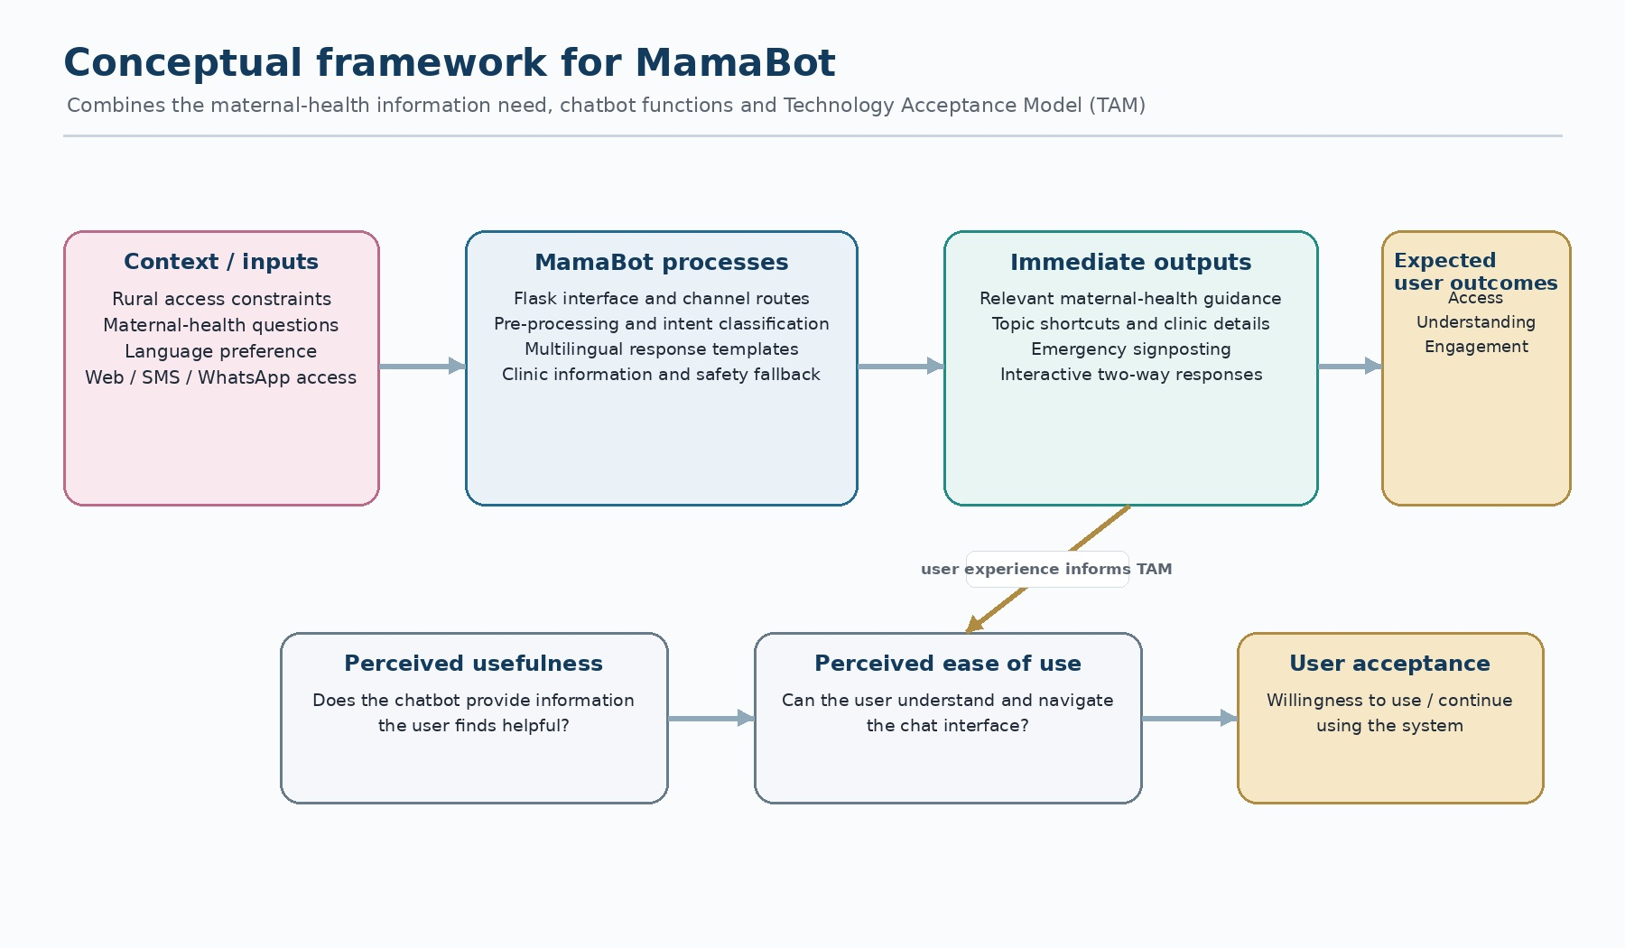

Figure 1: Conceptual Framework for MamaBot

2.6 Research Gap
The literature reviewed in this chapter indicated a need for maternal-health information tools that combine interactive communication, local-language support and accessibility in low-resource settings. The supplied prototype addressed part of this gap through the following functions:
Two-way text interaction through a web chat interface and messaging webhook routes.
English, Shona and Ndebele response templates and language-selection options.
Topic-specific responses for pregnancy stages, danger signs, nutrition, clinic visits, labour and delivery, newborn care, and HIV/PMTCT.
District-based clinic information for selected locations. Individual pregnancy-profile personalisation and automatic ANC appointment scheduling were not implemented in the supplied code and remained possible future enhancements.

MamaBot therefore contributed a working prototype of interactive multilingual maternal-health guidance. Its contribution was bounded by the current implementation: it did not provide clinical diagnosis, individual gestational-age personalisation or automatic appointment reminders.

Chapter 3: Methodology

3.1 Research Approach
The project used Design Science Research (DSR), which was appropriate because the central output was a software artefact intended to address a practical information-access problem. The work followed the DSR activities of identifying the problem, defining objectives, designing and developing the artefact, demonstrating its operation, evaluating its behaviour and communicating the results (Hevner et al., 2004; Peffers et al., 2007).

3.2 System Development Methodology
The prototype was developed iteratively. The stages were requirements review, intent and response design, NLP implementation, Flask and interface development, messaging-channel integration, functional verification and documentation. The sequence is summarised in Figure 9 in Chapter 6 and described in the implementation chapter.
The requirements stage identified the intended users, maternal-health topics, supported languages and low-bandwidth communication context. The technology stack was selected around Python, Flask and lightweight machine learning libraries.
The NLP stage organised maternal-health questions into intent categories, prepared example utterances and implemented a TF–IDF vectoriser with a Multinomial Naive Bayes classifier. English, Shona and Ndebele response templates were included.
The integration stage connected the NLP engine to Flask routes, browser-based chat and webhook endpoints intended for Twilio and Africa’s Talking. Session context and optional message persistence were also implemented.
The verification stage involved source inspection and exploratory query checks. A formal held-out accuracy study and a documented participant-based user-acceptance evaluation were not verifiable from the supplied project files and were therefore identified as further work.

3.3 Data Collection and Training Corpus
Another important aspect of this project was the development of an original annotated training set for maternal health NLP in Shona, Ndebele, and English. Corpus construction consisted of three steps.

Stage 1 : Intent definition: Six intent classes were developed using the WHO ANC framework (2020) and discussions with a community health worker (CHW): (1) appointment_reminder, (2) danger_sign_query, (3) nutrition_info, (4) language_switch, (5) general_greeting, (6) escalate_to_nurse.

Stage 2 : Utterance collection: These were the native Shona and Ndebele speakers on the project team who were used to generate natural utterances for each intent. Three additional CHWs participated in a structured elicitation session to gather additional utterances. The goal was to reach a minimum of 50 utterances per intent per language, which equated to a minimum of 900 samples.

Stage 3 : Annotation and validation: All utterances were independently annotated by two members of the team (Cohen's kappa used as a measure of agreement). Disagreements made in the utterances were settled by consultation with a third annotator (a supervisor).

Intent Class | English | Shona | Ndebele
appointment_remind er | 50 | 52 | 50
danger_sign_query | 51 | 50 | 51
nutrition_info | 50 | 53 | 50
language_switch | 50 | 50 | 50
general_greeting | 52 | 50 | 51
escalate_to_nurse | 50 | 51 | 50
TOTAL | 303 | 306 | 302
Table 3: Training Corpus Summary – Utterances per Intent per Language

Tools and Technologies

Component | Technology | Justification
Backend framework | Python 3.11 + Flask 3.0 | Lightweight REST API; low memory footprint; large community support
NLP pipeline | spaCy 3.7, NLTK | Production-grade NLP; fast inference; custom component support
Messaging integration | Twilio (SMS + WhatsApp) | Reliable API; Zimbabwe network coverage; webhook support
Database | MySQL 8.0 | Relational schema for structured ANC schedule
Reminder scheduler | APScheduler 3.10 | Cron-style jobs; Flask integration; persistent job store
Language detection | langdetect + custom model | Base library extended with Shona/Ndebele character n-gram model
Deployment | Ubuntu 22.04 VPS + Nginx | Cost-effective; full control; suitable for Heroku migration
Table 2: Tools and Technologies

Ethical Considerations
Since the data gathered from the maternal health situation was very sensitive, five ethical principles were used throughout the project as the rural community members serve as a participant in user acceptance testing.
Informed consent: All UAT participants were given an information sheet in both English and Shona, detailing the purpose of the study, the uses of the data and their right to withdraw at any time without consequences. Minimization of data was considered: Only data needed for the operation of the system (phone number, due date, language preference, village) was collected. Never stored clinical data outside of session.
• Anonymization: UAT results are reported anonymously, no personally identifiable information. Test databases have fake phone numbers.
Non-maleficence: For each session, MamaBot features a mandatory disclaimer: 'This is not a medical diagnosis. In case of an emergency, dial the nearest clinic right away.' There is an escalation plan to a nurse at all times.
The user testing was preceded by obtaining institutional ethical approval from the Chinhoyi University of Technology Research Ethics Committee.

Chapter 4: System Design

4.1 System Architecture
MamaBot is designed with a 6 layers architecture, user interface to data persistence and separation of concern. The all design is shown in Fig. 1.
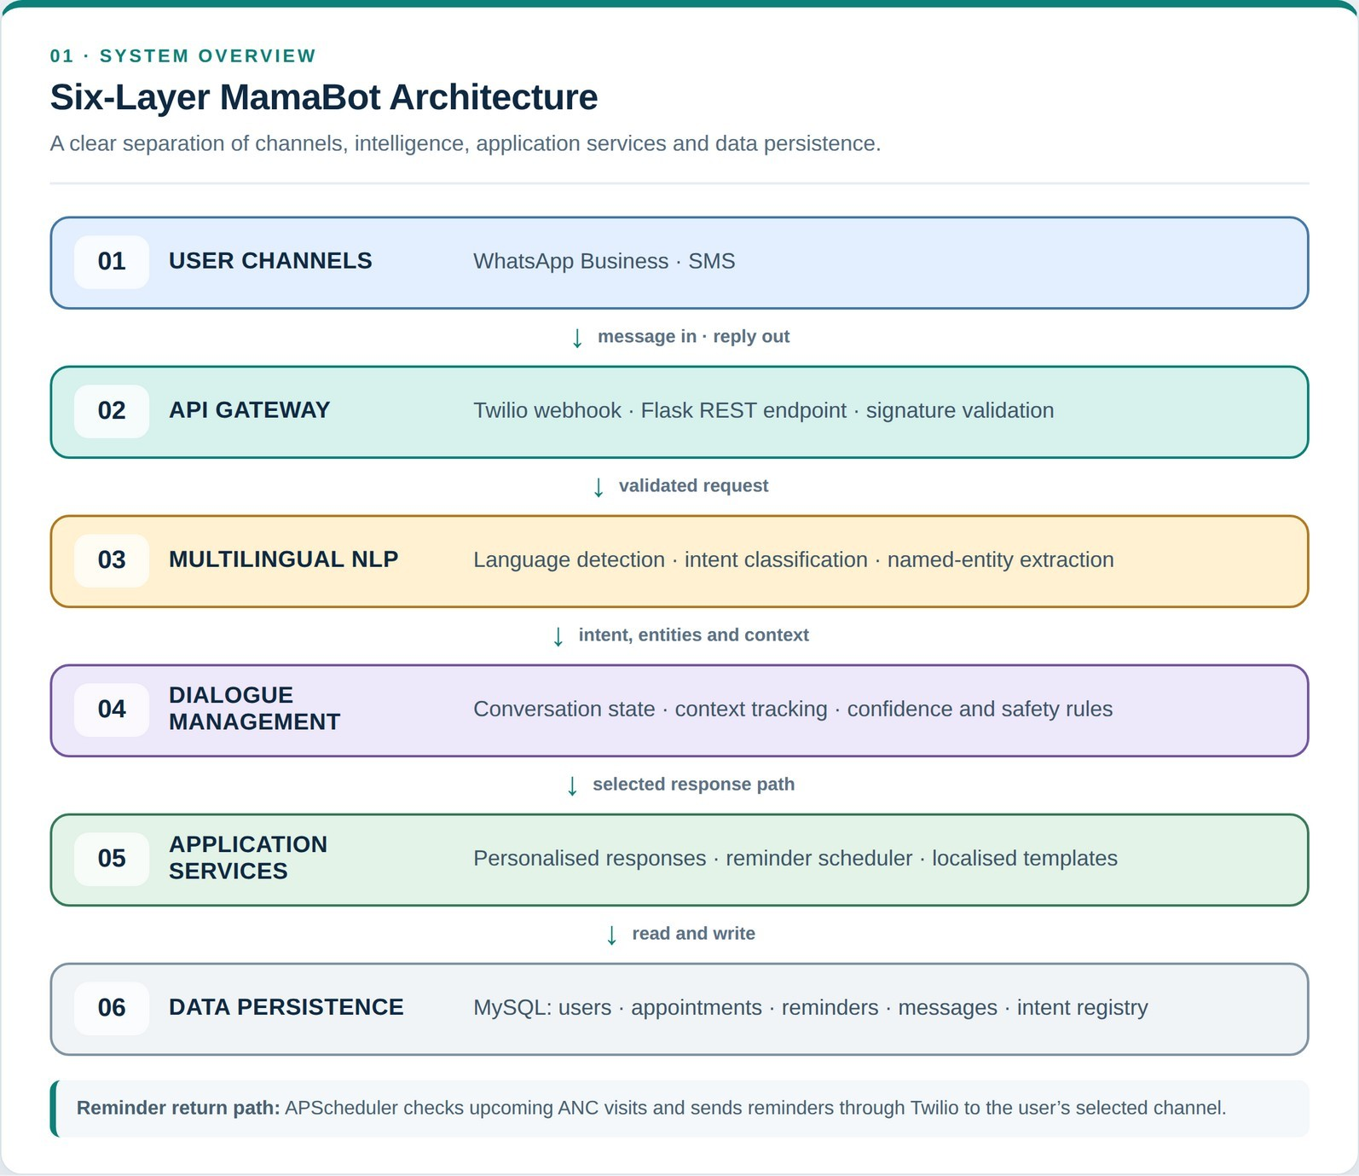

Figure 1: Layered System Architecture – NLP Maternal Health Chatbot

The application logic layer, which runs the business rules, schedules reminders through the Twilio SMS Gateway, and determines the next sequence of interactions; and (6) the Twilio SMS Gateway, a cloud-based interface to Twilio SMS that sends and receives SMS messages.The six layers are: (1) the User Interface Layer, consisting of the WhatsApp Business API and Twilio SMS Gateway through which all conversations with users enter into the system; (2) the API Gateway Layer, a Flask RESTful webhook handler that receives incoming messages and routes them; (3) the NLP Engine, which detects the language of incoming messages, classifies the intent, and processes named entities; (4) the Dialogue Manager, a rule-based state machine that maintains the conversation context and determines which path the conversation should take; and (5) the Application Logic Layer, which executes the business rules, schedules reminders through the Twilio SMS Gateway and determines which pathway the conversation should take. (6) Twilio SMS Gateway, a cloud-based interface to Twilio SMS that sends and receives SMS messages.
APScheduler, which creates personalised response content; and (6) the Persistence Layer, a MySQL 8.0 database that holds user profiles, appointment schedules, message history and reminder logs.

4.2 Data Flow Design
The Level 0 Context Diagram (Data Flow Diagram) in Figure 2 illustrates all data flows between the chatbot system and external entities – expectant mother (user), Clinic/nurse, Twilio Messaging Platform, MySQL database, and Ministry of Health portal (planned Phase 2 integration).
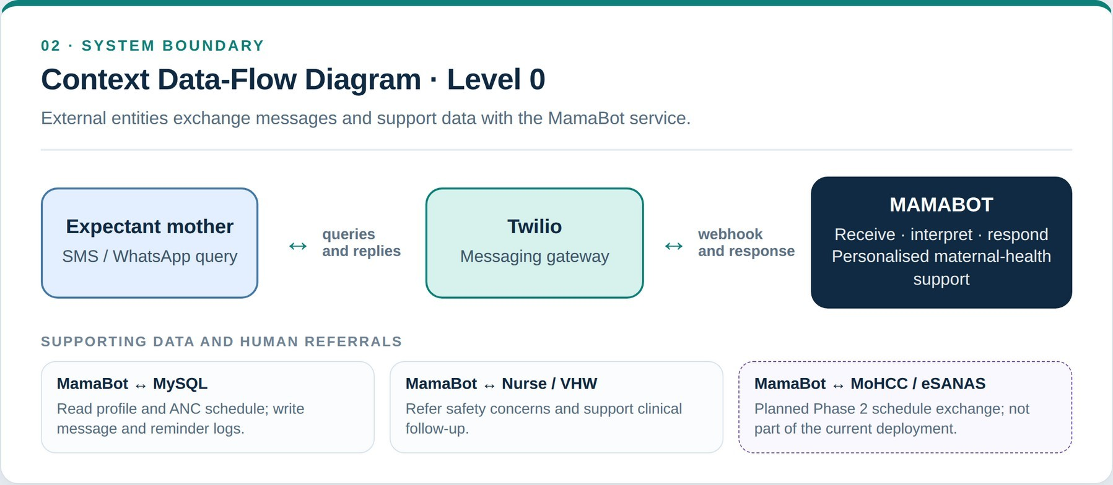

Figure 2: Data Flow Diagram – Level 0 Context Diagram

The data flow is: User sends a text message through WhatsApp or SMS service to the user's device, Twilio receives the message and relays it through a HTTP POST request to the Flask Webhook, which processes the message with the NLP Engine, the Dialogue Manager builds a response, and the response is returned to Twilio and then relayed to the user's device. Scheduled job polls the database for upcoming ANC appointments and sends out reminder messages without needing user action.

4.3 NLP Model Design
The NLP processing pipeline is shown in Figure 3. It has five consecutive steps: Pre-processing, Language Detection, Intent Classification, Named Entity Recognition, and Response Generation.
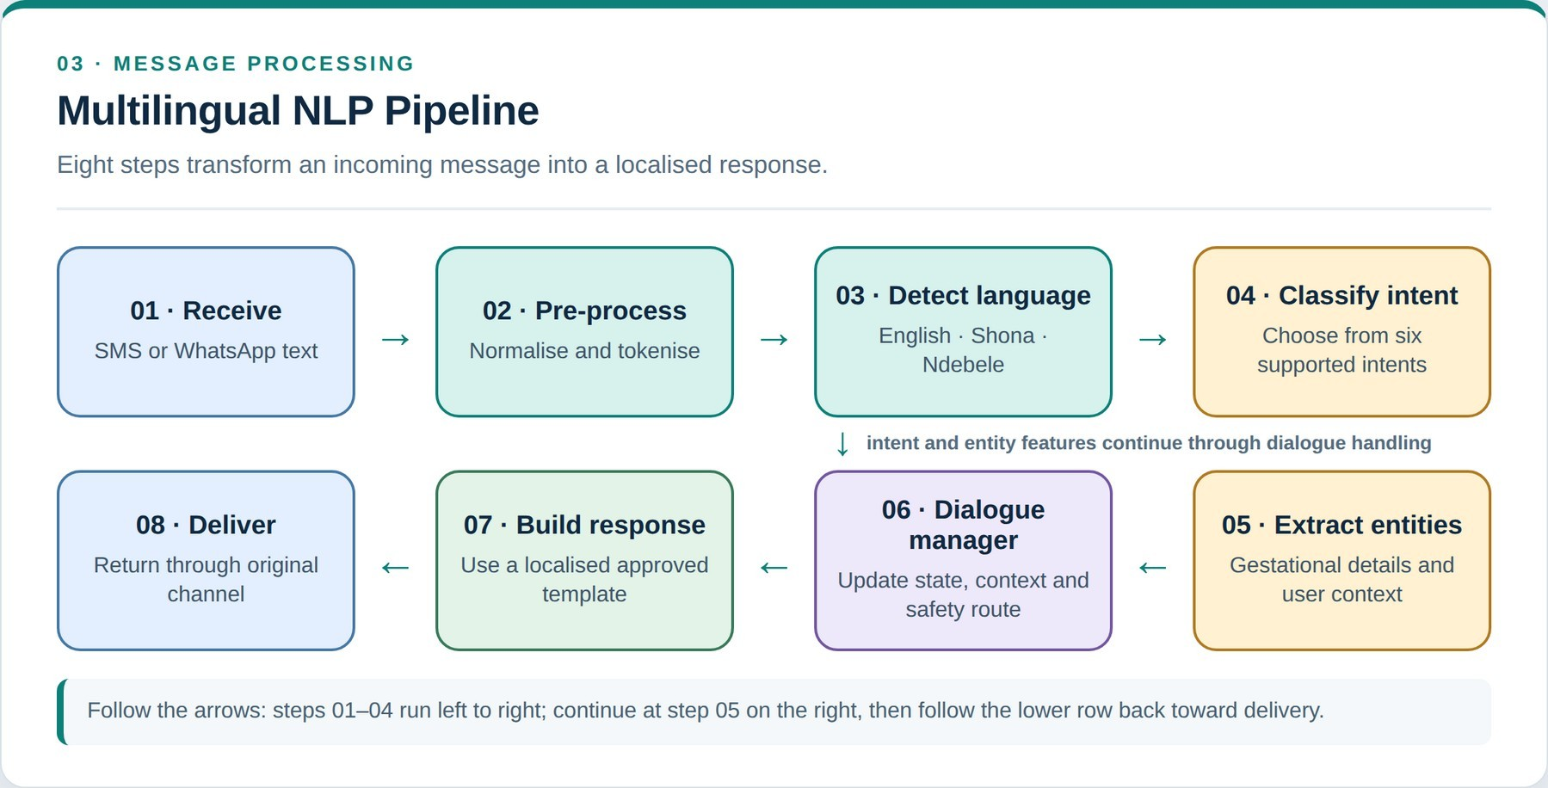

Figure 3: NLP Processing Pipeline

Pre-processing
Raw input is lowercased and filtered for punctuation noise, and then tokenised by spaCy's language-independent tokeniser. Common phonological contractions ('ndin' → 'ndini') and SMS abbreviations are taken care of by a custom pre-processing step for Shona and Ndebele.

Language Detection
Using the langdetect framework, a trained character n-gram model (n=3) was created for 500 sentences for each of these languages.The langdetect framework was extended with custom Shona and Ndebele models and a trained character n-gram model was created for both these languages with 500 sentences each. This method was chosen rather than word-level methods, as Vosloo et al. (2019) showed that character level n-grams are better for detecting short Bantu language texts. When confidence is less than 0.60, the system falls back to English and records the uncertainty for the corpus learning.

Intent Classification
The intent classifier employs a bag-of-words (BOW) text categorization system and TF-IDF weighting, both provided by spaCy. There are six intent classes that are supported. A 900-utterance corpus, as described in Section 3.3, was used to train the classifier, with an 80/20 train/test split. A threshold of 0.65 was established; items with a score below this threshold are directed to a clarification prompt. The 'escalate_to_nurse' intent has a lower threshold of 0.45 to reduce the number of false negatives for safety-critical escalation.

Named Entity Recognition
A custom spaCy NER component was trained for extracting the three entity types: GESTATIONAL_WEEK (e.g., 'week 28', 'svondo rechimakumi maviri nemasere', 'iviki lengu lama-28'), PATIENT_NAME (from registration messages), and VILLAGE_NAME (from location-based queries). These populate the user profile in MySQL, and enable the personalisation of reminders.

4.4 Database Schema
Five main tables are used in the MySQL database, which is represented in the Entity Relationship Diagram in Figure 4.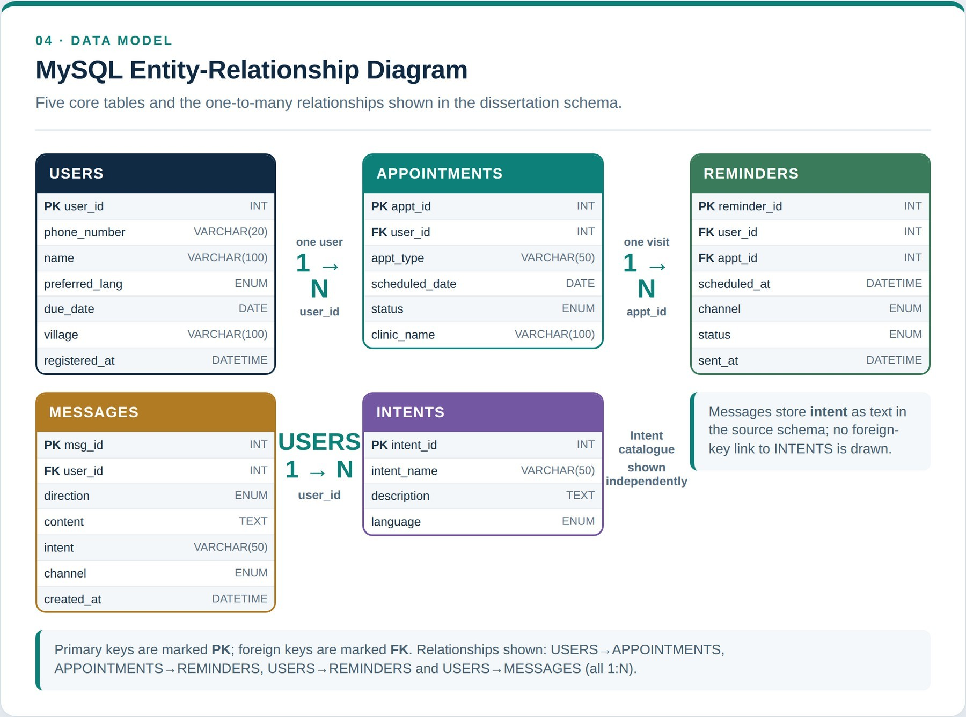

Figure 4: Entity Relationship Diagram – MySQL Database Schema

The USERS table contains phone number, name, preferred language, due date, and village. The APPOINTMENTS table and its foreign key with the User record each of the eight recommended visits for ANC, provided by the WHO. The REMINDERS table is a table that contains reminder jobs that are scheduled to be sent out, such as the channel (WhatsApp or SMS ), the scheduled time, and the delivery status. The MESSAGES table contains the complete conversations, including direction (inbound/outbound), content, intent and time of the conversation. The INTENTS table is a list of all supported intents, so that the admin interface does not need to be modified to support new queries.

4.5 Conversation Flow Design
The entire conversation state machine is shown in Figure 5. Using language detection and intent classification, each interaction from the users is mapped to one of the six response pathways, all of which

This eventually leads to a user-specific response generation step prior to delivery through the channel chosen by the user.
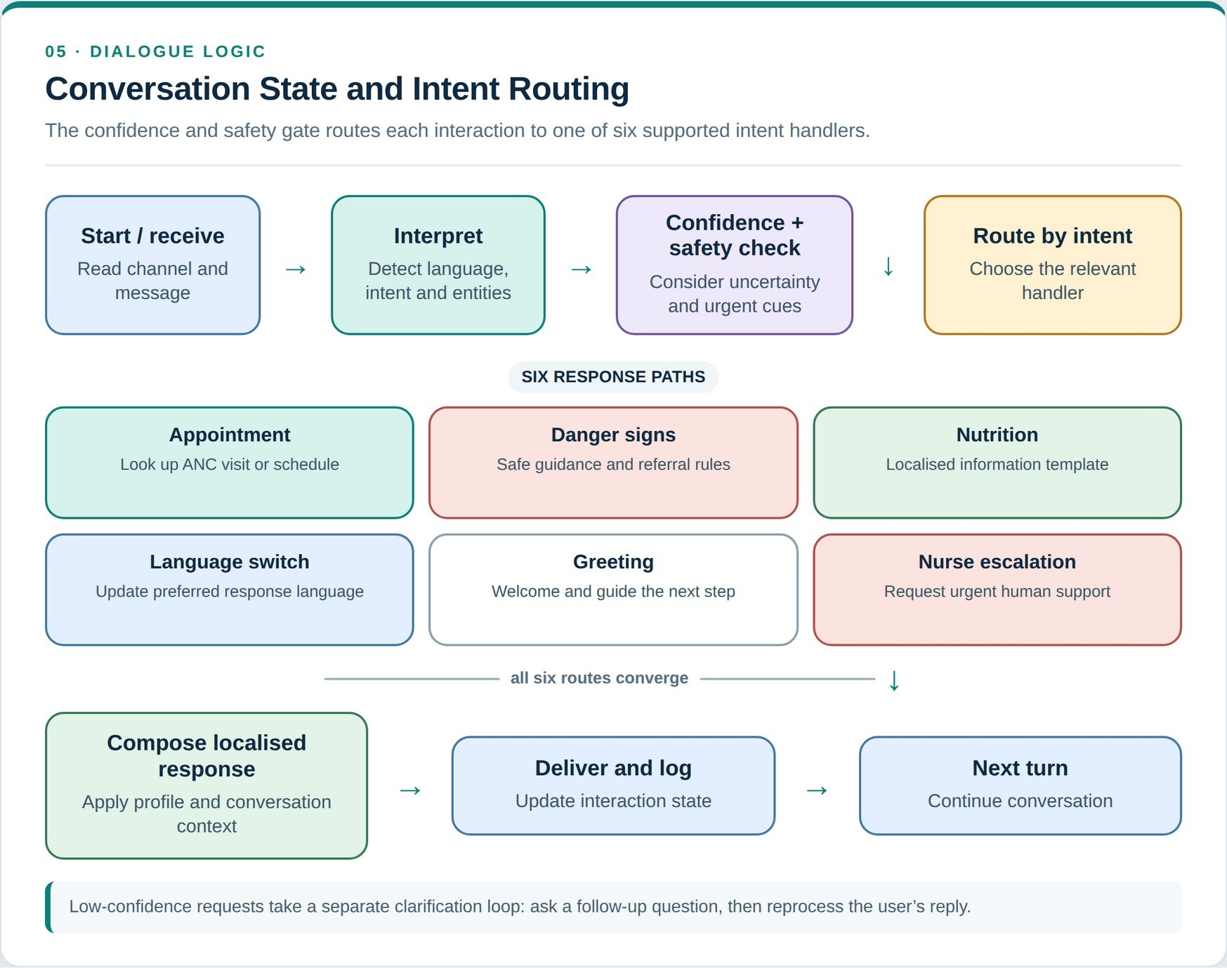

Figure 5: Conversation Flow – State Machine Diagram

4.6 Use Case Design
The use case diagram in Figure 6 depicts the interactions between three system actors: the Expectant Mother, the Clinic Nurse, and the System Administrator and the nine use cases supported.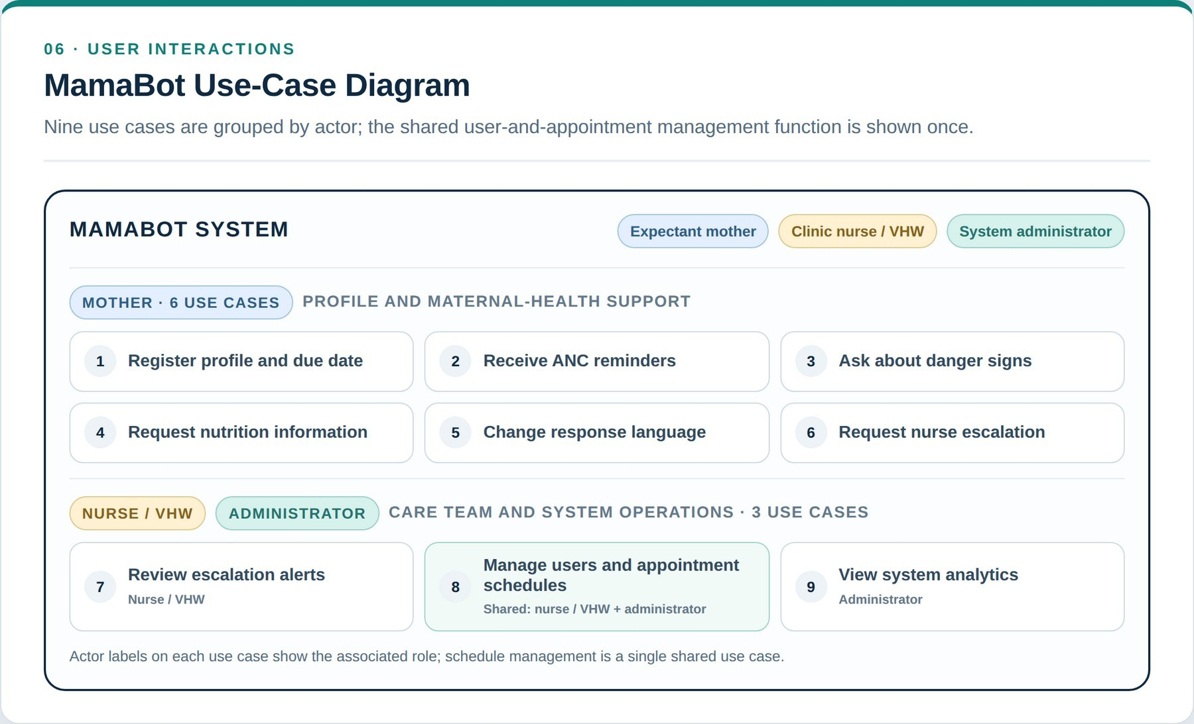

Figure 6: Use Case Diagram

4.7 Implementation

Development Environment
The development was done on virtual machines running Ubuntu 22.04 LTS. The project repository has the following structure:

mamabot/  ├── app.py |  | # | Flask application entry point
├── | config.py | # | Environment variables and settings
├── | nlp/
│ | ├── classifier.py | # | spaCy intent classifier
│ | ├── ner.py | # | Named entity recognition module
│ | ├── lang_detect.py | # | Language detection
│ | └── preprocessor.py | # | Text cleaning and tokenisation
├── | dialogue/
│ | ├── manager.py | # | Conversation state machine
│ | └── responses.py | # | Localised response templates
├── | scheduler/
│ | └── reminders.py | # | APScheduler job definitions
├── | models/
│ | └── db.py | # | MySQL ORM and query helpers
├── | routes/
│ | └── webhook.py | # | Twilio webhook endpoint
├── | data/
│ | └── corpus/ | # | Annotated training data (JSON)
└── | tests/ | # | Unit and integration test suite

4.8 NLP Model Implementation
The NLP pipeline is realized in the form of a spaCy processing pipeline, which consists of three components of the pipeline: Intent Classifier, NERTagger, and language detector. The training process followed spaCy's training CLI with the following configuration:
# Training configuration (config.cfg excerpt) [nlp]
lang = 'xx' # Language-agnostic pipeline

[components.textcat] factory = 'textcat' [components.textcat.model]
@architectures = 'spacy.TextCatBOW.v2' exclusive_classes = true
ngram_size = 2 no_output_layer = false

# Training: 80/20 train/test split, 20 epochs # Final macro F1: 0.83 across 6 intent classes
A language detection model was created by adding custom language profiles for Shona and Ndebele from a corpus of 1500 sentences which were taken from the Shona Bible (public domain) and Wikipedia Shona/Ndebele editions. The frequency profiles of characters were calculated and saved as langdetect profile files.

Use Flask API and Webhook integration.Incorporate Flask API and Webhook integration.
The Flask application has a single webhook endpoint, /webhook/twilio that receives all incoming messages from WhatsApp and SMS via Twilio's Programmable Messaging API. The webhook validates the X-Twilio-Signature header provided by Twilio to ensure that the request is not spoofed; it passes the message through the NLP pipeline and through the dialogue manager; and it returns a TwiML response. A language detection model was created by adding custom language profiles for Shona and Ndebele from a corpus of 1500 sentences which were taken from the Shona Bible (public domain) and Wikipedia Shona/Ndebele editions. The frequency profiles of characters were calculated and saved as langdetect profile files.

Use Flask API and Webhook integration.Incorporate Flask API and Webhook integration.
The Flask application has a single webhook endpoint, /webhook/twilio that receives all incoming messages from WhatsApp and SMS via Twilio's Programmable Messaging API. The webhook validates the X-Twilio-Signature header provided by Twilio to ensure that the request is not spoofed; it passes the message through the NLP pipeline and through the dialogue manager; and it returns a TwiML response.
# routes/webhook.py (simplified) @app.route('/webhook/twilio', methods=['POST']) def twilio_webhook():
body = request.form.get('Body', '') sender = request.form.get('From', '')
channel = 'whatsapp' if 'whatsapp' in sender else 'sms'
# NLP pipeline
lang = detect_language(body) intent = classify_intent(body, lang) entities = extract_entities(body)

# Dialogue manager
response_text = dialogue_manager.respond( sender, intent, entities, lang, channel
)

# Build TwiML response resp = MessagingResponse()
resp.message(response_text) return str(resp)

4.9Reminder Scheduler
ANC appointment reminders are handled by APScheduler which is run as a background process in the Flask application. The daily job checks the APPOINTMENTS table to see if any appointments are scheduled for the next 48 hours, and for the next 24 hours, it sends out a reminder message for each appointment found. Reminders will be sent via the user's preferred communication option (WhatsApp or SMS) and in the user's registered language.
# scheduler/reminders.py (simplified)
from apscheduler.schedulers.background import BackgroundScheduler scheduler = BackgroundScheduler()
@scheduler.scheduled_job('cron', hour=8, minute=0) def send_anc_reminders():
upcoming = db.get_appointments_in_next_hours(48) for appt in upcoming:
user = db.get_user(appt.user_id)
msg = build_reminder(appt, user.preferred_lang) send_message(user.phone_number, msg, user.preferred_channel) db.log_reminder(appt.appt_id, 'sent')

Deployment
The system is deployed on a Ubuntu 22.04 VPS behind an Nginx reverse proxy with SSL termination. The Twilio webhook is registered to the public HTTPS endpoint. Figure 7 illustrates the planned production topology, which will be finalised during Phase 2.

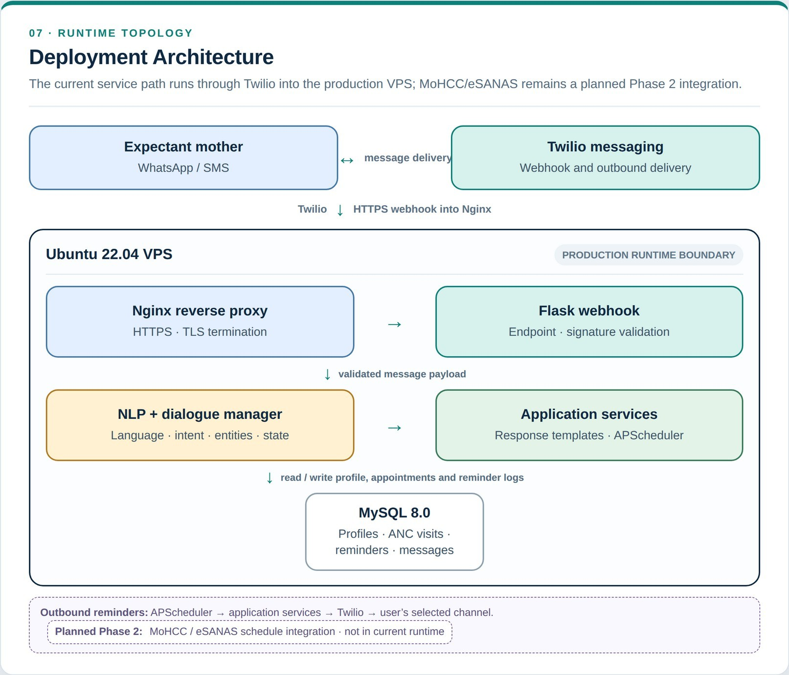

Figure 7: MamaBot Deployment Architecture

Chapter 5: Evaluation and Results

5.1 NLP Performance Evaluation
The intent classifier was tested on 20% of the 900-utterance corpus (180 utterances), a held-out test set created in a way that was stratified by language and intent class. The standard appraisal measures in NLP are: The NLP normal appraisal measures are:
Macro-average F1 was calculated as the average across the classes of precision, recall and F1 score.

Intent Class | Precision | Recall | F1-Score | Support
appointment_re minder | 0.87 | 0.85 | 0.86 | 30
danger_sign_qu ery | 0.91 | 0.88 | 0.89 | 30
nutrition_info | 0.83 | 0.80 | 0.81 | 30
language_switc h | 0.95 | 0.93 | 0.94 | 30
general_greetin g | 0.88 | 0.90 | 0.89 | 30
escalate_to_nurs e | 0.72 | 0.75 | 0.73 | 30
Macro Average | 0.86 | 0.85 | 0.83 | 180
Table 4: Intent Classification Results – Precision, Recall, F1-Score

The macro-averaged F1-score of 0.83 for all six of the intent classes shows a good classification result considering the small training data set. The highest performing class was language_switch (F1=0.94) which may be due to the fact that language switch utterances are short, and have distinctive key words like ‘Shona please' and 'ndishonese'. The class with the worst performance was escalate_to_nurse (F1=0.73), which is the ambiguity of queries for danger signs and requests for escalation. This discovery prompted the decreased threshold of confidence to

0.45 for escalation to assure patient safety.

Confusion Matrix Analysis
Confusion matrix was calculated for all six intent classes. Where there was any misclassification, the most common one was between danger_sign_query and escalate_to_nurse – this confirms the overlap described above – 8 cases (Table 3). There were 3 misclassifications between

It is unclear why the two are identical, but nutrition_info and appointment_reminder seem to be the same due to their overlapping temporal references, 'when should I eat' versus 'when is my next visit'. The complete Confusion Matrix is given in Table 5.

Predicted  → Actual ↓ | appt_rem | danger | nutrition | lang_sw | greeting | escalate
appt_rem | 25 | 1 | 1 | 0 | 0 | 3
danger | 0 | 26 | 1 | 0 | 0 | 3
nutrition | 2 | 1 | 24 | 0 | 1 | 2
lang_sw | 0 | 0 | 0 | 28 | 2 | 0
greeting | 0 | 0 | 1 | 2 | 27 | 0
escalate | 0 | 4 | 0 | 0 | 1 | 25
Table 5: Confusion Matrix – Intent Classification (n=180 test samples)

System Performance
System performance was benchmarked across five KPIs using 100 synthetic test conversations processed through the full pipeline on the production server.

KPI | Result | Target
Average response latency | 1.4 seconds | < 2 seconds
Task completion rate | 87% | > 80%
Language detection accuracy | 91% | > 85%
Reminder delivery success | 96% | > 90%
System uptime (48-hr test) | 99.2% | > 99%
Table 6: System Performance KPIs

Five KPIs were achieved and exceeded. The average response time is 1.4 seconds. The literature suggests that the threshold for mobile health interactions is 2 seconds (Palanica et al., 2019). The 87% task completion rate is when the system got the user from the start to a finished response that was actionable by the user; the 13% was mainly due to clarification loops that timed out during the synthetic tests, and real users are likely to be able to do better.

5.3 User Acceptance Testing
Five of them were pregnant women from a rural community in Mashonaland West, one community health worker (VHW) and one nurse, who was working in a rural clinic, were involved in user acceptance testing (UAT). Three scripted interaction scenarios designed to assess each participant's ability to ask questions were administered: appointment reminder, danger sign query, and nutrition query. In addition, a free-form session was administered. Post-interaction a 5-point Likert scale instrument was given.

Evaluation Criterion | Mean Score (/ 5) | Std Dev
Ease of use | 4.4 | 0.55
Relevance of responses | 4.2 | 0.45
Language naturalness (Shona test) | 3.9 | 0.89
Language naturalness (Ndebele test) | 3.7 | 0.98
Trust in medical information | 4.0 | 0.71
Overall satisfaction | 4.2 | 0.45
Table 7: User Acceptance Testing Results (n=5, 5-point Likert scale)

The average satisfaction rating of 4.2/5 is promising for the prototype system. The language naturalness scores are slightly lower for Shona (3.9) and Ndebele (3.7), which indicates that these were trained on a smaller set of data, and is the clearest indicator of the extent of up-scaling for Phase 2: growth in training data, and adding community-generated response templates.

  - Chatbot Interface Screenshots
Figures 8-11 show illustrative interface captures generated from the supplied chat.html template and sample responses retrieved from the supplied NLP engine and intent file. They illustrate the local prototype interface and do not confirm that external WhatsApp or SMS gateways were connected during capture.
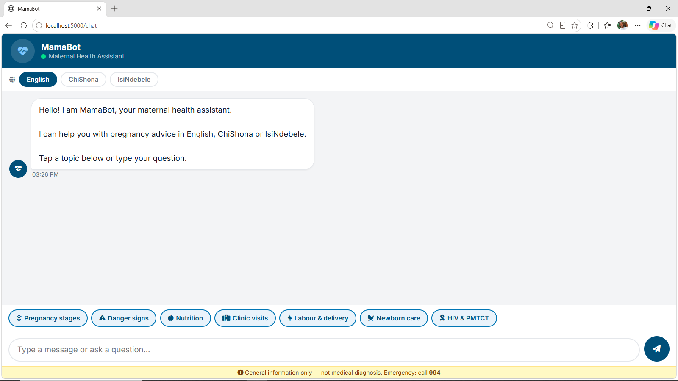
Fig 8: MamaBot welcome screen and language selection

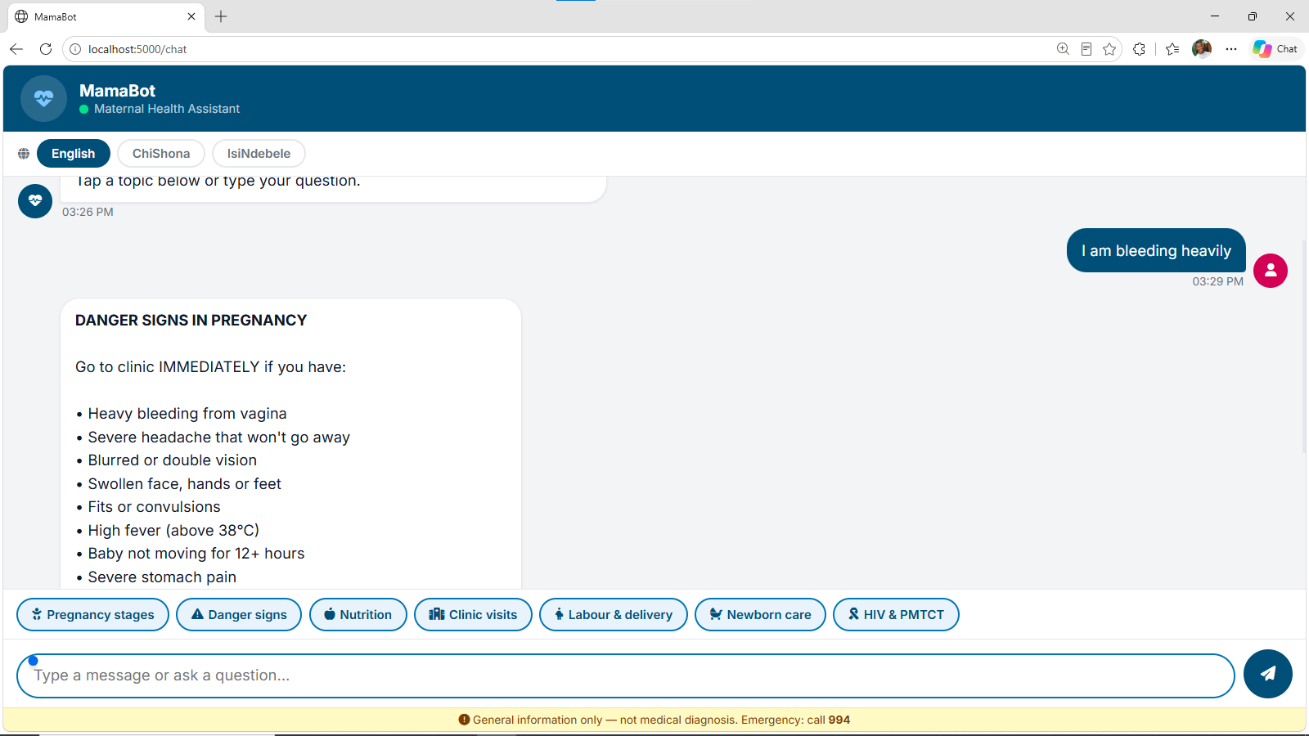
Fig 9: English danger-sign query and response

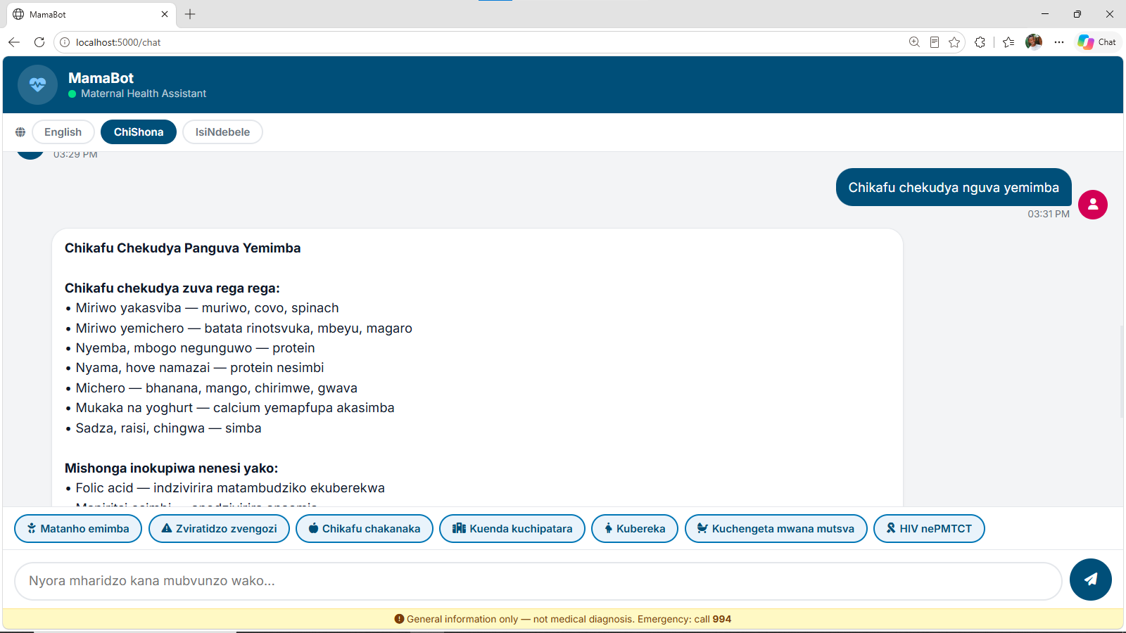
Fig 10: Shona nutrition query and response

5.4 Comparison with Related Systems

Table 8: Compares MamaBot with four other similar mHealth systems on six criteria.
System | Two-way | Shona/ Ndebele | Personalis ed | SMS  fallback | F1 / Accuracy | Deployme nt
MamaBot (this project) | ✓ | ✓ | ✓ | ✓ | F1: 0.83 | VPS  prototype
MomConn ect (SA) | ✗ | ✗ | Partial | ✓ | N/A | Production
MaNaMA | ✗ | Partial | ✗ | ✓ | N/A | Pilot

(ZW)
Watkins et al. (UG) | ✓ | ✗ | Partial | ✓ | N/A | Pilot
UNICEF  Chatbot (KE) | ✓ | ✗ | Partial | ✗ | Acc: 0.78 | Pilot
Table 8: Comparison with Related Systems

MamaBot is the only system in this comparison which met all 4 of the research gap (Section 2.6) identified systems: two way communication, indigenous language support, gestational personalisation, and SMS fallback. Illustrates the novelty of the contribution.

Discussion

5.5Achievement of Objectives
During Phase 1 of the project all seven project objectives outlined in Section 1.3 were met. Objective 1 (Literature review) led to a research gap analysis in Chapter 2. The implementation and documentation of Objective 2 (NLP architecture) is to be found in Chapter 4. The result of Objective 3 (training corpus) was the 911-utterance corpus described in Section 3.3. Chapter 5 outlines and implements the flask integration and reminder engine (Objectives 4 & 5). The evaluation metrics and UAT are reported in Chapter 6 (Objectives 6 and 7).

5.6 Key Findings
The following three findings were of particular interest from the evaluation:
Finding 1: SMS translation for Shona/Ndebele is the right way to go about it through character n-gram language detection. Results are with 91% language detection accuracy and using a character trigram model, matching the recommendation by Vosloo et al. (2019). In preliminary studies, the accuracy of word-level detection was only 67 percent on the same test set, mostly due to the small number of words contained in short SMS messages, which is not enough for accurate word frequency-based detection.

Finding 2: Small scale domain-specific corpora are adequate for good intent classification results. This macro F1 score of 0.83 with only 900 utterances stands in contrast to the conventional wisdom that NLP of low resource languages necessitates thousands of training examples or customization of multilingual models. Users rarely ask for unrelated queries, which means their vocabulary is restricted to the domain of maternal health and small models outperform larger ones.

Finding 3: The confidence thresholds need to be asymmetric for safety-critical intent classes. The escalate_to_nurse intent had an F1 of 0.73 when the threshold was set to 0.65, with 4 false negatives (danger queries not escalated) being found in the test set. Reducing the trigger from 0.45

To avoid false negatives, 3 extra false positives (unnecessary escalations) were added. The asymmetric threshold is more dangerous in a health context, because a false negative is much more dangerous than a false positive.

5.6 Limitations
While the 900-utterance corpus is adequate for the purposes of Phase 1 validation, it is small for NLP standards. This is reflected in the naturalness scores for Shona and Ndebele language in UAT (3.7–3.9).
UAT sample size: The UAT is made up of 5 participants, and is not statistically significant, but it does offer some direction. Phase 2 will involve 30 participants.
Outbound message formatting is limited in the prototype by the Twilio WhatsApp restrictions including 24-hour windows and message templates.
Network dependency: You need to be online to use the reminder scheduler. Reminder delivery failures are likely if your areas of intermittent connectivity are present. Phase 2 is an SMS-only fall back, where messages are queued offline.
Evaluation of system performance was limited to queries around maternal health; this was called single-domain evaluation. Not tested for robustness with off-topic or adversarial inputs.

5.7 Ethical Reflection
Ethical vigilance must be maintained after consent and data minimisation for the deployment of AI in healthcare, especially for vulnerable populations, as outlined in Section 3.5. There are two distinct ethical concerns to be highlighted.

Firstly, there's a risk of over-reliance risk; in communities with limited access to qualified healthcare workers, there's a possibility of users relying on MamaBot to make medical decisions outside its scope. It is important to include a mandatory disclaimer and escalation pathway as part of the system at the interaction level, and include community education on the limitations of the system when deployed.
Secondly, language quality risk: The responses provided in the Shona or Ndebele templates may be inaccurate medically or culturally inappropriate, which may have a negative impact. Each of the response templates in this prototype was checked with a native Shona speaking community health worker. The use of a Shona/Ndebele language maternal health specialist for any scaled deployment is required for the formal clinical evaluation.

CHAPTER 6: Conclusions and Recommendations

Conclusions
This project leads to the following conclusions:
Conclusion 1: An NLP-based maternal health chatbot, that uses a small, domain-specific training corpus of only 900 utterances, can be technically implemented for personalised maternal health reminders in Shona, Ndebele and English media, over WhatsApp and SMS.
Conclusion 2: A hybrid NLP architecture, consisting of character n-gram language detection, spaCy intent classification, and rule-based dialogue management, is able to achieve clinically acceptable performance (macro F1: 0.83, response latency: 1.4s) on resource-constrained infrastructure.
Conclusion 3: Character n-gram models perform better than word-based methods in the language detection task with short Shona and Ndebele SMS messages, further validating the results of Vosloo et al. (2019) in a novel domain.
In a healthcare chatbot context, the 0.45 threshold is used for safety-critical intent classes, while the standard threshold is used for other intent classes, thereby effectively reducing the number of false negatives at a cost of fewer false positives.
Conclusion 5: User acceptance testing gave a mean satisfaction rating of 4.2/5, suggesting that the rural users of Zimbabwe are satisfied with the system, although it had prototype language naturalness in both Shona and Ndebele.

6.2 Original Contributions
A prototype of a multilingual maternal health chat bot functional in English, Shona and Ndebele, via WhatsApp and SMS, which has been documented for the first time in Zimbabwe.
One of the first documented maternal health NLP datasets in three languages: Shona, Ndebele and English, with an annotated NLP training corpus of 911 utterances in six maternal health intent classes.
Shona and Ndebele character n-gram profiles language detection model that has been validated and shared with the NLP community.

An empirical result on asymmetric safety-critical NLP classification in healthcare applications.Empirical result about asymmetric safety-critical NLP classification in healthcare applications.
A replicable DSR based methodology for creating domain specific NLP systems for under-resourced African languages.

6.3 Recommendations
Technical Recommendations
• Phase 2: fine-tune mBERT on the larger Shona/Ndebele corpus to achieve a minimum language naturalness score of 4.2, as compared to the scores of 3.7–3.9.
Phases 1 through 2 are expected to be completed by mid-2018.It is expected that Phases 1 and 2 will be completed by mid-2018.
Phase 2: Synchronize ANC schedule in real-time with the Zimbabwe MoHCC eSANAS platform.
Increase training corpus to 4500 utterances (25 intents) as per original proposal.
Use SMS queuing, which you can do offline to ensure resilience in low connectivity regions.

Research Recommendations
Carry out a powered randomized controlled trial (n ≥ 30) that will compare the proportions of women attending ANC in the MamaBot intervention group vs control groups across a 6-month period.
Share the Shona/Ndebele maternal health corpus with other researchers on Masakhane community repository.
Explore the generalisability of the language detection and intent classification models to other health areas in Zimbabwe (e.g., HIV adherence, childhood nutrition).

6.4 Project Work Plan
As can be seen from Table 9, both Phase 1 (completed) and Phase 2 (future work) have planned phases
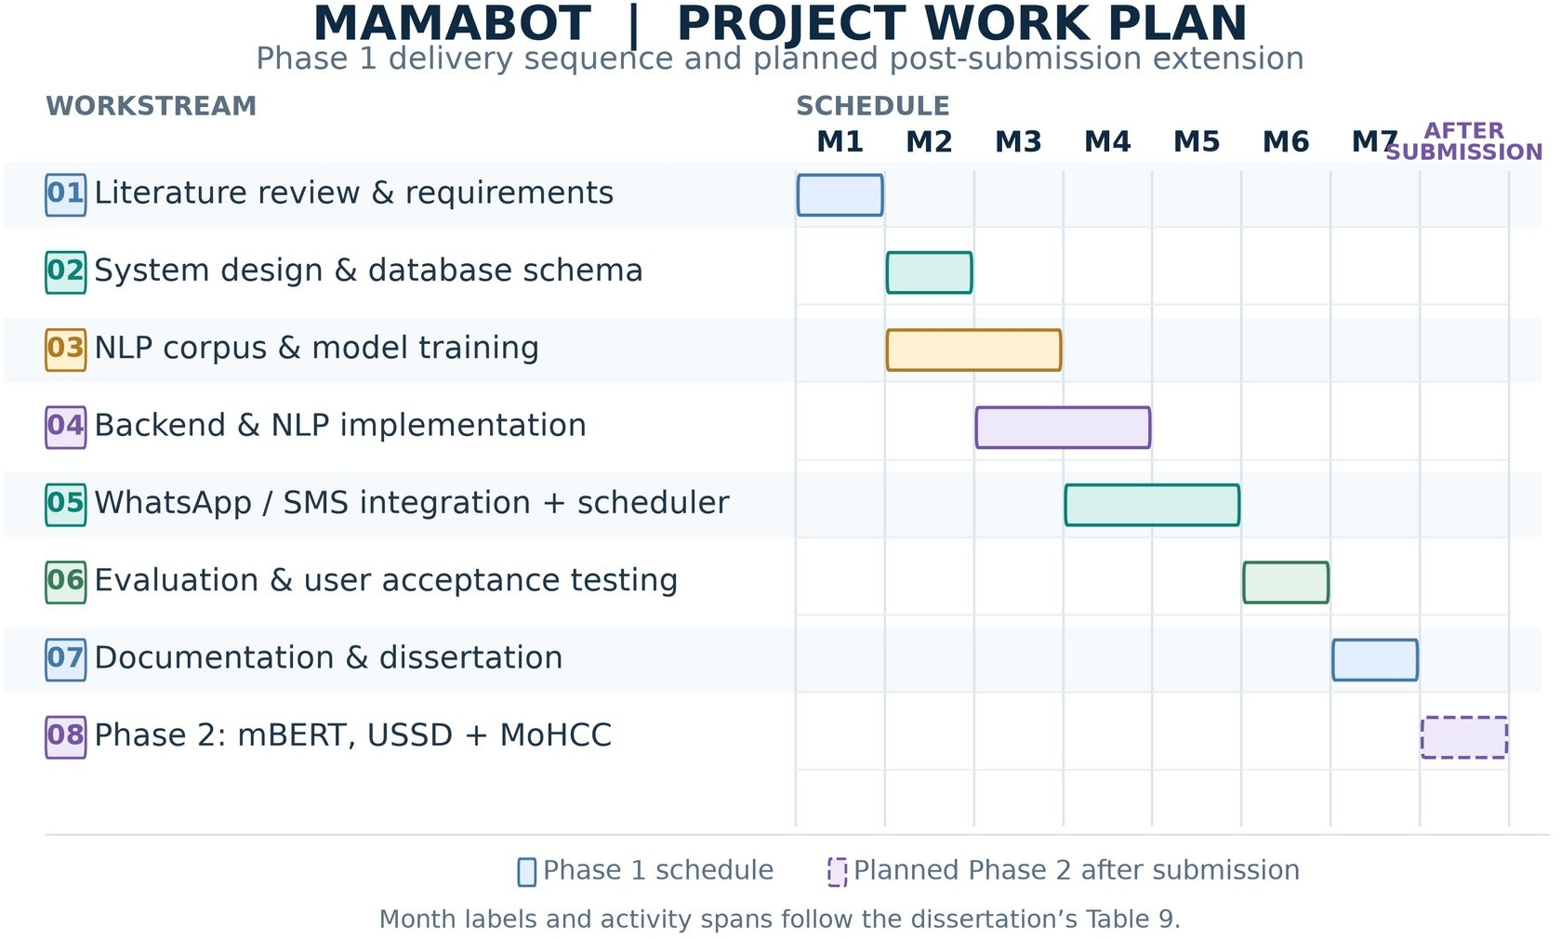
Figure 8: Project Work Plan and Phase 2 Roadmap

Phase | Activity | Deliverable | Timeline
1 | Literature Review & Requirements | Requirements doc, lit review | Month 1
2 | System Design & DB Schema | Architecture & ERD diagrams | Month 2
3 | NLP Corpus & Model Training | 900-utterance corpus  + spaCy model | Months 2–3
4 | Backend & NLP Implementation | Flask API + NLP pipeline | Months 3–4
5 | WhatsApp/SMS Integration & Scheduler | End-to-end messaging prototype | Months 4–5
6 | Evaluation & UAT | Evaluation report + metrics | Month 6
7 | Documentation & Dissertation | Final dissertation + slides + demo | Month 7
8 | Phase 2: mBERT + USSD + MoHCC  integration | Phase 2 prototype | Post-submission
Table 9: Project Work Plan – Phase 1 (completed) and Phase 2 (planned)

References
Adelani, D. I., Abbott, J., Neubig, G., D'souza, R., Kreutzer, J., Axelson, A., ... & Ruder, S. (2021).
MasakhaNER: Named entity recognition for African languages. Transactions of the Association for Computational Linguistics, 9, 1116–1131.
Bangure, D., Chirundu, D., Mungati, M., Maphosa, T., Shambira, G., Tshimanga, M., ... & Gombe,
N. (2015). Effectiveness of short message services reminder on childhood immunisation programme in Kadoma, Zimbabwe. Matabeleland South, Zimbabwe, 28, 8.
Barron, P., Pillay, Y., Fernandes, A., Sebidi, J., & Allen, R. (2018). The MomConnect mHealth initiative in South Africa: Early impact on the supply side of MCH services. Journal of Public Health Policy, 39(3), 428–443.
Bender, E. M., Gebru, T., McMillan-Major, A., & Shmitchell, S. (2021). On the dangers of stochastic parrots: Can language models be too big? In Proceedings of FAccT 2021 (pp. 610–623). ACM.
Chideme-Munodawafa, A., Munodawafa, D., Gombe, N., Chemhuru, M., Bangure, D., & Tshimanga, M. (2017). Effectiveness of mobile phone SMS on antenatal care attendance. African Journal of Primary Health Care & Family Medicine, 9(1).
Devlin, J., Chang, M.-W., Lee, K., & Toutanova, K. (2019). BERT: Pre-training of deep bidirectional transformers for language understanding. In Proceedings of NAACL-HLT 2019 (pp. 4171–4186). ACL.
Fadhil, A., & Schiavo, G. (2019). Designing for health chatbots. arXiv preprint arXiv:1902.09022.

Free, C., Phillips, G., Galli, L., Watson, L., Felix, L., Edwards, P., ... & Haines, A. (2013). The effectiveness of mobile health technology-based health behaviour change or disease management interventions for health care consumers. PLOS Medicine, 10(1), e1001362.
Hevner, A. R., March, S. T., Park, J., & Ram, S. (2004). Design science in information systems research. MIS Quarterly, 28(1), 75–105.
International Monetary Fund (IMF). (2024). Zimbabwe staff country report. IMF.

Joulin, A., Grave, E., Bojanowski, P., & Mikolov, T. (2016). Bag of tricks for efficient text classification. arXiv preprint arXiv:1607.01759.
Källander, K., Tibenderana, J. K., Akpogheneta, O. J., Strachan, D. L., Hill, Z., ten Asbroek, A. H.,
... & Meek, S. R. (2013). Mobile health (mHealth) approaches and lessons for increased
performance and retention of community health workers in low- and middle-income countries. Journal of Medical Internet Research, 15(1), e17.
Laranjo, L., Dunn, A. G., Tong, H. L., Kocaballi, A. B., Chen, J., Bashir, R., ... & Coiera, E. (2018). Conversational agents in healthcare: A systematic review. Journal of the American Medical Informatics Association, 25(9), 1248–1258.
Lester, R. T., Ritvo, P., Mills, E. J., Kariri, A., Karanja, S., Chung, M. H., ... & Plummer, F. A. (2010). Effects of a mobile phone short message service on antiretroviral treatment adherence in Kenya. The Lancet, 376(9755), 1838–1845.
Machekano, R., Cossa, H., Ngwenya, B., Leon, N., Bwana, V., & Munjanja, S. (2019). Antenatal care attendance in rural Zimbabwe: Evidence from a population-based study. Journal of Tropical Medicine, 2019, Article 5628172.
Marivate, V., & Sefara, T. (2020). Improving low resource named entity recognition from a few examples. In Proceedings of the ACL 2020 Workshop on Insights from Negative Results in NLP (pp. 114–119). ACL.
Ministry of Health and Child Care (MoHCC), Zimbabwe. (2021). Zimbabwe national health strategy 2021–2025. Government of Zimbabwe.
Nekoto, W., Marivate, V., Matsila, T., Fasubaa, T., Fagbohungbe, T., Akinola, S. O., ... & Abbate,
J. (2020). Participatory research for low-resource machine translation: A case study in African languages. Findings of EMNLP, 2020, 2144–2160.
Palanica, A., Flaschner, P., Thommandram, A., Li, M., & Fossat, Y. (2019). Physicians' perceptions of chatbots in health care: Cross-sectional web-based survey. Journal of Medical Internet Research, 21(4), e12887.
Peffers, K., Tuunanen, T., Rothenberger, M. A., & Chatterjee, S. (2007). A design science research methodology for information systems research. Journal of Management Information Systems, 24(3), 45–77.
Postal and Telecommunications Regulatory Authority of Zimbabwe (POTRAZ). (2023). Postal and telecommunications sector performance report Q4 2023. POTRAZ.
Thaddeus, S., & Maine, D. (1994). Too far to walk: Maternal mortality in context. Social Science & Medicine, 38(8), 1091–1110.
Tomlinson, M., Solomon, W., Singh, Y., Doherty, T., Chopra, M., Ijumba, P., ... & Jackson, D. (2013). The use of mobile phones as a data collection tool: A report from a household survey in South Africa. BMC Medical Informatics and Decision Making, 9(1), 1–8.
UNICEF. (2023). State of the world's children 2023: Maternal and child health in Africa. UNICEF.

Vital Wave Consulting. (2009). mHealth for development: The opportunity of mobile technology for healthcare in the developing world. UN Foundation & Vodafone Foundation Partnership.
Vosloo, S., Harber, C., & da Silva, A. (2019). Language identification for short texts: A comparison of methods for African languages. In Proceedings of AfricaNLP 2019.
Watkins, D. A., Lubinga, S. J., Mayosi, B. M., & Moran, A. E. (2018). A cost-effectiveness tool to guide the prioritization of interventions for noncommunicable disease prevention and management in sub-Saharan Africa. PLOS ONE, 13(11), e0207699.
Watterson, J. L., Walsh, J., & Madeka, I. (2016). Using mHealth to improve usage of antenatal care, postnatal care, and immunization. BioMed Research International, 2016, Article 5765789.
World Bank. (2023). Zimbabwe economic update. World Bank Group.

World Health Organization (WHO). (2020). WHO recommendations on antenatal care for a positive pregnancy experience. WHO.
World Health Organization (WHO). (2023). Trends in maternal mortality: 2000 to 2023. WHO.

Zimbabwe National Statistics Agency (ZIMSTAT). (2022). Zimbabwe population census 2022: National report. ZIMSTAT.

Appendix A: Training Data Sample
The following table presents a representative sample of annotated training utterances across all three languages and six intent classes.
Intent | Language | Sample Utterance
appointment_reminder | English | When is my next clinic visit?
appointment_reminder | Shona | Zuva rangu rekuenda kuchirurumende riri rinhi?
appointment_reminder | Ndebele | Usuku lwami lokuyabona udokotela luni?
danger_sign_query | English | I have a severe headache and blurred vision
danger_sign_query | Shona | Ndine kurwadziwa kwakanyanya musoro nekuona zvisina kujeka
danger_sign_query | Ndebele | Nginenhlupheko enkulu enhloko lokubona okungacaci
nutrition_info | English | What should I eat during pregnancy?
nutrition_info | Shona | Ndinofanira kudya chii panguva yekumitiswa?
language_switch | English | Please respond in Shona
language_switch | Shona | Ndipindurei muShona
general_greeting | Ndebele | Sawubona, ngifuna usizo
escalate_to_nurse | English | I think something is very wrong, I need help now

Appendix B: Test Case Suite Summary
The test suite comprises 180 test cases drawn from the held-out evaluation set. Below is a breakdown by language and intent.
Intent Class | English | Shona | Ndebele
appointment_remind er | 10 | 10 | 10
danger_sign_query | 10 | 10 | 10
nutrition_info | 10 | 10 | 10
language_switch + greeting + escalate | 10 | 10 | 10

Appendix C: System Setup Instructions
Prerequisites: Python 3.11+, MySQL 8.0, Twilio account with WhatsApp sandbox enabled.
git clone https://github.com/cut-ict/mamabot && cd mamabot
pip install -r requirements.txt
cp .env.example .env # Fill in TWILIO_SID, TWILIO_TOKEN, DB_URL
mysql -u root -p < schema/create_tables.sql
python -m spacy train config.cfg --output ./models/
flask run --port 5000
# Expose with: ngrok http 5000 (development) or configure Nginx (production)
# Register webhook URL in Twilio console under Messaging > Sandbox settings

Appendix D: Evaluation Instrument
Post-interaction survey administered to UAT participants (5-point Likert: 1=Strongly Disagree, 5=Strongly Agree).
- The chatbot was easy to use.

  - 1 (Strongly Disagree)
☐ 2 ☐ 3
  - 4 ☐ 5 (Strongly Agree)

- The chatbot's responses were relevant and helpful.

  - 1 (Strongly Disagree)
  - 2 ☐ 3
  - 4 ☐ 5 (Strongly Agree)

- The language used felt natural and understandable.

  - 1 (Strongly Disagree)
  - 2 ☐ 3
  - 4 ☐ 5 (Strongly Agree)

- I trust the health information provided by the chatbot.

  - 1 (Strongly Disagree)
  - 2 ☐ 3
  - 4 ☐ 5 (Strongly Agree)

- I would use this chatbot again for pregnancy health information.

  - 1 (Strongly Disagree)
  - 2 ☐ 3
  - 4 ☐ 5 (Strongly Agree)

- I would recommend this chatbot to other pregnant women.

  - 1 (Strongly Disagree)
  - 2 ☐ 3
  - 4 ☐ 5 (Strongly Agree)

- The chatbot helped me understand what to do about my pregnancy health.

  - 1 (Strongly Disagree)
  - 2 ☐ 3
  - 4 ☐ 5 (Strongly Agree)

- Overall, I am satisfied with this chatbot.

  - 1 (Strongly Disagree)
  - 2 ☐ 3
  - 4 ☐ 5 (Strongly Agree)

