Criteria | Score | Reasoning/Evidence
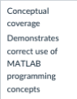 | 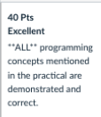 | - As stated by the criteria, the coding project in its entirety used all programming concepts including vectors, matrices, loops, functions, drivers, conditional execution, for loops, while loops, nested loops, binary operators, comparison operators, assignment, built in functions, custom functions, etc. (There may be more unmentioned here such as the extension functions, etc.)
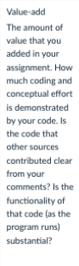 | 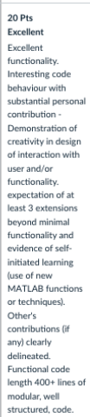 | - Code is functional with all conceivable edge cases such as special characters, spacing, @ symbols, guess word not being in dictionary and other such factors being accounted for and tested.  - All code used in the project besides in-built Matlab functions such as ismember was written independently.  - Design of game is dynamic with the figure being used to display output updating dynamically as the game progresses.  - Extensions beyond minimal functionality/evidence of self learning:  - Excel read function (xlsread function)  - Interactable menu options (Menu function)  - Audio reading from file (audioread)  - Audio playing (soundsc)  - Inbuilt replayer for game with menu at the end of game.  - Figure creation and dynamic updating with get current figure(gcf)  - Figure property manipulation  (setting name and windowstyle)  - Subplots  - Filling subplots based on coordinates to create a square with colour.  - Removing x axis and y axis titles by setting them to []  - Adding a unique title to subplots based on entry of character array at that index  - No direct third-party contributions for any code however online resources such as Matlab discussion forums were accessed to learn and use certain functions such as subplots.  - Functional, well-structured and commented code for final versions of files adding up to 728 lines. This is not including previous versions of code or the drivers for those respective versions. (Check all code file)  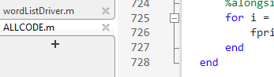
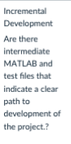 | 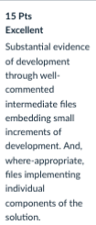 | - Flowcharts for game input and function flow map was created as part of planning and self-learning.  - Incremental development conducted by dividing the big game, into a set of smaller functions and steps with flow charts, and overall function maps. These smaller functions were then developed in independent files and versions were created for changes, etc.  - Various versions of the individual files were produced with each version being well commented and being tested with their own specific drivers where applicable, or with manual testing with test cases otherwise (manual testing for guesser and main game file).  - Drivers were also well commented with code explaining edge cases, etc.  - Individual components of the code, such as functions were stored in individual files in the same directory to simplify code and invoked by simply referring to them where necessary.  - All file versions were well commented throughout development.
 | 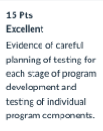 | - Each version of an independent file including unused versions was tested with their own specific drivers where applicable, or with manual testing with test cases otherwise (manual testing for guesser and main game file).  - Drivers were also well commented with code explaining edge cases, etc.  - These testing files can be accessed in the testing and planning folder.  - The order of testing followed order of development with drivers and test cases being produced alongside one another in development.
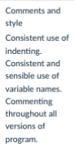 | 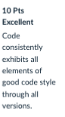 | - All versions of code including unused versions were well-commented throughout.  - Variable names followed the schemes laid out in week 1 videos.  - Code was well spaced and aligned in order of precedence.

