### **Capstone 01: Exploratory Data Analysis**

**SQL Queries – Use SQL queries to solve for the following problem snippets:**

Return the Cust ID that received the 5th highest number of campaigns for the entire duration (using only the campaign data: **1AoFEeF7oHoG1jRA17JejRHVjeEER18V**

SELECT CustID

FROM (

SELECT CustId, COUNT(DISTINCT Campaign_Channel) AS campaign_count

FROM campaign_data

GROUP BY CustID

ORDER BY campaign_count DESC

LIMIT 5

) AS top_5

ORDER BY CustId ASC

LIMIT 5;

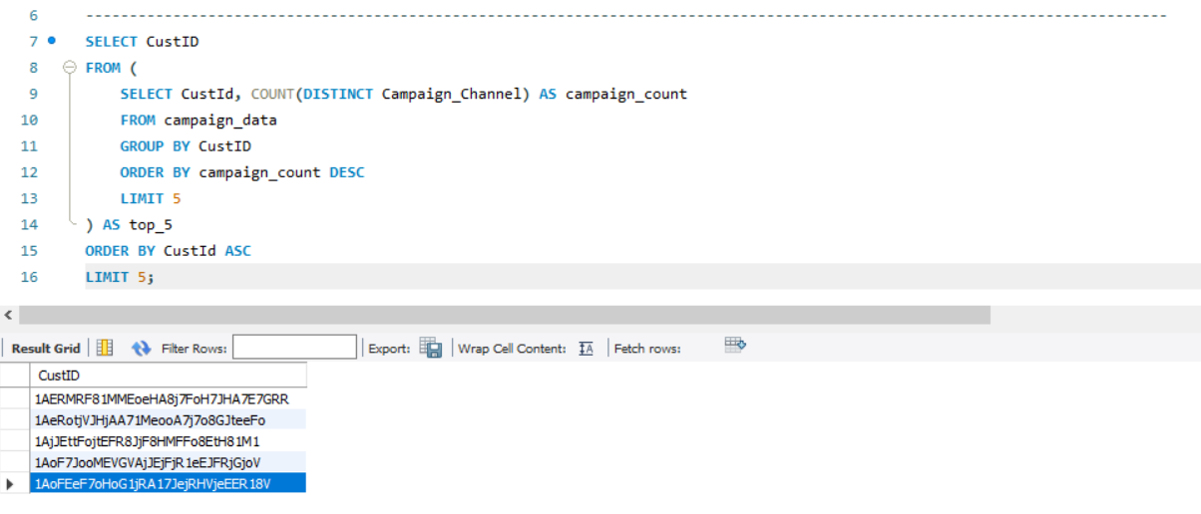

* Find the States for which the average time of delivery from the Sale Timestamp to the Delivered Timestamp is the minimum and the maximum respectively. Use the Delivery data for this and only those records for which the Sale Timestamp, Delivery Timestamp, and Ship to State – all variables are populated.

SELECT shiptostate , avg(delivered_timestamp) , avg(sale_timestamp) FROM customer_delivery_data

group by shiptostate

having max(delivered_timestamp);

