**Webapp - 'favorite dogs' Testing Results:**

Created a React webapp that will present a gallery of 6 random dog images from <https://random.dog/woof.json>.

Webapp has 2 endpoints (2 pages) on Nav bar:

Routing is used to navigate from one page to other page.

1. / :

It navigates to **All Dogs List** page. This page will have 6 random dogs images from given api. We can see dogs images and **Add to** **Favourite** button in below of every image. User can select favourite image by clicking on the button below the image. Storing favourite images is achieved by using localStorage. Also, there is refresh button which provides next set of random images to user to select favourite one.

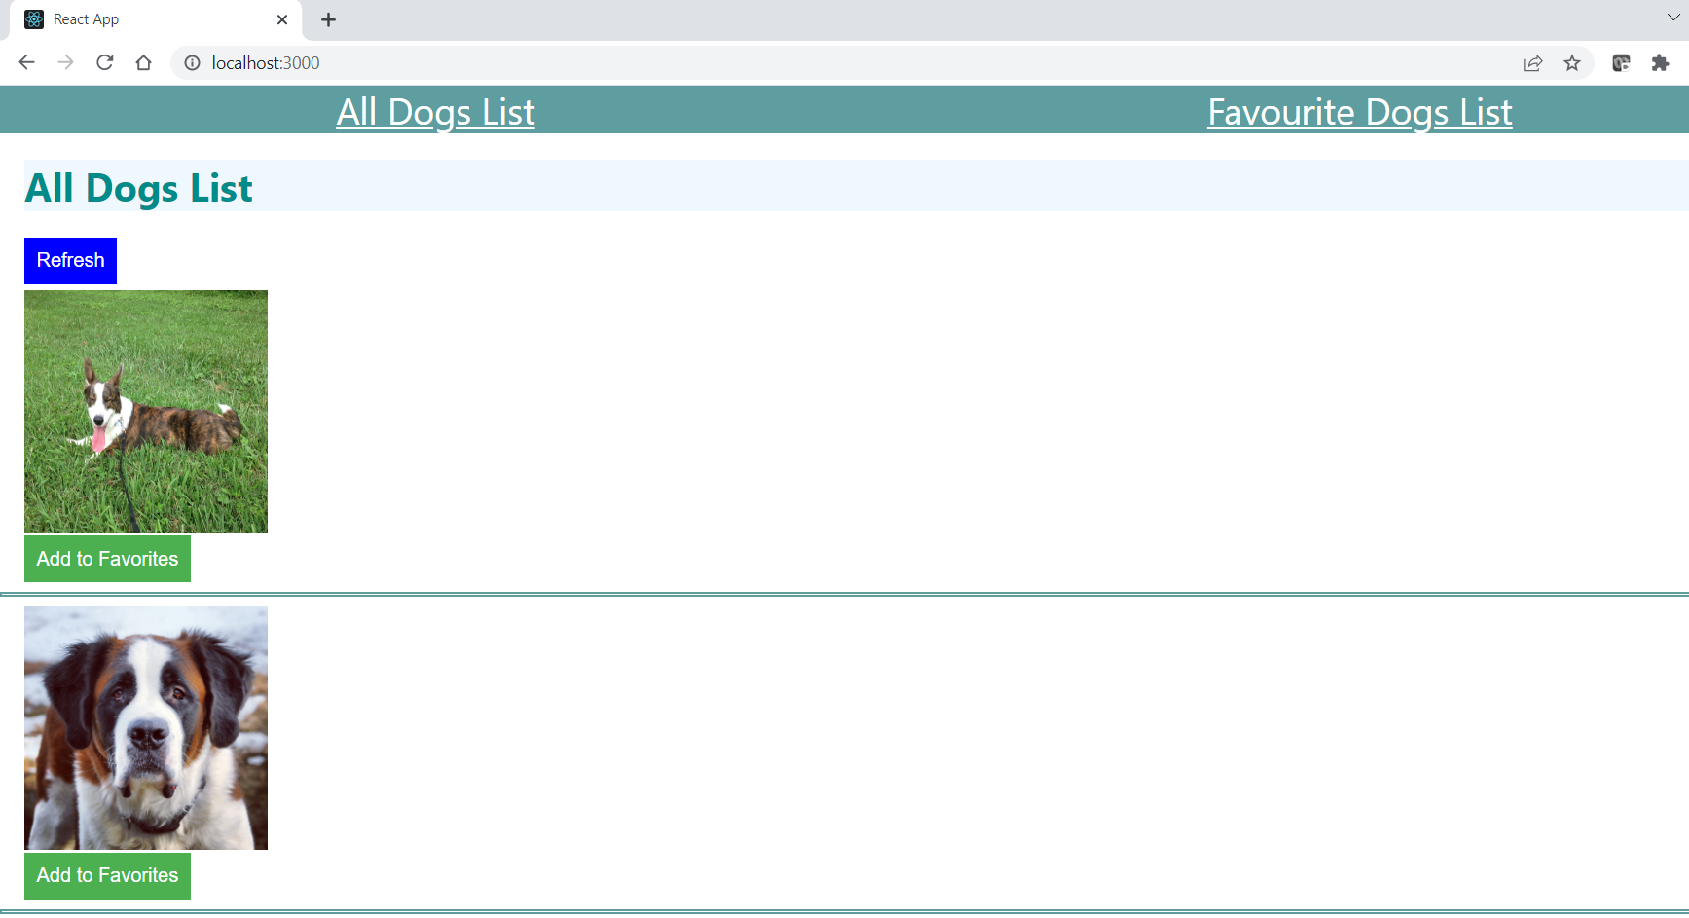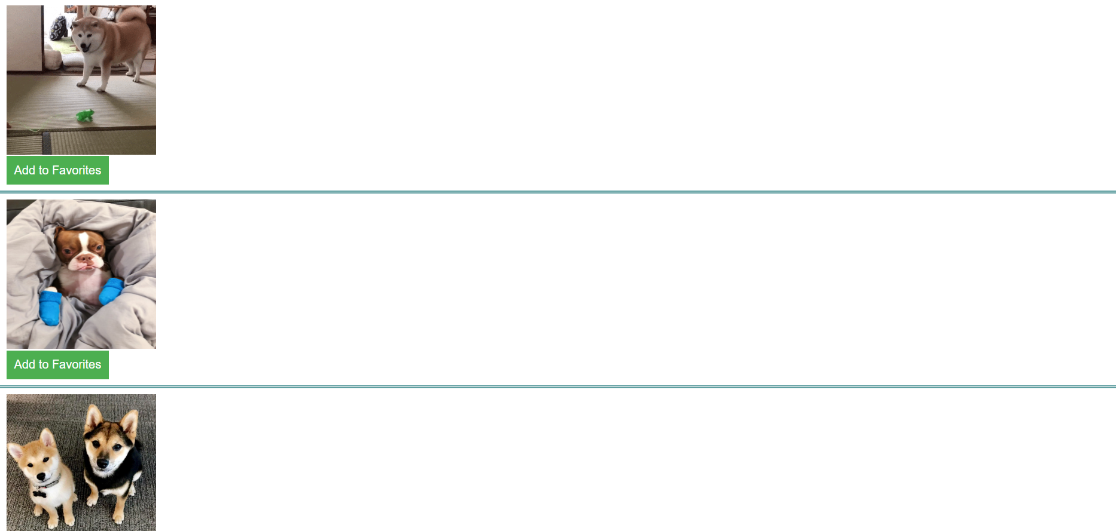 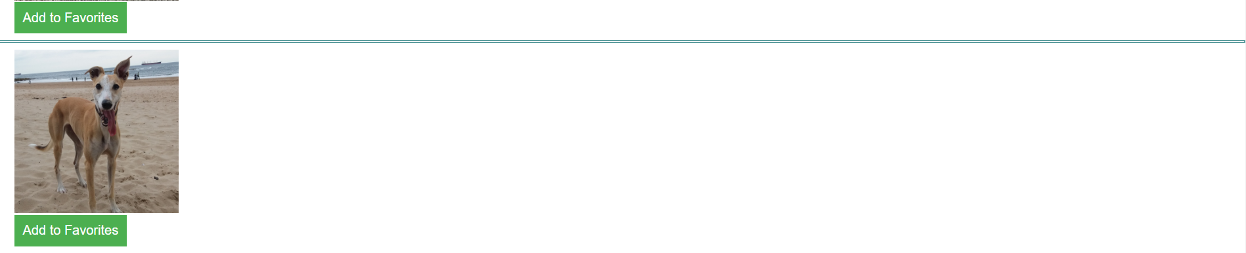

Api call: 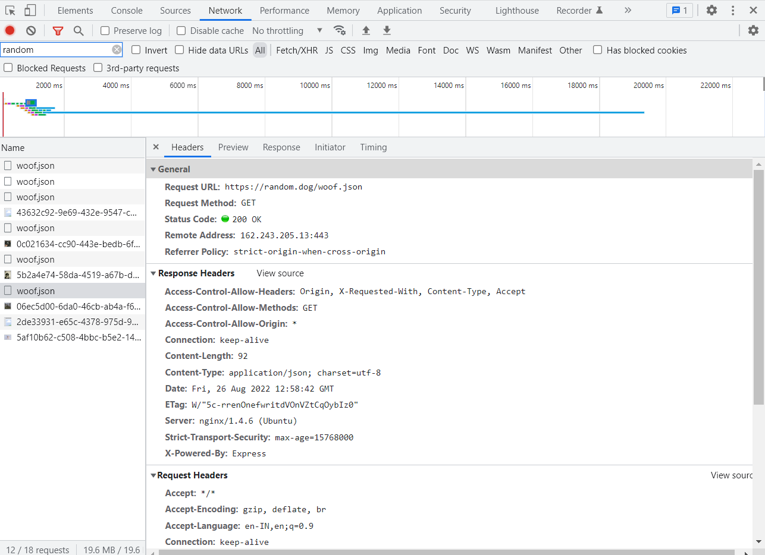

1. /favorites :

It navigates to **Favourite Dogs List page**

Initially when no favourite dog image has been selected, this page will show message as shown below,

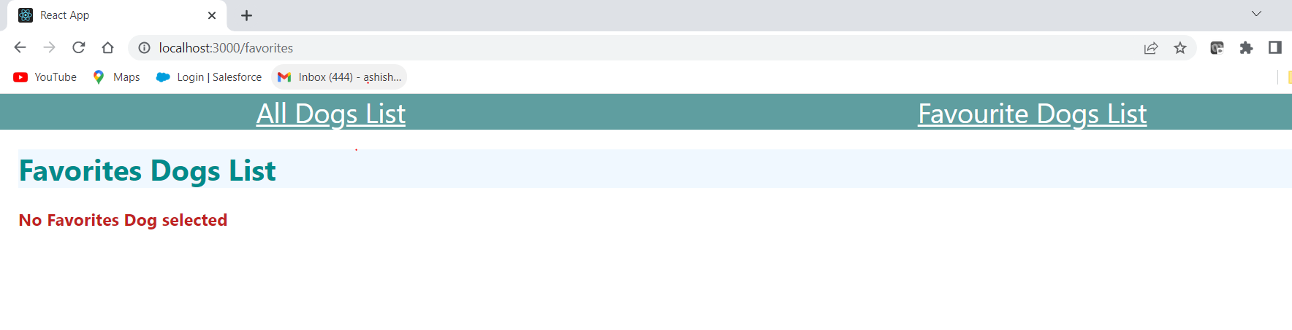

After selecting favourite dags, we can see selected dog images on the this page using localstorage values.

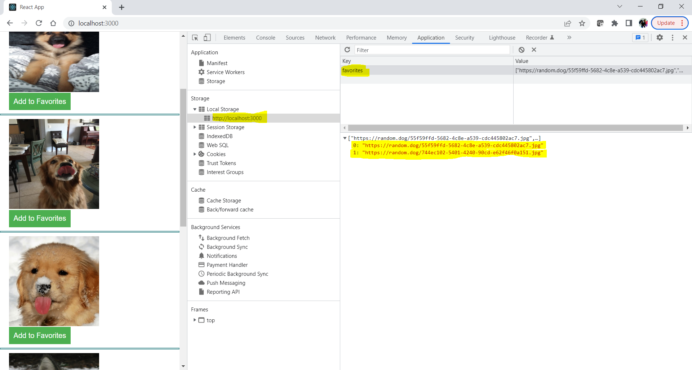

On Favourite Dogs List page 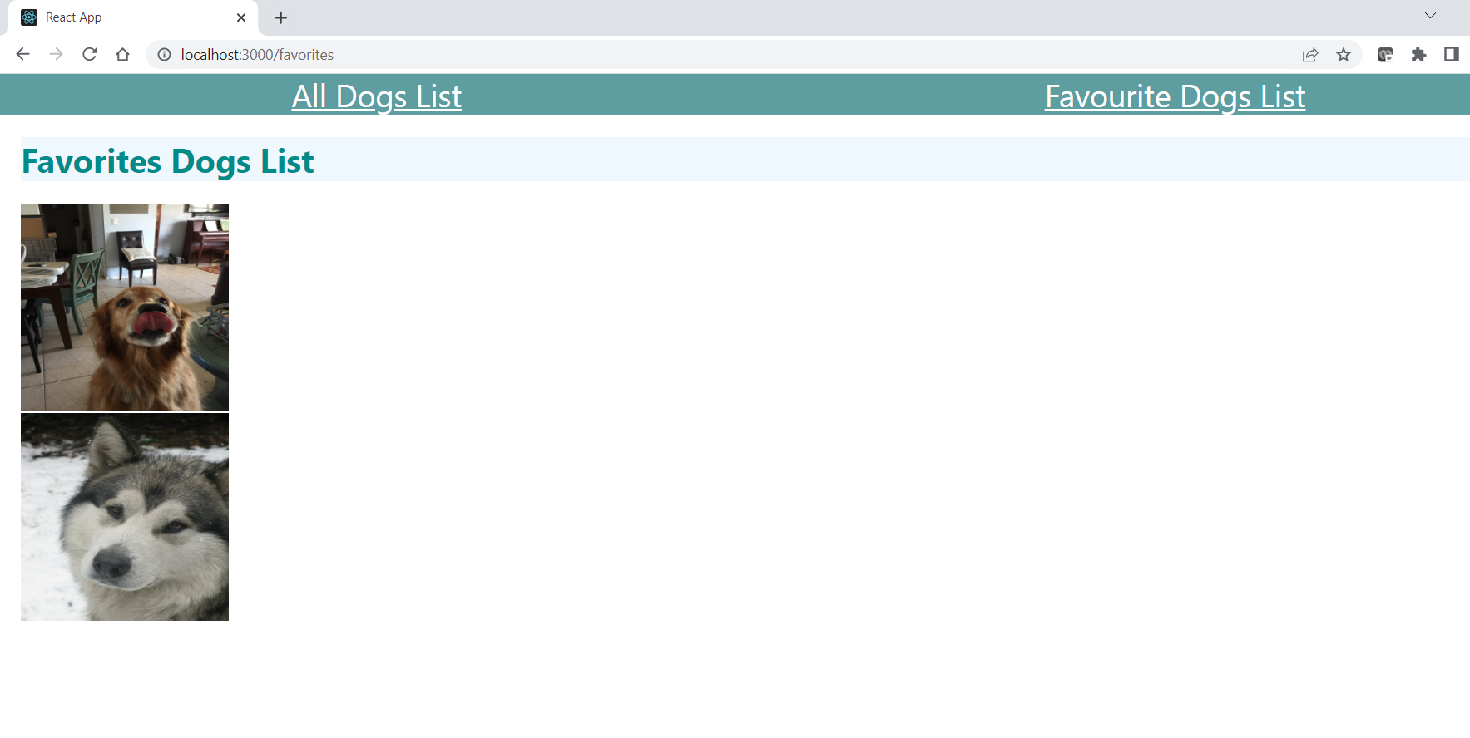

Added new image to favourites and it retains previously selected as well as new images :