**Application - 'math api' Testing Results**

Implement a webservices in Java Spring boot framework.

Webservice are tested for below data:

givenList = {11,10,4, 15, 17, 13, -2, 26};

quantifier = 4;

qth_percentile = 25;

1. /min :

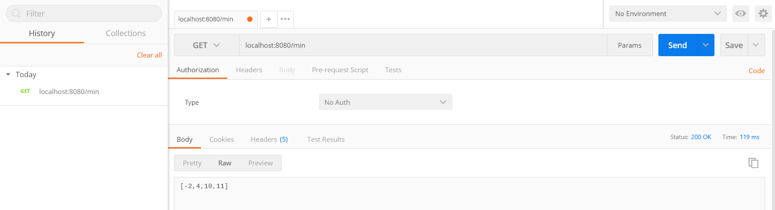

1. /max:

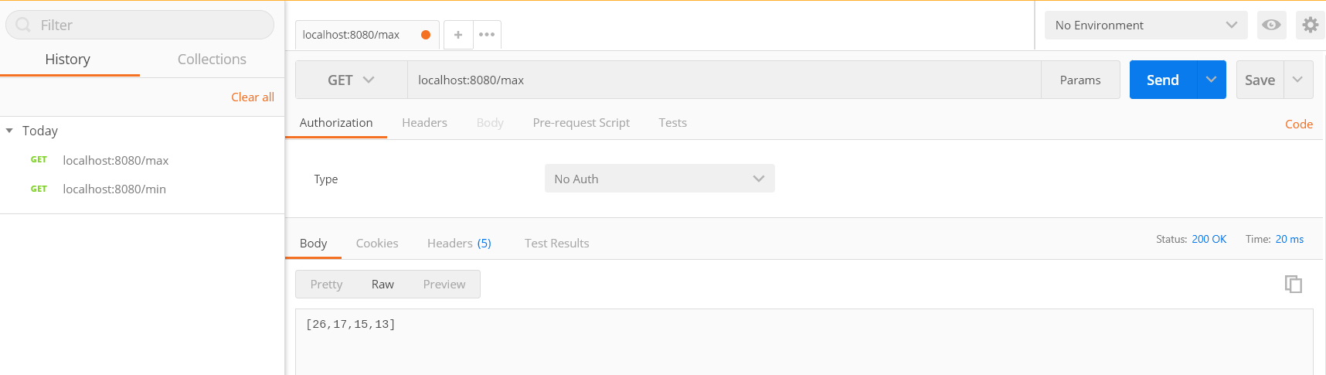

1. /avg:

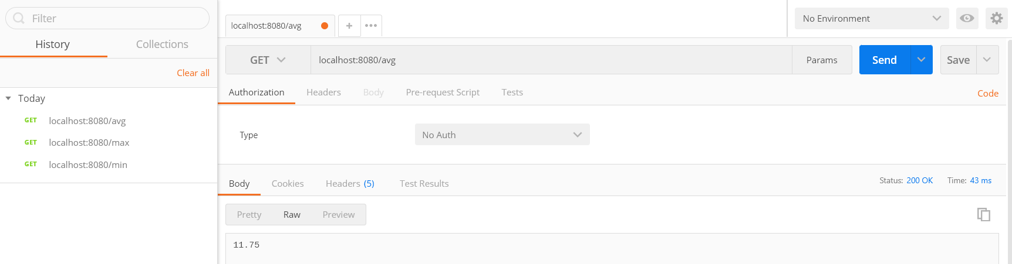

1. /median

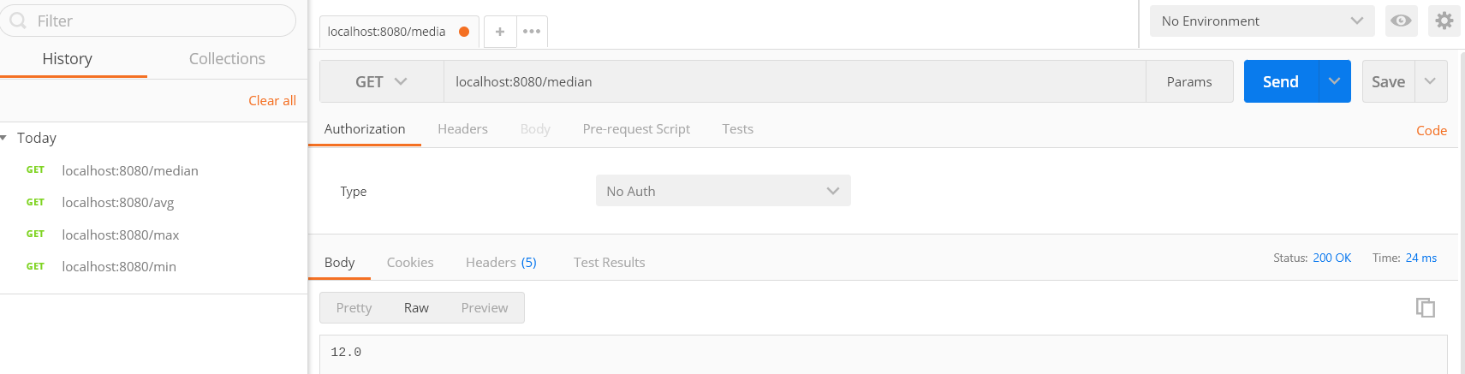

1. /percentile:

