Game Design Document

Fill up the Following document

1. Write the title of your project.

Keep going!

1. What is the goal of the game?

To overcome the obstacles and reach the finish line

1. Write a brief story of your game?

Two player’s racing game where the players need to overcome the

obstacles in the game and reach the finish line. Whoever comes first

wins the game.

1. Which are the playing characters of this game?

* Playing characters are the ones which respond to the user based on the input from the user
* Cars, monkeys, dinos, wizards etc, are the playing characters in the game.

|  |  |  |
| --- | --- | --- |
| Number | Character Name | What can this character do? |
| 1 | Player1 | Run,move sideways |
| 2 | Player2 | Run,move sideways |
| 3 |  |  |
| 4 |  |  |
| 5 |  |  |
| 6 |  |  |
| 7 |  |  |
| 8 |  |  |

1. Which are the Non Playing Characters of this game?

* Non Playing characters are the ones which don't have an action or a behaviour when the user interacts with the game.
* Hurdles, stones, bananas, coins, etc are non playing characters in the game.

|  |  |  |
| --- | --- | --- |
| Number | Character Name | What can this character do? |
| 1 | Hurdles | Block the players |
| 2 | coins | Increases the score |
| 3 |  |  |
| 4 |  |  |
| 5 |  |  |
| 6 |  |  |
| 7 |  |  |
| 8 |  |  |

Draw your imagination of this game. What does this game look like?

* Draw the game either on your computer or on paper,
* Add images of scenes of the game to show each of the playing and non-playing characters at least once.

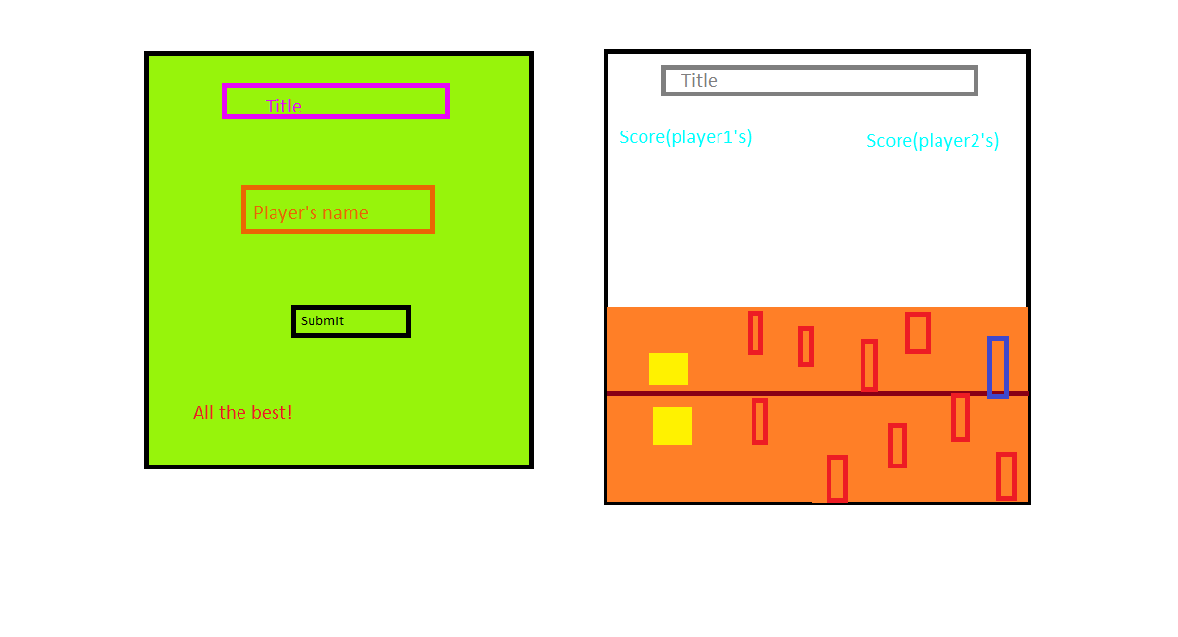

How do you plan to make your game engaging?

Add a sound when thepalyer wins,loses, hurdles are cleared