# PRACTICAL 1

**GRAPHICAL METHOD USING R PROGRAMMING**

# R Program

#Find a geometrical interpretation and solution as well for the following LP problem

#Max z= 3x1 + 5x2

#subject to constraints:

#x1+2x2<=2000

#x1+x2<=1500

#x2<=600

#x1,x2>=0

# Install.packages(“lpsolve”)

# Load lpSolve

require(lpSolve)

## Set the coefficients of the decision variables -> C of objective function

C <- c(3,5)

# Create constraint martix B

1. <- matrix(c(1, 2,

1, 1,

0, 1

), nrow=3, byrow=TRUE)

# Right hand side for the constraints

1. <- c(2000,1500,600) # Direction of the constraints sconstranints_direction <- c("<=", "<=", "<=")

# Create empty example plot

plot.new() plot.window(xlim=c(0,2000), ylim=c(0,2000))

axis(1) axis(2)

title(main="LPP using Graphical method")

title(xlab="X axis") title(ylab="Y axis") box()

# Draw one line

segments(x0 = 2000, y0 = 0, x1 = 0, y1 = 1000, col = "green") segments(x0 = 1500, y0 = 0, x1 = 0, y1 = 1500, col = "green") segments(x0 = 0, y0 = 0, x1 = 600, y1 = 0, col =

"green")

# Find the optimal solution

optimum <- lp(direction="max", objective.in = C, const.mat = A,

const.dir = constranints_direction, const.rhs = B,

all.int = T)

# Print status: 0 = success, 2 = no feasible solution print(optimum$status) # Display the optimum values for x1,x2 best_sol <- optimum$solution names(best_sol) <- c("x1", "x2")

print(best_sol)

# Check the value of objective function at optimal point print(paste("Total cost: ", optimum$objval, sep=""))

OUTPUT:

[Workspaceloadedfrom~/.RData] >#Righthandsidefortheconstraints

>B<-c(2000,1500,600) >#RProgram

>#LoadlpSolve

>require(lpSolve)

Loadingrequiredpackage:lpSolve >##Setthecoe cientsofthedecision variables->C>C<-c(3,5)

>#CreateconstraintmartixB

>A<-matrix(c(1,2,

+1,1,

+0,1

+),nrow=3,byrow=TRUE)

>

>#Righthandsidefortheconstraints

>B<-c(2000,1500,600)

>

>#Directionoftheconstraints

>constranints_direction<-c("<=","<=","<=")

>

>

>#Createemptyexampleplot

>#plot(2000,2000,col="white",xlab="", ylab="")>plot.new()

>plot.window(xlim=c(0,2000),ylim=c(0,2000))

>axis(1)

>axis(2)

>title(main="LPPusingGraphicalmethod")

>title(xlab="Xaxis") >title(ylab="Yaxis") >box()

>#Drawoneline

>segments(x0=2000,y0=0,x1=0,y1=1000,col= "green")>segments(x0=1500,y0=0,x1=0,y1=

1500,col="green")>segments(x0=0,y0=0,x1=

600,y1=0,col="green")>

>

>

>#Findtheoptimalsolution

>optimum<-lp(direction="max",

+objective.in=C,

+const.mat=A,

+const.dir=constranints_direction,+ const.rhs=B,

+all.int=T)

>#Printstatus:0=success,2=nofeasiblesolution

>print(optimum$status)

[1]0

>#Displa theoptimumvaluesforx1,x2

>best_sol<-optimum$solution

>names(best_sol)<-c("x1","x2")

>print(best_sol) x1x2

1000500

>

>#Checkthevalueofobjectivefunctionat optimalpoint>print(paste("Totalcost:", optimum$objval,sep=""))

[1]"Totalcost:5500"

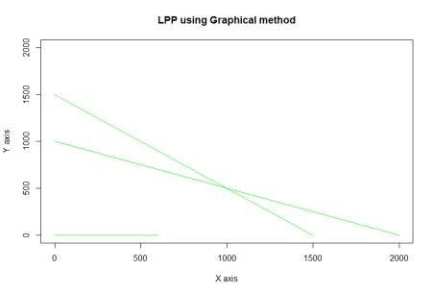

**PRACTICAL 2**

# Simplex Method with 2 variables using Python

from scipy.optimize import linprog

#Max z=3x1+2x2

#subject to

#x1 + x2 <=4

#x1 - x2 <=2 #x1,x2>=0 obj = [-3, -2]

lhs_ineq = [[ 1, 1], # Red constraint left side ... [1, -1]] # Blue constraint left side

rhs_ineq = [4, # Red constraint right side ... 2] # Blue constraint right side

bnd = [(0, float("inf")), # Bounds of x ... (0, float("inf"))] # Bounds of y

>>> opt = linprog(c=obj, A_ub=lhs_ineq, b_ub=rhs_ineq,

... bounds=bnd,method="revised simplex")

>>> opt

opt.fun

opt.success

opt.x

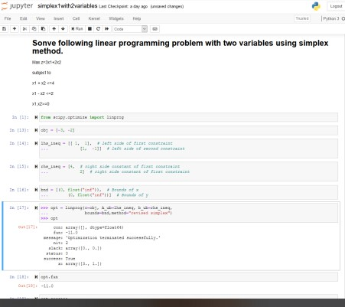

**PRACTICAL 3**

# Simplex Method with 3 variables using Python

from scipy.optimize import linprog

#Min z= x1-3x2+2x3

#subject to

#3x1-x2+3x3<=7

#-2x1+4x2<=12

#-4x1+3x2+8x3<=10 #x1,x2,x3>=0

obj = [1, -3, 2]

lhs_ineq = [[ 3, -1, 3], # Red constraint left side ... [-2, 4, 0], # Blue constraint left side ... [ -4, 3, 8]] # Yellow constraint left side

rhs_ineq = [7, # Red constraint right side ... 12, # Blue constraint right side ... 10] # Yellow constraint right side

bnd = [(0, float("inf")), # Bounds of x

... (0, float("inf")),

... (0, float("inf"))] # Bounds of y

>>> opt = linprog(c=obj, A_ub=lhs_ineq, b_ub=rhs_ineq,

... bounds=bnd,

... method="revised simplex")

>>> opt

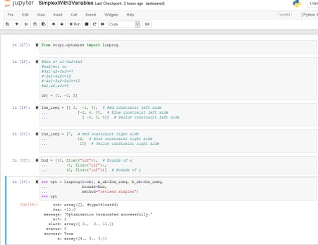

**PRACTICAL 4**

# Simplex Method with Equality Constraints Using Python

from scipy.optimize import linprog

#Max z=x+2y

#subject to

#2x+y<=20

#-4x+5y<=10

#-x+2y>=-2

#-x+5y=15 #x,y>=0 obj = [-1, -2]

lhs_ineq = [[ 2, 1], # Red constraint left side ... [-4, 5], # Blue constraint left side ... [ 1, -2]] # Yellow constraint left side

rhs_ineq = [20, # Red constraint right side

... 10, # Blue constraint right side ... 2] # Yellow constraint right side

lhs_eq = [[-1, 5]] # Green constraint left side rhs_eq = [15] # Green constraint right side

bnd = [(0, float("inf")), # Bounds of x ... (0, float("inf"))] # Bounds of y

opt = linprog(c=obj, A_ub=lhs_ineq, b_ub=rhs_ineq,

... A_eq=lhs_eq, b_eq=rhs_eq, bounds=bnd,

... method="revised simplex") Opt

## method =”revised simplex” solves linear programming problem using two phase simplex method.

:

con: array([0.]) fun: -16.818181818181817

message: 'Optimization terminated successfully.' nit: 3

slack: array([ 0. , 18.18181818, 3.36363636])

status: 0

success: True x: array([7.72727273, 4.54545455])

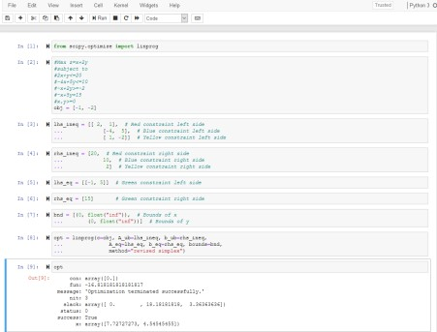

## PRACTICAL 5

## BigM Simplex Method using Python

Solve Following linear programming problem using Big M Simplex method. Min z= 4x1 + x2

subjected to:

3x1 + 4x2 >= 20 x1 + 5x2 >= 15 x1, x2 >= 0

from scipy.optimize import linprog obj = [4, 1] lhs_ineq = [[ -3, -4], # left side of first constraint

... [-1, -5]] # right side of first constraint

rhs_ineq = [-20, # right side of first constraint ... -15] # right side of Second constraint

bnd = [(0, float("inf")), # Bounds of x1

... (0, float("inf"))] # Bounds of x2

>>> opt = linprog(c=obj, A_ub=lhs_ineq, b_ub=rhs_ineq,

... bounds=bnd,method="interior-point")

>>> opt

## method =” interior-point” solves linear programming problem using default simplex method.

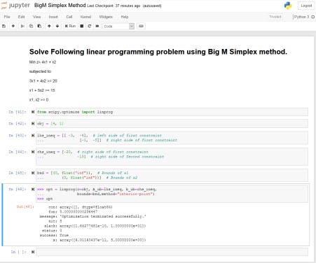

## PRACTICAL 6

**RESOURCE ALLOCATION PROBLEM BY SIMPLEX METHOD**

Use SciPy to solve the resource allocation problem stated as follows: Max z= 20x1 + 12x2 +40x3 + 25x4 .............(profit) subjected to:

x1 + x2 + x3 + x4 <= 50 -------------(manpower)

3x1 + 2x2 + x3 <= 100 -------------(material A) x2

+ 2x3 <= 90 -------------(material B)

x1, x2, x3, x4 >= 0

from scipy.optimize import linprog obj = [-20, -12, -40, -25] #profit objective function

lhs_ineq = [[1, 1, 1, 1], # Manpower

... [3, 2, 1, 0], # Material A ... [0, 1, 2, 3]] # Material B

rhs_ineq = [ 50, # Manpower

... 100, # Material A ... 90] # Material B

opt = linprog(c=obj, A_ub=lhs_ineq, b_ub=rhs_ineq,

... method="revised simplex")

Opt

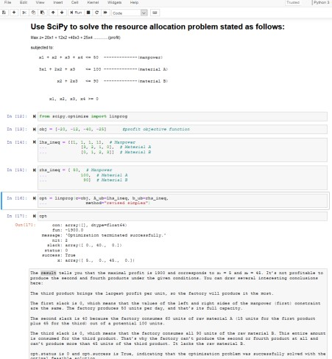

## PRACTICAL 7

**INFEASIBILITY IN SIMPLEX METHOD**

# Solve following linear programming problem using Simplex method

WHILE SOLVING LINEAR PROGRAMMING PROBLEM USING SIMPLEX METHOD, IF ONE OR

MORE ARTIFICIAL VARIABLES REMAIN IN THE BASIS AT POSITIVE LEVEL AT THE END OF PHASE 1 COMPUTATION , THE PROBLEM HAS NO FEASIBLE SOLUTION( INFEASIBLE SOLUTION).

Example:

Max z= 200x - 300y

subject to 2x+3y>=1200 x+y<=400 2x+3/2y>=900 x,y>=0

from scipy.optimize import linprog obj = [-200, 300] lhs_ineq = [[ -2, -3], # Red constraint left side ... [1, 1], # Blue constraint left side ... [ -2, -1.5]] # Yellow constraint left side

rhs_ineq = [-1200, # Red constraint right side ... 400, # Blue constraint right side ... -900] # Yellow constraint right side

bnd = [(0, float("inf")), # Bounds of x ... (0, float("inf"))] # Bounds of y

opt = linprog(c=obj, A_ub=lhs_ineq, b_ub=rhs_ineq,

... bounds=bnd, ... method="revised simplex") opt

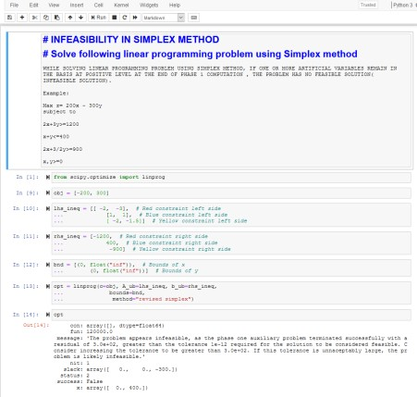

## PRACTICAL 8 DUAL SIMPLEX METHOD

**##SOLVE FOLLOWING LINEAR PROGRAMMING PROBLEM USING DUAL SIMPLEX**

**METHOD USING R PROGRAMMING**

# Max z=40x1+50x2

#subject to

#2x1 + 3x2 <= 3

#8x1 + 4x2 <= 5

# x1, x2>=0

# Import lpSolve package

library(lpSolve)

# Set coefficients of the objective function

f.obj <- c(40, 50)

# Set matrix corresponding to coefficients of constraints by rows # Do not consider the non-negative constraint; it is automatically assumed f.con <matrix(c(2, 3,

8, 4), nrow = 2, byrow = TRUE)

# Set unequality signs

f.dir <- c("<=", "<=")

# Set right hand side coefficients

f.rhs <- c(3,

5)

# Final value (z) lp("max", f.obj, f.con, f.dir, f.rhs)

# Variables final values lp("max", f.obj, f.con, f.dir, f.rhs)$solution

# Sensitivities

lp("max", f.obj, f.con, f.dir, f.rhs, compute.sens=TRUE)$sens.coef.from lp("max", f.obj, f.con, f.dir, f.rhs, compute.sens=TRUE)$sens.coef.to

# Dual Values (first dual of the constraints and then dual of the variables)

# Duals of the constraints and variables are mixed

lp("max", f.obj, f.con, f.dir, f.rhs, compute.sens=TRUE)$duals

# Duals lower and upper limits lp("max", f.obj, f.con, f.dir, f.rhs, compute.sens=TRUE)$duals.from lp("max", f.obj, f.con, f.dir, f.rhs, compute.sens=TRUE)$duals.to

OUTPUT:

##SOLVEFOLLOWINGLINEARPROGRAMMINGPROBLEMUSINGDUAL SIMPLEXMETHODUSINGRPROGRAMM>#Maxz=40x1+50x2

>#subjectto

>#2x1+3x2<=3 >#8x1+4x2<=5

>#x1,x2>=0

>

>

>#ImportlpSolvepackage

>library(lpSolve)

>

>#Setcoe cientsoftheobjectivefunction

>f.obj<-c(40,50)

>

>#Setmatrixcorrespondingtocoe cientsof constraintsbyrows>#Donotconsiderthenon-negative constraint;itisautomaticall assumed>f.con<matrix(c(2,3,

+8,4),nrow=2,byrow=TRUE)

>

>#Setunequalitysigns

>f.dir<-c("<=",

+"<=")

>

>#Setrighthandsidecoe cients

>f.rhs<-c(3,

+5)

>

>#Finalvalue(z)

>lp("max",f.obj,f.con,f.dir,f.rhs)

Success:theobjectivefunctionis51.25

>

>#Variablesfinalvalues

>lp("max",f.obj,f.con,f.dir,f.rhs)$solution

[1]0.18750.8750

>

>#Sensitivities

>lp("max",f.obj,f.con,f.dir,f.rhs, compute.sens=TRUE)$sens.coef.from[1]33.33333 20.00000

>lp("max",f.obj,f.con,f.dir,f.rhs, compute.sens=TRUE)$sens.coef.to[1]10060

>

>#DualValues(firstdualoftheconstraintsandthendual ofthevariables)>#Dualsoftheconstraintsandvariables aremixed

>lp("max",f.obj,f.con,f.dir,f.rhs,compute.sens=TRUE)$duals [1]15.001.250.000.00

>

>#Dualslowerandupperlimits >lp("max",f.obj,f.con,f.dir,f.rhs, compute.sens=TRUE)$duals.from[1]1.25e+00 4.00e+00-1.00e+30-1.00e+30 >lp("max",f.obj,f.con,f.dir,f.rhs, compute.sens=TRUE)$duals.to[1]3.75e+001.20e+01 1.00e+301.00e+30

>

## PRACTICAL 9 TRANSPORTATION PROBLEM

##sOLVE FOLLOWING TRANSPORTATION PROBLEM IN WHICH CELL ENTRIES REPRESENT UNIT COSTS USING R PROGRAMMING.

# "Customer 1", "Customer 2", "Customer 3", "Customer 4" SUPPLY

#sUPPLIER 1 10 2 20 11 15

#sUPPLIER 1 12 7 9 20 25

#sUPPLIER 1 4 14 16 18 10

#DEMAND 5 15 15 15

# Import lpSolve package library(lpSolve)

# Set transportation costs matrix costs <- matrix(c(10, 2, 20, 11,

12, 7, 9, 20,

4, 14 , 16, 18), nrow = 3, byrow = TRUE)

# Set customers and suppliers' names colnames(costs) <- c("Customer 1", "Customer 2", "Customer 3", "Customer 4") rownames(costs) <- c("Supplier 1", "Supplier 2", "Supplier 3")

# Set unequality/equality signs for suppliers row.signs <- rep("<=", 3)

# Set right hand side coefficients for suppliers row.rhs <- c(15, 25, 10)

# Set unequality/equality signs for customers col.signs <- rep(">=", 4)

# Set right hand side coefficients for customers col.rhs <- c(5, 15, 15, 15)

# Final value (z)

TotalCost <- lp.transport(costs, "min", row.signs, row.rhs, col.signs, col.rhs)

# Variables final values lp.transport(costs, "min", row.signs, row.rhs, col.signs, col.rhs)$solution print(TotalCost)

OUTPUT:

>##sOLVEFOLLOWINGTRANSPORTATIONPROBLEMINWHICHCELL ENTRIESREPRESENTUNITCOSTSU>

>#"Customer1","Customer2","Customer3","Customer4"

SUPPLY>#sUPPLIER1102201115>#sUPPLIER112792025>

#sUPPLIER1414161810>#DEMAND5151515

>

>#ImportlpSolvepackage

>library(lpSolve)

>

>#Settransportationcostsmatrix >costs<-matrix(c(10,2,20,11,

+12,7,9,20,

+4,14,16,18),nrow=3,byrow=TRUE)

>

>#Setcustomersandsuppliers'names

>colnames(costs)<-c("Customer1","Customer2", "Customer3","Customer4")>rownames(costs)<c("Supplier1","Supplier2","Supplier3")

>

>#Setunequality/equalitysignsforsuppliers

>row.signs<-rep("<=",3)

>

>#Setrighthandsidecoe cientsforsuppliers

>row.rhs<-c(15,25,10)

>

>#Setunequality/equalitysignsforcustomers

>col.signs<-rep(">=",4)

>

>#Setrighthandsidecoe cientsforcustomers

>col.rhs<-c(5,15,15,15)

>

>#Finalvalue(z)

>TotalCost<-lp.transport(costs,"min",row.signs,row.rhs, col.signs,col.rhs)>

>

>#Variablesfinalvalues

>lp.transport(costs,"min",row.signs,row.rhs,col.signs, col.rhs)$solution[,1][,2][,3][,4]

[1,]05010

[2,]010150

[3,]5005

>

>print(TotalCost)

Success:theobjectivefunctionis435

>

## PRACTICAL 10 ASSIGNMENT PROBLEM

#SOLVE FOLLOWING ASSIGNMENT PROBLEM REPRESENTED IN FOLLOWING MATRIX USING R PROGRAMMING

# Assignment Problem

# JOB1 JOB2 JOB3

#W1 15 10 9

#W2 9 15 10

#W3 10 12 8

# Import lpSolve package

library(lpSolve)

# Set assignment costs matrix

costs <- matrix(c(15, 10, 9,

9, 15, 10,

10, 12 ,8), nrow = 3, byrow = TRUE)

# Print assignment costs matrix

costs

# Final value (z)

lp.assign(costs)

# Variables final values lp.assign(costs)$solution

OUTPUT:

>#SOLVEFOLLOWINGASSIGNMENTPROBLEMREPRESENTEDIN

FOLLOWINGMATRIXUSINGRPROGRAMMI>#AssignmentProblem

>#JOB1JOB2JOB3

>#W115109

>#W291510

>#W310128

>

>#ImportlpSolvepackage

>library(lpSolve)

>

>#Setassignmentcostsmatrix

>costs<-matrix(c(15,10,9,

+9,15,10,

+10,12,8),nrow=3,byrow=TRUE)>

>#Printassignmentcostsmatrix

>costs

[,1][,2][,3] [1,]15109

[2,]91510

[3,]10128

>

>#Finalvalue(z)

>lp.assign(costs)

Success:theobjectivefunctionis27

>

>#Variablesfinalvalues

>lp.assign(costs)$solution

[,1][,2][,3]

[1,]010

[2,]100 [3,]001