Q.1) Write a Python function to check whether a string is a pangram or not. Note : Pangrams are words or sentences containing every letter of the alphabet at least once.
For example : "The quick brown fox jumps over the lazy dog"
Code :
def is_pangram(sentence):
sentence = sentence.lower()
letters = set()
for ch in sentence:
if 'a' <= ch <= 'z':
letters.add(ch)
return len(letters) == 26
text = input("Enter a sentence: ")
if is_pangram(text):
print("The string is a pangram")
else:
print("The string is not a pangram")
Output :
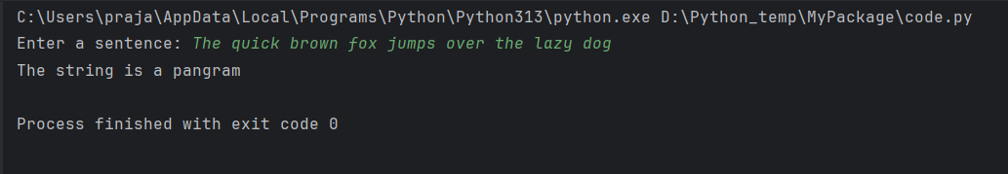

Q.2) Write a Python program to calculate the sum of the digits in an integer.
Code :
num = input("Enter any 3 digit number: ")
sum = 0
for i in num:
sum+=int(i)
print(sum)
Output :
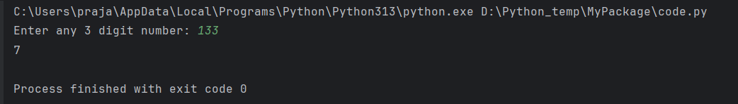
Q.3) Write a Python program to sort three integers without using conditional statements and loops. [ u can use built in functions for this]
Code :
num = input("Enter any 3 digit number: ")
print(sorted(num))
Output :
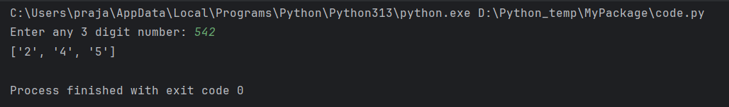
Q.4) Write a Python function to check whether a number is perfect or not.
Code :
def is_perfect(num):
if num <= 0:
return False
divisor_sum = 0
for i in range(1, num):
if num % i == 0:
divisor_sum += i
return divisor_sum == num
num = int(input("Enter a number: "))
if is_perfect(num):
print("Perfect Number")
else:
print("Not a perfect number")
Output :
