Q.1) Write a Python program to print all even numbers from a given list of numbers in the same order. Stop printing if any number that comes after 237 in the sequence is encountered.
Code:
numbers = [ 386, 462, 47, 418, 907, 344, 236, 375,
823, 566, 597, 978, 328, 615, 953, 345,
399, 162, 758, 219, 237, 412, 566, 731,
210, 912, 216, 244, 896, 101, 867, 355, 430 ]
for i in numbers:
if i%2==0:
print(i)
if i==237:
break
Output:
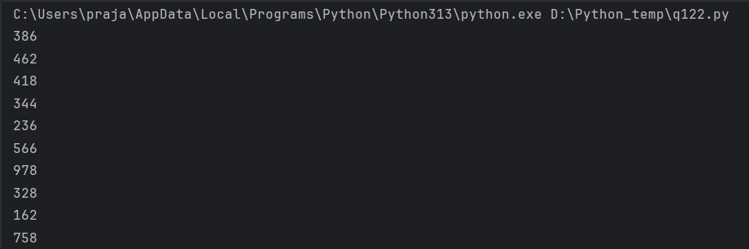
Q.2) Write a python program to get the path and name of the file that is currently executing
Code:
from pathlib import Path
path=Path(__file__).resolve()
print("File path is:",path)
print("Name of the file:",path.name)
Output:
Q.3) pattern
Code:
n = 5
for i in range(1, n + 1):
print(" " * (n - i), end="")
for j in range(i, 0, -1):
print(j, end="")
for j in range(2, i + 1):
print(j, end="")
print()

Output:
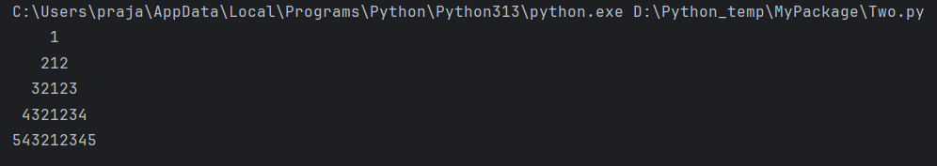

Q.4) Write a code to accept a number & print its digits in words . Ex: 321 Three Two One
Code:
num = input("Enter a number:")
words={'0':'zero','1':'one','2':'two','3':'three','4':'four','5':'five','6':'six','7':'seven','8':'eight','9':'nine'}
for digit in num:
print(words[digit])
Output:
