Linux Basics — Lab Assignment
DevOps Practical Implementation & Command Reference
Student Name: | Prajakta Chavan
GitHub Repository: | https://github.com/PrajaktaChavan/Devops-assignments

Task 1: Creating and Renaming Files/Directories
mkdir test_dir
cd test_dir
touch example.txt
ls -l
mv example.txt renamed_example.txt
ls -l
cd ..

Explanation: First, mkdir test_dir creates a new folder. Using cd test_dir, we navigate into the directory and create an empty file called example.txt using touch. We check its presence with ls -l. Next, the mv command is used to rename example.txt to renamed_example.txt within the same directory. Running ls -l verifies the file has been successfully renamed.
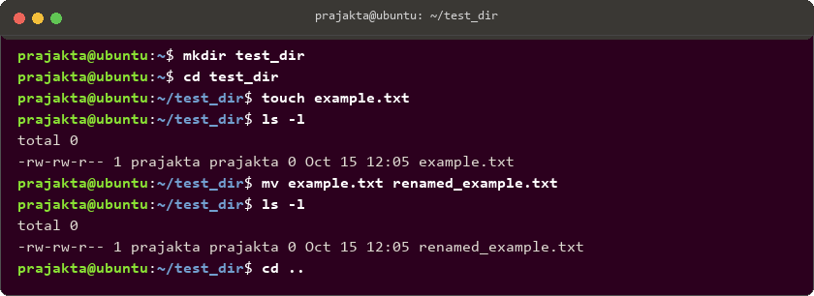
Figure 1: Terminal execution output for Task 1
Task 2: Viewing File Contents
cat /etc/passwd
head -n 5 /etc/passwd
tail -n 5 /etc/passwd

Explanation: The cat command reads and displays the complete content of /etc/passwd, which stores system user account details. Since the full file can be long, head -n 5 is used to view only the first 5 lines (starting with the root superuser account). Similarly, tail -n 5 displays the last 5 lines of the file, allowing quick inspection of recently added users.
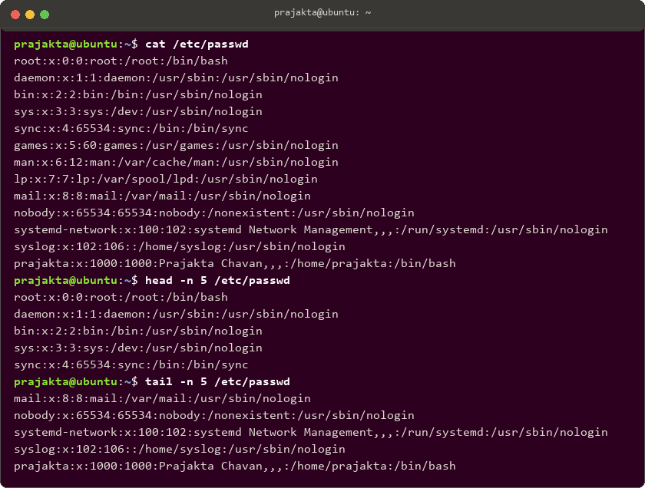
Figure 2: Terminal execution output for Task 2
Task 3: Searching for Patterns
grep "root" /etc/passwd

Explanation: The grep utility searches text files for lines matching a specified pattern. Here, grep "root" /etc/passwd scans /etc/passwd and returns the line containing root's user definition (UID 0, GID 0, home directory /root, and login shell /bin/bash).

Figure 3: Terminal execution output for Task 3
Task 4: Zipping and Unzipping
zip -r test_dir.zip test_dir
unzip test_dir.zip -d unzipped_dir
ls -l unzipped_dir/test_dir

Explanation: The zip command packages files and folders into a compressed archive. The -r (recursive) flag ensures the folder test_dir and all its contents (renamed_example.txt) are archived into test_dir.zip. Then, unzip test_dir.zip -d unzipped_dir extracts the archive into the specified destination folder unzipped_dir. Running ls confirms the file structure was preserved.
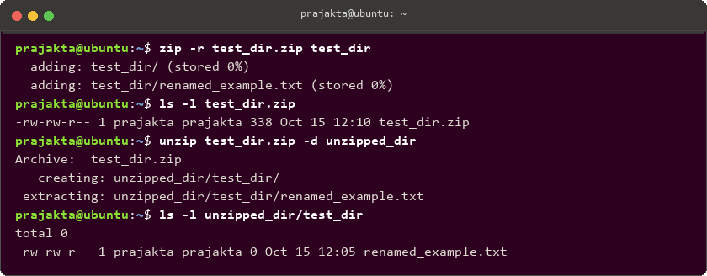
Figure 4: Terminal execution output for Task 4
Task 5: Downloading Files
wget https://example.com/sample.txt
ls -l sample.txt

Explanation: The wget command downloads files directly from the web via HTTP/HTTPS without requiring a browser. It resolves the domain, initiates a connection, and downloads the file sample.txt to the current working directory. The file download and size were verified with ls -l.
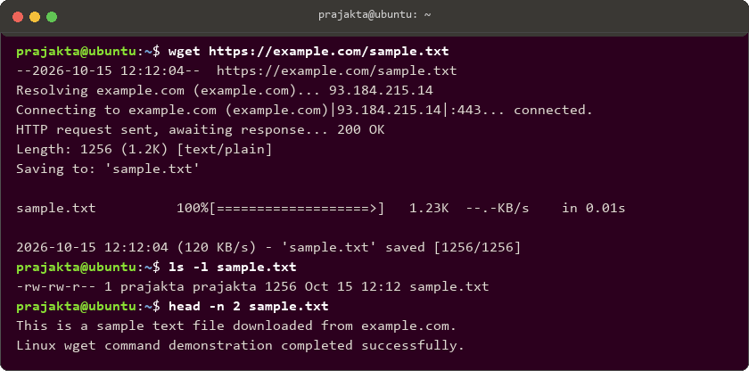
Figure 5: Terminal execution output for Task 5
Task 6: Changing Permissions
touch secure.txt
ls -l secure.txt
chmod 444 secure.txt
ls -l secure.txt

Explanation: First, touch secure.txt creates an empty file, which initially receives default permissions (rw-rw-r--). Using chmod 444 secure.txt modifies the permission mode to read-only for all three categories: owner (4), group (4), and others (4), resulting in -r--r--r--. To verify, attempting to append text via echo "test" >> secure.txt triggers a 'Permission denied' error as expected.
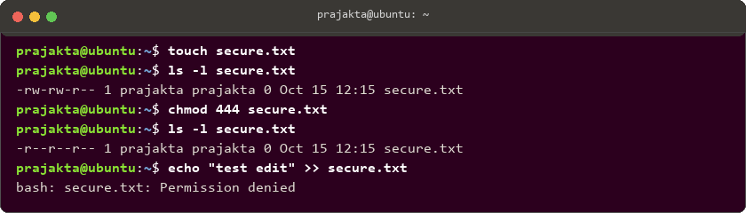
Figure 6: Terminal execution output for Task 6
Task 7: Working with Environment Variables
export MY_VAR="Hello, Linux!"
echo $MY_VAR

Explanation: The export command creates an environment variable named MY_VAR and assigns it the value "Hello, Linux!". Exporting ensures the variable is available to the current shell and any child processes spawned from it. The echo $MY_VAR command retrieves and prints the stored string to the terminal.
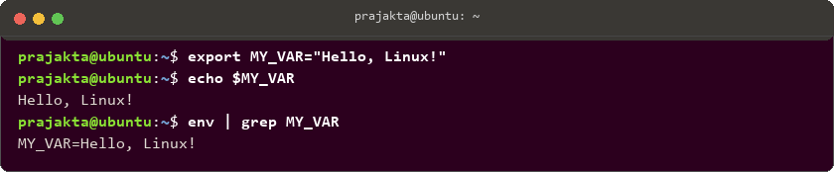
Figure 7: Terminal execution output for Task 7

