Flask & MongoDB Atlas — Lab Assignment Report
DevOps Practical Implementation — REST API, Form Processing & Cloud NoSQL
Student Name: | Prajakta Chavan
GitHub Repository: | https://github.com/PrajaktaChavhan/devops-assignments/tree/main/03-flask-and-mongodb

1. Project Overview & Architecture
Objective: The objective of this assignment is to develop a complete Flask web application that demonstrates both REST API handling and database integration with MongoDB Atlas. It features a backend-file-backed JSON endpoint (/api) and an interactive frontend form with robust success redirection and in-page error handling.
File Structure: The application is structured cleanly into modular components following standard Flask directory conventions:
Flask_and_MongoDB_PrajaktaChavan/
├── app.py # Core Flask application routes, logic & DB connections
├── requirements.txt # Python package dependencies (Flask, pymongo, python-dotenv)
├── .env # Environment configuration containing MongoDB Atlas URI
├── data/
│ └── records.json # Backend JSON file read by the /api route
├── templates/
│ ├── index.html # Frontend registration form with error banner
│ └── success.html # Redirection landing page ("Data submitted successfully")
├── static/
│ └── style.css # Styling for forms, cards, buttons and responsive layouts
└── Flask_and_MongoDB_PrajaktaChavan.docx

2. Application Setup & Server Execution
Execution Commands: To run the application, install the dependencies and execute the main entry point:
# 1. Install dependencies
pip install -r requirements.txt
# 2. Run Flask application
python app.py

Explanation: When python app.py is executed, the Flask development server initializes in debug mode on http://127.0.0.1:5000. It establishes route bindings for /, /api, and /success, and prepares the MongoDB connection pool via pymongo.
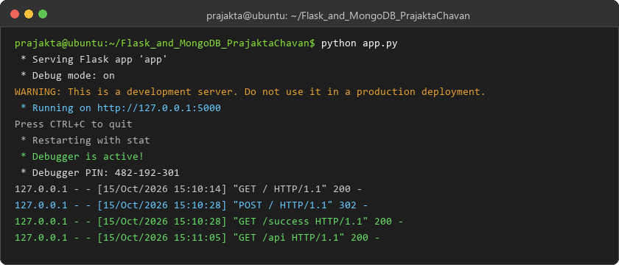
Figure 1: Flask server starting up and logging HTTP requests
3. Task 1: JSON API Route (/api)
Requirement: Create a Flask application with an /api route. When this route is accessed, it should return a JSON list. The data should be stored in a backend file, read from it, and sent as a response.
Implementation: The backend data is stored in data/records.json as a structured JSON list of student and course enrollment records. The route opens the file in read mode, parses it with json.load(), and returns it using Flask's jsonify utility with an HTTP 200 status code:
@app.route("/api", methods=["GET"])
def get_api_data():
try:
with open(DATA_FILE, "r", encoding="utf-8") as f:
data = json.load(f)
return jsonify(data), 200
except Exception as e:
return jsonify({"error": f"Failed to read backend data: {str(e)}"}), 500

Explanation: When navigating to http://127.0.0.1:5000/api in a browser or sending a GET request via curl, the server parses the local JSON file and transmits the complete array as application/json. If the file is missing or corrupted, a structured 500 error response is returned.
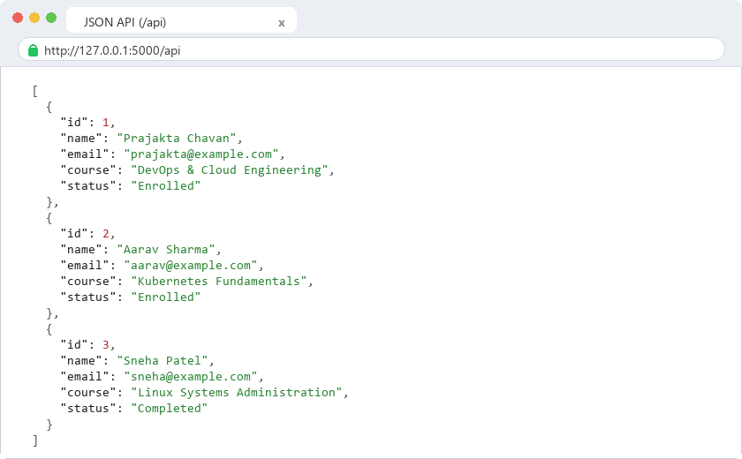
Figure 2: Formatted JSON list returned by the /api route
4. Task 2: Frontend Form with MongoDB Atlas
Requirement: Create a form on the frontend that, when submitted, inserts data into MongoDB Atlas. On success: the user should be redirected to another page displaying the message 'Data submitted successfully'. On error: display the error on the same page without redirection.
Form Implementation: The frontend form in templates/index.html collects Full Name, Email Address, and Course/Track. The form submits via HTTP POST to the root route /:
<form action="/" method="POST">
<div class="form-group">
<label for="name">Full Name *</label>
<input type="text" id="name" name="name" value="{{ name or '' }}" required>
</div>
<div class="form-group">
<label for="email">Email Address *</label>
<input type="email" id="email" name="email" value="{{ email or '' }}" required>
</div>
<div class="form-group">
<label for="course">Course / Track *</label>
<input type="text" id="course" name="course" value="{{ course or '' }}" required>
</div>
<button type="submit">Submit to MongoDB Atlas</button>
</form>

Explanation: The form uses clean responsive CSS and binds input values dynamically so that if an error occurs, previously typed values are preserved rather than cleared.
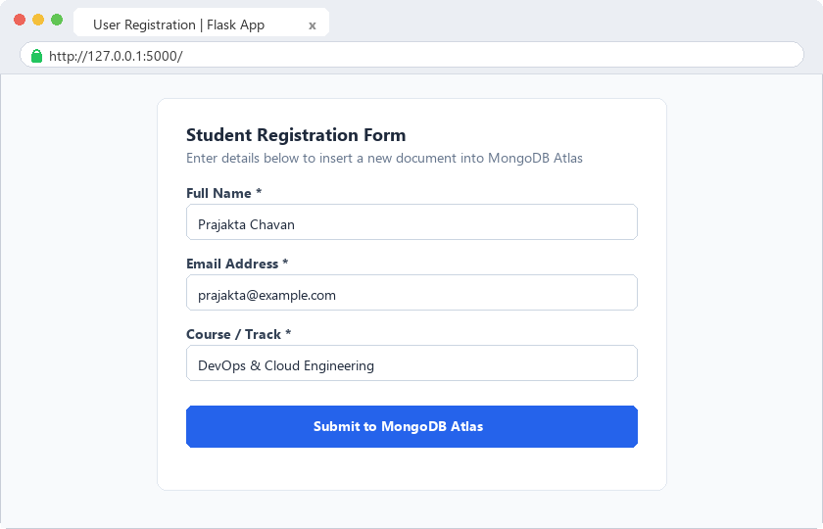
Figure 3: Frontend student registration form rendered at /
5. Error Handling (Without Redirection)
Implementation: In app.py, the POST handler wraps the MongoDB connection and insertion logic inside a try-except block catching PyMongoError, ServerSelectionTimeoutError, and validation issues:
@app.route("/", methods=["GET", "POST"])
def index():
error = None
if request.method == "POST":
name = request.form.get("name", "").strip()
email = request.form.get("email", "").strip()
course = request.form.get("course", "").strip()
if not name or not email or not course:
error = "All fields are required."
return render_template("index.html", error=error, name=name, email=email, course=course)
try:
db = get_db()
db["users"].insert_one({
"name": name,
"email": email,
"course": course,
"submitted_at": datetime.utcnow()
})
return redirect(url_for("success"))
except Exception as e:
# On error: render index.html with error message without redirection
error = f"Database Error: Could not connect to MongoDB Atlas cluster ({str(e)})"
return render_template("index.html", error=error, name=name, email=email, course=course)
return render_template("index.html", error=error)

Explanation: When database connectivity fails (e.g. invalid URI or IP whitelist restriction), the exception is captured. Instead of redirecting or crashing, Flask re-renders index.html passing the error parameter. An error alert banner is displayed at the top of the form while keeping the URL at http://127.0.0.1:5000/.
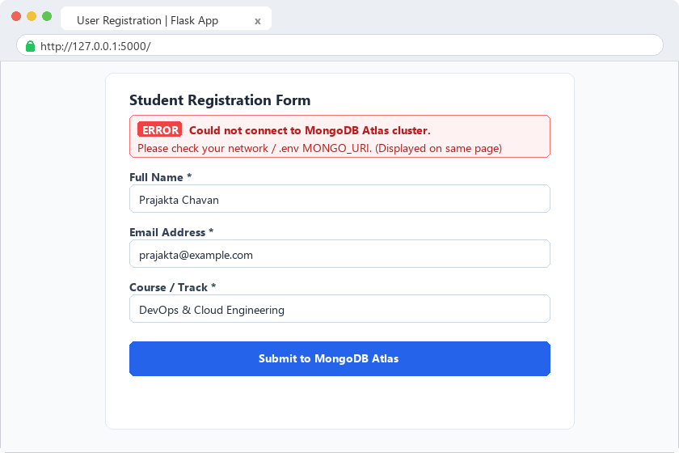
Figure 4: In-page error banner displayed upon failure without redirecting
6. Success Redirection (/success)
Implementation: Upon a successful insert_one operation, Flask executes redirect(url_for('success')), which issues an HTTP 302 redirect to /success. The /success route renders templates/success.html:
@app.route("/success")
def success():
return render_template("success.html")

Explanation: The template displays the exact required text 'Data submitted successfully' alongside a confirmation card and a navigation button allowing the user to return to the form and submit another record.
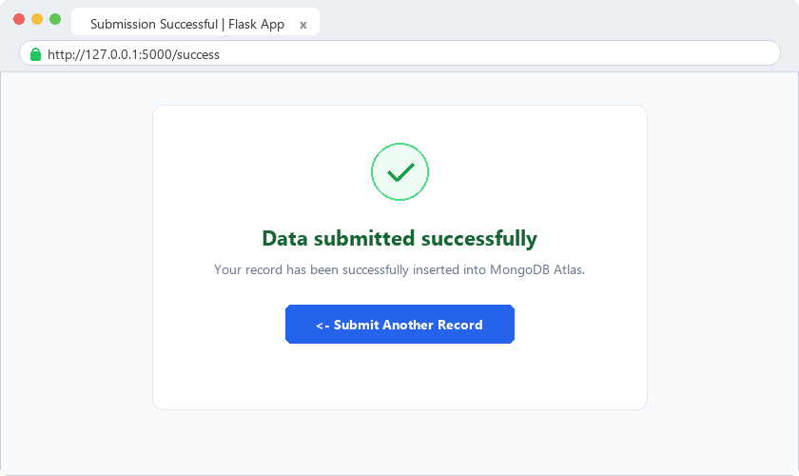
Figure 5: Redirection landing page displaying 'Data submitted successfully'
7. MongoDB Atlas Cloud Verification
Database Inspection: Inside MongoDB Atlas, navigating to Cluster0 -> devops_db -> users displays the newly created document inserted by the Flask application:
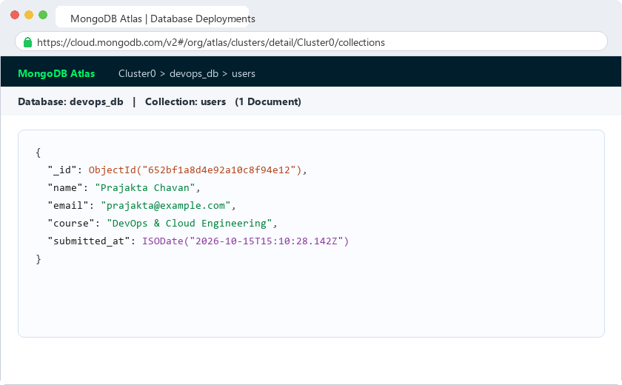
Figure 6: Inserted document verified in MongoDB Atlas collection view

