INTRODUCTION TO AUTONOMOUS VEHICLES & LEVELS OF AUTONOMY
ASSIGNMENT
SAE Levels of Driving Automation (L0 to L5)
A study of the J3016 taxonomy with real-world examples and the sensor and software requirements of each level

Submitted by
Name | Prajakta Ghosh
Enrollment No. | 12023002002107
Registration No. | 304202300900494
Department | Electronics and Communication Engineering (ECE)
Section | 4B
Roll No. | 34

September 2026

Table of Contents

Abstract
This report studies the six levels of driving automation defined by SAE International in its standard J3016 (April 2021 revision, published jointly with ISO as ISO/SAE PAS 22736). For every level from Level 0 (No Driving Automation) to Level 5 (Full Driving Automation) the report explains what the automation system does, what the human is still responsible for, which commercial products or services currently operate at that level, and which sensors and software functions the level requires. Real-world examples are taken from deployments that were current in 2025 and 2026, including driver-assistance systems sold in India, the Level 3 systems of Mercedes-Benz, BMW, Honda and the first Chinese Level 3 permits, and Level 4 robotaxi services such as Waymo and Baidu Apollo Go. The report closes with a comparison of sensor suites, software stacks, computing needs and safety standards across the levels, and with a discussion of why the industry has recently moved away from Level 3 on some premium cars while Level 4 robotaxi fleets keep growing.

1. Introduction
An autonomous vehicle (AV) is a road vehicle that can perform part or all of the driving task without continuous human input. Driving is not one skill but a combination of tasks: steering, accelerating and braking, watching the road for other road users and hazards, obeying traffic rules, and dealing with failures or unexpected situations. Because different products automate different parts of this work, engineers, regulators and the public need a common vocabulary to say exactly how much a given system does. Without it, marketing terms such as "Autopilot" or "self-driving" cause confusion about who is responsible for safety at any given moment.
SAE International first published the J3016 taxonomy in 2014 and revised it in 2016, 2018 and 2021. The 2021 revision (J3016_202104) was developed together with ISO Technical Committee 204 and is the reference used by regulators in the United States, Europe, China, Japan and India. It defines six levels, numbered 0 to 5. The levels describe driving automation features, not whole vehicles: one car can offer a Level 2 feature on city roads and a Level 3 feature in a highway traffic jam.

1.1 Objectives of this assignment
- Explain the key J3016 terms that decide the level of a feature.
- Describe each level from L0 to L5 with current real-world examples.
- Identify the sensors and software functions each level needs, and show how requirements grow with the level.
- Summarise the safety standards and regulations that apply, and the present state of the industry.

2. Key Concepts in SAE J3016
The level of a feature is decided by answering three questions: who performs the dynamic driving task, who responds when something goes wrong, and where the feature is allowed to work. The following terms are needed to answer them.
Table 1: Key terms defined in SAE J3016_202104
Term | Meaning
Dynamic Driving Task (DDT) | All real-time operational and tactical functions needed to drive: lateral control (steering), longitudinal control (acceleration and braking), and OEDR. It excludes strategic tasks such as choosing the destination or route.
Object and Event Detection and Response (OEDR) | Monitoring the driving environment, detecting objects and events (vehicles, pedestrians, signals, road works) and responding to them. In simple words, watching the road.
Operational Design Domain (ODD) | The conditions under which a feature is designed to work: road types, speed range, geographic area, weather, lighting, traffic conditions and so on.
DDT fallback | The response when the system fails or the vehicle is about to leave its ODD. It is performed either by a human (the fallback-ready user) or by the system itself.
Minimal Risk Condition (MRC) | A stable, stopped state that reduces the risk of a crash when a trip cannot be completed, for example stopped on the shoulder with hazard lights on.
Driving Automation System (DAS) | Any hardware and software that performs part or all of the DDT on a sustained basis (Levels 1 to 5).
Automated Driving System (ADS) | A driving automation system that performs the entire DDT on a sustained basis (Levels 3, 4 and 5 only).
Driver support vs. automated driving features | Levels 0 to 2 are driver support features: the human is driving even when the feature is on. Levels 3 to 5 are automated driving features: when engaged, the human is not driving.

A useful rule of thumb follows from these definitions. At Levels 0 to 2 the human must supervise all the time. At Level 3 the human may take the eyes off the road but must be ready to take over when asked. At Levels 4 and 5 nobody inside the vehicle has to be ready to drive.

3. Overview of the Six Levels
Figure 1 shows how responsibility moves from the human to the system as the level increases. The boundary that matters most for safety and law is between Level 2 and Level 3, because that is where monitoring of the road passes from the human to the machine.
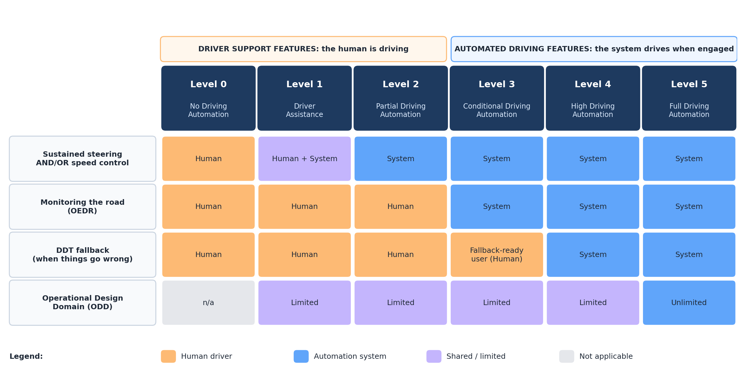
Figure 1: Allocation of driving responsibilities across SAE Levels 0 to 5 (based on SAE J3016_202104)
Table 2: Summary of SAE levels of driving automation
Level | Name | Steering & speed | Monitoring (OEDR) | Fallback | ODD | Typical example
L0 | No Driving Automation | Human | Human | Human | n/a | AEB, blind-spot warning, lane-departure warning
L1 | Driver Assistance | Human and system (one axis) | Human | Human | Limited | Adaptive cruise control only
L2 | Partial Driving Automation | System (both axes) | Human | Human | Limited | ACC + lane centring, GM Super Cruise, Tesla FSD (Supervised)
L3 | Conditional Driving Automation | System | System | Fallback-ready user | Limited | Mercedes DRIVE PILOT, Honda Traffic Jam Pilot
L4 | High Driving Automation | System | System | System | Limited | Waymo, Baidu Apollo Go robotaxis
L5 | Full Driving Automation | System | System | System | Unlimited | None exists yet

4. Level-by-Level Analysis

Level 0: No Driving Automation
At Level 0 the human performs the entire dynamic driving task. The vehicle may still contain active safety systems, but these only give warnings or intervene for a moment in an emergency; they do not drive the car on a sustained basis. The 2021 revision of J3016 made this explicit: automatic emergency braking (AEB), lane-departure warning and blind-spot warning are Level 0 features because they act only momentarily.

Role of the human
The driver steers, brakes, accelerates and watches the road at all times. Warnings are advisory, and momentary interventions such as AEB are a last-resort safety net.

Real-world examples
- Forward collision warning and automatic emergency braking, now common on new cars worldwide (for example Volvo City Safety).
- Blind-spot monitoring, rear cross-traffic alert and lane-departure warning.
- Reversing cameras and ultrasonic parking sensors that beep but do not steer.
- In India, most mass-market cars without ADAS packages, as well as cars offering only warnings, are at this level.

Sensor requirements
- Ultrasonic sensors (range roughly 0.2 m to 5 m) for parking distance warnings.
- Single front camera or short/medium-range radar for collision warning and AEB.
- Rear-corner radars (24 GHz or 77 GHz) for blind-spot and cross-traffic warnings.
- Wheel-speed sensors, steering-angle sensor and yaw-rate sensor already present for ABS and ESC.

Software requirements
- Object detection and time-to-collision (TTC) estimation in an embedded ECU.
- Simple rule-based warning logic and threshold-based brake activation.
- Driver interface for audible, visual and haptic alerts.
- Functional safety development to ISO 26262 (AEB usually ASIL B to C) and avoidance of false braking under ISO 21448 (SOTIF).

Level 1: Driver Assistance
A Level 1 feature performs either lateral control or longitudinal control on a sustained basis, but not both at the same time. The driver performs the other part and the whole OEDR.

Role of the human
The driver keeps hands on the wheel and eyes on the road. If the feature controls speed, the driver steers; if it controls steering, the driver manages speed.

Real-world examples
- Adaptive cruise control (ACC) on its own. Radar-based systems such as Mercedes-Benz Distronic first appeared on luxury cars in the late 1990s.
- Lane-keeping assist or lane-centring used without ACC.
- In India, the Hyundai Venue and Kia Sonet are marketed with "Level 1 ADAS" packages that combine warnings with a lane-following or cruise-control function.
- Park assist systems that steer while the driver controls the pedals.

Sensor requirements
- Forward long-range radar (77 GHz, up to about 150 to 250 m) for ACC, measuring distance and relative speed directly through the Doppler effect.
- Front mono camera (behind the windscreen) for lane markings and object classification.
- Ultrasonic sensors for low-speed functions and park assist.
- Existing chassis sensors (wheel speed, yaw rate, steering torque).

Software requirements
- Target selection and tracking of the lead vehicle (Kalman filtering).
- Longitudinal controller (PID or model-based) that keeps a time gap, with comfort limits on acceleration and jerk.
- Lane detection (classical edge detection or small CNNs) and a lateral controller for lane-keeping variants.
- Driver override detection (brake pedal, steering torque) and hands-on-wheel checks.
- Runs on a single ADAS ECU or camera SoC with a few TOPS of computing.

Level 2: Partial Driving Automation
A Level 2 feature performs both lateral and longitudinal control at the same time, in a limited ODD. The system still does not monitor the road on the driver's behalf: the driver must supervise continuously and intervene immediately if the system misses something. Level 2 is by far the most common form of automation on sale today.

Role of the human
The driver is still driving, even when their hands are off the wheel in "hands-free" versions. The driver must watch the road, and a driver monitoring system checks that they do.

Real-world examples
- Tesla Autopilot and FSD (Supervised): camera-only ("Tesla Vision") system that works on highways and city streets but requires constant supervision.
- GM Super Cruise and Ford BlueCruise: hands-free highway systems that use pre-mapped roads and an infrared driver-monitoring camera.
- Mercedes-Benz MB.Drive Assist Pro and BMW's newer hands-free highway assistant (2026): advanced Level 2 systems replacing earlier Level 3 offerings (see Level 3).
- India: Mahindra XUV700, Tata Harrier and Safari, Honda City (Honda Sensing), MG Gloster and Hyundai Creta offer ACC with stop-and-go plus lane-keeping or lane-centring, which together form a Level 2 feature.

Sensor requirements
- Front camera (often 8 MP) for lanes, vehicles, pedestrians, traffic signs and lights.
- Front long-range radar plus, on better systems, four corner radars for lane-change and cut-in detection.
- Surround-view cameras (4 to 8) on camera-centric systems such as Tesla's, which uses 8 cameras and no radar or lidar.
- Driver monitoring camera with infrared illumination for hands-free systems.
- Standard GNSS and, for Super Cruise-type systems, a lane-level map of approved highways.
- Some Chinese Level 2+ systems add a roof or grille lidar for better night and urban performance.

Software requirements
- Deep-learning perception (CNN or transformer networks) for multi-class object detection and lane estimation.
- Multi-sensor fusion (camera plus radar) and object tracking.
- Combined lateral and longitudinal planning and control (for example model predictive control) with automatic lane changes on some systems.
- Driver monitoring software (gaze and head pose estimation) with escalating alerts, as required by UN Regulation No. 171 (DCAS).
- Over-the-air (OTA) software updates under a certified software update management system (UN R156).
- Computing from about 10 TOPS (Mobileye EyeQ-class) to several hundred TOPS (NVIDIA DRIVE Orin, 254 TOPS).

Key limitation
Level 2 relies on a human who is expected to supervise a system that works well most of the time. Research on automation complacency shows that humans are poor at this kind of monitoring, which is why investigations of Level 2 crashes often point to driver inattention and mode confusion.

Level 3: Conditional Driving Automation
At Level 3 the automated driving system performs the entire DDT, including monitoring the road, while it is engaged inside its ODD. The human becomes a fallback-ready user: they may read or watch a film, but they must be receptive to a takeover request and to obvious vehicle failures, and take control within a short time (about 10 seconds in current systems).

Role of the human
The person in the driver's seat is not driving while the feature is active and is not legally responsible for its driving in jurisdictions that have approved it. They must stay awake, seated and able to take over when asked.

Real-world examples
- Mercedes-Benz DRIVE PILOT: first certified Level 3 system in series production (Germany 2022 at up to 60 km/h; approved for up to 95 km/h on German motorways in December 2024; approved in California and Nevada at up to 40 mph). In January 2026 Mercedes announced that the facelifted S-Class would not carry DRIVE PILOT and would move to a Level 2 urban system instead.
- Honda Legend with Traffic Jam Pilot (Japan, March 2021): the first Level 3 approval anywhere, sold as a limited lease series in congested expressway traffic.
- BMW Personal Pilot L3 (7 Series, Germany, 2024, up to 60 km/h). Reports in February 2026 said it would be dropped from the 7 Series facelift in favour of a cheaper Level 2 system.
- China: in December 2025 the Ministry of Industry and Information Technology issued the first Level 3 permits, to a Changan model in Chongqing (single-lane driving in congestion up to 50 km/h) and a BAIC Arcfox model in Beijing (up to 80 km/h on designated expressways).

Sensor requirements
- Redundant, diverse sensing so that no single sensor type is a single point of failure: lidar (DRIVE PILOT uses a Valeo SCALA lidar), stereo or multi-camera, long-range and corner radars, and ultrasonic sensors. Mercedes quotes more than 35 sensors for DRIVE PILOT 95.
- High-precision positioning (GNSS with correction data plus IMU) combined with an HD map accurate to a few centimetres.
- External microphones to detect emergency-vehicle sirens, and a road-wetness sensor to check the ODD.
- Driver availability camera to confirm the user can take over.
- Redundant steering, braking and electrical power supply, because the system must stay in control until the human has taken over.

Software requirements
- Full perception stack with 360-degree object detection, tracking and prediction of other road users.
- ODD monitoring: speed, road type, weather, lighting, map validity and lane geometry, with early detection of an approaching ODD exit.
- Takeover request (TOR) management: visual, audible and haptic warnings with a guaranteed transition period.
- Minimal risk manoeuvre (controlled stop in lane with hazard lights) if the user does not respond.
- Data Storage System for Automated Driving (DSSAD) to record who was in control, as required by UN Regulation No. 157 (ALKS).
- Development to ISO 26262 ASIL D for critical paths, SOTIF analysis (ISO 21448) and cybersecurity management (ISO/SAE 21434, UN R155).

Key limitation
The handover problem. Taking back control after minutes of distraction takes several seconds and is error-prone, so Level 3 systems are limited to narrow ODDs. Combined with high hardware cost (around 6,000 euros as an option for both Mercedes and BMW) and low customer uptake, this led both German makers to step back from Level 3 in 2026 while Chinese makers began to deploy it.

Level 4: High Driving Automation
A Level 4 feature performs the entire DDT and the DDT fallback within its ODD. If a failure occurs or the ODD ends, the system itself brings the vehicle to a minimal risk condition. No human needs to be ready to drive, so Level 4 vehicles may have no driver at all, and some purpose-built designs have no steering wheel or pedals.

Role of the human
Passengers are only passengers. A remote operations centre may give high-level guidance (for example confirming that a blocked road may be passed) but does not drive the vehicle in real time.

Real-world examples
- Waymo (Alphabet): fully driverless robotaxi service in more than ten US metros including Phoenix, San Francisco, Los Angeles, Austin and Atlanta, with around 500,000 paid rides per week by mid-2026 and over 20 million lifetime trips. Its 6th-generation Waymo Driver began fully autonomous operation in February 2026.
- Baidu Apollo Go (China): over 20 million cumulative rides by February 2026, about 300,000 rides per week in late 2025, operating in about 26 cities worldwide including Wuhan, Beijing, Dubai and Abu Dhabi.
- Zoox (Amazon): purpose-built bidirectional robotaxi with no steering wheel, carrying public riders in Las Vegas.
- Tesla Robotaxi: pilot service launched in Austin in June 2025 and expanded to several US metros; in 2026 it still mixed supervised and unsupervised operation depending on the city.
- Other examples include Pony.ai and WeRide robotaxis in China and the Middle East, low-speed autonomous shuttles, and driverless trucks on fixed freight routes.

Sensor requirements
- 360-degree coverage with at least three sensing modalities that fail in different ways. Waymo's 6th-generation Driver uses 13 cameras, 4 lidars, 6 radars and an array of external audio receivers, with overlapping fields of view up to 500 m.
- Long-range lidar (about 200 m or more) plus near-field lidars to remove blind spots around the vehicle body.
- 4D imaging radar that measures elevation and works in rain, fog and dust.
- RTK-GNSS, a navigation-grade IMU and wheel odometry for localization, matched against an HD map.
- Sensor cleaning systems (washers, air jets, heaters), since a dirty sensor is a failure for a vehicle with no driver.
- Redundant actuation (dual steering motors, dual brake circuits) and at least two independent power supplies.

Software requirements
- Complete autonomy stack: perception, localization, prediction of other agents, behaviour and motion planning, and control (the Level 4 project in this course describes such an architecture).
- A safety supervisor that monitors every module and can command a minimal risk manoeuvre on its own.
- Remote assistance, fleet management, dispatch and passenger interaction software.
- HD map creation and continuous map updates, and large-scale simulation for validation (billions of simulated kilometres).
- Computing in the hundreds to thousands of TOPS, split across a primary computer and an independent fallback computer.
- A documented safety case, for example to UL 4600, in addition to ISO 26262, ISO 21448 and cybersecurity standards.

Key limitation
Level 4 works only inside a mapped, validated geofence. Every new city requires mapping, local testing and regulatory approval, and unusual events (flooded roads, police hand signals, stalled vehicles) still require remote assistance. Scaling is therefore limited by operations and validation effort rather than by the driving software alone.

Level 5: Full Driving Automation
A Level 5 feature performs the entire DDT and the fallback without any ODD limitation: it can drive on any road, in any condition, where a typically skilled human driver could drive. It is the only level with an unlimited ODD.

Role of the human
None. There is no need for any driving controls or a licensed occupant.

Real-world examples
- No Level 5 system exists today, and no company has announced a credible date for one. Current robotaxis are Level 4 because they are limited to mapped areas and certain weather conditions.
- Research directions that aim towards Level 5 include end-to-end driving networks, large vision-language-action models that bring general world knowledge to driving, and map-light approaches that do not depend on a pre-built HD map.

Sensor requirements
- Sensor suites at least as capable as Level 4, but robust to every climate and road type: heated and self-cleaning sensors, thermal (infrared) cameras for night and fog, imaging radar for heavy rain and snow.
- Ability to localize without a pre-surveyed HD map (for example on unmapped rural roads), so maps become helpful rather than essential.
- V2X communication (C-V2X or 5G) to receive information beyond line of sight, such as signal phases and hazard warnings.

Software requirements
- Perception and reasoning that generalize to rare and never-seen situations (the "long tail"), including understanding of human gestures and local driving customs.
- Online learning and fleet-level data engines, with rigorous methods to prove safety across an unbounded ODD, which is itself an open research problem.
- Much greater computing power at low energy consumption, and fail-operational hardware at every level.

Key limitation
Demonstrating that a system is safe everywhere is fundamentally harder than building it. Because the ODD is unlimited, statistical validation by driving or simulation alone may never be sufficient, which is why most experts expect Level 4 services to expand gradually rather than a sudden jump to Level 5.

5. Comparison of Sensor Requirements
Figure 2 shows how the sensor suite grows with the level. The most important change happens at Level 3: once the system is responsible for monitoring the road, it needs overlapping, redundant sensing of different physical types, high-precision localization and redundant actuators.
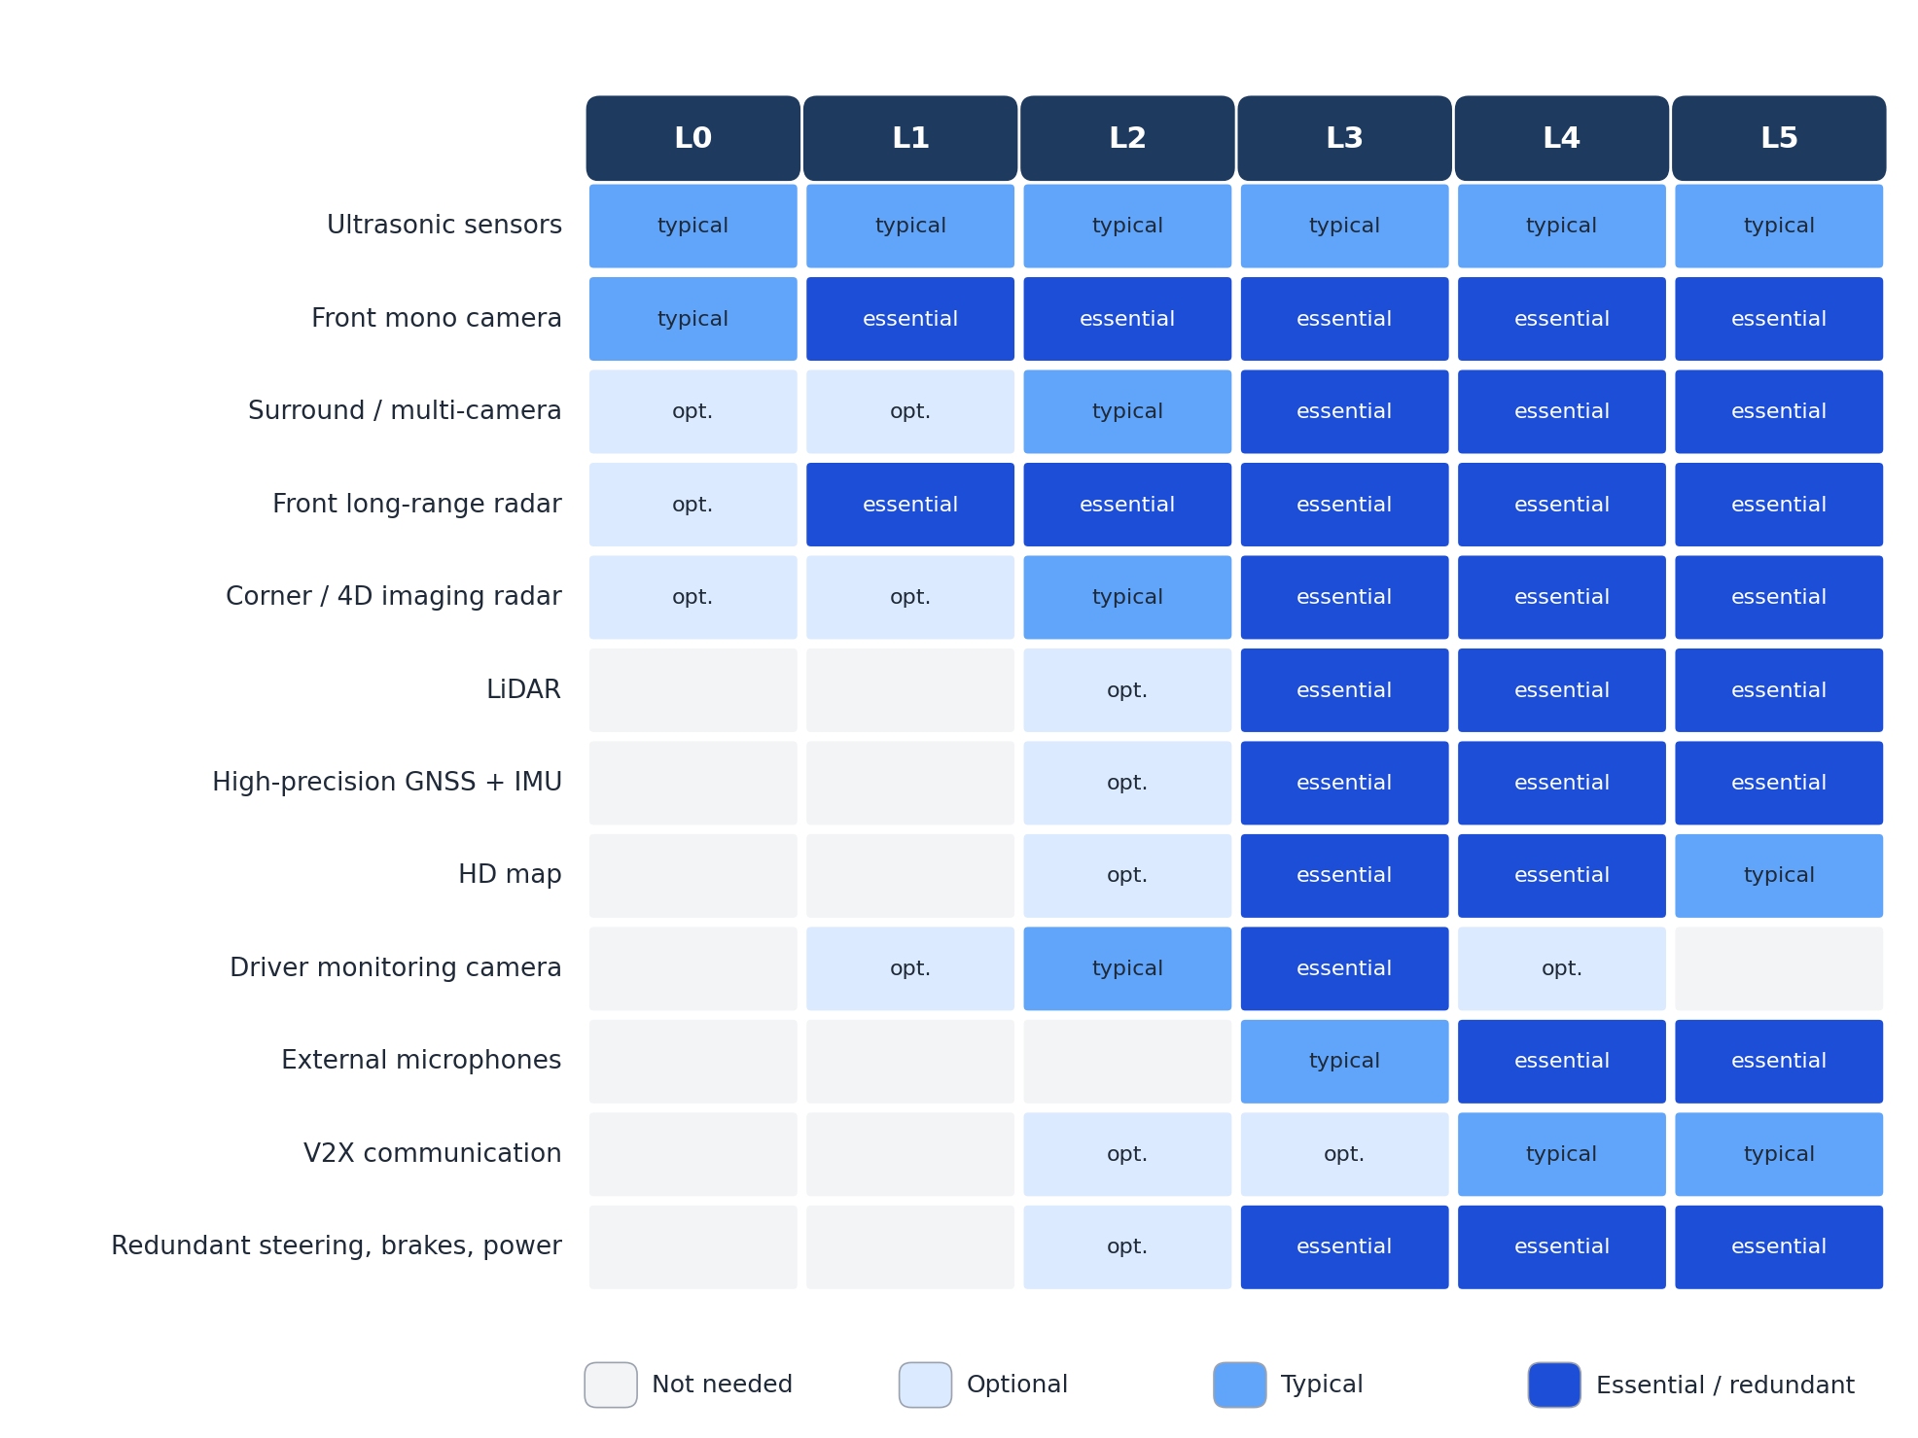
Figure 2: Indicative sensor and hardware requirements by SAE level (compiled from the examples in Section 4)
Table 3: Characteristics of the main automotive sensors
Sensor | Principle | Typical range | Strengths | Weaknesses | Relative cost
Camera | Passive imaging of visible (or near-IR) light | Up to about 250 m (telephoto) | Colour and texture, reads signs, lights and lane markings; cheap; high resolution | No direct depth; affected by glare, darkness, rain and dirt | Low
Radar (77 GHz) | Radio waves; range and velocity from time of flight and Doppler shift | Up to about 250 m | Works in rain, fog and darkness; measures relative speed directly | Low angular resolution (improved by 4D imaging radar); poor at classifying objects | Low to medium
LiDAR | Laser pulses (905 nm or 1550 nm); time of flight | About 100 to 300 m | Accurate 3D point cloud and shape; works at night | Degraded by heavy rain, fog and snow; higher cost; moving parts on some units | Medium to high (falling)
Ultrasonic | Sound waves (about 40 to 50 kHz) | About 0.2 to 5 m | Very cheap; reliable at very short range for parking | Very short range; slow update; cannot classify | Very low
GNSS + IMU | Satellite positioning with inertial measurement | Global | Absolute position (cm-level with RTK); smooth motion estimate from IMU | GNSS lost in tunnels and urban canyons; IMU drifts over time | Low to high (grade dependent)
Microphones | Acoustic sensing | Hundreds of metres for sirens | Detects emergency vehicles before they are visible | Noisy environment; limited localization | Low

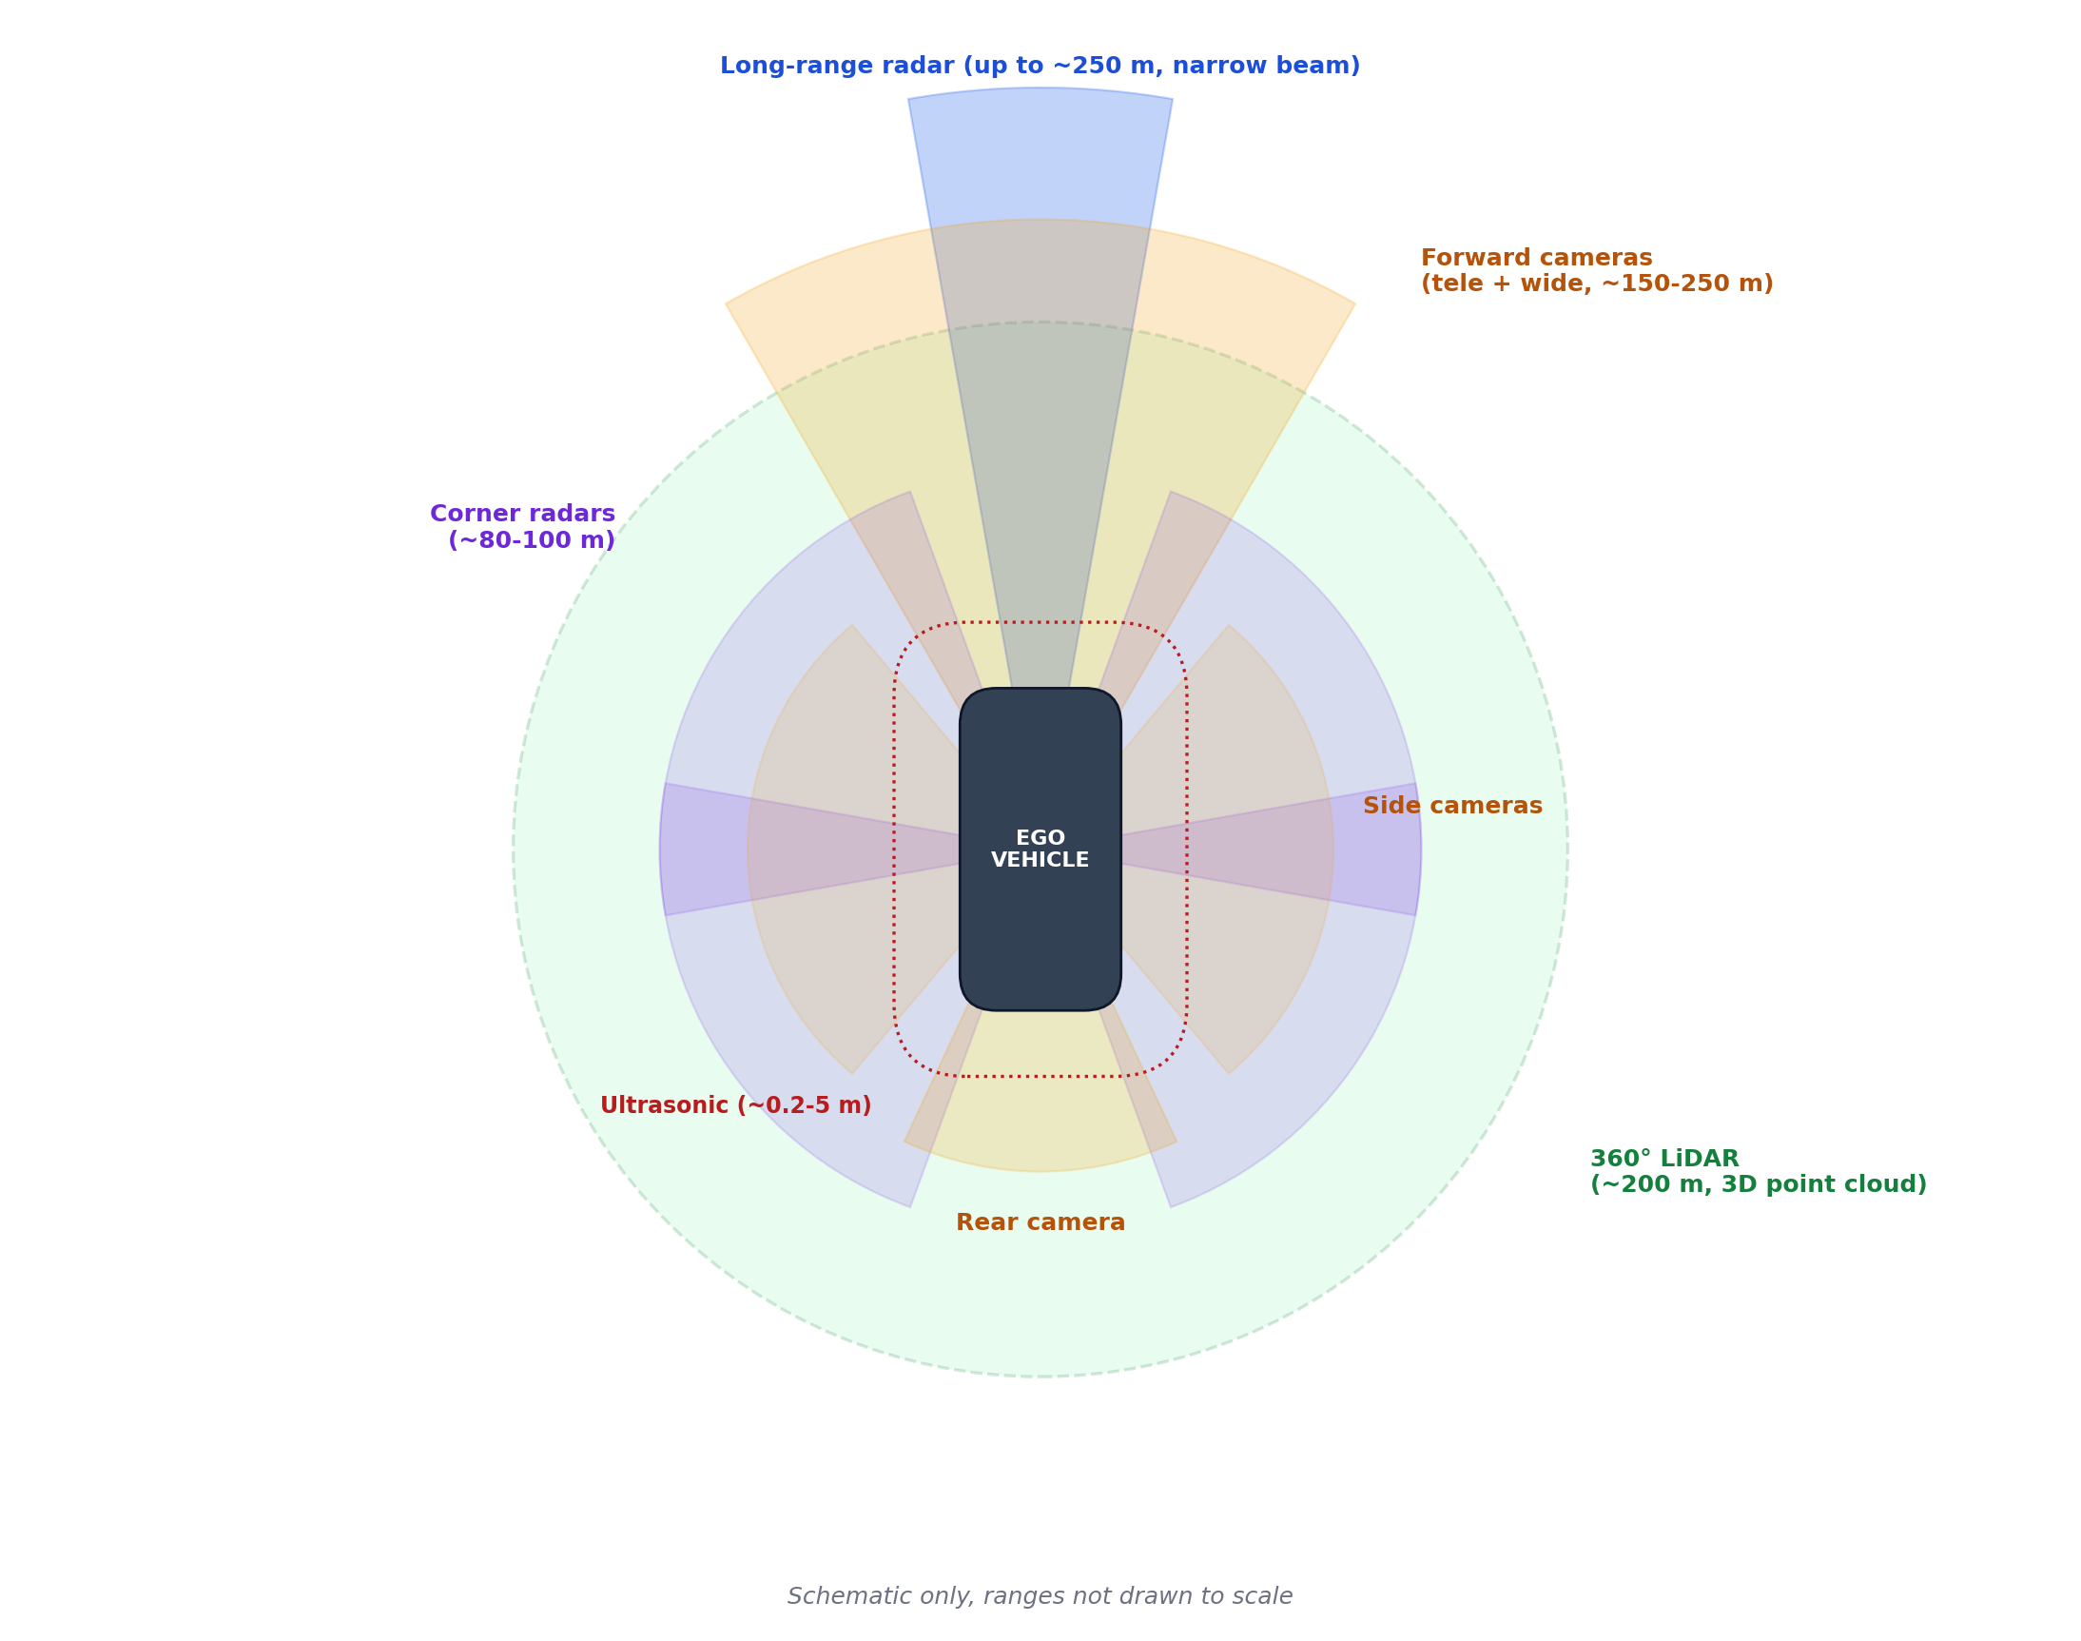
Figure 3: Typical sensor coverage around a Level 3 or Level 4 vehicle (schematic, not to scale)
No single sensor is sufficient for Level 3 and above. Cameras provide the meaning of the scene, radar provides robust range and speed in bad weather, and lidar provides precise geometry. Combining them through sensor fusion gives both better accuracy and redundancy: if one modality is blinded, the others still see the obstacle. Tesla is the notable exception, pursuing a camera-only approach for both its Level 2 product and its robotaxi pilot, while Waymo, Baidu, Zoox and most other Level 4 developers use all three modalities.

6. Comparison of Software Requirements
Software complexity grows even faster than the sensor suite. A Level 1 feature may contain a few hundred thousand lines of code on one ECU; a Level 4 stack contains many millions of lines, dozens of neural networks, and supporting cloud systems for mapping, simulation and fleet operations. Table 4 compares the main software functions.
Table 4: Software functions required at each SAE level
Function | L0 | L1 | L2 | L3 | L4 | L5
Perception | Single-sensor detection, TTC | Lead vehicle or lane detection | Multi-class DNN, camera + radar fusion | 360° multi-modal fusion, tracking | 360° fusion, occupancy, semantics | Open-world, long-tail generalization
Localization | Not needed | Not needed | Lane-relative, standard GNSS | cm-level with HD map | cm-level, map matching | Map-light, anywhere
Prediction | No | Lead vehicle only | Short-term, few agents | Multi-agent | Multi-modal, interaction-aware | Includes intent and social reasoning
Planning | No | Speed or steering only | Lane keeping, lane change | Full DDT in narrow ODD | Full DDT, urban routes | Full DDT, any road
Fallback | Human | Human | Human | Human after TOR; MRM if no response | System MRM, remote assistance | System MRM
HMI / monitoring | Warnings | Status display, hands-on check | Driver monitoring camera | TOR management, driver availability | Passenger app, remote ops | Passenger app
Safety target | ASIL B-C | ASIL B | ASIL B-D | ASIL D, SOTIF | ASIL D, SOTIF, UL 4600 | Beyond current standards
Compute | < 1 TOPS | About 1-5 TOPS | About 10-250 TOPS | Hundreds of TOPS | Hundreds to thousands of TOPS, redundant | Unknown

6.1 The common software pipeline
From Level 2 upwards, automated driving software follows the same basic pipeline, which becomes more complete and more redundant at each level:
- Sensing and pre-processing: time synchronization, calibration, noise filtering.
- Perception: detection, classification and tracking of objects; lane, sign and traffic-light recognition; free-space estimation.
- Localization: estimating the vehicle's position and orientation relative to the map.
- Prediction: forecasting the future motion of other road users.
- Planning: route planning, behaviour decisions (follow, change lane, yield, stop) and trajectory generation.
- Control: converting the planned trajectory into steering, throttle and brake commands.
- Safety monitoring and fallback: detecting faults and ODD exits and triggering the correct response.

7. Standards and Regulations
Table 5: Main standards and regulations for driving automation
Standard / regulation | Scope | Relevant levels
SAE J3016_202104 (ISO/SAE PAS 22736) | Taxonomy and definitions of driving automation levels | All
ISO 26262:2018 | Functional safety of electrical and electronic systems; ASIL A to D | All
ISO 21448:2022 (SOTIF) | Safety of the intended functionality: hazards from performance limits, e.g. sensor misdetection | L1 to L5
ISO/SAE 21434 and UN R155 | Road-vehicle cybersecurity engineering and cybersecurity management system | All connected vehicles
UN R156 | Software update management, including OTA updates | All
UN R157 (ALKS) | Type approval of Level 3 lane-keeping systems, up to 130 km/h since 2022 amendment | L3
UN R171 (DCAS) | Driver control assistance systems (Level 2), including driver monitoring | L2
UL 4600 | Safety case for autonomous products without a human driver | L4, L5

Indian context. Indian law under the Motor Vehicles Act still assumes a licensed human driver in control of the vehicle, so only Level 0 to Level 2 features are sold in India. Road conditions such as mixed traffic with two-wheelers, auto-rickshaws, pedestrians and animals, faded lane markings and unstructured intersections make automation harder than in the markets where Level 4 services currently operate. Indian start-ups are researching autonomy suited to these conditions, but commercial Level 3 or Level 4 deployment in India has not yet been approved.

8. Discussion: Industry Trends in 2025-2026
- Level 2 is getting more capable: hands-free systems now handle city streets (Tesla FSD Supervised, Mercedes MB.Drive Assist Pro), but legally they remain Level 2 because the driver must supervise.
- Level 3 is being questioned in Europe: both Mercedes-Benz and BMW announced in early 2026 that their facelifted flagships would drop Level 3 in favour of cheaper, more broadly usable Level 2 systems, citing cost, narrow ODD and low uptake. At the same time China issued its first Level 3 permits in December 2025.
- Level 4 robotaxis are scaling: Waymo and Baidu each passed 20 million cumulative rides, with weekly ride counts growing quickly, and new entrants (Zoox, Tesla, Pony.ai, WeRide) expanding in the US, China and the Middle East.
- Sensor costs are falling: fewer, better sensors (Waymo cut its sensor count by about 42 percent from the 5th to the 6th generation while keeping all three modalities) and cheaper lidar are bringing Level 4 hardware closer to consumer-car budgets.
- End-to-end AI is rising: many developers are replacing hand-written modules with large neural networks trained on fleet data, which raises new questions about how to verify and certify such systems.

9. Conclusion
The SAE J3016 levels describe how responsibility for driving moves from the human to the machine. Levels 0 to 2 only support a driver who remains fully responsible, and they can be built with a modest set of cameras, radars and ultrasonic sensors and a single computer. From Level 3 the system itself must monitor the road, which demands redundant and diverse sensing, precise localization with HD maps, fail-safe actuators and software developed to the highest safety integrity levels. Level 4 removes the human fallback entirely and adds a self-sufficient safety supervisor, remote assistance and fleet operations; this is where today's robotaxis operate. Level 5 remains a research goal because an unlimited ODD cannot yet be engineered or validated.
The real-world picture in 2026 shows two diverging paths: increasingly capable Level 2 systems in privately owned cars, and geofenced Level 4 services in commercial fleets, with Level 3 caught between them. For an engineer, the most important lesson is that each step up the ladder is not just more automation; it changes who is responsible for safety, and the sensors and software must be designed to carry that responsibility.

References
- SAE International, "J3016_202104: Taxonomy and Definitions for Terms Related to Driving Automation Systems for On-Road Motor Vehicles," April 2021. https://www.sae.org/standards/content/j3016_202104/
- P. Koopman, "SAE J3016 User Guide," Carnegie Mellon University. https://users.ece.cmu.edu/~koopman/j3016/
- Waymo, "Meet the 6th-generation Waymo Driver," August 2024. https://waymo.com/blog/2024/08/meet-the-6th-generation-waymo-driver/
- Waymo, "Beginning fully autonomous operations with the 6th-generation Waymo Driver," February 2026. https://waymo.com/blog/2026/02/ro-on-6th-gen-waymo-driver/
- TechCrunch, "Waymo's skyrocketing ridership in one chart," March 2026. https://techcrunch.com/2026/03/27/waymo-skyrocketing-ridership-in-one-chart/
- Automotive World, "Mercedes-Benz is approved for 95 km/h Level 3 autonomous driving in Germany," December 2024. https://www.automotiveworld.com/news-releases/mercedes-benz-is-approved-for-95-km-h-level-3-autonomous-driving-in-germany/
- electrive, "Mercedes pauses Level 3 driving assistance, for now," 12 January 2026. https://www.electrive.com/2026/01/12/mercedes-pauses-level-3-driving-assistance-for-now/
- BMW Group, "Level 3 highly automated driving available in the new BMW 7 Series from next spring," press release, 2023. https://www.press.bmwgroup.com/global/article/detail/T0438214EN/
- BMWBlog, "BMW 7 Series facelift losing Level 3 autonomous driving tech: report," 23 February 2026. https://www.bmwblog.com/2026/02/23/bmw-7-series-facelift-losing-level-3-autonomous-driving-tech-report/
- Xinhua, "China's first L3 autonomous driving permits pave way for smarter mobility," 17 December 2025. https://english.news.cn/20251217/71c203bbccfa40b8af15718bff40341b/c.html
- CnEVPost, "Baidu's Apollo Go robotaxi hits 300,000 weekly rides as service expands to South Korea," 27 February 2026. https://cnevpost.com/2026/02/27/baidu-apollo-go-robotaxi-300000-weekly-rides-expands-to-south-korea/
- The Charge Port, "Robotaxi status September 2026: Waymo, Tesla and Zoox." https://thechargeport.com/robotaxi-tracker
- UNECE, "UN Regulation No. 157: Automated Lane Keeping Systems (ALKS)." https://unece.org/transport/documents/2021/03/standards/un-regulation-no-157-automated-lane-keeping-systems-alks
- ISO 26262:2018, Road vehicles: Functional safety; ISO 21448:2022, Road vehicles: Safety of the intended functionality; ISO/SAE 21434:2021, Road vehicles: Cybersecurity engineering.
- UL 4600, Standard for Safety for the Evaluation of Autonomous Products, 3rd ed., Underwriters Laboratories, 2023.

