IN-VEHICLE INFOTAINMENT SYSTEMS
ARCHITECTURE DESIGN
Conceptual Architecture of an In-Vehicle Infotainment (IVI) System
Integrating media, navigation and smartphone projection, with annotated component interfaces and data flow

Submitted by
Name | Prajakta Ghosh
Enrollment No. | 12023002002107
Registration No. | 304202300900494
Department | Electronics and Communication Engineering (ECE)
Section | 4B
Roll No. | 34

September 2026

Table of Contents

Abstract
This document presents a conceptual architecture for an In-Vehicle Infotainment (IVI) system that integrates three feature groups: media (radio, USB, Bluetooth and streaming audio), navigation (positioning, routing and guidance) and smartphone projection (Apple CarPlay and Android Auto, wired and wireless). The architecture is built around a cockpit domain controller in which a Type-1 hypervisor separates an Android Automotive OS virtual machine, which runs the infotainment functions, from a real-time OS virtual machine that renders the safety-relevant instrument cluster and head-up display. The main diagram shows every component from the external sources and connectivity modules through the HMI, application, service, OS and hardware layers to the output devices and the vehicle network. Each of the 14 interfaces is annotated with its bus or protocol and the data it carries, and each data path is colour-coded by feature. Four supporting diagrams detail the media, navigation and projection data flows and the wireless projection session set-up, and a physical deployment view maps the functions onto ECUs and in-vehicle links.

1. Introduction
An In-Vehicle Infotainment system is the part of the car's electronics that provides information and entertainment to the driver and passengers: audio, navigation, phone connectivity, vehicle settings and increasingly apps and voice assistants. Modern IVI systems are no longer stand-alone radios. They are networked computers that must work with the driver's smartphone, the cloud, the instrument cluster, the head-up display, the audio amplifier and dozens of other ECUs on the vehicle network, while limiting driver distraction and never interfering with safety functions.
Three features dominate everyday use. Media must play audio from many different sources and mix it correctly with navigation prompts, phone calls and safety chimes. Navigation must know where the car is even in tunnels, find routes using live traffic, and present guidance on several screens and by voice. Smartphone projection lets the driver use apps from their phone on the car's display, which means the head unit must act as a display, speaker, microphone and input device for the phone while still sharing screen and audio with its own native functions.

1.1 Objectives
- Design a conceptual (logical) architecture of an IVI system that integrates media, navigation and projection.
- Identify every major component and its responsibility.
- Annotate each interface with the bus or protocol used and the data it carries.
- Show the data flow for each feature, including how the features share the display and the audio system.
- Map the logical architecture onto a plausible physical deployment.

1.2 Scope and assumptions
- The design is a reference architecture for a mid- to premium-segment car and is independent of any single manufacturer.
- The IVI runs on Android Automotive OS (AAOS), which is widely used by carmakers; the concepts apply equally to Linux-based (for example AGL or COVESA-based) or QNX-based head units.
- The instrument cluster and HUD are driven by the same cockpit domain controller in a separate, safety-oriented partition.
- Details such as exact chip part numbers, screen sizes and speaker counts are indicative.

2. Requirements

2.1 Functional requirements
Table 1: Functional requirements
ID | Feature | Requirement
FR-M1 | Media | Play audio from AM / FM / DAB+ radio, USB storage, Bluetooth (A2DP), online streaming and projected phones.
FR-M2 | Media | Display now-playing metadata (title, artist, album art, station) on the centre display and the cluster.
FR-M3 | Media | Arbitrate audio focus so that safety chimes, calls and navigation prompts take priority over media.
FR-N1 | Navigation | Determine vehicle position with lane-level accuracy using GNSS, IMU and wheel speed, including in tunnels.
FR-N2 | Navigation | Calculate routes using an on-board map and live traffic, and re-route automatically when off-route.
FR-N3 | Navigation | Show guidance on the centre display, cluster and HUD, and speak voice prompts.
FR-P1 | Projection | Support Apple CarPlay and Android Auto over USB and over Wi-Fi (wireless).
FR-P2 | Projection | Display the phone's UI, play its audio streams and forward touch, rotary, steering-wheel and microphone input to it.
FR-P3 | Projection | Send vehicle data (location, speed, night mode) to the phone and show phone navigation on the cluster and HUD.
FR-S1 | Shared | Allow native and projected features to run at the same time (e.g. projected music with native navigation).

2.2 Non-functional requirements
Table 2: Non-functional requirements
Category | Requirement
Start-up | Rear-camera image within 2 s of selecting reverse (as required by US FMVSS 111), early audio (chimes, radio) within a few seconds of wake-up, full HMI shortly after.
Responsiveness | Touch-to-visual response of about 100 ms or better; projection video at 30 to 60 frames per second without visible stutter.
Driver distraction | Lock out complex tasks (text entry, video) while driving, following visual-manual guidelines such as NHTSA's, which limit single glances away from the road to about 2 s.
Safety isolation | A crash or overload of the infotainment software must never affect cluster warning lamps (telltales) or the rear camera.
Security | Secure boot, isolated connectivity, signed OTA updates (UN R155 cybersecurity, UN R156 software updates).
Availability | If projection or the network fails, native media and navigation must keep working; calls continue over Bluetooth HFP.

3. Conceptual Architecture Overview
Figure 1 is the main deliverable of this assignment. It is organised from left to right in the direction of the main data flow, and the head unit is organised from top to bottom in software layers. Numbered circles mark the 14 annotated interfaces, which are listed on the diagram and specified in detail in Section 5. Line colours show which feature a data path belongs to.
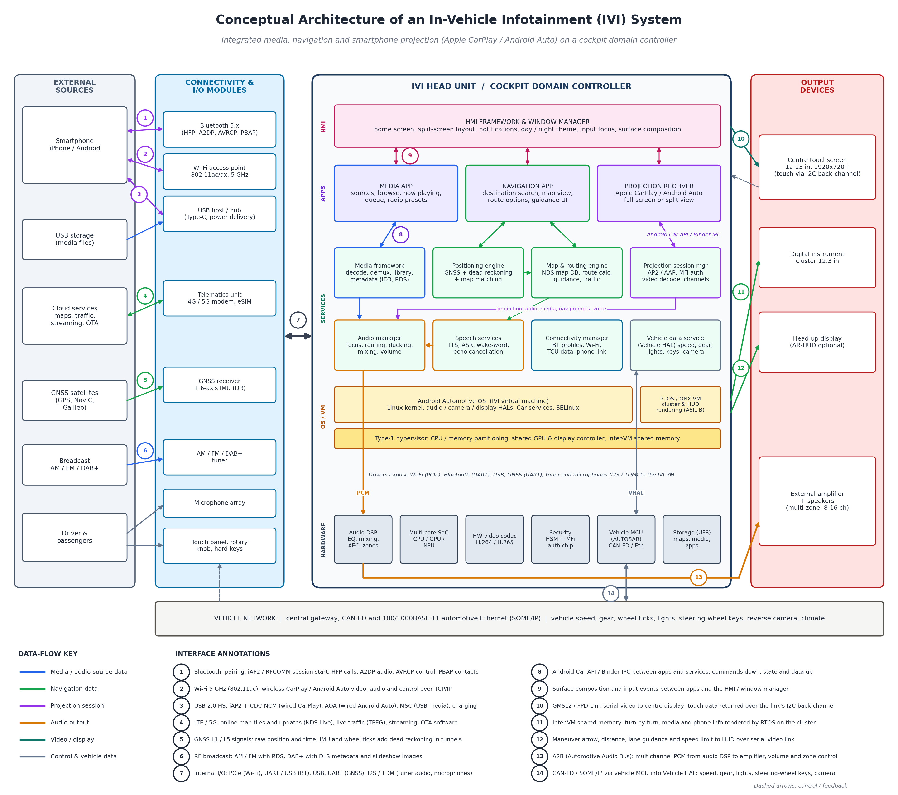
Figure 1: Conceptual architecture of the IVI system with annotated interfaces and colour-coded data flows (full-size vector version in 01_Diagrams)

3.1 Structure of the diagram
- External sources: the smartphone, USB storage, cloud services, GNSS satellites, broadcast radio and the occupants.
- Connectivity and I/O modules: the radio and interface hardware that turns these sources into digital data: Bluetooth, Wi-Fi, USB, the telematics unit (TCU), the GNSS receiver with IMU, the tuner, microphones and input devices.
- IVI head unit (cockpit domain controller), in five layers: HMI framework; applications (media, navigation, projection); middleware and services; operating systems and hypervisor; hardware platform.
- Output devices: centre touchscreen, digital instrument cluster, head-up display and the external amplifier with speakers.
- Vehicle network: the central gateway that provides vehicle speed, gear, wheel ticks, lights, steering-wheel keys and the reverse camera over CAN-FD and automotive Ethernet.

3.2 Design principles
- Mixed-criticality separation: a Type-1 hypervisor runs the feature-rich but non-safety IVI in one virtual machine and the cluster / HUD renderer in a real-time OS virtual machine, so that telltales and speed display stay available even if Android restarts.
- Service-oriented middleware: applications never talk to hardware directly. They use shared services (media framework, audio manager, positioning, routing, projection session, vehicle data) through a stable API, so that one service such as positioning serves both the native navigation app and the projected phone.
- Source-agnostic audio management: every audio stream, native or projected, goes through one audio manager that applies a single set of priority and ducking rules.
- Projection as a guest: the projected phone is treated as another source of video, audio and metadata. The head unit keeps control of the screen, the audio focus and the vehicle data it shares.
- Graceful degradation: loss of connectivity, phone or cloud reduces features but leaves the core system usable.

4. Component Descriptions

4.1 Connectivity and I/O modules
Table 3: Connectivity and I/O components
Component | Responsibility | Interfaces
Bluetooth 5.x module | Pairing, hands-free calls (HFP), audio streaming (A2DP), remote control and metadata (AVRCP), contacts (PBAP), projection session bootstrap | IF-01, IF-07
Wi-Fi access point | 5 GHz 802.11ac/ax access point that the phone joins for wireless CarPlay / Android Auto | IF-02, IF-07
USB host / hub | Wired projection, USB media playback and phone charging | IF-03, IF-07
Telematics unit (TCU) | 4G / 5G connectivity with eSIM for maps, traffic, streaming, OTA and emergency call | IF-04, IF-07
GNSS receiver + IMU | Satellite position and time, plus gyroscope and accelerometer for dead reckoning | IF-05, IF-07
AM / FM / DAB+ tuner | Demodulates broadcast radio and extracts RDS / DLS metadata | IF-06, IF-07
Microphone array | Voice commands, hands-free calls and projection voice assistants | IF-07
Touch panel, rotary knob, keys | Driver input, plus steering-wheel keys received via the vehicle network | IF-07, IF-14

4.2 Head-unit software components
Table 4: Head-unit software components
Layer | Component | Responsibility
HMI | HMI framework & window manager | Home screen and layouts, split-screen, notifications, day / night theme, input focus, composition of all app surfaces into the display image.
Apps | Media app | Source selection, browsing, now-playing view, radio presets, queue.
Apps | Navigation app | Destination search, map view, route options, guidance UI.
Apps | Projection receiver | Hosts the CarPlay / Android Auto surface in full-screen or split view and handles user switching between native and projected UI.
Services | Media framework | Source plug-ins, demuxing and decoding, metadata extraction (ID3, AVRCP, RDS, DLS), USB library indexing.
Services | Audio manager | Audio focus arbitration, ducking and muting, routing to zones, volume curves.
Services | Positioning engine | Fuses GNSS, IMU and wheel ticks with an extended Kalman filter, performs dead reckoning and map matching.
Services | Map & routing engine | Map database access (NDS), route calculation with live traffic, guidance and re-routing.
Services | Speech services | Text-to-speech for prompts, speech recognition, wake-word detection, echo cancellation.
Services | Projection session manager | iAP2 / Android Auto protocol handling, MFi / certificate authentication, channel multiplexing, video decoding, screen and audio resource negotiation.
Services | Connectivity manager | Bluetooth profiles, Wi-Fi access point, TCU data, phone link management.
Services | Vehicle data service (VHAL) | Exposes vehicle properties (speed, gear, lights, keys, camera state) from the vehicle network to apps and to the projected phone.
OS / VM | Android Automotive OS VM | Runs all infotainment software with Linux kernel, HALs, Car services and SELinux sandboxing.
OS / VM | RTOS / QNX VM | Renders the instrument cluster and HUD, including safety telltales, independently of Android.
OS / VM | Type-1 hypervisor | Partitions CPU cores and memory, shares GPU and display controller, provides inter-VM shared memory.

4.3 Hardware and outputs
- Multi-core SoC with CPU, GPU and NPU (automotive cockpit SoCs in the class of Qualcomm Snapdragon Cockpit or NXP i.MX 8 / 9) running both virtual machines.
- Hardware video codec for H.264 / H.265 projection and media video decoding.
- Audio DSP for mixing, equalisation, speed-dependent volume, sound zones and acoustic echo cancellation.
- Security: hardware security module (HSM) for secure boot and keys, and the Apple MFi authentication coprocessor required for CarPlay.
- Vehicle MCU running AUTOSAR Classic, which connects to CAN-FD and automotive Ethernet and handles power modes.
- Outputs: centre touchscreen, 12.3-inch digital cluster, head-up display and an external amplifier driving 8 to 16 speakers.

5. Interface Specification
Table 5 specifies the 14 interfaces annotated in Figure 1. External interfaces (IF-01 to IF-06) connect the car to the outside world; internal interfaces (IF-07 to IF-09) connect components inside the head unit; output and vehicle interfaces (IF-10 to IF-14) connect the head unit to displays, audio and the rest of the vehicle.
Table 5: Interface specification
IF | Endpoints | Bus / protocol | Data carried | Direction
01 | Phone ↔ Bluetooth module | Bluetooth BR/EDR + LE: HFP, A2DP, AVRCP, PBAP, iAP2 / RFCOMM | Call audio, music, play / pause, contacts, Wi-Fi credentials for wireless projection | Both
02 | Phone ↔ Wi-Fi AP | IEEE 802.11ac/ax, 5 GHz, TCP/IP | Wireless CarPlay / Android Auto video, audio, input, vehicle data | Both
03 | Phone / USB drive ↔ USB host | USB 2.0 High Speed (480 Mbit/s): iAP2 + CDC-NCM, Android Open Accessory, Mass Storage | Wired projection streams, media files, charging | Both
04 | Cloud ↔ TCU | LTE / 5G NR, HTTPS / MQTT | Map updates (NDS.Live), live traffic (TPEG), streaming audio, OTA packages | Both
05 | Satellites → GNSS receiver | GNSS L1 / L5 (GPS, NavIC, Galileo) | Raw position, velocity, time | In
06 | Broadcast → tuner | AM / FM RF with RDS; DAB+ with DLS | Audio, station name, song info, slideshow | In
07 | I/O modules ↔ SoC | PCIe (Wi-Fi), UART / USB (BT), USB, UART (GNSS), SPI (IMU), I2S / TDM (tuner, mics) | All connectivity, positioning and audio input data | Both
08 | Apps ↔ services | Android Car API, Binder IPC | Commands (play, set destination), state and data (position, route, metadata) | Both
09 | Apps ↔ HMI framework | Surface composition (SurfaceFlinger), input dispatch | App surfaces, touch and rotary events | Both
10 | Head unit ↔ centre display | GMSL2 / FPD-Link serial link with I2C back-channel | Composed video out, touch coordinates in | Both
11 | IVI VM → cluster | Inter-VM shared memory; GMSL2 / LVDS to display | Turn-by-turn, media and phone info for the cluster | Out
12 | Head unit → HUD | GMSL2 serial video | Maneuver arrow, distance, lane, speed limit | Out
13 | Audio DSP → amplifier | A2B Automotive Audio Bus (50 Mbit/s), TDM | Multichannel PCM, volume and zone control | Out (mics in)
14 | Vehicle network ↔ VHAL | CAN-FD, 100/1000BASE-T1 Ethernet (SOME/IP) via vehicle MCU | Speed, gear, wheel ticks, lights, steering-wheel keys, camera state | Both

6. Data Flows

6.1 Media
Figure 2 follows audio from each source to the speakers. Compressed sources (USB files, Bluetooth A2DP, streaming) are decoded by the media framework, while the tuner already delivers PCM. All decoded streams, together with projection audio, navigation prompts, phone calls and safety chimes, meet in the audio manager, which decides which streams are audible and at what level. The audio DSP mixes the streams per zone, applies equalisation and speed-dependent volume (using vehicle speed from the Vehicle HAL), and sends multichannel audio over A2B to the amplifier. In parallel, metadata travels up to the media app and is shown on the centre display and, through inter-VM shared memory, on the cluster.
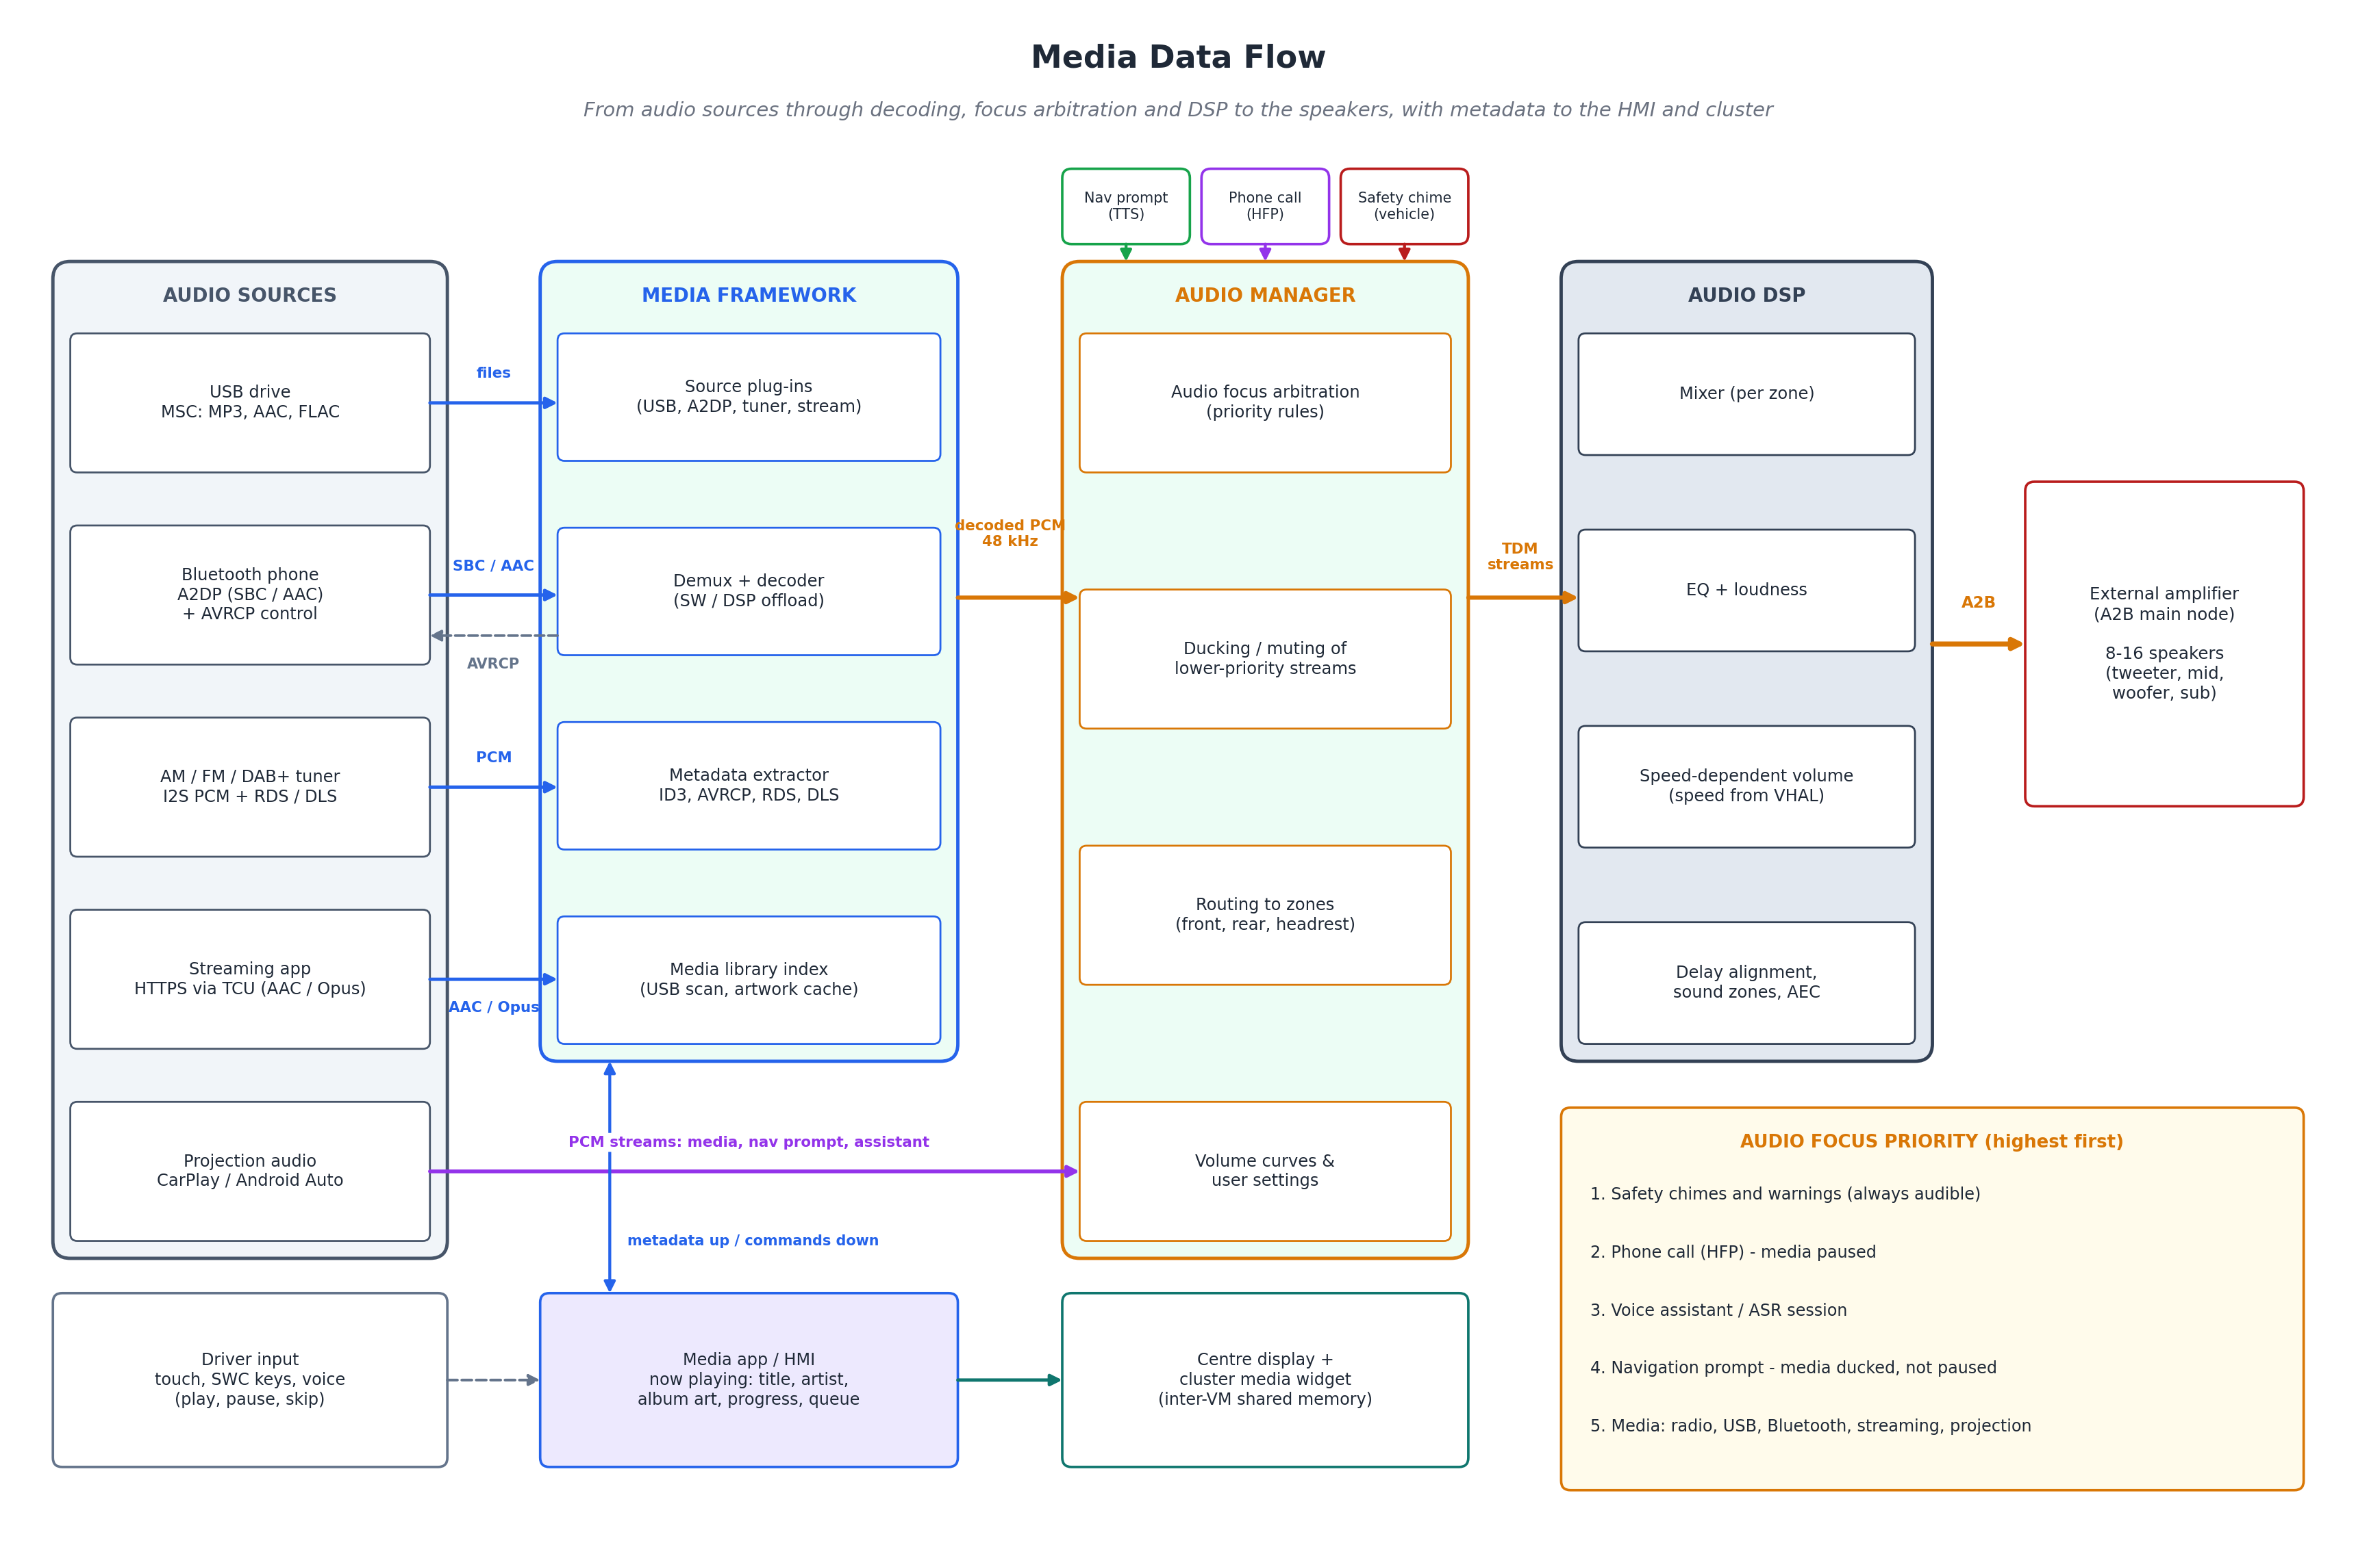
Figure 2: Media data flow

6.2 Navigation
Figure 3 shows the navigation pipeline. The positioning engine fuses GNSS fixes (1 to 10 Hz) with IMU data (100 Hz) and wheel ticks from the Vehicle HAL, so that position stays accurate in tunnels and multi-level car parks, then matches it to a road segment in the NDS map. The route engine computes a route on the road graph using live traffic from the cloud and re-routes when the guidance engine reports the car is off route. The guidance engine turns the route into maneuvers, distances and lane information, which go to the map view, the cluster, the HUD and, through text-to-speech, to the audio manager, which ducks the media while a prompt plays.
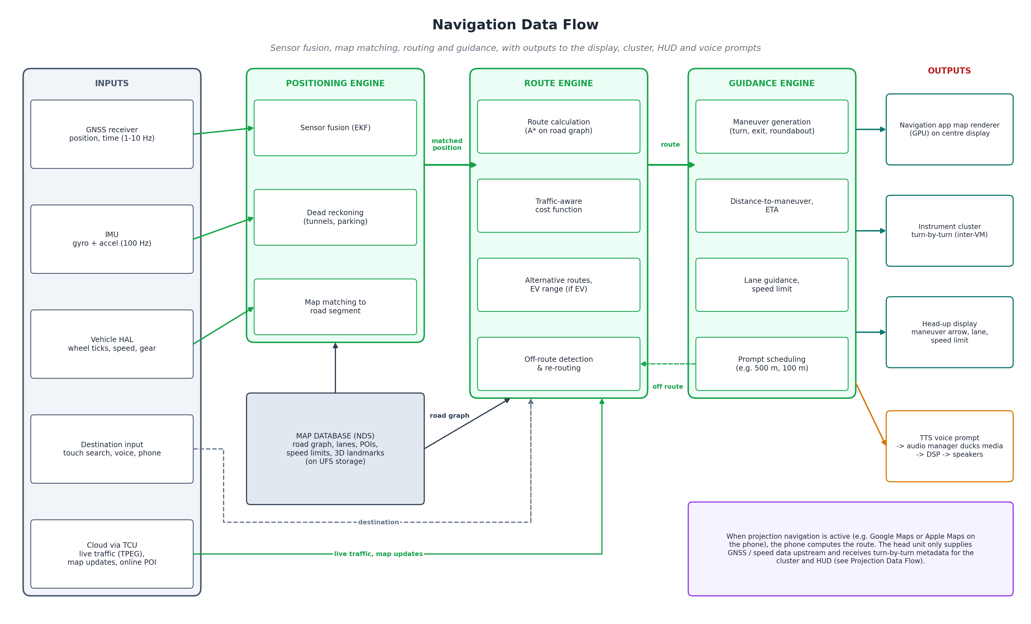
Figure 3: Navigation data flow

6.3 Smartphone projection
With projection, the phone runs the apps and renders the user interface, and the head unit becomes its display, speakers, microphone and input device (Figure 4). Downstream, the phone sends an H.264 video stream that the hardware decoder turns into a surface for the HMI compositor, several audio streams that enter the audio manager like any other source, and metadata such as turn-by-turn instructions for the cluster and HUD. Upstream, the head unit sends touch, rotary and steering-wheel events, microphone audio for the voice assistant and calls, and vehicle data: GNSS location, speed, night mode and gear. The session manager also negotiates who owns the screen and the main audio at any moment.
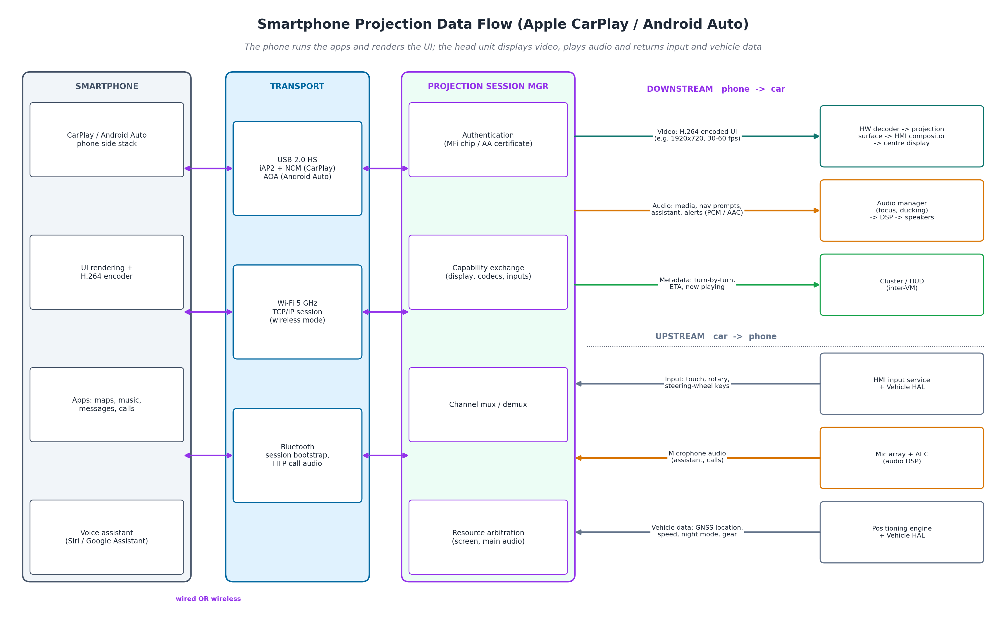
Figure 4: Smartphone projection data flow
Figure 5 shows how a wireless session starts. Bluetooth is used only to discover the phone and to share the Wi-Fi credentials; Apple recommends that the head unit's access point operates in the 5 GHz band with 802.11ac, because it offers more channels and less interference. All video, audio and control data then travel over Wi-Fi. If Wi-Fi is lost, the session ends cleanly and the HMI returns to its native screens while any phone call continues over Bluetooth HFP.
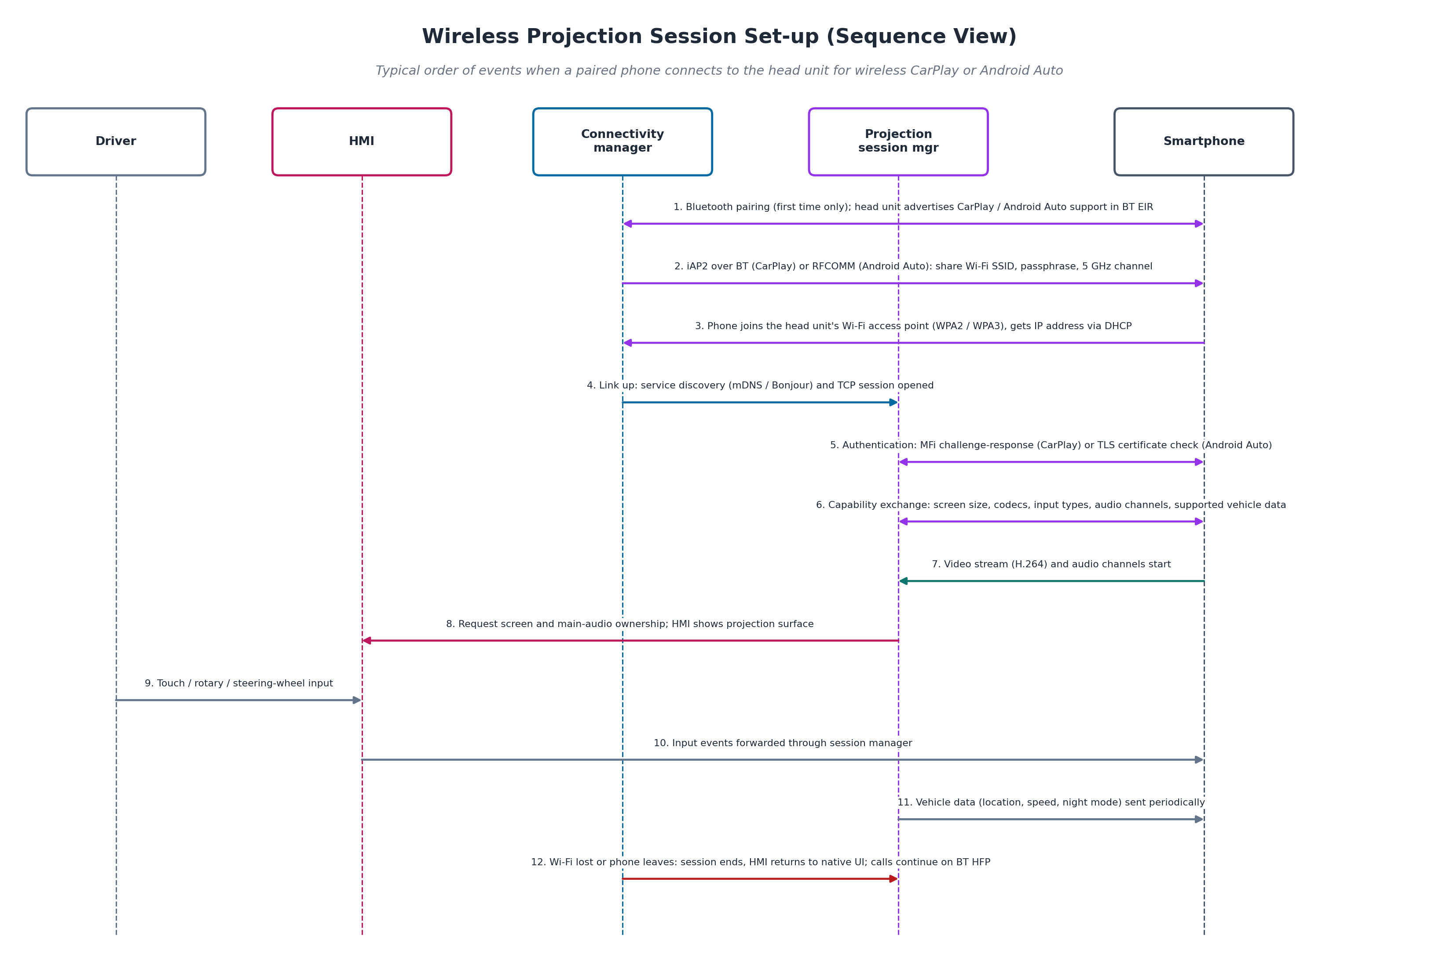
Figure 5: Wireless projection session set-up

6.4 Feature interaction scenarios
Table 6: Interaction between media, navigation and projection
Scenario | How the architecture handles it
Projected music + native navigation | Projection audio and native TTS prompts both enter the audio manager; media is ducked during each prompt. Native guidance goes to the cluster and HUD.
Phone navigation (projected) + native media | The phone owns navigation; its turn-by-turn metadata is forwarded to the cluster and HUD. Radio or USB audio stays on the native media path.
Incoming call during navigation | HFP call audio takes audio focus over media; navigation prompts are shortened or held according to the priority rules.
Driver selects reverse | The Vehicle HAL reports reverse gear; the HMI shows the rear camera full-screen over any native or projected content, and chimes remain audible.
Tunnel / GNSS loss | The positioning engine continues with dead reckoning; if projection navigation is active, the phone also receives the head unit's location data.
Phone disconnected | Projection ends; native media and navigation continue without interruption.

7. Physical Deployment
Figure 6 maps the logical architecture onto hardware. The cockpit domain controller integrates the SoC, Wi-Fi / Bluetooth combo chip, GNSS receiver, tuner, audio DSP and vehicle MCU in one box. High-bandwidth video uses serialised links (GMSL2 or FPD-Link), audio uses the A2B daisy-chain bus, which also carries microphone signals back, and vehicle data comes over automotive Ethernet and CAN-FD through the central gateway.
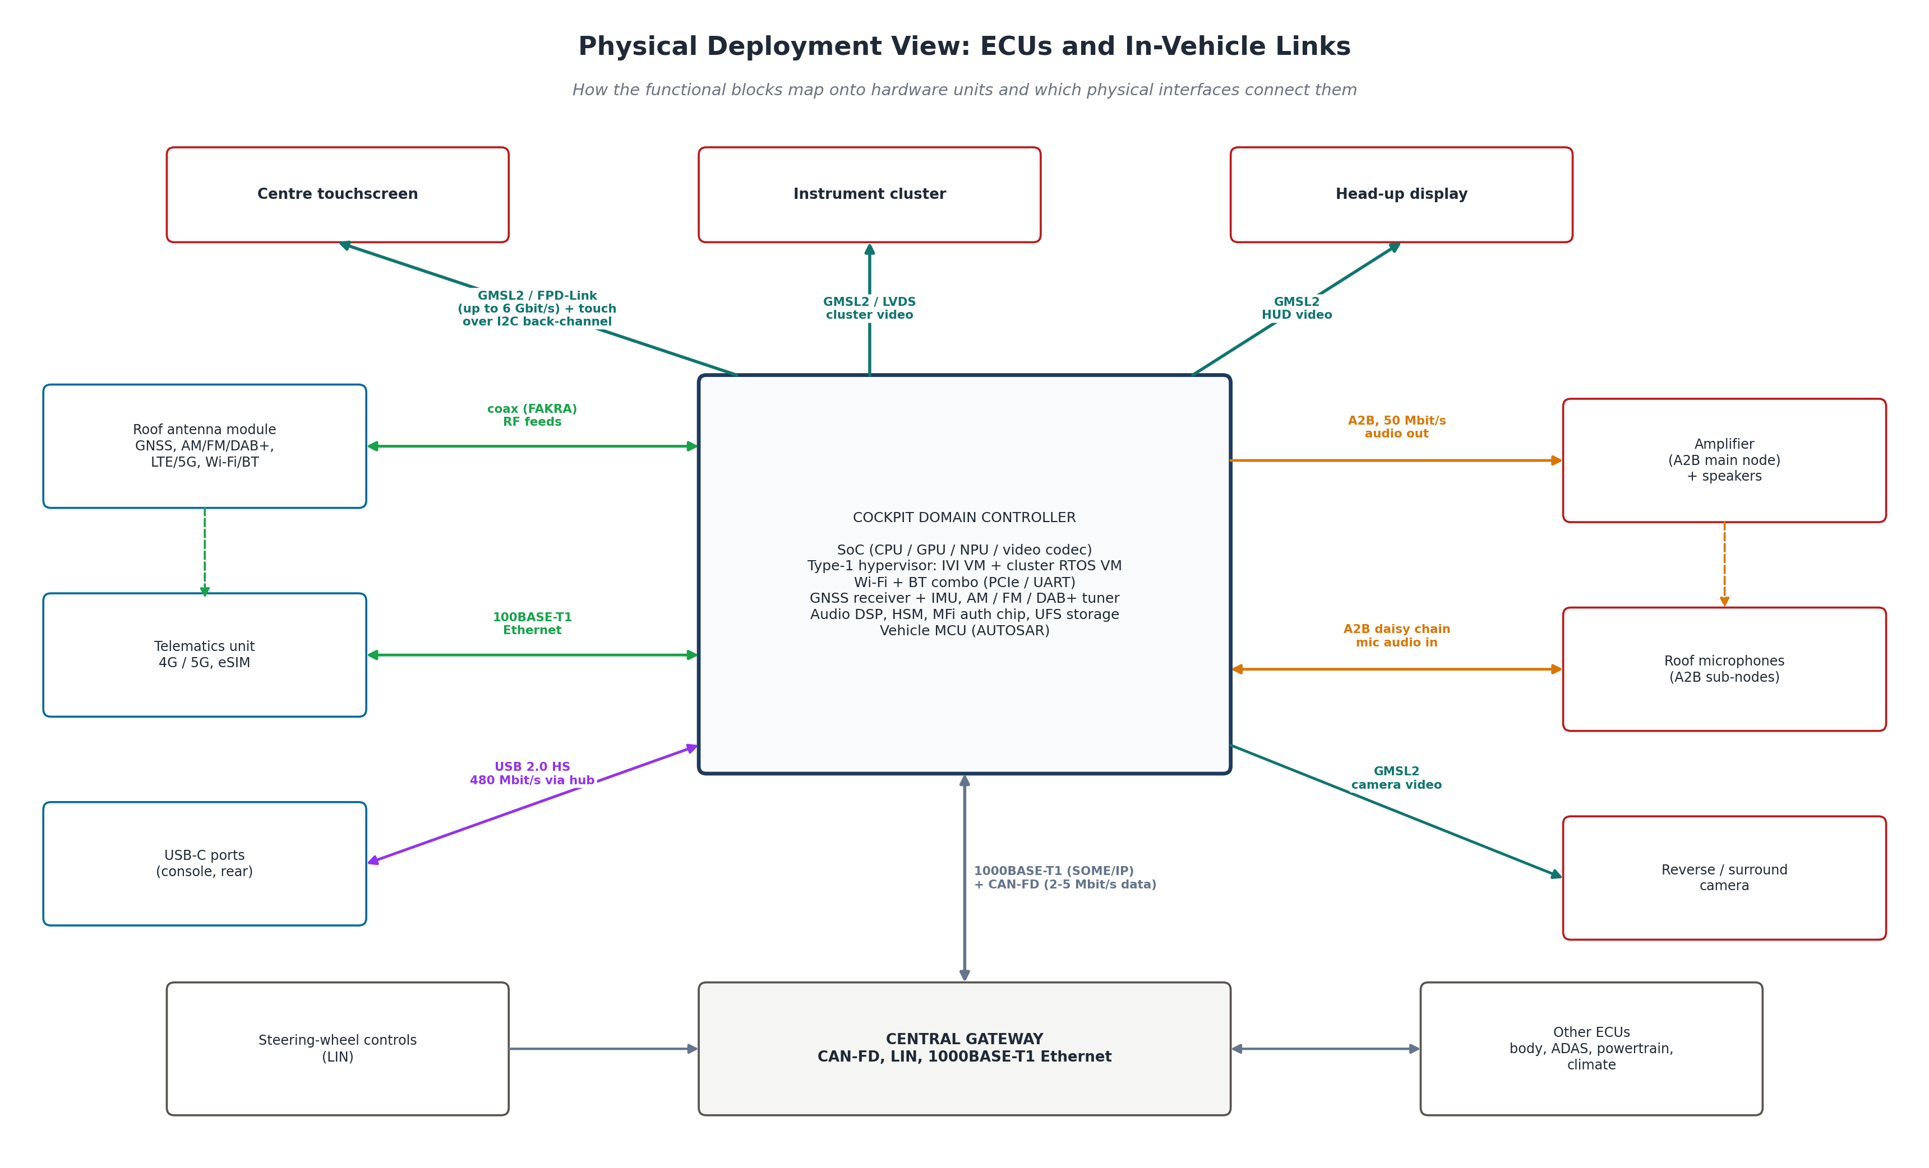
Figure 6: Physical deployment view
Table 7: In-vehicle links and their typical bandwidth
Link | Typical bandwidth | Used for
GMSL2 / FPD-Link | Up to about 6 Gbit/s per link | Centre display, cluster, HUD, cameras
USB 2.0 High Speed | 480 Mbit/s | Wired projection, USB media
Wi-Fi 802.11ac (5 GHz) | Hundreds of Mbit/s | Wireless projection
A2B | 50 Mbit/s | Speaker audio out, microphone audio in
100/1000BASE-T1 Ethernet | 100 Mbit/s / 1 Gbit/s | TCU link, vehicle data (SOME/IP)
CAN-FD | About 2 to 5 Mbit/s data phase | Vehicle signals via gateway
LIN | Up to 20 kbit/s | Steering-wheel switches

8. Safety, Security and Other Qualities
- Functional safety: the cluster telltales, speed display and rear camera are handled outside the Android VM (RTOS VM and dedicated camera path) so that they meet their safety requirements (typically ASIL-B for the cluster) regardless of infotainment load.
- Cybersecurity: the phone, Wi-Fi and cellular interfaces are the main attack surfaces. The design uses secure boot through the HSM, SELinux sandboxing of apps, a firewall between the IVI VM and the vehicle network (the VHAL only exposes approved properties), and signed OTA updates as required by UN R155 and UN R156.
- Driver distraction: the HMI applies driving-state restrictions (from the Vehicle HAL) to native apps; CarPlay and Android Auto apply their own driving-optimised templates.
- Performance: hardware video decoding and DSP audio processing keep the CPU free; early-boot services start the rear camera and chimes before the full Android system.
- Maintainability: service interfaces and OTA updates allow new features and map updates during the vehicle's life.

9. Conclusion
The proposed architecture integrates media, navigation and smartphone projection on a single cockpit domain controller. A layered, service-oriented design lets both native apps and the projected phone share the same positioning, audio and vehicle-data services, while a single audio manager and HMI framework keep the driver's experience consistent. A hypervisor keeps safety-relevant cluster and HUD functions independent of the infotainment software. The main diagram annotates all 14 interfaces with their protocols and data, and the supporting diagrams trace each feature's data flow from source to output, showing how the three features run together without conflict.

References
- Apple, "Developing Wireless CarPlay Systems," WWDC 2017, Session 717. https://developer.apple.com/videos/play/wwdc2017/717/
- Wikipedia, "CarPlay." https://en.wikipedia.org/wiki/CarPlay
- Engadget, "Bluetooth or Wi-Fi: How does wireless CarPlay connect?" https://www.engadget.com/2246396/how-does-wireless-apple-carplay-connect-bluetooth-wifi/
- Android Open Source Project, "Android Automotive" and "Vehicle Hardware Abstraction Layer (VHAL)." https://source.android.com/docs/automotive
- Android Open Source Project, "Automotive audio." https://source.android.com/docs/automotive/audio
- NDS Association, "Navigation Data Standard (NDS.Live)." https://nds-association.org/
- Analog Devices, "Automotive Audio Bus (A2B) technology." https://www.analog.com/
- NHTSA, "Visual-Manual Driver Distraction Guidelines for In-Vehicle Electronic Devices," 2013.
- U.S. FMVSS No. 111, Rear Visibility (rear-view image within 2.0 s).
- UNECE, UN Regulation No. 155 (Cyber security and cyber security management system) and No. 156 (Software update and software update management system), 2021.

