**Maven + Nexus Pipeline**

Launch two servers, maven and nexus

1. Install apache maven on maven server, and configure nexus on nexus server
2. Git clone the code myweb in maven server , and try to run mvn clean package command in maven server
3. If build is success install Jenkins
4. Create pipelin by adding stepsd – git checkout, maven build, nexus upload for this need to install plugin in Jenkins
5. And run the pipeline
6. **Release**  
   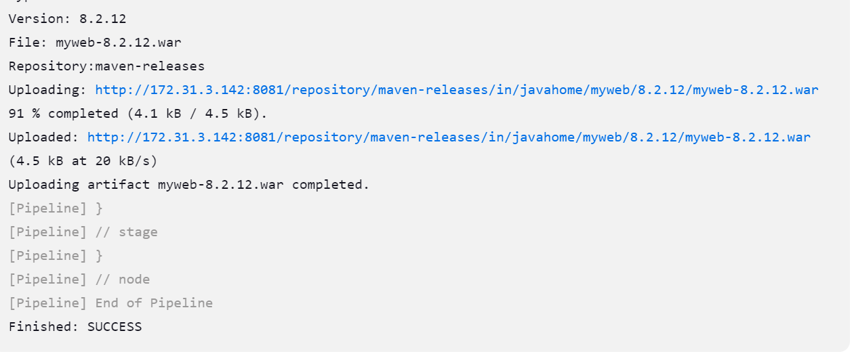

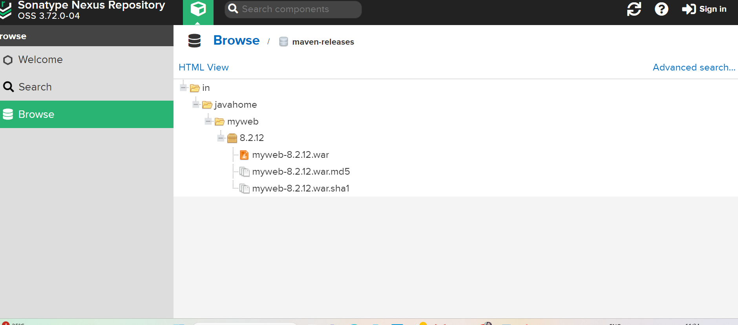

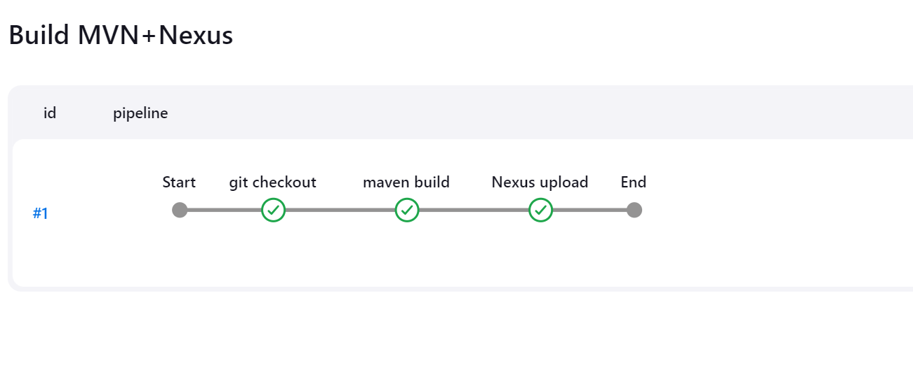

pipeline {

agent any

stages {

stage('git checkout') {

steps {

git 'https://github.com/PrajaktaGi/myweb.git'

}

}

stage('maven build') {

steps {

sh 'mvn clean package'

}

}

stage('Nexus upload') {

steps {

nexusArtifactUploader artifacts: [[artifactId: 'myweb', classifier: '', file: 'target/myweb-8.2.12.war', type: 'war']], credentialsId: 'nexus3', groupId: 'in.javahome', nexusUrl: '172.31.3.142:8081', nexusVersion: 'nexus3', protocol: 'http', repository: 'maven-releases', version: '8.2.12'

}

}

}

}

**Snapshot**

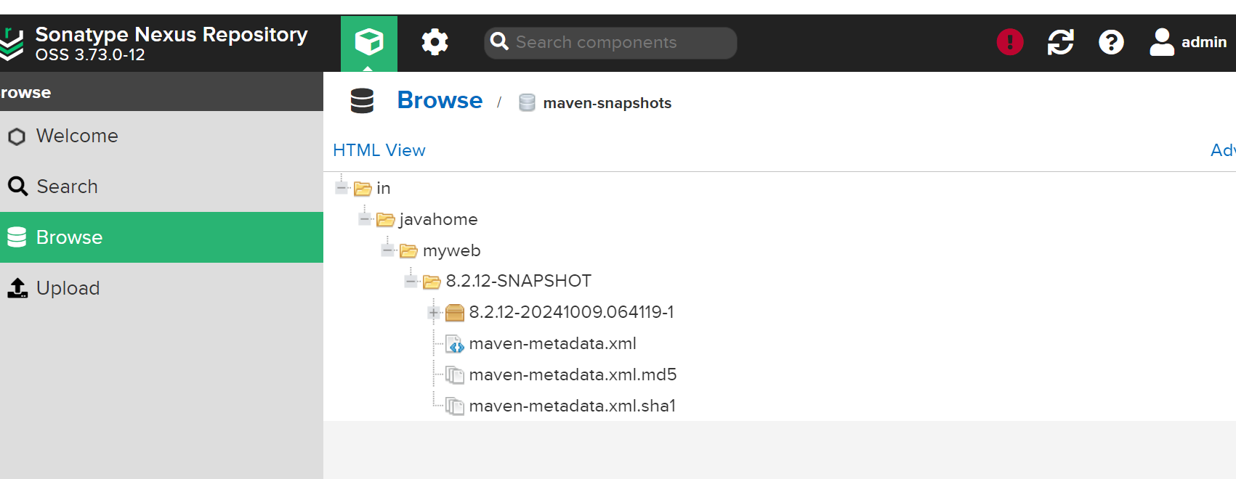

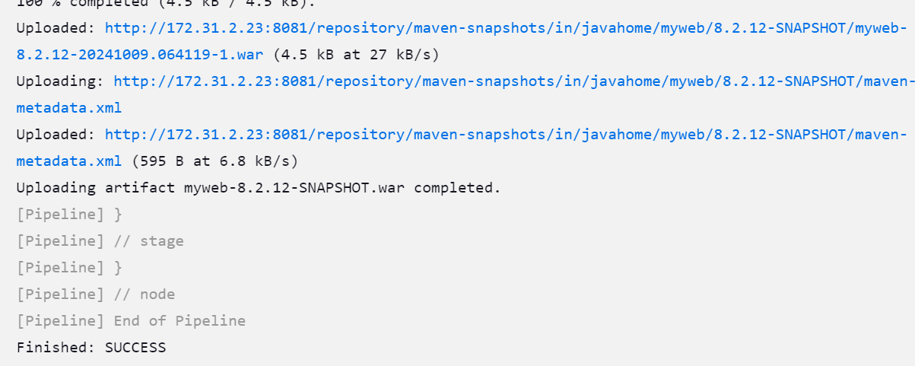

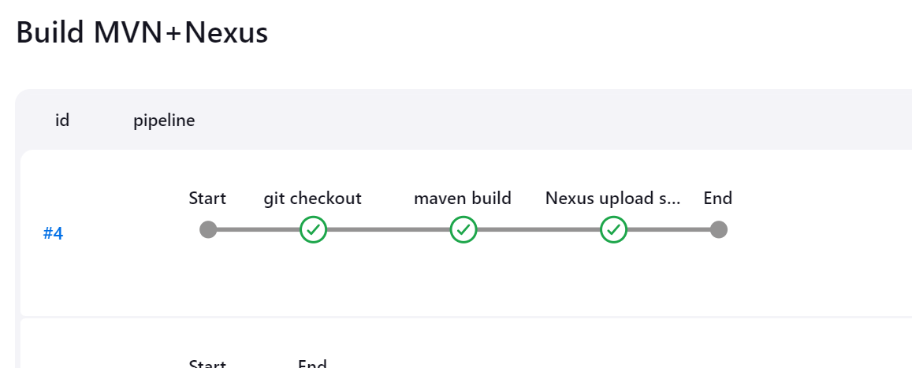

**pipeline {**

**agent any**

**stages {**

**stage('git checkout') {**

**steps {**

**git 'https://github.com/PrajaktaGi/myweb.git'**

**}**

**}**

**stage('maven build') {**

**steps {**

**sh 'mvn clean package'**

**}**

**}**

**stage('Nexus upload snapshot') {**

**steps {**

**nexusArtifactUploader artifacts: [[artifactId: 'myweb', classifier: '', file: 'target/myweb-8.2.12-SNAPSHOT.war', type: 'war']], credentialsId: 'nexus3', groupId: 'in.javahome', nexusUrl: '172.31.2.23:8081', nexusVersion: 'nexus3', protocol: 'http', repository: 'maven-snapshots', version: '8.2.12-SNAPSHOT'**

**}**

**}**

**}**

**}**