**A Mini Project Report**

**on**

**“Holiday Home Rental”**

Submitted by

**33217-Sakshi Deore**

**33218-Janhavi Deshmane**

**33229 -Dhanshree Kadam**

**33231-Prajakta Keer**



Department Of Information Technology

Pune Institute of Computer Technology College of Engineering

Sr. No 27, Pune-Satara Road, Dhankawadi, Pune - 411 043.

**A.Y. 2020-2021**

**Abstract:**

The management and booking of flats in large buildings, farmhouses and bungalows for holiday is a tedious and complicated task. The combination of different rooms with different sizes and equipment, the possibility to choose between different dates and times is the reason why a good online marketplace that connects people who want to rent out their homes with people who are looking for accommodations in that locale is needed, to make this task as easy as possible. A system that supports reservations of homes, flats in conference buildings, universities, or other large buildings.

This article shows how a complicated human task like reservation can be solved by using a database management system as the key tool in the development.

The basic functionality of the system is to keep track of farmhouses, bungalows or flats in different buildings, rooms and their equipment, reservations of rooms and different types of users.

Reservations of the rooms should be visualized to the user in a simple and intuitive way. There should be a simple way of getting overview of the reservations.

We are going to use Java as frontend for this and MySQL as a backend. The combinations of the search functions, the ability to reserve for any user and the ability to manage the whole database from the website will make this system a very powerful administrative holiday home booking system. The security model used based on different privilege for different users also will make the system a real-life application.

**Acknowledgement:**

We are privileged to express gratitude and respect toward all those who guided us . We are sincere thanks to all of them.

We are highly indebted to Dr. Emmanual M who taught us the mysql database .It was him who motivated us to learn. I would like to express my gratitude towards my team members for their kindly cooperation & encouragement which helped me in completion of the project.

**List Of Tables & Figures :**

|  |  |
| --- | --- |
| **Figure No** | **Page no** |
| Fig -1 | **11** |
| Fig-2 | **12** |
| Fig-3 | **13** |
| Fig-4 | **14** |
| Fig-5 | **15** |
| Fig-6 | **16** |
| Fig-7 | **17** |
| Fig-8.1 | **18** |
| Fig-8.2 | **19** |
| Fig-9 | **20** |
| Fig-10 | **21** |
| Fig-11 | **22** |
| Fig-12 | **23** |

**CONTENT**

**Sr.**   **Chapter Page No**

**1.Introduction 6-8**

**1.1 Purpose 6**

**1.2 Scope 6**

**1.3 Definition,Acronym and Abbreviations 7**

**1.4 References 7**

**1.5Developers Responsibilities:An Overview 8**

**2.General Description 9-10**

**2.1 Product Function Perspective 9**

**2.2 User Characteristics 9**

**2.3 Assumption and Dependencies 10**

**2.4 General Constraints 10**

**3.Sepecific Requirements 10-16**

**3.1 Inputs and Outputs 10**

**3.2 Functional Requirements 11**

**3.3 Functional Interface Requirements 15**

**3.4 Design Constraints 15**

**3.5 Acceptance Constraints 15**

**4.System Design 16- 23**

**4.1 ER model 16**

**4.2 Schema Description 17**

**4.3 Tables Description 18**

**4.4 System Flow Chart/Activity Diagram 20**

**4.5 User Interface Design 21**

**4.6 Error Messages/Alerts Design 22**

**5. System Implementation 23-26**

**5.1 Hardware and software Platform description 23**

**5.2 Tools used 23**

**5.3 System Verification and Testing 24**

**5.4 Future work/Extension 25**

**5.5 Conclusion 26**

**5.6 References 26**

**1)Introduction:-**

The manual method of booking for holiday homes is characterized with numerous problems. Some of these are :customers having little or no information about the hotels within their vicinity; A guest checking into a holiday home that is either too expensive or too unbefitting for his/her personality. The foul play that sometimes occurs when information about the guest that is checked into a holiday home is not officially documented by the concerned people. All these problems and more would definitely make a holiday experience a downturn in business

**1.1)Purpose:**

The purpose of this project is to outline house rental data and requirements, recommend data management solutions and provide information regarding the various houses. The purpose of this project is to develop a data management system to

consolidate,organize,document,store and distribute information related to the house management system.

**1.2)Scope:**

The scope of the project is clear to give a simple and attractive application to simplify the work as well as to reduce the efforts while doing it offline or we can say by doing it with old methods.In this application we are able to save database of all type of homes on the site .There prices and category like farmhouse,bungalows ,flats etc. By this we can book any kind of category very easily.

1)The proposed system will remove the hectic task of customers and executive for searching and booking the home.

2)The system will help the administrative staff i.e history record details of customers in proper database.

3)will generate proper reports for customers at the time of check-out.

4)Every novice user can easily interact with system.

**1.3) Definition,Acronym and Abbreviations:**

**Definition:**

The main purpose of this work is therefore to develop a web application program that would enable users to list, find and rent vacation homes. This project mainly focuses on the hospitality offered to the guest by the homeowners or the locals. Most visitors who visit places and stay in hotels never get to experience the true taste of hospitality. Our projects try to circumvent all these problems wherein, the guests are either accommodated in the family home, or in separate quarters nearby. Some customers prefer places which are closer to the city whereas some love to enjoy the natural beauty by living in cottages. Since different customers have varied interests it is essential that each customer gets a unique holiday experience and can choose the stay of his choice and according to his budget.

**1.4) References:**

1)Boyd Myers, C. (2011 October 6). Airbnb launches its photography program with 13,000 verified properties. The Next Web. Retrieved from<http://thenextweb.com/apps/2011/10/06/airbnb-launches-its-photography-program-with13000-verified-properties/>.

2)Kincaid, J. (2011, August 8). Airbnb rolls out 24/7 phone support, additional safety features. TechCrunch. Retrieved from http://techcrunch.com/2011/08/08/airbnb-rolls-out-247- phone-support-additional-safety-features/.

3)Geron, T. (2013b, September 17). Airbnb hires Joie de Vivre’s Chip Conley as Head of Hospitality. Forbes. Retrieved from<http://www.forbes.com/sites/tomiogeron/2013/09/17/airbnb-hires-joie-de-vivres-chipconley-as-head-of-hospitality/>

4)Nowak, B., Allen, T., Rollo, J., Lewis, V., He, L., Chen, A., Wilson, W. N., Costantini, M., Hyde, O., Liu, K., Savino, M., Chaudhry, B. A., Grube, A. M., Young, E. (2015). Global insight: Who will Airbnb hurt more - hotels or OTAs?. Morgan Stanley Research. Retrieved from http://linkback.morganstanley.com/web/sendlink/webapp/f/9lf3j168- 3pcc-g01h-b8bf005056013100?store=0&d=UwBSZXNlYXJjaF9NUwBiNjVjYzAyNi04NGQ2LTExZTUtYjFlMi03YzhmYTAzZWU4ZjQ%3D&user=bdvpwh9kcvqs49&__gda__=1573813969_cf5a3761794d8651f8618fc7a544cb82

**1.5) Developers Responsibilities: An Overview**

Developers have to do with managing the application lifecycle, knowledge of certain principles in coding, support and collaboration efforts.

1)Should have in-depth knowledge of coding and application design principles.

2)Application Management- a soft skill that application developers must present is an organized ability to manage the application lifecycle, and people involved in the process, to ensure smooth deployment and post-deployment modifications.

The application deployment lifecycle typically involves the following key stages: Initial Planning > Design > Development > Testing > Deployment > Support.

i)Planning & Design-The application developer must gather requirements that are based on the analysis of empirical data. For instance, the application developer should have access to end-user data that suggests what kind of issues the software sets out to solve.

ii)Development & Testing-Based on the design requirements gathered in the previous step, the developers will begin the iterative steps of coding, testing and revising.

iii)Deployment & Support

**2. General Description:**

**2.1 Product Function Perspective:-**

Home Rental System provides the features for booking a holiday home online. It includes several functionalities describes as below:

**HomeRentalManagement:**

It provides home reservation online facility. Customers can visit the website and check for various houses. If the homes satisfy their requirements, then booking can be done.

**Checking For Availability:**

Customers can check for the availability of the home to book it.The database admin maintains the database of the available houses with their availability dates. If no house is available it is the responsibility of the system to provide alternative options.

**Payment system:**

Administrator/owner of the application responsible for secure payment transactions after booking. Reservation cancellation, finalize, these all activities are done by the administrator of the application.

**2.2 User Characteristics:-**

There are various users use our product:

1)Customer

2)Host

**2.3 Assumption and Dependencies:-**

Proper working of this app is dependent on the internet connectivity of the users’ computer

Assumptions and dependencies:-

-It is assumed that the host/customer has basic knowledge of the system

-It is assumed that the data entered by the host/customer while registering is true.

**2.4 General Constraints:-**

If we see performance constraints as we are using java swing and mysql the performance will be on top.Again web interface is very friendly and customers can easily manipulate it.

**3.Sepecific Requirements**

**3.1 Inputs and Outputs:**

**Input**

**1)Customer:** customer can add their personal information for register and use email and password for login. And also can do payment

**2)Host:**Host can add their personal information for register and use email and password for login.and also add the information of home.

**Output:**

**1)Customer:** customer can see various home images and he can book it .

**2)Host:** Host will get payment for that home

**3.2 Functionality Requirements:**

Three modules are used in this project namely admin,customer and host

Admin:can insert and analyse the tables

Customer: can book the house/can register their information

Host:can give the adverstize the home.

1)Customer/Host login:

Description of feature:

The feature used by customer/Host to login into the system.they are required to enter user email and password before they are allowed to enter the system.The person email and password will be verified .

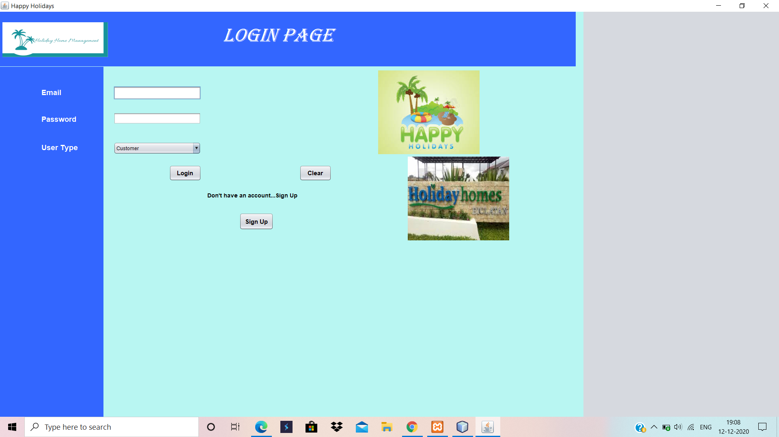

Fig-1

2)Customer features:

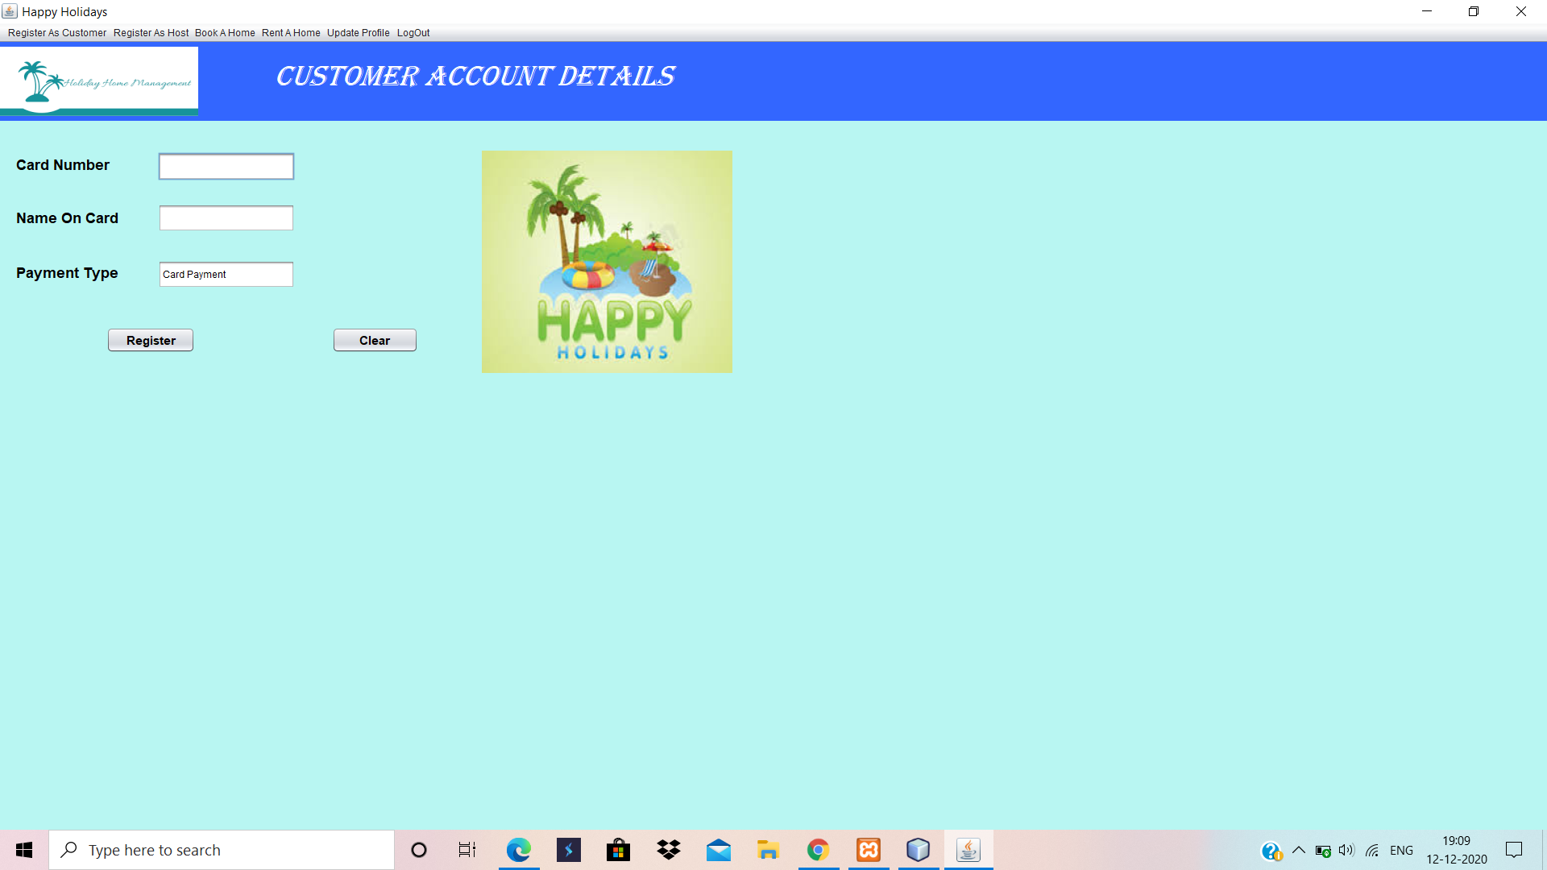

Fig-2

3)Book home feature:

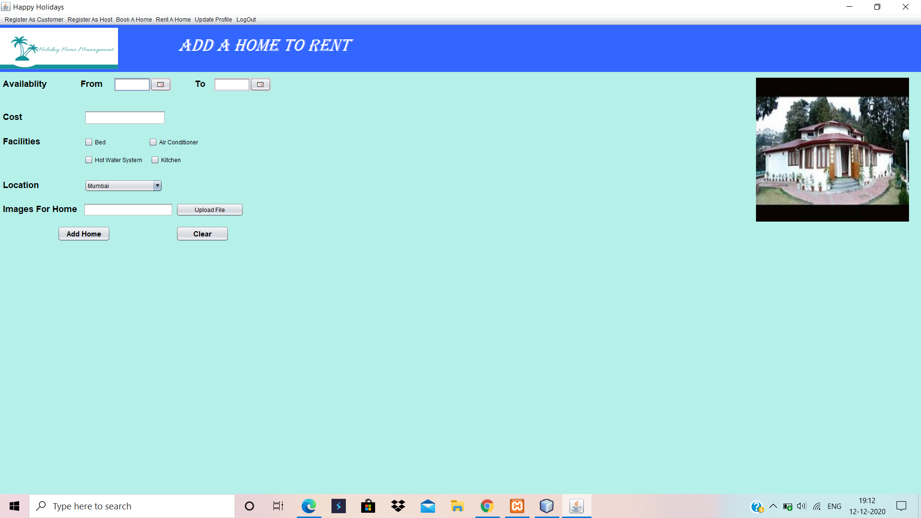

Fig-3

4)customer and user can be modify their information:

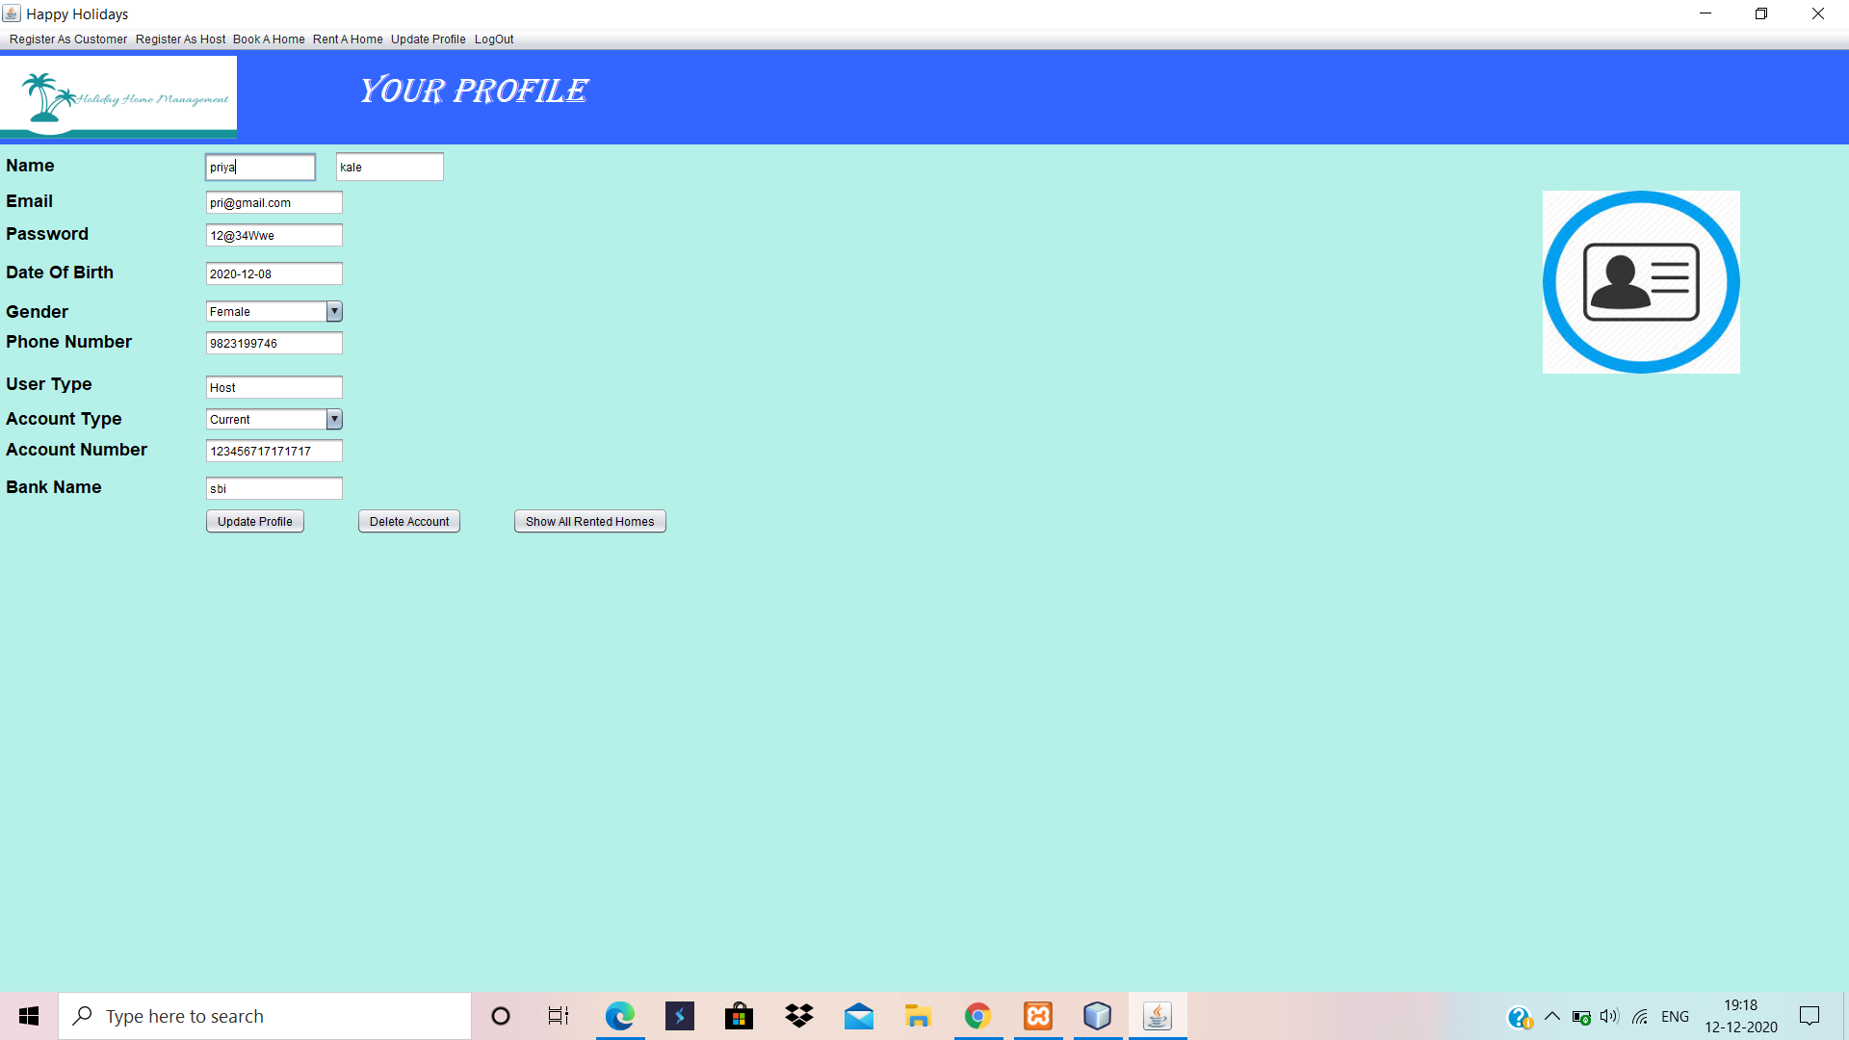

Fig-4

5)Rented homes details

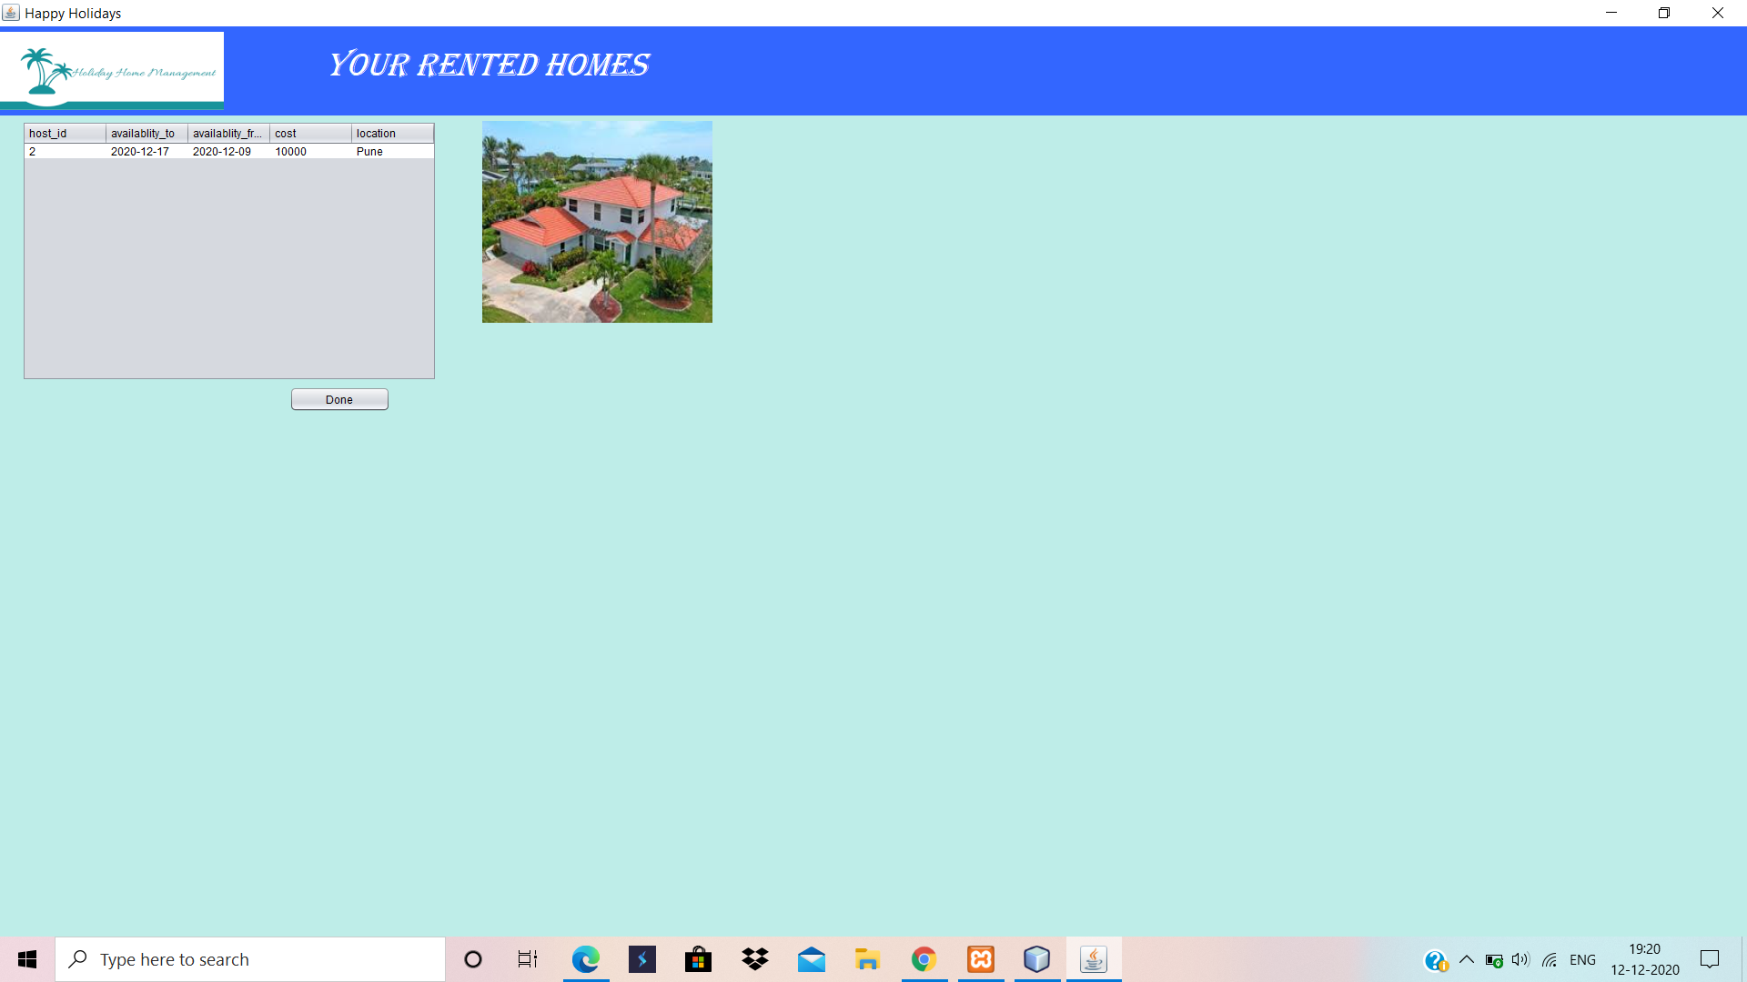

**Fig-5**

**3.3 Functional Interface Requirements:**

The website interface is very user friendly.customer /host easy add information and also delete it easy.First data is validate and then it will insert to database.

**3.4 Design Constraints:**

We use mysql and java swing. Mysql has data security,On-demand Scalability,High Performance,Round-the-clock Uptime,Complete Workflowetc.Due to these immense advantages of Mysql ans Java swing the performance will be on top.

**3.5 Acceptance Constraints:**

A customer cannot book home without login .Also he/she cannot confirm booking without giving transaction details.

**4.System Design**

**4.1 ER model:**

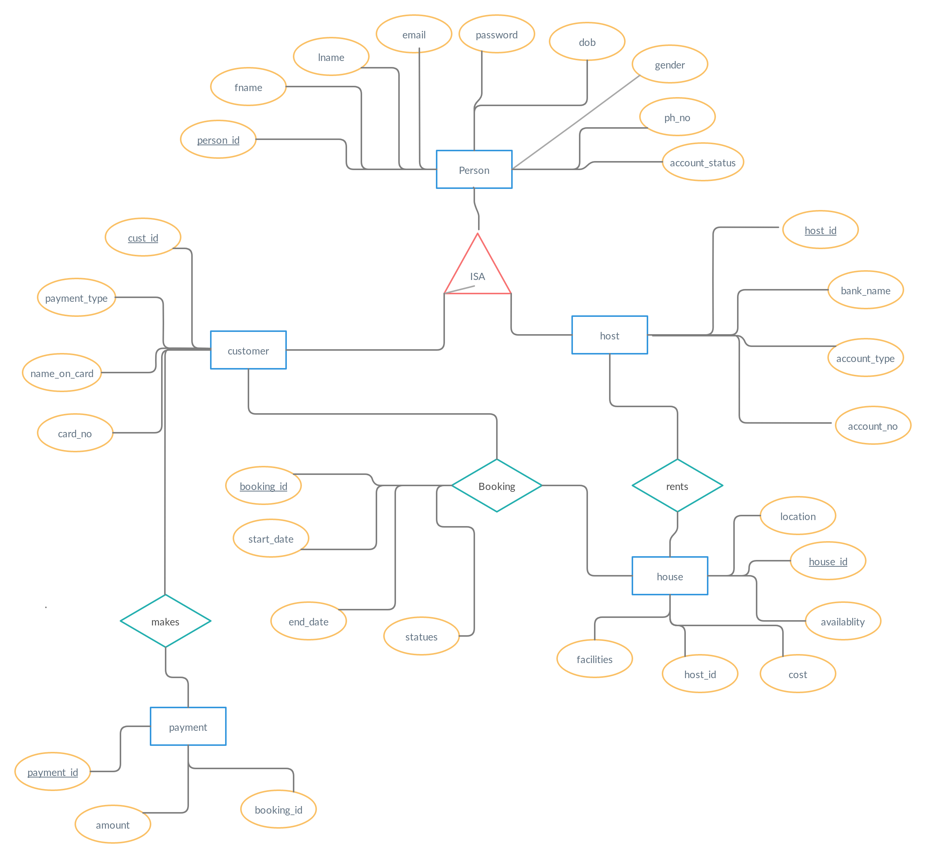

**Fig -6**

**4.2 Schema Description:**

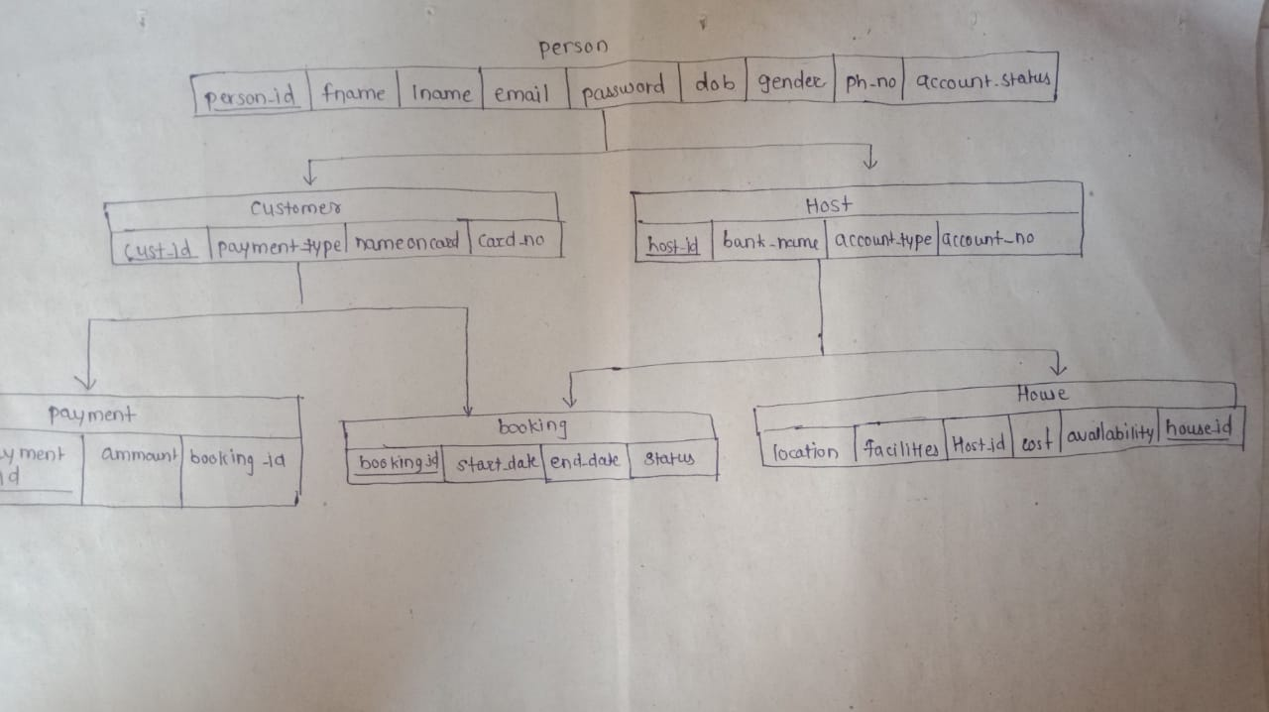

**Fig-7**

**4.3 Tables Description:**

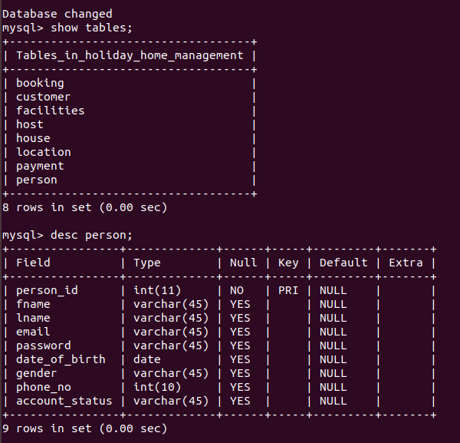

**Fig-8.1**

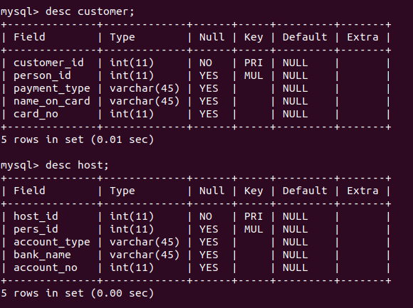

**Fig 8.2**

**4.4 System Flow Chart/Activity Diagram:**

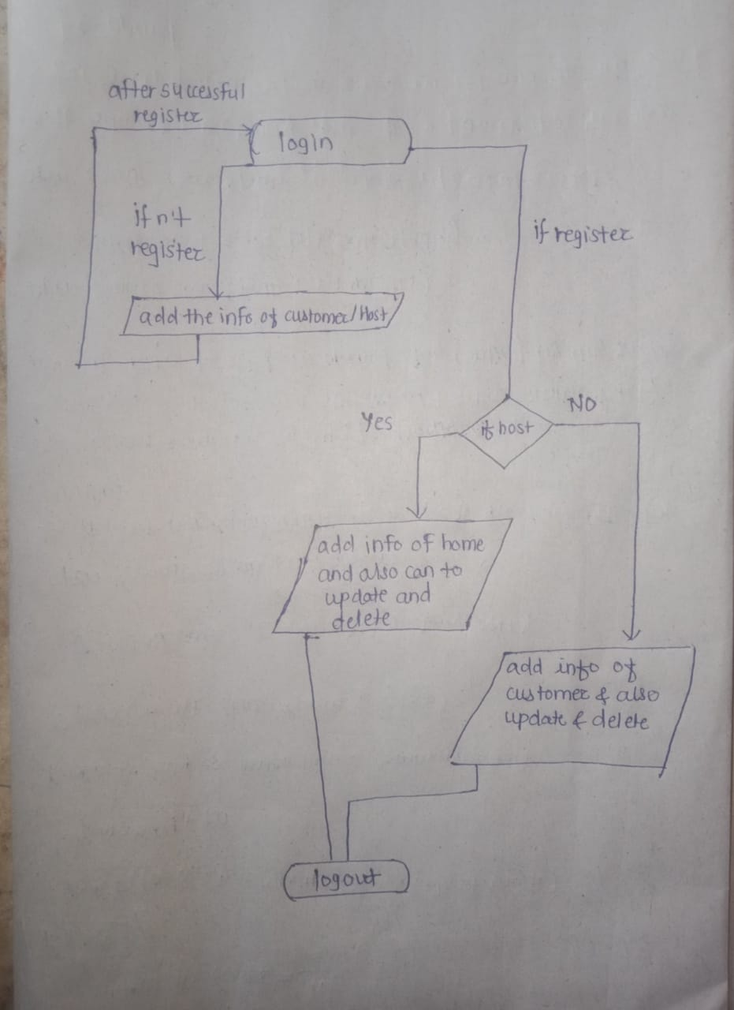

**Fig-9**

**4.5 User Interface Design:**

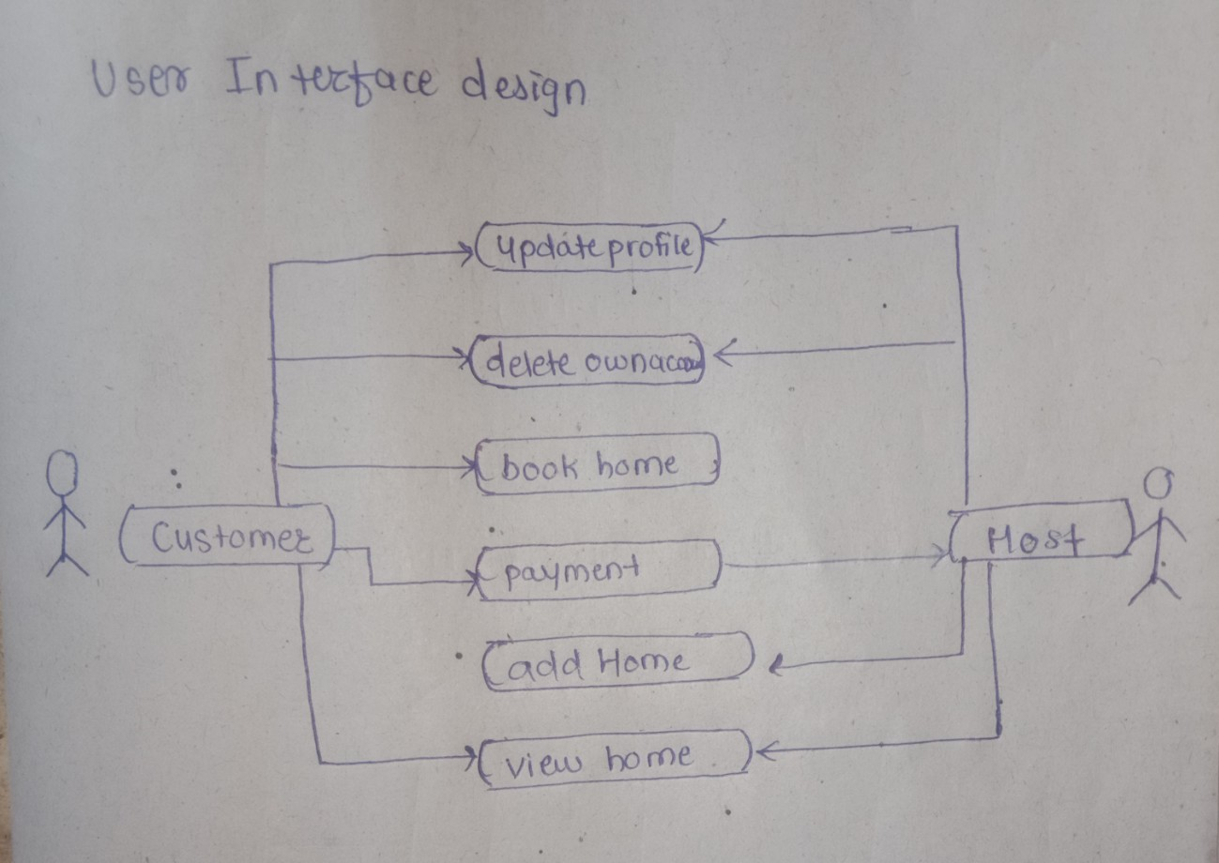

**Fig-10**

**4.6 Error Messages/Alerts Design:**

**After Successful login:**

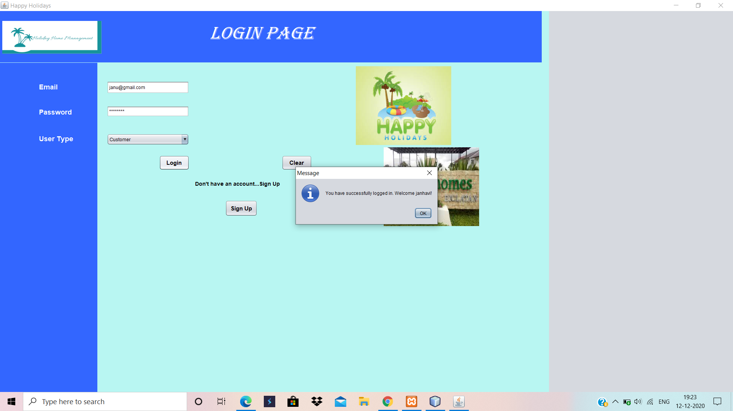

**Fig-11**

**Unsuccessful login:**

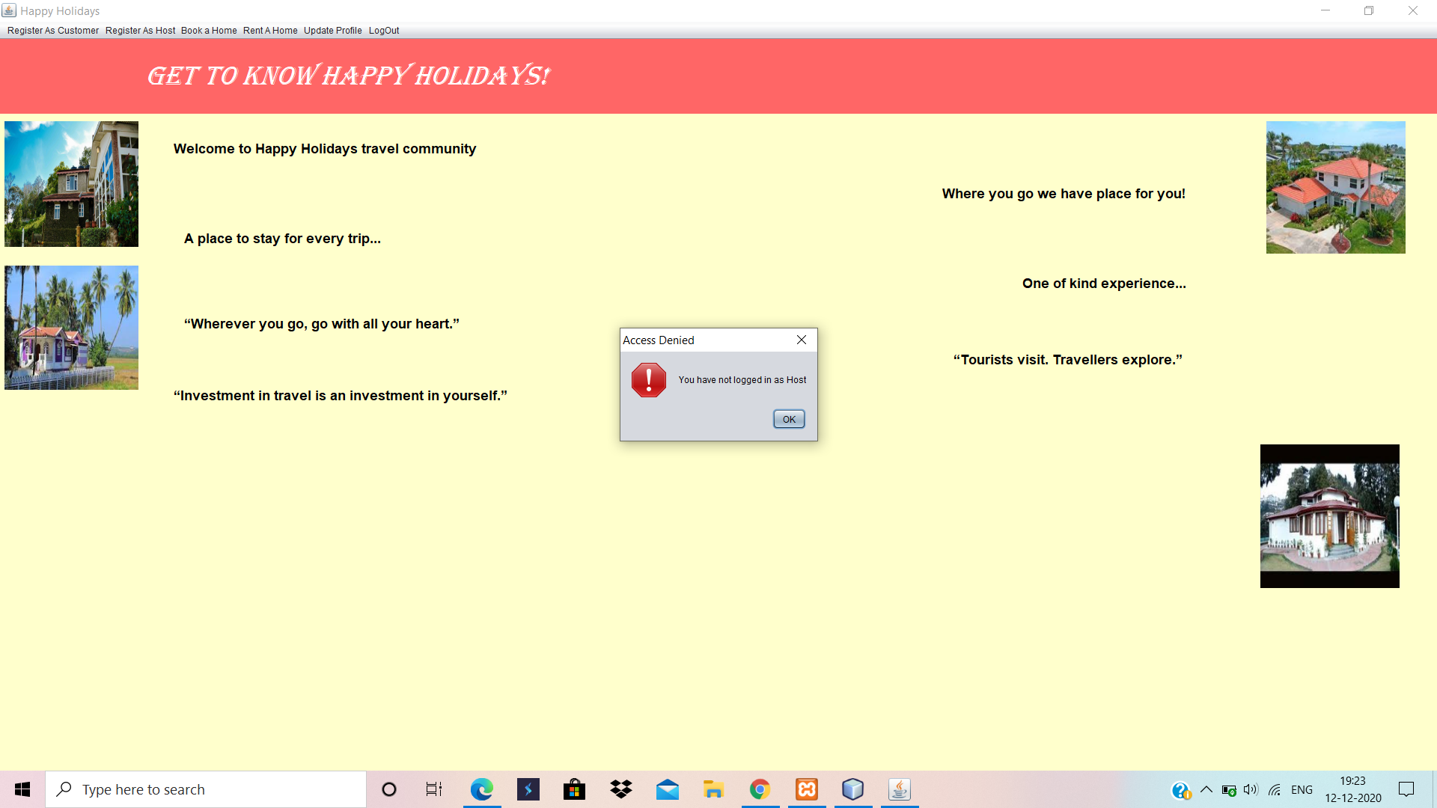

**Fig-12**

**5. System Implementation**

**5.1 Hardware and software Platform description**

**Software Platform Description:**

**Frontend**

Java Swing

**Backend:**

The backend is designed using mysql which is used to design the databases.

**Hardware Platform Description:**

**1)Netbeans**

**2)Xampp**

**3)Mysql Workbench**

**5.2 Tools used:-**

Hardware: Laptop

Software: mysql workbench,netbeans,xampp server.

**5.3 System Verification and Testing:**

In this project we have added various validations for name,phone,account number,password this fields.

**5.4 Future work/Extension:-**

1)The project can be developed further by optimising the scalability of the database.

2)The project can be made more interactive by designing a discussion forum where customers can chat with other customers who have stayed in that homes and get the honest review and rating from them and also people can chat with the home owners if they have any queries.

3)A receipt could be generated after a transaction as a proof of payment.

4)Software can be made secure for all transactions.

5)Users can be background checked to avoid fake profiles and scams.

6)Often it happens that the pictures are different from the actual homes so a facility can be provided so that people who have stayed at the place before can post authentic pictures of the homes.

7)The software can be optimised further wrt frontend and backend to make more flexible,interactive and secure.

**5.5 Conclusion :-**

It is very easy to access and user-friendly the application keeps a backup of the holiday home rental data which includes the customer details.

In this we will implement online holiday home booking which helps us in centralizing the data used for managing the task performed during a booking.

we will implement various functionalities of Mysql and Java and created the fully functional database management system for online holiday home booking

**5.6 References:-**

1)Boyd Myers, C. (2011 October 6). Airbnb launches its photography program with 13,000 verified properties. The Next Web. Retrieved from<http://thenextweb.com/apps/2011/10/06/airbnb-launches-its-photography-program-with13000-verified-properties/>.

2)Kincaid, J. (2011, August 8). Airbnb rolls out 24/7 phone support, additional safety features. TechCrunch. Retrieved from http://techcrunch.com/2011/08/08/airbnb-rolls-out-247- phone-support-additional-safety-features/.

3)Geron, T. (2013b, September 17). Airbnb hires Joie de Vivre’s Chip Conley as Head of Hospitality. Forbes. Retrieved from<http://www.forbes.com/sites/tomiogeron/2013/09/17/airbnb-hires-joie-de-vivres-chipconley-as-head-of-hospitality/>

4)Nowak, B., Allen, T., Rollo, J., Lewis, V., He, L., Chen, A., Wilson, W. N., Costantini, M., Hyde, O., Liu, K., Savino, M., Chaudhry, B. A., Grube, A. M., Young, E. (2015). Global insight: Who will Airbnb hurt more - hotels or OTAs?. Morgan Stanley Research. Retrieved from http://linkback.morganstanley.com/web/sendlink/webapp/f/9lf3j168- 3pcc-g01h-b8bf005056013100?store=0&d=UwBSZXNlYXJjaF9NUwBiNjVjYzAyNi04NGQ2LTExZTUtYjFlMi03YzhmYTAzZWU4ZjQ%3D&user=bdvpwh9kcvqs49&__gda__=1573813969_cf5a3761794d8651f8618fc7a544cb82