A PRILIMINARY PROJECT REPORT ON

“INFORMATION RETRIEVAL APPROACH BASED ON TERMINOLOGY EXTRACTION AND CONTEXT BASED SEARCH APPLIED TO WEB PAGES”

SUBMITTED TO THE UNIVERSITY OF PUNE, PUNE
IN PARTIAL FULFILLMENT OF THE REQUIREMENTS
FOR THE AWARD OF THE DEGREE OF

BACHELOR OF ENGINEERING (Computer Engineering)

BY

Prajakta Naik Exam No: B8054287
Aishwarya Bhide Exam No: B8054222
Mandar Haldekar Exam No: B8054246
Jayesh Pawar Exam No: B8054299

Under The Guidance of
Prof.Rekha Kulkarni



DEPARTMENT OF COMPUTER ENGINEERING

PUNE INSTITUTE OF COMPUTER TECHNOLOGY
Sr. No. 27, Pune Satara Road, Dhanakawadi, PUNE 411043
2011-12

DEPARTMENT OF COMPUTER ENGINEERING

PUNE INSTITUTE OF COMPUTER TECHNOLOGY
Sr. No. 27, Pune Satara Road, Dhanakawadi,
PUNE 411043

CERTIFICATE

This is to certify that the preliminary project report entitled

“INFORMATION RETRIEVAL APPROACH BASED ON TERMINOLOGY EXTRACTION AND CONTEXT BASED SEARCH APPLIED TO WEB PAGES”

Submitted by

Prajakta Naik Exam No: B8054287
Aishwarya Bhide Exam No: B8054222
Mandar Haldekar Exam No: B8054246
Jayesh Pawar Exam No: B8054299

is a bonafide work carried out by them under the supervision of Prof. Rekha Kulkarni and it is submitted for the partial fulfillment of the requirement of University of Pune, Pune, for the award of the degree of Bachelor of Engineering (Computer Engineering)

(Prof. Rekha Kulkarni )
Internal Guide

Name:
Signature:
External Examiner

Place : Pune Head,
Date : Department of Computer Engineering
PICT Pune



CERTIFICATE

This is to certify that the preliminary project report entitled

“INFORMATION RETRIEVAL APPROACH BASED ON TERMINOLOGY EXTRACTION AND CONTEXT BASED SEARCH APPLIED TO WEB PAGES”

Submitted by:

Prajakta Naik Exam No: B8054287
Aishwarya Bhide Exam No: B8054222
Mandar Haldekar Exam No: B8054246
Jayesh Pawar Exam No: B8054299

is a bonafide work being carried out by them with the Sponsorship from DREAMZ Group under the supervision of Mr.Vedang Manerikar .

(Mr. Vedang Manerikar)
Dreamz Group
External Guide

ACKNOWLEDGEMENT

We would like to take this opportunity to thank our internal guide Prof. Rekha Kulkarni for giving us all the help and guidance we needed. We are really grateful to her for her kind support throughout the analysis and design phase.
We are also grateful to Dr.Sarang Joshi, Head of Computer Department, Pune Institute of Computer Technology and other staff members for giving important suggestions.
We would also like to extend our thanks to Mr. Vedang Manerikar of Dreamz Group for his immense help, motivation and co-operation for being the guiding force behind the venture and an indispensable asset to us.

LIST OF DIAGRAMS

Figure Number | Name | Document | Page No
1 | Plan of project execution | synopsis | 19
2 | Result of keyword extraction | synopsis | 20
3 | Improvement in precision | synopsis | 21
4 | Result of keyword extraction | Problem Definition and scope | 30
5 | Improvement in precision | Problem Definition and scope | 31
6 | Dependancy Graph | Project Plan | 38
7 | Timeline Chart | Project Plan | 38
8 | Team Structure | Project Plan | 40
9 | Block Diagram | Software requirement specification | 44
10 | Usecase diagram | Software requirement specification | 48
11 | Data object and relationships | Software requirement specification | 53
12 | Context diagram | Software requirement specification | 55

13 | Web Scraping | Software requirement specification | 55
14 | Keyword Extraction | Software requirement specification | 56
15 | Domain categorization | Software requirement specification | 56
16 | Context of keywords | Software requirement specification | 57
17 | Search and Rank | Software requirement specification | 57
18 | Display | Software requirement specification | 58
19 | Activity Diagram | Software requirement specification | 59
20 | Behavioral model | Software requirement specification | 60
21 | Find relevant keywords | Software requirement specification | 61
22 | Categorize keywords | Software requirement specification | 62
23 | Context of keywords | Software requirement specification | 62

24 | Submit Query | Software requirement specification | 63
25 | Labeled Activity | Software requirement specification | 66
26 | Flow Graph | Software requirement specification | 67
27 | Architecture Diagram | Detailed design document | 71
28 | Class Diagram | Detailed design document | 73
29 | PSPEC for component Web Scraping | Detailed design document | 74
30 | Interaction diagram | Detailed design document | 74
31 | PSPEC for Keyword Extraction | Detailed design document | 75
32 | Interaction diagram | Detailed design document | 75
33 | PSPEC Domain Categorization | Detailed design document | 76
34 | Interaction diagram | Detailed design document | 76
35 | PSPEC for context mining | Detailed Design document | 76
36 | Interaction diagram | Detailed design document | 77

37 | Processing narrative(PSPEC) for component Search Result | Detailed design document | 77
38 | Interaction Diagram | Detailed design document | 78
39 | Processing narrative(PSPEC) for component Rank Result | Detailed design document | 78
40 | Interaction Diagram | Detailed design document | 79
41 | Interaction Diagram | Detailed design document | 79
42 | Function Dependency Graph | Test Spec | 91
43 | Function Scatter Diagram | Test Spec | 92
44 | Venn Digram | Annexure B | 99
45 | Functional Relations | Annexure B | 101
46 | Functional Dependency Graph | Annexure B | 103
47 | B+ tree | Annexure B | 103
48 | Testing using Maxima | Annexure B | 105
49 | Task Network | Annexure C | 107
50 | Planners | Annexure C | 120
51 | Timeline Chart | Annexure C | 123
52 | Architecture Diagram | Annexure F | 127

LIST OF TABLES

Seq. No. | Description | Page no.
1. | Risk table | 36
2. | Risk mitigation, monitoring and management | 36
3. | Program Task Set | 38
4. | Staff Organisation | 40
5. | Mapping Functions | 98
6. | Program Task Set | 107
7. | Module Development Plan | 126

ABSTRACT
When browsing something on the Internet, a user is interested in quickly finding relevant information about the subject. This information can be extracted by identifying key ideas on the web-page. This paper discusses an approach to find relevant content from the web based on the keywords extracted from the document. Keywords are extracted by mining web page based on their context. Keywords are categorized in predefined domains such as place, books, people etc. Search is performed on web depending on context to improve the accuracy of retrieved information. Social and location-based information is integrated by leveraging social networks like Twitter and Facebook. Our proposal automates the task of finding related information about the web-page and thus reducing user's browsing efforts.

CHAPTER 1
INDEX
Sr.no | Title | PageNo
1 | SYNOPSIS | 13
2 | TECHNICAL KEYWORDS | 22
3 | INTRODUCTION  Project Idea  Motivation of Project  Literature Survey | 24  25  25  25
4 | PROBLEM DEFINITION AND SCOPE  4.1 Problem Statement  4.2 Goals and Objectives  4.3 Statement of Scope  4.4 Software Context  4.5 Major Constraints  4.6 Approaches for solving problem and efficiency issues  4.7 Outcomes  4.8 Hardware and Software Resources Required  4.9 Area of the Project | 26  27  27  27  27  28  29  29  30  31
5 | PROJECT PLAN  5.1 Introduction  5.1.1 Problem Definition  5.1.2 Management and Technical Constraints  5.1.3 Purpose of Document  5.2 Project Estimates  5.2.1 Historical Data used for estimates  5.2.2 Estimation Techniques applied and Results  5.2.3 Reconciled Estimates  5.2.4 Project Resources  5.3 Risk Management  5.3.1 Risk Table  5.3.2 Overview of Risk Mitigation,Monitoring and Management  5.4 Project Schedule  5.4.1 Project Task Set  5.4.2 Task Network  5.4.3 Time Line Chart  5.5 Staff Organisation  5.5.1 Team Structure  5.5.2 Management Reporting and Communication  5.6 Tracking and Control Mechanism  5.6.1 Quality Assurance and Control  5.6.2 Change Management and Control | 32  34  33  34  36  38  39
6 | SOFTWARE REQUIREMENTS SPECIFICATION  6.1 Introduction  6.1.1 Purpose and Scope of Document  6.1.2 Overview of Responsibilities of Developer  6.2 Product Overview  6.3 Usage Scenario  6.3.1 User Profiles(Actors)  6.3.2 Use Case  6.3.3 Use Case View  6.4 Data Model and Description  6.4.1 Data Description  6.4.2 Data Objects and Relation  6.4.3 Data Dictionary  6.5 Functional Model and Description  6.5.1 Data Flow Diagram  6.5.2 Description for(Function /Module/Subsystem)  6.5.3 Non-Functional Requirements  6.5.4 Design Constraints  6.5.5 Software Interface Description  6.6 Behavioral Model and Description  6.6.1 Description for Software Behavior  6.6.2 State Transition Diagrams  6.7 Restrictions, Limitations and Constraints  6.8 Validation Criteria  6.8.1 Classes of Tests  6.8.2 Estimated Software Response  6.8.3 Performance Bounds  6.9 Appendices  6.10 References | 42  43  44  45  52  54  61  63  64  67  68
7 | DETAILED DESIGN DOCUMENT  7.1 Introduction  7.1.1 Purpose  7.1.2 Scope  7.1.3 Overview of Product  7.2 Architectural Design  7.2.1 Architectural Diagram  7.2.2 Architectural Description  7.3 Data Design  7.3.1 Internal Software Data Structure  7.3.2 Global Data Structure  7.3.3 Temporary Data Structure  7.4 Component Design  7.4.1 Program Structure  7.4.2 Description for Component  7.4.3 Software Interface Description  7.5 User Interface Design  7.5.1 Description of the User Interface  7.5.2 Interface Design Rules  7.5.3 Components Available  7.6 Restrictions, Limitations and Constraints | 69  72  71  72  73  80  80
8 | TEST SPECIFICATION  8.1Introduction  8.1.1 Goals and Objectives  8.1.2 Scope  8.1.3 Major Constraints  8.2Test Plan  8.2.1 Testing Resources and Staffing  8.2.2 Test work Products  8.2.3 Test Record Keeping  8.2.4 Testing Tools and Environment  8.2.5 Test Schedule  8.3 Test Procedure  8.3.1 Software to be tested  8.3.2 Testing Procedure  8.3.3 Unit Testing  8.3.4 Integration Testing  8.3.5 Validation Testing  8.3.6 GUI Testing  8.3.7 Higher Order Testing  8.3.8 Test Work Products  8.4 Function Dependency Graph  8.5 Function Scatter Diagram  8.6 Input Sequence Testing | 81  82  82  85  91  92  92
9 | FUTURE ENHANCEMENT | 93
10 | SUMMARY AND CONCLUSION | 95
11 | ANNEXURE  Annexure A  Annexure B  Annexure C  Annexure D  Annexure E  Annexure F  Annexure G  Annexure H | 97  98  100  107  124  125  126  129  130
12 | REFERENCES | 139

CHAPTER 1
SYNOPSIS

SYNOPSIS

Project Title: Information retrieval algorithm using terminology extraction and context-based searching applied to web pages.

Group ID- 16

Project Group Members:

Roll No | Name | Name of Guide and Sign
4208 | AishwaryaBhide | Prof.RekhaKulkarni
4244 | PrajaktaNaik | Prof.RekhaKulkarni
4123 | MandarHaldekar | Prof.RekhaKulkarni
4150 | JayeshPawar | Prof.RekhaKulkarni

Internal Guide: Prof.RekhaKulkarni

Sponsorship :DreamZ Group(PICT Alumni Group)

External Guide: Mr.Vedang Manerikar

Abstract:
When browsing something on the internet, a user is interested in quickly finding relevant information about the subject. This information can be extracted by identifying key ideas on the webpage. This paper discusses an approach to find relevant content from the web based on the keywords extracted from the document. In this approach keywords are extracted by mining web page based on their context . Keywords are categorized in predefined domains such as place, books, people etc. Search is performed on web depending on context to increase the accuracy of retrieved information. Social and location-based information is integrated by leveraging social networks like Twitter and Facebook.Our proposal automates the task of finding related information about the webpage and thus reducing user's browsing efforts.

Technical Key Words (Ref ACM Keywords) :
INFORMATION STORAGE AND RETRIEVAL
- Content Analysis and Indexing
- Abstracting methods
- Dictionaries
- Indexing methods
- Linguistic processing
- Thesauruses
- Information Storage
- File organization
- Record classification
- Information Search and Retrieval
  - Clustering
  - Information filtering
  - Query formulation
  - Relevance feedback
  - Retrieval models
  - Search process
  - Selection process

- Natural Language Processing
- Discourse
- Language generation
- Language models
- Language parsing and understanding
- Machine translation
- Speech recognition and synthesis
- Text analysis

- Database Applications
- Data mining

Need of Searching and sorting
- Searching is required to find keywords from documents as well as to find relevant results from large data obtained after search
- Sorting is requires to order tweets according to weight and search results according to relevance

Relevant mathematical models associated with the Project:

Sr. No. | Description | Observation
1. | Problem Description and System
 | Let S be Closed system defined as, S ={Text,K,D,KD,SR,CT | ф}  To extract keywords K from web page Text and then extract relevant search results and tweets from web with respect to set K, CT from set S | System
 | S ={Text,K,D,KD,SR,CT | ф}  Where,  Text = {w_{i} | w_{i} € webpage }  K= {k_{i} | k_{i} € Text and k_{i} € f₁(Text) }  D={books, places, movies, people}  KD={kd_{i}| ¥ ( kd_{i}€ K) and f₂ (kd_{i}) € D}  SR = {s_{i} | s_{i} € f₃(kd_{i} , ct_{i}) ¥ kd_{i} € KD }  CT = U_{i=1..m}CT_{i}  CT_{i}= {ct_{j} | ct_{j} € f₄(kd_{i}) } | Text on web page  Keywords extracted from Text  Set of Domains  Domain relevant keywords  Search results  Contexts of keywords

2. | Mapping Functions  f(x) | X | Y
 | F₁(Text,freq.dist,pos_tag,position, collection freq.) → K | Text | K
 | F₂(K,DC,DR)→KD  DC: Domain Consensus  DR: Domain Relevance | K | KD
 | F₄(KD)→ CT | KD | CT
 | F₃(KD,CT)→ SR | KD,CT | SR

Success and Failure Cases:

Success:

- |KD| > 0

- |SR| > 0

- SR contains context relevant results

Failure :
- KD= {}
- SR ={}

Problem statement feasibility assessment using satisfiability analysis and NP Hard, NP Complete or P type using modern algebra:

This problem is decision problem. Decision has be made to select keywords and decide their domain as follows
- Whether particular word is keyword or not
- Does the keyword belong to the predefined domain or not.
- Is the keyword searched by the context to get relevant information or not.

Hence our problem is NP.

Hitting Set problem: Consider set T = { S₁, S₂…S_{m}} as input. Find smallest subset H such that H C T and h_{i} €S_{j} for j= 1 to mi.e Every element in H hit every set collection T.

Our project consists of functions f₁, f₂, f₃, f_{4 .} We will reduce problem f₁ to hitting set problem .

For function f_{1:}
Input sets :Corpus, freq. dist, pos_tag, position, collection freq
Output set : K i.e set of keywords

Consider collection T of Si’s such that each Si is mapped to one input set of function f₁

Now prove,
T hitting set of H ↔ f1 has non empty set K

- Hitting set problem→ function f1

Suppose H is hitting set of size n.
But in H, h_{i}€Sj for all j= 1 to m,
then each h_{i} can be set to element of set K i.e keyword

- Hitting set problem← function f1

K ={ k₁…k_{n}} i.e set of keywords
As per definition of f₁ ,k_{i}€ all input sets of f₁ which are Corpus,freq.dist,pos_tag,position, collection freq
So , we can conclude analogy between input sets of f₁ and S_{i} belonging to collection T . Also
Each set K can be mapped to hitting set H.

So we have proved hitting set problem is polynomially reducible to function f _{1.} Since Hitting set problem is NP- complete , function f1 is NP-complete.

Our problem = f1 U f2 U f3 U f4

Therefore , Our problem is NP-complete.

Names of at least two conferences where papers can be published
1. ISAI 2011, 2nd International Conference on Information Security and Artificial Intelligence
2. PAKDD 2012 : The 16th Pacific-Asia Conference on Knowledge
Discovery and Data Mining (date of submission-Oct 02, 2011)
3. EMS2011, UKSim 5thEuropianModelling Symposium on Mathematical Modelling and Computer Simulation
4. SIAM international Conference of Data mining 2011
5. ECIR 2011,”European Conference of Information Retrieval”

Review of Conference/Journal Papers supporting project idea:

Review Form of ISAI 2011

December 28-30, 2011, Dubai, UAE
http://www.isai2010.org/
Paper ID | S0082 .
Paper Title | Information Retrieval Algorithm Based on Terminology Extraction and Context Based Searching Applied to WEB Pages

Evaluation:
 | Poor | Fair | Good | Very Good | Outstanding
Originality | ○ | ● | ○ | ○ | ○
Innovation | ○ | ○ | ● | ○ | ○
technical merit | ○ | ○ | ● | ○ | ○
Applicability | ○ | ○ | ○ | ● | ○
Presentation and English | ○ | ○ | ● | ○ | ○
Match to Conference Topic | ○ | ○ | ● | ○ | ○
Recommendation to Editors
 | Strongly Reject | Reject | Marginally Accept | Accept | Strong Accept
Recommendation | ○ | ○ | ○ | ● | ○
Comments:
Instructions for Composition of Final Paper:
The author should prepare the final version of the paper as per review instructions:
-the format of the paper is in disorder, which should be according to the ASM template.
-the materials and methods described in the paper should adequately support the arguments
-the graphics used in the paper should sufficiently annotated or captioned
-the references shown should be relevant and cited in the paper

Plan of project execution:
We are using “Aceproject” tool as a project planner . Detailed planning of the project is yet to be elucidated by project guide

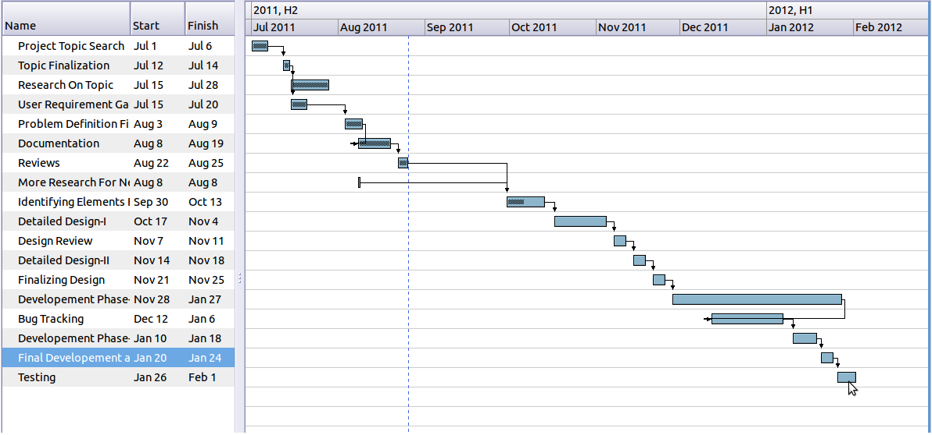

Figure1. Plan of Project Execution

1.5 Problem statement solving approach and efficiency issues
Following are the approaches involved:
        - Keyword Based Search:
        - Context Based Search with Categorisation:
The efficiency of results based on keywords search is around 65-70% while that with context based search is around 80% .Thus the context along with categorization helps to improve the efficiency of the results by approximately 10%.

  - Outcomes
          - Following diagram shows accuracy of keywords algorithm. Algorithm is tested on seven sites mentioned below. Around 70% of the keywords are accurately mined.
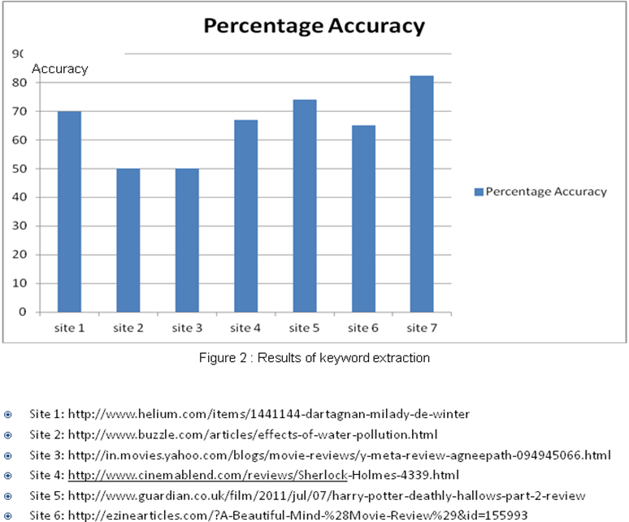
- Following graph shows improvement in Precision using categorization and context based approach over normal keyword based searching.
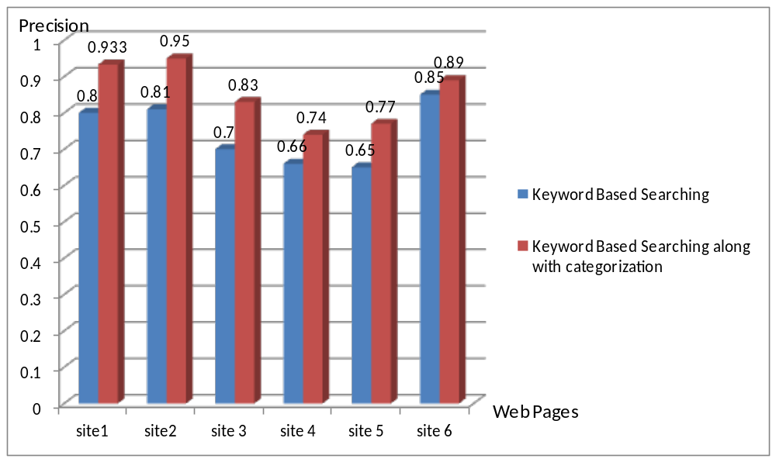
Figure 3 Improvement In Precision Using Categorization
- Site 1: http://www.helium.com/items/1441144-dartagnan-milady-de-winter
- Site 2: http://www.buzzle.com/articles/effects-of-water-pollution.html
- Site 3: http://in.movies.yahoo.com/blogs/movie-reviews/y-meta-review-agneepath-094945066.html
- Site 4: http://www.cinemablend.com/reviews/Sherlock-Holmes-4339.html
- Site 5: http://www.guardian.co.uk/film/2011/jul/07/harry-potter-deathly-hallows-part-2-review
- Site 6: http://ezinearticles.com/?A-Beautiful-Mind-%28Movie-Review%29&id=155993

CHAPTER 2
TECHNICAL KEYWORDS

TECHNICAL KEYWORDS(ACM)

INFORMATION STORAGE AND RETRIEVAL
  - Content Analysis and Indexing
- Abstracting methods
- Dictionaries
- Indexing methods
- Linguistic processing
- Thesauruses
  - Information Storage
- File organization
- Record classification
  - Information Search and Retrieval
  - Clustering
  - Information filtering
  - Query formulation
  - Relevance feedback
  - Retrieval models
  - Search process
  - Selection process

  - Natural Language Processing
- Discourse
- Language generation
- Language models
- Language parsing and understanding
- Machine translation
- Speech recognition and synthesis
- Text analysis
5. Database Applications

CHAPTER 3
INTRODUCTION

INTRODUCTION

Project Idea:
Our project provides the user with the information related to the current page through domain based extraction of keywords. Keywords are retrieved by natural language processing. These keywords are refined further according to the relevance of the subject. Later they are classified under predefined domain. Finally the query based on the context is submitted to the search engine to get all relevant information like related news, images, video, tweets about that subject. Context based searching provides results according to the usage of the keyword in current document eliminating results of other possible contexts. This provides the user with useful information on the same page and reduces his effort of searching frequently on various sites.

Motivation of Project:
With the huge and rapidly increasing amount of information available on the web, relevant information retrieval is one of the most challenging problem. When the user is reading a web document, very often he is interested in reading more about that subject and certain keywords related to that subject . The user normally submits a query to the search engine to find the information of his interest. The results may or may not be relevant to the current subject he is reading. This will consume extra search time to extract the relevant information he wants. Also if the topic of user’s interest contains images, videos and other information, the user needs to search different sites and read the contents. For example, consider the word “buffalo” that has come on different pages like Wild Life Animals, Buffalo University, Buffalo Awards. While reading any of these page the user expects to get the relevant information about buffalo based on the context it is put in every page. Thus the user expects relevant information on the context of the word ‘buffalo’ used each time.
Another example is, when a user is reading about a book, he is interested in knowing more about the book, its author, characters etc. Our proposal seeks to provide all such related information to the user.

Literature Survey:

The keywords are extracted from the web page content based on four parameters:
  - POS tags
  - Frequency of the keyword in page
  - Position of the word
  - Collection Frequency

The results generated were evaluated based on F-score given as:
F_{β} = ((β2+1) * Precision * Recall)/(β2 * Precision + Recall )

Where,

Precision = (no. of terms recognised correctly)/
(no. of terms recognised)
Recall = ( no. of terms recognised correctly) /
(no. of terms actually present)

To find out if a keyword is related to a domain, two measures are used which are:
- Domain Relevance
- Domain Consensus

Where,
Domain Relevance of a term t:

DR( t ,D_{i}) = P( t , D_{i})/∑_{(i=1..n)} P(t,d_{i} )

P( t , D_{i}) is conditional probability

P( t , D_{i}) = freq(t in D_{i}) /∑_{(i=1..n)} freq(t in D_{i})

And Domain Consensus of a term t :

DC(t, D_{i}) = ∑_{(tj€ di)} P(t,d_{j} ) log₂ {1/ P(t,d_{j} )}

An approach of information retrieval based on context distance and morphology.

Context distance is closeness of words. This context distance model measuressemantic distances between words using the local contexts of words within a single document as well as the lexical co-occurrence information in the set of documents to be retrieved.

Let CV₁ and CV₂ are context vector of two words. Let CV₁consists of 10 words A₁, A₂,…A₁₀ and CV₂ consists of B₁… B₁₀.
To computedistance we use following steps:

- We find matching between corresponding words of two vector based on corpus relevance. Corpus relevance can be found as

R(I1I2) = DF(I1I2)/( DF(I1) + DF(I2) − DF(I1I2) )

Where DF is document frequency.

- In the second step, we compute the distance betweenthe two context vectors based on the matching in the first step and the pre-computed corpus relevance.

Wi,jis the weight for the j-th word in the i-th vector. Suppose Ai is paired with Bm(i) in the first step, the context distance is computed as follows:

Dist = summation of (R(Ai ,Bm(i )) * W₁,i * W₂,m(i)) from i=1 to 10

whereR(Ai, Bm(i)) means the corpus relevance of A_{i}with Bm(i). We then compute the average distance between two context vectors by dividing thecomputed distance with the vector size, which is 10 in this case.

CHAPTER 4
PROBLEM DEFINITION AND SCOPE

PROBLEM DEFINITION AND SCOPE

- Problem Statement
Information retrieval algorithm using terminology extraction and context-based searching applied to web pages.
  - Goals and objectives
While browsing, when a user needs to know more about a key feature in the web page he is reading, he needs to spend considerable amount of time in searching about the key feature and getting the information he wants based on context of the document. The primary goal of this project is to make it easier for user to get more information about the topics related to the web document he is reading. This also aims to minimize the browsing time and thus, enhance the user's browsing experience.
The input to the project will be the web page that the user is currently reading. The web page will be processed and the main content of the web page will be input to the program. The web pages should be in HTML or XML format.
The output will be the relevant search results about the key topics in the web page. The context of the topic in that document will be used to improve the accuracy of the results.
1.2 Statement of scope
1.2.1 Size of input:
The input to the project is a web page. So the input size can vary from a few words to a few hundred words.
1.2.2 Bound of Input:
The input web page should be in HTML or XML format.
1.2.3 Input Validation:
The key features found on the web page are classified in domains and only the ones relevant to one or more of the predefined domains are taken into consideration for search.
1.2.4 Major Inputs:
1) Web page
2) Key topics on web page
3) Domain relevant keywords
4) Context of keywords

1.2.5 Major Output:

1) Domain relevant keywords in web page
2) Context based search results
1.3 Software context
The application reduces the user's browsing efforts and saves time. It also gives more relevant results considering the context. Thus, it gives useful information without any browsing efforts on the same web page
1.4 Major constraints based on SWOT Analysis
5.5.1 SWOT Analysis:
- Strengths:
- The application provides the relevant search results about the keywords in the document based on context which helps the user to get relevant and personalized information effectively.
- Machine Learning is used to improve the quality of the results.
- The application gives results on the current webpage itself and helps to reduce user’s browsing time.
- The application provides results automatically when the user opens a web page.
- Customizable GUI.
- Weakness:
- The accuracy depends on the web page that is being viewed.
- The results are according to predefined domains.
- Opportunities:
- The application is useful for any user to help browsing effectively.
- The project has a lot of scope for expansion to help the user to browse in various domains.
- Threats
- Service is interrupted in case of server crash.
5.5.2 Major Constraints:
- The domains are predefined. So the application can handle the key features on a web page related to specific domains.
- The keywords that do not belong to the specified domains are discarded.
- Web pages have various scripting formats. So generalized web scraping methods cannot be used.
  - Approaches for solving the problem and efficiency issues
Following are the approaches involved:
        - Keyword Based Search:
        - Context Based Search with Categorisation:
The efficiency of results based on keywords search is around 65-70% while that with context based search is around 80% .Thus the context helps to improve the efficiency of the results by approximately 10%.
  - Outcomes
          - Following diagram shows accuracy of keywords algorithm. Algorithm is tested on seven sites mentioned below. Around 70% of the keywords are accurately mined.
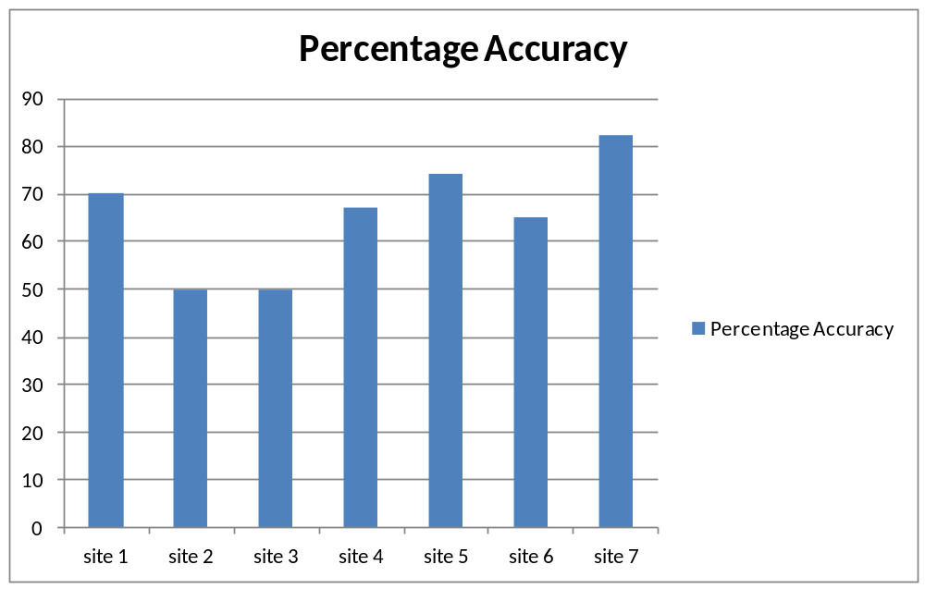
Figure 4: Results of keyword extraction

  - Following graph shows improvement in Precision using categorization and context based approach over normal keyword based searching.
Figure 5 Improvement In Precision Using Categorization
- Site 1: http://www.helium.com/items/1441144-dartagnan-milady-de-winter
- Site 2: http://www.buzzle.com/articles/effects-of-water-pollution.html
- Site 3: http://in.movies.yahoo.com/blogs/movie-reviews/y-meta-review-agneepath-094945066.html
- Site 4: http://www.cinemablend.com/reviews/Sherlock-Holmes-4339.html
- Site 5: http://www.guardian.co.uk/film/2011/jul/07/harry-potter-deathly-hallows-part-2-review
- Site 6: http://ezinearticles.com/?A-Beautiful-Mind-%28Movie-Review%29&id=155993

1.7 Hardware Resources Required
4 Dell laptops
Configuration:
- 2.2 GHz Intel core 2 duo processor
- 3 GB RAM
- 320 GB Hard Disk

Internet connection

Software Resources Required
Platform: Ubuntu 10.10
- Python 2.6
- Flask 0.8
- Mongodb 2.0
- Pymongo 2.1
- Natural Language Toolkit
- Bingapi 0.02
- Freebase API
- Gdata
- Jquery
1.9 Area of Project
ARTIFICIAL INTELLIGENCE
Natural Language Processing
Language parsing and understanding
Text analysis
Database Applications
Data mining

CHAPTER 5
PROJECT PLAN

  - PROJECT PLAN

5.1Introduction
When user is reading a web document, he is often interested in knowing more about topic discussed in that document. User has to search on web related information. This consumes extra time, also information may or may not be relevant to the current document. We propose approach that presents context-relevant information to the user. It caters to the need of user of having such extra information about current topics
5.1.1 Problem Definition
Information Retrieval approach using terminology extraction and context based searching applied to WEB pages.
When browsing something on the internet, a user is interested in quickly finding relevant information about the subject. This information can be extracted by identifying key ideas on the webpage. This paper discusses an approach to find relevant content from the web based on the keywords extracted from the document. In this approach keywords are extracted by mining web page based on their context. Keywords are categorized in predefined domains such as place, books, people etc. Search is performed on web depending on context to increase the accuracy of retrieved information. Social and location-based information is integrated by leveraging social networks like Twitter and Facebook. Our proposal automates the task of finding related information about the webpage and thus reducing user's browsing efforts.

5.1.2 Management and technical constraints
Each page may have different scripting language. So for scraping the web page, generalized method cannot be used. Project requires extensive use of Natural language processing, so study phase is bigger.
5.1.3 Purpose of the Document
This document seeks to provide the Project Plan for the project, ’Information Retrieval Algorithm based on Terminology Extraction and Context Based Searching’ to be developed as a part of Final Year Engineering Project at Pune Institute of Computer Technology with purpose of obtaining a degree in Computer Science at the Pune University.The purpose of this document is to identify the scope of the project, estimate the work involved, and create a project schedule.

5.2 Project Estimates
5.2.1 Historical data used for estimates
Data used in some other web application which extracts terminologies from documents. Applications performing context based searching are used for historical data.
5.2.2 Estimation techniques applied and results
Estimation technique : LOC(Lines of Code)
For estimation of project, Line of Code technique is used. It makes estimate based on Lines of Codes.
Estimate for technique: LOC(Lines of Code)
We are dealing with Text processing operations like tokenizing, categorizing etc. And also GUI will be made using HTML-CSS, JavaScript. So project code will be of 2000 lines.
5.2.3 Reconciled Estimate
Estimated Cost: As we are working using open source software and also open source web service to host our application. So there is hardly any finance needed.
Estimated Time: Roughly project will take around 4-5 months and the month thereafter to add additional functionality to this feature
5.2.4 Project Resources
Hardware Resources Required:
- Pentium 4 Processor, 512 MB RAM
- Network Interface Card
Software Resources Required:
- JavaScript Enabled Web Browser

5.3 Risk Management
We have classified the risks into different categories as:
1. Development Risks
2. Business Risks
3. Project Risks
4. Requirements Risks

No | Risks | Category | Probability | Impact
1 | Lack of training on tools | Development | 20% | Critical
2 | Delivery deadline will be tightened | Business | 20% | Critical
3 | Technology will not meet expectations | Technical | 5% | Critical
4 | Requirement will change | Project | 10% | Marginal
5 | Ambiguity in data structures written by developers | Development | 5% | Catastrophic
6 | Lack of experience with web services | Development | 10% | Marginal
Table 4.1: Risk Table

5.3.1 Risk Table

Catastrophic | Failure to meet the requirement would result in mission failure
Critical | Failure would degrade performance; mission success is Questionable.
Marginal | Failure would result in degradation of secondary mission.
Negligible | Failure would have slight impact

5.3.2 Overview of Risk Mitigation, Monitoring, Management
It will help the team to study the major risks in the initial stages. The requirement specification and software specification will be reviewed and studied. All the risks though making negligible impact will be taken into consideration. A proactive approach will be practiced. The risks will be recorded and a best course of action will be planned to avoid the risks. As all risks cannot be avoided, performing risk management, we can attempt to ensure that the right risks are taken at right time.

No. | Risks | Mitigation | Monitoring | Management
1 | Lack of training on tools | The tool manuals and tutorials are frequently practiced | Done by members of team | Assure foolproof understanding each time.
2 | Technology will not meet expectations | Study technology features for requirement’s fulfillment | Done by administrator and members | Discuss with technical experts and search online for newer versions.
3 | Ambiguity in data structures written by developers | Carry out unit tests on minimal set of rules | By members | Change the rule as and when required if ambiguity occurs
4 | Poor Documentation | The code is documented to reflect meaning to observer. | Done by team members | Any change in the document is corrected and documented properly
Table 1 Risk Mitigation, Monitoring and Management
5.4 Project Schedule
5.4.1 Project Task SetThe different task sets that are critical in the project are as follows: –
Serial No | Task ID | Name Of Task
1 | T-1 | Deciding Boundaries and scope of project
2 | T-2 | Installing NLTK, Flask, Extension
3 | T-3 | Deciding inputs and outputs
4 | T-4 | Learning tools required for the project
5 | T-5 | Design of classes and GUI
6 | T-6 | Preparation of 1st prototype
7 | T-7 | Revision of 1st Prototype
8 | T-8 | Testing
9 | T-9 | Documentation

Table 2 Program Task Set

5.4.2 Task network:
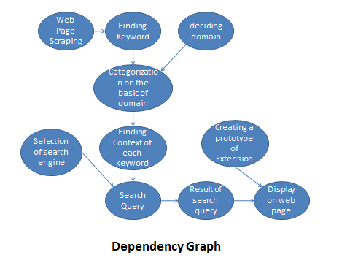
Figure 6
5.4.3 Timeline chart
Please refer annexure C for turn wise plans

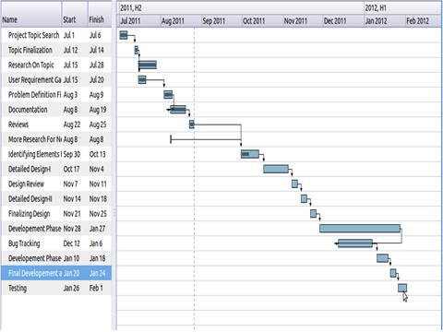

Figure 7. Time Line Chart

5.5 Staff Organization
Role | Responsibilities | Participant(s)
Project Sponsor | 1.Final decision-maker  2.Provide project oversight and guidance  3.Review/approve some project elements | Dreamz Group  Mr.VedangManerikar
Project Guide | 1.Manages project in accordance to the project plan  2.Provide overall project direction  3.Direct/lead team members toward project objectives  4.Handle problem resolution | Prof. RekhaKulkarni
Project Participants | 1.Communicate project goals, status and progress throughout the project to personnel in their area  2.Review and approve project deliverables  3.Coordinates participation of work groups, individuals and stakeholders  4.Assure quality of products that will meet the project goals and objectives  5. Identify risks and issues help in resolutions. | Group members

5.5.1 Team structure
Prof RekhaKulkarni
PICT, Pune

Mr.VedangManerikar

JayeshPawar
PrajaktaNaik
MandarHaldekar
AishwaryaBhide

Figure 8.Team Structure

5.5.2 Management reporting and communication
Communication with external guide began in July 2011. Initially domain of project as ‘WEB Application’ was finalized and some basic assignments on it were done. Each assignment was verified by external guide.
Meeting with external as well as internal guide have been holding on weekly basis. Minutes of each meeting have been posting on GITHUB. The group members being in the same institute and all pursuing final year of computer engineering met on daily basis depending on need and task to be done. For effective communication with external guide, a Google group, fantastic4_be@googlegroups.com , was created where periodic progress and queries were posted.

5.6 TRACKING AND CONTROL MECHANISMS
5.6.1 Quality assurance and control
Software quality is defined as conformance to explicitly state functional and performance requirements, explicitly documented development standards, and implicit characteristics that are expected of all professionally developed seawares. Software quality assurance (SQA) is an activity that is applied throughout the software process. It involves various steps like:
- Create a set of activities that will help ensure that every software engineering work product exhibits high quality.
- Perform quality assurance activities on every software products.
- Use matrix to develop strategies for improving your software process and as a consequence the quality of the product.
- Everyone involved in the software engineering process is responsible for the quality of product.
Documentation
As a part of ensuring software, project following documents should be prepared
- Software Requirement Specification
- Software Design Specification
- Risk Mitigation, Monitoring and Management Plan

Standards, Practices and Conversions
Document Standard
All documents are written in Microsoft Word in Font Times New Roman and size 12. The headings are bold with font size ranging from 12 to 14. The documents are fully justified.
Coding Standards
The code will be written in python programming language. HTML-CSS, Java-script will be used for GUI design.
Review Guidelines
The team will update the documents on regular basis and send the updated documents to internal as well as external guide for critical reviews assessments. These documents will also be posted on Google group. Suggested improvements and changes will be incorporated promptly.
Metrics
Following metrics will be used to ensure software quality:
- Team meeting every day to discuss progress.
- Meeting with internal guide every week to analyze the progress over previous week.
- Meeting with external guide once or twice in a week to discuss the progress till date, suggest changes for improvement and decide the future course of action.
- Logging of daily work by every team member.
- Use of group mailing list to manage work done by every team member
Quality Control through Testing Test cases will be designed to test each module thoroughly. Each test consists of requirements for performing the test; the exact procedure to be carried out, the correct results of the test and the errors, which the test might expose.
5.6.2 Change management and control
Any change in design or plan is immediately reported to external guide and design is modified after discussion with him. Further course of actions is decided based on this design.

CHAPTER 6
SOFTWARE REQUIREMENTS SPECIFICATION

SOFTWARE REQUIREMENT SPECIFICATION

6.1 Introduction
6.1.1 Purpose and Scope of Document
The purpose of this document is to serve as a guide to designers, developers and testers who are responsible for the engineering of the project “Information Retrieval algorithm using terminology extraction and context based searching”. It should give the engineers all of the information necessary to design, develop and test the software.It will explain the purpose and features of the system, the interfaces of the system, what the system will do, the constraints under which it must operate and how the system will react to external stimuli. This document contains a complete description of the functionality of the project. It consists of use cases, functional requirements and nonfunctional requirements, which, taken together form a complete description of the software.

6.1.2 Overview of responsibilities of Developer
The developer should understand the problem statement and project requirements properly before starting with the design of the project. The design of project should be done by considering the feasibility of the problem statement. Also, various ways of implementing the required functionalities should be considered and analyzed. The best possible way should be selected based upon various technical and nontechnical aspects. The product should be tested for various test cases so that the quality requirements of the product are met.

7.2ProductOverview
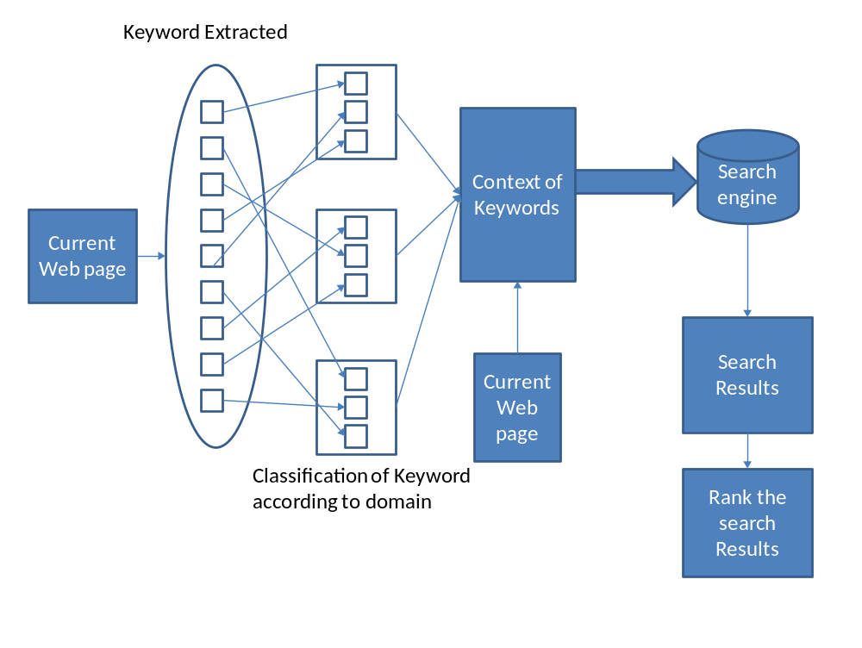
Figure 9. Block Diagram

This project gives an approach to find relevant content from the web based on the keywords extracted from the document. Keywords are extracted by mining web page based on their context. Keywords are categorized in predefined domains such as place, books, people etc. Search is performed on web depending on context to increase the accuracy of retrieved information.
The above diagram gives an overview of the steps performed.
- Extraction of keywords from current web page:
The web page that the user is currently reading is scanned and the words that describe some key topics related to the subject of the document are identified and stored.
- Classification of keywords according to domain:
The extracted keyword are then checked to see if they belong in the predefined domain(places,movies,books etc).If they belong to a particular domain then they are recorded as relevant keyword to the documents. Those keywords which do not belong to any predefined domain are discarded.Thus the relevant keywords are successfully filtered out.

- Contexts of the keywords:
Contexts of the keywords related to predefined domains are identified based on the usage of the words in the web page.
- Search on web:
Queries are formed based on the contexts of keywords and passed to search engine to get most relevant results.
- Ranking:
The search results found are then ranked according to the relevance of the results pages with keywords. Thus the user will get personalized results with considerably less efforts.

6.3 Usage scenario
6. 3.1 User profiles
1. User:User is the primary actor who reads the web page and after getting relevant information, he clicks on results.
2.Client side System: The client side system is the secondary actor that provides service to the user. This actor identifies which web page is being read by the user and sends it to the server side system.
3.Server side System: The server side system is the secondary actor that provides the service to the client system. It processes the webpage and provides the results to the client system.

6.3.2 Use-cases
1. Use case Id : 1
Usecase name : Fetch web page
Primary Actor : User
Secondary actors: Client side application, Server side application
Precondition : A web page should be opened in user’s browser.

Main flow:
- Use case starts when user opens a web page.
- The client application takes the url of page and sends it to server application.
- Server application fetches the web page.

Post condition:
The server app has required web page.
2. Use case ID: 2
Usecase name: Extract keywords
Primary actor: Server side application
Precondition: Server side app has the web page.
Main Flow:
- Use case starts after server side app fetches required webpage from web.
- The page is scraped and the main content is filtered out.
- The main content is then tokenized and POS tags are found.
- NP-Chunks are formed from the tokens.
- The frequency, position and collection frequency of NP-Chunks is found.
- Based on these criteria, the chunks that can be keywords are found out.
Post Condition:
The server side app has the keywords.
3. Use case ID: 3
Use case name: Categorize into domain
Primary Actor : Server side application
Precondition: The server side app has the keywords.
Main flow:
- Use case starts after extraction of keywords.
- The domain consensus (DC) and domain relevance (DR) is found out for each keyword for each domain.
- Based on DC and DR, the keywords that are related to at least one of the predefined domains are found.
Post Condition :
Server has domain relevant keywords.
4. Use case ID: 4
Use case name: Find context of keywords
Primary Actor : Server side application
Precondition: The server side app has the domain relevant keywords.
Main flow:
- Use case starts after categorization of keywords.
- The distance between words and the title, tags in page are analyzed to find context of keywords.
Post Condition :
Server has context of domain relevant keywords.
5. Use case ID: 5
Use case name : Search on web
Primary Actor : Server side application
Precondition: The server side app has the keywords and their contexts.
Main flow:
- Use case starts when keywords and their context is known.
- Search queries are formed based on keywords and contexts.
- The queries are passed to search engine and results returned are stored.
Post Condition :
Server has search results.
6. Use case ID: 6
Use case name: Rank the results
Primary Actor : Server side application
Precondition: The server side app has the search results for each query.
Main flow:
- The tf-idf for each search result is found out.
- The results are scored and ranked according to tf-idf.
- The ranked results are passed to the client side application.
Post Condition :
Client side app has ranked search results.
7. Use case ID: 7
Use case name: Fetch information from social networking sites
Primary Actor : Server side application
Precondition: The server side app has the keywords and their contexts.
Main flow:
- Queries are formed based on contexts.
- Search is performed using queries and results from social networking sites are fetched.
Post Condition :
Server has relevant search results from social networking sites.
8. Use case ID: 8
Use case name: Display results
Primary actor: User
Secondary Actor : Client side application
Precondition: The client side app has all the search results.
Main flow:
- Use case starts when client app has the ranked search results.
- The results are displayed in the browser extension on the same web page.
Post Condition :
Results are displayed to the user.
6.3.3 Use Case View
Server interaction:
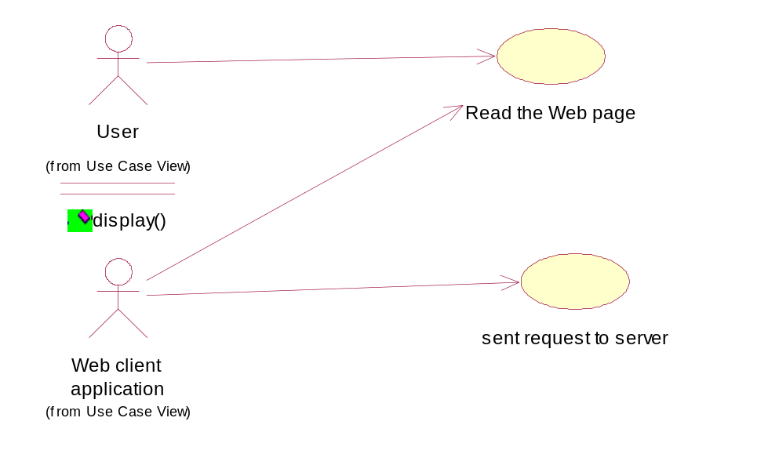
Figure 10.1

Keyword Extraction
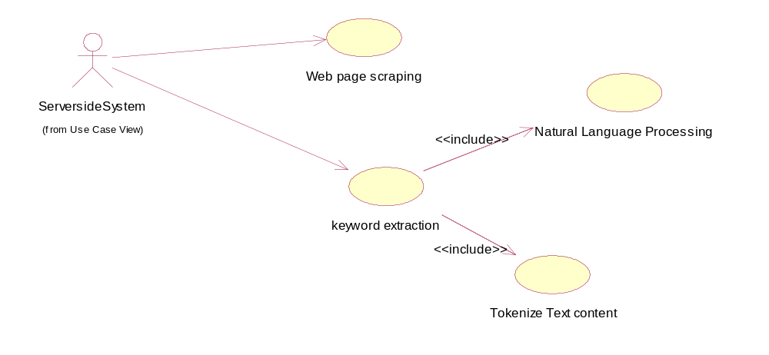
Figure 10.2

Categorisation:

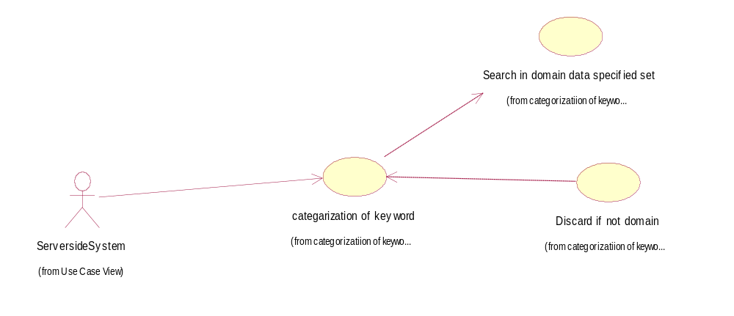
Figure 10.3

Find context

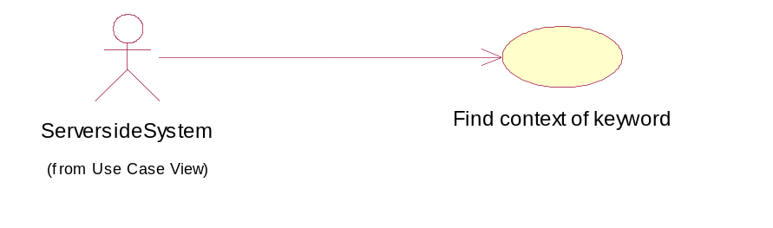
Figure 10.4

Search on web:

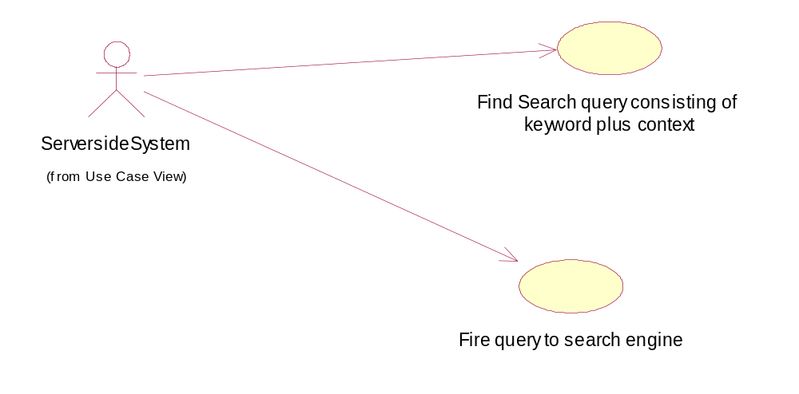

Figure 10.5

Social and location based info

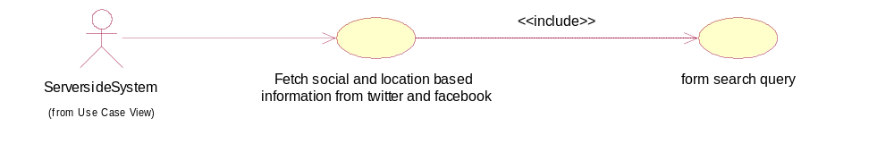
Figure 10.6

Ranking the results
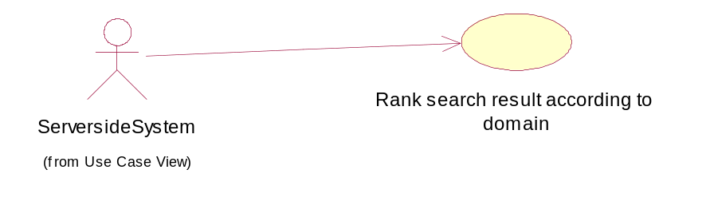
Figure 10.7

Send result to browser:
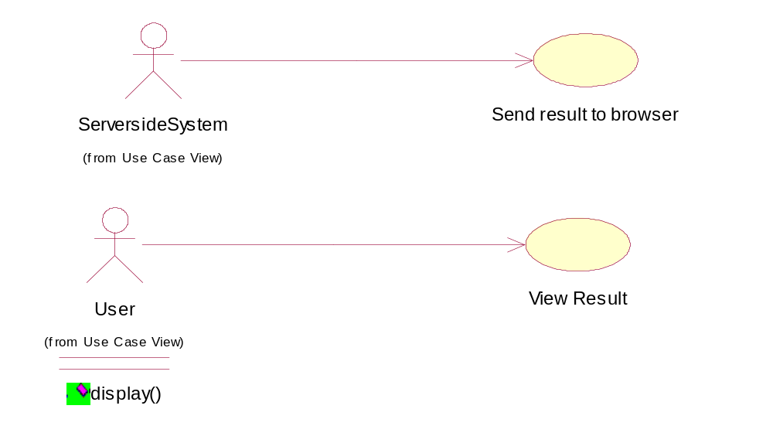
Figure 10.8

Global View:
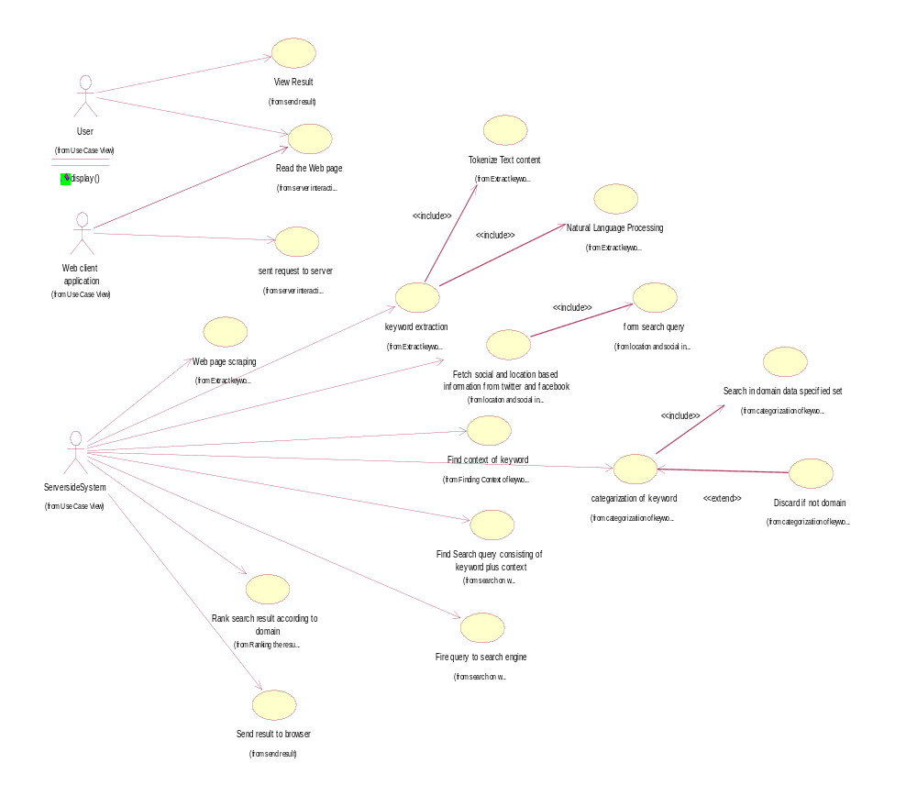
Figure 10.9

6.4 Data Model and Description
6.4.1 Data Description
Internal software data structure
Array of Objects: This structure holds array of instances of classes. These are created in NP-chunk class for each keyword, one instance of keyword class is created. Also for each search query, one instance of searchResult class is created.
Binary tree: This data structure holds page source code of wb page which is user is reading. Since it is hierarchical, it can be represented as tree.
String: URL of web page is stored as strings.
Global data structure
String: It is used to hold main text content of web page. It is available to all the components. Text is used to determine keywords, context , and also for domain categorization.
Temporary data structure
Array : arrays are used for storing results of operations like frequency distribution, POS_tag, etc. It is used to store contexts of keywords and also Domain Consensus(DC) and Domain Relevance(DR) values.
Structure: It is used to store search results of query. It has elements as snippet( which is result string), URL and tf-idf(term frequency and inverse document frequency ) score of that results.
Binary Tree: It is used while determining the contexts of keyword. Words are stored hierarchically in corpus such as WordNet , so binary distant trees can be used to find distance between two words.
6.4.2 Data objects and Relationships
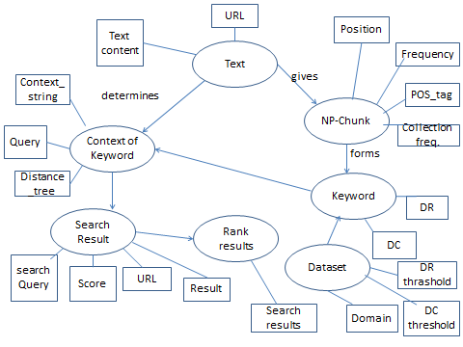
Figure 11 Data object and Relationship

6.4.3 Data dictionary
Corpus: We use corpus containing list of movies, books ,places etc. Also we maintain hierarchical corpus WordNet for context mining
Domain Specific Datasets: For each Domain, one dataset is maintained which is used for finding DC and DR.
6.5 Functional Model and Description
6.5.1 Data Flow Diagram:
- Context Diagram:
Information Retrieval System
0.0
View Page
Process the webpage
User
Keyword extract
Server Side System
View Result
Send results to client
Send request to server
Search query
Display Result
Give results
Client Side System
Search Engine

Figure 12

2.Sub System Process Diagram:
1.0WebScrapping
Client side system
Main text
Web page
2.0Keyword Extraction
Results
Web page
3.0Categorization to Domain
keywords
User
Server side system
Relevant Keywords
4.0Find Context of Keyword

Search Query
5.0Search on Web And rank
Query
Search Engine
Search Results
Figure 12.1
6.0View Result

Following are the main processes in the System:
- Web Scrapping
- Keyword Extraction
- Categorization to Domain
- Find the Context of Keywords
- Search and Rank
- View Result

1.Web Scrapping:
1.1Get main Text
Main text

Server side system
1.2Tokenise text
Tokenized text
1.3 Find Parts of speech tag
Np chunk
POS tagged

1.4Calculate Frequency Distribution
Np chunks

Figure 13
Web scrapping process involves getting the main text and store in the text store.The main text is then tokenized.Part of speech tags are found and frequency distribution is calculated to finally give np chunks that is stored.
2. Keyword Extraction
Np chunks

2.1 Frequency Distribution
keywords

Keywords
2.2Position Collection Frequency

Figure 14

The keywords are retrieved through position distribution and position collection frequency and then stored in data store keywords
3.Domain Categorization

keywords
3.1Domain Relevance

Domain relevant keywords
3.2Domain Consensus
Categorized keywords

Figure 15

The keywords from the store are categorized according to domain relevance and domain consensus. The categorized keywords are stored in the data store.

4.Context of Keywords
Main text
Query
4.1Relevance to topic of document
keywords
4.2Distance of the words

4.3Context of keywords in text
Figure 16

The context of the keywords are taken from the main text document. The title and the sentences near the keywords play an important role. Once the context of keyword is formed an augmented query is constructed and stored in data store.
5.Search on web and rank
query
5.1Search by Search Engine
Result
5.2Tf-idf ranking
Results

5.3Ranking and sorting
Figure 17
Relevant ranked results
Final ranked results

The query is passed to the search engine. The results given by the search engine are store in results data store. The tf-idf ranking is done on the results and final results are sorted and ranked.
6.Display
Final ranked results
Client side system

Relevant ranked results
6.1Display results

Figure 18

Final results that are ranked are sent to the client side system for the display to the user.
6.5.2 Description for(Function/Module/Subsystem)
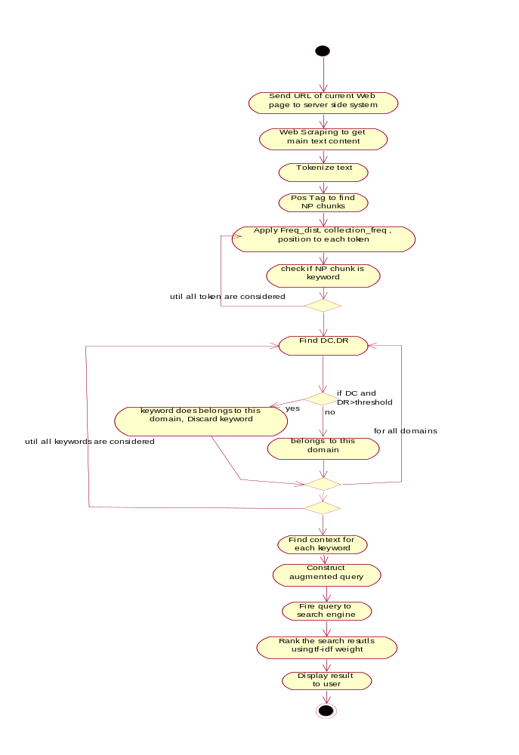
Figure 19 Activity Diagram
6.5.3 Non Functional Requirements
- The system is written in python language.
- The system must be installed first to run successfully.
- The system will extract only relevant keywords based on context of the document
- The software shows more relevant information about that document.
- The software requires internet connection.
- The keywords extracted must belong to the predefined domain. Only then the results are shown.
- The system shows tweets about the particular document.
- Keywords must be defined in some predefined domain.
- Each web page may have different scripting language. So for scarping web page, generalized method cannot be used.
    - Design Constraints:
- The screen space available to the toolbar is limited as it is shown on the current web page.
- The domains of web searching are predefined.
- The keywords which do not belong to any of the specified domains are discarded.

6.5.5 Software Interface Description
- A toolbar is used as an interface between the user and the software, to display all the relevant information.
- The toolbar provided on the browser will show the relevant information of the keywords extracted from the document, making the task of user easy and convenient.
- Each keyword will be provided with popup menus showing url of different sites. This helps the user to easily access those information. Improving the search and browsing efficiency.

6.6 Behavioral Model and Description
1.Start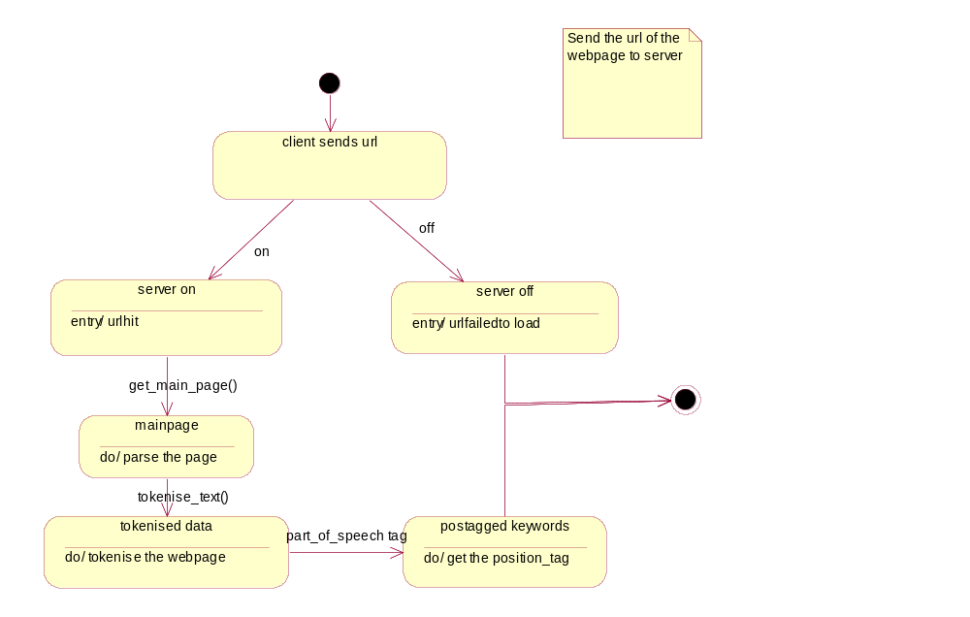
Figure 20
- The client sends the url of the page user is reading to the server .
- If the server is active then url is sent and the page is loaded at the server side else the url page is not loaded.
- After the page gets loaded at the server side, webpage scrapping is done to get the main text removing the advertisements and comments.
- The main text document is then tokenized along with the pos-tagging to find the keywords of the page
2.Find Relevant keywords
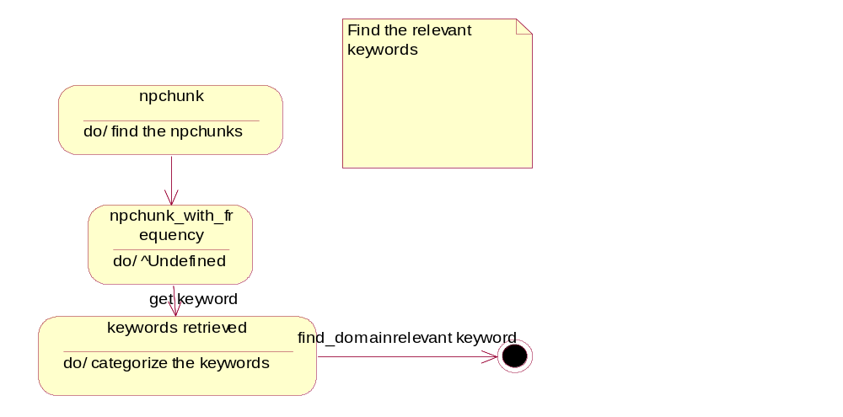
Figure 21
- Collect the np-chunks.
- From the np-chunks the keywords are retrieved.
3.Categorise the keywords
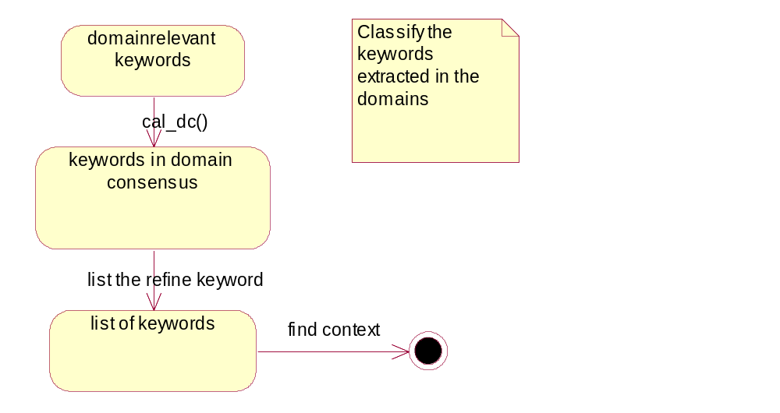
Figure 22
- Categorization of the keywords in the predefined domain.
- Categorization is done by domain relevance and domain consensus.
- Firstly take all domain relevant keywords and then calculate the domain consensus.
- List all the keyword that belong to the domains.

4.Context of keywords
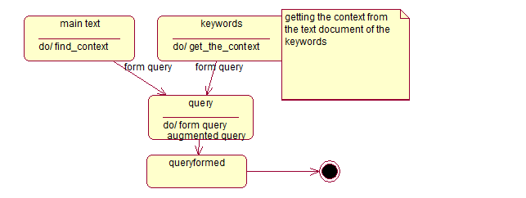
Figure 23
- Get the context of the keywords from the main text.
- The document title and the sentences in which the keyword is used will provide the context of the word.
- When the context of the keyword is known, an augmented query is formed.
5.Submit query
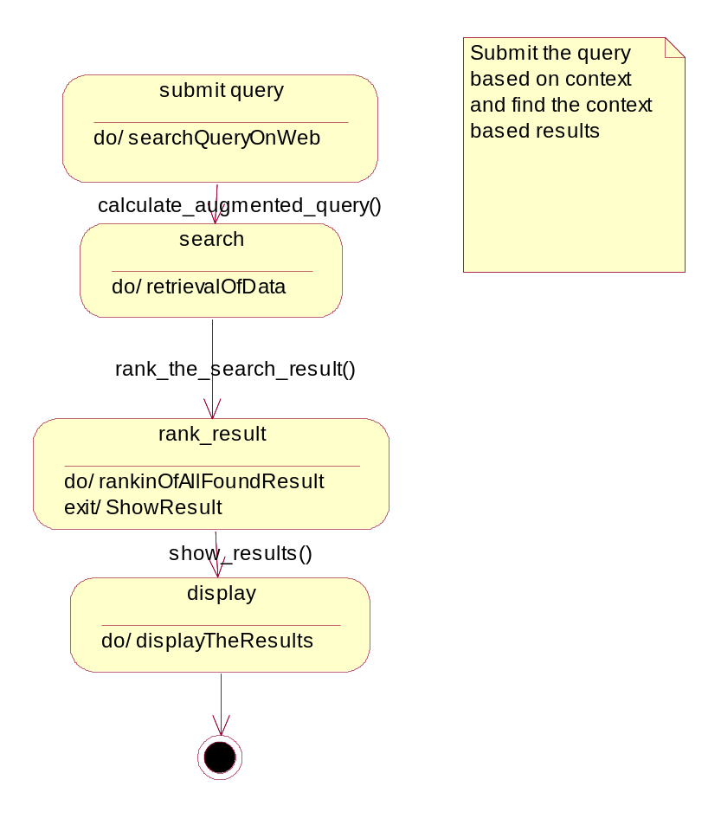
Figure 24
- The query formed is given to the search engine for the retrieval of the search results.
- The results provided by the search engine are then re-ranked and sorted to give the final result set to the client side system.
6.7 Restrictions, Limitations, and Constraints
To find out the key terminologies on the page, natural language processing is used which aims to maximize the accuracy of output but the output cannot be 100% accurate every time. Also, the classification of the terminologies depends on probability which might affect the accuracy of results.
The accuracy keeps improving over the time by using machine learning. This gives more useful results and the program becomes more reliable over time.
If the program cannot find any keywords matching the specifications, it will not show any results.
6.8.0 Validation Criteria
6.8.1 Classes of tests
BLACK BOX TESTING
In black box testing emphasis is on the behavioral response of the software in reference to the functionality it executes
- Compatibility of application with all browser is tested
- Check whether extracted keywords depicts subject of the topic
- Check whether search results are context-relevant or not

WHITE BOX TESTING:

Basis Path Testing:It is White-box testing method. The basis path method enables the test case designer to derive a logical complexity measure of a procedural design and use this measure as a guide for defining a basis set of execution paths. Test cases derived to exercise the basis set are guaranteed to execute every statement in the program at least one time during testing.

Steps:
- Construct Flow graph : Consider Activity Diagram of the system. Flow diagram cab be drawn from it as shown in figures below.

- Determine basis set of flow graph: basis test consist of set of all basis paths of flow diagram such that all nodes are executed at least once.

Path 1: 1-2-3-4-5-6-7-8-9-10-12-13-14-15-16-17-18-19
Path 2 1-2-3-4-5-6-7-8-9-11-12-13-14-15-16-17-18-19

- Prepare test cases that will force execution of each path in the basis: Data should be chosen so that conditions at the predicate nodes are appropriately set as each path is tested. Test cases that satisfy the basis set just described are

Path 1:
Test Case:

Input: K= { rose, wire, Pune}
These keywords rose and wire are not related to any of the related domain

Expected Result: First two keywords will be discarded and context-results are retrieved

Path 2:
Test Case

Input: K = {Jurassic Park, fiction, Steven Spielberg}
Jurassic Park ϵ movie
Fiction ϵ movie, books
Steven Spielberg ϵ movie, people

Expected Results: Keywords will be categorized into movie domain and context-relevant search results are retrieved.

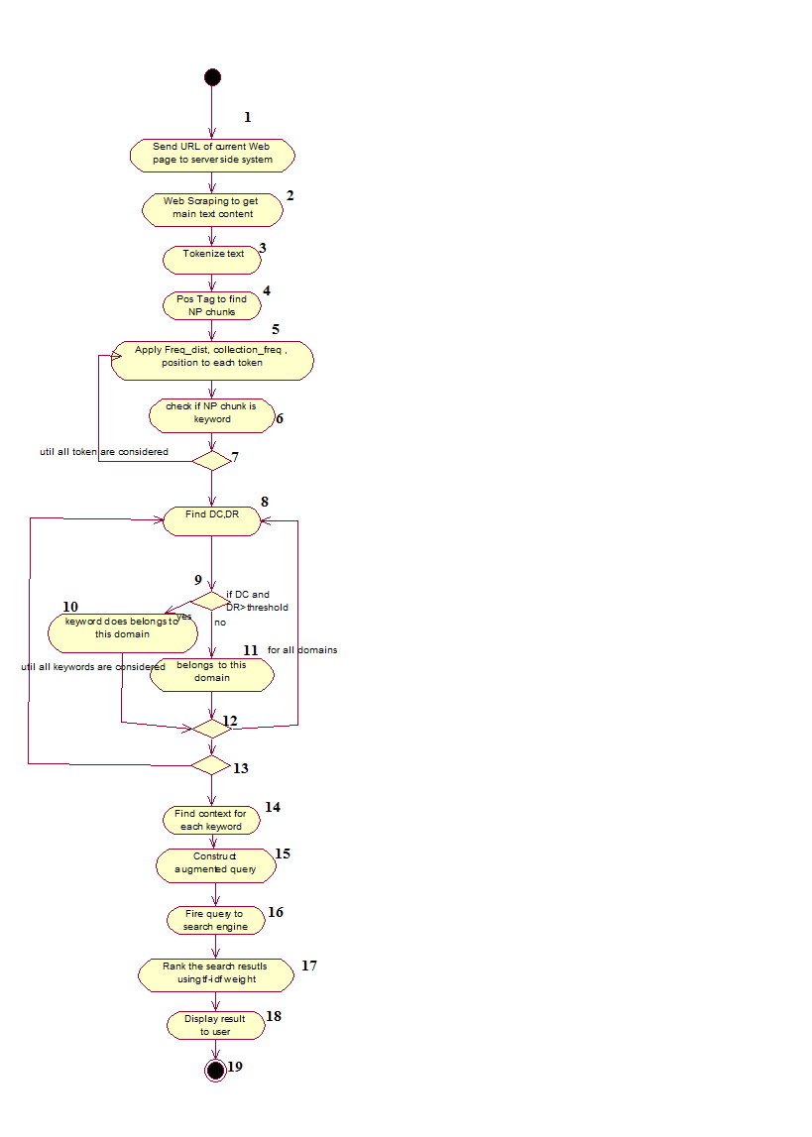
Labeled Activity Diagram
Figure 25

1
2,3,4
6,7
5
12,13
10
11
8,9
14,15,16
17.18

Figure 26. Flow Graph
6.8.2 Estimated software response
1. Software should give inputs as per design
2. Output results for all test cases should be relevant to input keywords
3. Context should be determined with respect usage of words in the document/
6.8.3 Performance bounds
Application should be connected to web server. Keywords should be in predefined domains. For more accurate results, document should be specific topic oriented .
6.9Appendices
Refer to annexure A, B, C, D

6.10 References
Backward references of the paper

- G. D. Abowd, A. K. Dey, P. J. Brown, N. Davies, M. Smith, and P. Steggles, “Towards a better understanding of context and context-awareness,” in Proc. 1st Int. Symp. Handheld Ubiquitous Computing, 1999, vol. 1707, pp. 304–307
- Ken Barker and Nadia Cornacchia. 2000. Using noun phrase heads to extract document keyphrases. In Canadian Conference on AI.
- E. Frank, G. W. Paynter, I. H. Witten, C. Gutwin and C.G. Nevill-Manning, "Domain-specific keyphrase Extraction”,In proceedings of 16th International Joint conference on Artificial Intelligence(IJCAI-99),pp. 668-673, Stockholm,Sweden,July 31- August 6, 1999
- Lawrence, S.: Context in Web search. IEEE Data Engineering Bulletin 23 (2000) 25.32
- Peter D. Turney. 2000. Learning algorithms for keyphrase extraction. Information Retrieval, 2(4):303–336
- P. D. Turney (2003), Coherent keyphrase extraction via Web mining, Proceedings of the Eighteenth International Joint Conference on Artificial Intelligence (IJCAI-03), Acapulco, Mexico, 434-439
Forward references of the paper

- Bhowmik, R. Sam, Huoston State Univesity, “Keyword Extraction from abstract and title” , Southeaston, 2008 IEEE.
- M. Brunzel and M spilopoulou, “Domain relevance on term weighting” Natural Language Processing and Information, pp 437-432, 2007
- Anette Hulth, “Improved Automatic Keyword Extraction given more linguistic knowledge ”
- Hongyan Jing, Evelyne Tzoukermann, “Information Retrieval Based on Context Distance and Morphology”, 22nd annual international ACM SIGIR conference on Research and development in information retrieval ,1999
- Li Liu , Quan Qi, “Combined method for automatic domain-specific Terminology Extraction” Eight International conference on Fuzzy System and knowledge Discovery(FSDK)
- Alexander Patry, Philippe Langlais ,”Corpus Based Terminology Extraction” 7th international conference of Terminology and knowledge Engineering, Copenhegan, Denmark, 2005, pp 313-321
- Salton, G., & McGill, M. “ Introduction to Modern Information Retrieval”, McGraw Hill.

CHAPTER 7
DETAILED DESIGN DOCUMENT

DETAILED DESIGN DOCUMENT

7.1 Introduction
The Software Design Document is a document to provide documentation which will be used to aid in software development by providing the details for how the software should be built. Within the Software Design Document are narrative and graphical documentation of the software design for the project including component, sequence diagrams, class diagram, object behavior models, and other supporting requirement information.
7.1.1 Purpose:
Purpose of this document is to present outline of technical design of Web Application Based on Terminology Extraction and Context-Based Searching and provide an basis for implementation
Its main purpose is to -
• Provide the link between the Functional Specification and the detailed Technical Design documents
• Detail the functionality which will be provided by each component or group of components and show how the various components interact in the design
• Provide a basis for the development of Web Application Based on Terminology Extraction and Context-Based Searching
    - Scope :
Web Application design outlined in this document built upon the scope and functionality specified in Problem Definition and Scope document. This document provides detailed description of Architecture, Data design, Component design, software interface , user interface, limitations and constraints

7.2 Architectural design
7.2.1 Architecture Diagram:

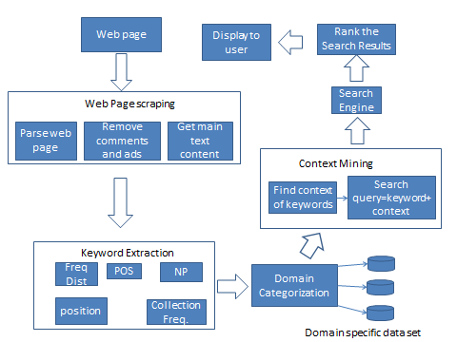
Figure 27. Architecture Diagram
7.2.2 Architecture Description:
Web scraping:
When user is reading a web page, client web application sends HTTP request containing URL of the page to server side system. User is mostly interested in main text content. Server side system fetches page source code at that URL. It parses the web page, removes unnecessary comments and advertisements and retrieves main text content of web page.
Keyword Extraction:
Web page text is parsed into tokens and various Natural language processing operations are applied to it. Tokens are sorted by part of speech tags. Out of those only nouns are considered. Frequency distribution, position, collection frequency are determined for these NP-chunks. Various criteria are applied to decide whether particular NP-chunk is keyword or not
Domain Categorization:
Keywords are then categorized into pre-defined domains. Domain specific datasets are used for categorization
Context-Mining:
Usage of keywords in the text is considered to find their context. For each keyword one or more contexts are mined. For finding context entire text of web page is examined and also some datasets such as WordNet is considered.
Search on Web:
To get most relevant results, while firing query to search engine, contexts are also considered. Augmented search queries consisting of context and keywords are formed and given to search engine. Also search is performed on social networking sites Facebook, Twitter.
Rank the search results:
After getting search results of all query , they are ranked according to term frequency-inverse document frequency weight for each keyword. Final results are then displayed to user.
7.3 Data design
7.3.1 Internal software data structure
Array of Objects: This structure holds array of instances of classes. These are created in NP-chunk class for each keyword, one instance of keyword class is created. Also for each search query, one instance of searchResult class is created.
Binary tree: This data structure holds page source code of wb page which is user is reading. Since it is hierarchical, it can be represented as tree.
String: URL of web page is stored as strings.
7.3.2 Global data structure
String: It is used to hold main text content of web page. It is available to all the components. Text is used to determine keywords, context , and also for domain categorization.
7.3.3 Temporary data structure
Array : arrays are used for storing results of operations like frequency distribution, POS_tag, etc. It is used to store contexts of keywords and also Domain Consensus(DC) and Domain Relevance(DR) values.
Structure: It is used to store search results of query. It has elements as snippet( which is result string), URL and tf-idf(term frequency and inverse document frequency ) score of that results.
Binary Tree: It is used while determining the contexts of keyword. Words are stored hierarchically in corpus such as WordNet , so binary distant trees can be used to find distance between two words.
7.3.4 Database description
Corpus: We use corpus containing list of movies, books ,places etc. Also we maintain hierarchical corpus WordNet for context mining
Domain Specific Datasets: For each Domain, one dataset is maintained which is used for finding DC and DR.
7.4 Component design
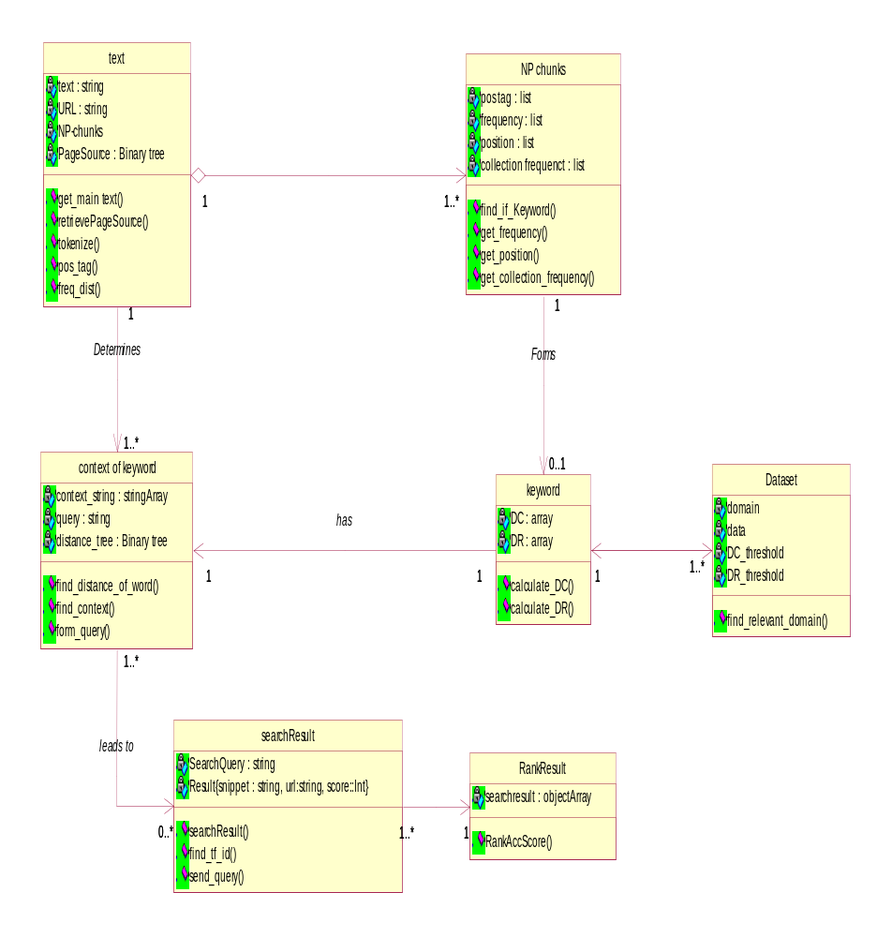
Figure 28 Class Diagram
7.4.1 Program Structure
Following components form program structure
- Web Scraping
- Keyword Extraction
- Domain Categorization
- Context Mining
- Search On Web
- Rank Search Results
- View Results
7.4.2 Description for Component n
Processing narrative (PSPEC) for components
- Processing narrative(PSPEC) for component Web Scraping:
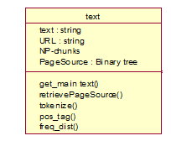Figure 29 Class for Web Scraping
In Web Scraping, we get main text content of web page from its source code. All advertisements and comments are removed an only main text is retrieved. This Web Scraping component is presented in following interaction diagram. Then text is tokenized and tokens are tagged with part of speech.
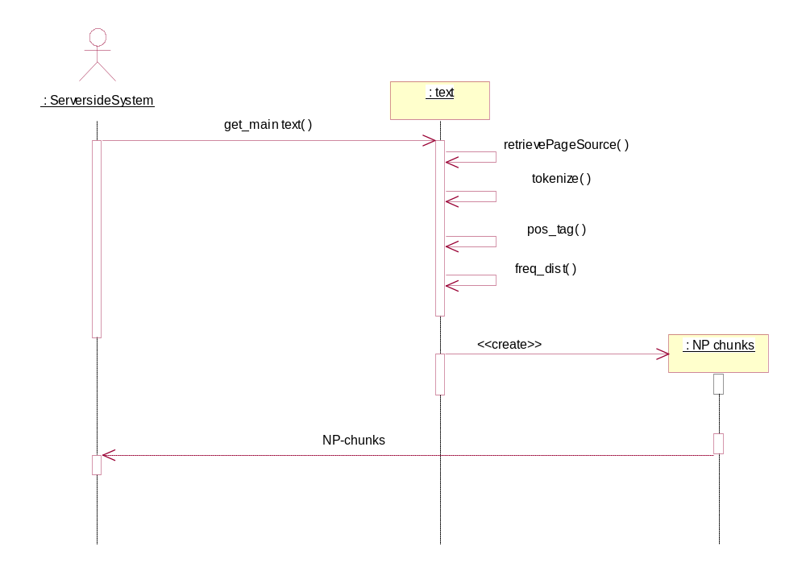
Figure 30
- Processing narrative(PSPEC) for component Keyword Extraction:
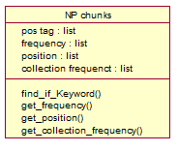Figure 31 Class for Keyword Extraction
Tokens from Web Scraping component are then processed on the basis of results of NLP operations which are POS_tag, freq_distribution, position, collection frequency etc. Only NP-chunks are considered for consideration of keywords. Those NP-chunks which has values for freq_distr, collection_freq etc greater than some threshold are considered as keywords.

Interaction Diagram:
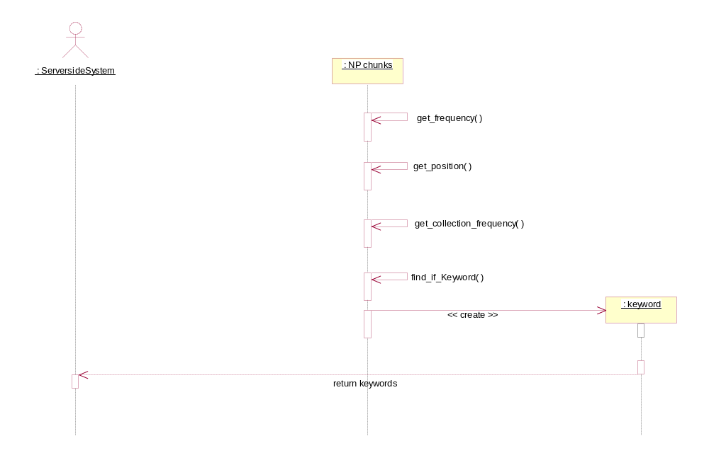 Figure 32

- Processing narrative(PSPEC) for component Domain Categorization:
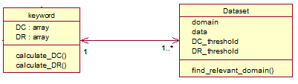
Figure 33 . Classes for domain Categorization
Keywords are categorized into predefined domains. For this DC(domain consensus) and DR(domain relevance) with each domain is calculated. If for a particular domain it is greater than DC_threshold and DR_threshold then that keyword belongs to this domain.
Interaction Diagram:
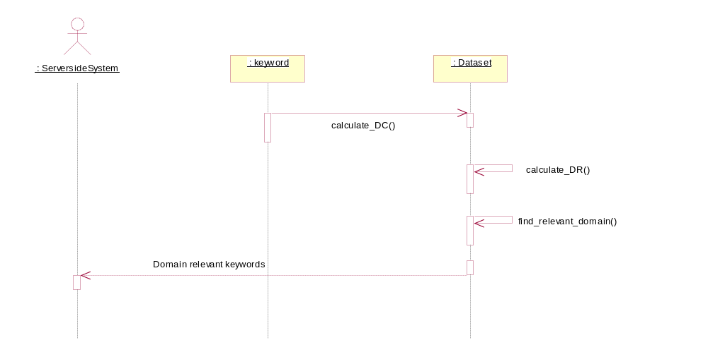
Figure 34
- Processing narrative(PSPEC) for component Context Mining:
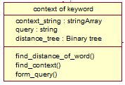Figure 35 Class for Context Mining
To get the most relevant results, usage of keyword in the document is considered while searching on web. Hence context is mined by processing the text. Keyword may have more than one contexts. Search query consisting of context and keyword is used to search on web
Interaction Diagram:
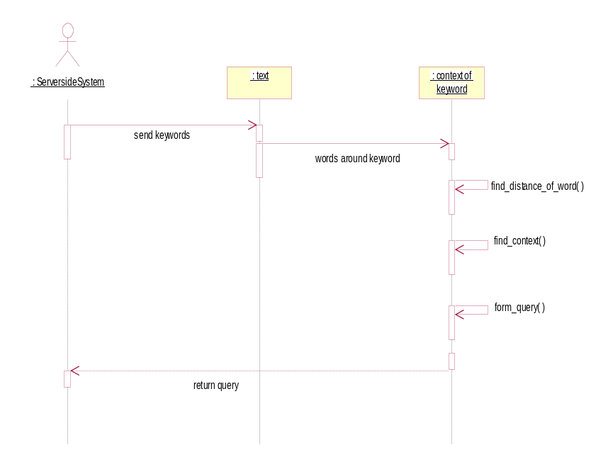
Figure 36
- Processing narrative(PSPEC) for component Search Engine:
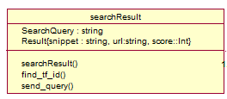Figure 37 Class SearchResult
Once the search query is formed, it is then given to search engine. Also search is performed on social networking sites such as Twitter and Facebook. For each search results , tf-idf weight is calculated.

Interaction Diagram:
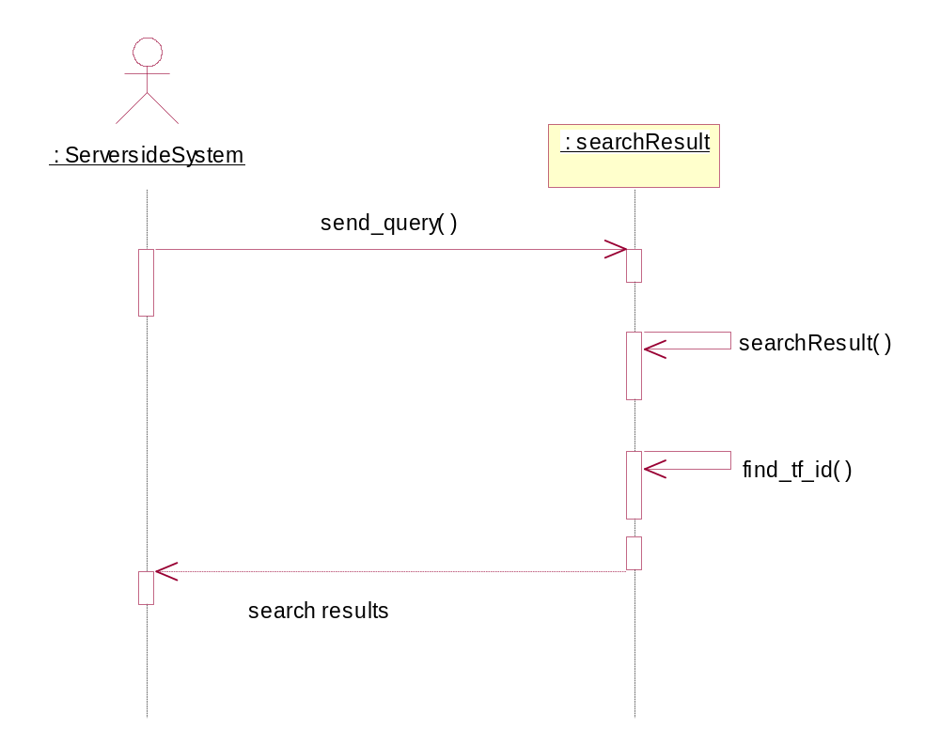
Figure 38
- Processing narrative(PSPEC) for component Rank Search Result:
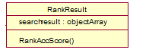Figure 39 Class Rank Result
After finding tf-idf weight of all search results, sorting of search results is done according to that score, so that user can see most relevant results at the top of list

Interaction Diagram:

Fi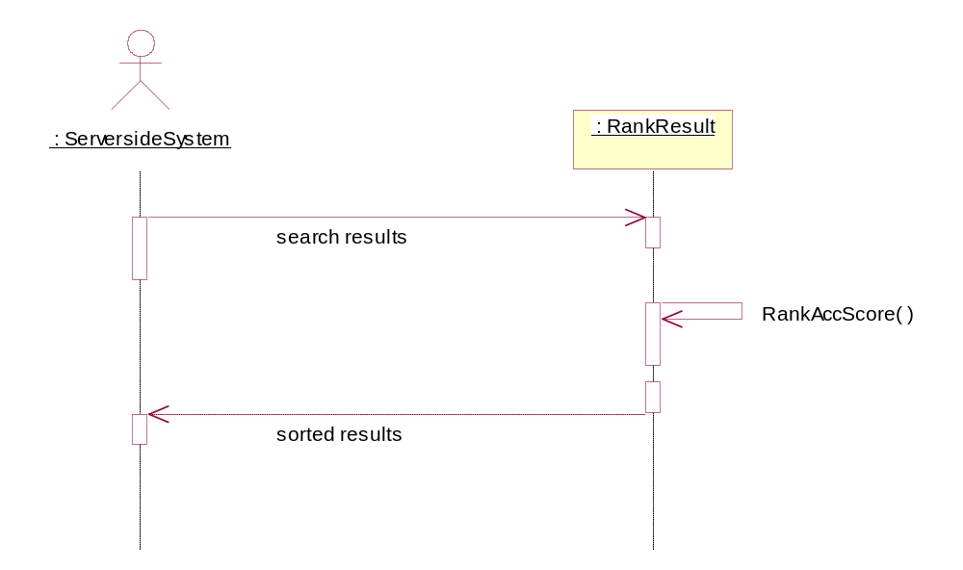
Figure 40
- Processing narrative(PSPEC) for component View Result:
Server side system sends search results to client web application and results are displayed to the user on same web page, thus reducing browsing efforts.
Interaction Diagram: Figure 41
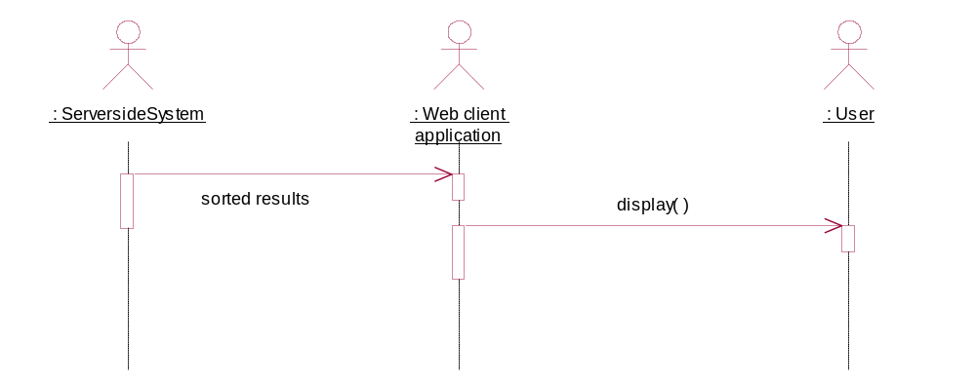
7.4.3 Software Interface Description
External machine interfaces
The project requires web server as external machine and HTTP protocol as interface. Client-server interaction occurs via HTTP request and response.
Human interface
This project requires web browser as human interface. User communicates with the applications via web browser. It provides facilities like clicking on search results , opening URL in different tab etc.
7.5 User interface design
7.5.1 Description of the user interface
User interface consists of web browser . Results are displayed on same web page in bottom side of page as web page pop-ups. Different types of results like images, news , video are grouped in different section of toolbar. Each enrty in the pop-up shows short text about that web page, URL and heading of the result.
7.5.2 Interface design rules
1. Enable users to use short-cuts
2. Enable user to customize interface
3. Enable user to sign into social networking sites
7.5.3 Components available
jquery
7.6 Restrictions, limitations, and constraints
Special design issues which impact the design or implementation of the software are noted here.
- A keyword may not belong to any domain, so it gets discarded
- Restricted only to pre-defined domains
- Each WEB page may have different scripting language. So for scraping the web page, generalized method cannot be used.

CHAPTER 8
TEST SPECIFICATION

8.0 Introduction
8.1 Goals and objectives
We have developed a chrome extension, named as RIFU, for relevant information retrieval based on keywords extraction and context based search. It automates the process of finding related content about the current web page user is reading. It provides user with the relevant content about the current web page on same page itself so that user can have access to related content without shifting to another tab. Thus it reduces user’s browsing efforts and does not deviate user from main web page.
Testing process for RIFU has number of goals. Software will be thoroughly tested for logical errors and coding bugs. In addition to this , RIFU is tested to ensure that results are accurate and quality is good. It is expected to exhibit following behavior: bug free execution, high production values, relevant information retrieval of most of the web pages, easy to use user interface etc.
8.2 Statement of scope
RIFU will be tested on a number of levels, beginning with unit testing
(using white box testing methods), integration testing (using black box testing methods),validation testing, and ending with high order system testing.
A number of design principles will be validated during the testing process. The interface should be easy to use. Data should read and write flawlessly from the database. Server and client should communicate flawlessly. Functionalities of scraping, keyword extraction, categorization, and context should work properly all the exception handling

8.3 Major constraints
Testing will occur only on systems with Ubuntu 10.10 with python 2.6 and Google-chrome browser.

8.2.0 Test Plan
This section describes the overall testing strategy and the project management issues that are required to properly execute effective tests.
8.2.1 Software (SCIís) to be tested
1. Scrapping of Web page
2. Keyword Extraction
3. Categorization of the Keywords into respective domains
4. Finding the context of the Keywords

8.2.2 Testing strategy
The overall strategy for software testing is described.
8.2.2.1 Unit testing
The following units are tested individually:
1. Scrapping of Web page
2. Keyword Extraction
3. Categorization of the Keywords into respective domains
4. Finding the context of the Keywords

8.2.2.2 Integration testing
All the modules tested in unit testing are integrated and the resulting software is tested. The input to this software is the url of the webpage while the output is the search results for each keyword based on its category and context.
8.2.2.3 Validation testing
Input validation: The input URL given to our software application should contain a considerable amount of text. If the text on a webpage is retrieved from database on the respective server of the websites then such content will not be considered for input.
eg.http://www.facebook.com,
http://www.gmail.com

8.2.2.4 GUI Testing
Following tests will performed on the GUI
- The extension is persistent on the required web pages without distorting them.
- The multiple client handling feature was tested by executing the application from various web pages on different tabs.
- Functioning of Next and previous buttons
- The videos from youtube are displayed in the popup and can be played there.
8.2.2.5 High-order testing
High order testing is performed on the complete integrated system. The software will be stress tested and performance
tested.
Also beta testing will be performed
8.2.3 Testing resources and staffing
Resources
No special resources are required beyond those already needed for development.
Staffing
Test Team Leader – Aishwarya Bhide
Unit Testing Coordinator – Prajakta Naik
Integration Testing Coordinator – Mandar Haldekar
System Testing Coordinator – Jayesh Pawar

8.2.4 Test work products
Graphs were drawn for showing the accuracy of keyword extraction and the precision in relevance of search results for various web pages.
8.2.5 Test record keeping
A test log is kept to monitor the tests that have been applied. Test files are maintained to store input and output for each test cases. Final results are stored in form of Microsoft Excel sheet and graph is plotted based on those results using Microsoft Word-2007
8.2.6 Testing tools and environment
Python 2.6 , Flask web Framework and Google Chorme browser are used as testing environment. Test data files will be constructed for unit and integration testing. There are no other special tools or hardware.
8.2.7 Test schedule
Unit Testing:
- Web Page Scraping : 22nd Jan 2012
- Keyword Extraction : 26th Jan 2012
- Categorisation: 20th Feb 2012
- Context of Keywords: 27th Feb 2012
Integration Testing: 1st March to 5th March

8.3.0 Test Procedure
8.3.1 Software (SCIís) to be tested
1. Scrapping of Web page
2. Keyword Extraction
3. Categorization of the Keywords into respective domains
4. Finding the context of the Keywords
8.3.2 Testing procedure

8.3.2.1 Unit test cases
1. Testing Procedure for Web Page Scraping: A Web page is tested for web page scraping
Stubs and/or drivers:
Alchemy API and Keyword keyword extraction module
Test cases component:
URL of web page is sent to server side.
Purpose of tests for component
Purpose of this testing is to ensure that scraping module accurately scrapes Text content from HTML DOM of web page
Expected results for component
Main the text content with adds and comments discarded

2.Testing Procedure for Keyword : Keywords are extracted from main text content
Stubs and/or drivers:
Scraping and Context Module
Test cases component:
Input for this test case consists of text of the web page. Consider UTR is http://www.helium.com/items/1441144-dartagnan-milady-de-winter
Purpose of tests for component”
Purpose of this testing is to ensure keywords are extracted accurately
Expected results for component
All relevant keywords as per the content described in web page
For above URL:
['three musketeers', 'alexendre dumas', 'felton', 'milady', 'gascony', 'paris', 'athos', 'porthos', 'aramis' 'france', 'la rochelle', 'england', 'cardinal richelieu', 'rochefort', D'artagnan']

3. Testing Procedure for Categorization of keywords: Categorization module is tested for set of keywords
Stubs and/or drivers:
MongoDB queries and Google custom search
Test cases component:
keywords are categorized in predefined domains
Keywords = [three musketers, France,]
Purpose of tests for component
Purpose of this testing is to ensure that each keywords is put in correct domain so that domain categorization will result in improving relevance of the information
Expected results for component
Category of each keywords is found correctly
Domains :
Three Musketers : {film , books}
Paris :{Place}
4. Testing Procedure for Context of Keyword: A Web page is tested for web page scraping
Stubs and/or drivers:
MongoDB queries and Search Module
Test cases component
A keywords and its all occurences in document are tested to find context for that keyword.
Eg. Keyword = Viday Bagachi
Nearby Nouns: Vidya, Kolkata, Parambrata, Bida

Purpose of tests for component”
Purpose of this testing is to ensure context of keywords is found accurately and so search query can be constructed accordingly to improve relevance of information
Expected results for component
Nearby words with higher document frequency should be considered as context
Eg. Conext for Vidya Bagachi= {Vidya, Parambrata}
8.3.2.2 Integration testing
8.3.2.2.1 Testing procedure for integration
The system will be integrated incrementally, to control the amount of bugs that need to be fixed at any given time. System is integrated in the following order: scrape, keywords , search , categorization, context finding
The system will be tested for errors in a black box fashion, after each component is integrated

8.3.2.2.2 Stubs and drivers required
python decorator , XHR(asynchronous request)
8.3.2.2.3 Test cases and their purpose
Test case consists of web page URL as input and test is performed to ensure that all the units perform accurately together.
8.3.2.2.4 Expected results
The system is expected to integrate without major flaws and provide required functionality accurately.
8.3.2.3 Validation testing

8.3.2.3.1 Testing procedure for validation
The features and functionality in the final system will be cross-referenced with the Software Requirements Specification document to verify that the software demonstrates conformity with the requirements.

8.3.2.3.3 Expected results
The software will perform within the specifications of the Software Requirements document.

8.3.2.3.4 Pass/fail criterion for all validation tests
Features corresponding to the design document requirements do not need to coincide verbatim with the requirements. Instead, it is important that they retain the spirit of the requirements.

8.3.2.4 GUI Testing
Testing Procedure for checking persistence of Extension: A Web page is tested for web for checking persistence of extension.
Stubs and/or drivers:
chrome.tab.executeScript
Test cases component:
Clicking on extension icon and shifting to new tab to check whether extension is still there on previous page

Purpose of tests for component
Purpose of this testing is to ensure that extension should remain consistent on current page even if user shifts to new tab
Expected results for component
Extension is still there on web page even if user shifts to new tab

Testing Procedure for Multiple Client handling: Extension is tested to check behavior in case of multiple client request
Stubs and/or drivers: chrome.tab.executeScript
Test cases component:
It consists of two clicks made on extension each one corresponding to a web page
Purpose of tests for component
Purpose of this testing is to ensure that multiple client requests are handled
Expected results for component
Result of each pages should go to content script associated with that page
Testing Procedure for Next and Previous Buttons: Extension is tested to check working of next and previous buttons
Stubs and/or drivers:
chrome.tab.executeScript
Test cases component:
It consists of two clicks made on next and previous buttons

Purpose of tests for component”
Purpose of this testing is to ensure that those buttons are working accurately
Expected results for component
Each button does necessary action when clicked and show “no more keywords” alert when keywords are fully traversed

Testing Procedure for Display of Video in PopUp :
Test is performed to check video in popup
Stubs and/or drivers:
chrome.tab.executeScript,object HTML tab
Test cases component:
It consists of a pop up containing video
Purpose of tests for component”
Purpose of this testing is to ensure that video related to keywords can be seen on popup correctly
Expected results for component
Video should appear on popup and one should be able to play it there only
8.3.2.5 High-order testing (System Testing)
8.3.2.5.1 Recovery testing
No Recovery testing will occur. While system failures are
undesirable, termination of the program in the event of a crash is acceptable.

8.3.2.5.2 Security testing
No Security testing will occur. There are no security issues withRIFU
8.3.2.5.3 Stress testing
Server is given many client requests at a time and how it handles them is analyzed
8.3.2.5.4 Performance testing
Server site is tested by providing URL of page having very large text and time required for execution is measured.
8.3.2.5.5 Alpha/beta testing
Alpha testing will occur in-house.Members of test team will attempt to test complete RIFU application. Beta testing will be semi-public. RIFU will be given to some users to use for sometime and there feedback will be collected
8.3.2.5.6 Pass/fail criterion for all validation tests
Features corresponding to the design document requirements do not need to coincide verbatim with the requirements. Instead, it is important that they retain the spirit of the requirements.

8.3.3 Test work products
Graphs were drawn for showing the accuracy of keyword extraction and the precision in relevance of search results for various web pages.
8.4 Function dependency graph
Figure 42
8.5 Function Scatter diagram
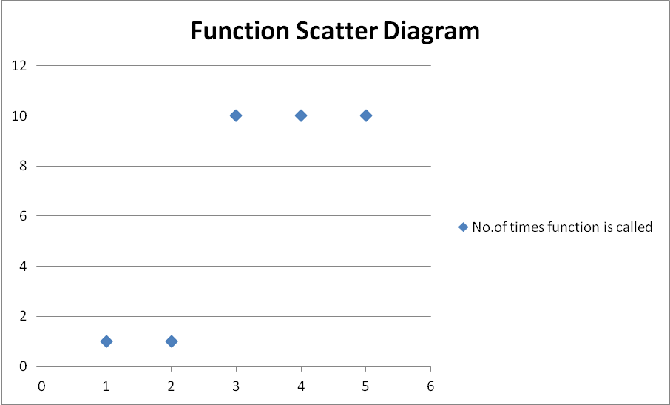
Figure 43
Function number function name
- web scrapping
- keyword extraction
- categorization
- finding context
- search results
- display results on extension
8.6 Input sequence testing
The queueing model used here is MM1 as the interarrival time and processing time for each webpage is independent of other webpages. Also, there is only one server which processes only one webpage at a time. FIFO scheduling is used as requests for web application execution are processed one by one on first come first served basis. A number of requests can be served on the same browser as multiple client support is provided.

CHAPTER 9
FUTURE ENHANCEMENT

FUTURE ENHANCEMENT

- Machine Learning
- Improving Context relevance
- Location based information
- Moving on Android
- Compatible for more languages

CHAPTER 10
SUMMARY AND CONCLUSION

SUMMARY AND CONCLUSION

We conclude that the developed web application provides the user with more relevant information about the current web page through the extraction of keywords and using context based searching. Thus the user reading the web page will be automatically provided with more information relevant to the current page. This information is extracted from different sites and gives the user all relevant information to the particular topic at one place. Thus the web application effectively reduces user’s searching time giving the user exactly what he wants to know about.

CHAPTER 11
ANNEXURE

Annexure A

ASSIGNMENT 1:

Problem statement feasibility assessment using satisfiability analysis and NP Hard, NP Complete or P type using modern algebra:

This problem is decision problem. Decision has be made to select keywords and decide their domain as follows
- Whether particular word is keyword or not
- Does the keyword belong to the predefined domain or not.
- Is the keyword searched by the context to get relevant information or not.

Hence our problem is NP.

Hitting Set problem: Consider set T = { S₁, S₂…S_{m}} as input. Find smallest subset H such that H C T and h_{i} € S_{j} for j= 1 to m i.e Every element in H hit every set collection T.

Our project consists of functions f₁, f₂, f₃, f₄ as follows:

2. | Mapping Functions  f(x) | X | Y
 | f₁(Text,freq.dist,pos_tag,position, collection freq.) → K | Text | K
 | f₂(K,DC,DR)→KD  DC: Domain Consensus  DR: Domain Relevance | K | KD
 | f₄(KD)→ CT | KD | CT
 | f₃(KD,CT)→ SR | KD,CT | SR

We will reduce problem f₁ to hitting set problem .

For function f_{1:}
Input sets : Text,freq.dist,pos_tag,position, collection freq
Output set : K i.e set of keywords

Consider collection T of Si’s such that each Si is mapped to one input set of function f₁

Now prove,
T hitting set of H ↔ f1 has non empty set K

- Hitting set problem → function f1

Suppose H is hitting set of size n.
But in H, h_{i} € Sj for all j= 1 to m,
then each h_{i} can be set to element of set K i.e keyword

- Hitting set problem← function f1

K ={ k₁…k_{n}} i.e set of keywords
As per definition of f₁ , k_{i} € all input sets of f₁ which are Corpus,freq.dist,pos_tag,position, collection freq
So , we can conclude analogy between input sets of f₁ and S_{i} belonging to collection T . Also
Each set K can be mapped to hitting set H.

So we have proved hitting set problem is polynomially reducible to function f _{1.} Since Hitting set problem is NP- complete , function f1 is NP-complete.

Our problem = f1 U f2 U f3 U f4

Therefore , Our problem is NP-complete.

Annexure B

ASSGINMENT 1

System S is defined as collection of following sets:

S ={Text,K,D,KD,SR,CT | ф}

Venn Diagrams:
Text of web page

Keywords
Contexts
Of keywords

Figure 44.1

Figure 44.2

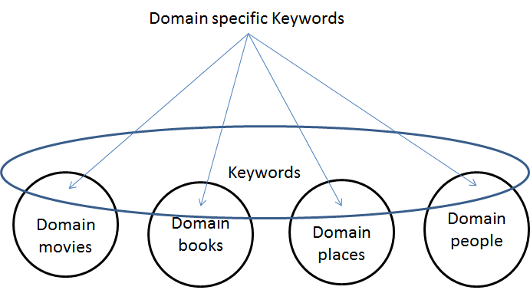

Figure 44.3

Search Results

Context based most relevant search results

Functions and i/o relations :

Mapping Functions  f(x) | X | Y
F₁ (web page) → Text | Web page | Text
F₂(Text,freq.dist,pos_tag,position, collection freq.) → K | Text | Keywords (K)
F₃(K,DC,DR)→KD  DC: Domain Consensus  DR: Domain Relevance | K | KD(Domain relevant keywords)
F₄(KD,Text)→ CT | KD, Text | CT(Context)
F₅(KD,CT)→ SR | KD,CT | SR(Search Results)

Functional relations:

F1:

Webpage1 Text1

Webpage2 Text2
. .
. .
WebpageN TextN

F2:

Text1 Keyword1
Text2 Keyword2
. .
. .
TextN KeywordM

F3:

K1 KD1
K2 KD2
K3 .
. .
. .
. KDm
Kn

F4:

KD1 CT1 Text1
KD2 CT2 Text2
. . .
. CTm-1 .
KDn CTm Textn

F5:

KD1 SR1 CT1
KD2 SR2 CT2
. . .
. . .
KDn SRm CTj

Figure 45. Functional Relations
Objects:

- Web Page : It is the current web page which is input to the program.

- Tagged Tokens : The main text in the web page is tokenized into words and the Part of Speech tags are assigned to each token.

- NP-Chunks : The Noun Phrase Chunks are found out from the tagged tokens.

- Keywords : These are the NP-Chunks that give topics related to the web page. They are classified into predefined domains.

- Queries : The search queries are formed for each domain relevant keyword. The context of the keyword in document is taken into consideration while forming the queries.

- Search Results: These are the results returned by the search engine for the queries. These results are scored according to their relevance with the keywords and the contexts of the keywords. They are then ranked based on these scores and displayed in sorted order.

- User Interface: The user interface is a browser extension which shows the most relevant results to the key features in the web page while the user is on the same page. This reduces the browsing efforts of the user.

Overloading:

- In function F_{3 ,} the keywords, domain consensusand domain relevance are used to find the domain relevant keywords.
These operations are performed for each of the predefined domains. Thus, here overloading is used to perform the same type of operations for different domains.

- Also, the function for calculation of domain consensus (DC) needs to be overloaded for each predefined domain.

- Similarly, the function for calculation of domain relevance (DR) needs to be overloaded for each predefined domain.

- The search function for results obtained should be overloaded to search for the results on web and the results on social networking sites like tweeter.

Morphism:

F1:web page → Text
for any two morphisms u,v: web page → Text, F1 u = F1 v implies that u = v.
So it is monomorphism.

F2:Text → Keywords
for any two morphisms u,v: Text → Keywords, F2 u = F2 v implies that u = v.
So it is monomorphism.

F3:Keywords → KD
for any two morphisms u,v: Keywords → KD, F3 u = F3 v implies that u = v.
So it is monomorphism.

F4:KD → CT
for any two morphisms u,v: KD → CT, F4 u = F4 v does not imply that u = v. So it is homomorphism.
F5:KD,CT → SR

for any two morphisms u,v: KD,CT → SR, F5 u = F5 v does not imply that u = v. So it is homomorphism

ASSIGNMENT 2:
Functional Dependency Graph:

F1 F2 F3

F4

F5

Figure 46

B+ Tree to identify dependencies in System “S”:
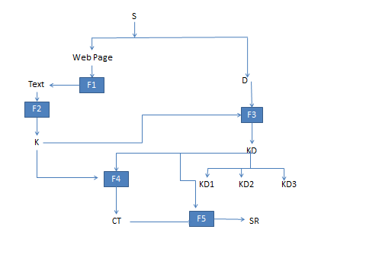
Figure 47
ASSIGNMENT 3:

Testing of problem statement:
System is defined as
S= {text,K,D,KD,SR,CT }
Where,
Text is main text content of web page
D is set of predefined domains
K = set of keywords
KD is set of domain specific keywords
CT is set collection of set of contexts for each kd_{i} ϵ KD
SR is set of search result

Consider a blog about book o
K= {Jeffry Archer, mystery, bestseller, England, The Fourth Estate, London}

For categorization into Domain,
We search in predefined domain specific data sets
Let probability for occurrence of each keyword into domain specific dataset is denoted by P(t|d_{i})

DR(domain relevance) can be calculated as

DR(t,D_{i}) = 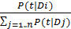

Consider keyword k1 from set K i.e. “Jeffrey Archer”
We have used Maxima tool to evaluate this test data as follows. Values for pobablities are estimated values.

For k_{i} ϵ Dj , DR(k_{i} , Dj ) > DR_threshold
From screen shots results given by Maxima tool,
Keyword “Jeffrey Archer” belongs to movie, people and books category
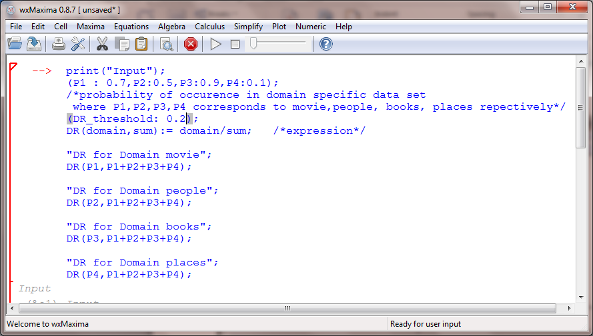

Output:

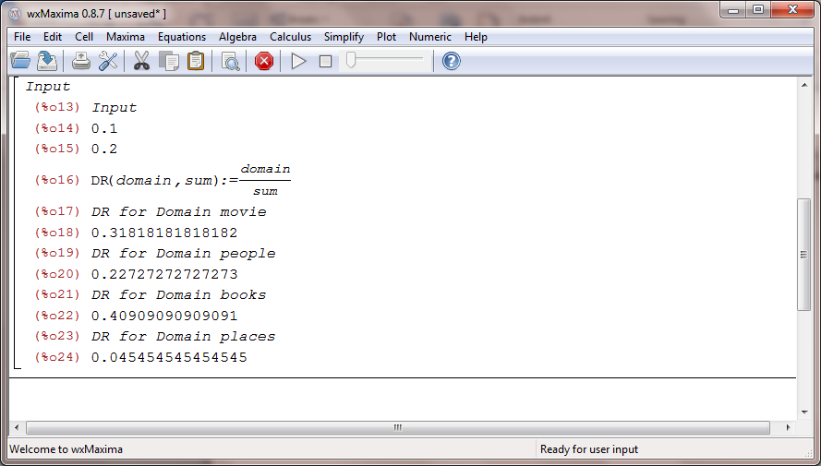

Figure 48. Testing of Problem statement using mathematical tool Maxima

Annexure C
Project Task Set
The different task sets that are critical in the project are as follows: –
Serial No | Task ID | Name Of Task
1 | T-1 | Deciding Boundaries and scope of project
2 | T-2 | Installing NLTK, Flask, Extension
3 | T-3 | Deciding inputs and outputs
4 | T-4 | Learning tools required for the project
5 | T-5 | Design of classes and GUI
6 | T-6 | Preparation of 1st prototype
7 | T-7 | Revision of 1st Prototype
8 | T-8 | Testing
9 | T-9 | Documentation

Table 6 Program Task Set

Task network:
Figure 49

Turn wise plans evaluated by lab teachers
Planners as per turn wise plans
Figure 50
Prajakta Naik

Mandar Haldekar:
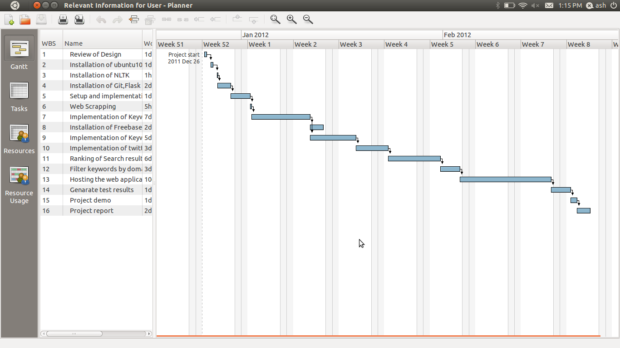

Aishwarya Bhide:
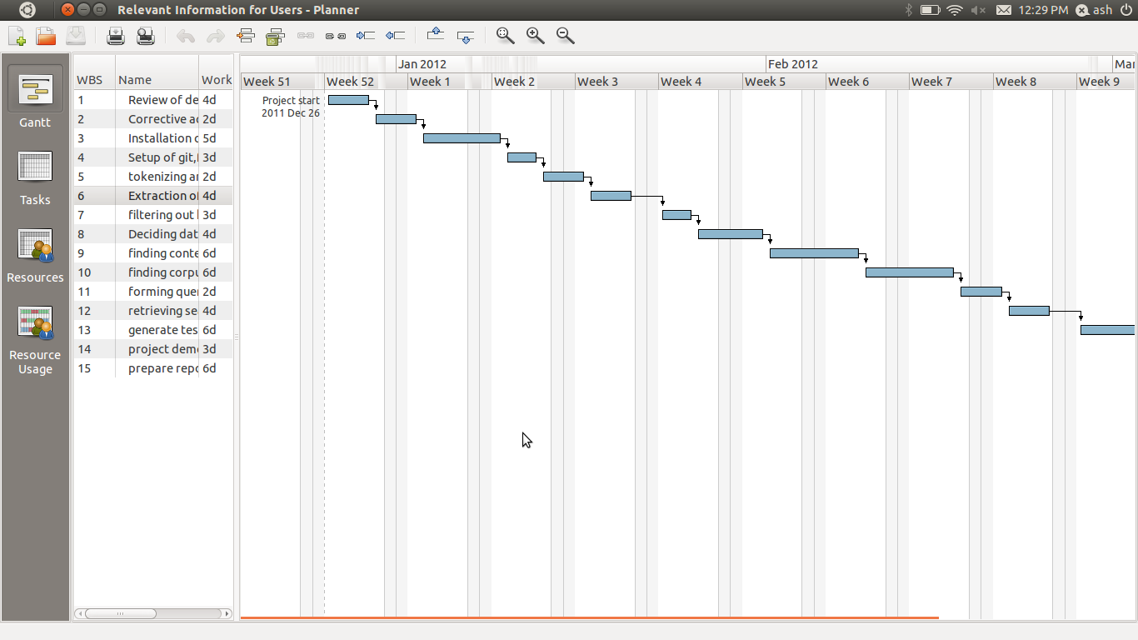

Timeline chart
Figure 51. Timeline chart

Annexure D

REVIEW OF DESIGN:
  - All the UML diagrams are as per algorithms so software is implemented with respect to design document.

  - All the functionalities are provided as per the design documents

BLACK BOX TESTING
In black box testing emphasis is on the behavioral response of the software in reference to the functionality it executes
- Compatibility of application with all browser is tested
- Check whether extracted keywords depicts subject of the topic
- Check whether search results are context-relevant or not

CORRECTIVE ACTIONS:
Ranking of the results is done implicitly by BING API so no explicit ranking mechanism is needed. Rest all other functionalities are given as per the design, no significant corrective actions are required.

ANNEXURE E

Workstation Selection Report
The workstations were selected according to the software and hardware requirements of the project as follows:

Hardware:
4 Dell laptops
Internet connection

Platform: Ubuntu 10.10

Installation and Setup:
Softwares installed:
Ubuntu 10.10
Python 2.6
Flask 0.8
Mongodb 2.0
Pymongo 2.1
Natural Language Toolkit
Bingapi 0.02
Freebase API
Gdata
Jquery

Tools used:
GNU Emacs23 Editor
Git version Control System

ANNEXURE F

Module Development Plan
Backend modules:
Sr no | Module Name | Description | Completion Date
1 | Web page scraping | To obtain the text content of the webpage by removing the ads,images and videos | 1/1/2012
2. | Keyword Extraction | Tokenise the web page,tag them to extract the keywords | 23/1/2012
3. | Categorisation | Classify the keywords in different categories by finding the document frequency | 30/1/2012
4. | Finding the context of Keywords | To Improve the relevance find the context of the keywords | 17/2/2012
5. | Ranking of the results | Ranking the results by relevance | 25/2/2012

Frontend modules:
Sr no. | Module Name | Description | Completion Date
1. | Extension on Web page | Creating the Extension for google chrome | 23/1/2012
2. | Fetching Url of the current webpage | Sending the XHR request to fetch url and send to server | 27/1/2012
3. | Displaying the Keywords | To show the keywords to the user | 5/2/2012
4. | Creating the popup for displaying results | Popups when clicked on the keywords to show results | 20/2/2012
5. | Showing Videos | Videos of that keywords on the popups | 24/2/2012
6. | Adding css and styling the extension |  | 30/2/2012

Hosting Module:
Our Web Application is hosted using the Heroku Hosting Service.
Sr no | Module Name` | Description | Completion Date
1. | Registering with Heroku and install dependancies | In order to use herroku register and install the dependancies | 5/3/2012
2. | Hosting on Heroku |  | 20/3/2012

Module Description
Figure 52. Architecture Diagram

Module Description:
Web scraping:
When user is reading a web page, client web application sends HTTP request containing URL of the page to server side system. User is mostly interested in main text content. Server side system fetches page source code at that URL. It parses the web page, removes unnecessary comments and advertisements and retrieves main text content of web page.
Keyword Extraction:
Web page text is parsed into tokens and various Natural language processing operations are applied to it. Tokens are sorted by part of speech tags. Out of those only nouns are considered. Frequency distribution, position, collection frequency are determined for these NP-chunks. Various criteria are applied to decide whether particular NP-chunk is keyword or not.
Domain Categorization:
Keywords are then categorized into pre-defined domains. Domain specific datasets are used for categorization.
Context-Mining:
Usage of keywords in the text is considered to find their context. For each keyword one or more contexts are mined. For finding context entire text of web page is examined.
Search on Web:
To get most relevant results, while firing query to search engine, contexts are also considered. Augmented search queries consisting of context and keywords are formed and given to search engine. Also search is performed on social networking sites like Twitter.
Rank the search results:
After getting search results of all query, they are ranked according to relevance with each keyword. Final results are then displayed to user.

ANNEXURE G

Unit Testing:
- Web Page Scraping : 22nd Jan 2012
- Keyword Extraction : 26th Jan 2012
- Categorisation: 20th Feb 2012
- Context of Keywords: 27th Feb 2012
Integration Testing: 1st March to 5th March

Testing :

- Module: Scraping 22nd Jan
Test Case
Input Url: http://www.helium.com/items/1441144-dartagnan-milady-de-winter
Result
The classic adventure novel, The Three Musketeers was written by Alexendre Dumas (1802 1870) and was first published in 1844. The first of three D'Artagnan romance novels, it is a story about international intrigue, assassination and political struggles in 17th century France. This is an intricate story with many plot twists and surprises. The story has many complex and interesting personalities. Among the main characters are:D'Artagnan is a young and dashing nobleman from Gascony who dreams of joining the esteemed musketeers, a force of French royal family bodyguards.

Porthos, Athos and Aramis are three musketeers who befriend D'Artagnan. They share a series of adventures.

Cardinal Richelieu is the main political rival of the King of France. It is said that he has as much power as the King.Milady de Winter is a scheming and evil seductress who was the former wife of the musketeer, Athos. She makes several attempts to kill D'Artagnan. As a teenager, she was former nun who seduced a priest and stole valuables from the church.

Felton is an English official who is seduced by Milady. He commits murder and other crimes at her request.

Rochefort is the other major antagonist of the story. He is a member of the Cardinal's body guards and an ally of Milady.

Constance is the love interest of D'Artagnan.

The story begins with D'Artagnan traveling from his home in Gascony to Paris, the headquarters of the musketeers. D'Artagnan carries a letter of recommendation addressed to captain of the musketeers. During his journey he is attacked by mysterious thieves. His money and recommendation letter are stolen and D'Artagnan is injured. He needs a period of time to recuperate before resuming his journey. He eventually arrives in Paris and meets the musketeers. Unfortunately, without his letter of recommendation the initial meeting goes poorly and D'Artagnan challenges three musketeers to a duel. The musketeers are Athos, Porthos and Aramis. As the duel begins, six of the Cardinal's guards arrive and attempt to arrest the four adversaries. The outnumbered musketeers immediately join forces with D'Artagnan and defeat the Cardinal's guards.

D'Artagnan becomes friends with his previous foes and a series of adventures follow. They recover stolen jewels that belong to the Queen of France, participate in the siege of the town of La Rochelle and engage in espionage in England, among other dangers. An arrest warrant (on false charges) is place on D'Artagnan and several attempts are made on his life. Eventually, the young D'Artagnan is brought before Cardinal Richelieu, who was impressed by his courage and integrity. The Cardinal clears D'Artagnan of all charges and instructs Rochefort to befriend the young musketeer.

The Three Musketeers is one of AlexandreDumas'earliest works and is widely considered to be his best. Although the plot is intricate and complicated, the story is extremely popular with young people. It was originally written in French, but it translates very well into English. The story has been made into several movies, a TV series, miniseries and even a cartoon. This work was followed in the D'Artagnan trilogy by "Twenty Years After in 1845" and by "The Vicomte of Bragelonne: Ten Years Later in 1850". These sequels depict the further adventures of the four friends.

This work is highly recommended for fans of literature. It is also an excellent way to introduce young people to the joys of reading the classics.

2. Module: Keywords 26th Jan
Test Case
Url: http://ezinearticles.com/?A-Beautiful-Mind-%28Movie-Review%29&id=155993

Result: KEYWORDS:
[u'nash', u'beautiful mind', u'russellcrowe', u'nobel prize', u'johnnash', u'jenniferconnelly', u'gladiator', u'la confidential', u'suffering', u'aliciajenniferconnelly', u'johnnashrussellcrowe', u'game theory " beautiful mind', u'andygriffith show', u'ronhowardopie', u'best picture', u'academy awards', u'nominated']

- Module: Categorization 20th Feb
Test Case
KEYWORDS:
[u'nash', u'beautiful mind', u'russellcrowe',u'nobel prize', u'johnnash', u'jenniferconnelly', u'gladiator', u'la confidential', u'suffering', u'aliciajenniferconnelly', u'johnnashrussellcrowe', u'game theory " beautiful mind', u'andygriffith show', u'ronhowardopie', u'best picture', u'academy awards', u'nominated']

Output :

Film :nash, beautiful mind, Russell crowe ,john nash, Jennifer Connelly , gladiator, la confedential, ronhoward, Academy Awards

Book :nash, John Nash, beautiful Mind

People: ronhoward, john nash.

- Search Result: 27th Feb
Test Case
input :
keywords::27
[u'holmes', u'watson', u'blackwood', u'ritchie', u'adler', u'strong', u'inspectorlestrade', u'eddiemarsan', u'hanszimmer', u'downeyjr', u'dipping', u'ireneadlerrachelmcadams', u'meanwhile', u'lord blackwood mark strong', u'months', u'marykellyreilly', u'baker street', u'watson law', u'holmesdowneyjr )', u'english', u'american', u'jude law', u'guy ritchie', u'victorianlondon', u'caribbean', u'sherlockholmes', u'robertdowneyjr']

OUTPUT:
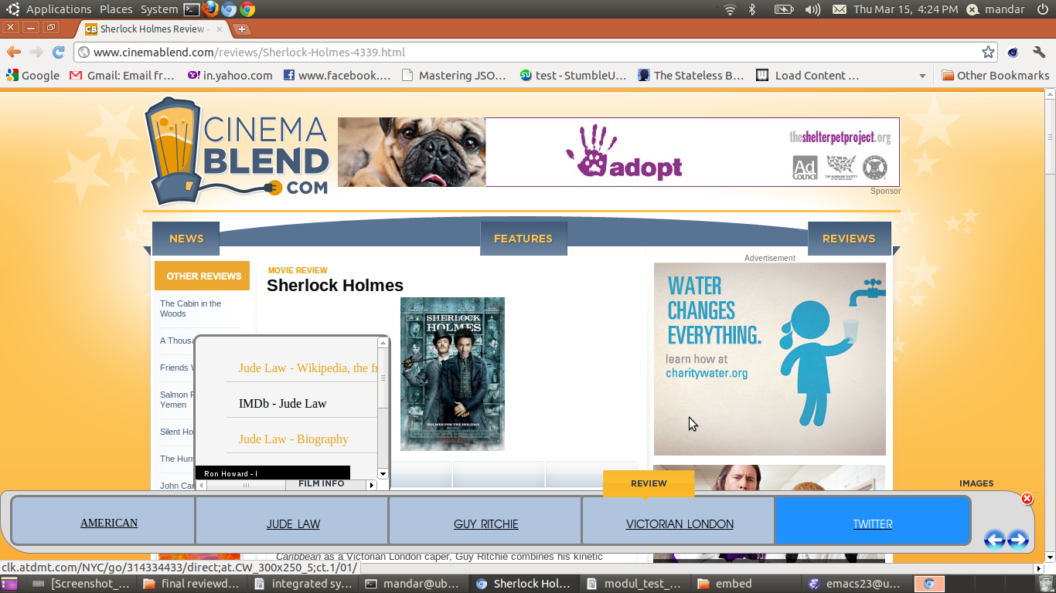

ANNEXURE H

Information Retrieval Approach Based on Terminology Extraction and Context Based Search Applied to WEB Pages

AishwaryaBhide, PrajaktaNaik, MandarHaldekar and JayeshPawar
aishwaryasbhide@gmail.com,nkprajakta@gmail.com, mandar.haldekar@gmail.com,jayeshrpawar@gmail.com
Computer Dept., Pune Institute of Computer Technology, Pune-411043,India
University of Pune, India

Abstract- While reading a web page, the user is often interested in more information about some key ideas on the web page which give the description of the document. This paper presents an idea of a web application which gives the user information related to such key ideas. The application extracts keywords from the page using Natural Language Processing operations. The keywords are then categorized into predefined domains such as books, movies, places and people. This categorization is used to fetch information from sites which are more relevant to that domain. The context of the keywords is taken from the page which is used to obtain better and more relevant search results. Social and location based information relevant to the web page content is fetched by leveraging social networks like Twitter and Facebook. The results will be displayed on a browser extension on the same web page. The user can effectively get more information about the keyideas he is interested in on the same page without actually searching for them. This paper provides an approach that will improve the searching mechanism thus reducing user's browsing efforts.
Keywords: Natural Language Processing, Context-based search, Terminology extraction, Information Retrieval

- INTRODUCTION
With the huge and rapidly increasing amount of information available on the web, extracting relevant information retrieval is a challenging issue. When the users are reading a web document, very often they are interested in reading more about that subject and certain keywords related to that subject. The user normally submits a query to the search engine to find the information of his interest. The results may or may not be relevant to the current subject they are reading. This will consume extra search time to extract the relevant information he wants. Also if the topic of user’s interest contains images, videos and other information, the user needs to search different sites and read the contents. For example, consider the word “buffalo” that has come on different pages like “Wild Life Animals”, “Buffalo University”, “Buffalo Awards”. While reading any of these pages the user expects to get the relevant information about buffalo based on the context it is present in on every page. Thus the user expects relevant information on the context of the word,“buffalo” used each time.
When a user is reading about a book, he is interested in knowing more about the book, its author, characters etc. Our proposal seeks to provide all such related information to the user on the same page without disturbing the current document the user is reading.
This approach provides the user with the information related to the current page through domain based extraction of keywords. Keywords are retrieved by natural language processing. Later they are classified under predefined domains. Context of each keyword is obtained by mining the web page. Finally the query based on the context is submitted to the search engine to get all relevant information like related news, images, videos, tweets about that subject. Context based searching provides results according to the usage of the keyword in current document eliminating results of other possible contexts. This provides the user with useful information and reduces his efforts of searching frequently on various sites.
The paper is organized as follows: Section 2 describes the terminology used, Section 3 gives the overview of our approach, section 4 presents result of this proposal when applied on web pages and section 5 concludes the paper.

- TERMINOLOGIES USED
Terminology extraction refers to the automatic extraction of keywords from a document. Natural Language Processing is used for this purpose. NP-chunks, POS tags and frequency distribution of words are obtained using NLP.

- Frequency Distribution:
The frequency distribution gives number of times particular word has occurred in the corpus.

- NP-Chunks:
The keywords of a document are mostly proper nouns. The NP(noun phrase) chunks which form proper nouns are source of useful information about the document.

- Part-of-speech(POS) Tag:
Part of Speech tagging is process of assigning part of speech to the words of corpus(text). It classifies corpus into noun, adjectives, verbs etc. and avails processing of text.

- Collection frequency:
It is the frequency of a word in the documents belonging to the same domain. Such collection of documents is stored for each predefined domain.

- Position of the first occurrence of the word:
Generally, the key ideas are introduced in the initial part of the document. So we can find out the words that can most likely be keywords using their position in the text.

- Context of keywords:
In English language, many words can be used in multiple distinct ways. A word can be a common noun, the name of a movie or a book, a proper noun etc. e.g. Emma can be a girl’s name or it can refer to the famous novel by Jane Austen. The keywords are used in a specific sense in a document. This usage gives the context of the keyword as specific to the document.

- SYSTEM OVERVIEW
System for this proposal is given as,
S ={Text,K,D,KD,SR,CT | ф}
Where,
Text is the main text content of current web page,
K is set of keywords,
D is set of domains given as:
D={books,places,people,movies}
KD is set of domain related keywords
CT is collection of sets CT_{i} which are set of context for each kd_{i}ϵ KD
SR is set of search results

In this approach we will derive this system from the web page that user is reading. User is interested in main text content given in that document. Relevant information retrieval is done in following steps as shown in figure 1:

  - Extraction of Keywords
  - Categorizing keywords into domains
  - Obtaining contexts of extracted keywords and performing web search using both keyword and context.
  - Extraction of the location based and social information from social networking sites.
  - Ranking Search Results

- Extraction of keywords
Keywords give overall idea of the document. So finding accurate keywords is very crucial. Web page scraping is done to process source code of page.Advertisements and comments on the page are discarded, while only main text content is retrieved and processed using NLP for keyword extraction. First text content in web page is tokenized into words. All words are assigned POS tags. Since proper nouns contain maximum information, NP-chunks are obtained which give chunks that contain successive words that are proper nouns. Frequency distribution is applied to all NP-chunks. Document frequencies of all NP-Chunks together with the nouns in title of the page are found out to measure the priority of that NP-Chunk as keyword.Also, position of first occurrence of each NP-chunk is obtained. Based on these factors, NP-chunks which can be keywords are found out.

- Categorizing Keywords into Pre-defined Domains:
Keywords extracted are filtered according to domains given by set D. Categorization of keywords into domains is done finding domain relevance (DR) and domain consensus (DC) [1] on predefined domain specific dataset. We have made use of Freebase [10] to form domain specific dataset. Freebase is online collection of structured data harvested from many sources. It has separate schema for films, books, locations and people. We shortlisted significant fields related to each domain and stored their values in domain specific collection of MongoDB database. Then number of occurrences of all keywords is found in all domain specific collections. Based on these frequencies of occurrences, Domain Relevance and Domain Consensus can be calculated as follows:
- Domain Relevance:It is measure of the degree of relevance of that term t to a specific domain D_{i}. DR is calculated as follows:

DR(t,D_{i}) =

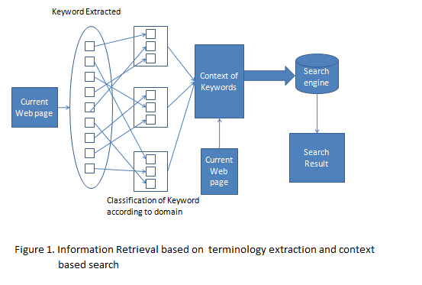

Where P(t|D_{i}) is conditional probability of that term t being relevant to particular domain D_{i} . It is calculated as ratio of the frequency of that term t in domain D_{i} with total of its frequency in all domains of set D.To determine domain to which a keyword belongs, we find threshold in case of every keyword. Threshold is average of DR scores of keyword with respect to all domains. A keyword having DRi score greater than threshold belongs to domain Di .

- Domain Consensus:It gives the measurement of distribution of term t in domain D_{i}.Distribution of t in a

domain can be taken as random variable estimated throughout the corpus of that domain.
Once category of a keyword is identified, it is searched in some popular sites for that domain. E.g. if a keyword belongs to book domain, then search is performed on Amazon, Wikipedia etc. because this is what most people would want to know when they are reading about particular book.

- Obtaining contexts of extracted keywords
Information Retrieval using only keywords returns large set of results, many of which may not be relevant to the current web document. In our proposal, context of the keywords are found based on document title, tags and usage of those keywords in documents. We consider the neighboring words of the keyword each time the keyword occurs in the text. These words are processed using algorithm given asbelow. In this we find corpus relevance (CR) of a keyword and its significant neighboring words.Corpus relevance is measure of mutual information between two words. It uses co-occurrence information of two words in corpus to find this information.
Algorithm GetContext (Keyword,Text)
//Keyword is an array containing keywords and Text is main text content of web page
//Context[][] is 2-D array for storing context of each keyword. //DF(i) is no. of documents from
dataset in which word i occurs i.e document frequency
//DF(w1,w2) is document frequency of co-occurrence of w1 and w2
{
For each element k_{i} of set Keyword do
Get neighboring words of k_{i}for each occurence
Remove the stopwords from neighboring words

For each neighboring word w_{m}
Find co-relevance of w_{m} with k_{i} using formula
CR(w_{m}, k_{i}) = DF(w_{m} , k_{i}) /(DF(w_{m})+DF(k_{i})-DF(w_{m},k_{i}))

If ( CR(w_{m},k_{i}) < threshold)
Discard w_{m}
Else
Add it to Context[k_{i}]
End if
End for

End for

}
These contexts of keywords are considered while performing search on web. Augmented queries consisting of keywords and their contexts are formed and passed to search engine. It gives more relevant and comparatively precise results than normal keyword-based searching.

DExtraction of social and location based information from social networking sites
Search results are enriched by retrieving related information about user’s friends on Facebook and followees from Twitter.e.g. When a person is reading about a book, he would like to have information whether any of their friends or followees have read or commented on that book.The information about the contents of the web page with respect to the user’s location is also found out e.g. If the user is reading a movie review, he might like to know about the movie theaters where that movie is currently playing.

E Ranking the Search Results

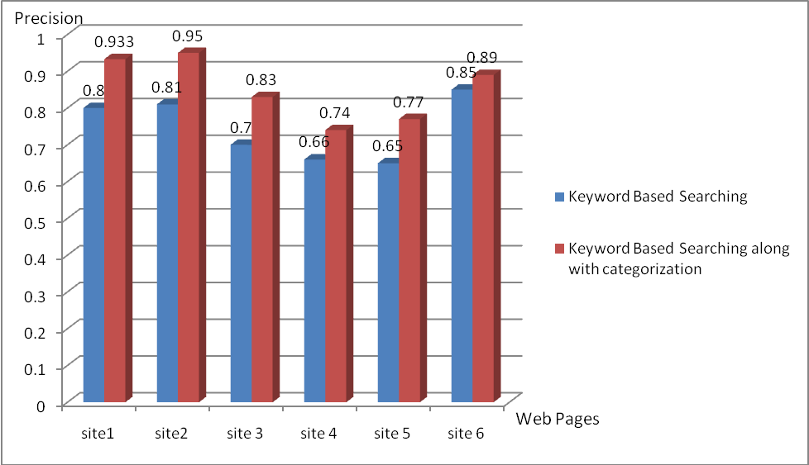

Figure 2. Improvement In Precision Using Categorization and Context Based Search

With each search query, many results are returned by the search engine. These are re-ranked according to the relevance of search query. To rank the results,tf-idf(term frequency -inverse document frequency) ranking method is used. Keyword plus its context are considered against corresponding search results. For each search query i.e.(keyword-context) , tf-idf weight is obtained. Results are sorted in decreasing order of tf-idf weights. In this way user can see most relevant results at the top of the search-result list.

- RESULTS
This proposal has been tested on web sites giving information about movies, books, location and people. We compared information retrieval using keywords based approach with our approach i.e. using categorization and context based search. We calculated precision for both approaches. Results obtained are shown by graph in figure 2. Web-sites for which these results were obtained are as follows:

- http://www.helium.com/items/1441144-dartagnan-milady-de-winter
- http://www.buzzle.com/articles/effects-of-water-pollution.html
- http://in.movies.yahoo.com/blogs/movie-reviews/y-meta-review-agneepath-094945066.html
- http://www.cinemablend.com/reviews/Sherlock-Holmes-4339.html
- http://www.guardian.co.uk/film/2011/jul/07/harry-potter-deathly-hallows-part-2-review
- Site 6: http://ezinearticles.com/?A-Beautiful-Mind-%28Movie-Review%29&id=155993

Graph shows that categorization and context-based search improves the relevance of information than normal keyword basedsearching. Based on this algorithm, we have developed Chrome extension in python that presents user with search results obtained.

- CONCLUSION
This proposal presents an approach for retrieving relevant content about current web page using domain-based terminology extraction and context-based searching.Augmented search queries which include context of the automatically extracted keywords are used for searching. Therefore search results are more satisfactory.This caters to the need of web users by automatically finding related useful information about web page.

REFERENCES

- Li Liu , Quan Qi,” Combined method for automatic domain-specific Terminology Extraction”, Eight International conference on Fuzzy System and knowledge Discovery(FSDK)
- AnetteHulth, “Improved Automatic Keyword Extraction given more linguistic knowledge ”
- Alexander Patry, Philippe Langlais ,”Corpus Based Terminology Extraction” 7th international conference of Terminology and knowledge Engineering, Copenhegan, Denmark, 2005, pp 313-321
- Bhowmik, R. Sam, Huoston State Univesity, “Keyword Extraction from abstract and title”, Southeaston, 2008 IEEE.
- M. Brunzel and M spilopoulou, “Domain relevance on term weighting” Natural Language Processing and Information, pp 437-432, 2007
- Hongyan Jing, EvelyneTzoukermann, “Information Retrieval Based on Context Distance and Morphology”, 22nd annual international ACM SIGIR conference on Research and development in information retrieval ,1999
- Salton, G., & McGill, M., Introduction to Modern Information Retrieval.,McGraw Hill.
- Hisham Al-Mubaid,PingChen,“Context-Based Similar Words Detection and its Application in Specialized Search Engines”.
- JiaYubo, Dong XingWang Yi, Fan Hongdan “A Document based Information Retrieval Model Vector Space”, 2011 Second International Conference on Networking and Distributed Computing.
- Homepage of Freebase [Online]Available:http://www.freebase.com/

Backward references of the paper

- G. D. Abowd, A. K. Dey, P. J. Brown, N. Davies, M. Smith, and P. Steggles, “Towards a better understanding of context and context-awareness,” in Proc. 1st Int. Symp. Handheld Ubiquitous Computing, 1999, vol. 1707, pp. 304–307
- Ken Barker and Nadia Cornacchia. 2000. Using noun phrase heads to extract document keyphrases. In Canadian Conference on AI.
- E. Frank, G. W. Paynter, I. H. Witten, C. Gutwin and C.G. Nevill-Manning, "Domain-specific keyphrase Extraction”,In proceedings of 16th International Joint conference on Artificial Intelligence(IJCAI-99),pp. 668-673, Stockholm,Sweden,July 31- August 6, 1999
- Lawrence, S.: Context in Web search. IEEE Data Engineering Bulletin 23 (2000) 25.32
- Peter D. Turney. 2000. Learning algorithms for keyphrase extraction. Information Retrieval, 2(4):303–336
- P. D. Turney (2003), Coherent keyphrase extraction via Web mining, Proceedings of the Eighteenth International Joint Conference on Artificial Intelligence (IJCAI-03), Acapulco, Mexico, 434-439
Forward references of the paper

- Bhowmik, R. Sam, Huoston State Univesity, “Keyword Extraction from abstract and title” , Southeaston, 2008 IEEE.
- M. Brunzel and M spilopoulou, “Domain relevance on term weighting” Natural Language Processing and Information, pp 437-432, 2007
- Anette Hulth, “Improved Automatic Keyword Extraction given more linguistic knowledge ”
- Hongyan Jing, Evelyne Tzoukermann, “Information Retrieval Based on Context Distance and Morphology”, 22nd annual international ACM SIGIR conference on Research and development in information retrieval ,1999
- Li Liu , Quan Qi, “Combined method for automatic domain-specific Terminology Extraction” Eight International conference on Fuzzy System and knowledge Discovery(FSDK)
- Alexander Patry, Philippe Langlais ,”Corpus Based Terminology Extraction” 7th international conference of Terminology and knowledge Engineering, Copenhegan, Denmark, 2005, pp 313-321
- Salton, G., & McGill, M. “ Introduction to Modern Information Retrieval”, McGraw Hill.

Names of at least two conferences where papers can be published
1. ISAI 2011, 2nd International Conference on Information Security and Artificial Intelligence
2. EMS2011, UKSim 5thEuropianModelling Symposium on Mathematical Modelling and Computer Simulation
3. ICIWE 2012, May 12-13 , Bangkok,Thailand

Review of Conference/Journal Papers supporting project idea:

Review Form of ISAI 2011

December 28-30, 2011, Dubai, UAE
http://www.isai2010.org/
Paper ID | S0082 .
Paper Title | Information Retrieval Algorithm Based on Terminology Extraction and Context Based Searching Applied to WEB Pages

Evaluation:
 | Poor | Fair | Good | Very Good | Outstanding
Originality | ○ | ● | ○ | ○ | ○
Innovation | ○ | ○ | ● | ○ | ○
technical merit | ○ | ○ | ● | ○ | ○
Applicability | ○ | ○ | ○ | ● | ○
Presentation and English | ○ | ○ | ● | ○ | ○
Match to Conference Topic | ○ | ○ | ● | ○ | ○
Recommendation to Editors
 | Strongly Reject | Reject | Marginally Accept | Accept | Strong Accept
Recommendation | ○ | ○ | ○ | ● | ○
Comments:
Instructions for Composition of Final Paper:
The author should prepare the final version of the paper as per review instructions:
-the format of the paper is in disorder, which should be according to the ASM template.
-the materials and methods described in the paper should adequately support the arguments
-the graphics used in the paper should sufficiently annotated or captioned
-the references shown should be relevant and cited in the paper

12. REFERENCES

- G. D. Abowd, A. K. Dey, P. J. Brown, N. Davies, M. Smith, and P. Steggles, “Towards a better understanding of context and context-awareness,” in Proc. 1st Int. Symp. Handheld Ubiquitous Computing, 1999, vol. 1707, pp. 304–307
- Ken Barker and Nadia Cornacchia. 2000. Using noun phrase heads to extract document keyphrases. In Canadian Conference on AI.
- E. Frank, G. W. Paynter, I. H. Witten, C. Gutwin and C.G. Nevill-Manning, "Domain-specific keyphrase Extraction”,In proceedings of 16th International Joint conference on Artificial Intelligence(IJCAI-99),pp. 668-673, Stockholm,Sweden,July 31- August 6, 1999
- Lawrence, S.: Context in Web search. IEEE Data Engineering Bulletin 23 (2000) 25.32
- Peter D. Turney. 2000. Learning algorithms for keyphrase extraction. Information Retrieval, 2(4):303–336
- P. D. Turney (2003), Coherent keyphrase extraction via Web mining, Proceedings of the Eighteenth International Joint Conference on Artificial Intelligence (IJCAI-03), Acapulco, Mexico, 434-439
- Bhowmik, R. Sam, Huoston State Univesity, “Keyword Extraction from abstract and title” , Southeaston, 2008 IEEE.
- M. Brunzel and M spilopoulou, “Domain relevance on term weighting” Natural Language Processing and Information, pp 437-432, 2007
- Anette Hulth, “Improved Automatic Keyword Extraction given more linguistic knowledge ”
- Li Liu , Quan Qi, “Combined method for automatic domain-specific Terminology Extraction” Eight International conference on Fuzzy System and knowledge Discovery(FSDK)
- Alexander Patry, Philippe Langlais ,”Corpus Based Terminology Extraction” 7th international conference of Terminology and knowledge Engineering, Copenhegan, Denmark, 2005, pp 313-321
- Salton, G., & McGill, M. “ Introduction to Modern Information Retrieval”, McGraw Hill.
- Hongyan Jing, Evelyne Tzoukermann, “Information Retrieval Based on Context Distance and Morphology”, 22nd annual international ACM SIGIR conference on Research and development in information retrieval ,1999

