LIBRARY MANAGEMENT SYSTEM
System Design & Technical Documentation

Prepared By: Prajakta Pare | Trainee Software Engineer |

Table of Contents

No. | Section Title | Pg.
1 | Introduction | —
2 | Problem Definition | —
2.1 | Background | —
2.2 | Problems with the Existing System | —
2.3 | Proposed Solution | —
3 | Need of the System | —
4 | Technology Stack | —
5 | Entity-Relationship Diagram (ERD) | —
5.1 | Entities and Attributes | —
5.2 | Relationships | —
5.3 | ERD Diagram | —
6 | Database Design | —
6.1 | Design Principles | —
6.2 | Key Constraints | —
6.3 | Default Seed Data | —
7 | API Design | —
7.1 | Base URL | —
7.2 | Authentication | —
7.3 | Response Format | —
7.4 | Auth Endpoints | —
7.5 | User Endpoints | —
7.6 | Book Endpoints | —
7.7 | Book Request Endpoints | —
7.8 | Issue & Return Endpoints | —
7.9 | Role Endpoints | —
8 | Backend Architecture | —
8.1 | Project Structure | —
11 | System Architecture Diagram | —
11.1 | Layer Responsibilities | —
12 | Logging & Monitoring | —
12.1 | Logging Framework | —
12.2 | Logger Configuration | —
12.3 | Log Transports | —
12.4 | Log Levels Used | —
12.5 | What Gets Logged | —
12.6 | Log File Sample | —
13 | Validation Strategy | —
13.2 | AJV JSON Schema Validation | —
13.3 | Per-Module Validation Schemas | —
13.4 | Controller Field Whitelisting | —
13.5 | Database Constraints | —
14 | Status Flow Diagrams | —
14.1 | User Account Lifecycle | —
14.2 | Book Request Lifecycle | —
14.3 | Issue Lifecycle & Fine Calculation | —
14.4 | Book Availability Status | —
15 | Future Enhancements | —
15.1 | Short-Term Enhancements | —
15.2 | Mid-Term Enhancements | —
15.3 | Long-Term Enhancements | —

1. Introduction
The Library Management System is a web-based application designed to digitize and streamline the core operations of a library. It enables efficient management of books, student registrations, book requests, and issue/return workflow all through a centralized platform accessible to both administrators and students.
This document covers the system's purpose, problem statement, technical stack, database design, entity-relationship model, API structure, and comprehensive Postman test cases.

2. Problem Definition

2.1 Background
Traditional library management relies heavily on manual processes physical registers for tracking issued books, handwritten student records, and manual fine calculations. This approach is error-prone, time-consuming, and difficult to scale.

2.2 Problems with the Existing System
- No centralized record of book availability; students must physically check shelves.
- Manual tracking of due dates leads to missed returns and uncollected fines.
- Lack of a request/reservation system causes conflicts and inequitable access.
- Administrators spend significant time on repetitive tasks such as issuing books and recording returns.
- No audit trail for issued books, returns, or fine payments.

2.3 Proposed Solution
- A role-based access system distinguishing administrators from students.
- A digital catalog of books with availability tracking.
- A request workflow where students apply for books and administrators approve/issue.
- Automated fine calculation based on due dates and return dates.
- Full audit history for all transactions.

3. Need of the System
# | Requirement | Justification
1 | User Authentication & Roles | Secure access control; admins and students have different permissions.
2 | Book Catalog Management | Centralized inventory prevents double-issuing and tracks available copies in real time.
3 | Request & Approval Workflow | Structured process ensures fairness and provides an auditable chain of custody.
4 | Issue & Return Tracking | Replaces manual registers; ensures accuracy and enables historical reporting.
5 | Automated Fine Calculation | Eliminates human error in fine computation and makes penalties transparent.
6 | Email Verification | Prevents fake accounts and ties each student to a verifiable identity.

4. Technology Stack
Layer | Technology | Purpose
Backend Runtime | Node.js | JavaScript runtime for server-side logic
Web Framework | Express.js v5 | Lightweight HTTP server and routing
Database | MySQL | Relational database for structured data storage
Query Builder | mysql2 | Direct SQL queries via connection pool
Authentication | JWT (jsonwebtoken) | Stateless, secure token-based authentication
Password Hashing | bcrypt | Salted hashing of passwords (cost factor 10)
Email Service | Nodemailer | Sends verification and notification emails
Validation | AJV (JSON Schema) | Request body/query/params validation
Logging | Winston | Structured application logging
Environment Config | dotenv | Manages environment variables securely

5. Entity-Relationship Diagram (ERD)

5.1 Entities and Attributes

ROLES
Attribute | Type | Notes
id | INT | Primary Key, Auto Increment
role_name | VARCHAR(50) | Unique

USERS
Attribute | Type | Notes
id | INT | Primary Key, Auto Increment
email | VARCHAR(100) | Unique, nullable
password_hash | VARCHAR(255) | bcrypt hash
first_name | VARCHAR(100) | Given name
last_name | VARCHAR(100) | Surname
phone | VARCHAR(20) | Unique, nullable
role_id | INT (FK) | References roles(id), default 2
is_active | BOOLEAN | Account active flag, default 0
is_verified | BOOLEAN | Email verified flag, default 0
is_deleted | BOOLEAN | Soft delete flag, default 0
verification_token | VARCHAR(255) | Token for email verification / password reset
created_at | TIMESTAMP | Auto set on insert
updated_at | TIMESTAMP | Auto updated on change

BOOKS
Attribute | Type | Notes
id | INT | Primary Key, Auto Increment
title | VARCHAR(255) | Book title
author | VARCHAR(100) | Author name
book_num | VARCHAR(20) | Unique identifier
category | VARCHAR(50) | Primary category
sub_category | VARCHAR(50) | Optional sub-category
total_copies | INT | Total copies in library, default 0
available_copies | INT | Currently available, default 0
status | ENUM | 'available' / 'unavailable', default 'unavailable'
created_at | TIMESTAMP | Auto set on insert
updated_at | TIMESTAMP | Auto updated on change

BOOK_REQUESTS
Attribute | Type | Notes
id | INT | Primary Key, Auto Increment
student_id | INT (FK) | References users(id)
book_id | INT (FK) | References books(id)
request_status | ENUM | 'pending' / 'issued' / 'rejected', default 'pending'
requested_at | TIMESTAMP | When request was created
issued_at | TIMESTAMP | When request was approved (nullable)
created_at | TIMESTAMP | Auto set on insert
updated_at | TIMESTAMP | Auto updated on change

ISSUES
Attribute | Type | Notes
id | INT | Primary Key, Auto Increment
request_id | INT (FK) | References book_requests(id)
student_id | INT (FK) | References users(id)
book_id | INT (FK) | References books(id)
issue_date | DATE | Date book was physically issued
due_date | DATE | Expected return date
return_date | DATE | Actual return date (nullable)
fine_amount | DECIMAL(10,2) | Calculated fine, default 0.00
status | ENUM | 'active' / 'due' / 'returned', default 'active'
created_at | TIMESTAMP | Auto set on insert
updated_at | TIMESTAMP | Auto updated on change

5.2 Relationships

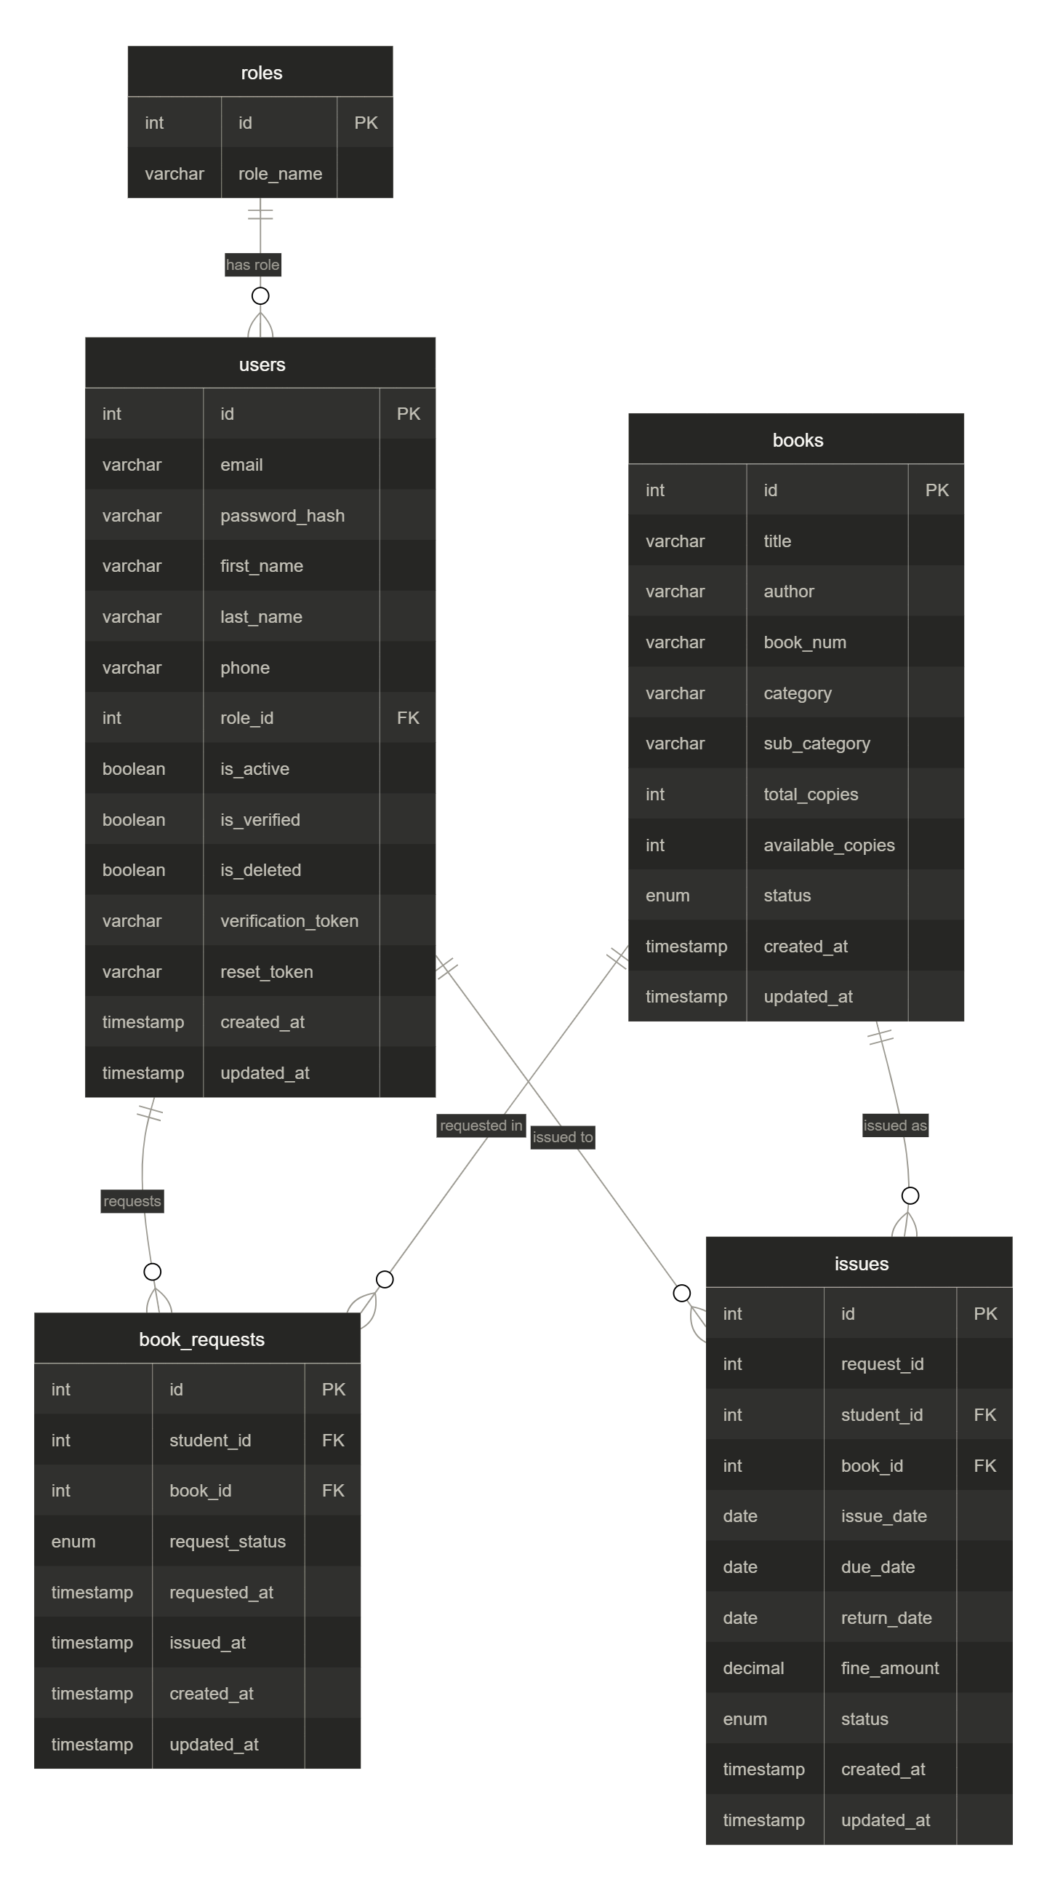

From | To | Relationship | On Key
users | roles | Many-to-One | users.role_id → roles.id
book_requests | users | Many-to-One | book_requests.student_id → users.id
book_requests | books | Many-to-One | book_requests.book_id → books.id
issues | book_requests | One-to-One | issues.request_id → book_requests.id
issues | users | Many-to-One | issues.student_id → users.id
issues | books | Many-to-One | issues.book_id → books.id

6. Database Design

6.1 Design Principles
- Referential integrity via foreign key constraints across all related tables.
- Soft delete for users (is_deleted flag) to preserve audit trails.
- Automatic timestamps (created_at, updated_at) on all tables.
- ENUM constraints on status fields for data consistency.

6.2 Key Constraints
- users.email and users.phone are UNIQUE.
- books.book_num is UNIQUE and NOT NULL.
- book_requests has composite logic preventing duplicate pending requests.
- issues.request_id is NOT NULL, linking every issue to its originating request.

6.3 Default Seed Data
- Roles: admin (id=1), student (id=2).
- Admin user: admin@gmail.com / Admin@123 (pre-hashed with bcrypt).

7. API Design

7.1 Base URL
http://localhost:3000

7.2 Authentication
All protected routes require a JWT token via cookie (access_token) set on login. The middleware extracts and verifies the token, attaching req.user = { id, role_id }.

7.3 Response Format
{ "success_flag": true, "message": "OPERATION_RESULT", "data": {} }

7.4 Auth Endpoints
Method | Endpoint | Access | Description
POST | /auth/login | Public | Login with email & password
GET | /auth/verify-email?uid=&token= | Public | Verify email via token
POST | /auth/forgot-password | Public | Send password reset email
POST | /auth/reset-password | Public | Reset password with token
POST | /auth/logout | Authenticated | Clear auth cookie

7.5 User Endpoints
Method | Endpoint | Access | Description
GET | /users/profile/me | Authenticated | Get own profile
PATCH | /users/profile/me | Authenticated | Update own profile
GET | /users | Admin | Get all users (filterable)
GET | /users/:id | Admin | Get user by ID
POST | /users | Admin | Create new user (sends verification email)
PATCH | /users/:id | Admin | Update user fields
DELETE | /users/:id | Admin | Soft/hard delete user

7.6 Book Endpoints
Method | Endpoint | Access | Description
GET | /books | Authenticated | Get all books (filterable)
GET | /books/:id | Authenticated | Get book by ID
POST | /books | Admin | Create new book
PATCH | /books/:id | Admin | Update book fields
DELETE | /books/:id | Admin | Delete book

7.7 Book Request Endpoints
Method | Endpoint | Access | Description
POST | /requests | Student | Request a book
GET | /requests | Admin | Get all requests (filterable)
GET | /requests/:id | Admin | Get request by ID
PATCH | /requests/:id/approve | Admin | Approve and issue book
PATCH | /requests/:id/reject | Admin | Reject request
DELETE | /requests/:id/cancel | Student | Cancel own pending request

7.8 Issue & Return Endpoints
Method | Endpoint | Access | Description
GET | /issues | Admin | Get all issues (filterable)
GET | /issues/:issue_id | Admin | Get issue details
PATCH | /issues/:issue_id/return | Admin | Return book & calculate fine
GET | /issues/student/me | Student | Get own issued books

7.9 Role Endpoints
Method | Endpoint | Access | Description
POST | /roles | Admin | Create new role
GET | /roles | Admin | Get all roles
GET | /roles/:id | Admin | Get role by ID
PATCH | /roles/:id | Admin | Update role
DELETE | /roles/:id | Admin | Delete role

8. Backend Architecture

8.1 Project Structure

backend/

├── app.js # Entry point, middleware, global error handler

├── package.json # Dependencies & scripts

├── .env # Environment variables

└── src/

├── config/

│ ├── db.js # MySQL connection pool

│ └── mailer.js # Nodemailer transporter

├── controllers/

│ ├── auth.controller.js # Login, verify, forgot/reset password, logout

│ ├── user.controller.js # CRUD users, profile

│ ├── book.controller.js # CRUD books

│ ├── book.request.controller.js # Request, approve, reject, cancel

│ ├── issue.controller.js # Issues, returns, fines

│ └── role.controller.js # CRUD roles

├── middlewares/

│ ├── auth.middleware.js # JWT verification & role authorization

│ └── schema.validator.middleware.js # AJV JSON schema validation

├── routes/

│ ├── index.js # Route aggregator

│ ├── auth.route.js

│ ├── user.route.js

│ ├── book.route.js

│ ├── book.request.route.js

│ ├── issue.route.js

│ └── role.route.js

├── services/

│ ├── email.service.js # Email templates & dispatcher

│ ├── jwt.service.js # Token generation & verification

│ ├── logger.service.js # Winston logger

│ └── verfication.token.service.js # Token generation

├── validators/ # AJV JSON schemas per module

├── utils/

│ ├── query.filter.js # Dynamic SQL filter builder

│ └── templates/ # HTML email templates

└── database/

├── schema/tables.sql # DDL for all tables

└── seeds/seed.sql # Default roles + admin user

11. System Architecture Diagram
The diagram below illustrates the layered architecture of the backend system, showing how a client request flows from entry through to the database and back.

11.1 Layer Responsibilities
Layer | Responsibility
Client Layer | Sends HTTP requests (Postman)
Express Server | Parses request body, cookies, and matches routes
Middleware Layer | Authenticates user (JWT), authorizes role, validates request schema
Business Logic | Controllers handle core logic, orchestrate services, and interact with DB
Service Layer | Encapsulates JWT , email dispatch, logging, token generation
Data Layer | MySQL database accessed via connection pool with parameterized queries
External Services | Gmail SMTP for transactional emails

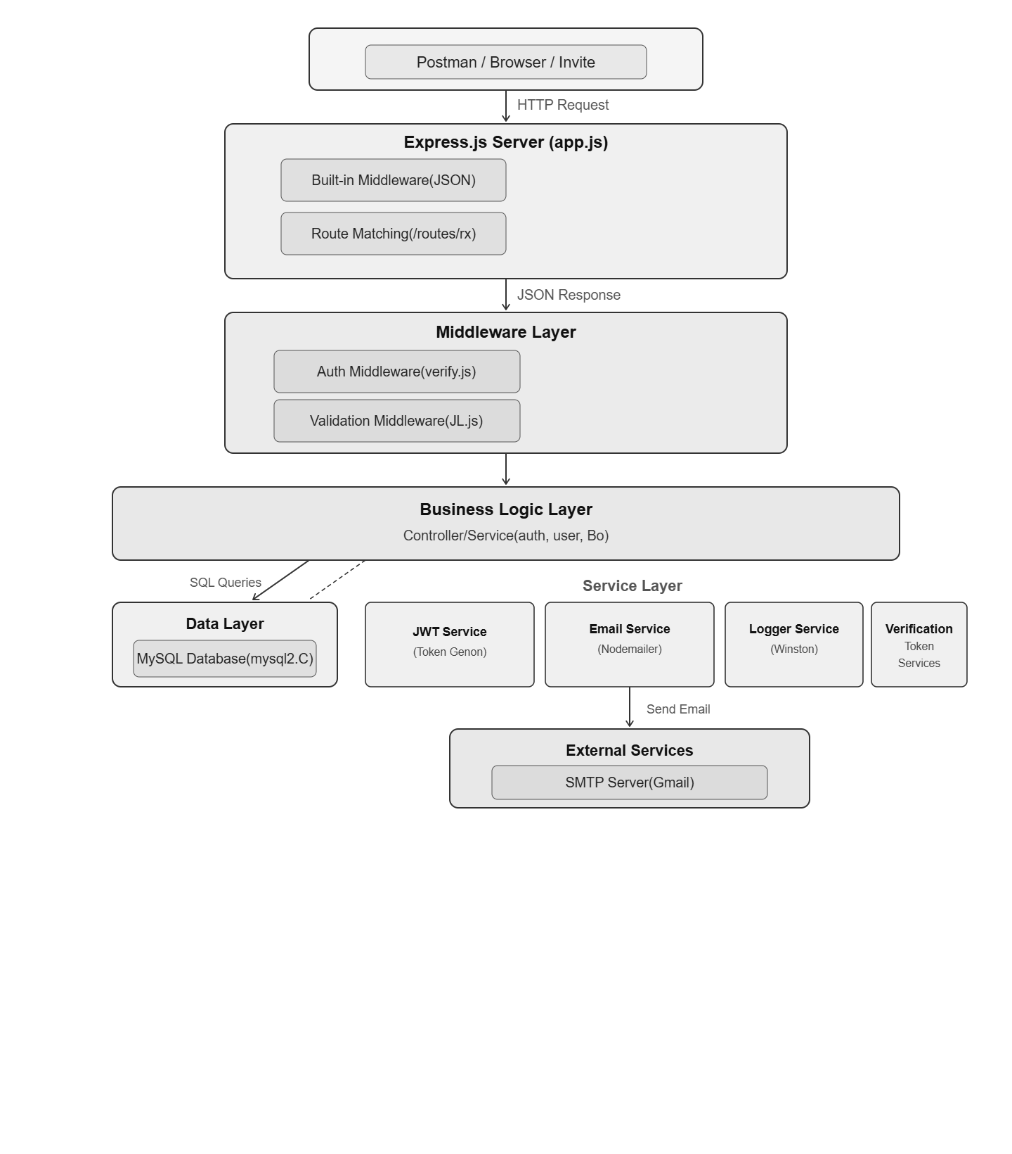

12. Logging & Monitoring

12.1 Logging Framework
The system uses Winston as the centralized logging framework, configured with structured JSON output and multiple transport targets.

12.2 Logger Configuration
Setting | Value | Purpose
Default Level | info | Captures info, warn, and error levels
Format | timestamp + errors + JSON | Structured logs with stack traces
Exit on Error | false | Server stays alive after logging errors

12.3 Log Transports
Transport | Target | Level | Format
Console | Terminal (stdout) | All (info+) | Colorized + simple text for readability
Error File | src/logs/error.log | error only | JSON with timestamp
Combined File | src/logs/combined.log | All (info+) | JSON with timestamp

12.4 Log Levels Used
Level | When Used | Example
info | Successful operations | LOGIN SUCCESS: admin@gmail.com
warn | Suspicious activity | AUTH HEADER MISSING, ACCESS DENIED
error | Failed operations | LOGIN ERROR, DB CONNECTION FAILED

12.5 What Gets Logged
Event Category | Logged Information
Authentication | Login attempts (success/fail), JWT verification, logouts
Authorization | Role checks, access denied events
CRUD Operations | User creation, book updates, request approvals
Email Delivery | Message IDs on success, errors on failure
Database | Connection status, query failures
Validation | AJV schema validation failures with field details
Server Lifecycle | Server start, port binding, DB connection

12.6 Log File Sample
{"level":"info","message":"LOGIN SUCCESS:admin@gmail.com","timestamp":"2026-05-24T07:00:00.000Z"}
{"level":"error","message":"LOGIN ERROR","stack":"Error: INVALID_PASSWORD...","timestamp":"..."}
{"level":"warn","message":"ACCESS DENIED - ROLE 2","timestamp":"2026-05-24T07:02:00.000Z"}

13. Validation Strategy
The system employs a multi-layered validation approach to ensure data integrity at every stage of the request lifecycle.

13.1 . Validation Pipeline

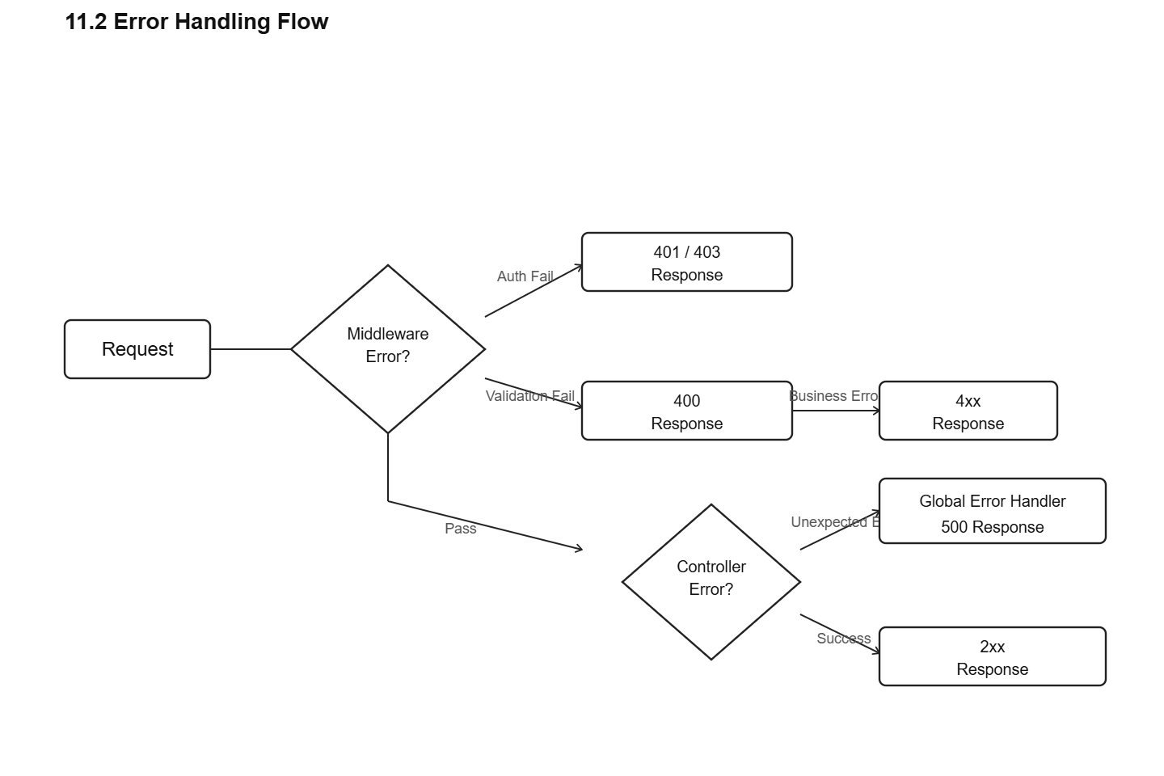

13.2 Layer 1 — AJV JSON Schema Validation
All incoming requests are validated against pre-compiled JSON schemas using AJV before reaching the controller.
Feature | Implementation
Library | AJV v8 with ajv-formats and ajv-errors plugins
Schema Caching | Compiled schemas are cached in a Map for performance
Validation Sources | Supports body, query, and params validation
Error Response | Returns first error message with field name
Strict Mode | additionalProperties: false blocks unexpected fields

13.3 Per-Module Validation Schemas
Module | Validator | Required Fields | Key Rules
Auth - Login | loginValidator | email, password | Email format, non-empty strings
Auth - Reset | resetPasswordValidator | email, token, password | 6-10 chars, 1 uppercase, 1 number, 1 special
User - Create | createUserValidator | first_name, last_name, email, password, phone, role_id | Phone: 10 digits, role_id: 1 or 2
Book - Create | createBookValidator | title, author, book_num, category | Status: enum, copies >= 0
Request - Create | createRequestValidator | book_id | Integer >= 1
Role - Create | createRoleValidator | role_name | String 1-50 chars

13.4 Layer 2 — Controller Field Whitelisting
For dynamic update endpoints (PATCH), controllers enforce an ALLOWED_FIELDS whitelist to prevent SQL injection and privilege escalation.
Endpoint | Allowed Fields
PATCH /users/:id | email, first_name, last_name, phone, role_id, is_active, is_verified
PATCH /users/profile/me | first_name, last_name, phone, password
PATCH /books/:id | title, author, book_num, category, sub_category, total_copies, available_copies, status

13.5 Layer 3 — Database Constraints
Constraint | Effect
UNIQUE(email) | Prevents duplicate email registration
UNIQUE(phone) | Prevents duplicate phone numbers
UNIQUE(book_num) | Prevents duplicate book identifiers
FOREIGN KEY | Ensures referential integrity across tables
NOT NULL | Enforces mandatory fields at DB level
ENUM | Restricts status values to predefined set

14. Status Flow Diagrams
The following state machine diagrams illustrate how entities transition through their lifecycle in the system.
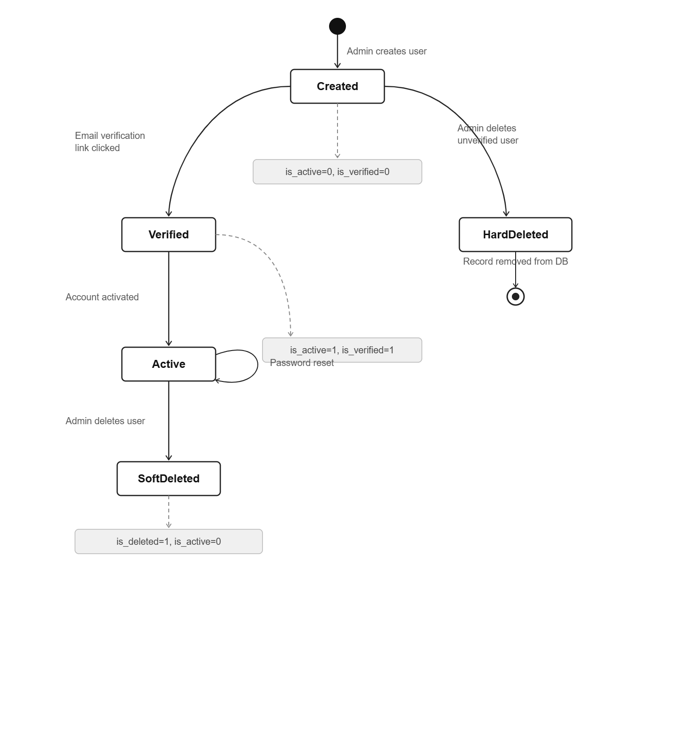

14.1 User Account Lifecycle
State | is_active | is_verified | is_deleted | Can Login?
Created | 0 | 0 | 0 | No
Verified / Active | 1 | 1 | 0 | Yes
Soft Deleted | 0 | 1 | 1 | No
Hard Deleted | — | — | — | Record removed

14.2 Book Request Lifecycle

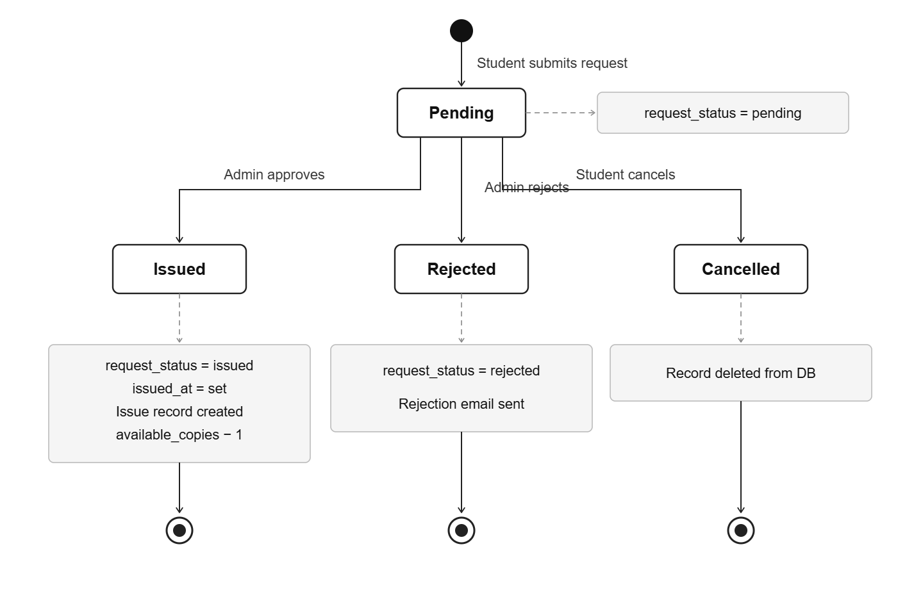

Business Rules:
- A student cannot have two pending requests for the same book.
- A student cannot request a book they currently have issued.
- Only books with available_copies > 0 and status = 'available' can be requested.
- Approval is transactional: copies decremented, issue record created, and email sent atomically.

14.3 Issue Lifecycle & Fine Calculation

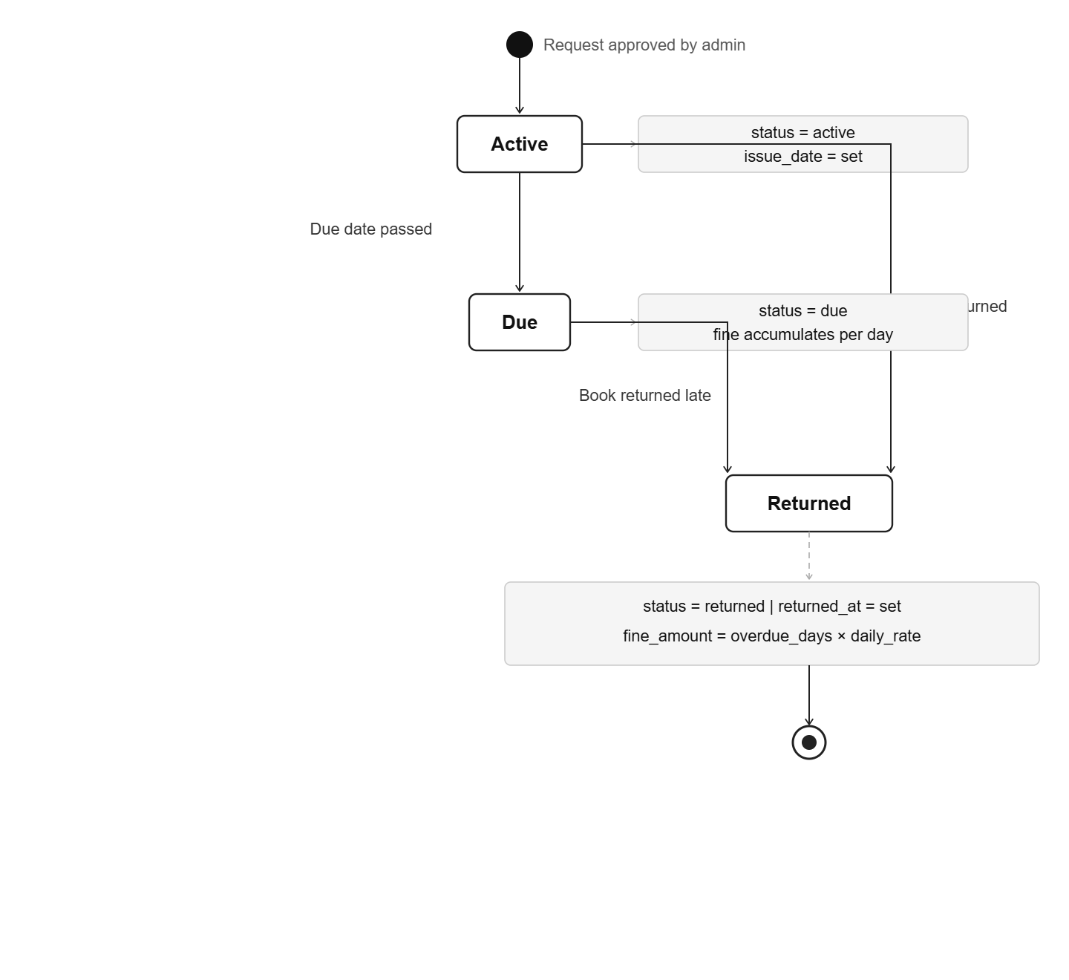

Fine Calculation Formula:
overdue_days = ceil((today - due_date) / one_day)
fine_amount = max(0, overdue_days) × FINE_PER_DAY
Default: FINE_PER_DAY = 5, ISSUE_DURATION_DAYS = 7

14.4 Book Availability Status

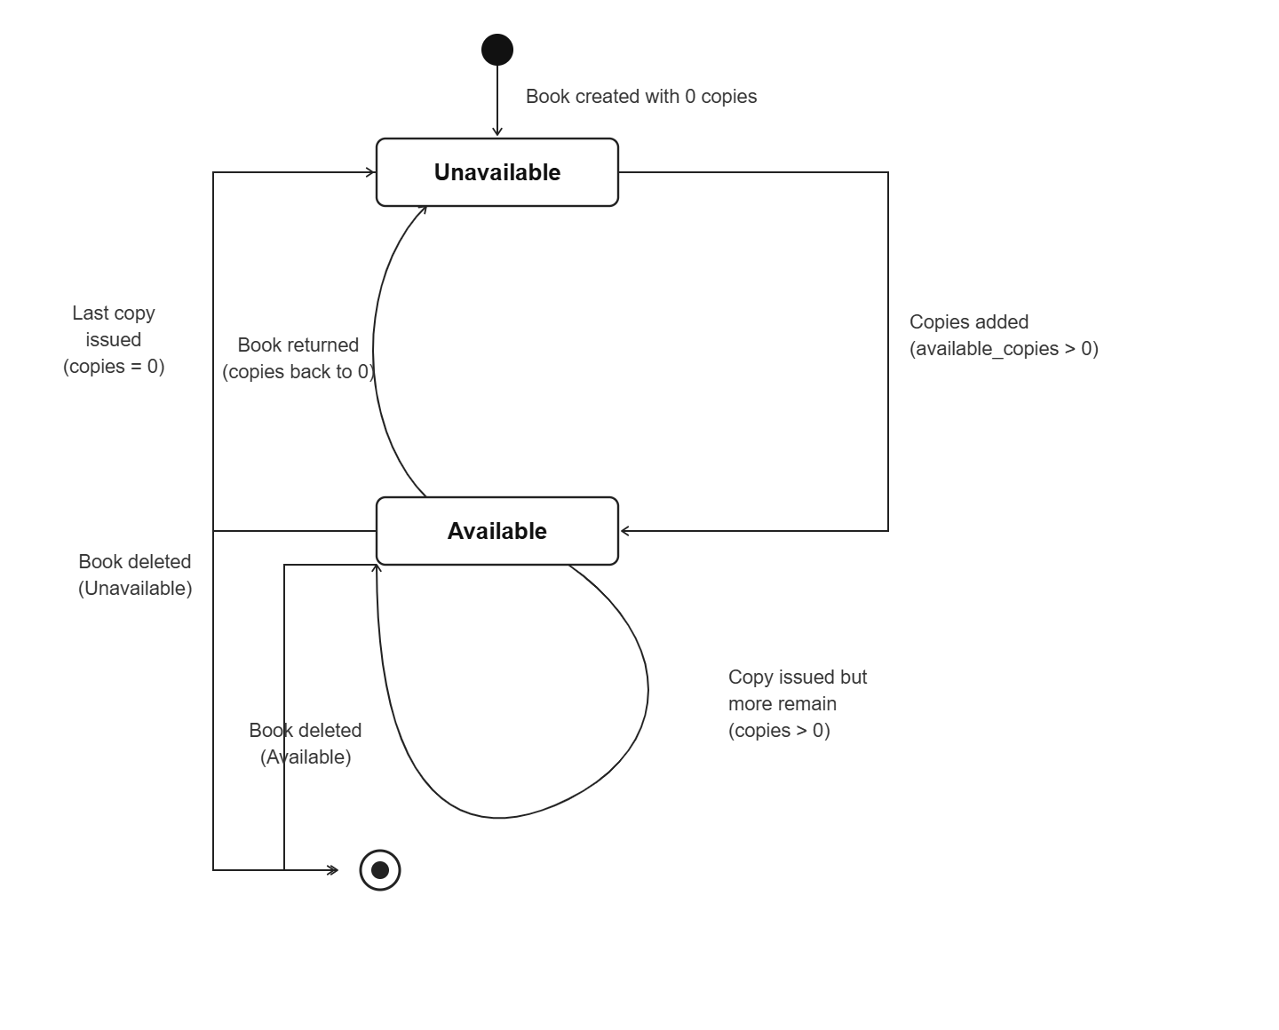
- When a book is issued: available_copies -= 1, status recalculated.
- When a book is returned: available_copies += 1, status recalculated.
- Books with active issues or pending requests cannot be deleted.

15. Future Enhancements
The system is designed with extensibility in mind. The following enhancements are planned across short-term, mid-term, and long-term milestones.

15.1 Short-Term Enhancements
# | Enhancement | Description | Impact
1 | Frontend Integration | Build a React.js frontend with role-based dashboards | Full-stack deployment
2 | Book Cover Images | Add image upload support (Multer + cloud storage) | Better UI/UX
3 | Profile Image Upload | Allow users to upload profile pictures to cloud | User personalization
4 | Due Date Reminders | Automated cron job to send email reminders 1-2 days before due | Reduce overdue returns

15.2 Mid-Term Enhancements
# | Enhancement | Description | Impact
5 | Redis Caching | Cache frequently accessed data using Redis | Performance improvement
6 | Rate Limiting | Add express-rate-limit to prevent brute-force attacks | Security hardening
7 | Pagination Metadata | Return total count, page number, total pages in list endpoints | Better frontend pagination
8 | Audit Log Table | Dedicated table recording who did what and when | Compliance and debugging
9 | Token Expiry | Add expiry timestamp to verification and reset tokens | Security improvement

15.3 Long-Term Enhancements
# | Enhancement | Description | Impact
10 | CI/CD Pipeline | GitHub Actions for automated testing, linting, and deployment | DevOps maturity
11 | Containerization | Docker + Docker Compose for consistent environments | Deployment reliability
12 | API Documentation | Auto-generate Swagger/OpenAPI docs from route definitions | Developer experience
The current monolithic architecture is appropriate for the system's scale. Each future enhancement can be added incrementally without requiring a full rewrite.

