LIBRARY MANAGEMENT SYSTEM
System Design & Technical Documentation

Prepared By: Prajakta Pare | Trainee Software Engineer |

Table of Contents

No. | Section Title | Pg.
1 | Introduction | 4
2 | Problem Definition | 5
2.1 | Background
2.2 | Problems with the Existing System
2.3 | Proposed Solution
3 | Need of the System | 6
4 | Technology Stack | 6
5 | Entity-Relationship Diagram (ERD) | 8
6 | API Design | 9
6.1 | Base URL
6.2 | Authentication
6.3 | Response Format
6.4 | Auth Endpoints
6.5 | User Endpoints
6.6 | Book Endpoints
6.6 | Book Request Endpoints
6.8 | Issue & Return Endpoints
6.9 | Role Endpoints
7 | Flow Diagrams | 11
8 | System Architecture Diagram | 14
9 | Validation Strategy | 15
10 | Future Enhancements | 16

1. Introduction

The Library Management System is developed to overcome the limitations of traditional library processes, where maintaining records of books, student details, book requests, and issue/return activities manually becomes time-consuming and difficult to manage. As the number of users and books increases, manual operations can lead to delays, errors, data inconsistency, and reduced efficiency.
This project provides a centralized web-based platform that automates and simplifies library operations. It allows administrators to manage books, users, and requests efficiently, while students can register, search books, request borrowing, and track issued books through an easy-to-use interface. The system improves accuracy, reduces manual effort, and enhances the overall library management process.

2. Problem Definition

2.1 Background
Traditional library management relies heavily on manual processes physical registers for tracking issued books, handwritten student records, and manual fine calculations. This approach is error-prone, time-consuming, and difficult to scale.

2.2 Problems with the Existing System
- No centralized record of book availability; students must physically check shelves.
- Manual tracking of due dates leads to missed returns and uncollected fines.
- Lack of a request/reservation system causes conflicts and inequitable access.
- Administrators spend significant time on repetitive tasks such as issuing books and recording returns.
- No audit trail for issued books, returns, or fine payments.

2.3 Proposed Solution
- A role-based access system distinguishing administrators from students.
- A digital catalog of books with availability tracking.
- A request workflow where students apply for books and administrators approve/issue.
- Automated fine calculation based on due dates and return dates.
- Full audit history for all transactions.

3. Need of the System

The need for the Library Management System arises from the challenges of managing library operations manually, which can lead to inefficiencies, errors, and difficulties in maintaining accurate records. Traditional methods of handling book inventories, student registrations, issue and return transactions, and request approvals become increasingly complex as the number of users and books grows. This system provides a secure and centralized solution by implementing user authentication and role-based access control, ensuring that administrators and students have appropriate permissions. It enables efficient book catalog management with real-time availability tracking, supports a structured request and approval process, automates issue and return records, and calculates fines accurately without manual intervention.
Additionally, email verification enhances security by allowing only valid users to access the system. Overall, the system improves operational efficiency, reduces administrative workload, and delivers a more organized and reliable library experience.

4. Technology Stack

4.1 Core Technology Stack

Category | Technology | Purpose
Environment | Node.js | Executes JavaScript on the server side
Web Framework | Express.js | Handles routing, middleware, and HTTP requests
Database | MySQL | Stores and manages relational data

4.2 NPM Packages and Libraries

Package | Category | Purpose
mysql2 | Database Connectivity | MySQL connection pooling and query execution
jsonwebtoken | Authentication | JWT generation and verification
bcrypt | Security | Password hashing and comparison
nodemailer | Communication | Sending emails and notifications
ajv | Validation | JSON Schema-based request validation
winston | Logging | Application logging and error tracking
dotenv | Configuration | Environment variable management
eslint | Code Quality | Static code analysis and linting
prettier | Code Formatting | Automatic code formatting

5. Entity-Relationship Diagram (ERD) 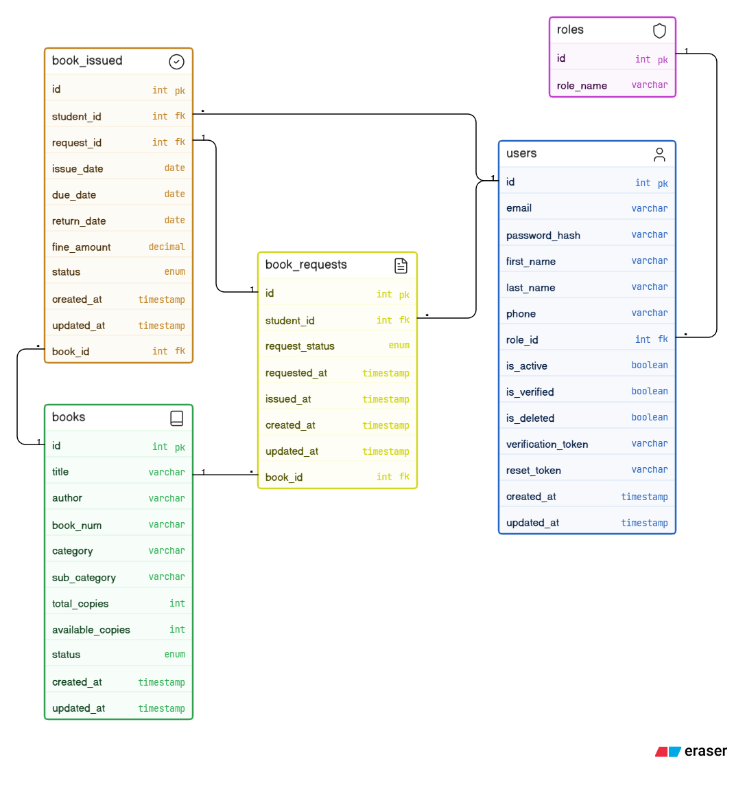
From | To | Relationship | On Key
users | roles | Many-to-One | users.role_id → roles.id
book_requests | users | Many-to-One | book_requests.student_id → users.id
book_requests | books | Many-to-One | book_requests.book_id → books.id
book_issued | book_requests | One-to-One | book_issued.request_id → book_requests.id
book_issued | users | Many-to-One | book_issued.student_id → users.id
book_issued | books | Many-to-One | book_issued.book_id → books.id

6. API Design

6.1 Base URL
http://localhost:3000

6.2 Authentication
All protected routes require a JWT token via cookie (access_token) set on login. The middleware extracts and verifies the token, attaching req.user = {id, role_id}.

6.3 Response Format
{"success_flag": true, "message": "SUCCESS_MESSAGE", "data": {}}
{"success_flag": false, "message": "ERROR_MESSAGE"}

6.4 Auth Endpoints
Method | Endpoint | Access | Description
POST | /auth/login | Public | Login with email & password
GET | /auth/verify-email?uid=&token= | Public | Verify email via token
POST | /auth/forgot-password | Public | Send password reset email
POST | /auth/reset-password | Public | Reset password with token
POST | /auth/logout | Public | Clear auth cookie

6.5 User Endpoints
Method | Endpoint | Access | Description
GET | /users/profile | Authenticated | Get own profile
PATCH | /users/profile | Authenticated | Update own profile
GET | /users | Admin | Get all users (filterable)
GET | /users/:id | Admin | Get user by ID
POST | /users | Admin | Create new user (sends verification email)
PATCH | /users/:id | Admin | Update user fields
DELETE | /users/:id | Admin | Soft/hard delete user

6.6 Book Endpoints
Method | Endpoint | Access | Description
GET | /books | Authenticated | Get all books (filterable)
GET | /books/:id | Authenticated | Get book by ID
POST | /books | Admin | Create new book
PATCH | /books/:id | Admin | Update book fields
DELETE | /books/:id | Admin | Delete book

6.6 Book Request Endpoints
Method | Endpoint | Access | Description
POST | /requests | Student | Request a book
GET | /requests | Authenticated | Get all requests (filterable)  Student can see his own requested books data
GET | /requests/:id | Admin | Get request by ID
PATCH | /requests/:id/approve | Admin | Approve and issue book
PATCH | /requests/:id/reject | Admin | Reject request
DELETE | /requests/:id/cancel | Student | Cancel own pending request

6.8 Issue & Return Endpoints
Method | Endpoint | Access | Description
GET | /book-issued | Authenticated | Get all issued books data (filterable)  Student can see his own issued or returned books
GET | /book-issued/:issue_id | Admin | Get issue details
PATCH | /book-issued/:issue_id/return | Admin | Return book & calculate fine

6.9 Role Endpoints
Method | Endpoint | Access | Description
POST | /roles | Admin | Create new role
GET | /roles | Admin | Get all roles
GET | /roles/:id | Admin | Get role by ID
PATCH | /roles/:id | Admin | Update role
DELETE | /roles/:id | Admin | Delete role

7. Flow Diagram

7.1 Registration flow

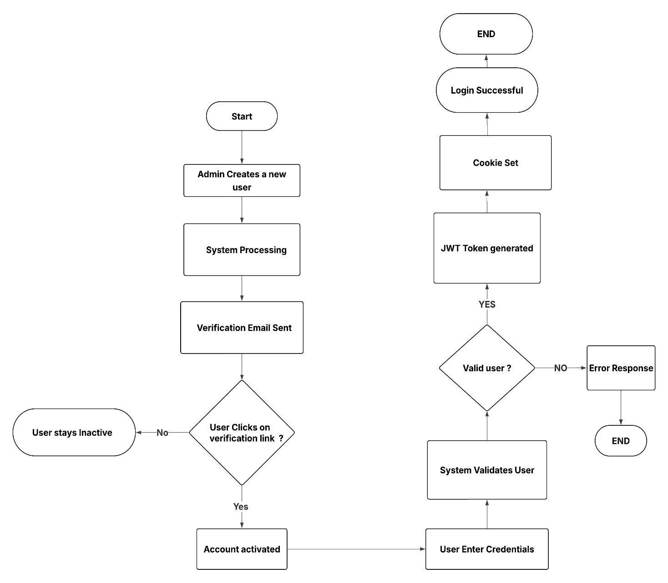

7.2 Student request flow 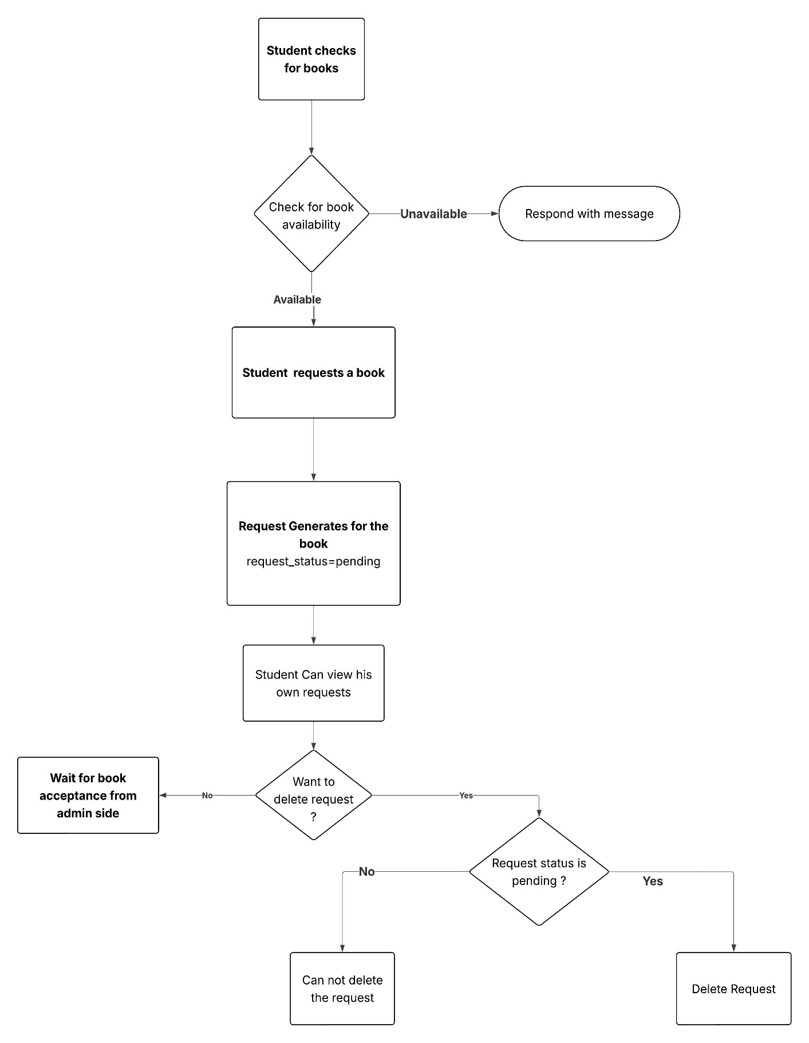

7.3 Book Request & Issue flow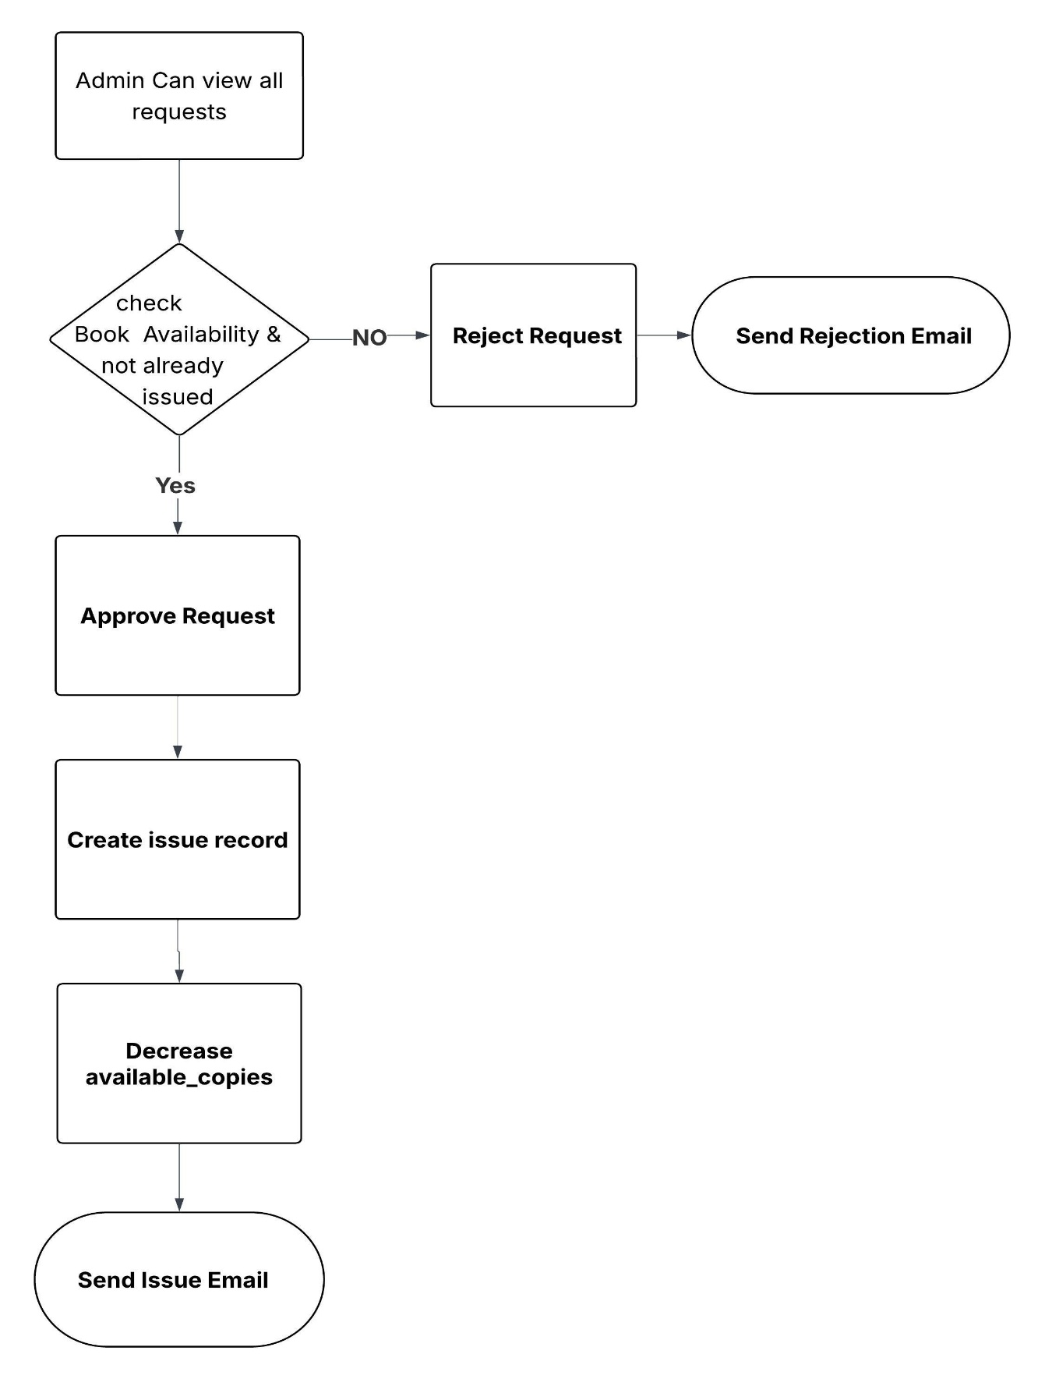

7.4 Book Return Flow

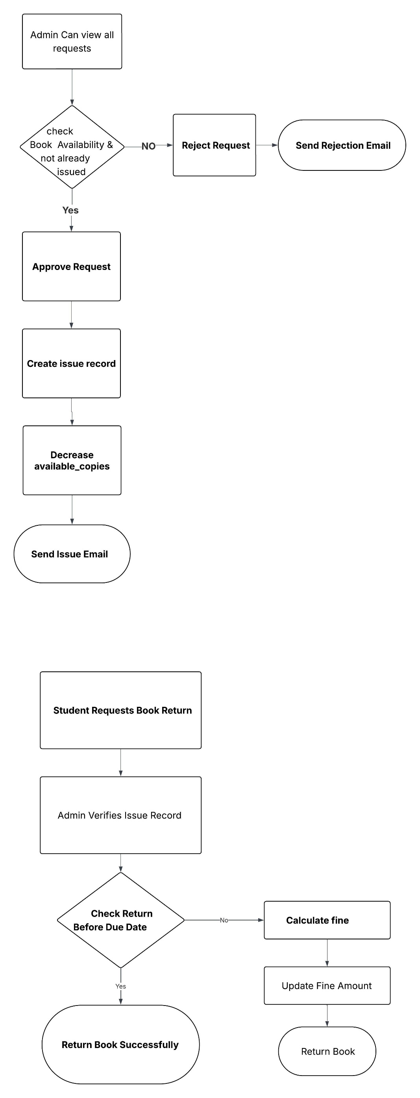

8. System Architecture

Layer Responsibilities
Layer | Responsibility
Client Layer | Sends HTTP requests (Postman)
Express Server | Parses request body, cookies, and matches routes
Middleware Layer | Authenticates user (JWT), authorizes role, validates request schema
Business Logic | Controllers handle core logic, orchestrate services, and interact with DB
Service Layer | Encapsulates JWT, email dispatch, logging, token generation
Data Layer | MySQL database accessed via connection pool with parameterized queries
External Services | Gmail SMTP for transactional emails

9. Validation Strategy
The system employs a multi-layered validation approach to ensure data integrity at every stage of the request lifecycle.

Validation Pipeline
Auth Fail
Response
Middleware
Request
Business Error
Response
^{Validation Fail}
Response

Unexpected Error
Global Error Handler
Pass
Controller

^{Success}
Response

The validation strategy uses three layers:
Layer 1 — AJV Schema Validation: All requests are validated against JSON schemas (body, query, params) before reaching the controller. Uses AJV v8 with strict mode (additional Properties: false).
Layer 2 — Controller Whitelisting: PATCH endpoints enforce an ALLOWED_FIELDS list to block unexpected or malicious fields.
Layer 3 — Database Constraints: Enforced via UNIQUE, NOT NULL, FOREIGN KEY, and ENUM constraints as a final safety net.

10. Future Enhancements
The system is designed with extensibility in mind.
# | Enhancement | Description | Impact
1 | Frontend Integration | Build a React.js frontend with role-based dashboards | Full-stack deployment
2 | Book Cover Images | Add image upload support (Multer + cloud storage) | Better UI/UX
3 | Profile Image Upload | Allow users to upload profile pictures to cloud | User personalization
4 | Due Date Reminders | Automated cron job to send email reminders 1-2 days before due | Reduce overdue returns

