# S boxe
sbox = [9, 4, 10, 11, 13, 1, 8, 5, 6, 2, 0, 3, 12, 14, 15, 7]

def convertNumToAsciiBit(x): # coverts decimal to binary
y = ""
for i in range(len(x)):
val = ord(x[i])
j = 7
ans = ""
while j >= 0:
w = val // (pow(2, j))
ans += str(w)
val = val % (pow(2, j))
j -= 1
y += ans
return y

def convertAsciiToChar(x): # converts ASCII value to char
y = ""
for i in range(0, len(x), 8):
ans = 0
for j in range(8):
ans += int(x[i + j]) * pow(2, 7 - j)
if i == len(x) - 8:
if chr(ans) != '#':
y += chr(ans)
else:
y += chr(ans)
return y

def keyExpansion(key): # generates 2 round keys
x = [key[:4], key[4:8], key[8:12], key[12:16]]
for i in range(4): # binary to decimal for each nible
x[i] = list(map(int, x[i]))
x[i] = x[i][0] * 8 + x[i][1] * 4 + x[i][2] * 2 + x[i][3]
keylist = [x[0], x[1], x[2], x[3]]
for i in range(2):
w2 = [0, 0, 0, 0]
if i == 0:
val = 8 # rcon for first round
else:
val = 3 # rcon for 2nd round
w2[0] = keylist[4 * i] ^ val ^ (sbox[keylist[4 * i + 3]])
w2[1] = keylist[4 * i + 1] ^ 0 ^ (sbox[keylist[4 * i + 2]])
w2[2] = w2[0] ^ keylist[4 * i + 2]
w2[3] = w2[1] ^ keylist[4 * i + 3]
keylist.append(w2[0])
keylist.append(w2[1])
keylist.append(w2[2])
keylist.append(w2[3])
return keylist # has all 3 sub-keys

def getByteFromBit(x):# converts binary to bytes
y = []
i = 0
while i < (len(x)):
y.append(8 * x[i] + 4 * x[i + 1] + 2 * x[i + 2] + x[i + 3])
i += 4
return y

def mixCols(y): # applies Mix-Columns
w = []
for i in range(len(y)):
val = y[i] * 4
if val >= 32:
val ^= 38
if val >= 16:
val ^= 19
w.append(val)
ans = [0, 0, 0, 0]
ans[0] = y[0] ^ w[1]
ans[1] = y[1] ^ w[0]
ans[2] = y[2] ^ w[3]
ans[3] = y[3] ^ w[2]
return ans

def convertByteToBit(y): # converts byte value to binary
cipher = []
for i in range(len(y)):
val = y[i]
val1 = val // 8
cipher.append(val1)
val = val % 8
val1 = val // 4
cipher.append(val1)
val = val % 4
val1 = val // 2
cipher.append(val1)
val1 = val % 2
cipher.append(val1)
cipher = list(map(str, cipher))
return "".join(cipher)

def mult(x, y):
val = x * y
if y == 2:
if val >= 32:
val ^= 38
if val >= 16:
val ^= 19
else:
val = x * 8
if val >= 64:
val ^= 76
if val >= 32:
val ^= 38
if val >= 16:
val ^= 19
val ^= x
return val

def inverseMixCols(y): # applies inverse Mix-Columns
w = [0, 0, 0, 0]
w[0] = mult(y[0], 9) ^ mult(y[1], 2)
w[1] = mult(y[1], 9) ^ mult(y[0], 2)
w[2] = mult(y[2], 9) ^ mult(y[3], 2)
w[3] = mult(y[3], 9) ^ mult(y[2], 2)
return w

def aesDecrypt(y, keylist): # applies Decryption Algorithm
j = 2
for i in range(len(y)):
y[i] ^= keylist[4 * j + i]
j = 1
while j >= 0:
y[1], y[3] = y[3], y[1]
for i in range(len(y)):
y[i] = sbox.index(y[i])
for i in range(len(y)):
y[i] ^= keylist[4 * j + i]
if j != 0:
y = inverseMixCols(y)
j -= 1
return convertByteToBit(y)

def aesEncrypt(y, keylist): # applies Encryption Algorithm
for i in range(len(y)):
y[i] ^= keylist[i % 4]
for i in range(1, 3):
for j in range(len(y)):
y[j] = sbox[y[j]]
y[1], y[3] = y[3], y[1]
if i != 2:
y = mixCols(y)
for j in range(len(y)):
y[j] = y[j] ^ keylist[4 * i + j]
return convertByteToBit(y)

if __name__ == "__main__":
print("Enter the plaintext : ") # any length char input
x = input()
print("Enter the key : ") # char input of length 2
key = input()
if len(key) != 2:
print("BAD KEY : Should be 16 bits")
exit(0)
key = convertNumToAsciiBit(key)
keylist = keyExpansion(key)
if len(x) % 2 != 0:
x += '#' # filler - #
x = convertNumToAsciiBit(x)
x = list(map(int, x))
i = 0
cipher = ""
while i < len(x) - 1:
y = getByteFromBit(x[i:i + 16])
cipher += aesEncrypt(y, keylist)
i += 16
print("Cipher text after encryption is : ")
print(cipher)
print(convertAsciiToChar(cipher))
x = list(map(int, cipher))
i = 0
plaintext = ""
while i < len(x) - 1:
y = getByteFromBit(x[i:i + 16])
plaintext += aesDecrypt(y, keylist)
i += 16
print("Plain text after decryption is : ")
print(plaintext)
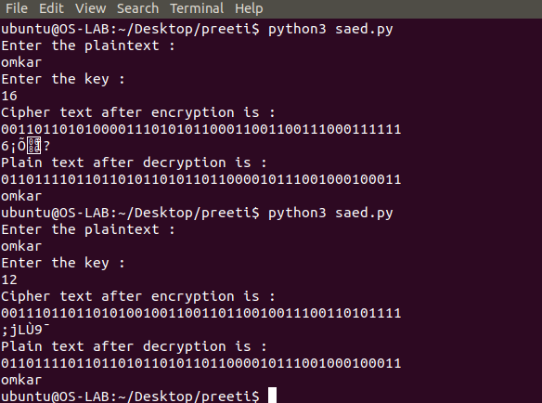
print(convertAsciiToChar(plaintext))

