**Redux – Independent state management libaries**

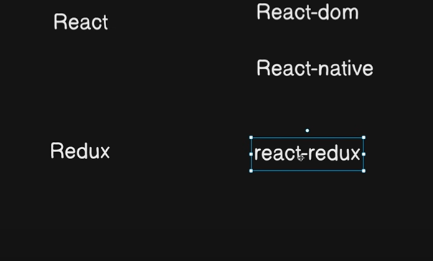

Want 🡪 redux for react-redux

Bez redux is independent library so to connect with react we want react-redux

Redux and react-toolkit

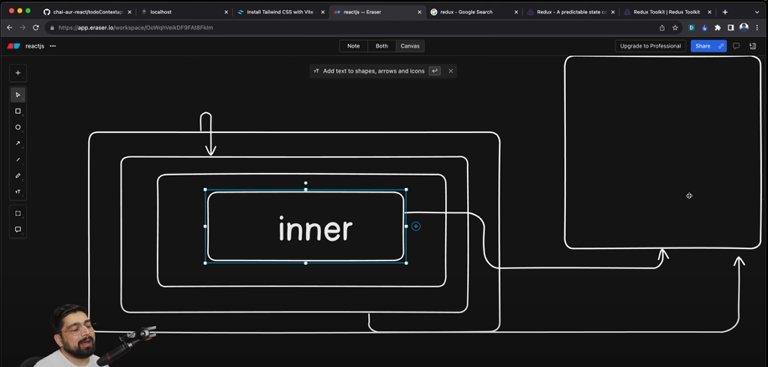

Context api come too later before that facebook go throught this

1st core of redux--- flux

State management,central store,data flow -🡪 data go in one way to data store and get the data and update it and there want structure to update this

Then after that redux come-🡪 u should never modify state 🡪 functionality done by reducer only

Redux-🡪 is independent libaray so it can work with react,veu

Redux-toolkit 🡪 not needed the whole setup battery included 🡪 it will give all the step in one setup

Easy configuration, built-in middleware

Concepts:

Store: single store from where we get all the things

Reducers: control functionality part ( object) where to do which changes like

useSelector: value want to select

useDispatch: value want to dispatch(send)

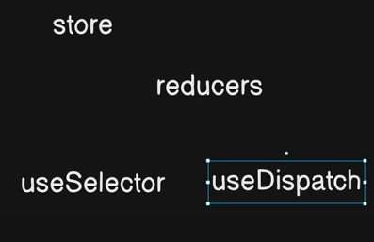

Project has been start:

Here 1st we want to install 2 libaries

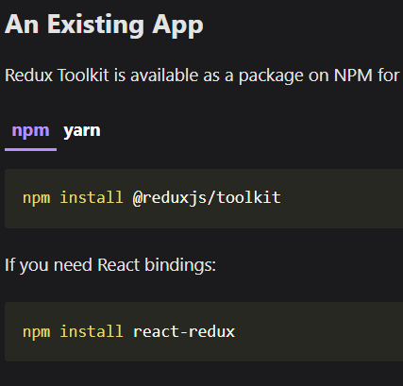

Steps

1. Create store -🡪 and configure it and in this we will take objects only

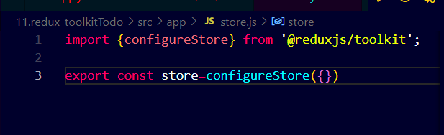

1. Reducers (we call it as slices):
2. Initialstate create with objects

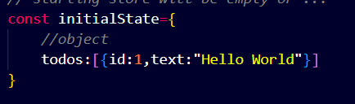

1. Then createslice like addTodo,removeTodo …,update…

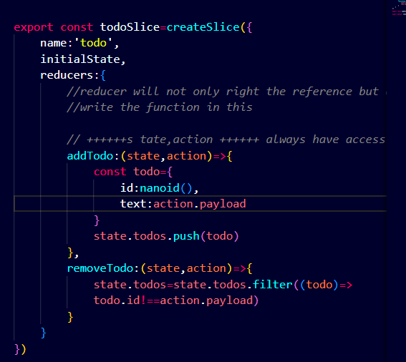

1. Export this slice addTodo,removeTodo

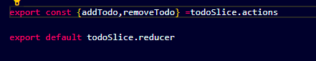

As this will export all ………and reducer is export here

1. Then add in the store … reducer will be add in the store and reducer can be many (more than 1)

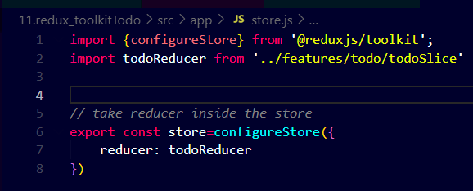

1. UseDispatch

-🡪 usedispatch🡪use reducer🡪 to make value changes in state

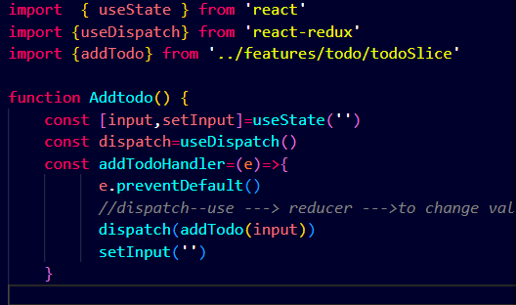

Here 1st take useDispatch then inside it reducer will be used then valuew will be change in the store ------------------- input is todo things that we will write in inputbox

1. Now go for useSelector

How it will work as

Like the data is save in state (but there is reducer who make changes in store )

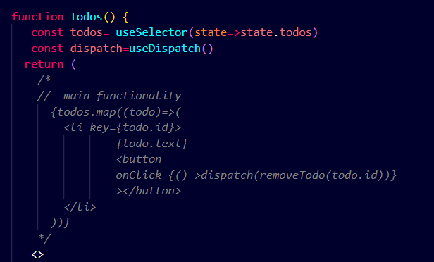

Here u can see 1st we select the todos in the state

Then dispatch have removeTodo which remove or filter out that id

Todos map the todos that in in list bez it is array then if the id is found then there is onclick button for make changes remove if u want

As onclick have array bez if not it will run itself without clicking the button

Last step is add this in main file using Provider

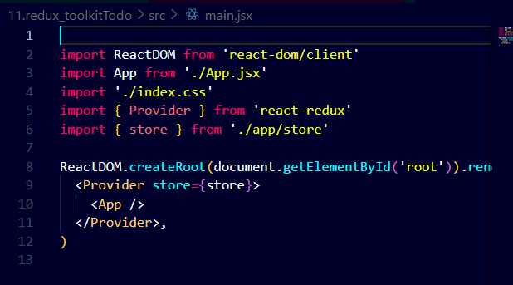

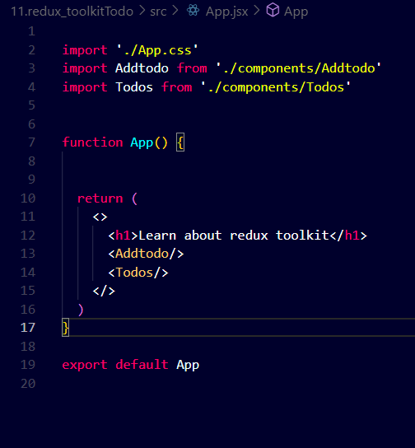

All in one

1. There is only one store in each application

**Configure store inside that reducer will be there(one or many)**

1. **Reducer will be there so**

**Create slice🡪 name, initialstate, reducers list**

**(initial state🡪 default things)**

**Reducer(object) 🡪 addTodo,removeTodo 🡪 add and remove from the state**

**Contain state,action**

**Then export all reducer**

**Then main source of all reducer .reducer will be there**

**Then add in store**

1. **Dispatch () method then import reducer and add in store**
2. **Selector () method where use dispatch for removeTodo**

**Update want to add**