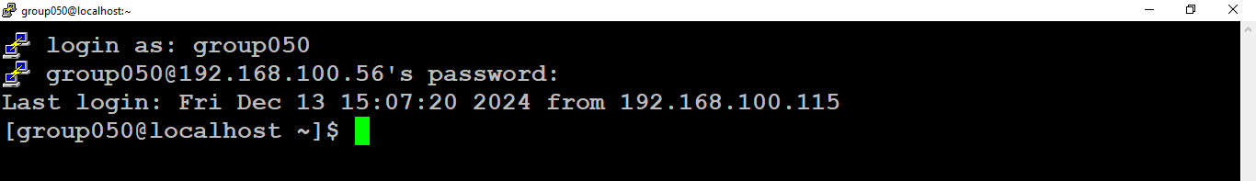
Q.1 - OS -
Script -
then
echo "All the three numbers are equal"

elif [[ $a -eq $b || $b -eq $c || $c -eq $a ]];

then
echo "I cannot figure out which number is largest"
else
if [ $a -gt $b -a $a -gt $c ];

then
echo "$a is biggest number"
elif [ $b -gt $a -a $b -gt $c ];

then
echo "$b is biggest number"
elif [ $c -gt $a -a $c -gt $b ];
then
echo "$c is biggest number"
fi
fi

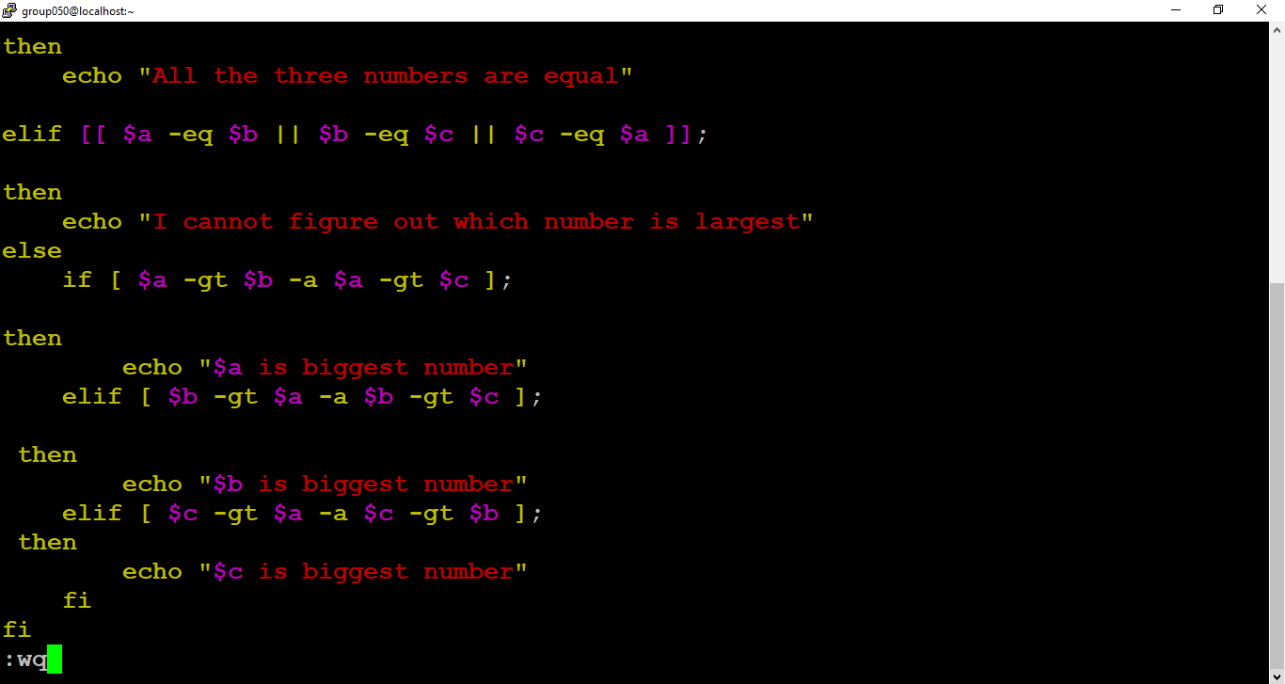
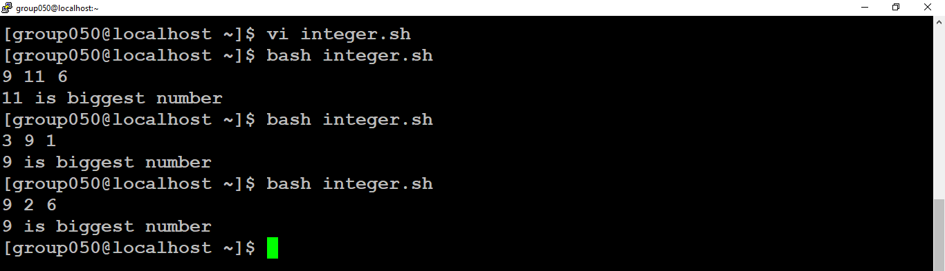

Q.2 – Agile and JIRA
- create project named – IET App Testing
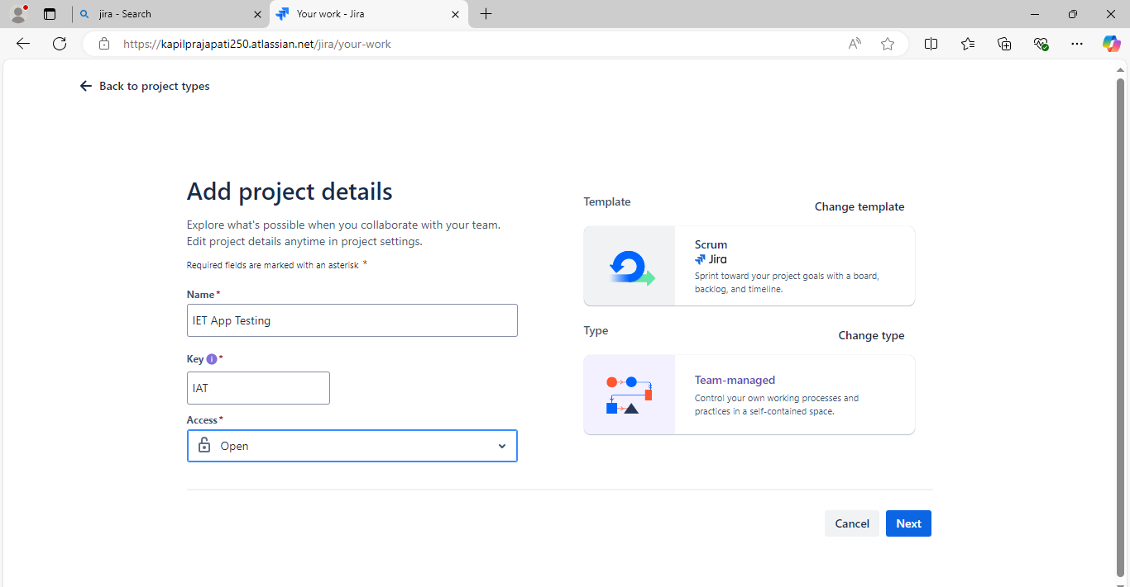

- create 2 story.....

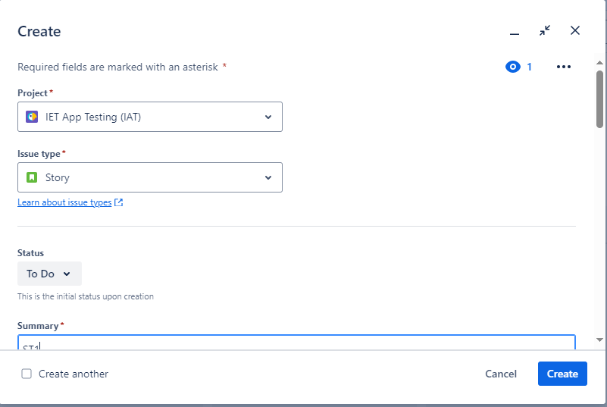

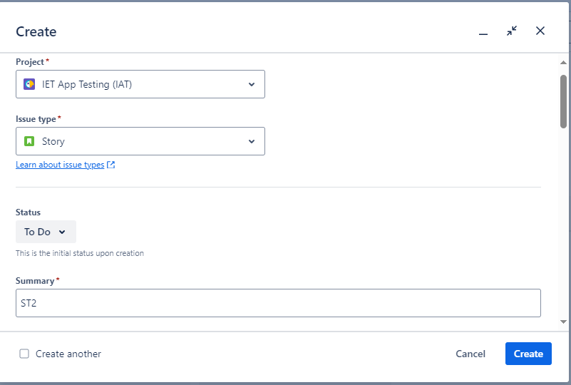

- create 1 epic and add user story....
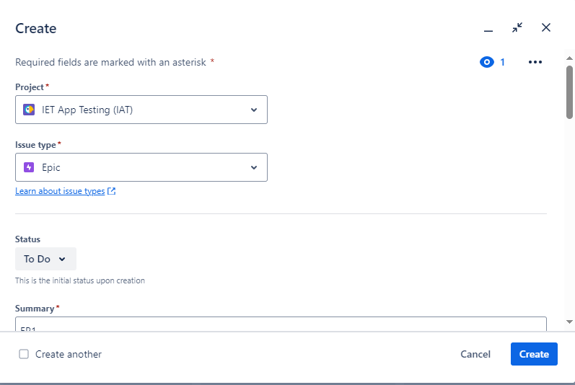
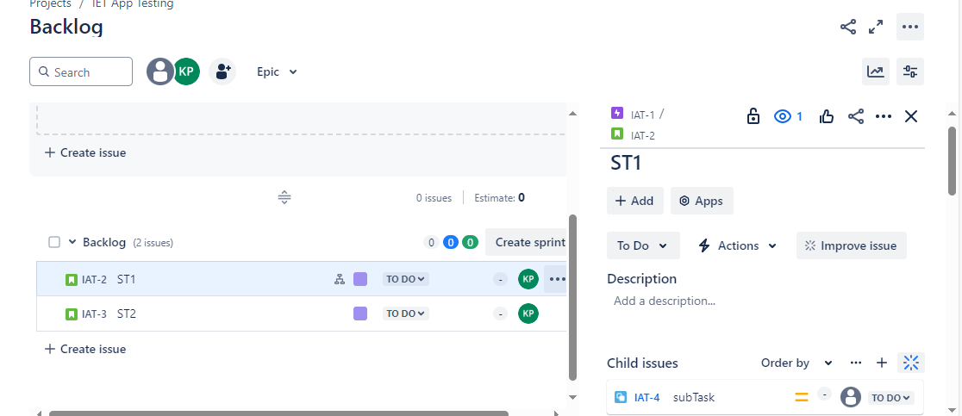
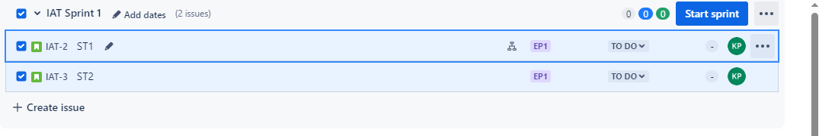
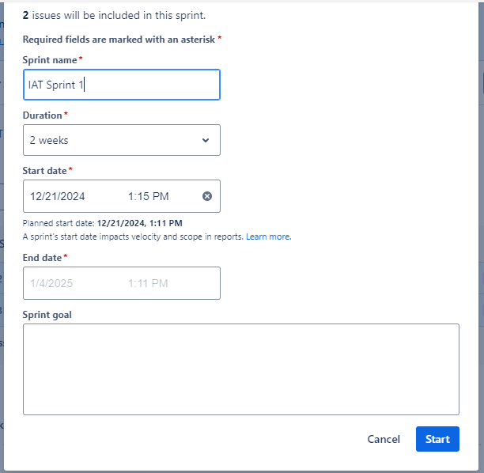
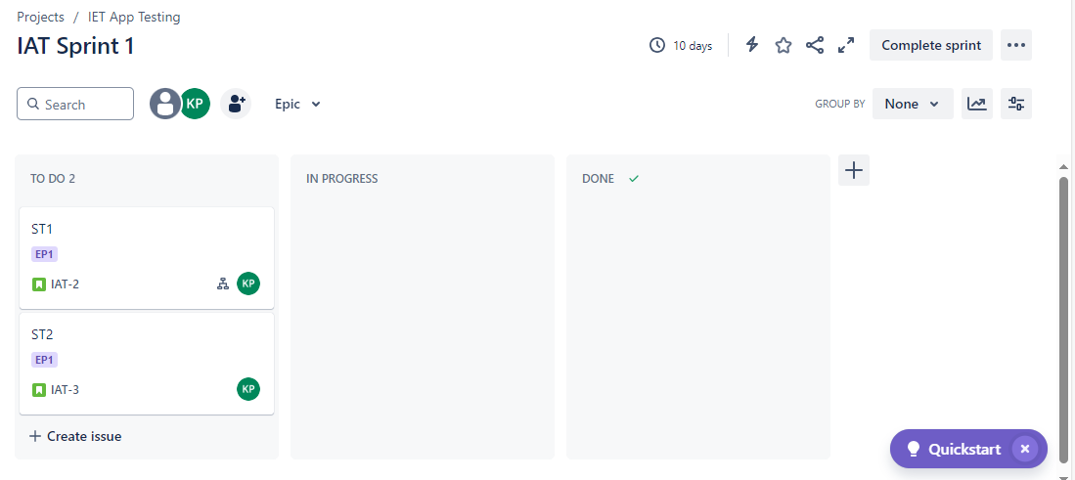

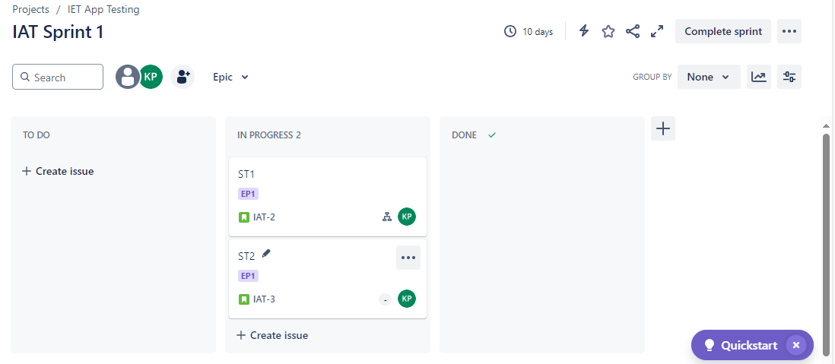
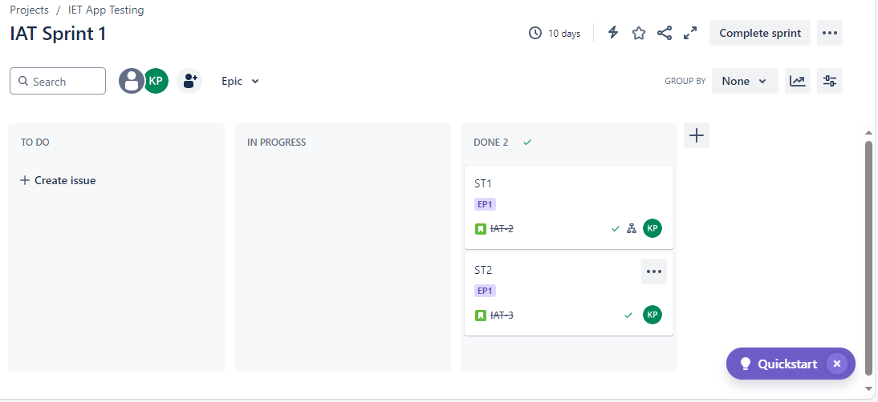
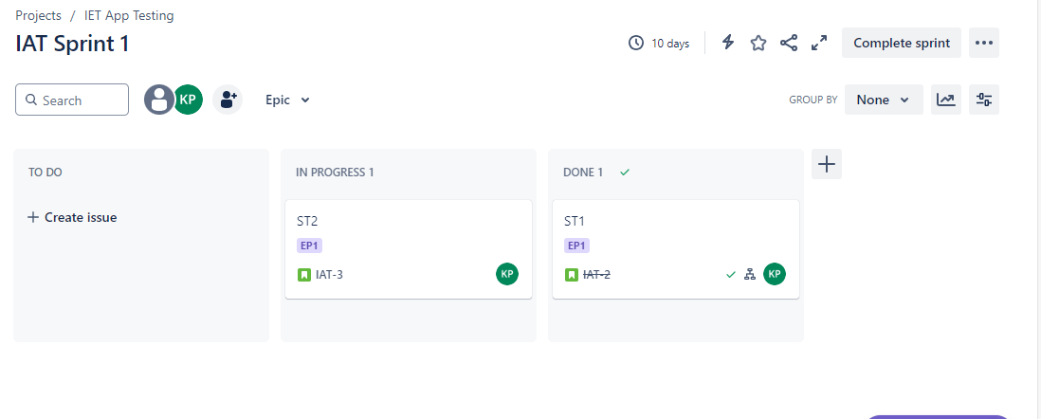

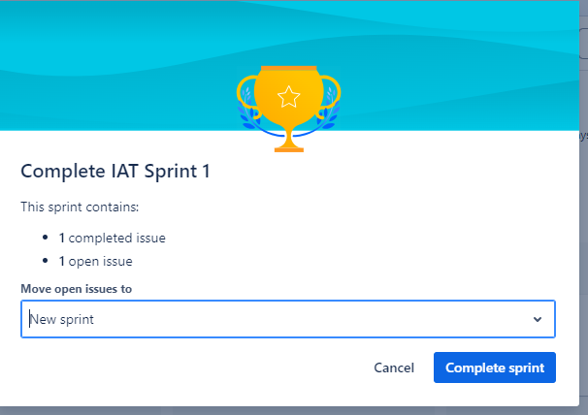

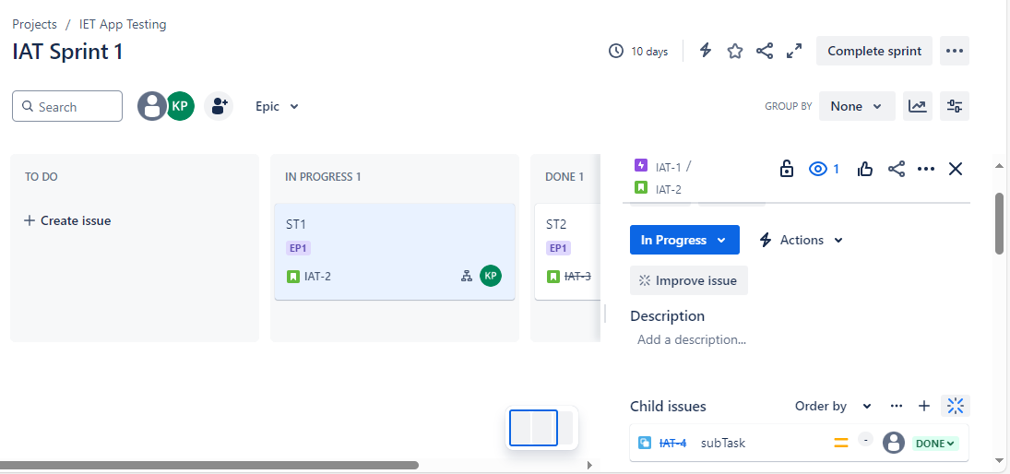

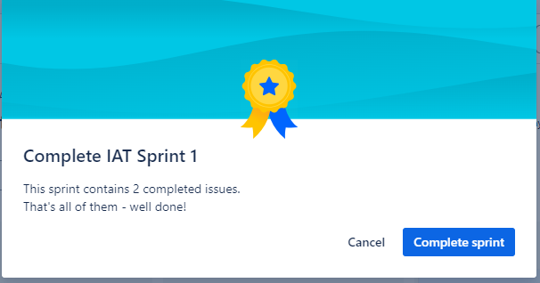
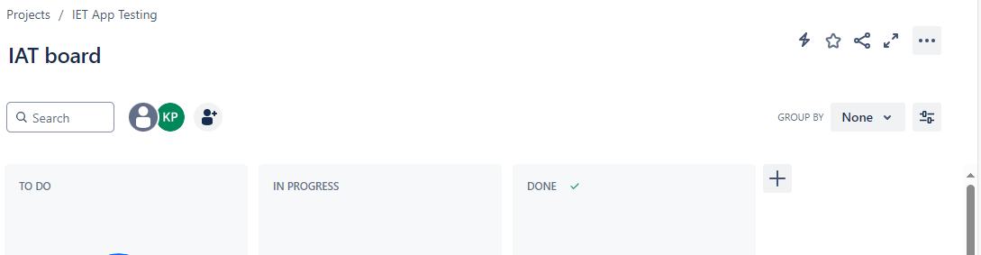

selenium

create mvn project -
dependencies -
[
<dependencies>
<!-- https://mvnrepository.com/artifact/org.seleniumhq.selenium/selenium-java -->
<dependency>
<groupId>org.seleniumhq.selenium</groupId>
<artifactId>selenium-java</artifactId>
<version>3.14.0</version>
</dependency>

<!-- https://mvnrepository.com/artifact/io.github.bonigarcia/webdrivermanager -->
<dependency>
<groupId>io.github.bonigarcia</groupId>
<artifactId>webdrivermanager</artifactId>
<version>5.0.3</version>
</dependency>

</dependencies>

]

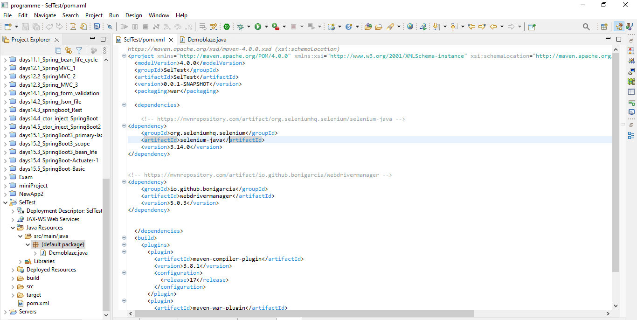

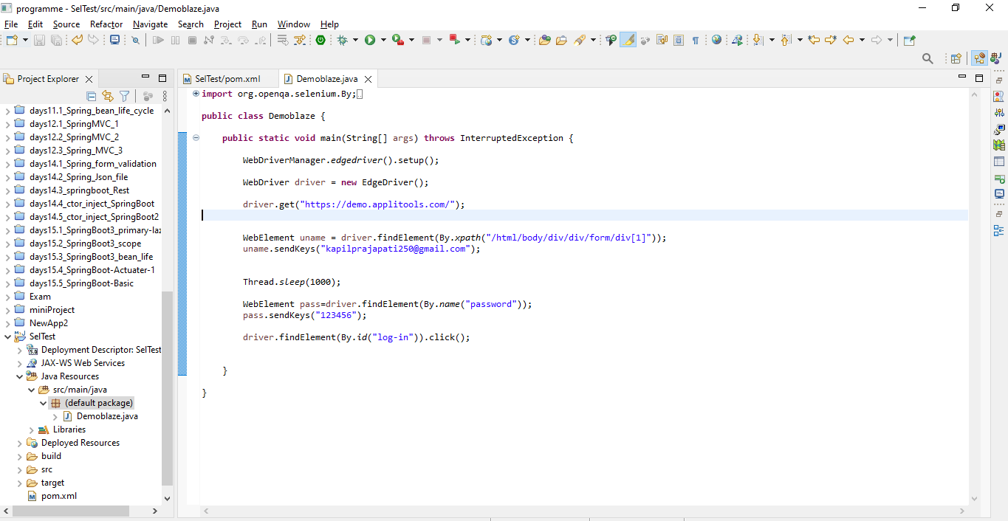

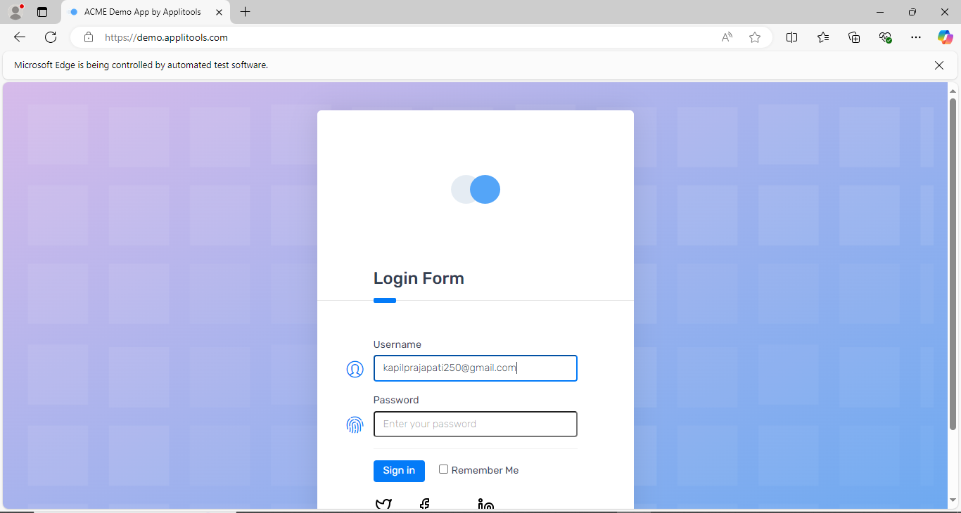

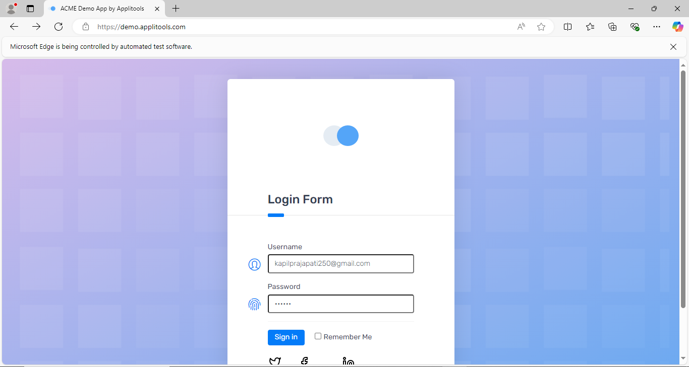
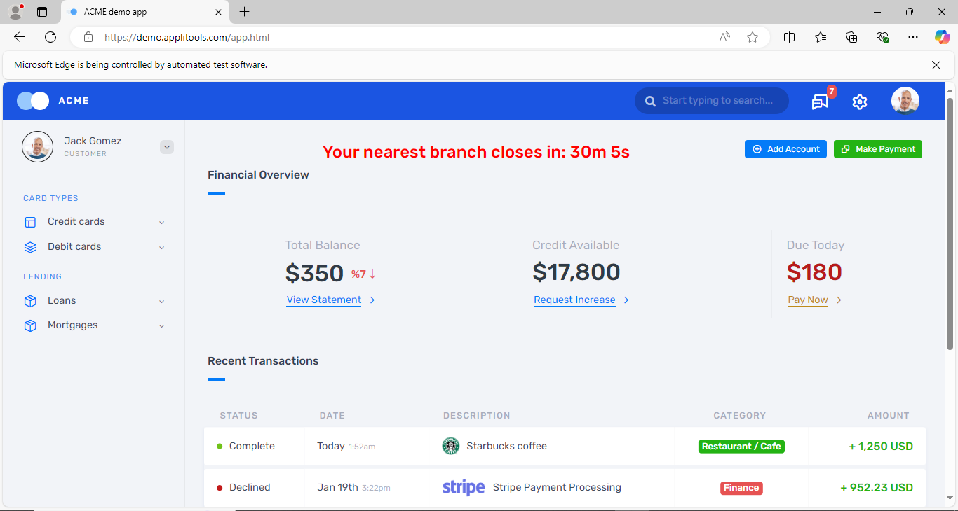

GIT Command-

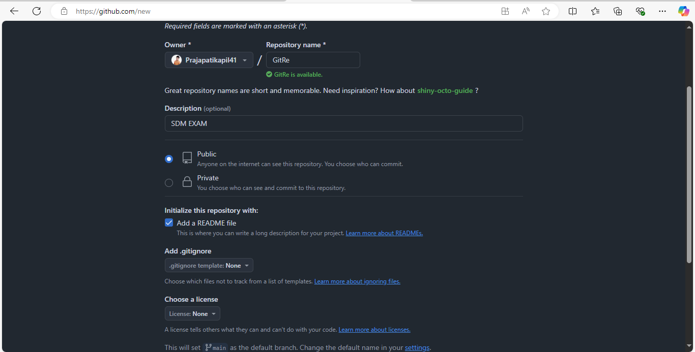
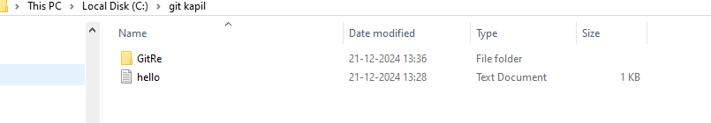

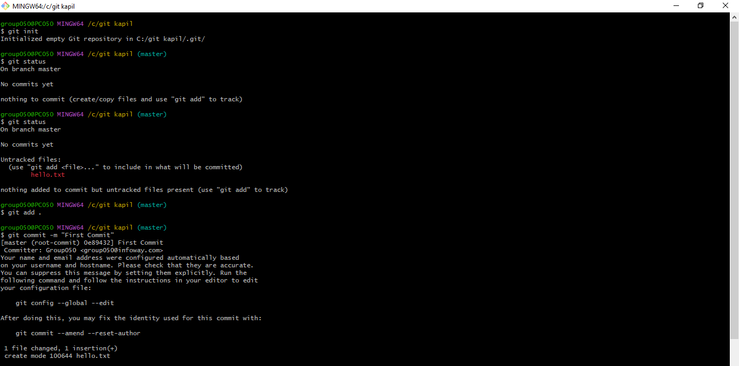

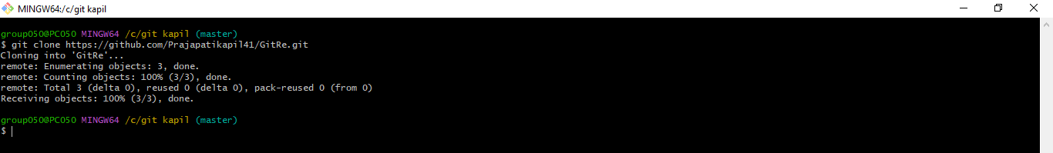
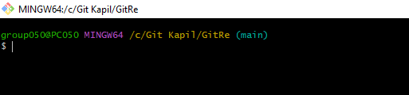
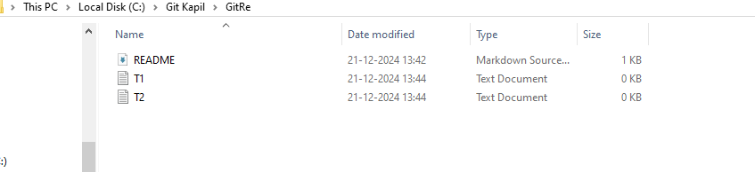
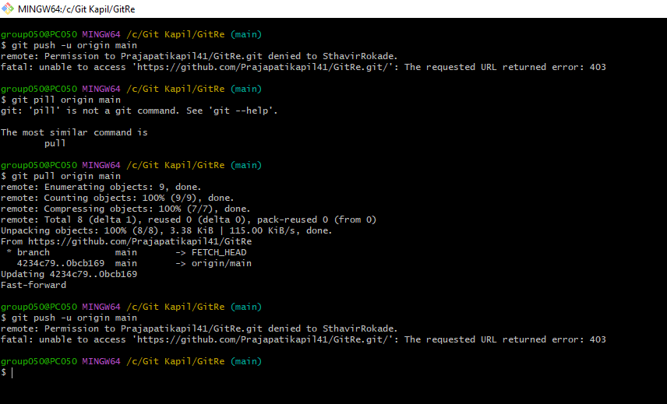
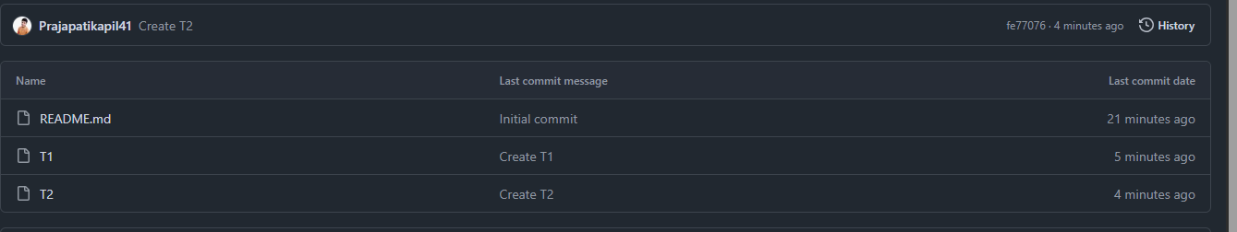

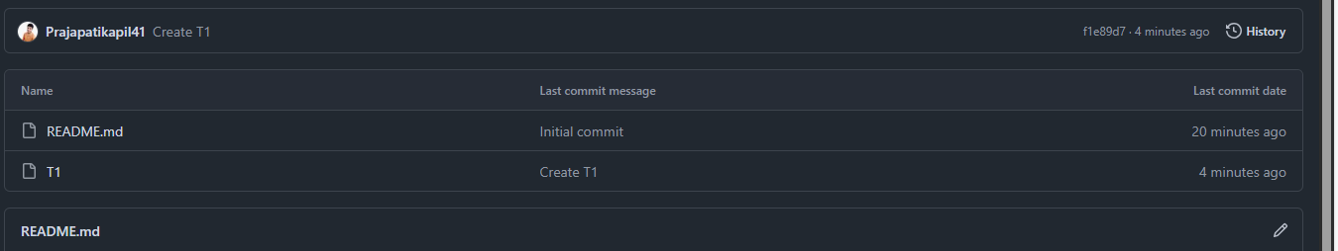

Docker
show how to execute docker command
-start, run, stop container
docker start <img name>
docker run <Cont.. Name>
docker stop <img name>

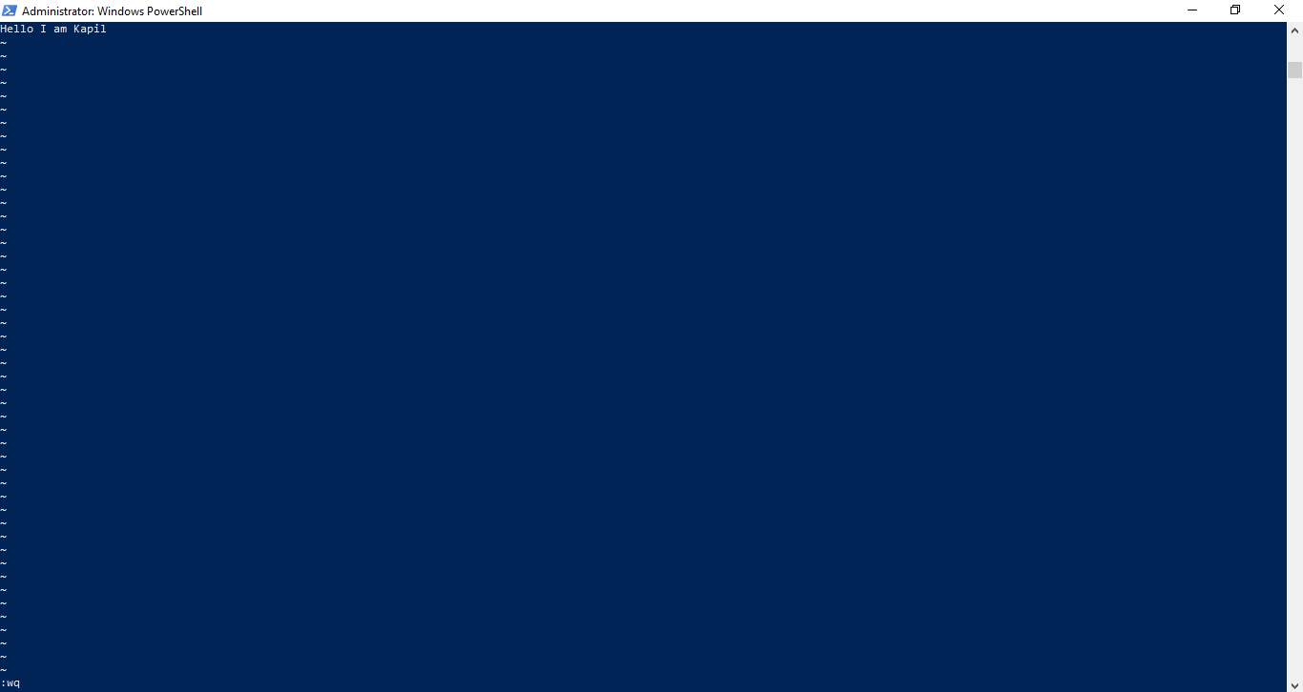
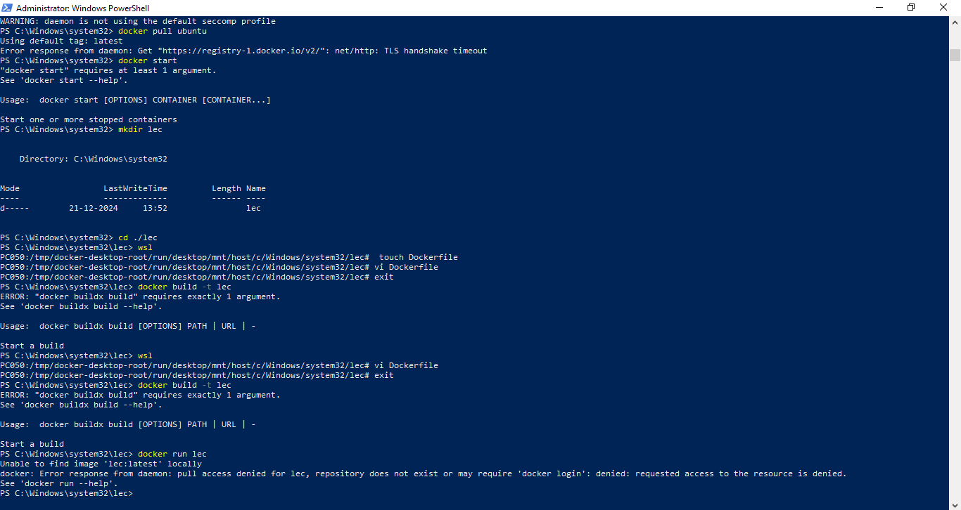

-rm
docker rm <name>
-rmi
docker rmi <name>
-ls
docker ps
docker ps -a
-help
docker run --help

