1. **Creating and renaming files/directories**

* Create a directory named test_dir using mkdir.

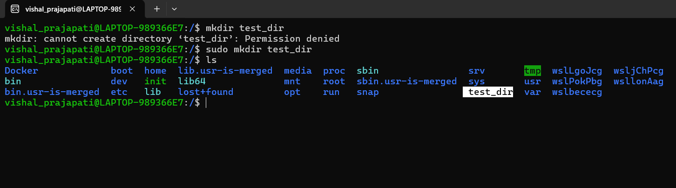

In above screenshot I have highlighted the test_dir directory which is created using mkdir command.

* Inside test_dir, create an empty file called example.txt.

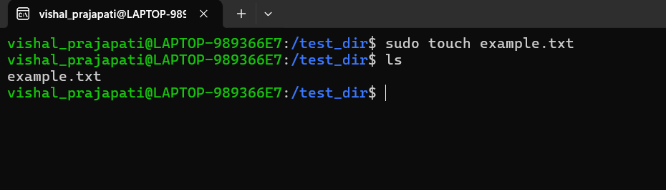

In above screenshot, After creating directory I have create an empty file using touch command named as example.txt.

* Rename example.txt to renamed_example.txt using mv

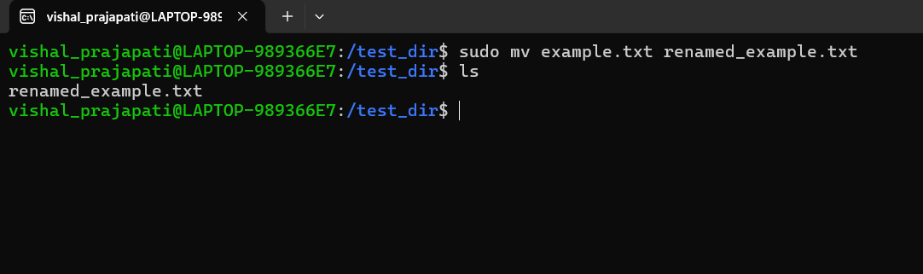

In above screenshot, I rename file example.txt file to renamed_example.txt using mv command.

1. **Viewing File Contents**

* Use cat to display the contents of /etc/passwd.

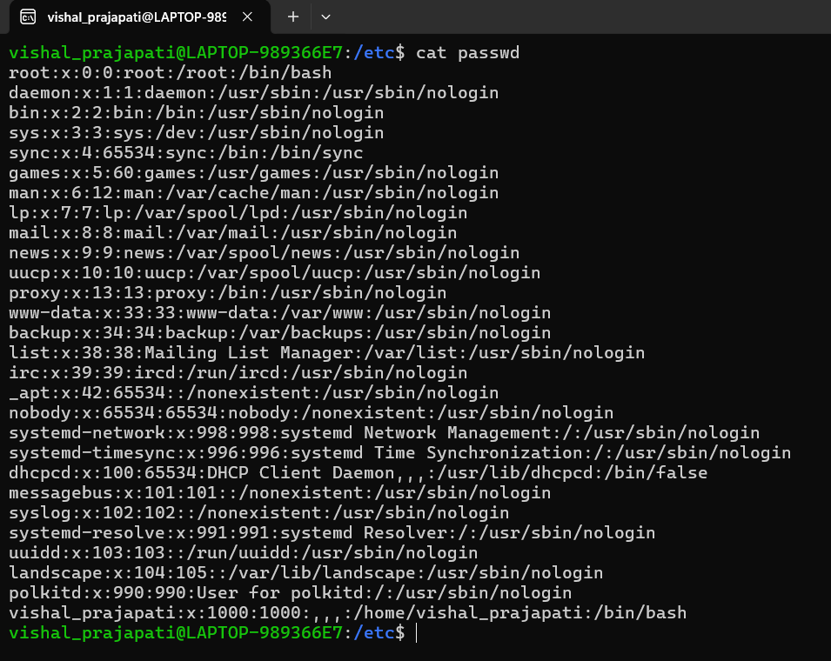

In this screenshot, I have display passwd file using cat command.

* Display only the first 5 lines of /etc/passwd using head.

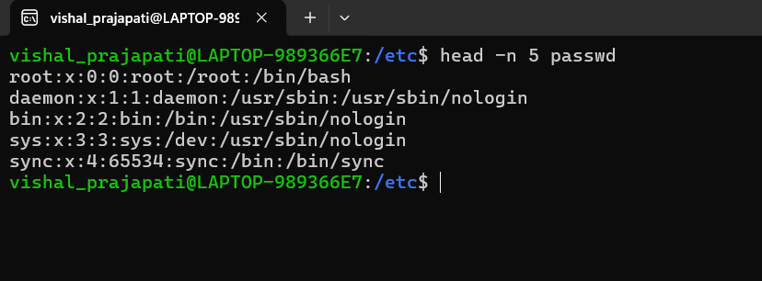

In this screenshot, I have displayed top 5 lines using head command.

* Display only the last 5 lines of /etc/passwd using tail.

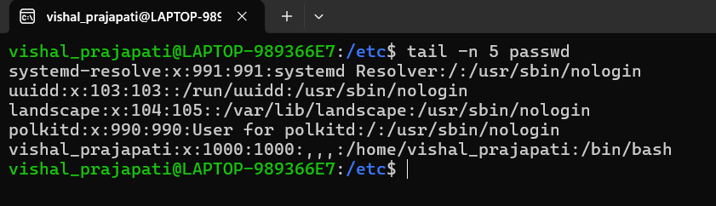

In this screenshot, I have displayed bottom 5 lines using tail command.

1. **Searching for Patterns**

* Use grep to find all lines containing the word "root" in /etc/passwd

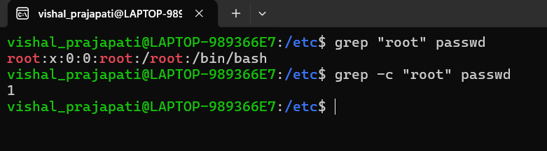

In this screenshot, I have displayed line and count that containing the word “root”.

1. **Zipping and Unzipping**

* Compress the test_dir directory into a file named test_dir.zip using zip.

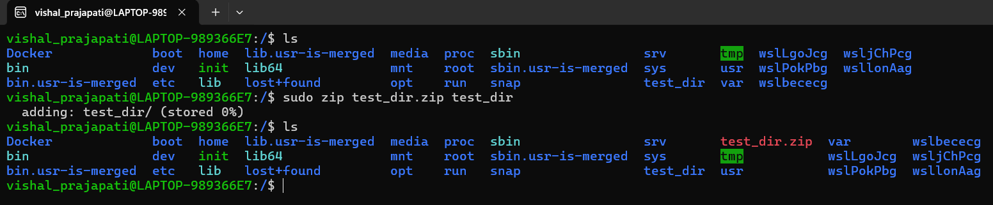

In above screenshot I have compress the test_dir into tezt_dir.zip using zip command.

1. **Downloading Files**

* Use wget to download a file from a URL

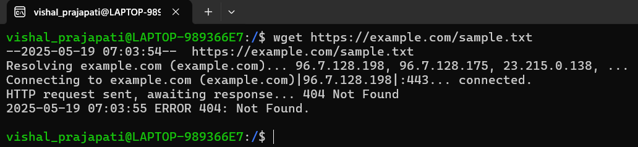

In above screenshot, I have download a file from given url.

1. **Changing Permissions**

* Create a file named secure.txt and change its permissions to read-only for everyone using chmod.

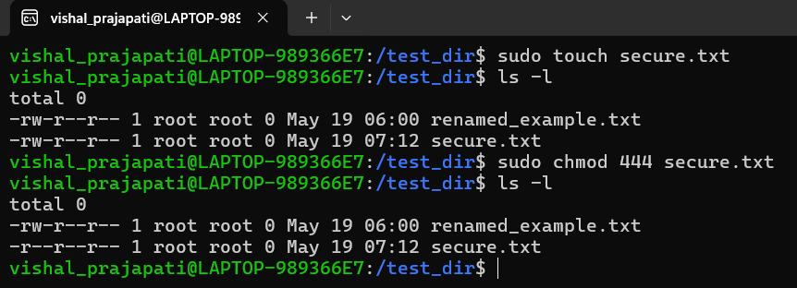

In above screenshot, I have change permission of file from read-write to read only to everyone using chmod command.

1. **Working with Environment Variables**

* Use export to set a new environment variable called MY_VAR with the value "Hello, Linux!".

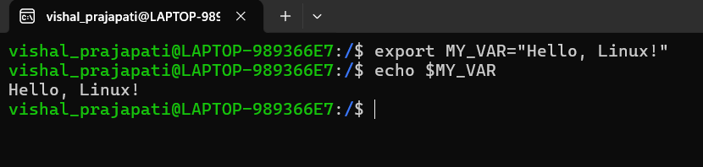

In above screenshot, I have set new variable using export command and displayed the variable using echo command.