# Flask-python Projects

## Project 1: Flask API

* This project is a simple web API.
* When you run it, you can open your browser and go to /api to see some data in JSON format.
* The data comes from a file in the project folder.

### Screenshot Section

* a screenshot of browser showing the JSON data.

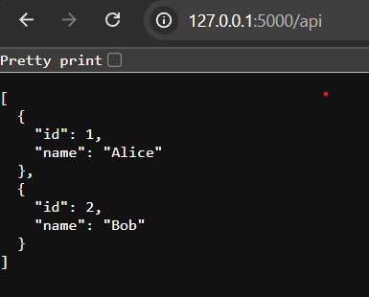

## Project 2: Flask Form with MongoDB

* This project is a simple web form.
* When you fill out the form and submit, your data is saved to a database (MongoDB Atlas).
* If it works, you see a success message. If there is an error, you see an error message on the same page.

### Screenshot Section

* a screenshot of the form page.

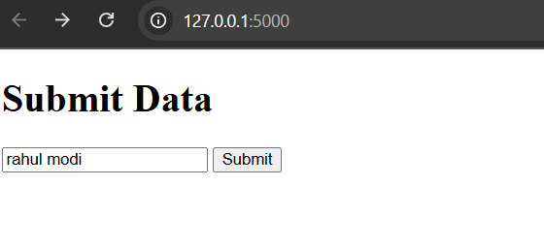

* a screenshot of the success message.

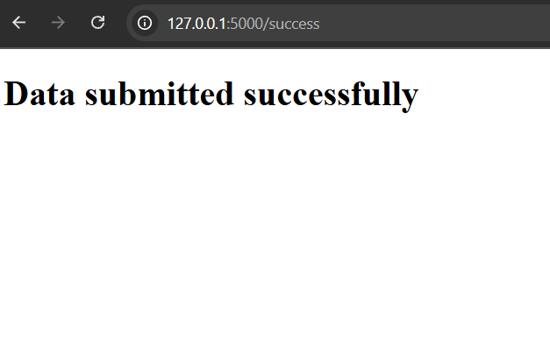

* a screenshot of data in MongoDB Atlas.

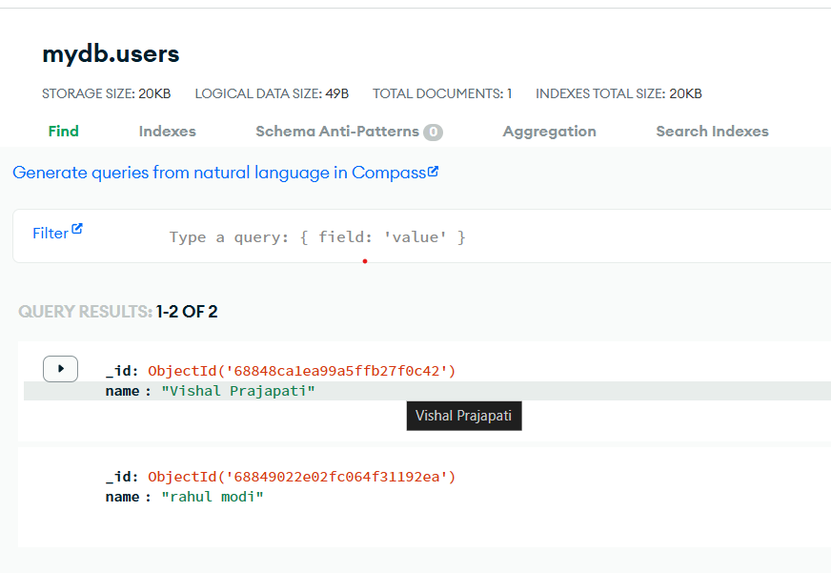

## GitHub Link

* GitHub repository link: https://github.com/Prajapativish29/flask-python-project.git