1. **Grade Checker**

* Take a score as input and print the grade based on the following:

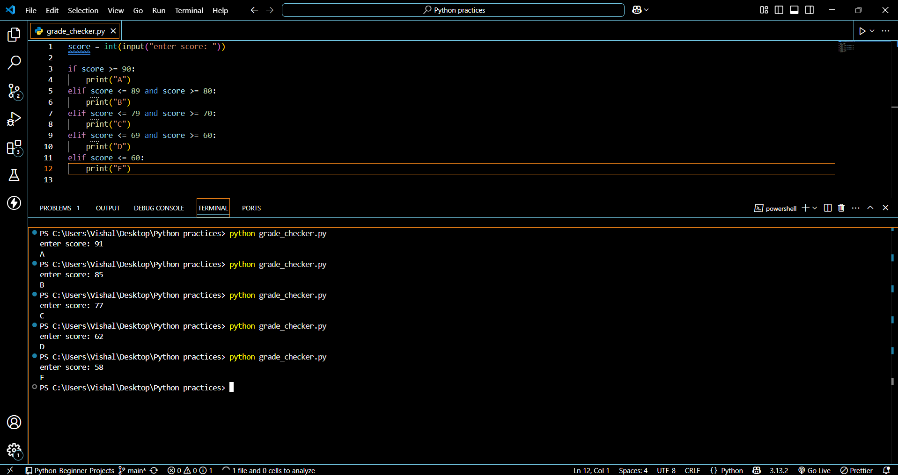

1. **Student Grades**

* Create a dictionary where the keys are student names and the values are their grades. Allow the user to:
* Add a new student and grade.
* Update an existing student’s grade.
* Print all student grades.
* Used dictionary and basic operations. Using if else:

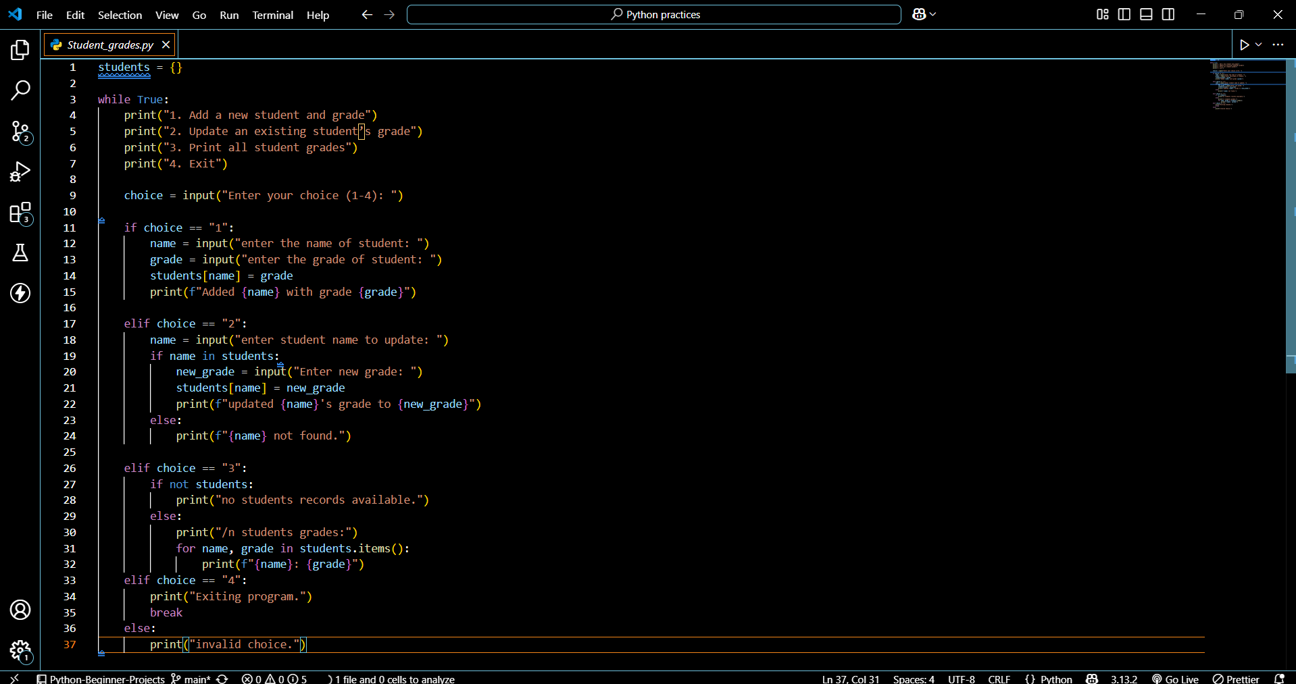

1. **Write to a File**

* Write a program to create a text file and write some content to it. Using file functions like write and open.

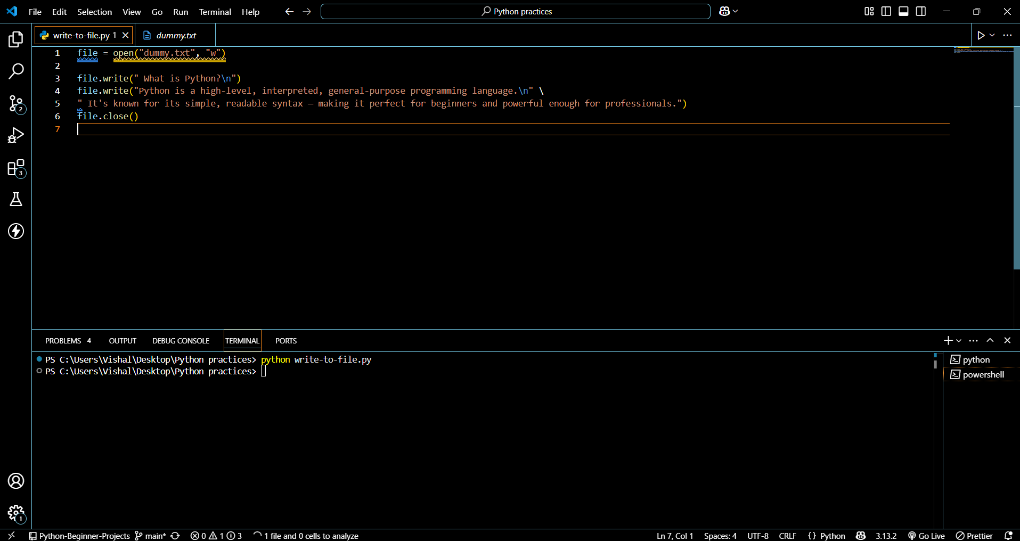

1. **Read from a File**

* We used open in read mode and file. read to read and print to display.

