For line charts:

please enter your from above given options=1

press 1 to print the data for POKEMON v/s HP

press 2 to print the data for POKEMON v/s ATTACK

press 3 to print the data for POKEMON v/s DEFENCE

press 4 to print the data for POKEMON v/s ALL ABILITIES

Enter your choice=___

want to do it again(yes/no)=yes

Figures is shown at back.

For Bar charts:

press 1 for the data for name of pokemon Vs HP

press 2 for the data for name of pokemon Vs Attack

press 3 for the data for name of pokemon Vs Defense

press 4 to merge all the data in one stackbar chart

press 5 to merge all the data in one multibar chart

enter what type of graph u want to see:___

want to do it again(yes/no)=yes

Figures is shown at back.

For Pie charts:

please enter your from above given options=3

press 1 for the data for name of pokemon Vs HP of pokemons

press 2 for the data for name of pokemon Vs Attack strength of pokemons

press 3 for the data for name of pokemon Vs Defense strength of pokemons

enter what type of graph u want to see:___

want to do it again(yes/no)=yes

For all Scatter charts:

please enter your from above given options=4

press 1 for the data for name of pokemon Vs HP

press 2 for the data for name of pokemon Vs Attack

press 3 for the data for name of pokemon Vs Defense

press 4 to merge all the data in one scatter chart

enter what type of graph u want to see:___

want to do it again(yes/no)=yes

For all Histographs:

please enter your from above given options=4

press 1 for the data for name of pokemon Vs HP

press 2 for the data for name of pokemon Vs Attack

press 3 for the data for name of pokemon Vs Defense

press 4 to merge all the data in one scatter chart

enter what type of graph u want to see:___

want to do it again(yes/no)=no

Thanks for viewing our project

program terminated

Intro pie chart: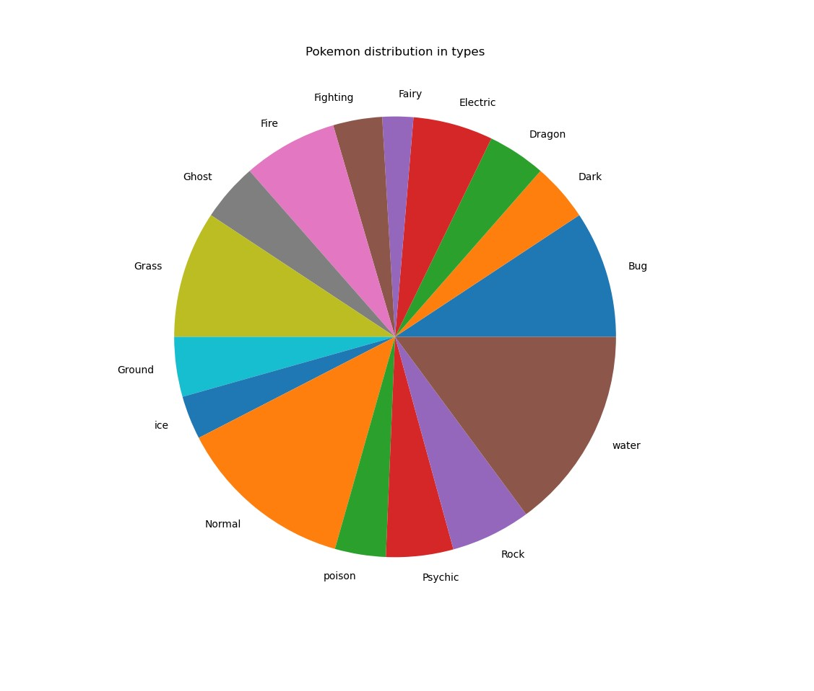

Flowchart:

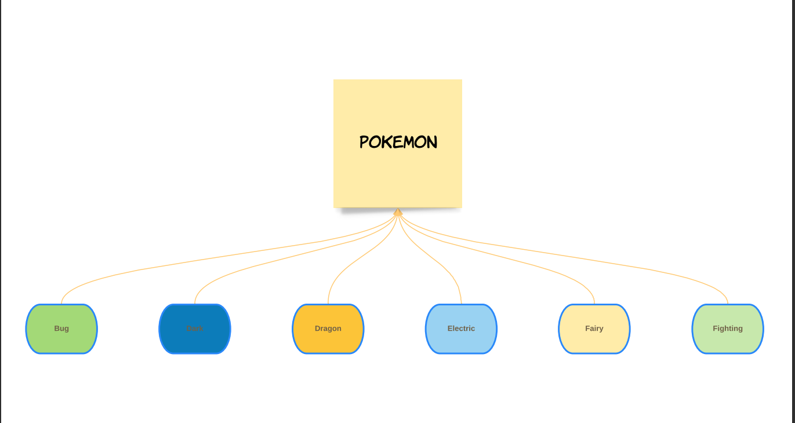

Line Charts:

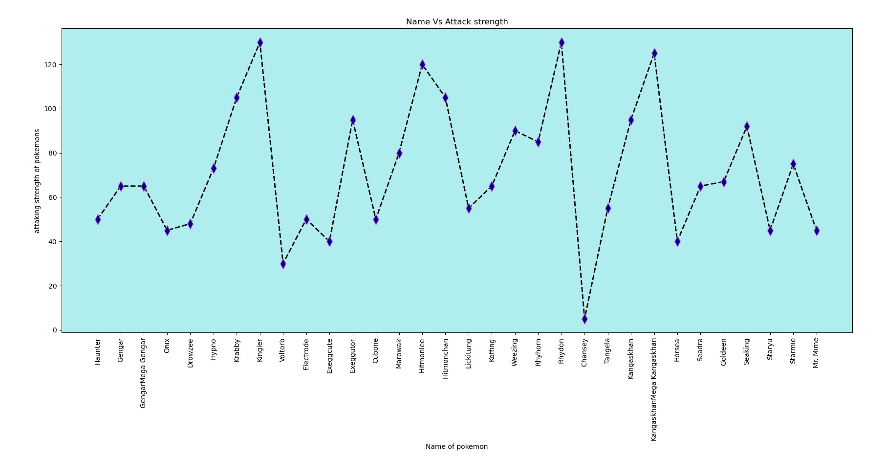

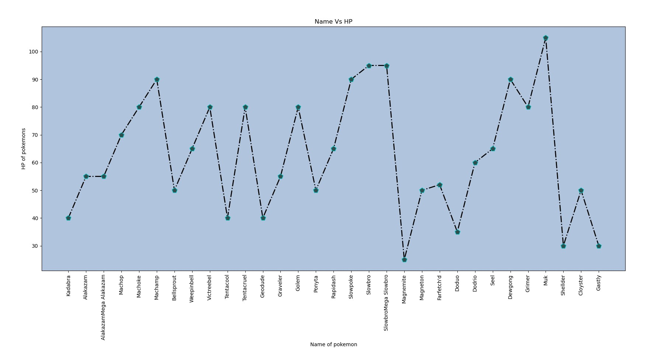

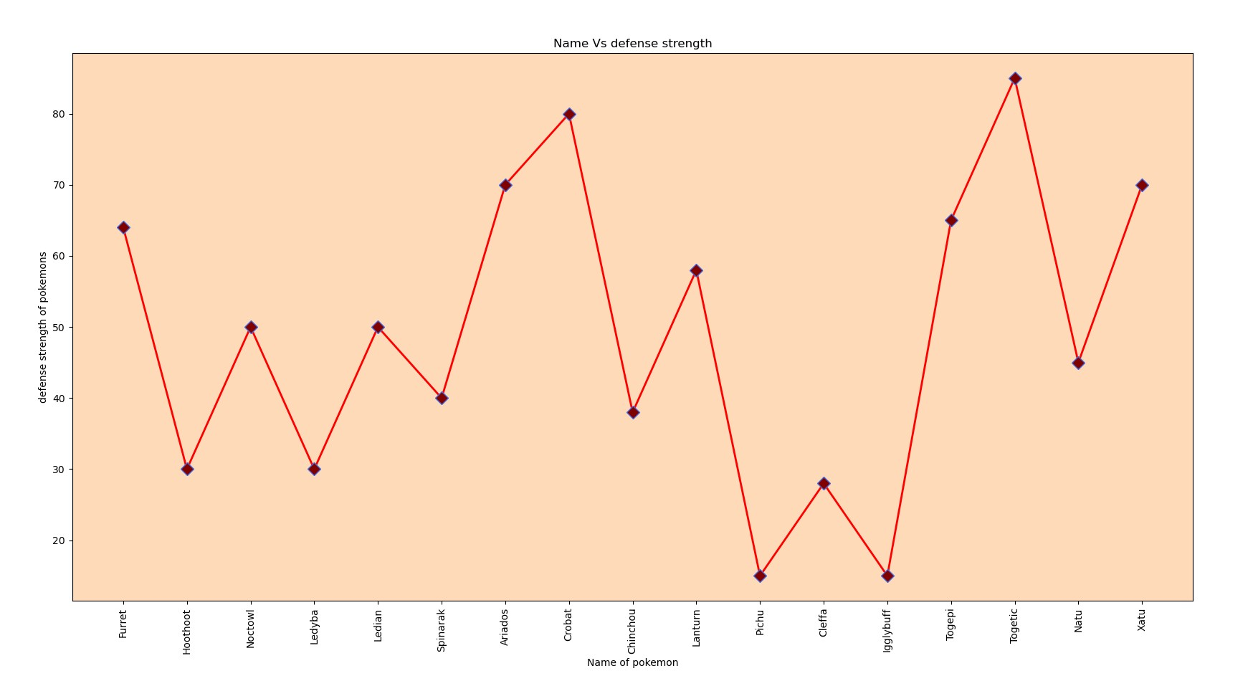

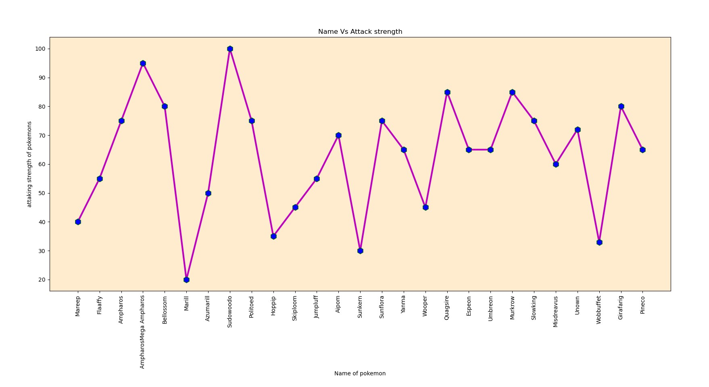

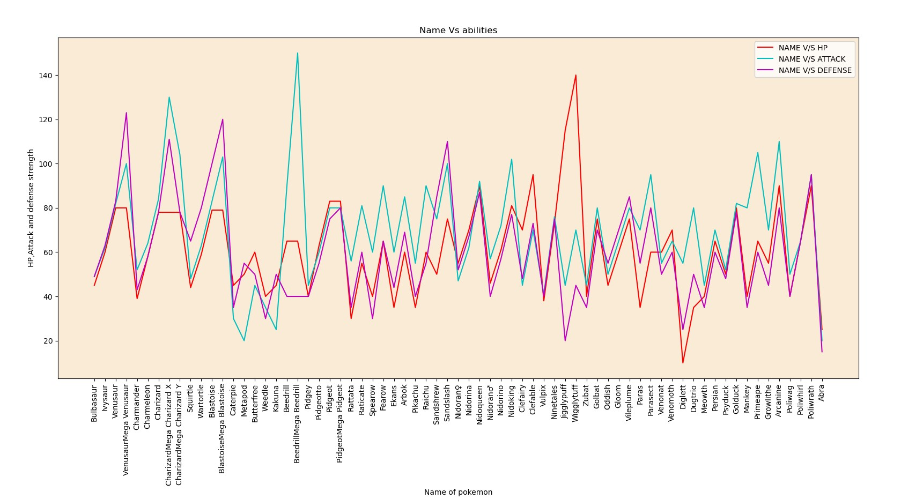

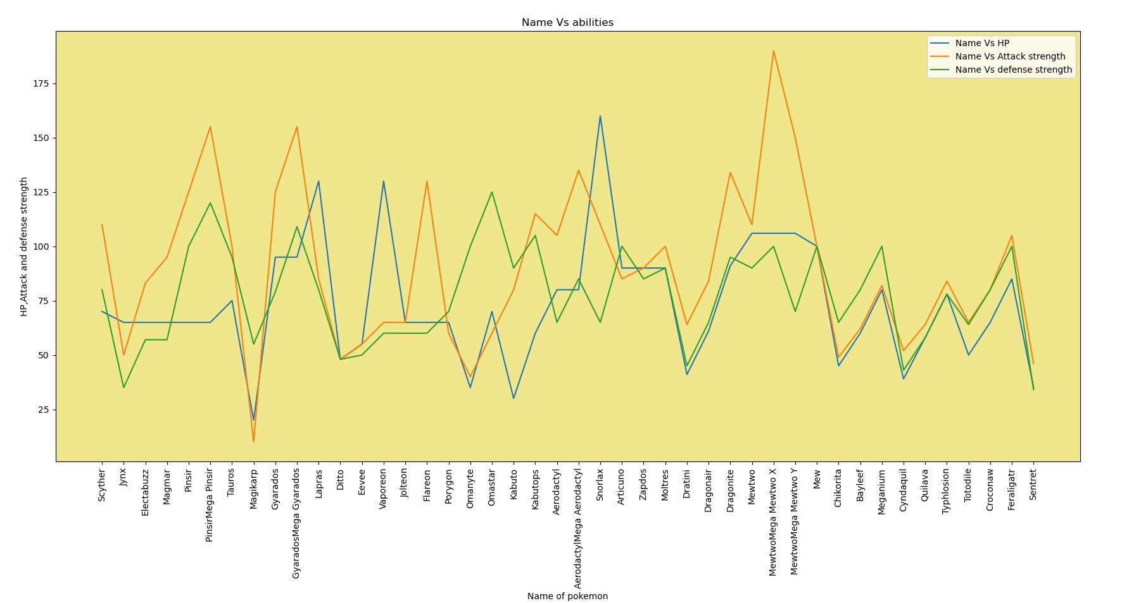

Bar Charts:

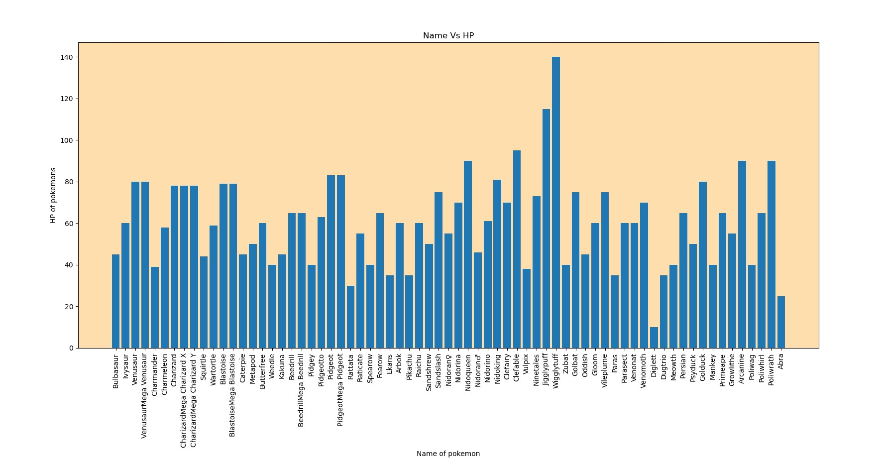

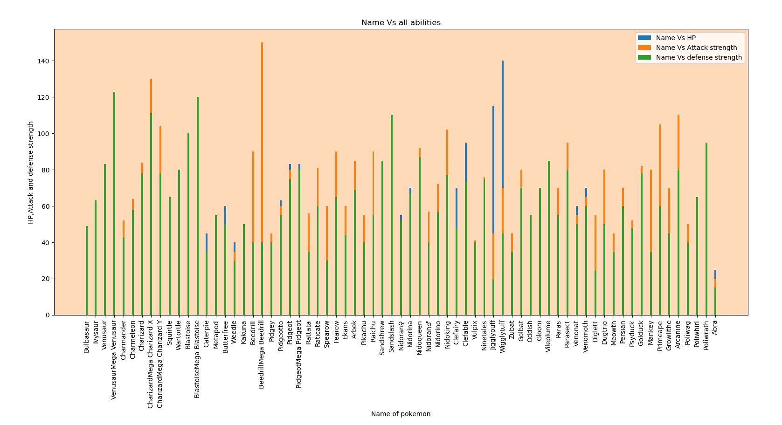

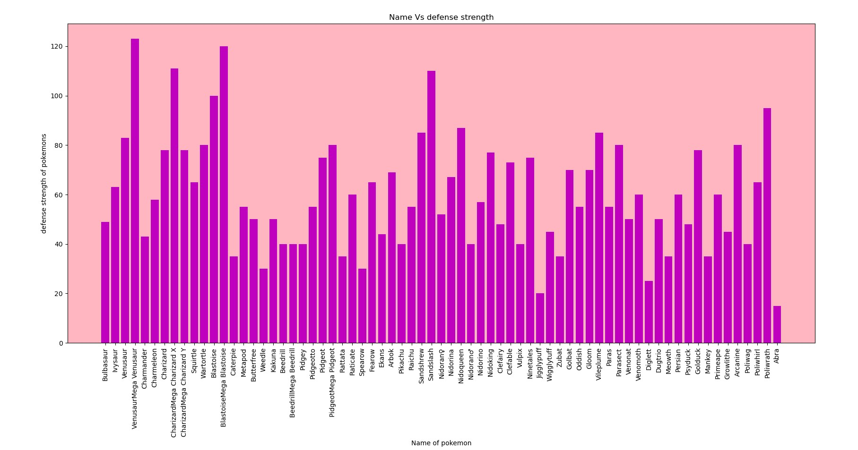

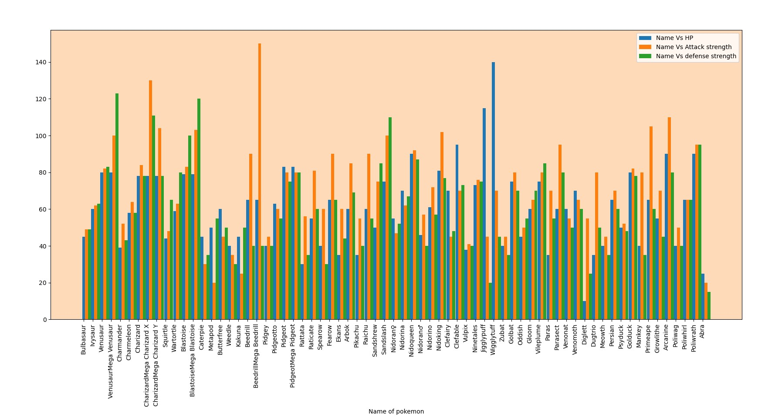

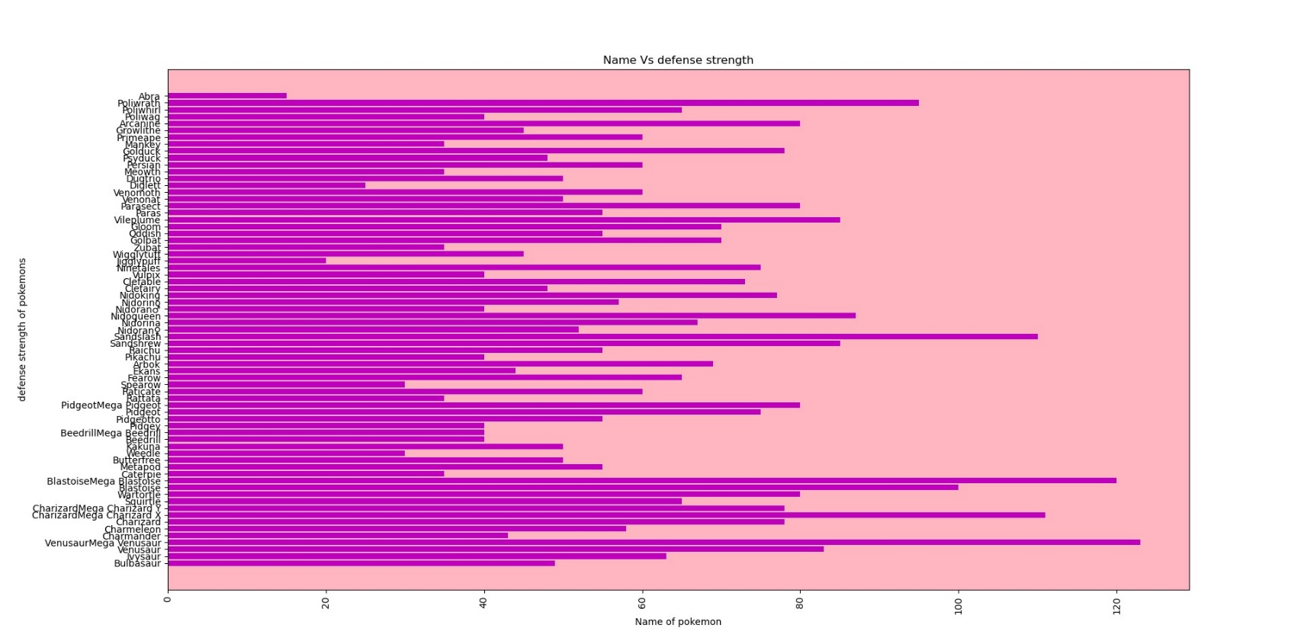

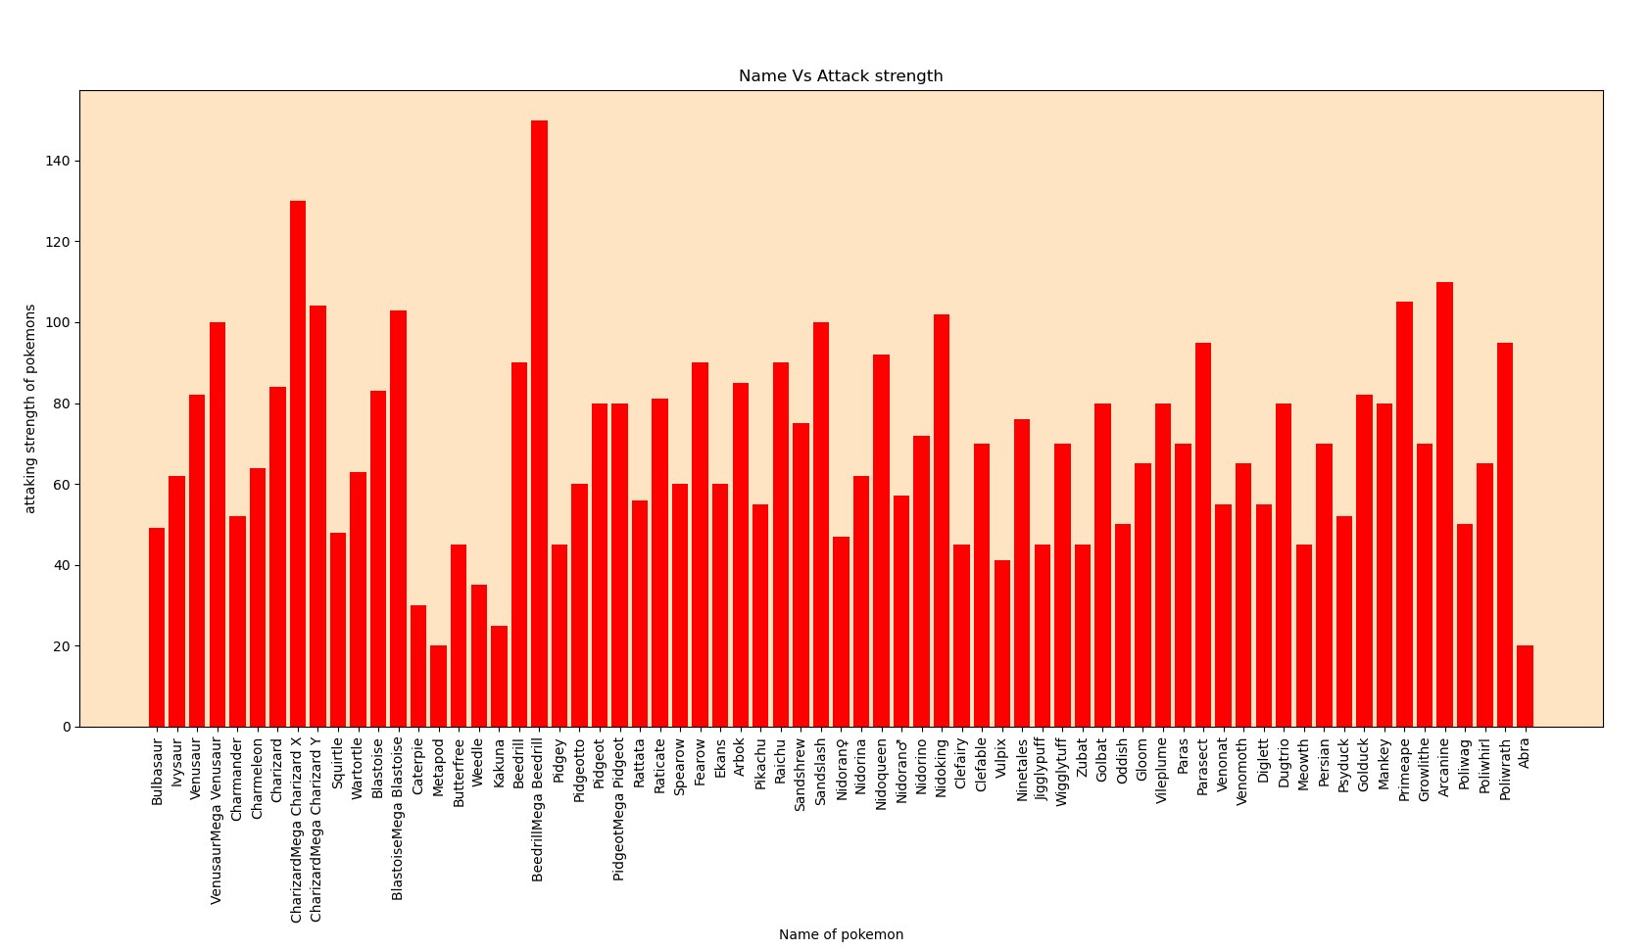

Pie charts: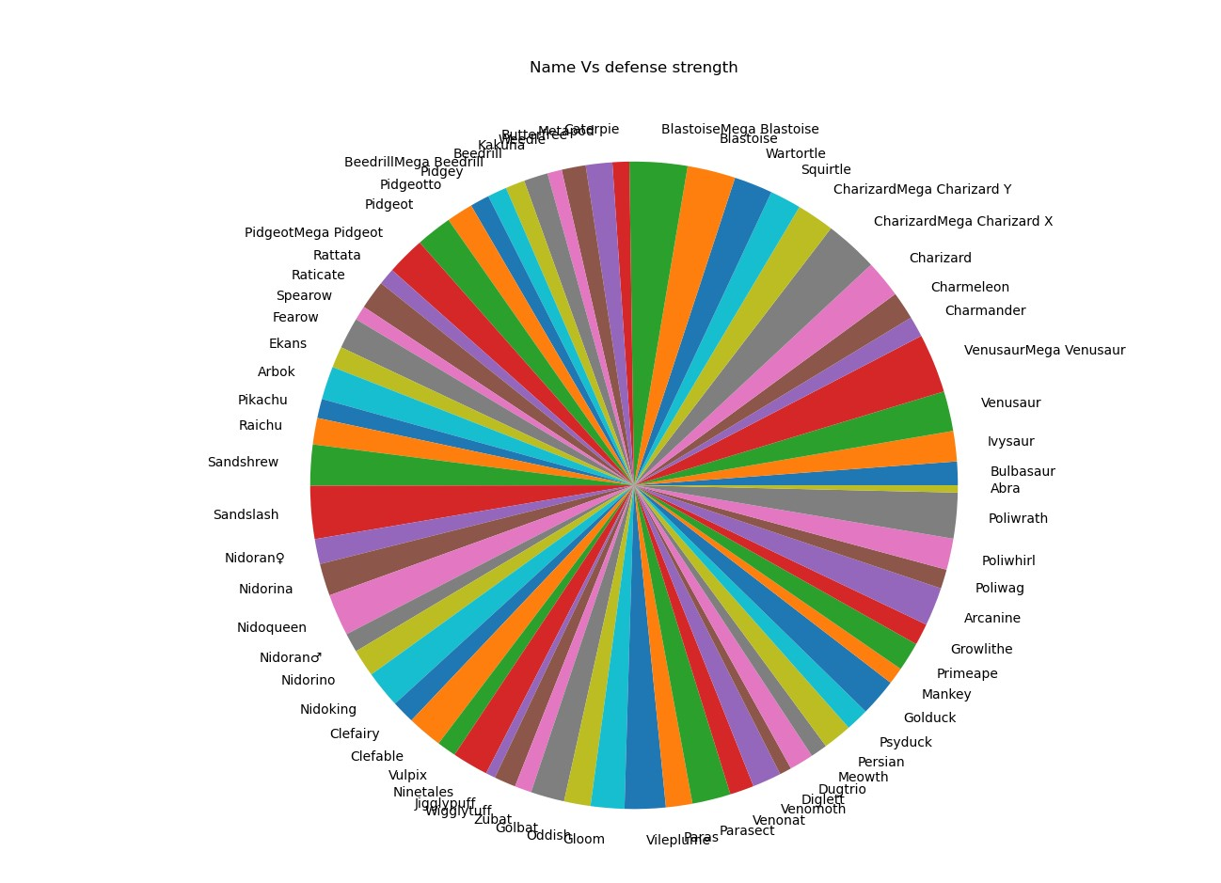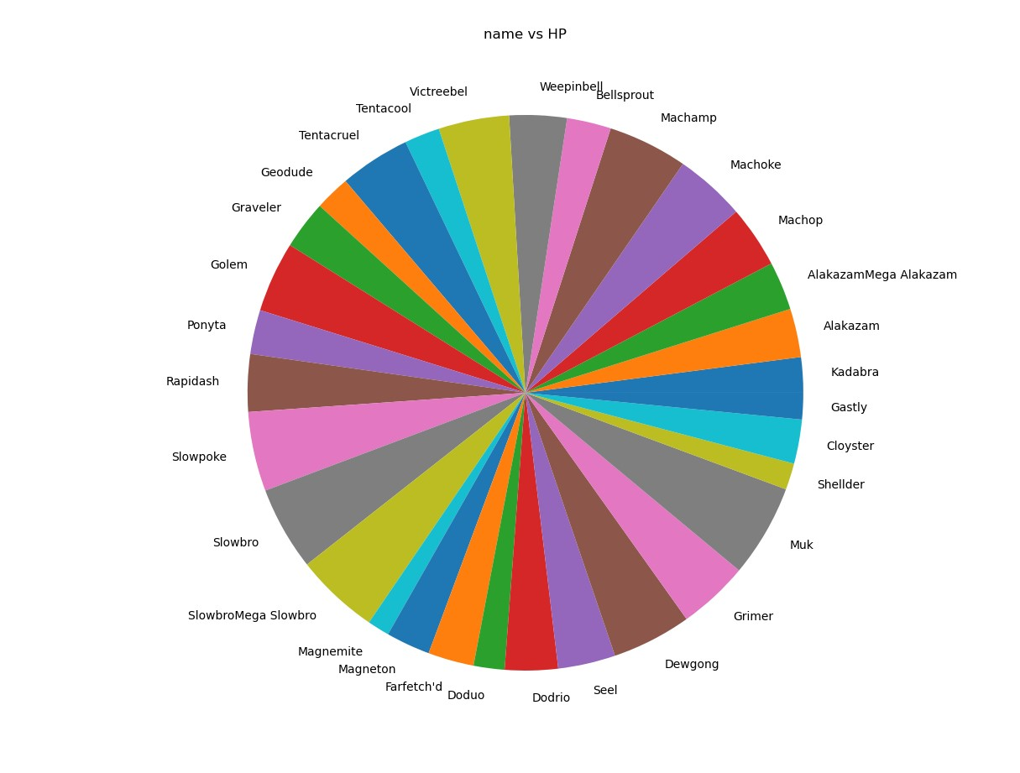

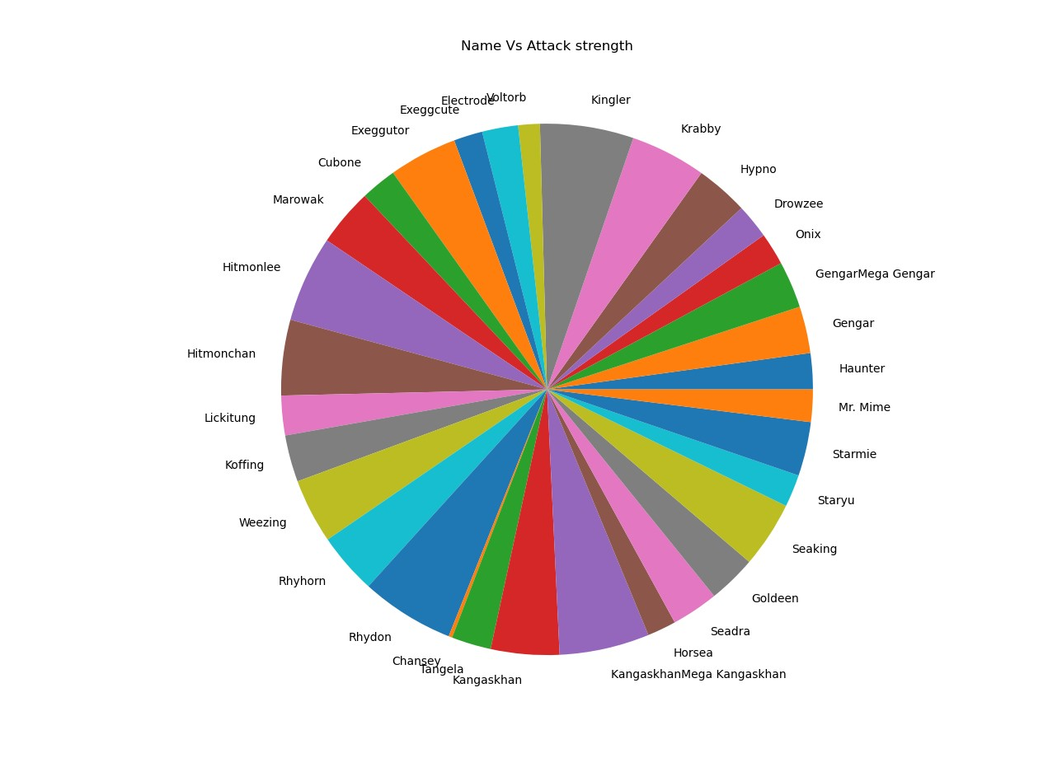

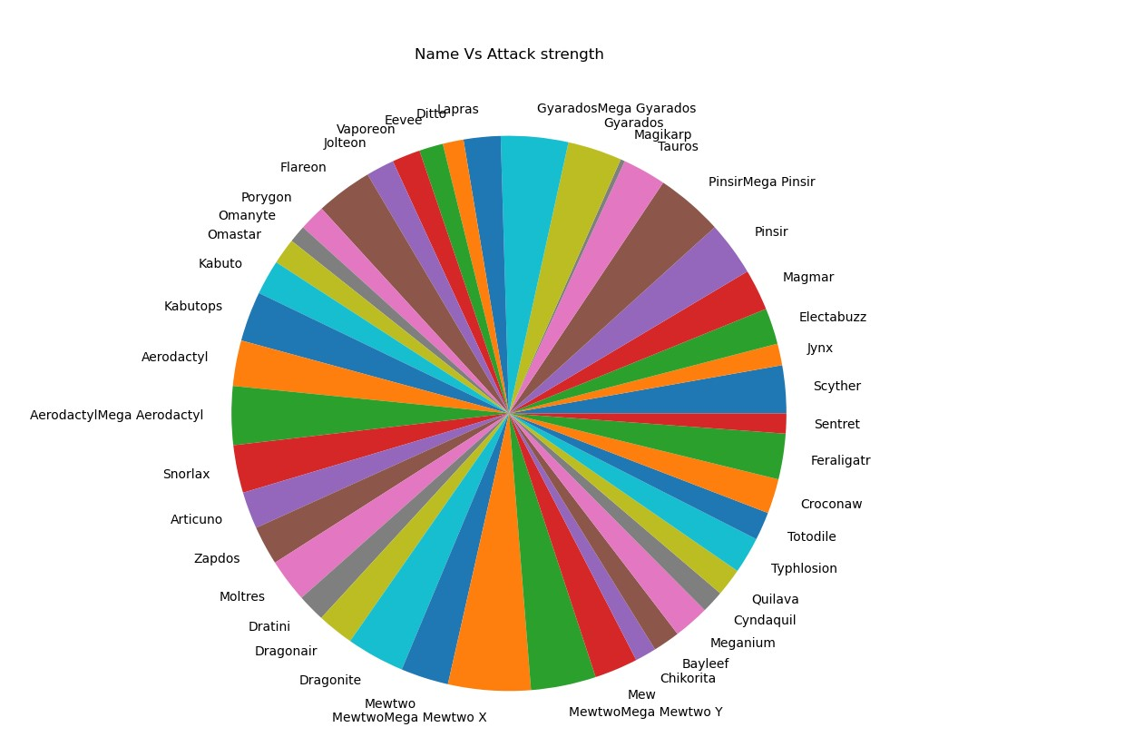

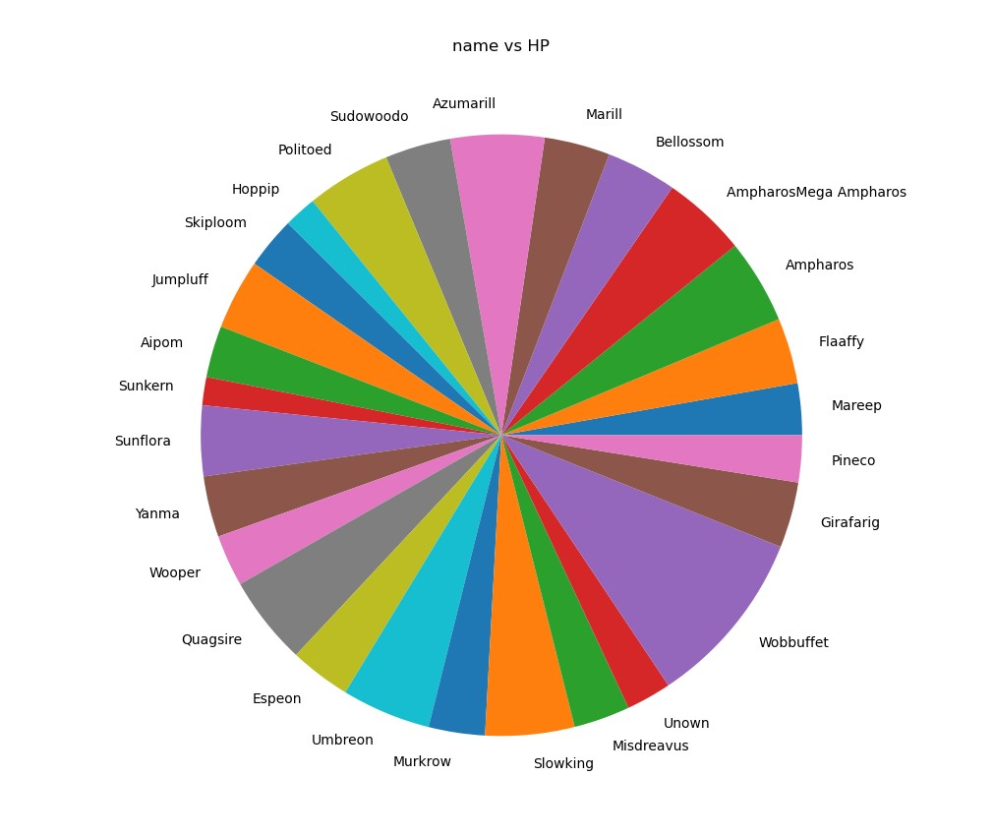

Scatter Charts:

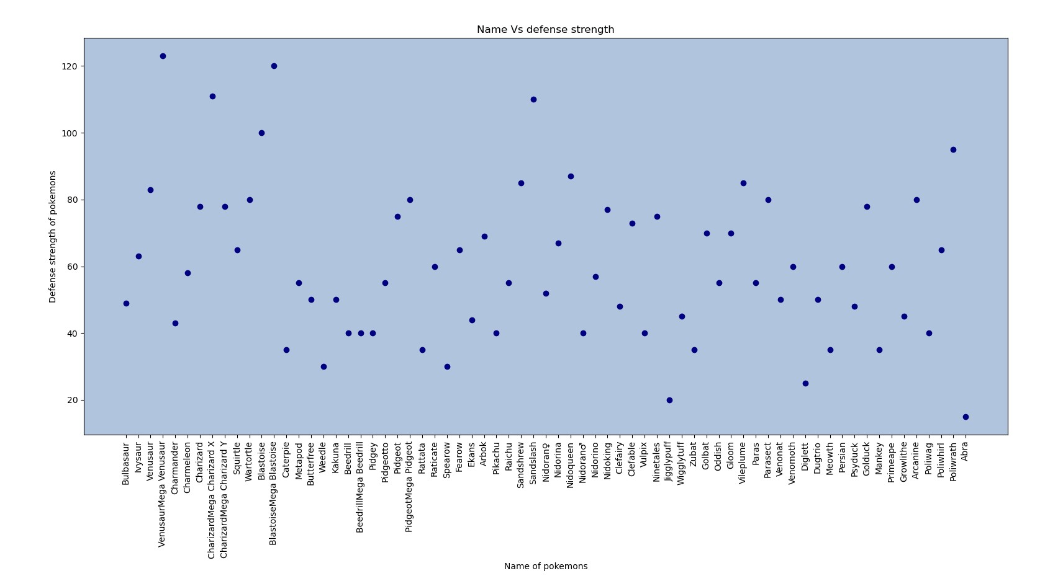

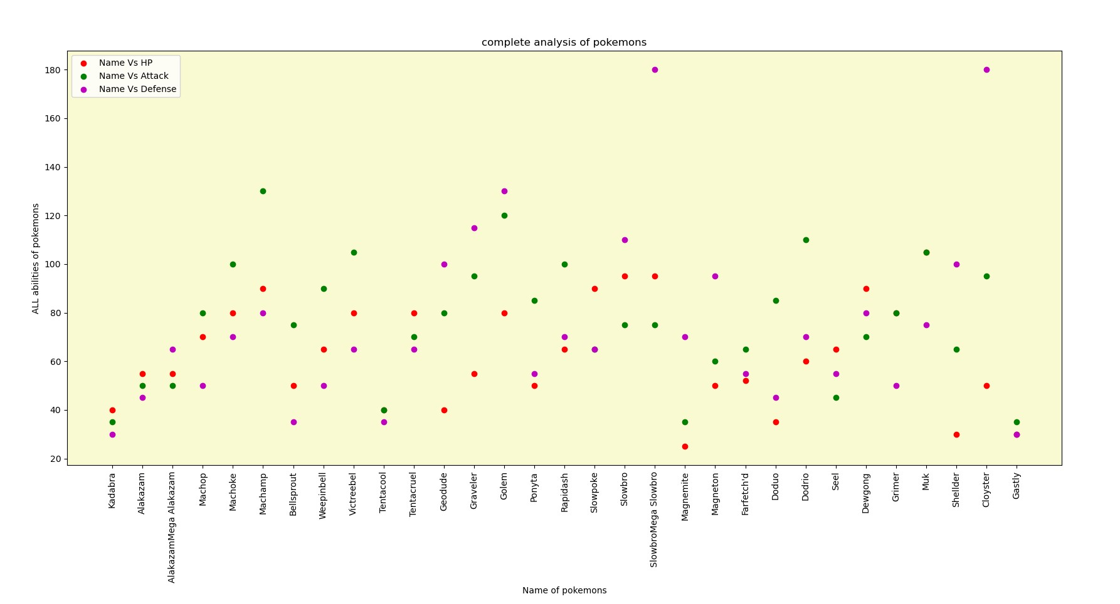

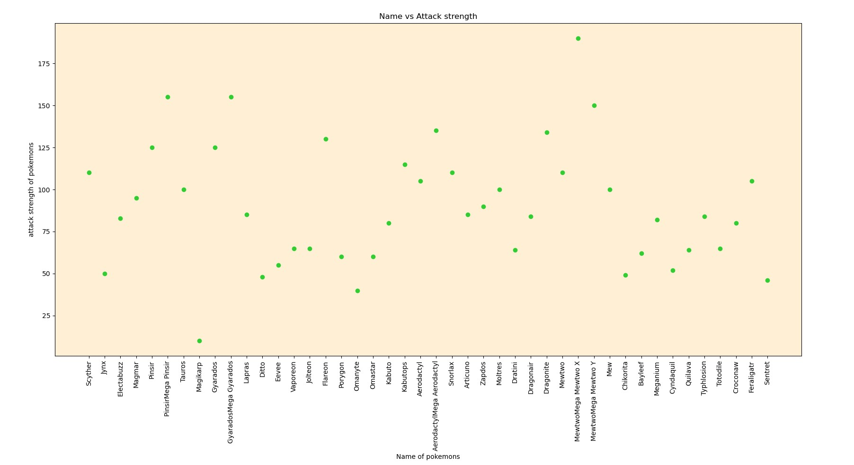

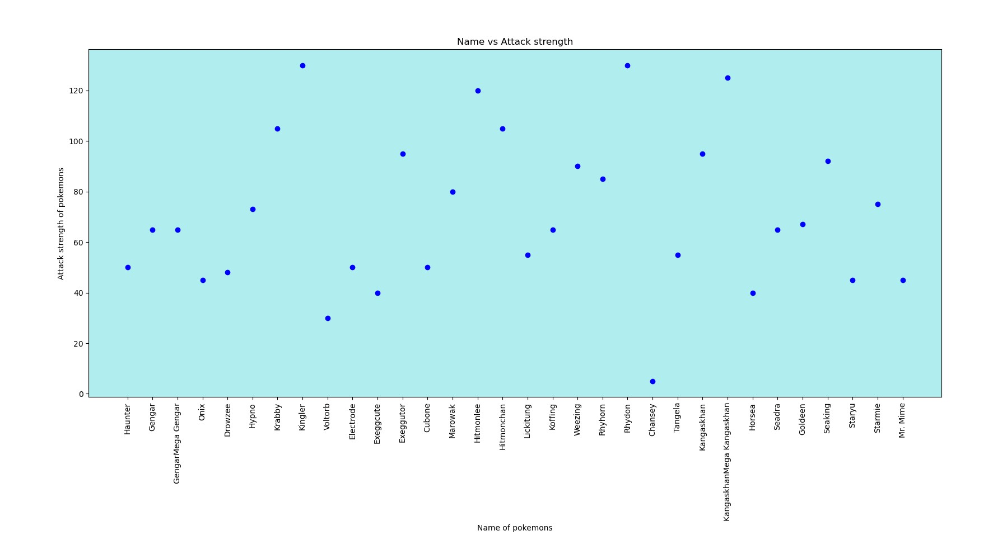

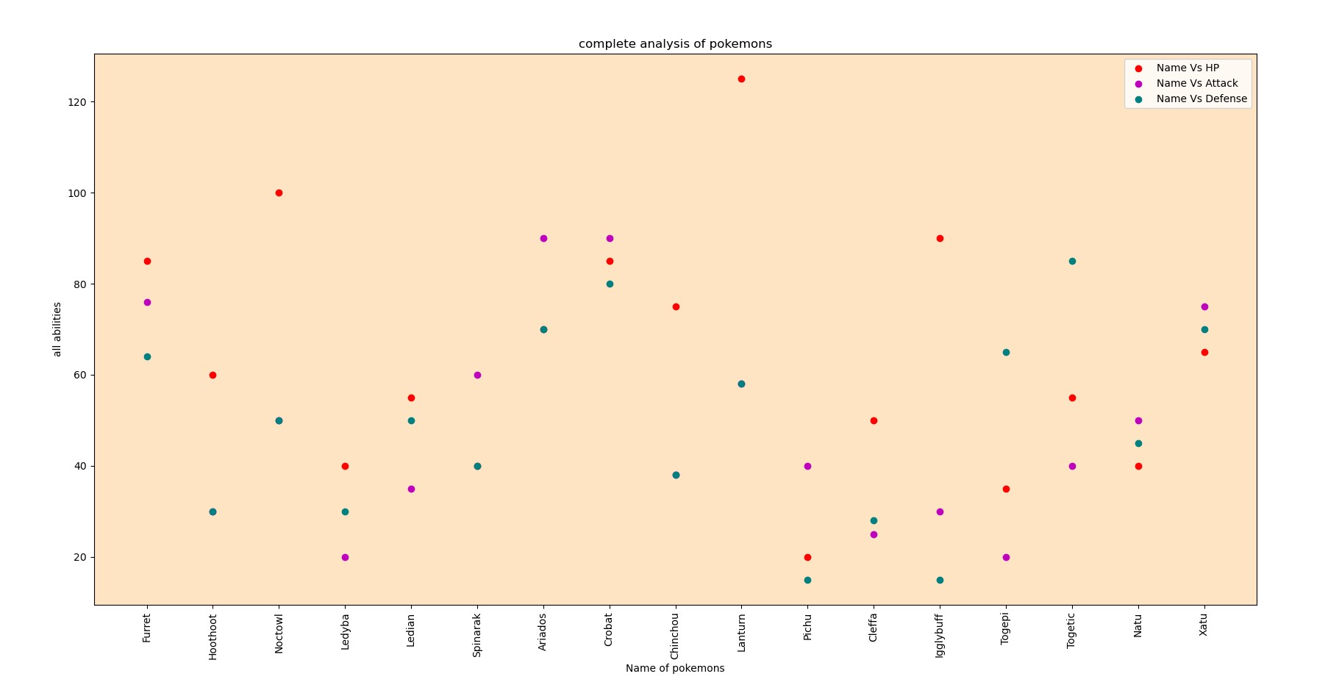

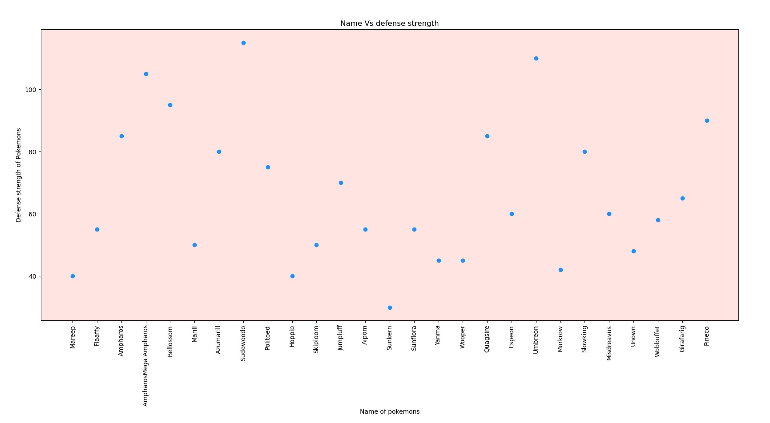

Histographs :

