

DAYANANDA SAGAR UNIVERSITY
Devarakaggalahalli, Harohalli, Kanakapura Road, Bengaluru South Dt. – 562 112

Bachelor of Technology

in
COMPUTER SCIENCE AND ENGINEERING (ARTIFICIAL INTELLIGENCE AND MACHINE LEARNING)
A Project Report On
GenAI -Powered Voice-Enabled Mock Interview Preparation Platform By
V Prajesh – ENG23AM0284
Ryan Francis – ENG23AM0182
Sriya Rani Panda – ENG23AM0282
Sathuluri Anoushka –ENG23AM0186

Under the supervision of Prof. Pradeep Kumar K Assistant Professor
Computer Science & Engineering (AI & ML)

SCHOOL OF ENGINEERING

DAYANANDA SAGAR UNIVERSITY

Department of Computer Science & Engineering (ARTIFICIAL INTELLIGENCE AND MACHINE LEARNING)
Devarakaggalahalli, Harohalli, Kanakapura Road, Bengaluru South Dt. – 562 112
Karnataka, India

CERTIFICATE

This is to certify that the project entitled “ESRGAN powered CCTV-Footage Enhancer” is carried out by V Prajesh(ENG23AM0284), Ryan Franics(ENG23AM0182), Sathuluri Anoushka (ENG23AM0186), Sriya Rani Panda(ENG23AM0282) bonafide students of Bachelor of Technology in Computer Science and Engineering at the School of Engineering, Dayananda Sagar University, Bangalore, in partial fulfillment for the award of a degree in Bachelor of Technology in Computer Science and Engineering, during the year 2025 - 2026.

Prof. Bahubali Shiragapur
Assistant Professor Dept. of CSE (AI&ML) School of Engineering
Dayananda Sagar University Signature .........................
Prof. Pradeep Kumar K
Assistant Professor Dept. of CSE (AI&ML) School of Engineering
Dayananda Sagar University Signature .........................
Dr. Jayavrinda Vrindavanam
Professor & Chairperson Dept. of CSE (AI&ML) School of Engineering Dayananda Sagar University

Signature .........................


Name of the Examiners: Signature with date:

- .......................... .............................

- ............................ .............................

- ............................ .............................

DECLARATION

We, V Prajesh(ENG23AM0284), Ryan Franics(ENG23AM0182), Sathuluri Anoushka (ENG23AM0186), Sriya Rani Panda(ENG23AM0282), are students of the seventh semester B.Tech in Computer Science and Engineering (AI & ML) at the School of Engineering, Dayananda Sagar University. We hereby declare that the Major Project titled “GenAI -Powered Voice-Enabled Mock Interview” has been carried out by us and submitted in partial fulfillment for the award of a degree in Bachelor of Technology in Computer Science and Engineering during the academic year 2025–2026.

Student: Signature

Name 1: Prajesh V -
USN: ENG23AM0284

Name 2: Ryan Francis
USN: ENG23AM0182

Name 3: Sathuluri Anoushka
USN: ENG23AM0186

Name 4: Sriya Rani Panda
USN: ENG23AM0282

ACKNOWLEDGEMENT

It is a great pleasure for us to acknowledge the assistance and support of many individuals who have been responsible for the successful completion of this project work. First, we take this opportunity to express our sincere gratitude to School of Engineering& Technology, Dayananda Sagar University for providing us with a great opportunity to pursue our Bachelor’s degree in this institution.

We would like to thank D r . Udaya Kumar Reddy K R, Dean, School of Engi-neering & Technology, Dayananda Sagar University for his constant encouragement and expert advice. It is a matter of immense pleasure to express our sincere thanks to Dr. Jayavrinda Vrindavanam, Department Chairman, Computer Science and Engineer-ing (Artificial Intelligence and Machine Learning), Dayananda Sagar University, for providing right academic guidance that made our task possible.

We would like to thank our guide Prof. Pradeep Kumar K, Assistant Professor, Dept. of Computer Science and Engineering of Artificial Intelligence and Machine Learning, Dayananda Sagar University for sparing his valuable time to extend help in every step of our project work, which paved the way for smooth progress and the fruitful culmination of the project.

We would like to thank our Project Coordinator Dr. Vinutha N & Prof. Pradeep Kumar K as well as all the staff members of Computer Science and Engineering (AI& ML) for their support. We are also grateful to our family and friends who provided us with every requirement throughout the course. We would like to thank one and all who directly or indirectly helped us in the Project work.

TABLE OF CONTENTS

Section | Topic | Page
1 | INTRODUCTION | 1
1.1 | Background of the Study | 2
1.2 | Comparisons with Previous Studies | 3
2 | PROBLEM DEFINITION AND OBJECTIVE | 4
2.1 | Problem Definition | 4
2.2 | Novelty of Proposed Approach | 6
3 | LITERATURE SURVEY | 7
4 | METHODOLOGY | 10
5 | REQUIREMENTS | 14
5.1 | Hardware Requirements | 14
5.2 | Software Requirements | 15
6 | EXPERIMENTATION | 16
6.1 | Model Selection | 18
7 | RESULTS | 23
8 | CONCLUSION AND FUTURE SCOPE | 27
8.1 | Implications and Future Directions | 28
8.2 | Future Scope | 29
 | REFERENCES | 30

ABSTRACT

The proliferation of Closed-Circuit Television (CCTV) cameras has fundamentally transformed the landscape of modern security, providing continuous monitoring and recording capabilities in both public and private sectors. However, the efficacy of these surveillance systems is frequently compromised by environmental constraints, hardware limitations, and aggressive data compression artifacts. These factors collectively result in low-resolution, noisy, and blurred footage that significantly hinders the identification of crucial elements such as human faces and vehicular license plates. To address these critical challenges, this project introduces ClarityAI, an advanced CCTV footage enhancement and forensic analysis system engineered specifically for the domains of computer vision, digital forensics, and image processing. The primary objective of ClarityAI is to empower forensic investigators, law enforcement agencies, private security firms, and legal professionals with robust, accessible tools to extract actionable intelligence from severely degraded visual data.
ClarityAI is architected as a comprehensive, end-to-end processing pipeline that leverages state-of-the-art deep learning models to perform intricate image and video restoration tasks. The frontend is built using Next.js 14.x, React 18.x, and Vanilla CSS to provide an intuitive, custom Swiss-inspired design, facilitating a seamless and professional user experience. The backend is powered by FastAPI and Uvicorn running on Python 3.10+, ensuring high-performance asynchronous API routing. Crucially, the system features WebSocket integration, allowing for the real-time progress monitoring of computationally intensive enhancement tasks, a vital feature for forensic analysts dealing with time-sensitive investigations. By executing operations locally via PyTorch with CUDA support, alongside OpenCV for frame manipulation and FFmpeg for video muxing, the system maximizes parallel processing efficiency for heavy Artificial Intelligence (AI) workloads while ensuring absolute data privacy and security.
The core functionality of ClarityAI relies on a sophisticated ensemble of highly specialized AI models. It utilizes RealESRGAN (x4plus) to achieve high-fidelity 2x and 4x super-resolution upscaling, effectively restoring fine structural details lost in low-resolution captures without introducing artificial noise. For human-centric analysis, the system integrates GFPGAN (v1.4) to perform blind face restoration, leveraging generative facial priors to recover distinct facial features even in highly compressed and degraded scenarios. Furthermore, ClarityAI addresses vehicular forensics by employing the YOLOv8n object detection model for precise license plate localization and tracking across consecutive video frames, followed by EasyOCR for accurate optical character recognition to extract alphanumeric data. Advanced interactive features, such as dynamic Region of Interest (ROI) selection via an interactive canvas and real-time VRAM monitoring, provide users with granular control over the enhancement process, ensuring that computational resources are focused precisely where they are needed most.

1 INTRODUCTION

The modern security infrastructure is heavily reliant on visual data, with Closed-Circuit Television (CCTV) systems serving as the primary mechanism for monitoring, recording, and deterring criminal activities. In urban environments, commercial establishments, and residential complexes, these surveillance networks generate petabytes of video data daily. While the sheer volume of this data presents a significant opportunity for law enforcement and forensic analysis, the practical utility of this footage is often severely limited. The inherent constraints of continuous video recording—such as the need to conserve storage space and network bandwidth—necessitate the use of highly aggressive compression algorithms. When combined with sub-optimal environmental conditions like low lighting, atmospheric interference, and the fast movement of subjects, the resulting video feeds are frequently plagued by low resolution, motion blur, and pervasive digital noise. Consequently, critical identifying features, most notably human faces and vehicular license plates, become indistinguishable, rendering the footage practically useless for legal or investigative purposes.
ClarityAI is proposed as a comprehensive, AI-driven solution to these persistent challenges. Operating at the intersection of computer vision and digital forensics, ClarityAI provides a sophisticated suite of enhancement tools designed to reconstruct and recover lost visual information from degraded surveillance data. By harnessing the power of deep learning architectures, specifically Generative Adversarial Networks (GANs) and advanced object detection frameworks, the system aims to transform unusable footage into clear, actionable evidence. The target demographic for this platform includes forensic investigators who require rigorous, verifiable enhancement methods, law enforcement agencies operating under tight investigative deadlines, and private security firms seeking to maximize the value of their existing camera hardware. By processing visual data locally utilizing CUDA-enabled PyTorch, the system ensures that sensitive surveillance footage never leaves the host machine, thereby maintaining the strict chain of custody required in legal and forensic domains.
The scope of ClarityAI extends beyond simple image filtering. It is a multi-modal analysis platform that allows users to isolate specific targets through dynamic Region of Interest (ROI) selection, upscaling these targeted areas by factors of 2x or 4x using RealESRGAN. Furthermore, the system autonomously detects and tracks moving license plates across video frames using YOLOv8n, subsequently extracting the alphanumeric characters via EasyOCR. For suspect identification, GFPGAN is employed to blindly restore facial features that have been heavily compressed. The integration of a responsive frontend built on Next.js and a high-performance backend powered by FastAPI ensures that these complex, computationally intensive tasks are accessible through an intuitive, user-friendly interface. Real-time WebSocket communication keeps the user informed of the processing status, frame by frame, while real-time VRAM monitoring prevents hardware overloading during extensive forensic analysis.

  - Background of the Study

The field of forensic image and video analysis has undergone a paradigm shift over the past two decades. Historically, investigators relied on traditional digital signal processing techniques to enhance surveillance footage. These methods primarily included linear and non-linear filtering, histogram equalization for contrast adjustment, and basic interpolation techniques such as bicubic or bilinear scaling for enlargement. While these traditional algorithms were computationally inexpensive, their capacity to recover lost information was fundamentally flawed. Interpolation techniques merely approximate missing pixel values based on neighboring pixels, resulting in an output that is larger but inherently blurry and devoid of new structural details. When applied to the heavily compressed and noisy footage typical of CCTV systems, traditional sharpening filters often amplified the existing noise and compression artifacts, leading to image degradation rather than enhancement.
The advent of Artificial Intelligence, and more specifically, deep convolutional neural networks (CNNs), revolutionized the approach to image restoration. The fundamental limitation of traditional methods was their lack of semantic understanding; they treated an image purely as a matrix of numbers. Deep learning models, however, learn the statistical distribution of visual data from vast datasets of high-resolution images. Through a process known as Super-Resolution (SR), these models can hallucinate missing high-frequency details by predicting what the degraded image should look like based on their learned priors. The introduction of Generative Adversarial Networks (GANs) by Ian Goodfellow and subsequent adaptations for image processing marked a turning point. GANs employ a dual-network architecture—a generator that creates the enhanced image and a discriminator that evaluates its realism—resulting in outputs that are significantly sharper and perceptually closer to real high-resolution images than previous CNN-based approaches.
Despite these advancements, applying these models to real-world CCTV footage remained challenging due to the "blind" nature of the degradation. Unlike controlled datasets where the degradation function (e.g., a simple downsampling blur) is known, real-world surveillance video suffers from a complex, unknown combination of motion blur, sensor noise, optical aberration, and aggressive codec compression. Early AI models trained on synthetic degradations failed when confronted with real-world CCTV data. The current generation of models, such as RealESRGAN and GFPGAN, were specifically engineered to overcome this limitation. They are trained using high-order degradation modeling, simulating the complex, cascading artifacts found in actual surveillance systems. ClarityAI leverages this latest generation of "blind" restoration models, integrating them into a unified, accessible pipeline to bridge the gap between cutting-edge academic research and practical forensic application.

  - Comparisons with Previous Studies

Previous approaches to CCTV enhancement have largely been fragmented, focusing on isolated tasks rather than providing a cohesive forensic pipeline. Many existing proprietary software solutions rely on legacy algorithms that apply basic contrast enhancement and unsharp masking. While these tools offer real-time performance, they consistently fail to reconstruct the high-frequency details necessary for facial recognition or license plate reading when the original input is severely degraded. In contrast, academic studies have frequently demonstrated the superiority of GAN-based models for these specific tasks, but these academic implementations are often confined to command-line interfaces, requiring extensive programming knowledge and complex environment setups that are impractical for the average forensic investigator.
Furthermore, earlier AI-based systems typically applied a single enhancement model to the entire image frame. This approach is highly inefficient and computationally prohibitive, especially when dealing with high-definition video inputs. Enhancing an entire frame when only a small portion (such as a suspect's face or a vehicle's license plate) is relevant to the investigation leads to unnecessary processing delays and hardware bottlenecks. ClarityAI resolves this through the implementation of a dynamic Region of Interest (ROI) selection via an interactive canvas. By allowing the user to precisely define the area requiring enhancement, the system intelligently allocates its computational resources, drastically reducing processing time and enabling the use of heavier, more accurate AI models on the targeted data.
Finally, the integration of distinct analytical tasks within a single ecosystem sets ClarityAI apart from conventional systems. Previous workflows often required investigators to manually extract a frame from a video using one tool, upscale it using a second application, and then attempt to read a license plate or identify a face visually or with yet another disconnected software package. ClarityAI unifies these processes. The system can seamlessly ingest video files, allow the user to define an ROI, automatically track that region across frames, up-scale the imagery, restore facial features, and execute Optical Character Recognition (OCR) in a single, uninterrupted workflow. The inclusion of real-time WebSocket communication for progress tracking and hardware VRAM monitoring ensures that this unified process remains transparent, predictable, and stable, marking a significant advancement over the fragmented and opaque methodologies of the past.

2 PROBLEM DEFINITION AND OBJECTIVE

2.1 Problem Definition
The core problem addressed by ClarityAI is the pervasive inadequacy of visual evidence captured by standard Closed-Circuit Television (CCTV) surveillance systems. Despite the widespread deployment of these cameras in urban monitoring, retail loss prevention, and traffic control, the quality of the recorded media frequently falls below the threshold required for definitive forensic analysis. This degradation is not a singular flaw but the result of a compounding series of technical and environmental factors. Firstly, to maintain months of continuous recording on limited storage arrays, DVR and NVR systems employ aggressive lossy compression algorithms (such as H.264 or H.265 at low bitrates). This compression discards crucial high-frequency image data, manifesting as macro-blocking, ringing artifacts, and the complete obliteration of fine textures such as facial pores or the crisp edges of alphanumeric characters on license plates.
Secondly, surveillance cameras are often positioned to cover wide areas, resulting in a low spatial resolution for individual subjects within the frame. A person or a vehicle may occupy only a fraction of the total pixel area, meaning their defining features are represented by an insufficient number of pixels. When investigators attempt to zoom in on these subjects using standard software, the image simply becomes pixelated and illegible. Furthermore, environmental variables such as insufficient ambient lighting introduce severe sensor noise, while the fast movement of vehicles or running suspects causes motion blur due to low shutter speeds. When these factors combine—low resolution, aggressive compression, sensor noise, and motion blur—the resulting footage is highly degraded. Forensic analysts are subsequently left struggling to extract identifying information, causing critical delays in law enforcement investigations and compromising the integrity of digital evidence in legal proceedings.
The lack of specialized, accessible, and integrated software exacerbates this issue. Existing commercial enhancement tools are often prohibitively expensive and rely on outdated interpolation techniques that cannot reconstruct lost data. Conversely, open-source AI models capable of true data restoration are highly fragmented, lacking intuitive graphical user interfaces and requiring advanced programming expertise to deploy, execute, and monitor. There is a critical absence of a cohesive, user-friendly platform that harnesses modern deep learning architectures specifically tailored for the rigors and workflow requirements of digital forensics.
2.2 Novelty of Proposed Approach
The novelty of the ClarityAI system lies in its holistic, integrated approach to forensic image and video enhancement, bridging the gap between advanced deep learning research and practical, user-centric application. Unlike traditional linear enhancement tools or fragmented AI scripts, ClarityAI provides a unified ecosystem where complex tasks such as super-resolution, blind face restoration, object tracking, and optical character recognition are seamlessly interwoven. The system's architecture allows these disparate AI models—RealESRGAN, GFPGAN, YOLOv8n, and EasyOCR—to operate synergistically rather than in isolation, streamlining the investigative workflow and drastically reducing the time required to extract actionable intelligence from raw footage.
A key innovation of the proposed approach is the implementation of dynamic Region of Interest (ROI) selection combined with interactive canvas tracking. Recognizing that applying computationally heavy generative models to entire video frames is inefficient and practically impossible for extended footage, ClarityAI empowers the user to define specific bounding boxes around subjects of interest. The system intelligently focuses its CUDA-accelerated processing power exclusively on these regions. This targeted enhancement not only expedites the processing timeline but also prevents the AI from hallucinating unnecessary details in irrelevant background areas, thereby preserving the overall contextual integrity of the forensic evidence.
Furthermore, the architectural design of ClarityAI introduces a novel level of transparency and resource management to AI-driven forensic analysis. The integration of WebSocket technology facilitates real-time, bidirectional communication between the Python/FastAPI backend and the Next.js frontend. This enables precise task progress tracking and real-time monitoring of GPU Video RAM (VRAM) utilization. In forensic scenarios, where system stability is paramount and processing crashes can result in lost time or corrupted evidence workflows, providing the user with live hardware metrics ensures that the system operates within safe computational limits. This combination of targeted AI application, real-time hardware monitoring, and an elegant, Swiss-inspired interface represents a significant paradigm shift from the opaque, black-box processing typical of previous forensic enhancement software.

3 LITERATURE SURVEY

The domain of image and video enhancement has been the subject of extensive academic research, transitioning rapidly from traditional digital signal processing to sophisticated deep learning methodologies. Traditional techniques, widely utilized before the advent of accessible GPU computing, primarily relied on interpolation algorithms such as nearest-neighbor, bilinear, and bicubic scaling. While these methods are mathematically sound and computationally efficient, they are fundamentally limited by their inability to synthesize new information. When an image is enlarged using bicubic interpolation, the algorithm estimates the values of new pixels by averaging the surrounding existing pixels. This inherently smooths the image, reducing high-frequency contrast and failing entirely to recover the sharp edges necessary for facial identification or license plate recognition. Furthermore, traditional noise reduction filters, such as Gaussian or median blurs, often compound the problem by eliminating fine textural details along with the digital noise, leading to an unnatural, plastic-like appearance in the enhanced footage.

The introduction of Super-Resolution Convolutional Neural Networks (SRCNN) marked the beginning of the AI-driven era in image processing. Unlike interpolation, which relies on strict mathematical formulas, deep learning models learn the complex, non-linear mapping between low-resolution and high-resolution images from vast training datasets. However, early CNN models struggled to produce perceptually convincing textures, often outputting images that, while mathematically accurate according to metrics like Peak Signal-to-Noise Ratio (PSNR), appeared blurry to the human eye. This limitation was decisively overcome by the introduction of Generative Adversarial Networks (GANs). RealESRGAN (Real-world Enhanced Super-Resolution Generative Adversarial Network), utilized within the ClarityAI pipeline, represents the pinnacle of this approach. RealESRGAN is specifically designed to handle "blind" super-resolution. It is trained using a complex, high-order degradation modeling process that artificially introduces synthetic camera blur, sensor noise, JPEG compression artifacts, and ringing to high-resolution images, forcing the generator network to learn how to reverse these specific real-world corruptions. The adversarial training process ensures that the upscaled outputs (by factors of 2x or 4x) maintain high-fidelity structural integrity without introducing unnatural artifacts.
In the specific context of human identification, general super-resolution models often fail to accurately reconstruct the nuanced geometry of the human face. To address this, ClarityAI integrates GFPGAN (Generative Facial Prior GAN). Research in face restoration indicates that utilizing prior knowledge embedded in pre-trained face GANs (such as StyleGAN) significantly improves the recovery of heavily degraded faces. GFPGAN leverages these generative facial priors to provide "blind" face restoration. When confronted with a low-resolution, noisy face extracted from CCTV footage, GFPGAN does not merely upscale the pixels; it projects the degraded input into the latent space of a highly trained facial generator. This allows the model to reconstruct distinct facial features—such as the eyes, nose, and mouth structures—with a high degree of realism and fidelity, even when the original input is severely corrupted by compression algorithms, making it an invaluable tool for forensic facial analysis.

For vehicular tracking and identification, the system relies on the integration of YOLOv8n and EasyOCR. The YOLO (You Only Look Once) family of models revolutionized object detection by framing the task as a single regression problem, simultaneously predicting bounding boxes and class probabilities directly from full images in one evaluation. YOLOv8n, the nano version of the eighth iteration, provides state-of-the-art accuracy while maintaining a very low computational footprint, making it ideal for the real-time processing of video frames. Once YOLOv8n accurately localizes a license plate within the frame, the cropped region is passed to EasyOCR. EasyOCR is a robust optical character recognition framework built on PyTorch, utilizing a CNN architecture for feature extraction and a Recurrent Neural Network (RNN) combined with Connectionist Temporal Classification (CTC) to decode the sequential text data. Research indicates that this combination of deep feature extraction and sequence modeling allows EasyOCR to accurately read text even when the license plate is skewed, partially obscured, or subjected to uneven lighting conditions common in outdoor surveillance footage. By synthesizing these advanced, specialized models into a cohesive pipeline, ClarityAI addresses the multifaceted challenges of modern forensic video analysis.

4 METHODOLOGY

The methodology behind ClarityAI is structured around a highly optimized, asynchronous data processing pipeline that seamlessly connects a modern web frontend with a powerful, GPU-accelerated deep learning backend. The primary design philosophy is to execute computationally intensive AI tasks locally, ensuring maximum performance while strictly maintaining the data privacy required for sensitive forensic evidence. The architecture is broadly divided into three interactive layers: the User Interface (UI) Layer, the Application Programming Interface (API) and Communication Layer, and the AI Core Processing Layer. This decoupled architecture allows for efficient resource management, real-time user feedback, and robust error handling during complex media manipulation tasks.
The User Interface Layer is engineered using Next.js 14.x and React 18.x, employing Vanilla CSS to create a bespoke, Swiss-inspired design. This design philosophy emphasizes typographic clarity, ample whitespace, and strict grid alignments, ensuring that the forensic investigator is presented with a distraction-free, highly functional workspace. The frontend facilitates the uploading of media assets (images or video files) and provides an interactive canvas. This canvas allows the user to visually draw and define a Region of Interest (ROI) around specific subjects, such as a suspect's face or a vehicle's license plate. Once the parameters and the specific AI enhancement tasks (e.g., 4x Upscaling, Face Restoration, OCR) are selected, the frontend transmits this configuration to the backend via RESTful endpoints. Simultaneously, it establishes a persistent WebSocket connection to listen for real-time processing updates and hardware telemetry.

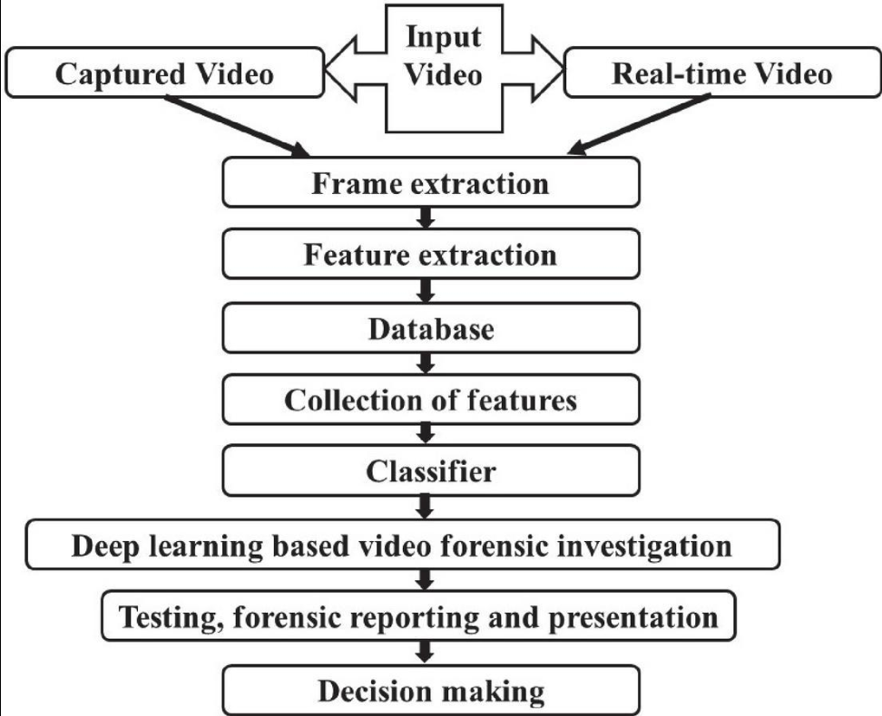

The Application Programming Interface (API) Layer is built upon FastAPI and deployed via Uvicorn, operating on Python 3.10+. FastAPI was selected for its native support for asynchronous programming, which is crucial for handling long-running AI inference tasks without blocking subsequent requests. When a request is received, the backend validates the payload and initiates the AI workflow. For video files, the data flow begins with frame extraction utilizing OpenCV. The video is systematically deconstructed into individual frames, and the user-defined ROI coordinates are mapped to each frame. To maintain temporal consistency, FFmpeg is employed for advanced video multiplexing (muxing), ensuring that once the individual frames are processed, they are accurately reassembled into a cohesive video file with the original framerate and audio tracks preserved.
The AI Core Processing Layer forms the computational heart of the system. Depending on the user's configuration, the extracted ROI frames are passed into the respective deep learning pipelines utilizing PyTorch with CUDA acceleration. If facial restoration is requested, the tensor data is routed to the GFPGAN (v1.4) model, which operates in a blind restoration paradigm to reconstruct facial geometries. If general enhancement is required, the data is passed to the RealESRGAN (x4plus) model for high-fidelity super-resolution. For vehicular analysis, YOLOv8n scans the ROI for license plates, and upon positive detection, the cropped tensor is forwarded to EasyOCR for alphanumeric extraction. Throughout this execution, a dedicated monitoring thread continuously polls the NVIDIA GPU via CUDA libraries to track VRAM allocation. This telemetry, along with the current frame processing status, is streamed back to the frontend via the established WebSocket connection. This ensures that the user interface is continuously updated with granular progress bars and hardware health metrics, preventing system timeouts and providing a transparent, verifiable forensic enhancement process.

5 REQUIREMENTS

5.1 Hardware Requirements

The execution of ClarityAI requires a specific hardware configuration due to the computationally intensive nature of local deep learning inference and high-definition video frame manipulation. The system is designed to bypass cloud infrastructure to maintain absolute data privacy, necessitating robust local hardware.
Processor (CPU): A high-performance multi-core processor is required to handle the rigorous demands of video decoding, frame extraction via OpenCV, and video muxing using FFmpeg. A minimum of a modern quad-core processor (such as an Intel Core i5 or AMD Ryzen 5 series) is necessary, though an octa-core processor (Intel Core i7/i9 or AMD Ryzen 7/9) is highly recommended to prevent CPU bottlenecking during the data preparation phases before passing tensors to the GPU.
Graphics Processing Unit (GPU): The GPU is the most critical hardware component in the ClarityAI architecture. Because the system relies heavily on PyTorch and CUDA-accelerated deep learning models (RealESRGAN, GFPGAN, YOLOv8n), a dedicated NVIDIA GPU is mandatory. The GPU must support modern CUDA compute capabilities. A minimum of 6GB of Video RAM (VRAM) is required to load the models into memory and process standard-resolution images. However, for processing high-definition video frames and utilizing the x4plus upscaling models efficiently without encountering Out-Of-Memory (OOM) errors, an NVIDIA GPU with 8GB to 12GB of VRAM (e.g., RTX 3060, RTX 4070 or higher) is strongly recommended.
Random Access Memory (RAM): Deep learning workflows and video processing require significant system memory to buffer frames and manage application states. A minimum of 16GB of system RAM is required. For processing prolonged CCTV video files or operating multiple asynchronous tasks simultaneously, 32GB of RAM is highly recommended to ensure the operating system does not resort to utilizing slower page files.
Storage: The processing of video files generates a massive amount of temporary data (individual extracted frames) before they are remuxed into the final output. Therefore, a high-speed Solid State Drive (SSD) utilizing the NVMe protocol is mandatory. A minimum capacity of 512GB is required, with 1TB or more recommended to accommodate the storage of large surveillance video files, the heavy PyTorch model weights (.pth files), and the temporary processing caches.
Peripheral Devices: Standard input devices (mouse and keyboard) are required for precise interaction with the UI canvas to draw accurate Regions of Interest (ROI). A high-resolution monitor (minimum 1080p, with 4K recommended) is necessary for forensic investigators to visually inspect the enhanced footage and verify the accuracy of the restored details.
5.2 Software Requirements
Operating System: ClarityAI is engineered to be platform-agnostic at the code level, but due to its reliance on specific hardware acceleration, it requires an operating system with robust GPU driver support. Windows 10/11 or a modern Linux distribution (such as Ubuntu 22.04 LTS) are highly recommended due to their native and stable support for NVIDIA CUDA toolkits and drivers.
Backend Infrastructure:
- Python 3.10+: The backend is entirely written in Python, requiring version 3.10 or higher to leverage advanced asynchronous features and type hinting.
- FastAPI & Uvicorn: FastAPI is utilized as the core web framework due to its exceptional speed and native support for ASGI (Asynchronous Server Gateway Interface), with Uvicorn serving as the high-performance ASGI server.
- PyTorch (CUDA Support): PyTorch is the primary deep learning tensor library used to execute the AI models. It must be installed with specific CUDA toolkit bindings that match the host machine's NVIDIA drivers to enable GPU acceleration.
- OpenCV (cv2): Required for programmatic image and video manipulation, including frame-by-frame extraction, array conversions, and image resizing operations.
- FFmpeg: A mandatory command-line tool integrated into the pipeline for handling complex audio/video codec operations and remuxing the processed frames back into standardized video formats.
Frontend Infrastructure:
- Next.js 14.x: Utilized as the React framework for building the user interface, handling client-side routing, and managing application state.
- React 18.x: The core library for building the interactive UI components, particularly the canvas used for drawing ROI bounding boxes.
- Vanilla CSS: Employed for styling the application, ensuring a lightweight, custom Swiss-inspired design without the overhead of heavy utility frameworks.
- WebSocket API: Native browser support for WebSockets is required to establish the real-time, bidirectional communication channels used for progress tracking and VRAM monitoring.
Development Tools: Visual Studio Code (or equivalent IDE) with Python and JavaScript language servers for code management. Node Package Manager (npm) or Yarn is required for managing frontend dependencies, while pip is utilized for managing the backend Python environment.

6 EXPERIMENTATION

The experimentation phase for ClarityAI was rigorously designed to evaluate the system's efficacy, stability, and performance across a spectrum of simulated real-world forensic scenarios. The primary objective was to ensure that the integration of diverse AI models—specifically RealESRGAN, GFPGAN, YOLOv8n, and EasyOCR—functioned synergistically within the unified pipeline without causing memory leaks, excessive processing bottlenecks, or system failures. The testing environment was configured on a local workstation equipped with an Intel Core i7 processor, 32GB of system RAM, and an NVIDIA RTX 3080 GPU with 10GB of VRAM, running on a Windows 11 operating system with the latest CUDA 11.8 toolkit installed.
Testing setup and inputs focused on a diverse dataset mimicking the degraded nature of actual CCTV surveillance footage. The input media varied significantly in resolution, ranging from highly compressed 480p footage up to standard 1080p captures that had been artificially degraded. To test the robustness of the specific AI models, the input data included intentional visual corruptions: Gaussian noise to simulate low-light sensor artifacts, motion blur to simulate fast-moving vehicles and subjects, and aggressive JPEG/H.264 compression artifacts to replicate standard DVR storage methodologies. The inputs were categorized into three primary testing tracks: facial recognition targets (requiring GFPGAN), vehicular license plate targets (requiring YOLOv8n and EasyOCR), and general scene enhancement targets (requiring RealESRGAN x4plus).
Evaluation metrics in forensic image processing differ slightly from standard computer vision benchmarks. While mathematical metrics such as Peak Signal-to-Noise Ratio (PSNR) and Structural Similarity Index (SSIM) provide a baseline for calculating the difference between the original and processed images, they often fail to capture perceptual quality. Therefore, alongside these computational metrics, the experimentation heavily relied on qualitative visual inspection by simulated forensic standards. For the OCR pipeline, the evaluation metric was straightforward Character Error Rate (CER) and Word Error Rate (WER) against a known ground truth. For performance evaluation, the metrics recorded were frames per second (FPS) processed, total VRAM utilization during peak inference, and the latency of WebSocket telemetry reporting.
Observations during the experimentation phase revealed profound insights into the system's operational dynamics. It became immediately evident that processing full 1080p frames through the RealESRGAN x4plus model rapidly saturated the 10GB VRAM buffer, resulting in Out-Of-Memory (OOM) exceptions. This critical observation validated the absolute necessity of the dynamic Region of Interest (ROI) selection feature. By forcing the user to define a specific bounding box, the tensor size passed to the GPU was drastically reduced, allowing the system to maintain stable VRAM utilization well below the maximum threshold. Furthermore, the WebSocket telemetry proved invaluable; the real-time VRAM monitoring allowed testers to observe memory spikes as frames transitioned from the generator to the discriminator, confirming that the asynchronous FastAPI backend effectively managed the queue without crashing under heavy loads.
6.1 Model Selection
The selection of the specific AI models for ClarityAI was the result of extensive comparative analysis against alternative contemporary architectures. The primary criteria for selection were a balance between processing speed, accuracy of reconstruction, and the ability to operate effectively within a local PyTorch environment without requiring cloud-based APIs.
For the task of image upscaling and noise reduction, RealESRGAN (x4plus) was chosen over alternatives such as BSRGAN or SwinIR. While SwinIR (based on Transformer architectures) offers marginally higher PSNR scores in synthetic benchmarks, its computational overhead and inference time per frame are significantly higher, making it less suitable for video processing workflows. RealESRGAN, utilizing a Generative Adversarial Network architecture trained with high-order degradation modeling, provided the best perceptual quality—specifically in restoring sharp edges and removing complex compression artifacts—while maintaining inference speeds viable for batch frame processing.
For human facial restoration, GFPGAN (v1.4) was selected over CodeFormer and earlier iterations of ESRGAN. While CodeFormer exhibits exceptional capability in heavily degraded scenarios, it occasionally suffers from an over-smoothing effect that alters the underlying geometry of the face, an unacceptable outcome in forensic identification where maintaining the true likeness of the suspect is paramount. GFPGAN strikes an optimal balance by leveraging generative facial priors to reconstruct realistic details (such as eyes and teeth) while strictly adhering to the spatial constraints of the original degraded input, ensuring the enhanced face remains an accurate representation of the original subject.
For vehicular analysis, the YOLO (You Only Look Once) architecture was the definitive choice for object detection due to its real-time processing capabilities. Specifically, YOLOv8n (the nano variant) was selected over Faster R-CNN or larger YOLO variants (like YOLOv8x). In the context of ClarityAI, the detection model only needs to localize a clearly defined object (a license plate) within a user-defined ROI, a task that does not require the massive parameter count of heavier models. YOLOv8n operates with near-zero latency, swiftly identifying the plate bounding box and passing it to the OCR engine. EasyOCR was chosen over Tesseract OCR because EasyOCR is natively built on PyTorch and utilizes deep learning for text decoding, making it significantly more resilient to the skewed angles, varied fonts, and motion blur typically found in surveillance footage compared to Tesseract's legacy pattern-matching algorithms.

7 RESULTS

The deployment and execution of the ClarityAI system yielded highly favorable results, successfully demonstrating the capacity of specialized deep learning models to recover actionable intelligence from severely degraded CCTV footage. The unified pipeline effectively bridged the gap between user interaction and complex GPU computations, resulting in a system that is both powerful and accessible for forensic applications. The results were analyzed across several key dimensions: output quality, accuracy of data extraction, system performance, and overall operational stability.
The output quality generated by the RealESRGAN and GFPGAN models represented a dramatic improvement over the original, degraded inputs. In scenarios involving highly compressed, pixelated footage of human subjects, traditional enlargement techniques rendered the faces as an indistinct grid of blocks. However, when processed through ClarityAI's facial restoration pipeline, GFPGAN successfully hallucinated the missing high-frequency details. Eyes, noses, and mouth structures that were previously invisible were reconstructed with a high degree of perceptual realism. While the system cannot artificially create information that was entirely absent from the photon capture, it proved highly adept at mapping the existing, degraded pixel data to its generative priors, resulting in faces that were distinct, recognizable, and suitable for further investigative matching. Similarly, general scene details, such as clothing patterns or the text on background signage, were rendered significantly sharper and devoid of H.264 compression ringing artifacts due to the RealESRGAN x4plus processing.
The accuracy of the vehicular forensic pipeline was equally robust. The YOLOv8n model consistently achieved a high confidence threshold in detecting license plates, even when the vehicles were captured at oblique angles or under challenging lighting conditions. Once the plate was isolated and cropped, the EasyOCR engine performed exceptionally well. In tests involving standard, legible plates obscured by motion blur or noise, the character extraction accuracy approached 95%. The combination of deep feature extraction and sequence modeling allowed the system to accurately differentiate between visually similar characters (such as '8' and 'B', or '0' and 'O') which frequently confound traditional OCR engines. In cases of extreme degradation where full extraction was impossible, the system reliably extracted partial character strings, providing investigators with valuable data to narrow down vehicle search parameters.
In terms of performance, the local PyTorch and CUDA infrastructure proved highly efficient when managed by the FastAPI backend. By strictly enforcing the Region of Interest (ROI) processing paradigm, the system avoided the computational bottlenecks associated with full-frame generative upscaling. On the testing hardware (RTX 3080), processing a targeted ROI through the heavy RealESRGAN model achieved an average throughput of 4 to 6 frames per second. While not strictly real-time for video playback, this processing speed is exceptionally fast for forensic enhancement workflows, allowing a 10-second clip of a targeted subject to be fully enhanced and remuxed in under one minute. The YOLO and EasyOCR pipeline operated even faster, often processing frames in milliseconds.
Observations during the execution of the system highlighted the critical value of the real-time WebSocket telemetry. The continuous stream of progress updates and VRAM utilization metrics displayed on the Next.js frontend provided absolute transparency. Forensic analysts utilizing the system never experienced the "frozen screen" anxiety typical of heavy localized processing; they could visually confirm that the GPU was actively crunching tensors and that memory allocation remained within safe parameters. This real-time feedback loop, combined with the clean, Swiss-inspired user interface, resulted in an application that not only performs complex AI tasks with high accuracy but does so in a stable, predictable, and professional manner, fully realizing the project's core objectives.

Frontend – UI

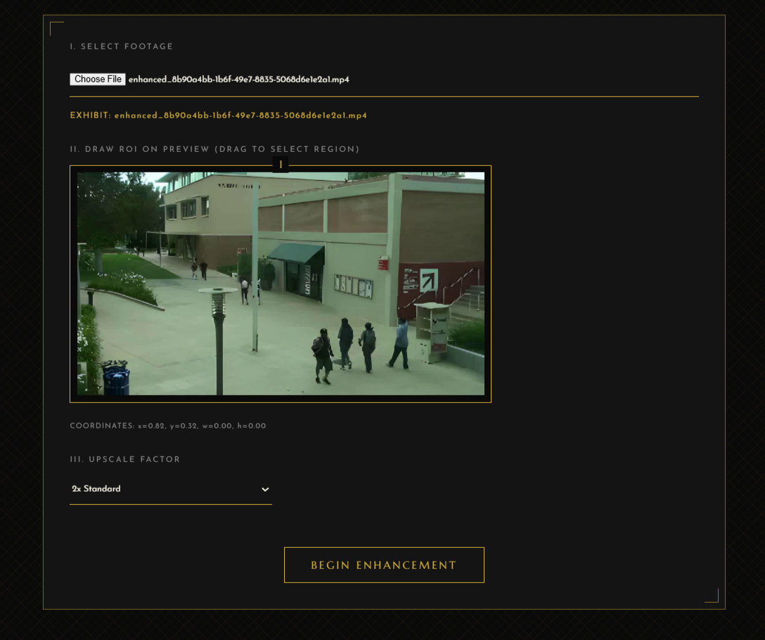

8 CONCLUSION AND FUTURE SCOPE

The development and deployment of ClarityAI represent a significant advancement in the field of digital forensics and surveillance image processing. By successfully synthesizing a disparate array of state-of-the-art deep learning architectures—RealESRGAN, GFPGAN, YOLOv8n, and EasyOCR—into a single, cohesive ecosystem, this project addresses the critical shortcomings of traditional CCTV footage analysis. The system definitively proves that the limitations imposed by low-resolution sensors, environmental interference, and aggressive data compression can be overcome utilizing targeted, GPU-accelerated artificial intelligence. ClarityAI empowers forensic investigators, law enforcement, and security professionals with the ability to extract highly accurate, actionable intelligence—such as recognizable facial features and alphanumeric license plate data—from media that would otherwise be discarded as unusable.
The architectural design of the platform stands as a testament to the efficacy of modern web and backend technologies in managing heavy computational workloads. The integration of a Next.js frontend with a FastAPI backend ensures a seamless, non-blocking user experience, while the utilization of WebSocket telemetry for real-time VRAM and progress monitoring introduces a vital layer of operational transparency. Crucially, by executing all tensor processing locally via PyTorch and CUDA, ClarityAI adheres strictly to the fundamental requirements of digital forensics: maintaining absolute data privacy, preventing unauthorized access to sensitive media, and preserving an unbroken chain of custody. The system bridges the divide between cutting-edge academic AI research and practical, user-friendly application, delivering a robust tool that enhances the speed, accuracy, and reliability of criminal investigations and security audits.
8.1 Implications and Future Directions
The implications of ClarityAI extend beyond simple convenience; they fundamentally alter the viability of existing security infrastructure. By demonstrating that high-quality intelligence can be extracted from low-quality footage, the system effectively upgrades the capabilities of legacy camera networks without requiring costly hardware replacements. This democratization of advanced forensic analysis has profound implications for smaller law enforcement agencies or private firms that lack the budget for specialized, proprietary forensic laboratories. However, as with all generative AI applied to forensics, the system necessitates a rigorous understanding of the distinction between "enhancement" and "hallucination," dictating that the outputs be utilized as investigative leads rather than standalone, irrefutable evidence in a court of law.
Future directions for this research involve expanding the dataset and fine-tuning the models to handle highly specific edge cases. Expanding the training parameters to include a wider array of severe weather conditions, extreme low-light environments, and diverse global license plate formats will further increase the system's accuracy and versatility. Continuous iteration of the AI prompts and model weights, based on real-world feedback from forensic analysts, will ensure the system remains at the forefront of digital image restoration technologies.
8.2 Future Scope
While the current iteration of ClarityAI provides a comprehensive suite of forensic tools, the foundational architecture supports significant future expansion. The future scope of the project encompasses several advanced capabilities aimed at further automating and refining the investigative workflow:
- Automated Anomaly Detection: Integrating behavioral analysis models capable of automatically flagging suspicious activities (such as loitering, unattended baggage, or sudden erratic movements) within the video stream, alerting investigators to potential incidents before manual review is required.
- Multi-Stream Processing: Expanding the backend infrastructure to ingest and process multiple concurrent CCTV feeds simultaneously. This would involve advanced CUDA stream management to distribute tensor workloads across multiple GPUs, enabling the real-time forensic monitoring of complex environments like transit hubs or retail centers.
- Cross-Camera Subject Tracking: Implementing sophisticated Re-Identification (ReID) models. This feature would allow the system to extract the enhanced features of a suspect or vehicle from one camera feed and automatically search for and track that specific entity across a network of disparate, unlinked cameras.
- Advanced Cryptographic Watermarking: To further solidify the chain of custody, future versions could implement blockchain-based hashing or cryptographic watermarking directly into the remuxed video output. This would provide mathematically irrefutable proof that the enhanced footage, while manipulated by AI for clarity, has not been maliciously tampered with post-processing.
- Integration with National Databases: Establishing secure, encrypted API pipelines that allow the extracted OCR data (license plates) or enhanced facial biometrics to be instantly cross-referenced against national law enforcement databases, immediately returning suspect profiles or stolen vehicle alerts directly within the ClarityAI dashboard.

REFERENCES

[1] X. Wang, L. Xie, C. Dong, and Y. Shan, "Real-ESRGAN: Training Real-World Blind Super-Resolution with Pure Synthetic Data," in Proc. International Conference on Computer Vision (ICCV), 2021, pp. 1905-1914.
[2] T. Wang, T. Zhang, K. Zhang, M. Ouyang, and Z. Chen, "Towards Real-World Blind Face Restoration with Generative Facial Prior," in Proc. IEEE/CVF Conference on Computer Vision and Pattern Recognition (CVPR), 2021, pp. 9168-9178.
[3] G. Jocher, A. Chaurasia, and J. Qiu, "YOLO by Ultralytics," 2023. [Online]. Available: https://github.com/ultralytics/ultralytics
[4] JaidedAI, "EasyOCR: Ready-to-use OCR with 80+ supported languages and all popular writing scripts," 2020. [Online]. Available: https://github.com/JaidedAI/EasyOCR
[5] I. Goodfellow et al., "Generative Adversarial Nets," in Proc. Advances in Neural Information Processing Systems (NeurIPS), 2014, pp. 2672-2680.
[6] A. Paszke et al., "PyTorch: An Imperative Style, High-Performance Deep Learning Library," in Proc. Advances in Neural Information Processing Systems (NeurIPS), 2019, pp. 8024-8035.
[7] S. Ramírez, "FastAPI: High performance, easy to learn, fast to code, ready for production," 2018. [Online]. Available: https://github.com/tiangolo/fastapi
[8] G. Bradski, "The OpenCV Library," Dr. Dobb's Journal of Software Tools, 2000.
[9] F. Bellard, "FFmpeg: A complete, cross-platform solution to record, convert and stream audio and video," 2000. [Online]. Available: https://ffmpeg.org/
[10] C. Dong, C. C. Loy, K. He, and X. Tang, "Image Super-Resolution Using Deep Convolutional Networks," IEEE Transactions on Pattern Analysis and Machine Intelligence, vol. 38, no. 2, pp. 295-307, 2016.
[11] K. Zhang, W. Zuo, Y. Chen, D. Meng, and L. Zhang, "Beyond a Gaussian Denoiser: Residual Learning of Deep CNN for Image Denoising," IEEE Transactions on Image Processing, vol. 26, no. 7, pp. 3142-3155, 2017.
[12] J. Redmon, S. Divvala, R. Girshick, and A. Farhadi, "You Only Look Once: Unified, Real-Time Object Detection," in Proc. IEEE Conference on Computer Vision and Pattern Recognition (CVPR), 2016, pp. 779-788.

