ST6005CEM — Security
Coursework CW2 (Regular) — Secure Web Application Development and Internal Penetration Test
Comprehensive Security Development of GadgetHub
A Secure-by-Design E-Commerce Platform
Submitted by: [Your Name]
CU ID: [Your Student ID]
Module Leader: [Module Leader]
Submission date: [Date] · Due: 31 Jul 2026
GitHub: [repo URL] · PoC video (Drive, editor access): [link]
HOW TO USE THIS DOCUMENT — READ FIRST
• The screenshots and evidence below were captured from YOUR OWN running GadgetHub app and database — they are genuine and repeatable.
• Each 'WRITE:' note marks analysis / justification / a citation you must add IN YOUR OWN WORDS (the module runs AI-detection).
• Each '[ INSERT SCREENSHOT — ... ]' is a figure I could not auto-capture (needs admin login or a diagram) — add it yourself.
• Target ~2000 words of prose (front matter, tables, captions, references, appendices do NOT count). Delete this box before submitting; file name: NAME_studentID.

Table of Contents
Generate in Word (References ▸ Table of Contents) using the Heading styles applied here.

Table of Figures
Generate in Word (References ▸ Insert Table of Figures) — the figures below are already captioned 'Figure N: ...'.

Table of Abbreviations
Abbreviation | Full form
AES | Advanced Encryption Standard
API | Application Programming Interface
CAPTCHA | Completely Automated Public Turing test to tell Computers and Humans Apart
CIA | Confidentiality, Integrity and Availability
CORS | Cross-Origin Resource Sharing
CSP | Content-Security-Policy
CSRF/XSRF | Cross-Site Request Forgery
CVSS | Common Vulnerability Scoring System
DoS | Denial of Service
GCM | Galois/Counter Mode
HSTS | HTTP Strict Transport Security
HTTP(S) | HyperText Transfer Protocol (Secure)
IDOR | Insecure Direct Object Reference
JWT | JSON Web Token
MFA | Multi-Factor Authentication
NoSQL | Not only SQL (non-relational database)
OAuth | Open Authorization
OTP | One-Time Password
OWASP | Open Worldwide Application Security Project
PII | Personally Identifiable Information
RBAC | Role-Based Access Control
SSRF | Server-Side Request Forgery
TLS | Transport Layer Security
TOTP | Time-based One-Time Password
WAF | Web Application Firewall
WSTG | Web Security Testing Guide
XSS | Cross-Site Scripting

Abstract
GadgetHub is a custom-built, secure-by-design e-commerce platform for electronics retail, developed for the ST6005CEM CW2 coursework. It is a full-stack application (Express + TypeScript API and a Next.js/React front end over MongoDB) in which security is treated as a first-class feature. Authentication is hardened with bcrypt hashing, a strong password policy with reuse/expiry controls, TOTP multi-factor authentication, a self-hosted CAPTCHA, account lockout and per-IP rate limiting, and optional OAuth 2.0 federated login. Sensitive data is protected with AES-256-GCM encryption at rest; RBAC and CSRF tokens guard state-changing actions; and an application-layer WAF, SSRF-safe outbound requests and strict CORS provide defence-in-depth. An internal white-box penetration test identified and mitigated nine vulnerabilities, each rated with CVSS v3.1.
WRITE: Trim/expand to ~150 words in your own words; one paragraph; no citations here.

Introduction & System Design
GadgetHub is an online electronics store where customers browse a catalogue, manage a cart and check out, and administrators manage products and review security logs. Because it handles credentials, personal profile data and purchase transactions, security is central to its design.
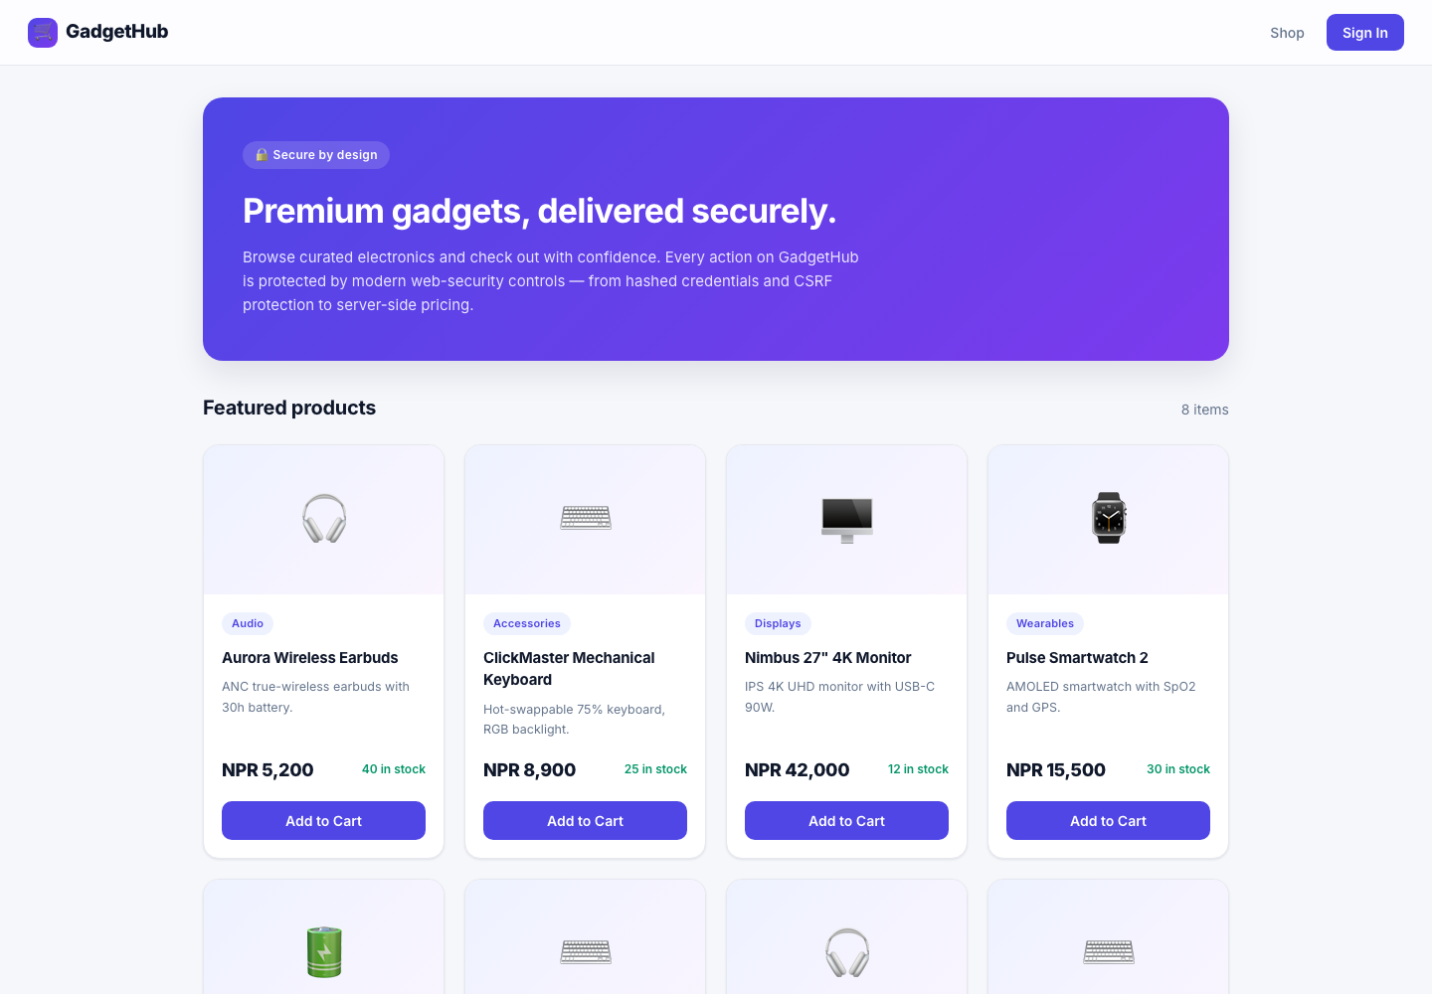
Figure 1: GadgetHub storefront (Next.js/React front end)
WRITE: Define the user need and why the concept is meaningful/original (brief §1). Add a breach/threat statistic with a citation.
The CIA triad frames the security goals:
- Confidentiality: bcrypt-hashed passwords; AES-256-GCM encryption of MFA secrets and PII; JWT in an httpOnly cookie; RBAC; strict CORS; TLS.
- Integrity: server-side price authority; atomic stock with rollback; CSRF tokens; AES-GCM auth tag; Zod validation; audit logging.
- Availability: per-IP and per-account rate limiting/lockout; 10 kb body cap; WAF; health checks and container restart policies.
[ INSERT SCREENSHOT — System design / layered architecture diagram (draw in draw.io) ]
Figure 2: System design / layered architecture diagram (draw in draw.io)
WRITE: Discuss the legal context — Nepal's Electronic Transactions Act 2063 and Individual Privacy Act 2075 — and map each to a control. Cite both.

Software Details
GadgetHub uses a clean layered architecture on the back end (routes → controllers → services → repositories → models), which keeps security logic (validation, authorisation, pricing) in the service/repository layers. The API is Express + TypeScript over MongoDB (Mongoose); the front end is Next.js (App Router) + React + TypeScript. The app is fully containerised (Docker + docker-compose) and MongoDB is kept on a private network, never published to the host.
WRITE: Explain the back-end-first approach and how logic was verified (automated test suite in backend/tests; custom fuzzer scripts/fuzz.mjs).
Key backend dependencies:
Package | Version | Purpose
express | ^4.21.2 | Web framework / API
typescript | (dev) | Static typing — fewer runtime flaws
mongoose | ^8.9.5 | MongoDB ODM
bcryptjs | ^2.4.3 | Password hashing (salted, cost 12)
jsonwebtoken | ^9.0.2 | JWT session tokens
otplib | ^13.4.1 | TOTP multi-factor authentication
qrcode | ^1.5.4 | MFA enrolment QR codes
helmet | ^8.0.0 | Security headers (CSP, HSTS, …)
cors | ^2.8.5 | CORS allowlist
cookie-parser | ^1.4.7 | Read httpOnly/CSRF cookies
express-rate-limit | ^7.4.1 | Rate limiting / throttling
zod | ^3.24.1 | Input validation & strict allowlists
dotenv | ^16.4.5 | Environment-based configuration

Front end: next ^14.2.33, react 18.3.1, react-dom 18.3.1 (TypeScript).
[ INSERT SCREENSHOT — GitHub repository — branches and commit history ]
Figure 3: GitHub repository — branches and commit history

Security by Design Principles
Security was built in from the start. OWASP Top 10:2021 was used as the threat catalogue and each relevant risk is countered by a specific control. A zero-trust posture is enforced: every request re-validates the JWT, and a correct password alone never establishes a session — it only issues a short-lived MFA challenge token that must be exchanged with a valid TOTP code.
WRITE: Introduce OWASP and secure-by-design with citations; add a short STRIDE/Top-10 threat model (diagram).
Defence-in-depth — application-layer WAF.
A production deployment would sit behind an edge WAF (e.g. Cloudflare). In addition, GadgetHub ships an application-layer WAF that inspects each request for attack signatures and known scanner user-agents, returning a generic 403 while letting legitimate traffic through:
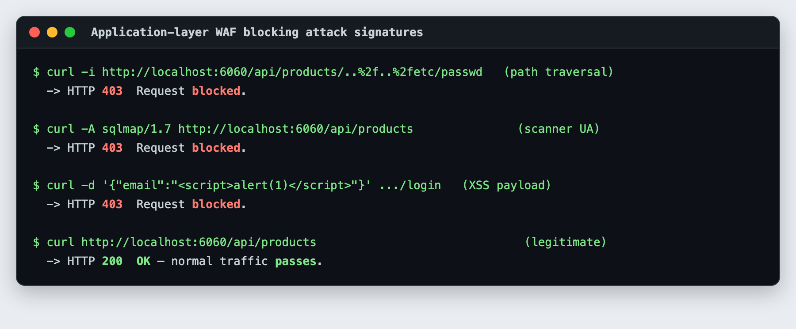
Figure 4: Application-layer WAF blocking traversal, scanner and XSS payloads (real HTTP responses)
Strict CORS (the "null" origin is rejected).
CORS uses an allowlist function that only reflects known front-end origins and explicitly rejects the "null" origin, so a sandboxed/file:// page cannot make credentialed cross-origin calls:
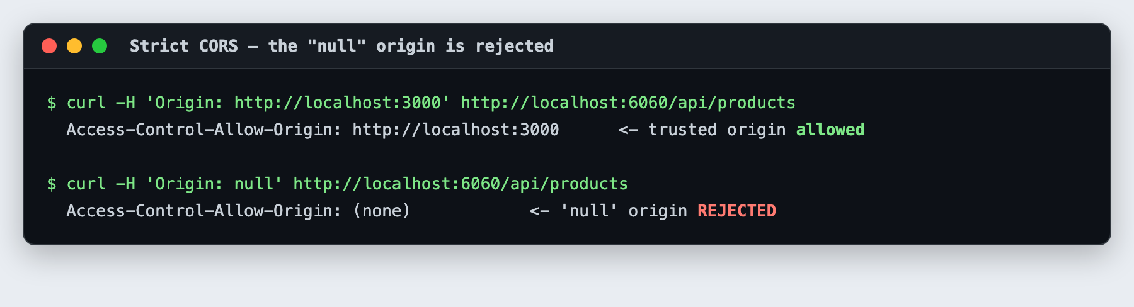
Figure 5: CORS allows the trusted origin but returns no ACAO header for Origin: null
WRITE: Explain why the null origin is dangerous and how your allowlist prevents it (cite PortSwigger/OWASP CORS). Note generic error handling (errorHandler.ts) preventing stack-trace leakage.

The Checklist
These checklists index every security feature in GadgetHub, mapped to the CW2 requirements, before the detailed walkthrough that follows.
Table: Core Functional Features
Feature | Requirement | Done | How it was achieved | Why
Accessible UI | Intuitive, responsive, all roles | ✔ | Next.js/React, semantic HTML, WCAG 2.1 AA audit | Usability & accessibility
Registration & login | Secure sign-up/sign-in | ✔ | bcrypt, Zod policy, generic errors, CAPTCHA | Prevent credential abuse
MFA | Multi-factor support | ✔ | TOTP (otplib), stepped login, encrypted secret | Stolen-password resistance
Brute-force protection | Rate limit + lockout + CAPTCHA | ✔ | express-rate-limit, 10-attempt lockout, HMAC CAPTCHA | Stop online guessing
Customisable profiles | Secure personalisation | ✔ | Strict Zod allowlist, session-scoped identity | Block IDOR / mass assignment
Data export/import | Privacy / portability | ✔ | Minimised export, profile-only import | Data-minimisation
Transactions | Integrity & rollback | ✔ | Server-side pricing, atomic stock + rollback | No price/stock tampering
Activity logging | Auditing & monitoring | ✔ | audit.service, gateway access log, alerts | Incident response

Table: Password & Session Security
Feature | Requirement | Done | How it was achieved | Why
Password policy | 8+ upper/lower/digit/special | ✔ | Zod (dtos/auth.dto.ts), client + server | Strong credentials
Reuse prevention | No recent reuse | ✔ | Hashed passwordHistory compared on change | Stop recycling
Password expiry | Rotate after N days | ✔ | passwordChangedAt, 90-day check | Limit exposure
Strength feedback | Real-time meter | ✔ | components/PasswordStrength | User guidance
Account lockout | 10–15 attempts | ✔ | Lock after 10 fails for 15 min | CW2 baseline
Secure cookie | httpOnly+SameSite+Secure | ✔ | setAuthCookie (auth.controller.ts) | Session-theft resistance
Session expiry | ≥15-day token; logout clears | ✔ | JWT_EXPIRES_IN=15d; logout clears cookies | CW2 baseline + control
Session binding | Bind to user agent | ✔ | UA fingerprint in JWT (utils/jwt.ts) | Replay resistance

Table: Encryption, Access Control & Extra Measures
Feature | Requirement | Done | How it was achieved | Why
Password hashing | Salted, slow hash | ✔ | bcrypt cost 12 (utils/password.ts) | DB-leak resistance
Encryption at rest | AES for sensitive data | ✔ | AES-256-GCM: MFA secret + PII (crypto.ts, pii.ts) | Confidentiality + integrity
Key management | Safe key handling | ✔ | Env-derived key, prod fail-fast on default | Key hygiene
RBAC | Least privilege | ✔ | rbac.middleware.ts (customer/admin) | Access control
CSRF protection | Anti-forgery token | ✔ | Double-submit cookie (csrf.middleware.ts) | Block CSRF
Input sanitisation | Strip NoSQL operators | ✔ | utils/sanitize.ts + Zod | Injection defence
Security headers / CSP | Helmet CSP/HSTS/XFO | ✔ | app.ts | XSS/clickjacking
WAF | Attack-signature filter | ✔ | middleware/waf.middleware.ts | Defence-in-depth
SSRF protection | Outbound allowlist | ✔ | utils/safeFetch.ts (private-IP guard) | Block SSRF
IP allow/block list | Network access control | ✔ | middleware/ipAccess.middleware.ts | Abuse control
OAuth 2.0 | Federated login | ✔ | Google auth-code + state (oauth.service.ts) | Delegated strong auth
Containerisation + CI/CD | Reproducible + scanned | ✔ | Docker/compose; npm audit, CodeQL, Gitleaks | Supply-chain & repeatability

Making GadgetHub Secure
The features above are detailed below with code references and screenshots captured from the running app.

E1) Password & Brute-Force Protection
Passwords are validated against a strong policy on client and server via a Zod schema, then hashed with bcrypt (cost 12). A capped history prevents reuse, passwordChangedAt enforces a 90-day expiry, and a strength meter gives real-time feedback. Online guessing is countered by three layers: a self-hosted arithmetic CAPTCHA, per-IP rate limiting, and account lockout after 10 failed attempts.
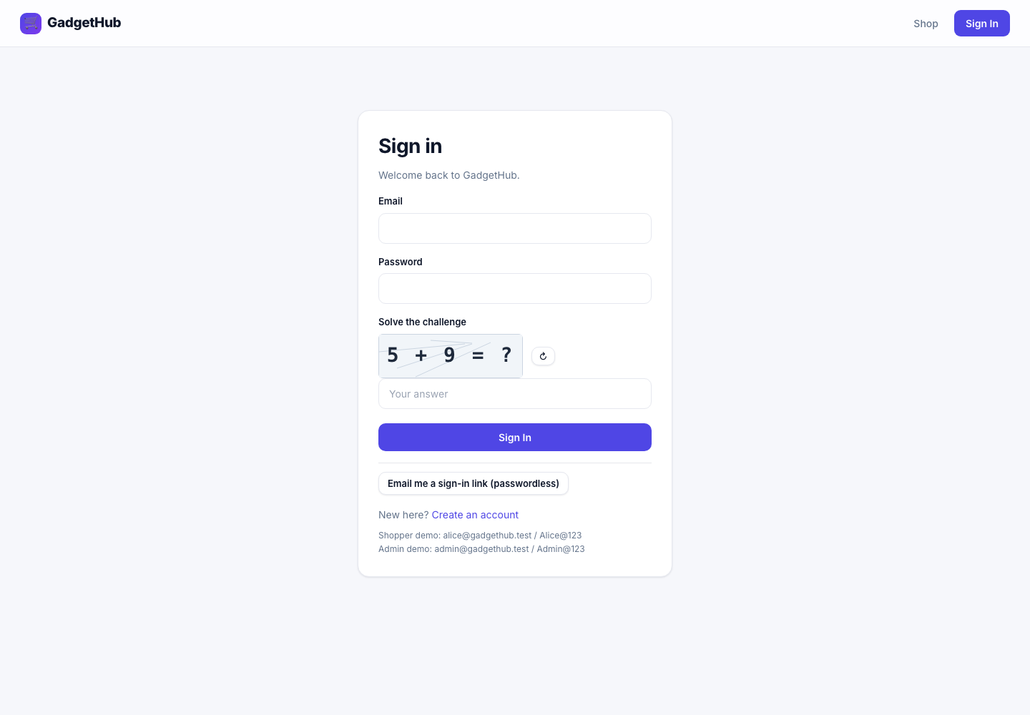
Figure 6: Sign-in page with the self-hosted CAPTCHA challenge and passwordless option
Account lockout, demonstrated live — ten failed attempts lock the account:
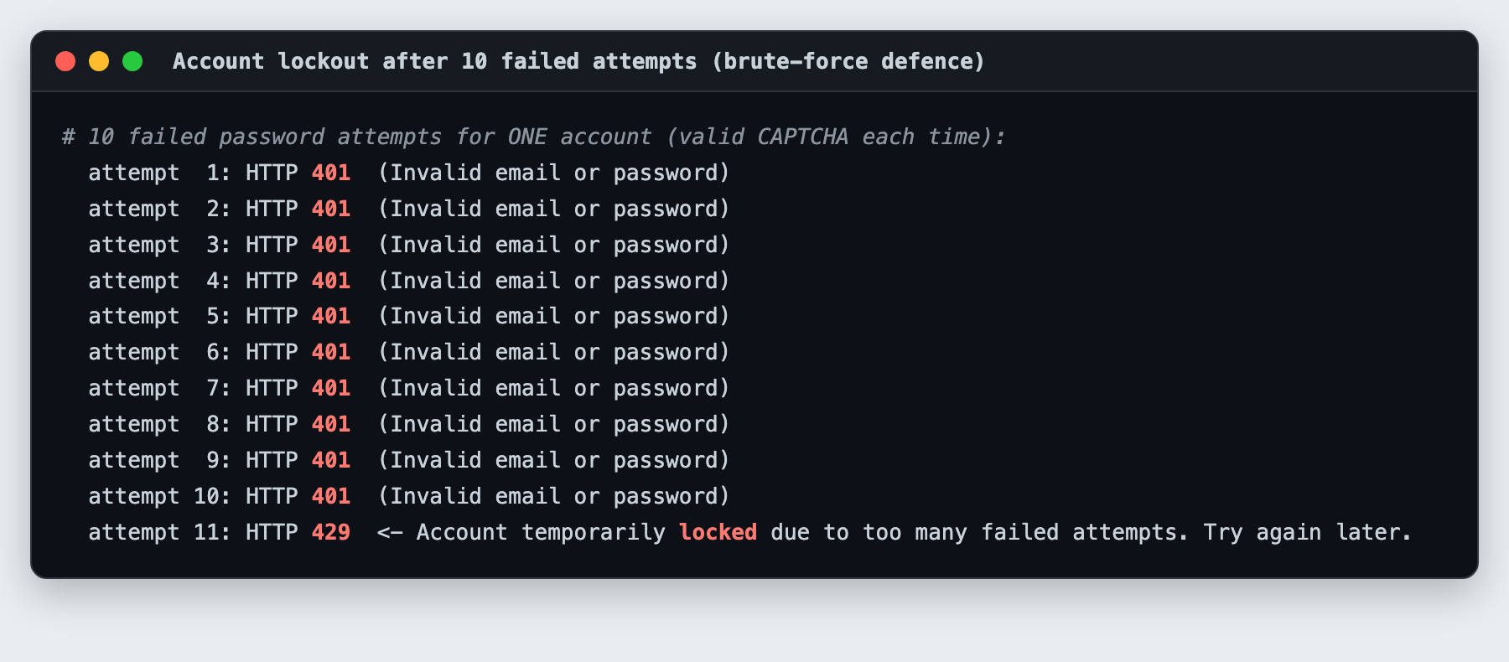
Figure 7: Account lockout: 10 × HTTP 401 then HTTP 429 (account temporarily locked)
Per-IP rate limiting throttles automated abuse independently of the per-account lockout:
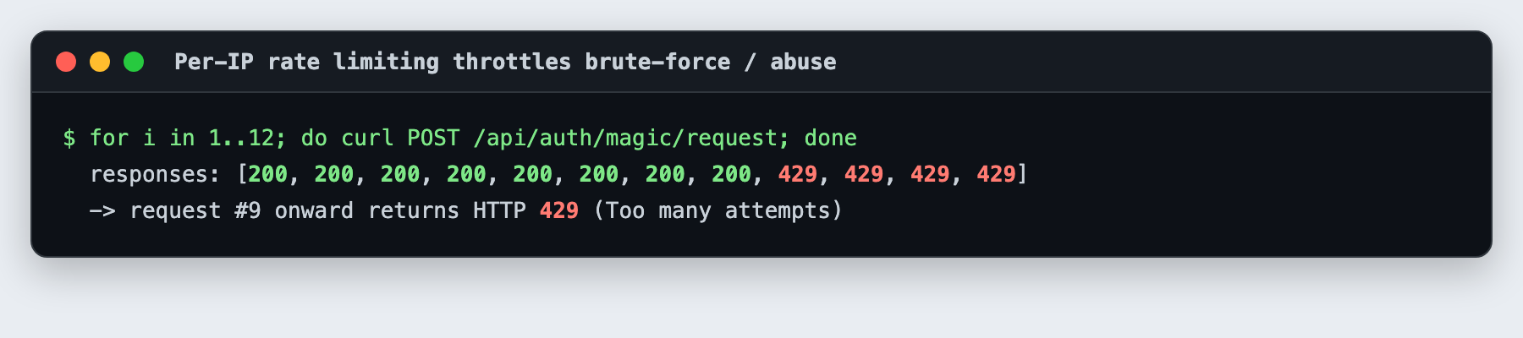
Figure 8: Per-IP rate limiting returning HTTP 429 after repeated requests
WRITE: Justify bcrypt vs plain hashing (salting + work factor) and lockout at 10 (usability vs brute-force). Cite NIST SP 800-63B and the bcrypt paper.

E2) Audit Trail & Monitoring
Security-relevant events (logins, failures, lockouts, profile updates, orders, admin actions) are recorded by an audit service for accountability, excluding sensitive values. A gateway access log records request metadata (method, path, status, latency, IP) but never bodies or PII, and a monitoring service raises real-time anomaly alerts for admins.
[ INSERT SCREENSHOT — Audit log entries in the admin dashboard (log in as admin@gadgethub.test to capture) ]
Figure 9: Audit log entries in the admin dashboard (log in as admin@gadgethub.test to capture)
WRITE: Explain how this supports auditing/incident response and how you avoid logging sensitive data (cite OWASP Logging Cheat Sheet).

E3) User Authentication & Access Control
GadgetHub has two roles — customer and admin — enforced by RBAC middleware. Protected areas (cart, orders, account, admin) require authentication; the navigation only exposes them once the server confirms a session. Sessions use a JWT in an httpOnly cookie; on MFA-enabled accounts the password step only issues a challenge token and the session is established solely after a valid TOTP code. IDOR is closed by design (queries are scoped to the authenticated user id — there is no /users/:id or /orders/:id), and mass-assignment/privilege escalation is blocked by a strict Zod allowlist on profile updates.
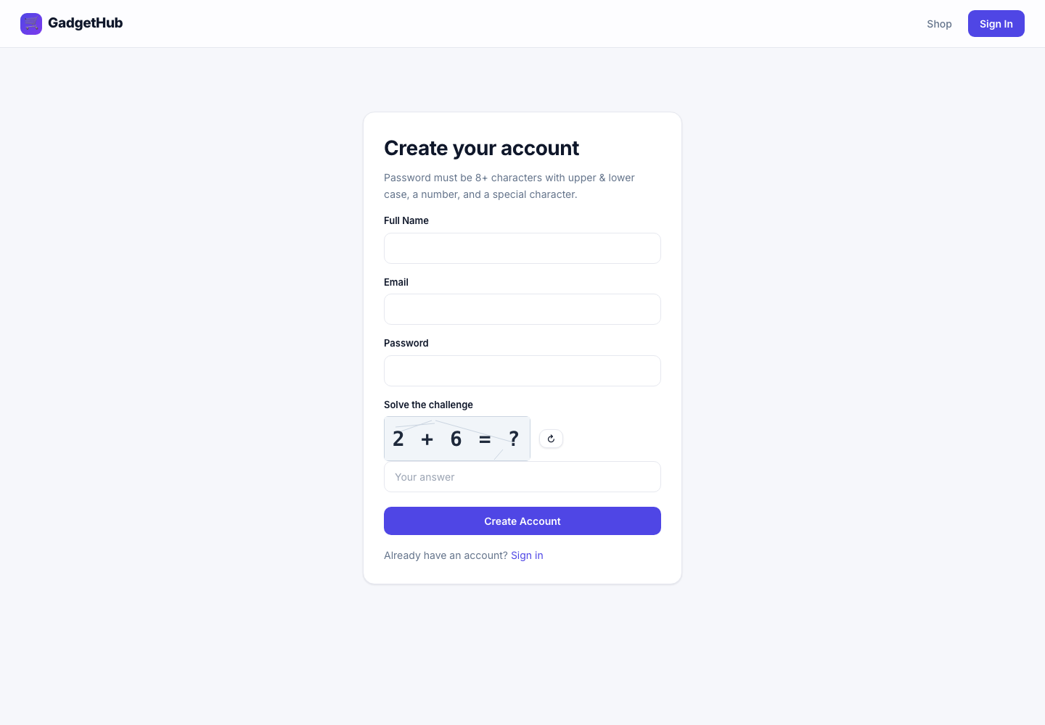
Figure 10: Registration page (bcrypt + strong-password policy + CAPTCHA)
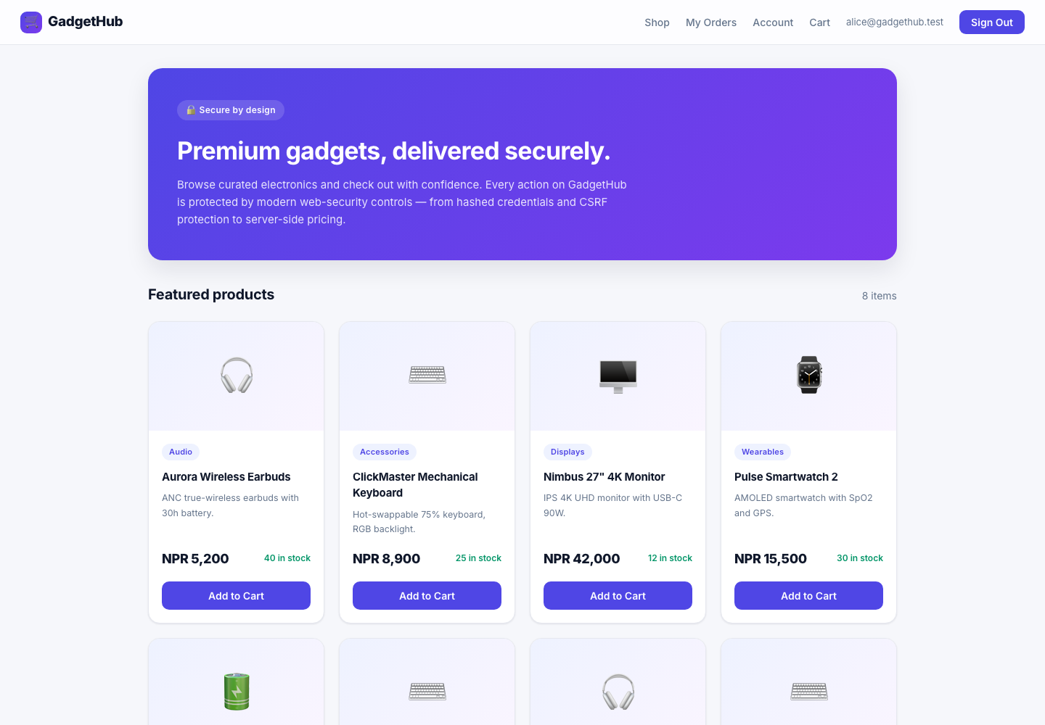
Figure 11: Authenticated navigation — Orders, Account and Cart appear only after sign-in
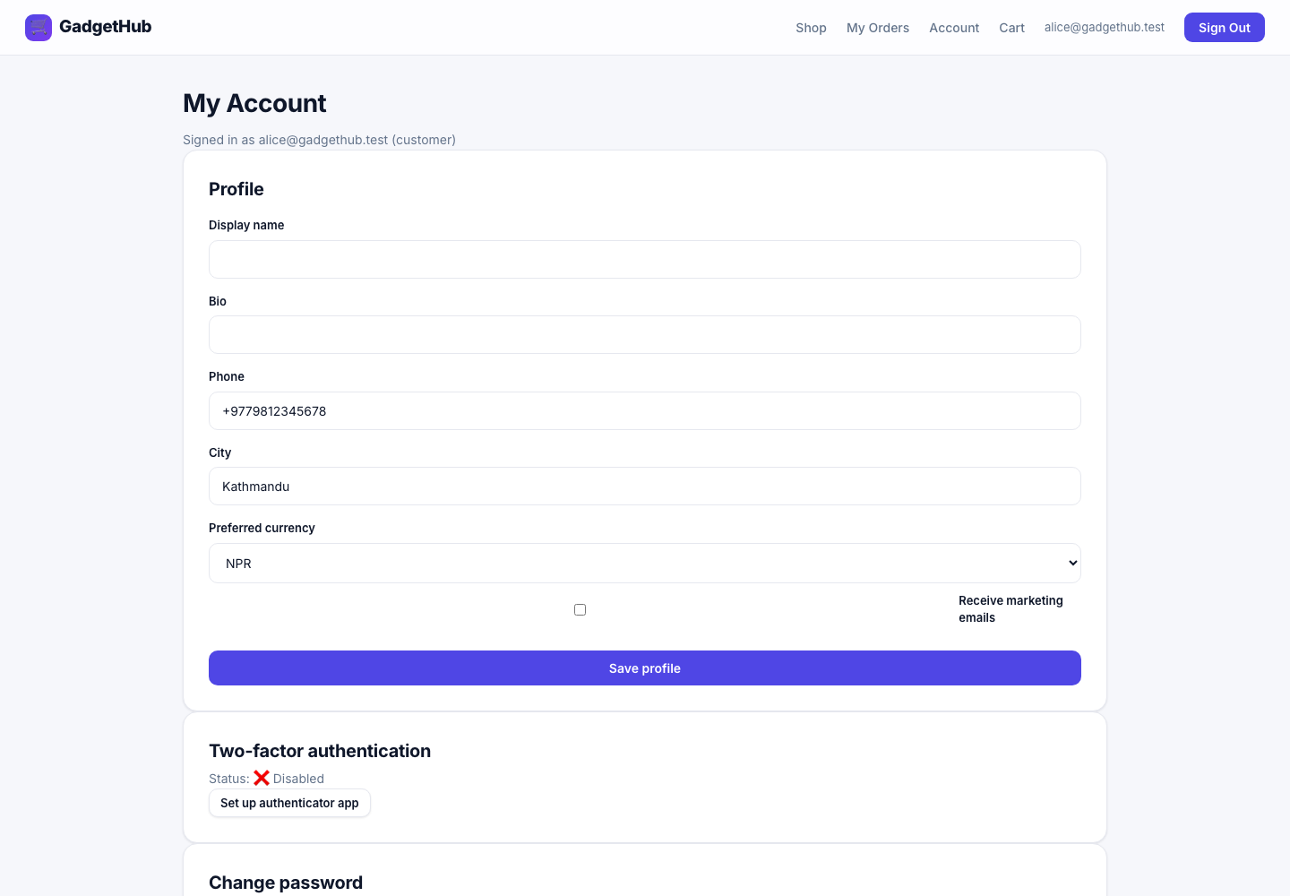
Figure 12: Signed-in account page: profile, MFA setup, and password change
WRITE: Explain zero-trust and how MFA + RBAC + IDOR/mass-assignment defences align with it. Cite OWASP Access Control/Authentication cheat sheets, RFC 6238 (TOTP), RFC 6749 (OAuth 2.0).

E4) Session Management
The session JWT is stored in a cookie marked httpOnly (XSS-resistant), SameSite=Strict (a CSRF defence) and Secure (HTTPS-only in production). Per the CW2 baseline the token lasts 15 days, with the cookie maxAge matched to it; theft risk is contained by these flags plus user-agent binding rather than by a short lifetime. Logout clears the cookies, and all state-changing requests additionally require a double-submit CSRF token:
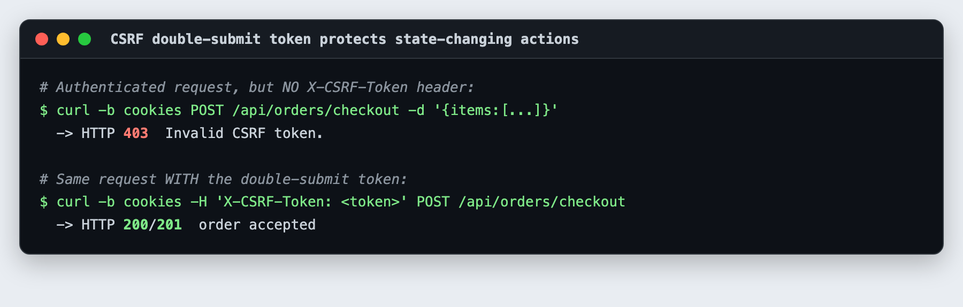
Figure 13: CSRF protection: an authenticated checkout without the X-CSRF-Token header is rejected
WRITE: Explain each cookie attribute and why a 15-day token is acceptable given the flags + UA binding. Cite MDN Cookies and OWASP Session Management Cheat Sheet.

E5) Encryption & Data Protection
Passwords are stored only as bcrypt hashes. The most sensitive personal data — the MFA secret and profile PII (phone and address) — is encrypted at rest with AES-256-GCM, an authenticated cipher providing confidentiality and integrity. The 256-bit key is derived from an ENCRYPTION_KEY secret; the app fails fast in production if the default key is left in place, and the key belongs in a KMS with rotation. A raw database read shows only ciphertext, while the API returns the decrypted values transparently:
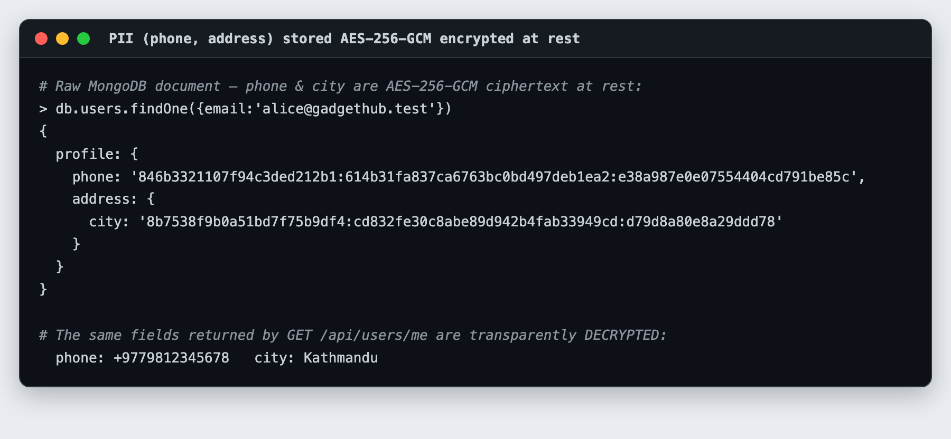
Figure 14: PII encrypted at rest: phone/city are AES-256-GCM ciphertext in MongoDB but plaintext via the API
WRITE: Justify GCM over CBC (authenticated encryption) and discuss key management. Cite NIST SP 800-38D (GCM) and NIST SP 800-63B.

E6) Extra Security Features
- Input sanitisation: utils/sanitize.ts strips $/.-prefixed keys to defeat NoSQL operator injection.
- Security headers / CSP: Helmet sets a strict CSP, HSTS, X-Frame-Options and nosniff (shown below).
- SSRF-safe fetch: utils/safeFetch.ts enforces a host allowlist and blocks private/loopback addresses.
- IP allow/block list: deny-by-default network access control (ipAccess.middleware.ts).
- Transaction integrity: server-side pricing and atomic stock updates prevent tampering and overselling.
- Containerisation & CI/CD: non-root multi-stage Docker images + GitHub Actions (npm audit, CodeQL, Gitleaks).
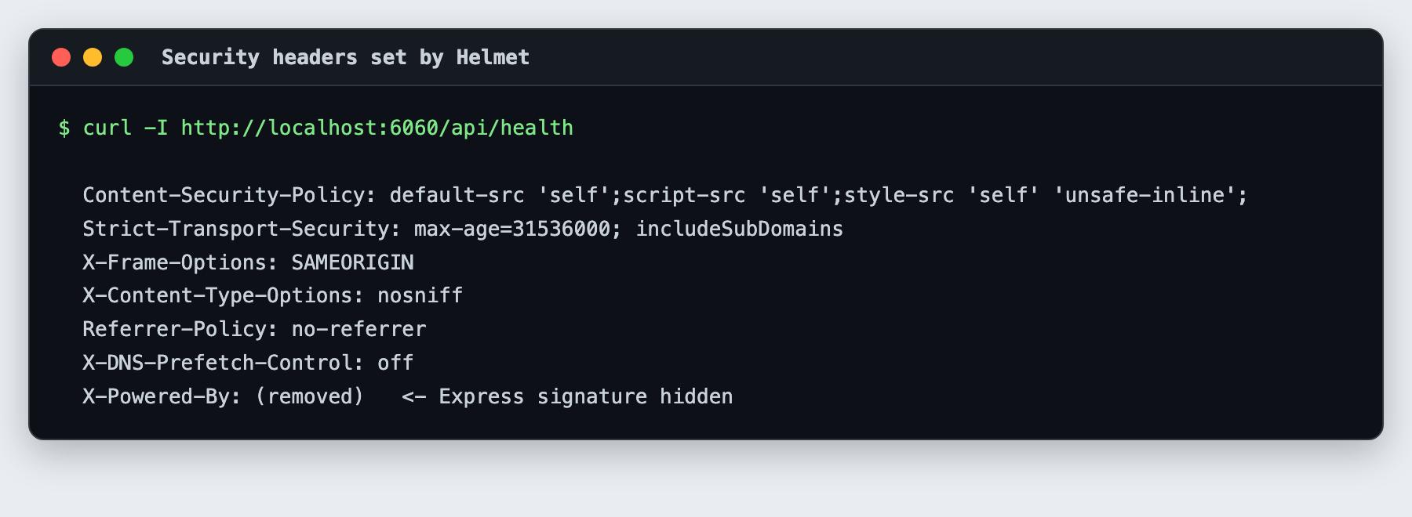
Figure 15: Security headers set by Helmet (CSP, HSTS, X-Frame-Options, nosniff; X-Powered-By removed)
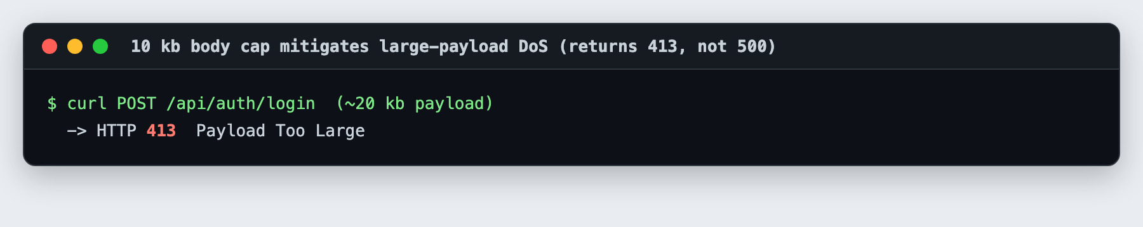
Figure 16: 10 kb request-body cap returns HTTP 413 (not a 500) for oversized payloads
WRITE: Analyse 2–3 of these in depth (e.g. NoSQL sanitisation, SSRF guard) with citations; keep the rest brief.

Secure Development & Internal Penetration Test
A white-box internal penetration test was conducted against a local instance only, following OWASP WSTG/ASVS, with manual testing primary and automated tools (npm audit, CodeQL, Gitleaks, a custom fuzzer) supplementary. Coverage included authentication, authorisation, business logic, input validation, session handling, client-side and API security; no post-exploitation beyond proving impact was performed. Nine findings were rated with CVSS v3.1 (scores reflect severity if the control were absent).
# | Finding | OWASP | CVSS v3.1 vector | Score | Sev | Status
F-01 | NoSQL operator injection (auth bypass) | A03 | AV:N/AC:L/PR:N/UI:N/S:U/C:H/I:H/A:N | 9.1 | Critical | Mitigated (sanitisation)
F-02 | Priv-esc via mass assignment | A01 | AV:N/AC:L/PR:L/UI:N/S:U/C:H/I:H/A:N | 8.8 | High | Mitigated (allowlist)
F-03 | IDOR on order/profile | A01 | AV:N/AC:L/PR:L/UI:N/S:U/C:H/I:N/A:N | 6.5 | Medium | Mitigated (scoped queries)
F-04 | Price tampering at checkout | A04 | AV:N/AC:L/PR:L/UI:N/S:U/C:N/I:H/A:N | 6.5 | Medium | Mitigated (server pricing)
F-05 | CSRF on state-changing endpoints | A01 | AV:N/AC:L/PR:N/UI:R/S:U/C:N/I:H/A:N | 6.5 | Medium | Mitigated (double-submit)
F-06 | Online credential brute force | A07 | AV:N/AC:H/PR:N/UI:N/S:U/C:H/I:H/A:N | 7.5 | High | Mitigated (lockout+RL+CAPTCHA)
F-07 | TOTP code brute force | A07 | AV:N/AC:H/PR:N/UI:N/S:U/C:H/I:N/A:N | 5.9 | Medium | Mitigated (rate-limited verify)
F-08 | Vulnerable dependency (Next.js DoS) | A06 | AV:N/AC:L/PR:N/UI:N/S:U/C:N/I:N/A:H | 7.5 | High | Triaged/patched
F-09 | Oversized payload → 500 | A05 | AV:N/AC:L/PR:L/UI:N/S:U/C:N/I:N/A:L | 2.7 | Low | Fixed (413 mapping)

Example: F-04 (price tampering) is mitigated by server-side price authority — an injected price is ignored and the authoritative database price is charged:
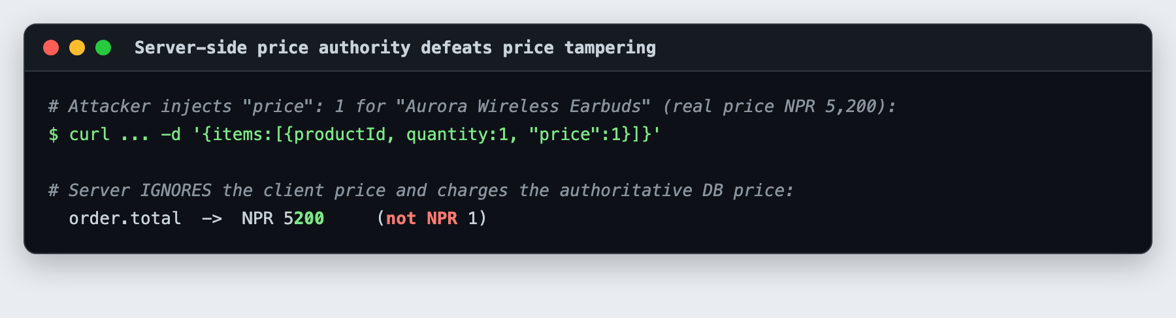
Figure 17: F-04 fixed: an injected price of 1 is ignored; the server charges the real DB price
WRITE: For at least TWO findings (your two before/after video scenarios) write: name & category, technical explanation & exploitation path, evidence, and remediation with retest evidence (see docs/PENTEST-REPORT.md).

Conclusion
GadgetHub demonstrates a defence-in-depth, secure-by-design approach: hardened authentication (bcrypt, MFA, CAPTCHA, lockout, OAuth), strict access control (RBAC, IDOR/mass-assignment defences), encrypted data at rest (AES-256-GCM), secure session and CSRF handling, and network-layer protections (WAF, SSRF guard, CORS, IP control). An internal penetration test confirmed the controls by mitigating nine vulnerabilities.
WRITE: State achievements vs objectives, honest limitations (in-memory rate limiter → Redis; single-node Mongo → replica-set for ACID; OAuth needs prod credentials) and future work (WebAuthn, edge WAF/Cloudflare, SIEM). ~90 words.

References
Minimum 15, CU Harvard or CU APA, in-text cited. Verify each URL/edition before citing.
- OWASP (2021) OWASP Top 10:2021. https://owasp.org/Top10/
- OWASP. Web Security Testing Guide (WSTG). https://owasp.org/www-project-web-security-testing-guide/
- OWASP. Application Security Verification Standard (ASVS). https://owasp.org/www-project-application-security-verification-standard/
- OWASP. Cheat Sheet Series (Authentication, Password Storage, Session Management, CSRF, Access Control, Logging, Mass Assignment). https://cheatsheetseries.owasp.org/
- NIST (2020) SP 800-63B: Digital Identity Guidelines. https://pages.nist.gov/800-63-3/sp800-63b.html
- Dworkin, M. (2007) NIST SP 800-38D: Block Cipher Modes of Operation: GCM.
- M'Raihi, D. et al. (2011) RFC 6238: TOTP. https://datatracker.ietf.org/doc/html/rfc6238
- Jones, M., Bradley, J. and Sakimura, N. (2015) RFC 7519: JSON Web Token (JWT). https://datatracker.ietf.org/doc/html/rfc7519
- Hardt, D. (2012) RFC 6749: The OAuth 2.0 Authorization Framework. https://datatracker.ietf.org/doc/html/rfc6749
- Provos, N. and Mazieres, D. (1999) 'A Future-Adaptable Password Scheme', USENIX ATC. (bcrypt)
- PortSwigger. Web Security Academy — CORS, CSRF, SQL/NoSQL injection, XSS. https://portswigger.net/web-security
- MDN Web Docs. HTTP cookies (Secure, HttpOnly, SameSite). https://developer.mozilla.org/en-US/docs/Web/HTTP/Cookies
- Helmet.js. Security headers for Express. https://helmetjs.github.io/
- MongoDB. Security Checklist. https://www.mongodb.com/docs/manual/administration/security-checklist/
- GitHub Docs. CodeQL code scanning. https://docs.github.com/code-security/code-scanning
- FIRST. CVSS v3.1 Specification & Calculator. https://www.first.org/cvss/
- Imperial Law Associates. Electronic Transactions Act, 2063 (Nepal). https://www.lawimperial.com/
- Government of Nepal. Individual Privacy Act, 2075 (2018).
- Stuttard, D. and Pinto, M. (2011) The Web Application Hacker's Handbook. 2nd edn. Wiley.
- Shostack, A. (2014) Threat Modeling: Designing for Security. Wiley.

Appendix A — Rubric Self-Check
Criterion | Where you earn it | Done?
Alignment / Functional Features | Checklist + working app (all CW2 baseline features) | ☐
Report Structure / Analytical Depth | Analytical prose you add at each WRITE note | ☐
Security Features Implementation | E1–E6 (+ zero-trust, WAF, SSRF, PII encryption = advanced/defence-in-depth) | ☐
Testing / Auditing / Vuln Mgmt | Pentest section, PENTEST-REPORT, CI/CD, 40+ commits, before/after | ☐
Research & Referencing | 15+ refs, CU Harvard/APA, in-text | ☐

Appendix B — Action Items BEFORE Submission
- COMMIT HISTORY: you currently have ~19 commits; the brief requires a MINIMUM of 40 meaningful commits (§4.2). Commit the project's work in logical, security-themed chunks that explain each decision.
- Replace every WRITE note with your own analysis and add in-text citations.
- Add the two [ INSERT SCREENSHOT ] figures (admin audit log; architecture diagram).
- Record the compulsory PoC video: face visible, closed captions, clear audio, 2× before/after scenarios; Google Drive with editor permission.
- Push to GitHub; put the repo URL on the cover page.
- Keep prose to ~2000 words; export as .docx/.pdf named NAME_studentID; test the Drive link.

