Sample Questions for CO1 – AT1 – Data Interpretation

1. Employee Salary Analysis
A CSV file (employees.csv) contains employee details.
Task:
- Read the CSV file.
- Display employees earning more than ₹50,000.
- Calculate average salary department-wise.
Code:
import pandas as pd

df = pd.read_csv("../Csv/Employee.csv")

print("Employees earning more than ₹50,000")
print(df[df["Salary"] > 50000])

print("\nAverage Salary Department-wise")
print(df.groupby("Department")["Salary"].mean())

Output:
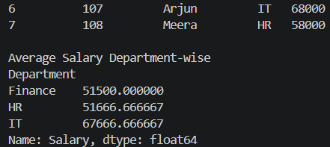

2. Missing Data Handling
Given a CSV file containing student marks with missing values.
Task
- Identify missing values.
- Replace missing marks with the column average.
- Display the cleaned dataset.
Code:
import pandas as pd

df = pd.read_csv("students.csv")

print("Missing Values")
print(df.isnull())

df.fillna(df.mean(numeric_only=True), inplace=True)

print("\nCleaned Dataset")
print(df)

Output:
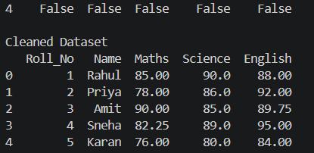

3. Duplicate Record Removal
A customer dataset contains duplicate rows.
Task:
- Read the dataset.
- Find duplicate records.
- Remove duplicates.
- Display the updated dataset.
Code:
import pandas as pd

df = pd.read_csv("../Csv/customer.csv")

print("Duplicate Records")
print(df[df.duplicated()])

df = df.drop_duplicates()

print("\nUpdated Dataset")
print(df)
Output:

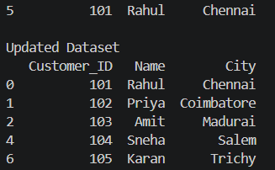

4. Data Transformation
A product dataset stores prices in USD.
Task
- Convert prices into INR.
- Add a new column called &quot;Price_INR

Code:
import pandas as pd

df = pd.read_csv("../Csv/product.csv")

exchange_rate = 83

df["Price_INR"] = df["Price_USD"] * exchange_rate

print(df)
Output:
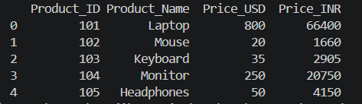

5. Data Aggregation
Given monthly sales data.
Task
- Calculate total sales.
- Average sales.
- Maximum sales.
- Minimum sales.

Code:
import pandas as pd

df = pd.read_csv("monthly_sales.csv")

print("Total Sales:", df["Sales"].sum())
print("Average Sales:", df["Sales"].mean())
print("Maximum Sales:", df["Sales"].max())
print("Minimum Sales:", df["Sales"].min())
Output:
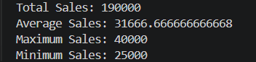

6. Grouping Data
Given employee information.
Task
- Group employees by department and calculate:
- Total salary
- Average salary
- Employee count
Code:
import pandas as pd

df = pd.read_csv("employees.csv")

result = df.groupby("Department")["Salary"].agg(
Total_Salary="sum",
Average_Salary="mean",
Employee_Count="count"
)

print(result)
Output:
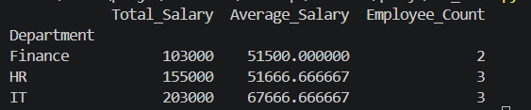

7. XML Data Analysis
Given library.xml
Task
Display:
- Total books
- Books written after 2020
- Books costing more than ₹500
Code:
import xml.etree.ElementTree as ET

tree = ET.parse("library.xml")
root = tree.getroot()

print("Total Books:", len(root.findall("book")))

print("\nBooks written after 2020:")
for book in root.findall("book"):
if int(book.find("year").text) > 2020:
print(book.find("title").text)

print("\nBooks costing more than ₹500:")
for book in root.findall("book"):
if float(book.find("price").text) > 500:
print(book.find("title").text)
Output:
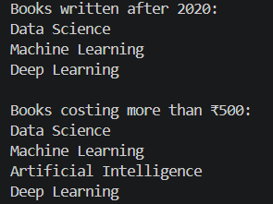

8. Data Interpretation using Python
Given marks of students.
Task
- Store marks in a list.
- Find:
- Highest mark
- Lowest mark
- Average mark
- Number of students passed.
Code:
marks = [78, 65, 90, 45, 35, 88, 55, 72]

print("Marks:", marks)
print("Highest Mark:", max(marks))
print("Lowest Mark:", min(marks))
print("Average Mark:", sum(marks) / len(marks))

passed = 0
for mark in marks:
if mark >= 40:
passed += 1

print("Number of Students Passed:", passed)
Output:
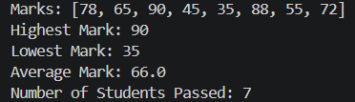

9. Dictionary-Based Analysis
Store employee information using dictionaries.

Task
Display:
- Highest salary employee
- Lowest salary employee
- Average salary
Code:
employees = {
"Rahul": 45000,
"Priya": 60000,
"Amit": 55000,
"Sneha": 75000,
"Karan": 52000
}

highest = max(employees, key=employees.get)
lowest = min(employees, key=employees.get)
average = sum(employees.values()) / len(employees)

print("Highest Salary Employee:", highest, "-", employees[highest])
print("Lowest Salary Employee:", lowest, "-", employees[lowest])
print("Average Salary:", average)
Output:
