**Real World Analytics**

**Assignment 3 - Linear Programming and Game Theory**

**Name: Prajith Raj Suresh**

**Student ID: S220156351**

**Deakin University (2022-2024)**

**Unit Code: SIT718**

**Unit Chair: Prof. Maia Angelova Turkedjieva**

**Date: 30/09/2022**

**Word count: 1843**

**Question 1: The Cheese Factory Model using Linear Programming - Graphical Method**

***Solution:***

**1.a)**

In general, **Linear programming** is the commonly used **mathematical model** in terms of **optimizing a real-world problem into a viable solution**. LP (Linear Programming) always involves a **decision variable** for which the optimisation needs to be done, **an objective function** which indicates whether the solution needs to be **maximized or minimized** and all of these are **subject to multiple constraints**.

In the same way, the problem that is poised on us has the necessity to **minimize the cost of producing cheese** which is obtained by mixing 2 products A and B whilst also being **subject to constraints like having at least 45 litres of cow milk**, so on and so forth in the mixture while also dealing with **minimum** **production quantities of cheese**. Thus, all of this puts it in a plate for us into using **an LP model with the decision variables, objective function, constraints**.

**1.b)**

***Formulating an LP model***

***Decision Variables:***

* Let **‘a’** be the product of A.
* Let **‘b’** be the product of B.

***Objective Function:***

* To minimize the cost of production
* Cost of A - **$5/kg**
* Cost of B - **$8/kg**

Therefore, the objective function is **Min z = 5a + 8b**

***Constraints:***

1. ***Ratio for recipe constraint:***
   * 1. Cow Milk: **(60a + 40b)/(a+b) >= 45**
     2. Goat Milk: **(40a + 70b)/(a+b) >= 50**
     3. Sheep Milk: **(30a + 80b)/(a+b) <= 60**
2. ***Production constraint:***

A minimum of 60 kgs of cheese needs to be produced per week.

* + 1. **(a+b)>=60**

***Non-Negativity constraint:*** a,b >=0

**1.c)**

***Optimal Solution:***  The optimal cost for the minimum production of cheese is **$360**. The optimal point of the decision variables is: **(a,b) = (40,20)**

**Refer to R code for the solution of First Question.**

**1.d)**

The range for the cost of A that can be change without affecting the optimal point of (40,20) is **$0-$8**. This is obtained by performing sensitivity analysis on the equations by replacing the cost of **A** which is 5 with a Constant **C** and checking for values of A that produce the same optimal solution. The aforementioned sensitivity analysis can be performed by taking the **slope** of the **Objective function** and checking for slope for the **outer constraint (a+b) >= 60**, which provides the slope value range of **8>= C >= -24.** Thus, we ignore the negation value of -24 as we are dealing with cost and consider the range as 0 to 8.

**Question 2: The Food Factory Model using LP with more than 2 variables**

***Solution:***

**2.a) *Formulating an LP model***

***Decision Variables:***

Let **xij** be the decision variable that denotes the **number of tons of ingredients** that is **i**, where i could be **Oats, Apricots, Coconuts, Hazelnuts** that are being used to produce **cereal j** , here j is one of **A,B, and C (in boxes)**.

* Let **x11**be the number of tons of Oats in Cereal A
* Let **x21** be the number of tons of Apricots in Cereal A
* Let **x31** be the number of tons of Coconuts in Cereal A
* Let **x41** be the number of tons of Hazelnuts in Cereal A
* Let **x12** be the number of tons of Oats in Cereal B
* Let **x22** be the number of tons of Apricots in Cereal B
* Let **x32** be the number of tons of Coconuts in Cereal B
* Let **x42** be the number of tons of Hazelnuts in Cereal B
* Let **x13** be the number of tons of Oats in Cereal C
* Let **x23** be the number of tons of Apricots in Cereal C
* Let **x33** be the number of tons of Coconuts in Cereal C
* Let **x43** be the number of tons of Hazelnuts in Cereal C

***Number of Cereals using the ingredients:***

* A : **x11 + x21 + x31 + x41**
* B: **x12 + x22 + x32 + x42**
* C: **x13 + x23 + x33 + x43**

***Number of ingredients used to make the cereals:***

* Oates: **x11 + x12 + x13**
* Apricots: **x21 + x22 + x23**
* Coconuts: **x31 + x32 + x33**
* Hazelnuts: **x41 + x42 + x43**

***Note:*** I have converted the **kgs(box) into tons** for uniformity.

***Objective Function:***

* To **maximize** the profit.
* **Profit = Sales - Purchase Price - Production Cost**
* Salesequation is : **2500(x11 + x21 + x31 + x41) + 2000(x12 + x22 + x32 + x42) + 3500(x13 + x23 + x33 + x43)**
* Purchase price equation is : **100(x11 + x12 + x13) + 120(x21 + x22 + x23) + 80(x31 + x32 + x33) + 200(x41 + x42 + x43)**
* Production cost equation is : **4.00(x11 + x21 + x31 + x41) + 2.80(x12 + x22 + x32 + x42) + 3.00(x13 + x23 + x33 + x43)**
* Profit= **2500(x11 + x21 + x31 + x41) + 2000(x12 + x22 + x32 + x42) + 3500(x13 + x23 + x33 + x43) – (100(x11 + x12 + x13) + 120(x21 + x22 + x23) + 80(x31 + x32 + x33) + 200(x41 + x42 + x43)) – (4.00(x11 + x21 + x31 + x41) + 2.80(x12 + x22 + x32 + x42) + 3.00 (x13 + x23 + x33 + x43))**

***Constraints:***

1. ***Minimum Demand Constraint***
2. ***Maximum Availability Constraint***
3. ***Proportion Constraint***

***1. Minimum Demand Constraint:***

* **x11 + x21 + x31 + x41  1**
* **x12 + x22 + x32 + x42 0.7**
* **x13 + x23 + x33 + x43  0.75**

2. ***Maximum Availability Constraint:***

* **x11 + x12 + x13 ≤ 10**
* **x21 + x22 + x23 ≤ 5**
* **x31 + x32 + x33 ≤ 2**
* **x41 + x42 + x43 ≤ 2**

3. ***Proportion Constraint:***

* **x11 / x11 + x21 + x31 + x41 = 0.8**
  + **Simplifying: 0.2x11 - 0.8x21 - 0.8x31 - 0.8x41 = 0**
* **x21 / x11 + x21 + x31 + x41 = 0.1**
  + **Simplifying: - 0.1x11 + 0.9x21 - 0.1x31 - 0.1x41 = 0**
* **x31 / x11 + x21 + x31 + x41 = 0.05** 
  + **Simplifying: - 0.0.5x11 - 0.05x21 + 0.95x31 - 0.05x41 = 0**
* **x41 / x11 + x21 + x31 + x41 = 0.0.5**
* **Simplifying: - 0.05x11 - 0.05x21 - 0.05x31 + 0.95x41 = 0**
* **x12 / x12 + x22 + x32 + x42 = 0.65**
* **Simplifying: 0.35x12 – 0.65x22 – 0.65x32 – 0.65x42 = 0**
* **x22 / x12 + x22 + x32 + x42 = 0.2**
* **Simplifying: - 0.2x12 + 0.8x22 – 0.2x32 – 0.2x42 = 0**
* **x32 / x12 + x22 + x32 + x42 = 0.05**
* **Simplifying: - 0.05x12 - 0.05x22 + 0.95x32 – 0.05x42 = 0**
* **x42 / x12 + x22 + x32 + x42 = 0.1**
* **Simplifying: - 0.1x12 - 0.1x22 - 0.1x32 + 0.9x42 = 0**
* **x13 / x13 + x23 + x33 + x43 = 0.5**
* **Simplifying: 0.5x13 - 0.5x23 - 0.5x33 – 0.65x43 = 0**
* **x23 / x13 + x23 + x33 + x43 = 0.1**
* **Simplifying: - 0.1x13 + 0.9x23 – 0.1x33 – 0.1x43 = 0**
* **x33 / x13 + x23 + x33 + x43 = 0.1**
* **Simplifying: - 0.1x13 - 0.1x23 + 0.933 – 0.1x43 = 0**
* **x43 / x13 + x23 + x33 + x43 = 0.3**
* **Simplifying: - 0.3x13 - 0.3x23  - 0.3x33 + 0.7x43 = 0**

***Non-Negativity Constraints:*** x11 0, x21 0, x31 0 ,x41 0 ,x12 0, x22 , x32, 0, x42 0, x13 0, x23 0 ,x33 ,x43  0

**2.b)**

***Optimal Solution:***

The optimal solution for the **maximum** **profit** is **$39,129**.

The optimal values are :

**x11 = 7.0641 tons, x21 = 0.8830 tons , x31 = 0.4415 tons , x41 = 0.4415 tons ,**

**x12 = 0.4550 tons , x22 = 0.140 tons , x32 = 0.0350 tons, x42 = 0.070 tons ,**

**x13 = 2.4808 tons, x23 = 0.4961 tons, x33 = 0.4961 tons , x43 = 1.4884 tons**

**Refer to R code for the solution of Second Question.**

**Question 3: The Bidding Model using LP and Game Theory with more than 2 strategies**

***Solution:***

**3.a)**

The game provided is to be considered as a **Two-Player-Zero-Sum** game as we can clearly see that there are only **2** players (companies) involved in the name of **RED** and **BLUE**. Additionally, we all see that there are a number of **strategies (5)** that each player is using which also provides us with the scenario wherein by using either of these strategies, there can only be **ONE sole winner** and the other one will be a **LOSER.** In this scenario, we see that the company that makes the **highest bid is considered as winner** and in the **event of a tie**, the **RED** company will take the spoils of the share and will be considered as winners. Thus, we can confidently say that this is a TWO-PLAYER-ZERO-SUM game.

**3.b)**

**The Payoff matrix is given by:**

|  |  |  |  |  |  |
| --- | --- | --- | --- | --- | --- |
| **RED** | **BLUE** | | | | |
| **15** | **25** | **35** | **45** | **50** | |
| **15** | **+1** | **+1** | **-1** | **-1** | **-1** | |
| **25** | **+1** | **+1** | **-1** | **-1** | **-1** | |
| **35** | **+1** | **+1** | **+1** | **-1** | **-1** | |
| **45** | **1** | **1** | **1** | **+1** | **-1** | |
| **50** | **-1** | **-1** | **-1** | **-1** | **+1** | |

**3.c)**

***SADDLE POINT:*** A saddle point is considered as an **optimal solution** using the **Pure strategy** where neither player has an incentive to change their strategy. Thus, a saddle point can be considered as **(Ai , Bj)** wherein **Ai** is the ith strategy (pure) for Player 1 and **Bj** is the jth strategy (pure) for Player 2. This is achieved by checking the **Lower Bound (LB)** and **Upper Bound (UB)** values using the **MinMax** technique and checking for similar values. If LB=UB, then that is the **optimal solution**, if it is 0, then it is **FAIR GAME**, and if UB>LB or vice versa, then we will have to perform **Mixed Strategy**.

**NO**, this game does not have a saddle point as the **LOWER BOUND is -1 and the UPPER BOUND is 1**. Both the values are not identical and hence this needs to be done with mixed strategy.

**3.d)**

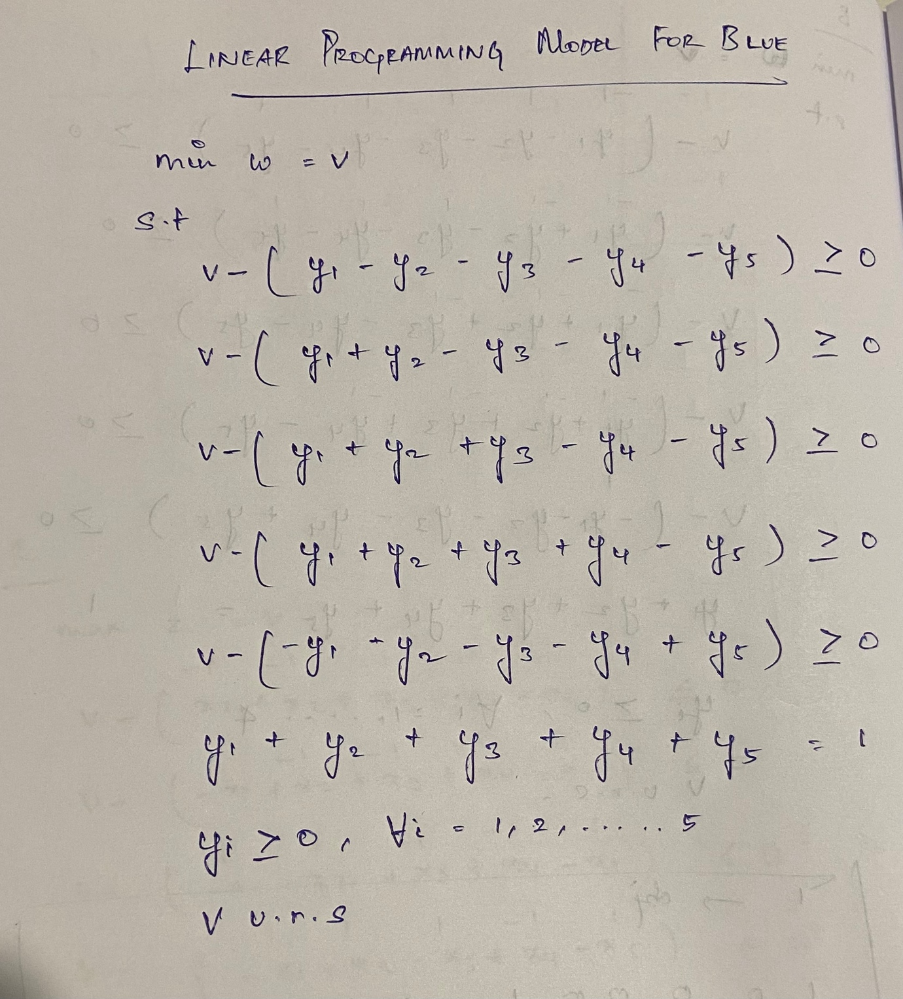

**3.e) Refer to R code for Solution of the LP model**

**3.f)**

The interpretation of the solution obtained from the LP model for solving Blue Company is that the value happens to have **‘0’** which gives the notion that the bidding is tied. However, since it is explicitly mentioned in the question that in an event of a tie in the bidding, the **winner** will be **RED.** Thus, we’ll have to conclude that **BLUE** has **lost** the bidding war. Additionally, we can also say that we are **50%** certain that RED will be the winner in the context of a tie when they bid with the values **15** and **50**. Thus, we conclude that **BLUE has lost the bidding war**.

**References:**

**# "Wayne L. Winston, Operations Research: Applications and Algorithms, Deakin University Library, Melbourne”**

**# "Hamdy A. Taha, Operations Research: An Introduction, Deakin University Library, Melbourne”**