**VISVESVARAYA TECHNOLOGICAL UNIVERSITY**

**“JnanaSangama”, Belgaum -590014, Karnataka.**



**LAB REPORT**

**on**

**Object Oriented Modelling And Design**

***Submitted by***

**PRAJITH AARYA (1BM19CS113)**

***in partial fulfillment for the award of the degree of***

**BACHELOR OF ENGINEERING**

***in***

**COMPUTER SCIENCE AND ENGINEERING**



**B.M.S. COLLEGE OF ENGINEERING**

**(Autonomous Institution under VTU)**

**BENGALURU-560019**

**May-2022 to July-2022**

**B. M. S. College of Engineering,**

**Bull Temple Road, Bangalore 560019**

(Affiliated To Visvesvaraya Technological University, Belgaum)

**Department of Computer Science and Engineering**



**CERTIFICATE**

This is to certify that the Lab work entitled “LAB COURSE **Object Oriented Modelling And Design**” carried out by **PRAJITH AARYA(1BM19CS113),** who is bonafide student of **B. M. S. College of Engineering.** It is in partial fulfillment for the award of **Bachelor of Engineering in Computer Science and Engineering** of the Visvesvaraya Technological University, Belgaum during the year 2022. The Lab report has been approved as it satisfies the academic requirements in respect of a **Object Oriented Modelling And Design- (20CS6PCOMD)** work prescribed for the said degree.

Name of the Lab-Incharge               **Dr. Nandini Vineeth**

Designation Assistant Professor

Department of CSE Department of CSE

BMSCE, Bengaluru BMSCE, Bengaluru

`

**Index Sheet**

|  |  |  |
| --- | --- | --- |
| **Sl. No.** | **Experiment Title** | **Page No.** |
| **1.** | **College Management System** | **4** |
| **2.** | **Hostel Management System** | **5** |
| **3.** | **Stock Management System** | **6** |
| **4.** | **Coffee Vending Machine** | **7** |
| **5.** | **Online Shopping System** | **8** |
| **6.** | **Railway Reservation System** | **9** |
| **7.** | **Graphics Editor** | **10-11** |
|  |  |  |
|  |  |  |
|  |  |  |
|  |  |  |
|  |  |  |
|  |  |  |
|  |  |  |
|  |  |  |

**Course Outcome**

|  |  |
| --- | --- |
|  | **CO1** Ability to apply the knowledge of class, State & Interaction Modelling using Unified  Modeling Language to solve a given problem.  **CO2** Ability to analyze a System for a given requirement using Unified Modeling language.  **CO3** Ability to design a given system using high level strategy.  **CO4** Ability to conduct practical experiment to solve a given problem using Unified Modeling  language. |

**LAB 1:**

**College Management System**

**Class Diagram:**

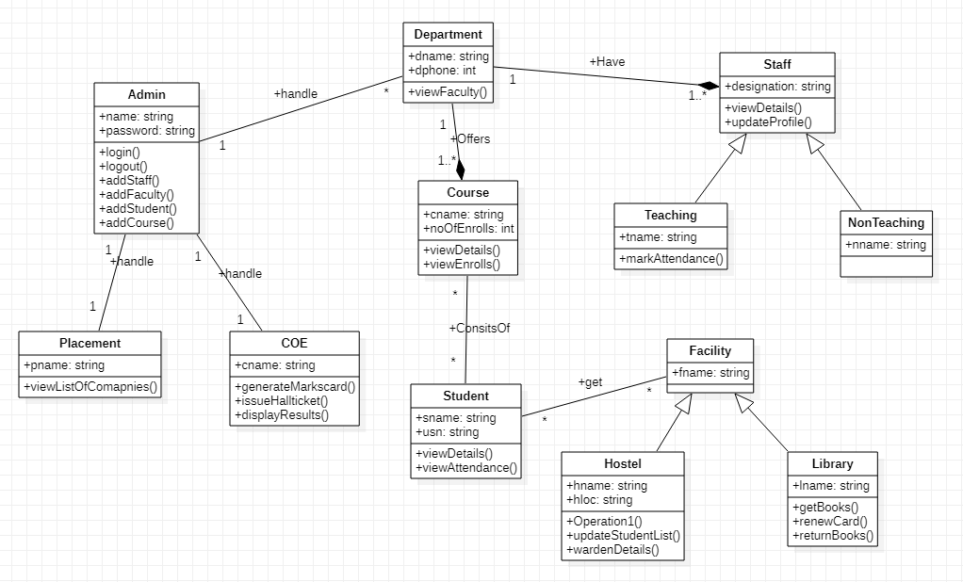

**State Diagram:**

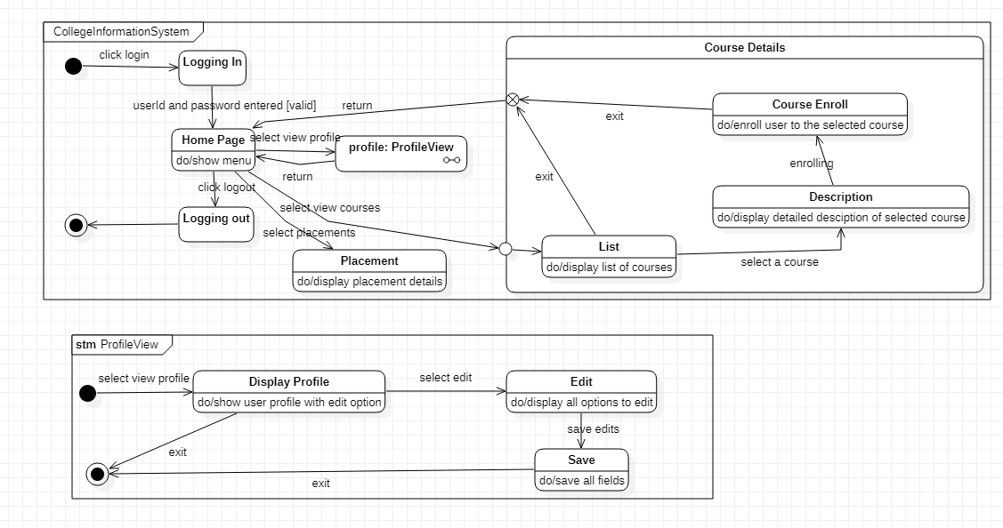

**LAB 2:**

**Hostel Management System**

**Class Diagram:**

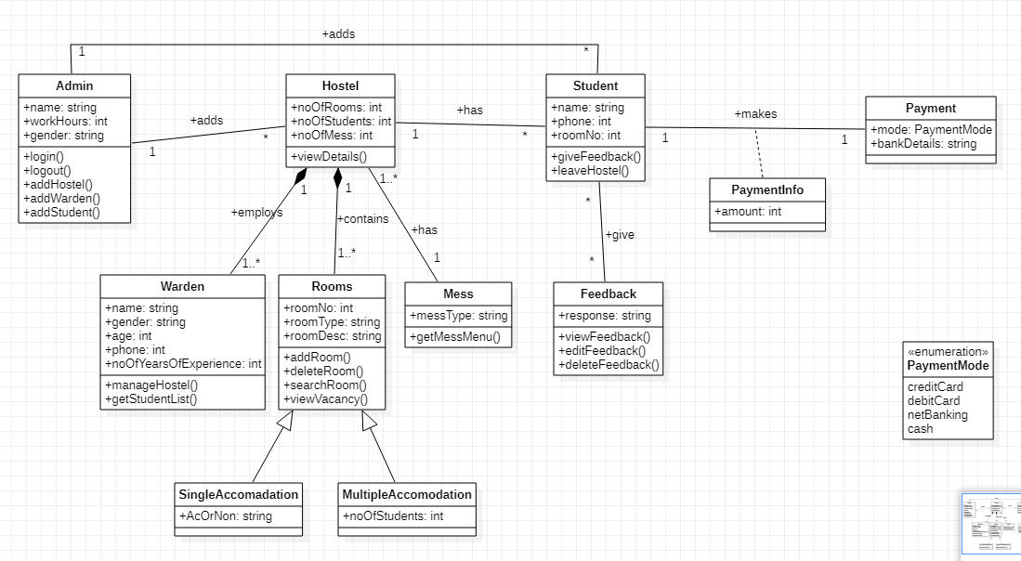

**State Diagram:**

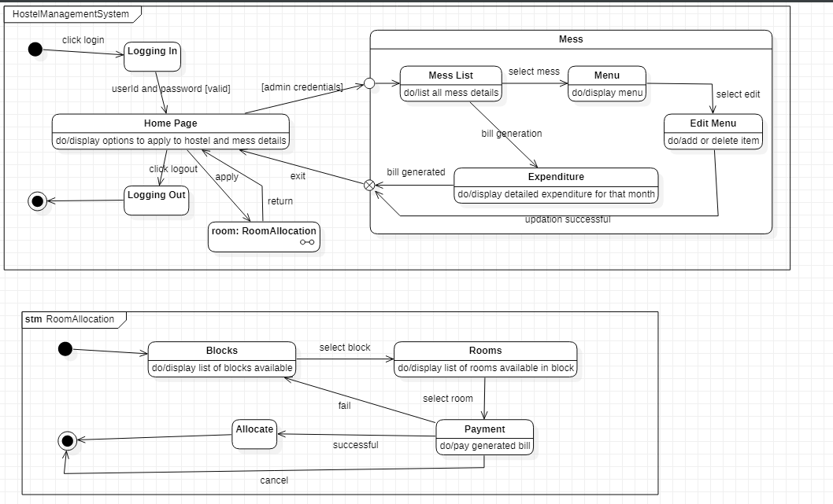

**LAB 3:**

**Stock Management System**

**Class Diagram:**

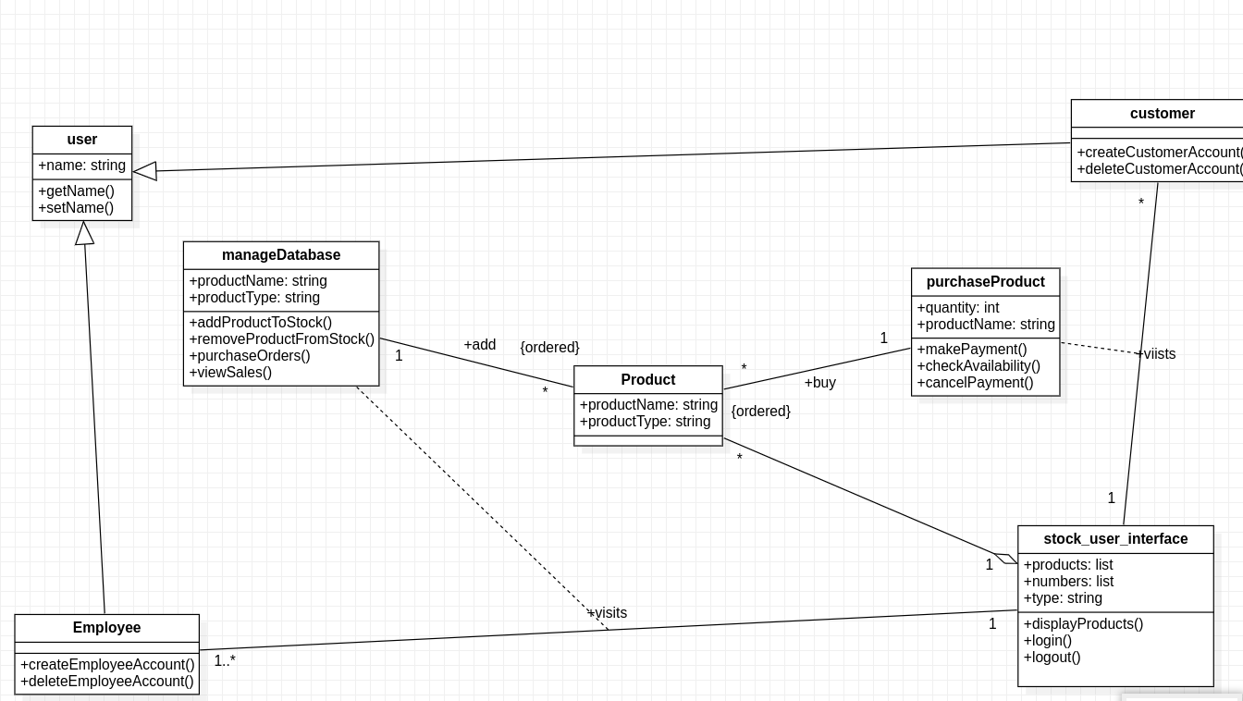

**State Diagram:**

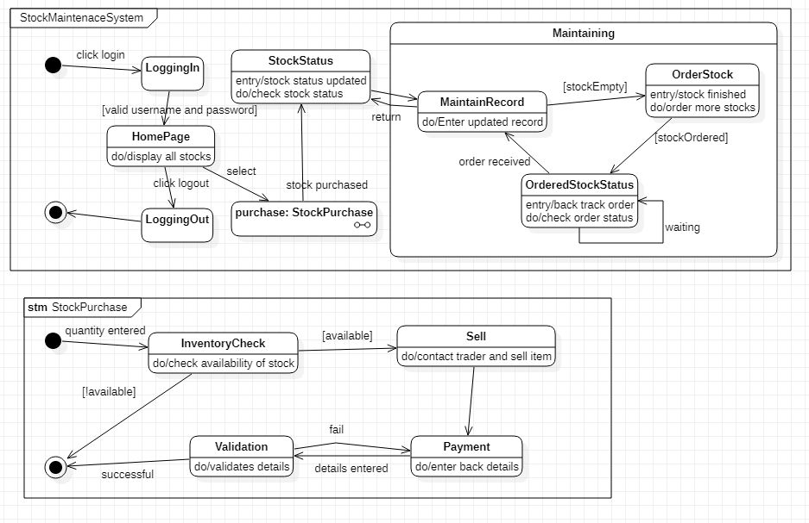

**LAB 4:**

**Coffee Vending Machine**

**Class Diagram:**

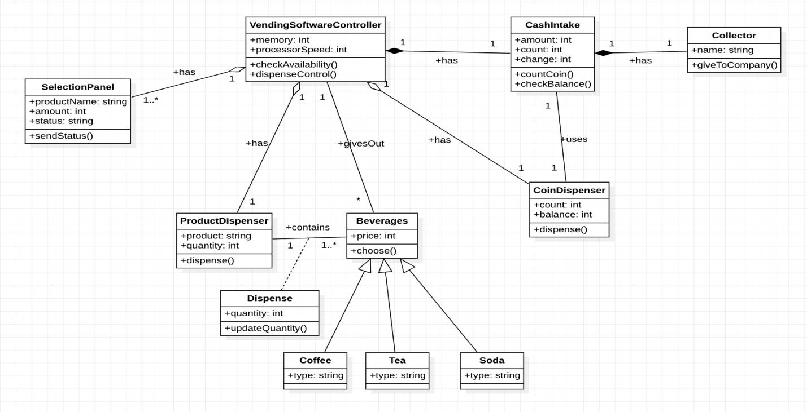

**State Diagram:**

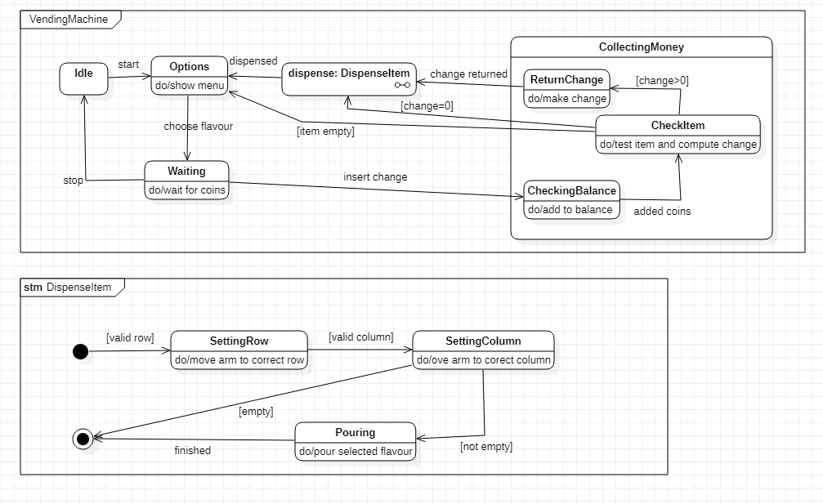

**LAB 5:**

**Online Shopping System**

**Class Diagram:**

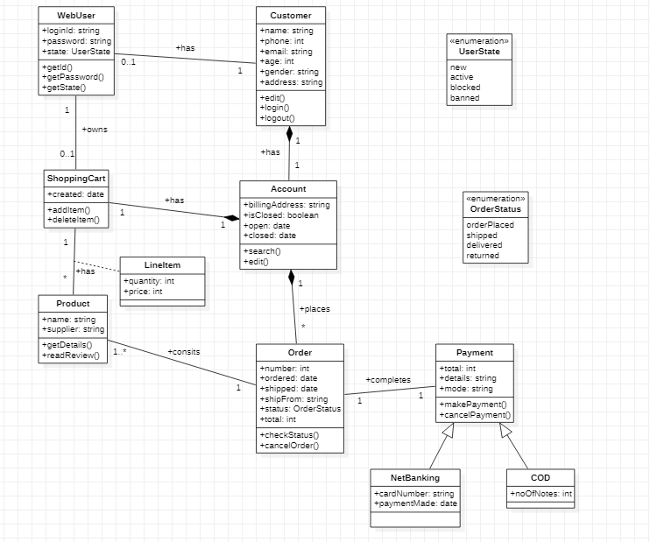

**State Diagram:**

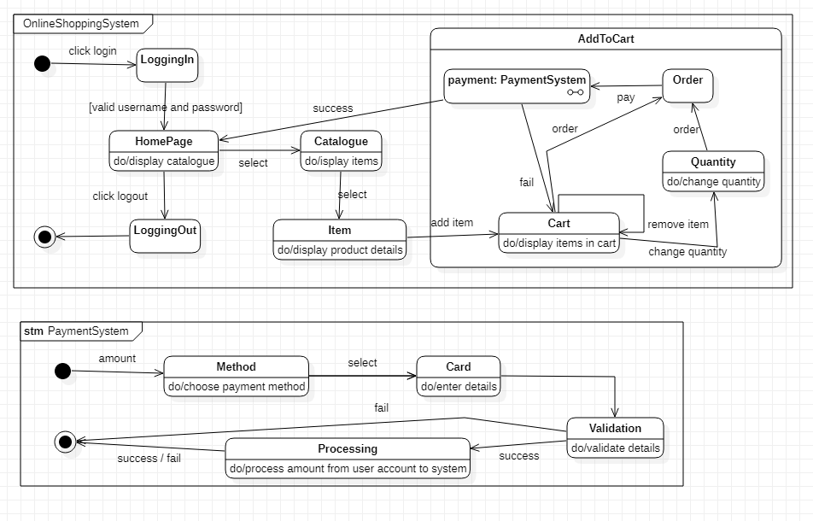

**LAB 6:**

**Railway Reservation System**

**Class Diagram:**

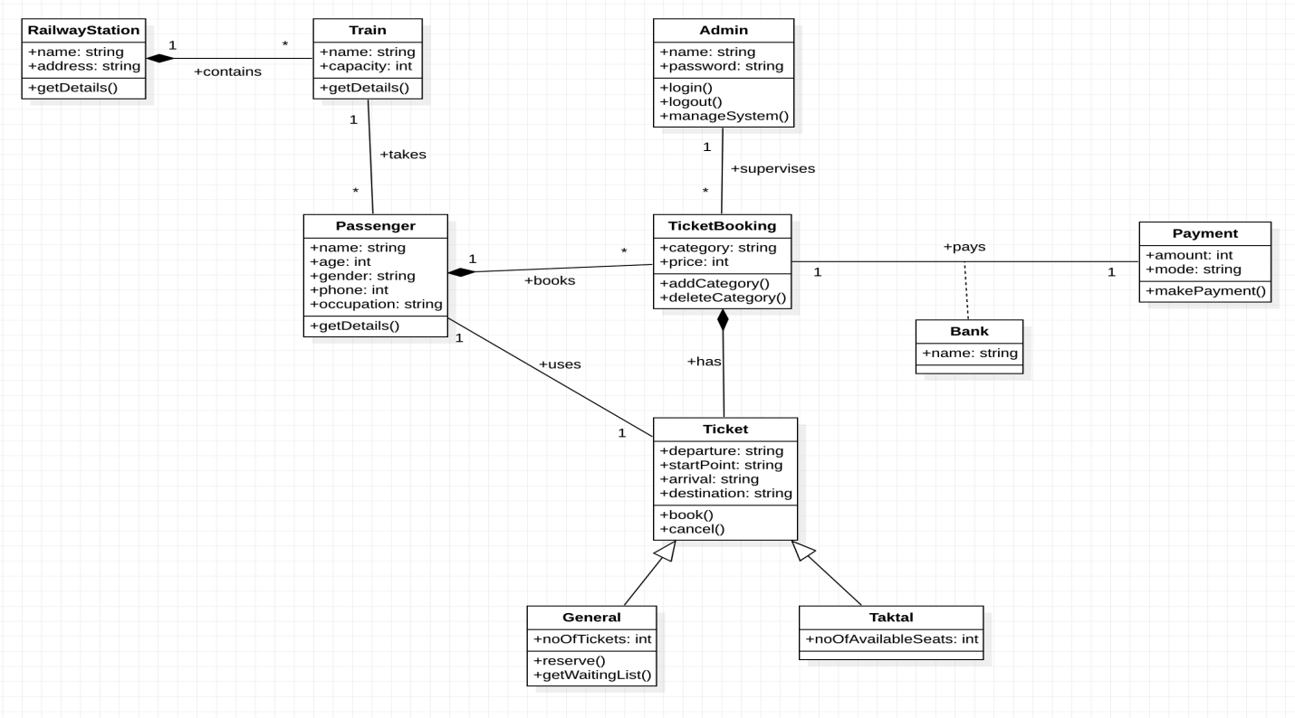

**State Diagram:**

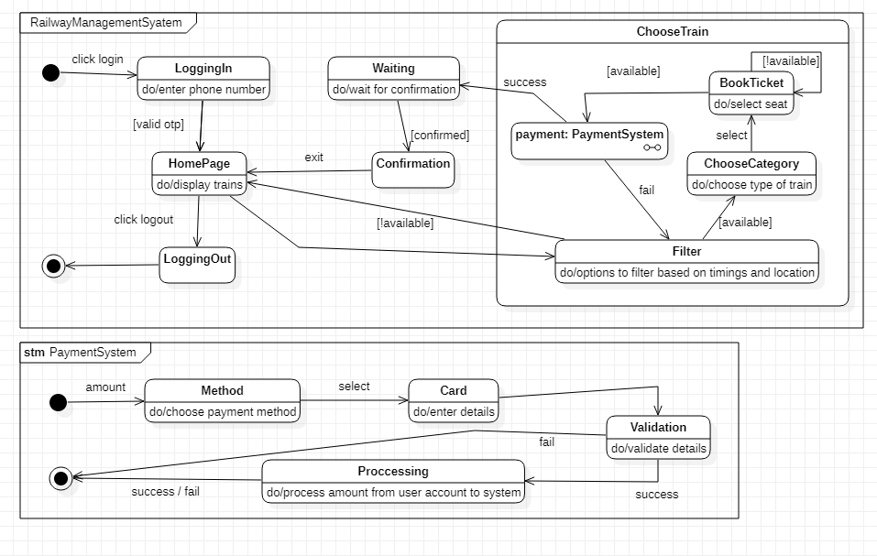

**LAB 7:**

**Graphics Editor System**

**Class Diagram:**

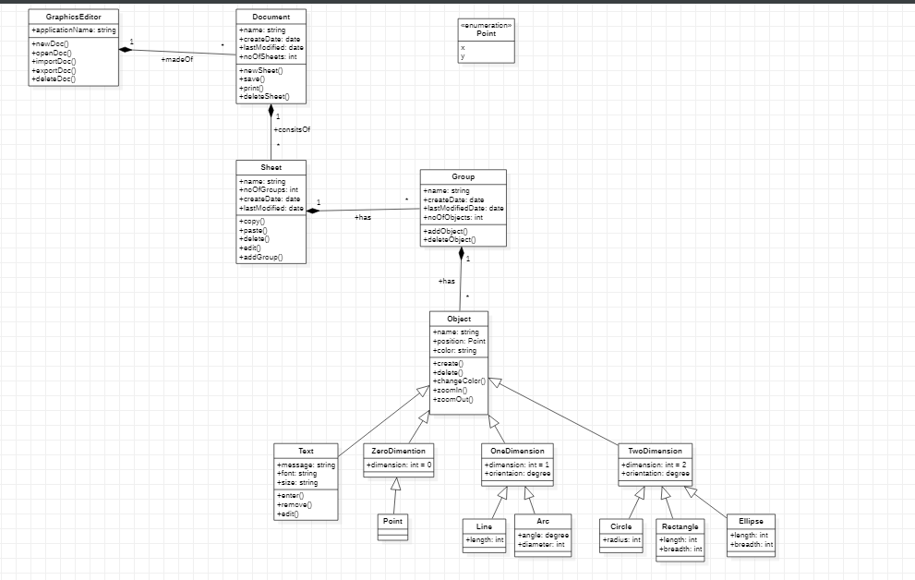

**State Diagram:**

