**1.Write a recursive program to**

**a. Solve Towers-of-Hanoi problem**

#include<stdio.h>

void towers(int num, char s, char d, char t)

{

if (num == 1)

{

printf("\n Move disk 1 from peg %c to peg %c", s, d);

return;

}

towers(num - 1, s, t, d);

printf("\n Move disk %d from peg %c to peg %c", num, s, d);

towers(num - 1, t, d, s);

}

int main()

{

int num;

printf("Enter the number of disks : ");

scanf("%d", &num);

printf("The sequence of moves involved in the Tower of Hanoi are :\n");

towers(num, 'A', 'B', 'C');

return 0;

}

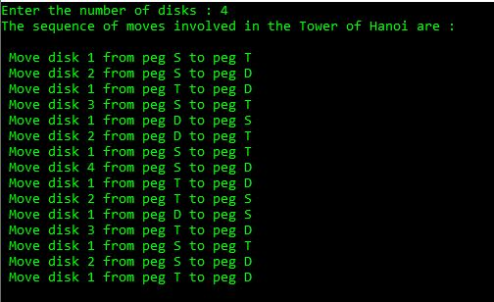

**b. To find GCD**

#include <stdio.h>

int gcd(int a, int b)

{

if (a == 0)

return b;

if (b==0)

return a;

return gcd(b, a%b);

//return gcd(b%a, a);

}

int main()

{

int a,b;

printf("Enter the two numbers:\n");

scanf("%d%d",&a,&b);

printf("GCD(%d, %d) = %d\n", a, b, gcd(a, b));

return 0;

}

