LAB 1:

1. Create a key space by name Employee
create keyspace employee with replication={
‘class’: ‘SimpleStrategy’, ‘replicaiton_factor’ : 1
};

2. Create a column family by name Employee-Info with attributes Emp_Id Primary Key, Emp_Name, Designation, Date_of_Joining, Salary, Dept_Name.

create table employee_info( emp_id int PRIMARY KEY, emp_name text, designation text, DOJ timestamp, Salary int, dept_name text );

3. Insert the values into the table in batch

BEGIN batch insert into employee_info(emp_id,emp_name,designation,doj,salary,dept_name) values (121,'prajith','CEO','2022-01-01',600000000,'admin') insert into employee_info(emp_id,emp_name,designation,doj,salary,dept_name) values (1,'aarya','CTO','2022-01-04',50000000,'IT') insert into employee_info(emp_id,emp_name,designation,doj,salary,dept_name) values (2,'vasu','HR','2022-01-07',6700000,'HR') insert into employee_info(emp_id,emp_name,designation,doj,salary,dept_name) values (3,'puneeth','Software engineer','2022-01-09',2000000,'IT') apply batch;

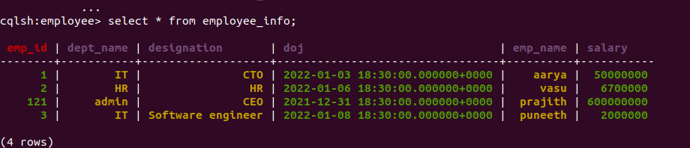

4. Update Employee name and Department of Emp-Id 121

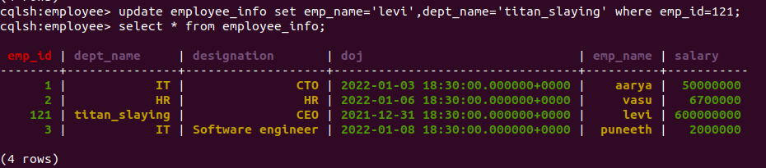

5. Sort the details of Employee records based on salary

6. Alter the schema of the table Employee_Info to add a
column Projects which stores a set of Projects done by the corresponding Employee.
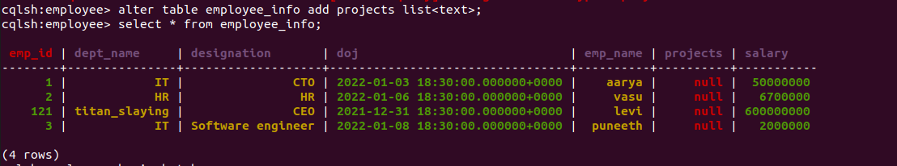

7. Update the altered table to add project names.

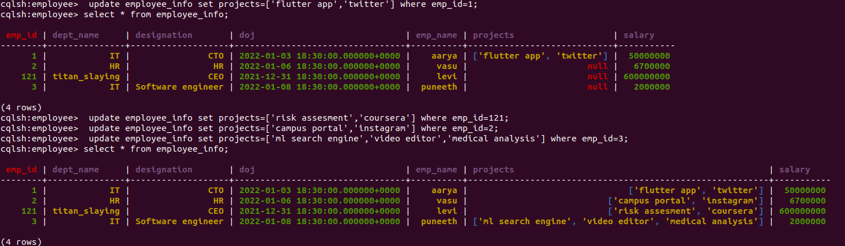

8 Create a TTL of 15 seconds to display the values of Employees.

