Consider the Insurance database given below. The primary keys are underlined and the data types are specified.

PERSON (driver-id #: String, name: String, address: String)

CAR (Regno: String, model: String, year: int)

ACCIDENT (report-number: int, date: date, location: String)

OWNS (driver-id #: String, Regno: String)

PARTICIPATED (driver-id: String, Regno: String, report-number: int, damage-amount: int)

1. Create the above tables by properly specifying the primary keys and the foreign keys.

**[CREATE](http://localhost/phpmyadmin/url.php?url=https://dev.mysql.com/doc/refman/8.0/en/create-table.html" \t "http://localhost/phpmyadmin/index.php?route=/database/mysql_doc) [TABLE](http://localhost/phpmyadmin/url.php?url=https://dev.mysql.com/doc/refman/8.0/en/create-table.html" \t "http://localhost/phpmyadmin/index.php?route=/database/mysql_doc) PERSON (**

**Driver\_ID [char](http://localhost/phpmyadmin/url.php?url=https://dev.mysql.com/doc/refman/8.0/en/string-types.html" \t "http://localhost/phpmyadmin/index.php?route=/database/mysql_doc)(5) NOT null,**

**Name [varchar](http://localhost/phpmyadmin/url.php?url=https://dev.mysql.com/doc/refman/8.0/en/string-types.html" \t "http://localhost/phpmyadmin/index.php?route=/database/mysql_doc)(30),**

**Address [varchar](http://localhost/phpmyadmin/url.php?url=https://dev.mysql.com/doc/refman/8.0/en/string-types.html" \t "http://localhost/phpmyadmin/index.php?route=/database/mysql_doc)(100),**

**primary key (Driver\_ID));**

**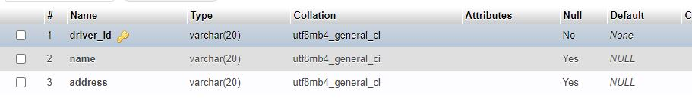**

**[CREATE](http://localhost/phpmyadmin/url.php?url=https://dev.mysql.com/doc/refman/8.0/en/create-table.html" \t "http://localhost/phpmyadmin/index.php?route=/database/mysql_doc) [TABLE](http://localhost/phpmyadmin/url.php?url=https://dev.mysql.com/doc/refman/8.0/en/create-table.html" \t "http://localhost/phpmyadmin/index.php?route=/database/mysql_doc) CAR (Reg\_no [char](http://localhost/phpmyadmin/url.php?url=https://dev.mysql.com/doc/refman/8.0/en/string-types.html" \t "http://localhost/phpmyadmin/index.php?route=/database/mysql_doc)(4) NOT null, model [varchar](http://localhost/phpmyadmin/url.php?url=https://dev.mysql.com/doc/refman/8.0/en/string-types.html" \t "http://localhost/phpmyadmin/index.php?route=/database/mysql_doc)(10), Year int(4));**

**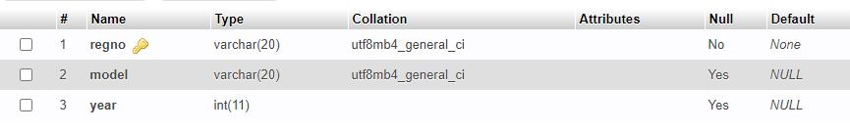**

**CREATE table accident (Report\_number int(5) NOT NULL,Date date,Location varchar(15));**

**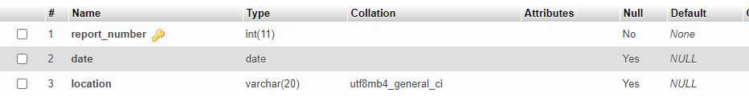**

**CREATE table owns(Driver\_ID char(5), Reg\_no char(4),FOREIGN KEY (Driver\_ID) REFERENCES person(Driver\_ID));**

****

**CREATE table participated(**

**Driver\_ID char(5),**

**Reg\_no char(4),**

**Report\_number int(5),**

**Damage\_amount int(7),**

**FOREIGN KEY (Driver\_ID) REFERENCES person(Driver\_ID));**

**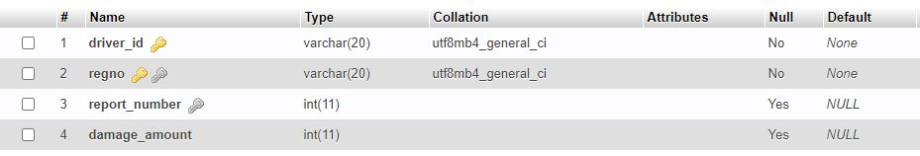**

1. Enter at least five tuples for each relation.

**PERSON:**

**INSERT into person VALUES("1412","Aarya","bangalore");**

**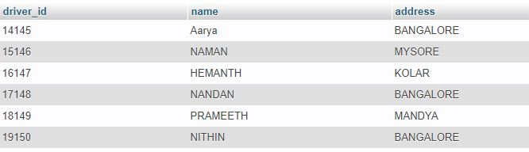**

**CAR:**

**insert INTO car VALUES("KA01AS7894","1234",2001); 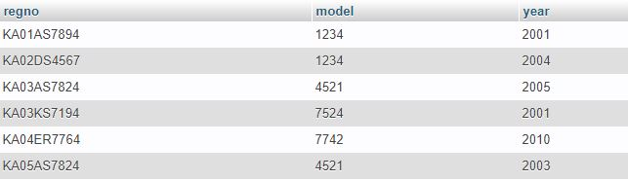**

**Accident:**

**insert INTO accident VALUES(10,"2022-01-18","VIJAYANAGAR");**

**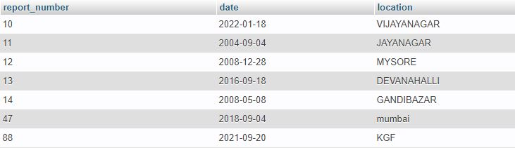**

**OWNS:**

**INSERT INTO owns VALUES ('14145', 'KA01AS7894');**

**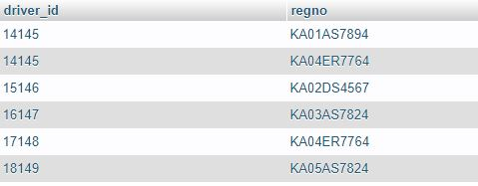**

1. Demonstrate how you

a.Update the damage amount for the car with a specific Regno in the accident with report number 12 to

25000.

**[UPDATE](http://localhost/phpmyadmin/url.php?url=https://dev.mysql.com/doc/refman/8.0/en/update.html" \t "http://localhost/phpmyadmin/index.php?route=/table/mysql_doc) participated [SET](http://localhost/phpmyadmin/url.php?url=https://dev.mysql.com/doc/refman/8.0/en/set.html" \t "http://localhost/phpmyadmin/index.php?route=/table/mysql_doc) damage\_amount=25000 WHERE regno='KA03AS7824' [and](http://localhost/phpmyadmin/url.php?url=https://dev.mysql.com/doc/refman/8.0/en/logical-operators.html" \l "operator_and" \t "http://localhost/phpmyadmin/index.php?route=/table/mysql_doc) report\_number=13**

**3a**

b. Add a new accident to the database.

**INSERT INTO accident VALUES ('345', '2021-04-13', 'mumbai');**

**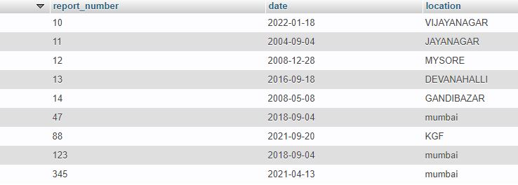**

1. Find the total number of people who owned cars that involved in accidents in 2008.

**SELECT count(driver\_id) AS COUNT**

**from PARTICIPATED WHERE report\_number IN (SELECT report\_number FROM ACCIDENT WHERE YEAR (date)=2008 )**

**4**

1. Find the number of accidents in which cars belonging to a specific model were involved.

**select count(\*) from car c,participated p where c.regno=p.regno and c.model='1234';**

**5**