Consider the following database for a banking enterprise.

BRANCH (branch-name: String, branch-city: String, assets: real)

ACCOUNTS (accno: int, branch-name: String, balance: real)

DEPOSITOR (customer-name: String, customer-street: String, customer-city: String)

LOAN (loan-number: int, branch-name: String, amount: real)

BORROWER (customer-name: String, loan-number: int)

i.Create the above tables by properly specifying the primary keys and the foreign keys.

create table branch(branch_name varchar(30),branch_city varchar(20),assets int,primary key(branch_name));

create table account(accno int,branch_name varchar(20),balance int,primary key(accno));

create table customer(customer_name varchar(20),customer_street varchar(20),customer_city varchar(20),primary key(customer_name));

create table depositor(customer_name varchar(20),accno int,primary key(customer_name,accno),foreign key(customer_name) references customer(customer_name),foreign key(accno) references account(accno) on delete cascade);

create table loan(loan_number int,branch_name varchar(20),amount int,primary key(loan_number),foreign key(branch_name) references branch(branch_name));

create table borrower(customer_name varchar(20),loan_number int,primary key(customer_name,loan_number),foreign key(customer_name) references customer(customer_name),foreign key(loan_number) references loan(loan_number));

ii.Enter at least five tuples for each relation.

INSERT INTO customer VALUES ('aarya', 'rajajinagar', 'bangalore');

INSERT INTO account VALUES ('123123', 'malleshwaram', '30000');

INSERT INTO depositor VALUES ('aarya', '576124');

INSERT INTO loan VALUES ('87', 'malleshwaram', '70000000');

INSERT INTO borrower VALUES ('aarya', '91');

iii. Find all the customers who have at least two accounts at the Main branch.

SELECT D.customer_name

FROM DEPOSITOR D, ACCOUNT A

WHERE A.accno = D.accno AND

A.branch_name= 'malleshwaram'

GROUP BY D.customer_name

HAVING COUNT(*) >= 2;

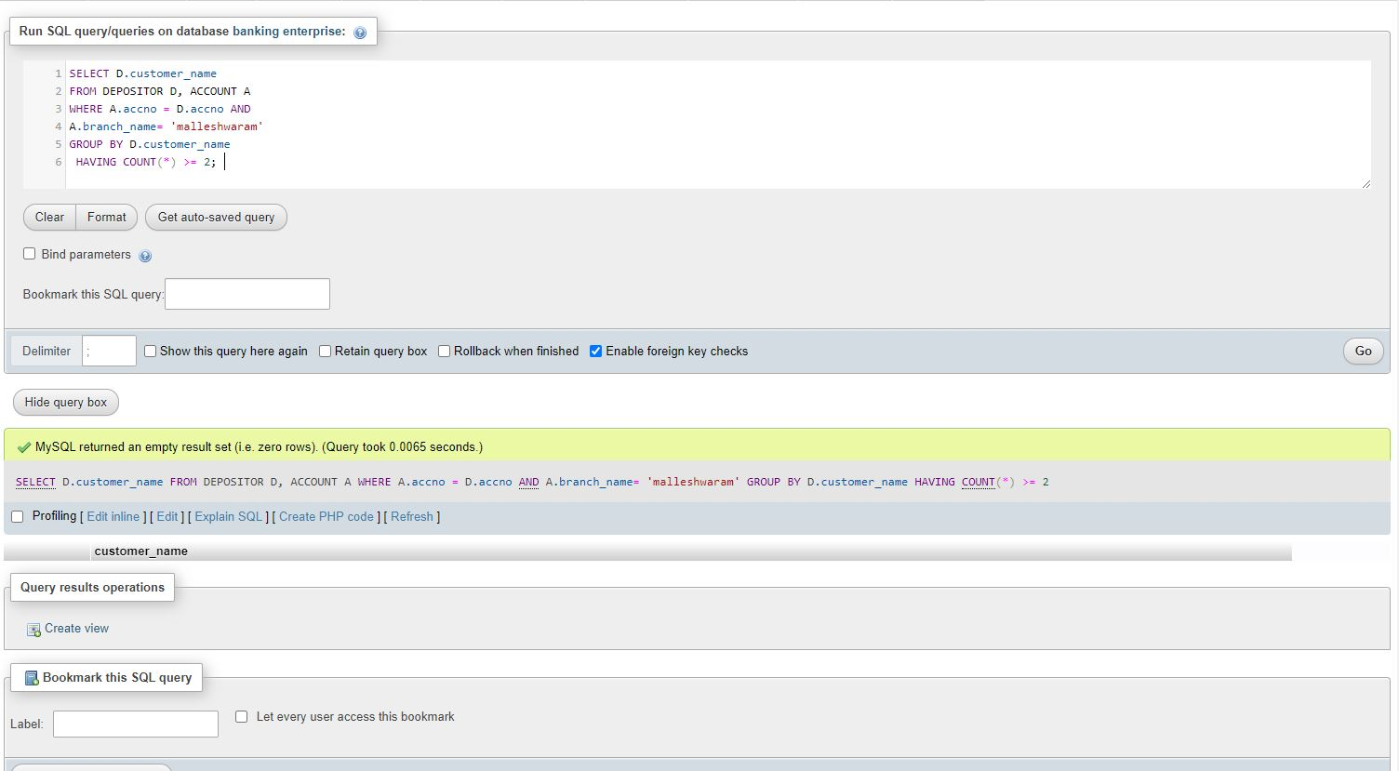

iv.Find all the customers who have an account at all the branches located in a specific city.

SELECT d.customer_name

FROM account a,branch b,depositor d

WHERE b.branch_name=a.branch_name AND

a.accno=d.accno AND

b.branch_city='bangalore'

GROUP BY d.customer_name

HAVING COUNT(distinct b.branch_name)=(

SELECT COUNT(branch_name)

FROM branch

WHERE branch_city='bangalore');

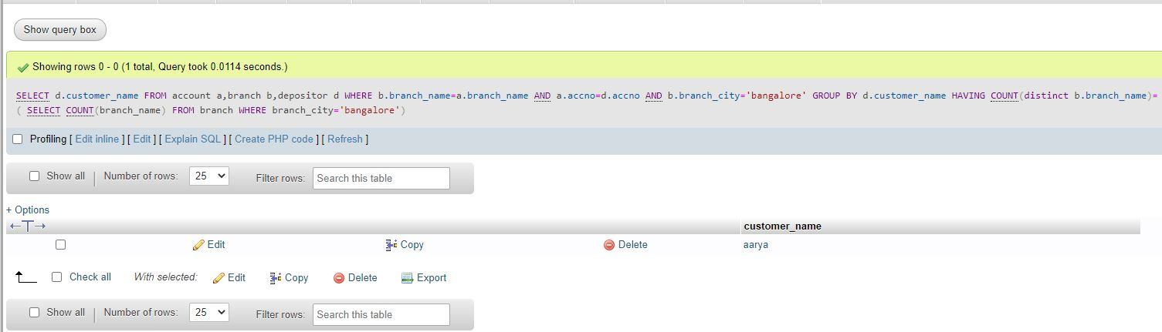

v.Demonstrate how you delete all account tuples at every branch located in a specific city.

