**Consider the following schema:**

**SUPPLIERS (sid: integer, sname: string, address: string)**

**PARTS (pid: integer, pname: string, color: string)**

**CATALOG (sid: integer, pid: integer, cost: real)**

**The Catalog relation lists the prices charged for parts by Suppliers. Write the following queries in SQL:**

create TABLE suppliers(sid int(4),sname varchar(20),address varchar(100),CONSTRAINT ID PRIMARY key(sid))

CREATE TABLE parts(pid int,pname varchar(20), color varchar(10),CONSTRAINT PID PRIMARY KEY(pid))

CREATE table catalog(sid int,pid int,cosr real,CONSTRAINT F\_sid FOREIGN KEY(sid) REFERENCES suppliers(sid), CONSTRAINT F\_pid FOREIGN KEY(pid) REFERENCES parts(pid));

insert into suppliers values(123,'aarya','rajajinagar')

INSERT INTO parts VALUES ('1', 'radio', 'grey');

INSERT INTO catalog VALUES ('123', '1', '10000');

1. **Find the pnames of parts for which there is some supplier.**

Select distinct p.pname from parts p, catalog c WHERE p.pid=c.pid

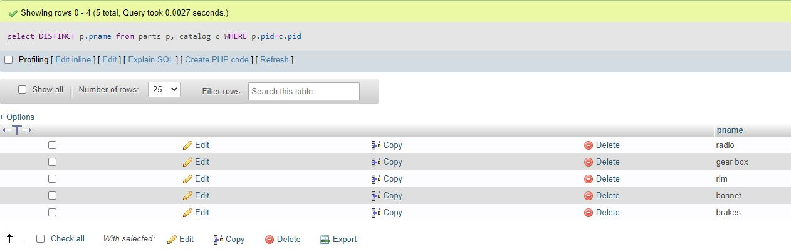

1. **Find the snames of suppliers who supply every part.**

select s.sname from suppliers s where not exists ((select \* from parts p) except (select c.pid from catalog c where c.sid = s.sid))

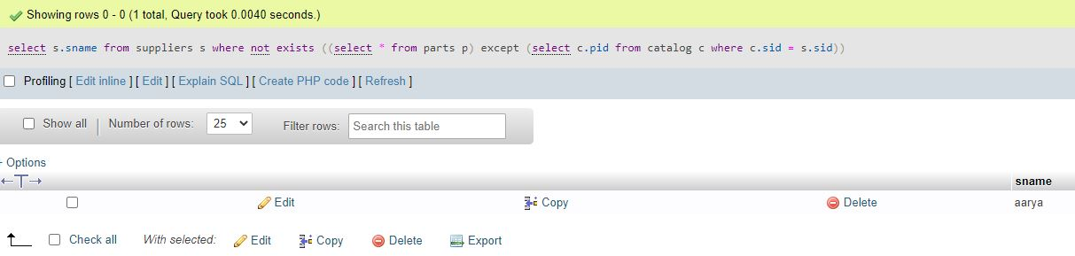

1. **Find the snames of suppliers who supply every red part.**

Select S.sname From suppliers s where not exists ( (select \* from parts p where p.color = 'red') except (select c.pid from catalog c, parts p where c.sid = s.sid and c.pid = p.pid and p.color = 'red'))

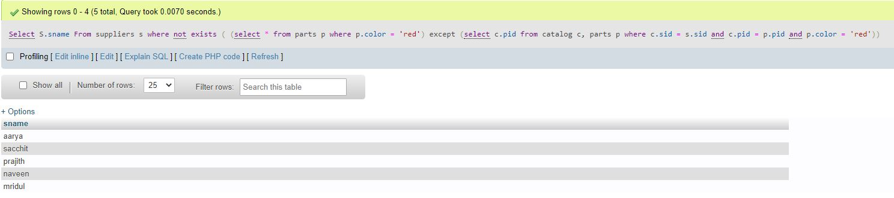

1. **Find the pnames of parts supplied by Acme Widget Suppliers and by no one else.**

[select](http://localhost/phpmyadmin/url.php?url=https://dev.mysql.com/doc/refman/8.0/en/select.html" \t "http://localhost/phpmyadmin/index.php?route=/database/mysql_doc) p.pname from parts p where p.pid [in](http://localhost/phpmyadmin/url.php?url=https://dev.mysql.com/doc/refman/8.0/en/comparison-operators.html" \l "function_in" \t "http://localhost/phpmyadmin/index.php?route=/database/mysql_doc)([select](http://localhost/phpmyadmin/url.php?url=https://dev.mysql.com/doc/refman/8.0/en/select.html" \t "http://localhost/phpmyadmin/index.php?route=/database/mysql_doc) c.pid from catalog c where c.sid [in](http://localhost/phpmyadmin/url.php?url=https://dev.mysql.com/doc/refman/8.0/en/comparison-operators.html" \l "function_in" \t "http://localhost/phpmyadmin/index.php?route=/database/mysql_doc) ([select](http://localhost/phpmyadmin/url.php?url=https://dev.mysql.com/doc/refman/8.0/en/select.html" \t "http://localhost/phpmyadmin/index.php?route=/database/mysql_doc) s.sid from suppliers s WHERE s.sname="AcmeWidget" ))

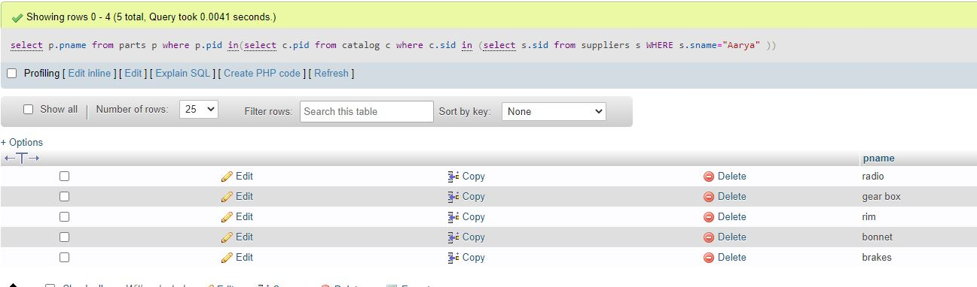

v. **Find the sids of suppliers who charge more for some part than the average cost of that part (averaged over**

**all the suppliers who supply that part).**

[SELECT](http://localhost/phpmyadmin/url.php?url=https://dev.mysql.com/doc/refman/8.0/en/select.html" \t "http://localhost/phpmyadmin/index.php?route=/database/mysql_doc) s.sid FROM suppliers s WHERE s.sid [IN](http://localhost/phpmyadmin/url.php?url=https://dev.mysql.com/doc/refman/8.0/en/comparison-operators.html" \l "function_in" \t "http://localhost/phpmyadmin/index.php?route=/database/mysql_doc)

 ([SELECT](http://localhost/phpmyadmin/url.php?url=https://dev.mysql.com/doc/refman/8.0/en/select.html" \t "http://localhost/phpmyadmin/index.php?route=/database/mysql_doc) c.sid FROM catalog c WHERE c.cost>([SELECT](http://localhost/phpmyadmin/url.php?url=https://dev.mysql.com/doc/refman/8.0/en/select.html" \t "http://localhost/phpmyadmin/index.php?route=/database/mysql_doc) [AVG](http://localhost/phpmyadmin/url.php?url=https://dev.mysql.com/doc/refman/8.0/en/group-by-functions.html" \l "function_avg" \t "http://localhost/phpmyadmin/index.php?route=/database/mysql_doc)(c.cost) FROM catalog c) )

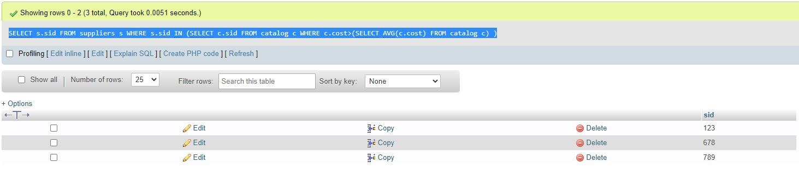

**vi. For each part, find the sname of the supplier who charges the most for that part.**

**select s.sname, p.pname from suppliers s,parts p where s.sid in(SELECT c.sid from catalog c where c.cost)**

SELECT P.pid, S.sname FROM Parts P, Suppliers S, Catalog C WHERE C.pid = P.pid AND C.sid = S.sid AND C.cost = (SELECT MAX (C1.cost) FROM Catalog C1 WHERE C1.pid = P.pid)

SELECT P.pid, S.sname FROM Parts P, Suppliers S,catalog c WHERE c.pid=p.pid AND c.sid=s.sid AND s.sid IN (SELECT c2.sid from catalog c2 where c2.pid=p.pid AND c2.pid in (select max(c1.pid) FROM catalog c1 group by c1.pid ))

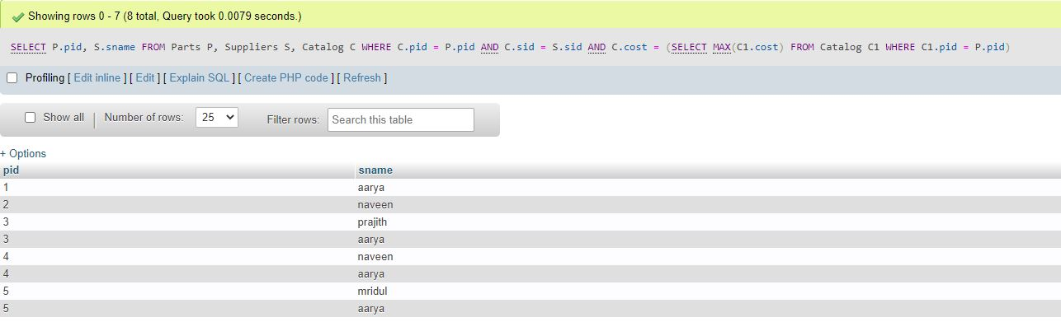

vii. **Find the sids of suppliers who supply only red parts.**

SELECT DISTINCT C.sid FROM Catalog C WHERE NOT EXISTS ( SELECT \* FROM Parts P WHERE P.pid = C.pid AND P.color ="Red" )

