**PROGRAM 10:COLLEGE DATABASE  
  
  
Consider the schema for College Database:**

**STUDENT(USN, SName, Address, Phone, Gender)**

**SEMSEC(SSID, Sem, Sec)**

**CLASS(USN, SSID)**

**SUBJECT(Subcode, Title, Sem, Credits)**

**IAMARKS(USN, Subcode, SSID, Test1, Test2, Test3, FinalIA)**

**Write SQL queries to  
i. List all the student details studying in fourth semester ‘C’ section.**

[SELECT](http://localhost/phpmyadmin/url.php?url=https://dev.mysql.com/doc/refman/8.0/en/select.html" \t "http://localhost/phpmyadmin/index.php?route=/database/mysql_doc) S.\*, SS.SEM, SS.SEC FROM STUDENT S, SEMSEC SS, CLASS C WHERE S.USN = C.USN [AND](http://localhost/phpmyadmin/url.php?url=https://dev.mysql.com/doc/refman/8.0/en/logical-operators.html" \l "operator_and" \t "http://localhost/phpmyadmin/index.php?route=/database/mysql_doc) SS.SSID = C.SSID [AND](http://localhost/phpmyadmin/url.php?url=https://dev.mysql.com/doc/refman/8.0/en/logical-operators.html" \l "operator_and" \t "http://localhost/phpmyadmin/index.php?route=/database/mysql_doc) SS.SEM = 4 [AND](http://localhost/phpmyadmin/url.php?url=https://dev.mysql.com/doc/refman/8.0/en/logical-operators.html" \l "operator_and" \t "http://localhost/phpmyadmin/index.php?route=/database/mysql_doc) SS.SEC='C'

1

**ii. Compute the total number of male and female students in each semester and in each section.**

[SELECT](http://localhost/phpmyadmin/url.php?url=https://dev.mysql.com/doc/refman/8.0/en/select.html" \t "http://localhost/phpmyadmin/index.php?route=/database/mysql_doc) SS.SEM, SS.SEC, S.GENDER, [COUNT](http://localhost/phpmyadmin/url.php?url=https://dev.mysql.com/doc/refman/8.0/en/group-by-functions.html" \l "function_count" \t "http://localhost/phpmyadmin/index.php?route=/database/mysql_doc)(S.GENDER) AS [COUNT](http://localhost/phpmyadmin/url.php?url=https://dev.mysql.com/doc/refman/8.0/en/group-by-functions.html" \l "function_count" \t "http://localhost/phpmyadmin/index.php?route=/database/mysql_doc) FROM STUDENT S, SEMSEC SS, CLASS C WHERE S.USN = C.USN [AND](http://localhost/phpmyadmin/url.php?url=https://dev.mysql.com/doc/refman/8.0/en/logical-operators.html" \l "operator_and" \t "http://localhost/phpmyadmin/index.php?route=/database/mysql_doc) SS.SSID = C.SSID GROUP BY SS.SEM, SS.SEC, S.GENDER ORDER BY SEM

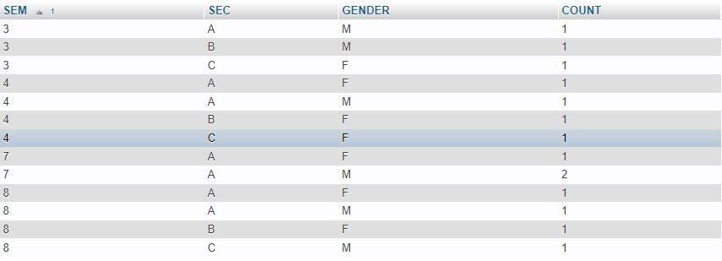

**iii. Create a view of Test1 marks of student USN ‘1BI15CS101’ in all subjects.**

CREATE VIEW STUDENT\_TEST1\_MARKS\_V AS SELECT TEST1, SUBCODE FROM IAMARKS

WHERE USN = '1BI15CS101';

SELECT \* FROM STUDENT\_TEST1\_MARKS\_V;

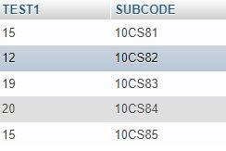

**iv. Calculate the FinalIA (average of best two test marks) and update the corresponding table for all students.**

**v. Categorize students based on the following criterion:   
If FinalIA = 17 to 20 then CAT = ‘Outstanding’   
If FinalIA = 12 to 16 then CAT = ‘Average’  
If FinalIA< 12 then CAT = ‘Weak’   
Give these details only for 8th semester A, B, and C section students.**

[SELECT](http://localhost/phpmyadmin/url.php?url=https://dev.mysql.com/doc/refman/8.0/en/select.html" \t "http://localhost/phpmyadmin/index.php?route=/table/mysql_doc) S.USN,S.SNAME,S.ADDRESS,S.PHONE,S.GENDER, IA.SUBCODE, ([CASE](http://localhost/phpmyadmin/url.php?url=https://dev.mysql.com/doc/refman/8.0/en/control-flow-functions.html" \l "operator_case" \t "http://localhost/phpmyadmin/index.php?route=/table/mysql_doc) WHEN IA.FINALIA BETWEEN 17 [AND](http://localhost/phpmyadmin/url.php?url=https://dev.mysql.com/doc/refman/8.0/en/logical-operators.html" \l "operator_and" \t "http://localhost/phpmyadmin/index.php?route=/table/mysql_doc) 20 THEN 'OUTSTANDING' WHEN IA.FINALIA BETWEEN 12 [AND](http://localhost/phpmyadmin/url.php?url=https://dev.mysql.com/doc/refman/8.0/en/logical-operators.html" \l "operator_and" \t "http://localhost/phpmyadmin/index.php?route=/table/mysql_doc) 16 THEN 'AVERAGE' ELSE 'WEAK' END) AS CAT FROM STUDENT S, SEMSEC SS, IAMARKS IA, SUBJECT SUB WHERE S.USN = IA.USN [AND](http://localhost/phpmyadmin/url.php?url=https://dev.mysql.com/doc/refman/8.0/en/logical-operators.html" \l "operator_and" \t "http://localhost/phpmyadmin/index.php?route=/table/mysql_doc) SS.SSID = IA.SSID [AND](http://localhost/phpmyadmin/url.php?url=https://dev.mysql.com/doc/refman/8.0/en/logical-operators.html" \l "operator_and" \t "http://localhost/phpmyadmin/index.php?route=/table/mysql_doc) SUB.SUBCODE = IA.SUBCODE [AND](http://localhost/phpmyadmin/url.php?url=https://dev.mysql.com/doc/refman/8.0/en/logical-operators.html" \l "operator_and" \t "http://localhost/phpmyadmin/index.php?route=/table/mysql_doc) SUB.SEM = 8

