**PROGRAM 8. STUDENT ENROLLMENT DATABASE  
Consider the following database of student enrollment in courses and books adopted for each course.**

**STUDENT (regno: String, name: String, major: String, bdate: date)**

**COURSE (course #: int, cname: String, dept: String)**

**ENROLL (regno: String, cname: String, sem: int, marks: int)**

**BOOK_ADOPTION (course #: int, sem: int, book-ISBN: int)**

**TEXT(book-ISBN:int, book-title:String, publisher:String, author:String)**

**i. Create the above tables by properly specifying the primary keys and the foreign keys.**

CREATE TABLE student(

regno VARCHAR(15),

name VARCHAR(20),

major VARCHAR(20),

bdate DATE,

PRIMARY KEY (regno) )

CREATE TABLE course(

courseno INT,

cname VARCHAR(20),

dept VARCHAR(20),

PRIMARY KEY (courseno) )

CREATE TABLE enroll(

regno VARCHAR(15),

courseno INT,

sem INT(3),

marks INT(4),

PRIMARY KEY (regno,courseno),

FOREIGN KEY (regno) REFERENCES student (regno),

FOREIGN KEY (courseno) REFERENCES course (courseno) )

CREATE TABLE text(

book_isbn INT(5),

book_title VARCHAR(20),

publisher VARCHAR(20),

author VARCHAR(20),

PRIMARY KEY (book_isbn) )

CREATE TABLE book_adoption(

courseno INT,

sem INT(3),

book_isbn INT(5),

PRIMARY KEY (courseno,book_isbn),

FOREIGN KEY (courseno) REFERENCES course (courseno),

FOREIGN KEY (book_isbn) REFERENCES text(book_isbn) )

**ii. Enter at least five tuples for each relation.**

INSERT INTO student (regno,name,major,bdate) VALUES ('1pe11cs002','b','sr','19930924')

INSERT INTO course VALUES (111,'OS','CSE')

INSERT INTO book_adoption (courseno,sem,book_isbn) VALUES (111,5,900)

INSERT INTO enroll (regno,courseno,sem,marks) VALUES ('1pe11cs002',114,5,100)

INSERT INTO text (book_isbn,book_title,publisher,author) VALUES

(10,'DATABASE SYSTEMS','PEARSON','SCHIELD')

**iii. Demonstrate how you add a new text book to the database and make this book be adopted by some   
department.**

INSERT INTO `book_adoption` (`courseno`, `sem`, `book_isbn`) VALUES ('114', '6', '10')

INSERT INTO `text` (`book_isbn`, `book_title`, `publisher`, `author`) VALUES ('10’, 'DATABASE SYSTEMS', 'PEARSON', 'SCHIELD')

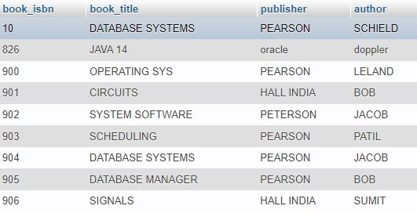

**iv. Produce a list of text books (include Course #, Book-ISBN, Book-title) in the alphabetical order for courses offered by the ‘CS’ department that use more than two books.**

SELECT c.courseno,t.book_isbn,t.book_title

FROM course c,book_adoption ba,text t

WHERE c.courseno=ba.courseno

AND ba.book_isbn=t.book_isbn

AND c.dept='CSE'

AND 2<(

SELECT COUNT(book_isbn)

FROM book_adoption b

WHERE c.courseno=b.courseno)

ORDER BY t.book_title

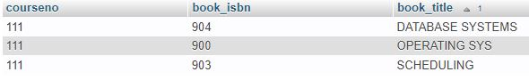

**v. List any department that has all its adopted books published by a specific publisher.**

SELECT DISTINCT c.dept

FROM course c

WHERE c.dept IN

( SELECT c.dept

FROM course c,book_adoption b,text t

WHERE c.courseno=b.courseno

AND t.book_isbn=b.book_isbn

AND t.publisher='PEARSON')

