**PROGRAM 9: MOVIE DATABASE  
  
  
Consider the schema for Movie Database:**

**ACTOR(Act_id, Act_Name, Act_Gender)**

**DIRECTOR(Dir_id, Dir_Name, Dir_Phone)**

**MOVIES(Mov_id, Mov_Title, Mov_Year, Mov_Lang, Dir_id)**

**MOVIE_CAST(Act_id, Mov_id, Role)**

**RATING(Mov_id, Rev_Stars)**

**Write SQL queries to**

**i. List the titles of all movies directed by ‘Hitchcock’.**

SELECT MOV_TITLE FROM MOVIES WHERE DIR_ID = (SELECT DIR_ID FROM DIRECTOR WHERE DIR_NAME='HITCHCOCK')

**1**

**ii. Find the movie names where one or more actors acted in two or more movies.**

SELECT MOV_TITLE FROM MOVIES M,MOVIE_CAST MC WHERE M.MOV_ID=MC.MOV_ID AND ACT_ID IN (SELECT ACT_ID FROM MOVIE_CAST GROUP BY ACT_ID

HAVING COUNT(ACT_ID)>1) GROUP BY MOV_TITLE HAVING COUNT(*)>1

**2**

**iii. List all actors who acted in a movie before 2000 and also in a movie after 2015 (use JOIN operation).**

SELECT ACT_NAME FROM ACTOR A JOIN MOVIE_CAST C ON A.ACT_ID=C.ACT_ID JOIN MOVIES M ON C.MOV_ID=M.MOV_ID WHERE M.MOV_YEAR NOT BETWEEN 2000 AND 2015

**3**

**iv. Find the title of movies and number of stars for each movie that has at least one rating and find the highest number of stars that movie received. Sort the result by movie title.**

SELECT MOV_TITLE,MAX(REV_STARS) FROM MOVIES INNER JOIN RATING USING (MOV_ID) GROUP BY MOV_TITLE HAVING MAX(REV_STARS)>0 ORDER BY MOV_TITLE

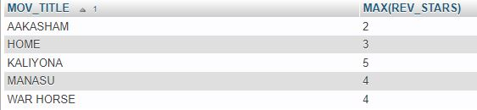

**v. Update rating of all movies directed by ‘Steven Spielberg’ to 5.**

UPDATE RATING SET REV_STARS=5 WHERE MOV_ID IN (SELECT MOV_ID FROM MOVIES WHERE DIR_ID IN (SELECT DIR_ID FROM DIRECTOR WHERE DIR_NAME='STEVEN SPIELBERG'))

