LAB Program-4 ( Student Faculty Database):  
Upload the document(Queries with output screenshot)/github link here  
  
  
**PROGRAM 4: STUDENT  
FACULTY DATABASE**  
  
  
**Consider the following database for  
student enrollment for course :**  
  
  
**STUDENT(snum: integer, sname:  
string, major: string, lvl: string, age: integer)**  
  
  
**CLASS(cname: string, meets  
at: time, room: string, fid: integer)**  
  
  
**ENROLLED(snum: integer, cname:  
string)**  
  
  
**FACULTY(fid: integer, fname:  
string, deptid: integer)**  
  
  
**The meaning of these relations is  
straightforward; for example, Enrolled has one record per student-class pair  
such that the student is enrolled in the class. Level(lvl) is a two character  
code with 4 different values (example: Junior: JR etc)**  
  
  
**Write the following queries in SQL.  
No duplicates should be printed in any of the answers.**  
  
 **i.                  
Find  
the names of all Juniors (level = JR) who are enrolled in a class taught by**

SELECT DISTINCT S.Sname

FROM Student S, Class C, Enrolled E, Faculty F

WHERE S.snum = E.snum AND E.cname = C.cname AND C.fid = F.fid AND

1. fname = ‘Murty’ AND S.lvl = ‘JR’

**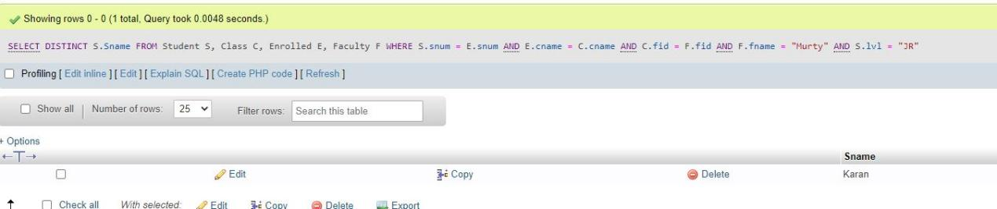**

**ii.                
Find  
the names of all classes that either meet in room R128 or have five or more  
Students enrolled.**

SELECT C.cname FROM Class C WHERE C.room = '128' OR C.cname IN (SELECT E.cname FROM Enrolled E GROUP BY E.cname HAVING COUNT(\*)>=3);

**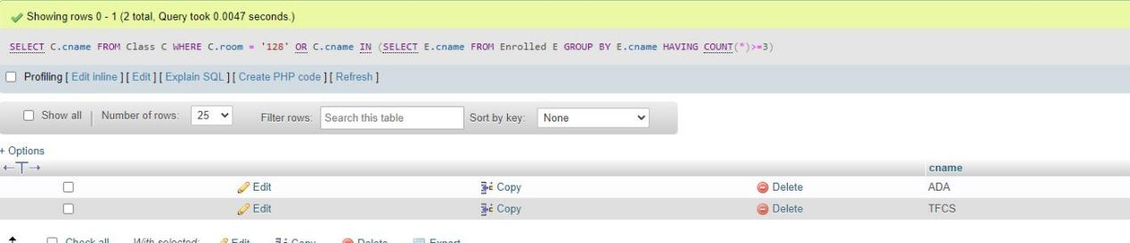**

**iii.              
Find  
the names of all students who are enrolled in two classes that meet at the same  
time.**

select distinct s.sname from student s

where s.snum in (select e1.snum

from enrolled e1,enrolled e2,class c1,class c2

where e1.snum=e2.snum and e1.cname<>e2.cname and

e1.cname=c1.cname and e2.cname=c2.cname and

c1.meets\_at=c2.meets\_at);

**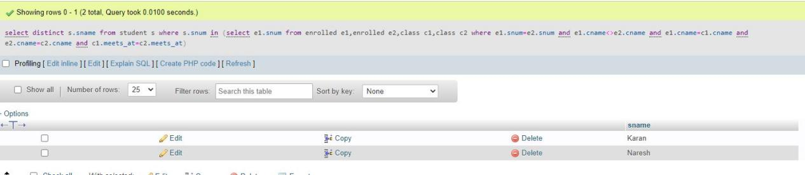**  
  
  
**iv.              
Find  
the names of faculty members who teach in every room in which some class is  
taught.**

select f.fname

from faculty f

where f.fid in(select fid from class

group by fid having count(\*)=(select count(distinct room)from class));

**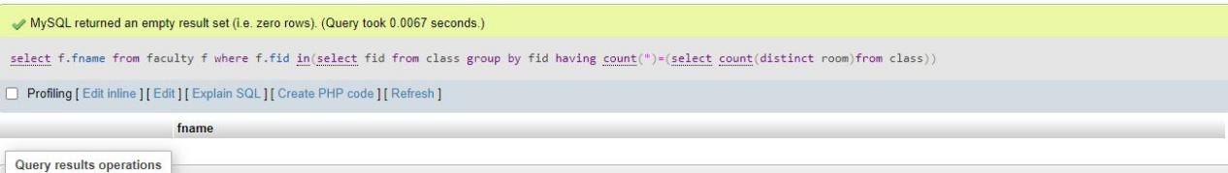**  
  
  
**v.                
Find  
the names of faculty members for whom the combined enrollment of the courses  
that they teach is less than five.**

[SELECT](http://localhost/phpmyadmin/url.php?url=https://dev.mysql.com/doc/refman/8.0/en/select.html" \t "http://localhost/phpmyadmin/index.php?route=/database/mysql_doc) DISTINCT F.fname FROM Faculty F WHERE 5 > ([SELECT](http://localhost/phpmyadmin/url.php?url=https://dev.mysql.com/doc/refman/8.0/en/select.html" \t "http://localhost/phpmyadmin/index.php?route=/database/mysql_doc) [COUNT](http://localhost/phpmyadmin/url.php?url=https://dev.mysql.com/doc/refman/8.0/en/group-by-functions.html" \l "function_count" \t "http://localhost/phpmyadmin/index.php?route=/database/mysql_doc)(E.snum) FROM Class C, Enrolled E WHERE C.cname = E.cname [AND](http://localhost/phpmyadmin/url.php?url=https://dev.mysql.com/doc/refman/8.0/en/logical-operators.html" \l "operator_and" \t "http://localhost/phpmyadmin/index.php?route=/database/mysql_doc) C.fid = F.fid)

**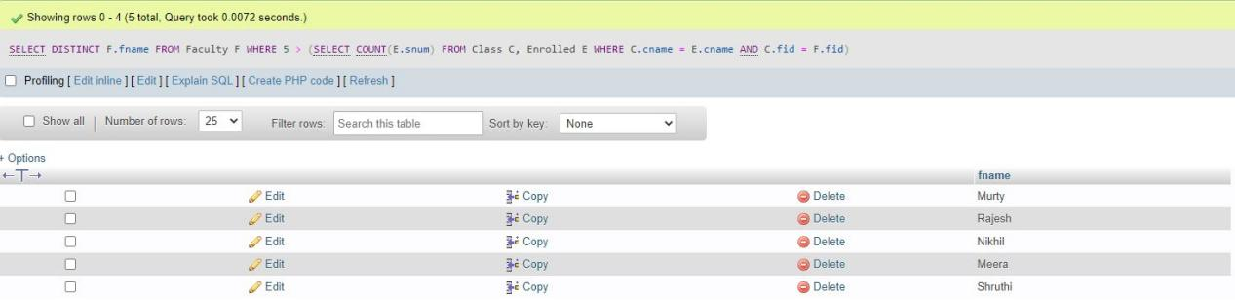**  
  
  
**vi.              
Find  
the names of students who are not enrolled in any class.**

**SELECT DISTINCT S.sname**

**FROM Student S**

WHERE S.snum NOT IN (SELECT E.snum

FROM Enrolled E );

**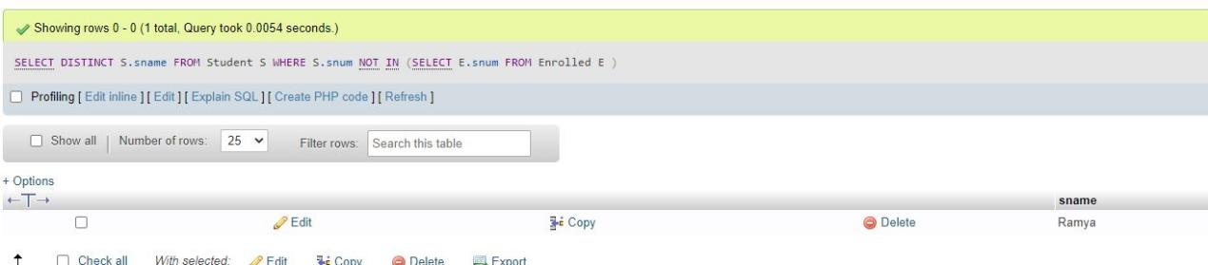**

**vii.             
For each age value that appears in Students, find the level value that appears most often. For example, if there are more FR level students aged 18 than SR, JR, or SO students aged 18, you should print the pair (18, FR).**

SELECT S.age, S.level FROM Student S GROUP BY S.age, S.level, HAVING S.level IN (SELECT S1.level FROM Student S1 WHERE S1.age = S.age GROUP BY S1.level, S1.age HAVING COUNT (\*) >= ALL (SELECT COUNT (\*) FROM Student S2 WHERE s1.age = S2.age GROUP BY S2.level, S2.age))

**