**Consider the following database that  
keeps track of airline flight information:  
  
  
FLIGHTS(flno: integer, from:  
string, to: string, distance: integer, departs: time, arrives: time, price:  
integer)  
  
  
AIRCRAFT(aid: integer,  
aname: string, cruisingrange: integer)  
  
  
CERTIFIED(eid: integer, aid:  
integer)  
  
  
EMPLOYEES(eid: integer,  
ename: string, salary: integer)  
  
  
Note that the Employees relation  
describes pilots and other kinds of employees as well; Every pilot is certified  
for some aircraft, and only pilots are certified to fly.  
  
  
Write each of the following queries  
in SQL.**

create table flight( fno int,ffrom varchar(20),fto varchar(20),distance int(11),departs time,arrives

time,price float , primary key(fno));

create table aircraft(aid int,aname varchar(20),crange int,CONSTRAINT aid\_pk primary key(aid));

create table employees(eid int, ename varchar(20),salary int,constraint eid\_pk primary key(eid));

create table certified(eid int,aid int,primary key(eid,aid) , CONSTRAINT eid\_fk foreign key(eid) references employees(eid), CONSTRAINT aid\_fk foreign key(aid) references aircraft(aid));

**i.                  
Find  
the names of aircraft such that all pilots certified to operate them have  
salaries more than Rs.80,000.**

SELECT a.aid,a.aname from aircraft a,employees e,certified c where a.aid=c.aid and e.eid=c.eid and e.salary>80000

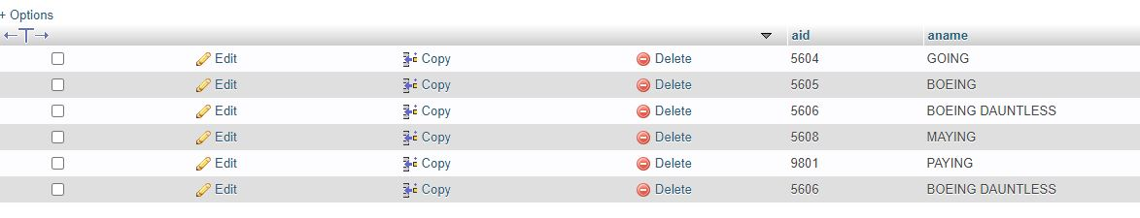 **ii.                
For each pilot who is certified for more than three aircrafts, find the eid and the maximum cruisingrange of the aircraft for which she or he is certified.**

select e.eid,max(a.crange) from employees e,aircraft a ,certified c where a.aid=c.aid and e.eid=c.eid GROUP by c.eid HAVING COUNT(\*)>3

 **iii.              
Find the names of pilots whose salary is less than the price of the cheapest route from Bengaluru to Frankfurt.**

select distinct e.ename from employees e,certified c where

e.eid=c.eid and e.salary<(select min(price) from flight f where

f.ffrom='bangalore' and f.fto='frankfurt')

 **iv.              
For all aircraft with cruisingrange over 1000 Kms, find the name of the aircraft and the average salary of all pilots certified for this aircraft.**

select a.aname,AVG(e.salary) from aircraft a,employees e,certified c where a.aid=c.aid and e.eid=c.eid and a.crange>1000 group by a.aname

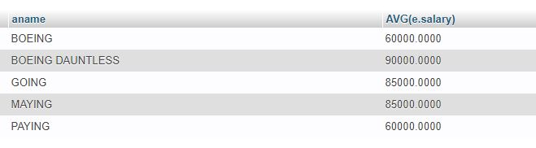 **v.                
Find the names of pilots certified for some Boeing aircraft.**

select ename from aircraft a,certified c,employees e where

1. aid=c.aid and c.eid=e.eid and a.aname like '%boeing%

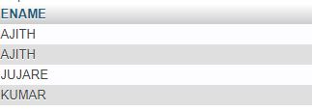

**vi.              
Find the aids of all aircraft that can be used on routes from Bengaluru to New Delhi.**

select a.aid from aircraft a where a.crange>=(select

min(f.distance) from flight f where f.ffrom='bangalore' and

f.fto='new delhi')



**vii.             
A customer wants to travel from Madison to New York with no more than two changes of flight. List the choice of departure times from Madison if the customer wants to arrive in New York by 6 p.m.**

[SELECT](http://localhost/phpmyadmin/url.php?url=https://dev.mysql.com/doc/refman/8.0/en/select.html" \t "http://localhost/phpmyadmin/index.php?route=/database/mysql_doc) F.departs FROM Flight F WHERE F.fno [IN](http://localhost/phpmyadmin/url.php?url=https://dev.mysql.com/doc/refman/8.0/en/comparison-operators.html" \l "function_in" \t "http://localhost/phpmyadmin/index.php?route=/database/mysql_doc) ( ( [SELECT](http://localhost/phpmyadmin/url.php?url=https://dev.mysql.com/doc/refman/8.0/en/select.html" \t "http://localhost/phpmyadmin/index.php?route=/database/mysql_doc) F0.fno FROM Flight F0 WHERE F0.ffrom = "Madison" [AND](http://localhost/phpmyadmin/url.php?url=https://dev.mysql.com/doc/refman/8.0/en/logical-operators.html" \l "operator_and" \t "http://localhost/phpmyadmin/index.php?route=/database/mysql_doc) F0.fto = "New York" [AND](http://localhost/phpmyadmin/url.php?url=https://dev.mysql.com/doc/refman/8.0/en/logical-operators.html" \l "operator_and" \t "http://localhost/phpmyadmin/index.php?route=/database/mysql_doc) F0.arrives < "18:00" ) UNION ( [SELECT](http://localhost/phpmyadmin/url.php?url=https://dev.mysql.com/doc/refman/8.0/en/select.html" \t "http://localhost/phpmyadmin/index.php?route=/database/mysql_doc) F0.fno FROM Flight F0, Flight F1 WHERE F0.ffrom = "Madison" [AND](http://localhost/phpmyadmin/url.php?url=https://dev.mysql.com/doc/refman/8.0/en/logical-operators.html" \l "operator_and" \t "http://localhost/phpmyadmin/index.php?route=/database/mysql_doc) F0.fto <> "New York" [AND](http://localhost/phpmyadmin/url.php?url=https://dev.mysql.com/doc/refman/8.0/en/logical-operators.html" \l "operator_and" \t "http://localhost/phpmyadmin/index.php?route=/database/mysql_doc) F0.fto = F1.ffrom [AND](http://localhost/phpmyadmin/url.php?url=https://dev.mysql.com/doc/refman/8.0/en/logical-operators.html" \l "operator_and" \t "http://localhost/phpmyadmin/index.php?route=/database/mysql_doc) F1.fto = "New York" [AND](http://localhost/phpmyadmin/url.php?url=https://dev.mysql.com/doc/refman/8.0/en/logical-operators.html" \l "operator_and" \t "http://localhost/phpmyadmin/index.php?route=/database/mysql_doc) F1.departs > F0.arrives [AND](http://localhost/phpmyadmin/url.php?url=https://dev.mysql.com/doc/refman/8.0/en/logical-operators.html" \l "operator_and" \t "http://localhost/phpmyadmin/index.php?route=/database/mysql_doc) F1.arrives < "18:00") UNION ( [SELECT](http://localhost/phpmyadmin/url.php?url=https://dev.mysql.com/doc/refman/8.0/en/select.html" \t "http://localhost/phpmyadmin/index.php?route=/database/mysql_doc) F0.fno FROM Flight F0, Flight F1, Flight F2 WHERE F0.ffrom = "Madison" [AND](http://localhost/phpmyadmin/url.php?url=https://dev.mysql.com/doc/refman/8.0/en/logical-operators.html" \l "operator_and" \t "http://localhost/phpmyadmin/index.php?route=/database/mysql_doc) F0.fto = F1.ffrom [AND](http://localhost/phpmyadmin/url.php?url=https://dev.mysql.com/doc/refman/8.0/en/logical-operators.html" \l "operator_and" \t "http://localhost/phpmyadmin/index.php?route=/database/mysql_doc) F1.fto = F2.ffrom [AND](http://localhost/phpmyadmin/url.php?url=https://dev.mysql.com/doc/refman/8.0/en/logical-operators.html" \l "operator_and" \t "http://localhost/phpmyadmin/index.php?route=/database/mysql_doc) F2.fto = "New York" [AND](http://localhost/phpmyadmin/url.php?url=https://dev.mysql.com/doc/refman/8.0/en/logical-operators.html" \l "operator_and" \t "http://localhost/phpmyadmin/index.php?route=/database/mysql_doc) F0.fto <> "New York" [AND](http://localhost/phpmyadmin/url.php?url=https://dev.mysql.com/doc/refman/8.0/en/logical-operators.html" \l "operator_and" \t "http://localhost/phpmyadmin/index.php?route=/database/mysql_doc) F1.fto <> "New York" [AND](http://localhost/phpmyadmin/url.php?url=https://dev.mysql.com/doc/refman/8.0/en/logical-operators.html" \l "operator_and" \t "http://localhost/phpmyadmin/index.php?route=/database/mysql_doc) F1.departs > F0.arrives [AND](http://localhost/phpmyadmin/url.php?url=https://dev.mysql.com/doc/refman/8.0/en/logical-operators.html" \l "operator_and" \t "http://localhost/phpmyadmin/index.php?route=/database/mysql_doc) F2.departs > F1.arrives [AND](http://localhost/phpmyadmin/url.php?url=https://dev.mysql.com/doc/refman/8.0/en/logical-operators.html" \l "operator_and" \t "http://localhost/phpmyadmin/index.php?route=/database/mysql_doc) F2.arrives < "18:00" ))

