**Program 6 : Order Database**  
  
**Consider the  
following schema for Order Database:**  
  
**SALESMAN (*Salesman\_id,  
Name, City, Commission*)**  
  
  
**CUSTOMER (*Customer\_id,  
Cust\_Name, City, Grade, Salesman\_id*)**  
  
  
**ORDERS (*Ord\_No,  
Purchase\_Amt, Ord\_Date, Customer\_id, Salesman\_id*)**  
  
  
**Write SQL queries  
to**

**1. Count the customers with grades above Bangalore’s average.**  
  
[SELECT](http://localhost/phpmyadmin/url.php?url=https://dev.mysql.com/doc/refman/8.0/en/select.html" \t "http://localhost/phpmyadmin/index.php?route=/table/mysql_doc) Grade, [COUNT](http://localhost/phpmyadmin/url.php?url=https://dev.mysql.com/doc/refman/8.0/en/group-by-functions.html" \l "function_count" \t "http://localhost/phpmyadmin/index.php?route=/table/mysql_doc)( Distinct Customer\_id) FROM customer GROUP BY Grade HAVING Grade > ([SELECT](http://localhost/phpmyadmin/url.php?url=https://dev.mysql.com/doc/refman/8.0/en/select.html" \t "http://localhost/phpmyadmin/index.php?route=/table/mysql_doc) [AVG](http://localhost/phpmyadmin/url.php?url=https://dev.mysql.com/doc/refman/8.0/en/group-by-functions.html" \l "function_avg" \t "http://localhost/phpmyadmin/index.php?route=/table/mysql_doc)(Grade) FROM customer WHERE City='BANGALORE')  
   
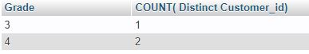  
  
**2. Find the name and numbers of all salesmen who had more than one customer.**  
  
SELECT SALESMAN\_ID, NAME FROM SALESMAN A WHERE 1 < (SELECT COUNT(\*) FROM CUSTOMER WHERE SALESMAN\_ID=A.SALESMAN\_ID);   
   
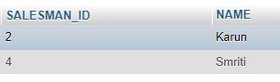  
  
**3. List all salesmen and indicate those who have and don’t have customers in their cities  
(Use UNION operation.)**

SELECT SALESMAN.SALESMAN\_ID, NAME, CUST\_NAME, COMMISSION FROM SALESMAN, CUSTOMER WHERE SALESMAN.CITY = CUSTOMER.CITY UNION SELECT SALESMAN\_ID, NAME, 'NO MATCH', COMMISSION FROM SALESMAN WHERE NOT CITY = ANY (SELECT CITY FROM CUSTOMER) ORDER BY 2 DESC;   
  
 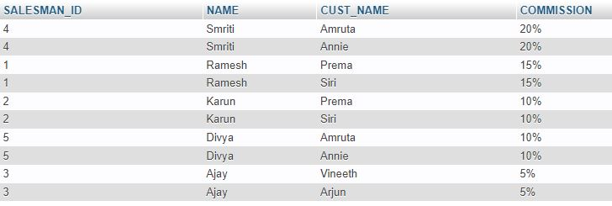  
  
  
**4. Create a view  
that finds the salesman who has the customer with the highest order of a day.**  
  
CREATE VIEW ELITSALESMAN AS SELECT B.ORD\_DATE, A.SALESMAN\_ID, A.NAME FROM

SALESMAN A, ORDERS B WHERE A.SALESMAN\_ID = B.SALESMAN\_ID AND B.PURCHASE\_AMT=(SELECT MAX(PURCHASE\_AMT) FROM ORDERS C WHERE C.ORD\_DATE = B.ORD\_DATE);

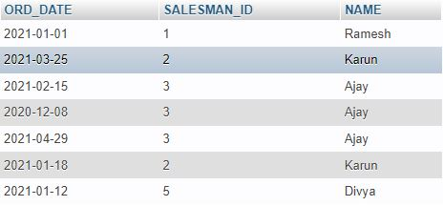  
   
  
**5. Demonstrate  
the DELETE operation by removing salesman with id 1000. All his orders must  
also be deleted.**

[DELETE](http://localhost/phpmyadmin/url.php?url=https://dev.mysql.com/doc/refman/8.0/en/delete.html" \t "http://localhost/phpmyadmin/index.php?route=/table/mysql_doc) FROM SALESMAN WHERE SALESMAN\_ID=1000

